UNITED STATES
SECURITIES AND EXCHANGE COMMISSION
Washington, D.C. 20549

FORM 8-K

CURRENT REPORT
Pursuant to Section 13 OR 15(d)
of The Securities Exchange Act of 1934

Date of Report (Date of earliest event reported): October 31, 2026

RECURSION PHARMACEUTICALS, INC.
(Exact name of registrant as specified in its charter)

Delaware |  |  |  |  |  | 001-40323 |  |  |  |  |  | 46-4099738
(State or other jurisdiction of incorporation) |  |  |  |  |  | (Commission File Number) |  |  |  |  |  | (I.R.S. Employer Identification No.)
41 S Rio Grande Street
Salt Lake City, UT 84101
(Address of principal executive offices) (Zip code)

(385) 269 - 0203
(Registrant’s telephone number, including area code)

Not Applicable
(Former name or former address, if changed since last report.)

Check the appropriate box below if the Form 8-K filing is intended to simultaneously satisfy the filing obligation of the registrant under any of the following provisions:

☐ Written communications pursuant to Rule 425 under the Securities Act (17 CFR 230.425)

☐ Soliciting material pursuant to Rule 14a-12 under the Exchange Act (17 CFR 240.14a-12)

☐ Pre-commencement communications pursuant to Rule 14d-2(b) under the Exchange Act (17 CFR 240.14d-2(b))

☐ Pre-commencement communications pursuant to Rule 13e-4(c) under the Exchange Act (17 CFR 240.13e-4(c))

Securities registered pursuant to Section 12(b) of the Act:
Title of each class |  |  | Trading symbol(s) |  |  | Name of each exchange on which registered
Class A Common Stock, par value $0.00001 per share |  |  | RXRX |  |  | Nasdaq Global Select Market

Indicate by check mark whether the registrant is an emerging growth company as defined in Rule 405 of the Securities Act of 1933 or (§230.405 of this chapter) or Rule 12b-2 of the Securities Exchange Act of 1934 (§240.12b-2 of this chapter).

Emerging growth company ☐

If an emerging growth company, indicate by check mark if the registrant has elected not to use the extended transition period for complying with any new or revised financial accounting standards provided pursuant to Section 13(a) of the Exchange Act. ☐

Item 2.02. Results of Operations and Financial Condition.

On November 2, 2026, Recursion Pharmaceuticals, Inc. (the “Company”) issued a press release announcing its results of operations and financial condition for the third quarter ended September 30, 2026. A copy of the press release is furnished as Exhibit 99.1 and is incorporated herein by reference.

Item 5.02. Departure of Directors or Certain Officers; Election of Directors; Appointment of Certain Officers; Compensatory Arrangements of Certain Officers.

On October 31, 2026, the Board of Directors (the “Board”) of the Company, upon the recommendation from its Nominating and Corporate Governance Committee (the “Nominating Committee”), increased the number of members of the Board from 9 to 10 and appointed Fred Hassan as Chair of the Board, effective immediately.

The Board appointed Mr. Hassan as a Class II Director of the Board, with his initial term to extend until the 2029 Annual Meeting of Stockholders. Mr. Hassan has not yet been appointed to any committee of the Board.

As a non-employee director, Mr. Hassan will receive cash and equity compensation paid by the Company pursuant to the Recursion Pharmaceuticals, Inc. Outside Director Compensation Policy (the “Director Compensation Policy”), which is described under the caption “Director Compensation – 2026 Changes to the Outside Director Compensation Policy” in the Company’s definitive proxy statement on Schedule 14A filed with the SEC on April 30, 2026, as amended by the Board from time to time, and Mr. Hassan will enter into an indemnification agreement with the Company on the Company’s standard form of indemnification agreement for officers and directors.

There are no transactions in which Mr. Hassan has a direct or indirect material interest requiring disclosure under Item 404(a) of Regulation S-K and there are no arrangements or understandings between Mr. Hassan and any other person pursuant to which he was selected as a director of the Company.

Item 7.01. Regulation FD Disclosure.

On November 2, 2026, the Company released a press release announcing the appointment of Mr. Hassan as Chair of the Board, as described in Item 5.02, above. A copy of the press release is attached hereto as Exhibit 99.2 to this Current Report on Form 8-K and incorporated into this Item 7.01 by reference.

Also on November 2, 2026, the Company released a press release announcing the data presented at CGA-IGC conference on November 2, 2026. A copy of the press release is attached hereto as Exhibit 99.3 to this Current Report on Form 8-K and incorporated into this Item 7.01 by reference.

Also on November 2, 2026, the Company released a presentation made in connection with its earnings call on November 3, 2026. A copy of the presentation is attached hereto as Exhibit 99.4 to this Current Report on Form 8-K and incorporated into this Item 7.01 by reference.

The information furnished pursuant to Item 2.02 (including Exhibit 99.1) and 7.01 (including Exhibits 99.2 and 99.3) on this Form 8-K, shall not be deemed “filed” for purposes of Section 18 of the Securities Exchange Act of 1934, as amended (the “Exchange Act”), or otherwise subject to the liabilities of that section, nor shall it be deemed incorporated by reference into any other filing under the Securities Act of 1933, as amended, or the Exchange Act, except as expressly set forth by specific reference in such a filing.

Forward Looking Statements

The Company cautions you that statements contained in this report include or are based upon “forward-looking statements” within the meaning of the Securities Litigation Reform Act of 1995, including all statements that are not historical facts. Forward-looking statements may or may not include identifying words such as “plan,” “will,” “expect,” “anticipate,” “intend,” “believe,” “potential,” “continue,” and similar terms. These statements are subject to known or unknown risks and uncertainties that could cause actual results to differ materially from those expressed or implied in such statements such as those described under the heading “Risk Factors” in the Company’s filings with the SEC, including the Company’s most recent Annual Report on Form 10-K and all subsequently filed Quarterly Reports on Form 10-Q. All forward-looking statements are based on management’s current estimates, projections, and assumptions, and the Company undertakes no obligation to correct or update any such statements, whether as a result of new information, future developments, or otherwise, except to the extent required by applicable law.

Item 9.01. Financial Statements and Exhibits.

(d) Exhibits.

Exhibit Number |  |  | Description
99.1 |  |  | Press release issued by the Company dated November 2, 2026.
99.2 |  |  | Press release issued by the Company announcing the appointment of Mr. Hassan, dated November 2, 2026.
99.3 |  |  | Press release issued by the Company announcing REC-4881 Data Presented at CGA-IGC dated November 2, 2026.
99.4 |  |  | Earnings call presentation of Recursion Pharmaceuticals, Inc. dated November 3, 2026.
104 |  |  | Cover Page Interactive Data File (embedded within the Inline XBRL document)

SIGNATURES
Pursuant to the requirements of the Securities Exchange Act of 1934, the registrant has duly caused this report to be signed on its behalf by the undersigned hereunto duly authorized on November 2, 2026.

 |  |  | RECURSION PHARMACEUTICALS, INC.
 |  |  | By: |  |  | /s/ Ben Taylor
 |  |  |  |  |  | Ben Taylor
 |  |  |  |  |  | Chief Financial Officer

Exhibit 99.1

Recursion Reports Third Quarter 2026 Financial Results and Extends Cash Runway; Highlights Positive Clinical Data in REC-4881 and REC-1245, Sanofi Development Candidate Option and Appointment of Fred Hassan as Chair

•New Phase 2 REC-4881 data presented at CGA-IGC in an expanded adult population aged 18 years and older show deep, durable polyp burden reductions in FAP, with activity throughout the GI tract and in larger, higher-risk polyps.
•REC-4881 shows deep activity throughout the GI tract in post colectomy patients, After 12 weeks of treatment, nearly 1 in 2 patients in the upper GI and more than 1 in 3 in the lower GI achieved polyp burden reductions of ≥65%. Two patients achieved ≥98% reductions in upper GI polyp burden.
•REC-4881 reductions persisted off treatment: Twelve weeks after stopping treatment, 85% of evaluable patients remained below baseline polyp burden.
•REC-4881 reductions in larger, higher-risk polyps: Six of eight patients with polyps >5 mm at baseline had reductions in these polyp counts after 12 weeks of treatment; four had reductions of at least 80%, including two whose larger-polyp counts fell from more than 90 to one.
•REC-4881 no new safety signals observed: Favorable chronic dosing safety profile, with predominantly Grade 1/2 AEs, and no additional discontinuations reported since the prior data cutoff.
•REC-1245 Phase 1 data update: Encouraging monotherapy activity with 2 confirmed partial responses in endometrial cancer, 1 unconfirmed partial response in liver cancer, and a 91.7% disease control rate (11/12) at doses ≥45 mg; 45 mg selected for exploratory expansion cohort based on emerging efficacy and manageable safety profile.
•Sanofi options the first development candidate from Recursion collaboration, a potential first-in-class, dual targeting inhibitor oral small molecule in immunology, which will now advance into Sanofi’s portfolio, with Phase 1 clinical study expected to begin in 2027.
•Expected cash runway extended into 2029, including proceeds from the October 2026 follow-on offering; 2026 cash operating expense guidance reiterated at less than $375 million, with 2027 guidance of less than $360 million.
•Appointed Fred Hassan as Chair of the Board, effective October 31, 2026. Mr. Hassan brings more than four decades of pharmaceutical leadership and Board experience across company transformation, drug development and commercialization.

SALT LAKE CITY, November 2, 2026 (GLOBE NEWSWIRE) — Recursion (Nasdaq: RXRX), a leading clinical-stage company pioneering AI-enabled drug discovery and development to decode biology and radically improve lives, today reported financial results for the third quarter ended September 30, 2026, together with business updates highlighting continued clinical, pipeline and platform execution.

Recursion will host a webinar with earnings updates on REC-4881 data, REC-1245 data, as well as REC-4881 KOL and patient panels, presented live from CGA-IGC on Tuesday, November 3, 2026 at 8:00 am ET / 6:00 am MT / 1:00 pm GMT from Recursion’s X, LinkedIn, and YouTube accounts giving analysts, investors, and the public the opportunity to ask questions of the Company by submitting questions here: https://forms.gle/qvyd1riijt3D2ZUy8

"To pioneer a new blueprint for making medicines with AI, we believe you have to tie together three core capabilities in one engine: uncover novel biology, design differentiated molecules against challenging targets, and generate clinical evidence that matters for patients,” said Najat Khan, Ph.D., President and Chief Executive Officer of Recursion. “The new TUPELO data are important clinical evidence, with REC-4881 showing deep polyp burden reductions across the upper and lower GI tract, including larger, higher-risk polyps, and reductions that persist after treatment stops. REC-1245 is an encouraging early example of that engine coming together within a single program, from biological insight surfaced by our platform to molecule design and now early clinical signals in heavily pretreated patients.”

“Beyond our own pipeline, Sanofi has optioned a potential first-in-class molecule against a challenging dual target, while Genentech has advanced an unexplored neuroscience target from our maps. These are different programs, but they are outputs of the same AI-native engine, providing evidence of repeatability. We will keep concentrating capital where the evidence is strongest and turning innovation into impact for patients who are waiting.”

Internal Pipeline Highlights
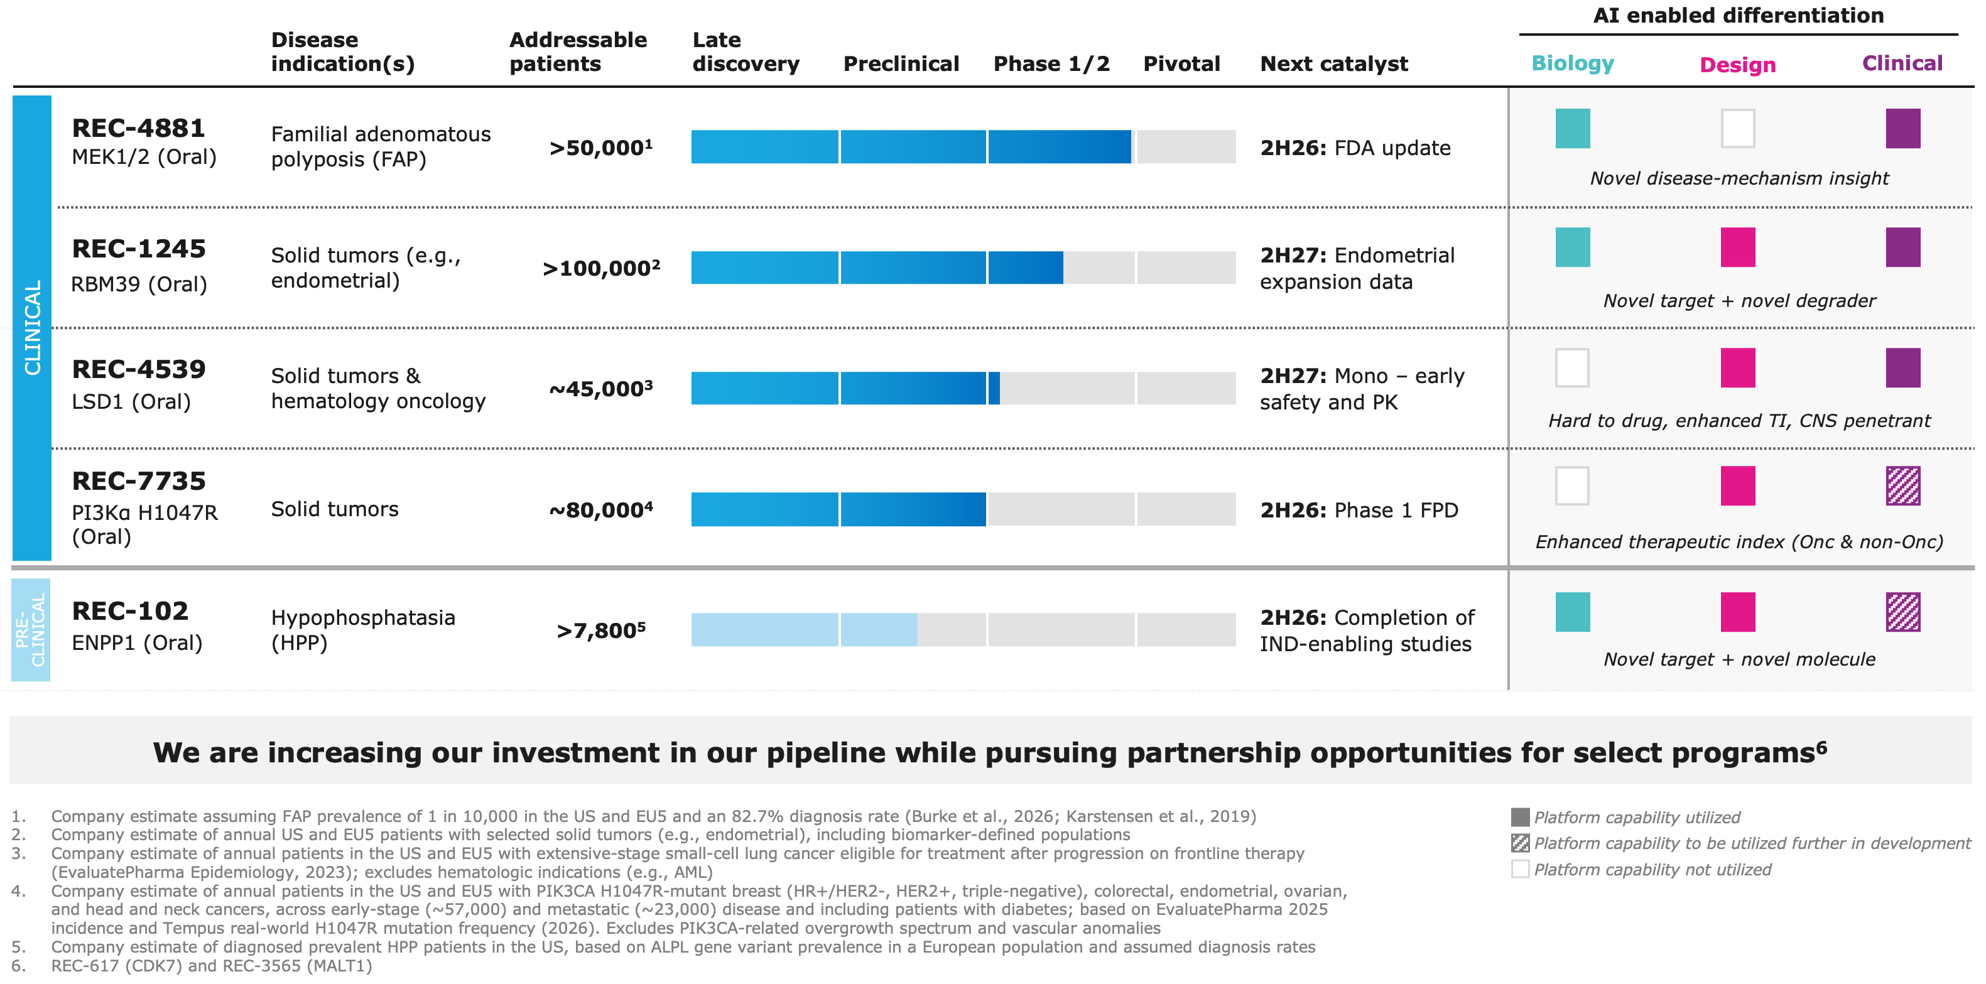

Positive Phase 2 results from ongoing TUPELO trial of REC-4881 in FAP highlight activity across GI tract and on larger polyps

FAP is a genetically defined driver of GI cancer, affecting >50,000 patients in the US and EU5 who face major surgeries and life-long surveillance with no approved therapies, representing a potential $15 billion opportunity, based on Company estimates. Among the approximately 35,000 post-colectomy patients, upper GI disease represents the highest unmet need in FAP, due to risks of bleeding and perforation from polyp removal, high complication and morbidity rates from surgery, and higher cancer risk.

REC-4881, a potential first-in-class oral therapy granted FDA Orphan Drug and Fast Track designations, is designed to address both Wnt/β-catenin initiation and MAPK evolution pathways. The opportunity was identified through unbiased phenotypic screening using Recursion’s proprietary AI foundation models, which revealed MEK1/2 inhibition as a potential way to reverse cellular phenotypes associated with APC loss, a previously unappreciated synthetic rescue relationship.

On November 2, Recursion announced further positive data from its ongoing Phase 1b/2 TUPELO trial of REC-4881, an investigational, oral MEK1/2 inhibitor in development for FAP. These data were presented by Lisa Boardman, M.D., Professor of Medicine at Mayo Clinic, in a presidential plenary session at The Collaborative Group of the Americas on Inherited Gastrointestinal Cancer (CGA-IGC) Annual Meeting in Denver, Colorado.

•Deep, durable reductions in total polyp burden, strengthened in the expanded adult FAP population (18+): After 12 weeks of REC-4881 (4 mg QD), 87% of patients (13 of 15) had a

reduction in total polyp burden, with a 47% median reduction; approximately 1 in 3 achieved reductions of ≥65%. Twelve weeks after stopping treatment, 85% of evaluable patients (11 of 13) remained below baseline.
•Activity across the upper and lower GI tract, including near-clearance: After 12 weeks of treatment, median polyp burden reductions were 55% in the upper GI and 50% in the lower GI, supporting REC-4881’s potential as a single oral therapy to address FAP across the GI tract.
•Upper GI, the area of greatest unmet need in FAP (results first reported Oct. 15): 92% of patients (12 of 13) had reductions after 12 weeks of treatment, with two patients achieving ≥98% reductions; half (6 of 12) improved by at least one Spigelman stage; and 92% (11 of 12) remained below baseline 12 weeks after stopping treatment.
•New lower GI results highlight breadth of activity: 9 of 11 patients (82%) with measurable lower GI polyp burden at baseline had reductions after 12 weeks of treatment, with a 50% median reduction and 1 in 3 achieving ≥65%; 70% of evaluable patients remained below baseline 12 weeks after stopping treatment.
•New analysis shows substantial reductions in larger, higher-risk polyps: 6 of 8 patients with polyps >5 mm at baseline had fewer of these polyps after 12 weeks of treatment. Four achieved reductions of ≥80%, including two whose counts fell from more than 90 polyps to one. Six of eight remained below their baseline count 12 weeks after stopping treatment.
•No new safety signals observed: Favorable chronic dosing safety profile. The highest-grade treatment-related adverse event was Grade 1 or 2 in 21 of 26 patients (81%) and Grade 3 in four patients (15%); one patient had no TRAEs. No Grade 4 or 5 TRAEs, and no additional discontinuations since the previous data cutoff.

The Company anticipates initiating a registrational trial in the second half of 2027, pending ongoing FDA discussions, and will provide additional details later this year.

Early data from the Phase 1 dose-escalation portion of DAHLIA, our ongoing open-label Phase 1/2 study of REC-1245, show the following (data cutoff: August 21, 2026):

REC-1245 is a potential first-in-class oral molecular glue designed to exploit a synthetic-lethal vulnerability in cancers by degrading RBM39, a splicing factor that regulates genes involved in DNA repair and stress response. The Recursion platform contributed each of the three core elements of the program: the target, the molecule and the initial hypotheses on which patients are most likely to benefit. The target emerged from Recursion’s platform, which found that degrading RBM39 mimics the loss of CDK12, while sparing CDK13-associated liabilities. REC-1245 was identified within 18 months after screening only 204 compounds using Recursion’s design platform. The same platform-derived biology pointed to tumors intrinsically primed by replication stress and reliance on accurate splicing, including hard-to-treat cancers such as endometrial, hepatocellular and ovarian cancers and transcriptionally driven tumors.

•Three partial responses per RECIST 1.1 criteria (2 confirmed, 1 unconfirmed) in heavily pretreated patients with endometrial cancer and hepatocellular carcinoma, all at doses of 45 mg once daily (QD) or higher, with a disease control rate of 91.7% at those doses (n=12).
•Recursion has selected 45 mg QD for exploratory expansion cohorts, including endometrial cancer, where limited second-line treatments are approved; at the 45 mg QD dose (n=10), no dose-limiting toxicities or treatment-related serious adverse events were observed, and treatment-related adverse events were predominantly Grade 1 or 2. Most frequent TRAEs were Grade 1 or Grade 2 fatigue and anemia (30% each).
•Preliminary dose expansion data in endometrial cancer are expected in the second half of 2027. Dose escalation will also continue in other solid tumor indications.

Other Portfolio Updates: REC-7735 is an orally bioavailable, precision-designed small molecule inhibitor of PI3Kα H1047R generated using the Recursion OS. In the second half of 2026, Recursion initiated the Phase 1/2 ZINNIA clinical study for patients with select PIK3CA H1047R-mutant solid tumors.

As announced in October 2026, given the promising data in REC-4881 and REC-1245, Recursion plans to continue to focus resources on its high-impact partnerships and internal programs including REC-4881 (MEK1/2 - familial adenomatous polyposis), REC-1245 (RBM39 - endometrial cancer and other solid tumors), REC-4539 (LSD1 - solid tumors and hematology), REC-7735 (PI3Kα H1047R - solid tumors) and REC-102 (ENPP1 - hypophosphatasia). Recursion intends to pursue partnership opportunities to advance REC-617 (CDK7) and REC-3565 (MALT1).

Partnered Discovery Highlights Recursion’s 9th Milestone Achieved in Past Two Years

Sanofi options potential first-in-class immunology development candidate

Sanofi has optioned the first development candidate from the two companies’ multi-program research collaboration. The candidate has now been added to Sanofi’s development pipeline and is expected to enter Phase 1 clinical trials in 2027, with Sanofi funding and leading further development and commercialization to advance the program toward patients.

The option triggered a $10 million milestone payment to Recursion, bringing total upfront and milestone payments achieved from Sanofi under the collaboration to $144 million; Recursion is eligible for more than $300 million in additional milestones under the program, with double digit royalties on net product sales, if approved.

The potential first-in-class oral small molecule was designed to achieve a differentiated profile against a challenging dual target implicated in inflammatory disease. Optimizing for this target pair required navigating complex and competing chemistry constraints to achieve the desired balance of drug-like properties. The candidate was delivered by the combination of Recursion’s integrated AI-enabled drug design platform and small-molecule chemistry capabilities with Sanofi’s deep expertise in drug discovery and immunology. Recursion applied multiple computational design approaches across iterative cycles of prediction, chemical design, synthesis, and experimental validation to rapidly explore and optimize a complex chemical space.

With the first development candidate optioned, the collaboration has now achieved six progress-based milestones across five programs. Additional programs across the collaboration continue to advance. Over the next 12 months, other programs in the joint portfolio have the potential to reach development candidate and other progress-based milestones.

To learn more about this milestone, read the press release.

Genentech advanced first neuroscience target into early discovery program

In 3Q26, Genentech exercised the first Validated Target Option under the companies' neuroscience collaboration, advancing a previously unexplored neuroscience target.

The milestone provides additional early evidence that Recursion's AI-native platform can both discover and play a key role experimentally validating unexplored therapeutic targets in neuroscience, one of

medicine's most challenging therapeutic areas, where decades of research have largely focused on a limited number of well-studied targets. Predictions generated from the first whole-genome CRISPR knockout map, which was built by Recursion in partnership with Roche and Genentech from a subset of over 1 trillion internally manufactured iPSC-derived neuronal cells, were rigorously jointly validated with Genentech. Only targets that consistently demonstrated compelling evidence across pathway, functional, and disease validation progress into a validation package.

Next steps will include advancing the target through small molecule design, hit generation, and validation using Recursion's AI-native chemistry platform. More broadly, the neuronal and microglial maps of biology remain reusable assets capable of being collaboratively utilized with biological, genetics, and computational expertise to generate and experimentally validate additional therapeutic hypotheses. To date, Recursion has achieved $216 million in upfront and milestone payments from the Roche and Genentech collaboration. The collaboration includes up to 40 potential small molecule discovery programs, each carrying the potential for more than $300 million in development, commercialization, and net sales milestones as well as tiered royalties up to high single digits per small molecule program for Recursion.

Potential upcoming milestones across partnered discovery:
•Potential for additional differentiated AI-enabled oral molecules to reach development candidate and late-stage discovery milestones with Sanofi over the next 12 months
•Translating AI-driven insights from maps of biology into new potentially novel targets from reusable high-dimensional data/maps with Roche and Genentech
•Using Recursion’s chemistry platform to design potential first-in-class molecules for the collaboration's first neuroscience target with Genentech

Fred Hassan appointed Chair of the Board
Recursion announced that its Board of Directors has appointed Fred Hassan as Chair, effective October 31, 2026.

Mr. Hassan brings more than four decades of pharmaceutical leadership spanning company transformation, drug development, commercialization, investing and Board service. As Chairman and Chief Executive Officer of Schering-Plough, he led a transformation that restored sales growth and strong cash flow while expanding the company’s Phase 3 pipeline from three new molecular entities to eight. He previously served as Chairman and Chief Executive Officer of Pharmacia.

Mr. Hassan also brings extensive perspective from across the biotechnology and investment ecosystem. He serves as Lead Independent Director of BridgeBio Pharma, where his Board tenure has spanned the FDA approval and U.S. launch of Attruby, and as Executive Chair of Norstella, the pharmaceutical intelligence company behind Citeline, MMIT and Evaluate. His prior Board roles include Amgen and Prometheus Biosciences. He is also a Director at Warburg Pincus, where he previously served as Partner and Managing Director.

Third Quarter 2026 Financial Results

•Cash Position: Cash, cash equivalents and restricted cash were $561.5 million as of September 30, 2026. Including net proceeds of approximately $187.2 million from the Company's underwritten offering which completed on October 16, 2026, pro forma cash, cash equivalents and restricted cash were approximately $748.7 million. Based on current operating plans with no additional financing, the Company expects its cash runway to extend into 2029.
•Revenue: Total revenue, consisting primarily of revenue from collaboration agreements, was $18.6 million for the third quarter of 2026, compared to $5.2 million for the third quarter of 2025. The increase was driven primarily by the Company's collaboration with Sanofi, under which the

Company achieved a $10.0 million milestone for an immunology small molecule program during the quarter.
•Research and Development Expenses: Research and development expenses were $99.1 million for the third quarter of 2026, compared to $121.1 million for the third quarter of 2025. The decrease was driven primarily by $22.8 million of in-process research and development costs related to the acquisition of full rights to REC-102, Recursion’s ENPP1 inhibitor for the treatment of hypophosphatasia (HPP), from its joint venture with Rallybio that were recognized in the third quarter of 2025 and did not recur in the current period.
•General and Administrative Expenses: General and administrative expenses were $32.6 million for the third quarter of 2026 compared to $41.6 million for the third quarter of 2025. The decrease in general and administrative expense compared to the prior period was primarily driven by a decrease in infrastructure technology expenses and professional service costs.
•Net Loss: Net loss was $119.0 million for the third quarter of 2026, compared to a net loss of $162.3 million for the third quarter of 2025.
•Operational cash flows: Net cash used in operating activities was $77.4 million for the three months ended September 30, 2026, compared to net cash used in operating activities of $117.4 million for the three months ended September 30, 2025. The decrease in cash used in operating activities was primarily driven by operating efficiencies across the company and working capital movements.
•Cash Operating Expense: Cash operating expense, excluding partnership inflows and transaction costs, for the nine months ended September 30, 2026 was $271.5 million compared to $323.2 million for the nine months ended September 30, 2025.

About Recursion
Recursion (NASDAQ: RXRX) is a leading clinical-stage company pioneering AI-enabled drug discovery and development decoding biology to radically improve lives. Recursion is advancing a portfolio of differentiated investigational medicines across its wholly owned and partnered pipeline in oncology, rare disease, neuroscience, immunology, and other therapeutic areas with significant unmet need. Enabling its mission is the Recursion OS, an AI-native, end-to-end drug discovery and development platform integrating biology, chemistry, and clinical development into a unified intelligence system. Powered by proprietary multimodal data, purpose-built AI models, and bilingual teams fluent in both science and AI, the Recursion OS is designed to translate complex science into medicines that matter — faster, better, and at scale — for patients who are waiting.

Recursion's platform infrastructure is anchored in Salt Lake City, Utah and Milton Park, Oxfordshire, where its automated biology and chemistry laboratories generate proprietary data at industrial scale. Recursion also maintains offices in New York, Montréal, and London, three global hubs for talent and leadership at the intersection of AI and scientific innovation.

Media Contact
media@recursion.com

Investor Contact
investor@recursion.com

Recursion Pharmaceuticals, Inc.
Condensed Consolidated Statements of Operations (unaudited)
(in thousands, except share and per share amounts)

 |  |  | Three months ended September 30, |  |  |  |  |  |  |  |  | Nine months ended September 30,
 |  |  | 2026 |  |  | 2025 |  |  |  |  |  | 2026 |  |  | 2025
Revenue
Operating revenue |  |  | $ | 18,055 |  | $ | 4,983 |  |  |  |  | $ | 31,659 |  | $ | 38,905
Grant revenue |  |  | 497 |  |  | 192 |  |  |  |  |  | 1,035 |  |  | 238
Total revenue |  |  | 18,552 |  |  | 5,175 |  |  |  |  |  | 32,694 |  |  | 39,143
Operating costs and expenses
Cost of revenue |  |  | 10,045 |  |  | 14,687 |  |  |  |  |  | 34,026 |  |  | 56,678
Research and development |  |  | 99,122 |  |  | 121,062 |  |  |  |  |  | 276,632 |  |  | 379,331
General and administrative |  |  | 32,561 |  |  | 41,628 |  |  |  |  |  | 108,684 |  |  | 142,932
Total operating costs and expenses |  |  | 141,728 |  |  | 177,377 |  |  |  |  |  | 419,342 |  |  | 578,941
Loss from operations |  |  | (123,176) |  |  | (172,202) |  |  |  |  |  | (386,648) |  |  | (539,798)
Other income, net |  |  | 4,165 |  |  | 9,952 |  |  |  |  |  | 14,524 |  |  | 3,005
Loss before income taxes |  |  | (119,011) |  |  | (162,250) |  |  |  |  |  | (372,124) |  |  | (536,793)
Income tax benefit (expense) |  |  | (25) |  |  | (3) |  |  |  |  |  | 4,579 |  |  | 156
Net loss |  |  | $ | (119,036) |  | $ | (162,253) |  |  |  |  | $ | (367,545) |  | $ | (536,637)
Per share data
Net loss per share of Class A, B and Exchangeable common stock, basic and diluted |  |  | $ | (0.22) |  | $ | (0.36) |  |  |  |  | $ | (0.69) |  | $ | (1.27)
Weighted-average shares (Class A, B and Exchangeable) outstanding, basic and diluted |  |  | 543,000,977 |  |  | 446,988,046 |  |  |  |  |  | 534,971,854 |  |  | 422,642,653

Recursion Pharmaceuticals, Inc.
Condensed Consolidated Balance Sheets (unaudited)
(in thousands)
 |  |  | September 30, |  |  | December 31,
 |  |  | 2026 |  |  | 2025
Assets
Current assets
Cash and cash equivalents |  |  | $ | 549,853 |  | $ | 743,294
Restricted cash |  |  | 6,657 |  |  | 4,594
Other receivables |  |  | 34,065 |  |  | 24,649
Prepaid data assets |  |  | 2,882 |  |  | 11,742
Other current assets |  |  | 22,564 |  |  | 28,566
Total current assets |  |  | 616,021 |  |  | 812,845
Restricted cash, non-current |  |  | 5,020 |  |  | 6,033
Property and equipment, net |  |  | 85,838 |  |  | 103,931
Operating lease right-of-use assets |  |  | 51,198 |  |  | 45,339
Financing lease right-of-use assets |  |  | 15,663 |  |  | 20,210
Intangible assets, net |  |  | 273,677 |  |  | 309,903
Goodwill |  |  | 160,710 |  |  | 162,158
Deferred tax assets |  |  | 957 |  |  | 957
Other assets, non-current |  |  | 12,628 |  |  | 12,754
Total assets |  |  | $ | 1,221,712 |  | $ | 1,474,130
Liabilities and stockholders’ equity
Current liabilities
Accounts payable |  |  | $ | 16,384 |  | $ | 18,118
Accrued expenses and other liabilities |  |  | 66,651 |  |  | 70,230
Unearned revenue |  |  | 15,811 |  |  | 37,605
Operating lease liabilities |  |  | 12,264 |  |  | 12,663
Notes payable and financing lease liabilities |  |  | 11,808 |  |  | 9,091
Total current liabilities |  |  | 122,918 |  |  | 147,707
Unearned revenue, non-current |  |  | 120,020 |  |  | 114,012
Operating lease liabilities, non-current |  |  | 50,535 |  |  | 46,647
Notes payable and financing lease liabilities, non-current |  |  | 93 |  |  | 9,564
Deferred tax liabilities |  |  | 18,371 |  |  | 23,255
Other liabilities, non-current |  |  | 3,963 |  |  | 2,080
Total liabilities |  |  | 315,900 |  |  | 343,265
Stockholders’ equity
Common stock |  |  | 6 |  |  | 5
Additional paid-in capital |  |  | 3,319,723 |  |  | 3,170,145
Accumulated deficit |  |  | (2,443,547) |  |  | (2,076,002)
Accumulated other comprehensive income |  |  | 29,630 |  |  | 36,717
Total stockholders’ equity |  |  | 905,812 |  |  | 1,130,865
Total liabilities and stockholders’ equity |  |  | $ | 1,221,712 |  | $ | 1,474,130

Recursion Pharmaceuticals Inc
Selected Cash Flow Information (unaudited)
(in thousands)
 |  |  |  |  |  | Three months ended September 30, |  |  |  |  |  | Nine months ended September 30,
 |  |  |  |  |  | 2026 |  |  | 2025 |  |  | 2026 |  |  | 2025
Net cash used in operating activities |  |  |  |  |  | $ | (77,406) |  | $ | (117,360) |  | $ | (264,454) |  | $ | (325,735)
Net cash used in investing activities |  |  |  |  |  | (407) |  |  | (2,549) |  |  | (2,704) |  |  | (15,627)
Net cash provided by (used in) financing activities |  |  |  |  |  | 83,144 |  |  | 251,340 |  |  | 78,407 |  |  | 389,526
Effect of exchange rate changes on cash, cash equivalents and restricted cash |  |  |  |  |  | (621) |  |  | 1,869 |  |  | (3,640) |  |  | 15,957
Cash, cash equivalents and restricted cash, beginning of period |  |  |  |  |  | 556,820 |  |  | 533,845 |  |  | 753,921 |  |  | 603,024
Cash, cash equivalents and restricted cash, end of period |  |  |  |  |  | $ | 561,530 |  | $ | 667,145 |  | $ | 561,530 |  | $ | 667,145

Non-GAAP Financial Measure

The reconciliation of operating cash expense to net cash used in operating activities is provided in the following tables:

Cash Operating Expense - Nine months ended September 30 2026 |  |  | (in millions)
Net cash used in operating activities |  |  | $ | 264.5 |  | *
Add: partnership inflows |  |  | 7.0
Cash Operating Expense - Nine months ended September 30 2026 |  |  | $ | 271.5
*This is from the Recursion Inc Consolidated Statement of Cash Flows for the nine months ended September 30, 2026 (see above)

Cash Operating Expense - Nine months ended September 30 2025 |  |  | (in millions)
Net cash used in operating activities |  |  | $ | 325.7 |  | *
Add: partnership inflows |  |  | 7.0
Subtract: Transaction costs |  |  | (9.6)
Cash Operating Expense - Nine months ended September 30 2025 |  |  | $ | 323.1
*This is from the Recursion Inc Consolidated Statement of Cash Flows for the nine months ended September 30, 2025 (see above)

To supplement our financial statements prepared in accordance with U.S. GAAP, we monitor and consider operating cash expense, which is a non-GAAP financial measure. We define cash operating expense as the net cash used in operating activities, excluding non-ordinary course transaction costs and partnership cash inflows. This non-GAAP financial measure is not based on any standardized methodology prescribed by U.S. GAAP and is not necessarily comparable to similarly-titled measures presented by other companies. We believe operating cash expense to be a liquidity measure that provides useful information to management and investors about the amount of cash consumed by the operations of the business. A limitation of using this non-U.S. GAAP measure is that operating cash expense does not represent the total change in cash and cash equivalents for the period because it excludes cash provided by or used for other investing and financing activities. We account for this limitation by providing information about our capital expenditures and other investing and financing activities in the statements of cash flows in our financial statements. Additionally, we reconciled operating cash expense above to net cash used in operating activities, the most directly comparable U.S. GAAP financial measure. In addition,

it is important to note that other companies, including companies in our industry, may not use operating cash expense, may calculate operating cash expense in a different manner than we do or may use other financial measures to evaluate their performance, all of which could reduce the usefulness of operating cash expense as a comparative measure. Because of these limitations, operating cash expense should not be considered in isolation from, or as a substitute for, financial information prepared in accordance with U.S. GAAP.

Forward-Looking Statements
This document contains information that includes or is based upon “forward-looking statements” within the meaning of the Private Securities Litigation Reform Act of 1995, including, without limitation, those regarding the impact of preclinical and clinical data from our programs, including the Phase 2 data from the TUPELO trial of REC-4881; the timing and outcome of anticipated engagement with the FDA, including the definition of a registrational path for REC-4881; the impact of the Phase 1 data from the DAHLIA trial of REC-1245 on the future success of that program; the selection of a dose for REC-1245 expansion cohorts; the potential for REC-7735 to limit metabolic liabilities and improve therapeutic index; Recursion’s ability to translate platform insights into validated targets and optimized development candidates; Recursion’s plans to focus resources on its high-impact partnerships and internal programs and to pursue partnership opportunities for REC-617 and REC-3565; the expected initiation of a Phase 1 clinical study of the development candidate optioned by Sanofi; the impact of Genentech’s option of any neuroscience target on future development of that or other potential targets; the reusability of our maps of biology and the potential to generate and experimentally validate additional therapeutic hypotheses, including through multi-modal maps combining our phenomics data with partner-provided data; financial position, including the expected impact of the net proceeds of our October 2026 underwritten offering, cash runway, cash burn, and 2026 and 2027 cash operating expense guidance; the occurrence or realization of potential milestones; the timing of data readouts and other milestones; Recursion’s future as a leader in AI-enabled drug discovery and development and ability to deliver better treatments to patients faster; expectations relating to early and late stage discovery, preclinical, and clinical programs, including timelines for commencement of and enrollment in studies, data readouts, presentations at scientific and medical meetings, and meetings with regulators; expectations and developments with respect to licenses and collaborations, including option exercises by partners and the amount and timing of potential milestone payments and royalties; prospective products and their potential future indications, differentiated profiles, and market opportunities; developments with Recursion OS, including the ability to discover and develop new medicines; and all other statements that are not historical facts. Forward-looking statements may or may not include identifying words such as “plan,” “will,” “may,” “could,” “should,” “expect,” “anticipate,” “intend,” “believe,” “estimate,” “project,” “designed to,” “potential,” “continue,” and similar terms. These statements are subject to known or unknown risks and uncertainties that could cause actual results to differ materially from those expressed or implied in such statements, including but not limited to: challenges inherent in pharmaceutical research and development, including the timing and results of preclinical and clinical programs, where the risk of failure is high and failure can occur at any stage prior to or after regulatory approval due to lack of sufficient efficacy, safety considerations, or other factors; the risk that interim, preliminary, or topline data from our clinical trials may change as more patient data become available and may not be predictive of final results; our ability to leverage and enhance our drug discovery platform; the performance and limitations of our artificial intelligence and machine learning models and the data on which they are trained; our reliance on third parties, including collaborators, contract research organizations, and manufacturers; our ability to initiate clinical trials and enroll patients on expected timelines; competition from other therapies and platforms; our ability to obtain financing for development activities and other corporate purposes; the success of our collaboration activities and our collaborators’ discretion over option exercises, program advancement, and funding; our ability to obtain regulatory approval of, and ultimately commercialize, drug candidates; our ability to obtain, maintain, and enforce intellectual property protections; cyberattacks or other disruptions to our technology systems; our ability to attract, motivate, and retain key employees and manage our growth; inflation and other macroeconomic issues; and other risks and uncertainties such as those described under the heading “Risk Factors” in our filings with the U.S. Securities and Exchange Commission, including our Annual Report on Form 10-K and our subsequent Quarterly Reports on Form

10-Q. All forward-looking statements speak only as of the date of this document and are based on management’s current estimates, projections, and assumptions, and Recursion undertakes no obligation to correct or update any such statements, whether as a result of new information, future developments, or otherwise, except to the extent required by applicable law.

Exhibit 99.2

Recursion Appoints Fred Hassan as Chair of the Board
SALT LAKE CITY, Nov. 2, 2026 (GLOBE NEWSWIRE) -- Recursion (Nasdaq: RXRX), a leading clinical-stage company pioneering AI-enabled drug discovery and development, today announced that its Board of Directors has appointed Fred Hassan as Chair, effective October 31, 2026.
Mr. Hassan arrives with a strong track record of more than four decades in the pharmaceutical industry. He has grown global businesses and led teams that brought multiple medicines through development, regulatory approval and commercial launch. As an example, the severely challenged Schering-Plough returned to sales growth, strong cash flow, and expanded the number of new molecular entities in Phase 3 development from three to eight.
Mr. Hassan serves as Lead Independent Director of BridgeBio Pharma and was a member of its Board when the company secured FDA approval for the heart failure drug, Attruby and executed a successful launch, substantially ahead of market expectations. He is also Executive Chair of Norstella, the pharmaceutical intelligence company behind Citeline, MMIT and Evaluate. His prior board roles include Amgen, a biotechnology pioneer, and Prometheus Biosciences, which used patient data to develop precision therapies for inflammatory bowel disease. Mr. Hassan also brings experience as an investor. He is a Director and was a Partner and Managing Director at Warburg Pincus.
“Fred has repeatedly built, scaled and transformed some of the most important companies in our industry. His first-hand experience will bring invaluable perspective as we advance from clinical proof of concept through approval and launch - and ultimately to meaningful impact for patients. Our next chapter becomes even more exciting with Fred as Chair. The Board remains deeply grateful to Rob Hershberg for his steady commitment to Recursion, and we’re delighted that we will continue to benefit from his perspective as a physician-scientist and biotech CEO,” said Najat Khan, Ph.D., President and Chief Executive Officer of Recursion.
“What excites me is the prospect of chairing a Board where its dynamic CEO pairs the courage of striking into the unknown with the unrelenting discipline of turning prioritized projects into innovative medicines,” said Fred Hassan.
“Fred brings proven operating experience, a well-honed investor’s discipline and a track record of repeatedly creating important value through transformation. The Board unanimously believes that he is the right person for the Chairman’s role. I welcome Fred and look forward to my continuing role on the Board,” said Dr. Hershberg.
About Fred Hassan
Mr. Hassan currently serves as a Director at Warburg Pincus LLC, a global private equity firm, which he joined in 2010, and as Executive Chair of Norstella, a role he has held since January 2026. Previously, Mr. Hassan served as Chairman and Chief Executive Officer of Schering-Plough Corporation from 2003 to 2009 and as Chairman and Chief Executive Officer of Pharmacia Corporation from 2001 to 2003. He previously held executive and leadership positions with Wyeth and Sandoz Pharmaceuticals (now Novartis). Mr. Hassan’s current public board memberships include Precigen and

BridgeBio Pharma. His previous boards included Prometheus Biosciences, Amgen, Time Warner, Avon and Bausch & Lomb. Mr. Hassan has chaired the Pharmaceutical Research and Manufacturers of America and the International Federation of Pharmaceutical Manufacturers & Associations. Mr. Hassan co-founded the CEO Forum with Accenture to bring together chief executives from across the life sciences. He has also played a leadership role in the R&D Leadership Summit, an annual gathering of biopharma CEOs and research leaders focused on improving R&D productivity. He holds a B.S. in chemical engineering from the Imperial College of Science and Technology at the University of London and an M.B.A. from Harvard Business School.
About Recursion
Recursion (NASDAQ: RXRX) is a leading clinical-stage company pioneering AI-enabled drug discovery and development decoding biology to radically improve lives. Recursion is advancing a portfolio of differentiated investigational medicines across its wholly owned and partnered pipeline in oncology, rare disease, neuroscience, immunology, and other therapeutic areas with significant unmet need. Enabling its mission is the Recursion OS, an AI-native, end-to-end drug discovery and development platform integrating biology, chemistry, and clinical development into a unified intelligence system. Powered by proprietary multimodal data, purpose-built AI models, and bilingual teams fluent in both science and AI, the Recursion OS is designed to translate complex science into medicines that matter — faster, better, and at scale — for patients who are waiting.

Recursion's platform infrastructure is anchored in Salt Lake City, Utah and Milton Park, Oxfordshire, where its automated biology and chemistry laboratories generate proprietary data at industrial scale. Recursion also maintains offices in New York, Montréal, and London, three global hubs for talent and leadership at the intersection of AI and scientific innovation.

Forward-Looking Statements
This document contains information that includes or is based upon “forward-looking statements” within the meaning of the Private Securities Litigation Reform Act of 1995. Forward-looking statements may or may not include identifying words such as “plan,” “will,” “may,” “could,” “should,” “expect,” “anticipate,” “intend,” “believe,” “estimate,” “project,” “designed to,” “potential,” “continue,” and similar terms. These statements are subject to known or unknown risks and uncertainties that could cause actual results to differ materially from those expressed or implied in such statements, including risks and uncertainties such as those described under the heading “Risk Factors” in our filings with the U.S. Securities and Exchange Commission, including our Annual Report on Form 10-K and our subsequent Quarterly Reports on Form 10-Q. All forward-looking statements speak only as of the date of this document and are based on management’s current estimates, projections, and assumptions, and Recursion undertakes no obligation to correct or update any such statements, whether as a result of new information, future developments, or otherwise, except to the extent required by applicable law.

Media Contact
media@recursion.com

Investor Contact
investor@recursion.com

Exhibit 99.3

New Phase 2 REC-4881 Data Presented at CGA-IGC Show Deep, Durable Polyp Burden Reductions in FAP, with Activity Across the GI Tract and in Larger, Higher-Risk Polyps
●Updated TUPELO results featured in a Presidential Plenary at CGA-IGC: Lisa Boardman, M.D., Professor of Medicine at Mayo Clinic, presented updated findings from the Phase 1b/2 TUPELO trial in familial adenomatous polyposis (FAP) at the Collaborative Group of the Americas on Inherited Gastrointestinal Cancer (CGA-IGC) Annual Meeting.
●Deep reductions sustained off treatment: In an expanded adult population aged 18 years and older, after 12 weeks of treatment, patients achieved a 47% median reduction in total polyp burden, with approximately 1 in 3 achieving reductions of ≥65%. Twelve weeks after stopping treatment, 85% of evaluable patients remained below baseline.
●Activity throughout the upper and lower GI tract, including near-clearance: After 12 weeks of treatment, nearly 1 in 2 patients in the upper GI and more than 1 in 3 in the lower GI achieved polyp burden reductions of ≥65%. Two patients achieved ≥98% reductions in upper GI polyp burden.
●Substantial reductions in larger, higher-risk polyps: Six of eight patients with polyps >5 mm at baseline had reductions in the number of these polyps after 12 weeks of treatment. Four achieved reductions of ≥80%, including two whose larger-polyp counts fell from more than 90 polyps to one.
●No new safety signals observed: Favorable chronic dosing safety profile, consistent with the MEK inhibitor class. The highest-grade treatment-related adverse event (TRAE) was Grade 1 or 2 in 21 of 26 patients (81%) and Grade 3 in four patients (15%); one patient experienced no TRAEs. No Grade 4 or 5 TRAEs were reported. No additional discontinuations were reported since the previous data cutoff.
●Registrational trial: The Company anticipates initiating a registrational trial in the second half of 2027, pending ongoing FDA discussions, and will provide additional details later this year.
SALT LAKE CITY, Nov. 2, 2026 (GLOBE NEWSWIRE) -- Recursion (Nasdaq: RXRX), a leading clinical-stage company pioneering AI-enabled drug discovery and development, today announced new positive Phase 2 data from the ongoing TUPELO trial of REC-4881, an investigational, oral MEK1/2 inhibitor for familial adenomatous polyposis (FAP). The new analyses show that most patients had reductions in both the number of larger, higher-risk polyps and in lower GI polyp burden, building on the upper GI results announced on October 15, 2026. Together, these findings support the potential of REC-4881 as an oral therapy to address FAP across the GI tract. Lisa Boardman, M.D., a gastroenterologist and Professor of Medicine at Mayo Clinic, presented the results in a Presidential Plenary at the Collaborative Group of the Americas on Inherited Gastrointestinal Cancer (CGA-IGC) Annual Meeting in Denver, Colorado.
“People have been doing research in the chemoprevention space in FAP for decades, and at least in the United States, we still don’t have an agent that is FDA approved. We’re still having to send FAP patients for major surgeries and we’re still doing frequent scopes on these patients. The need for effective chemoprevention in FAP is very large, and it’s only going to increase over time as the number of FAP patients continues to increase,” said Bryson Katona, M.D., Ph.D., Director of the GI Cancer Genetics Program, University of Pennsylvania Perelman School of Medicine, and TUPELO study investigator.

“We recently shared data that showed deep, durable reductions in polyps with REC-4881, particularly in the upper GI, where patients with FAP face the greatest risk and the fewest options. Today's update goes a layer deeper. REC-4881 is reducing the larger polyps that often drive much of the surgery for these patients, across the GI tract from a single oral therapy,” said Najat Khan, Ph.D., President and Chief Executive Officer of Recursion. “This is a lifelong disease with no approved pharmacologic therapies, and REC-4881 is the clearest proof point yet of what we built Recursion to do. Our priority now is to align with the FDA on a registrational path and move with focus and discipline toward a trial in the second half of 2027.”
Latest Data from Phase 2 Trial of REC-4881
Deep reductions in total polyp burden, sustained off treatment

The TUPELO study was designed to study polyp burden reduction after 12 weeks on REC-4881 (4 mg QD) and again after 12 weeks off-treatment. Results in an expanded adult population aged 18 years and older show a rapid and durable treatment effect across the GI tract. Trial results have strengthened since the November 2025 data cut, including expanded adult FAP population ages 18 years and older:

●87% of patients (13 of 15) had a reduction in total polyp burden after 12 weeks of treatment, with a 47% median reduction. One in three patients achieved reductions of 65% or more.
●All patients added since the November 2025 data cut (n=4) had a reduction in total polyp burden, including two patients with 89% and 98% reduction, respectively. At Week 25, after 12 weeks off-treatment, 85% of patients (11 of 13) remained below baseline.
●The persistence of polyp burden reduction below baseline in most patients may allow for dosing flexibility, which could matter in the long-term management of a chronic disease.

“The durability of a reduction in polyp burden is an important metric to understand for any type of chemopreventive agent in FAP. The dream chemopreventive agent for FAP is one that a patient doesn’t have to take lifelong and that potentially could be taken for a shorter amount of time or with an intermittent dosing pattern. Seeing durability over a twelve-week course is certainly encouraging. In longer trials we’ll see exactly how long that durability lasts, but I think it is a very encouraging first sign for this drug,” said Dr. Katona.

Activity across the upper and lower GI tract, including near-clearance

For post-colectomy patients, upper GI disease represents the highest unmet need in FAP, due to risks of bleeding and perforation from polyp removal, high complication rates from surgery, and high cancer risk. When endoscopic management is no longer sufficient to control duodenal disease, patients may require major surgery, including removal of the duodenum. Lower GI disease also remains a concern after colectomy, as polyps can continue to develop in the remaining rectum or ileal pouch, posing an ongoing cancer risk and potential need for additional surgery. REC-4881 has now shown polyp burden reductions in both regions.

Upper GI findings:
●92% of patients (12 of 13) had reductions in polyp burden after 12 weeks of treatment, with a 55% median reduction. Nearly 1 in 2 patients achieved reductions of ≥65%, and two patients achieved reductions of ≥98%.

●Half (6 of 12) improved by at least one Spigelman stage at Week 13, a widely used system clinicians use to grade duodenal polyposis and decide how often patients need endoscopy and when surgery is recommended.
●92% (11 of 12) remained below baseline at Week 25, after 12 weeks off-treatment, and 6 of 11 had equal or greater reductions during the off-treatment period than during treatment.

Lower GI findings:
●9 of 11 patients (82%) with measurable polyp burden at baseline had reductions after 12 weeks of treatment, with a 50% median reduction, and 1 in 3 achieved reductions of 65% or more.
●At Week 25, after 12 weeks off-treatment, 70% of evaluable patients remained below baseline.

Substantial reductions in larger, higher-risk polyps

Polyp size is one of the primary risk factors in FAP. The chance that a polyp contains high-grade dysplasia or cancer increases with polyp size, and clinical guidelines use size to decide which polyps to remove and how often patients need endoscopy. In a new analysis, REC-4881 reduced the number of polyps >5 mm in most patients who had them at baseline:

●Six of eight patients had fewer polyps >5 mm after 12 weeks of treatment, and in four patients the count fell by ≥80%.
●In two patients, more than 90 larger polyps were reduced to a single polyp. In both of those patients, all of the larger polyps were in the upper GI.
●The highest Week 13 responder went from 1,344 mm of total polyp burden to 32 mm, a 98% reduction, and from 96 upper GI polyps >5 mm to one. This is a single patient and is not representative of the overall population.
●Six of the eight patients assessed at Week 25 were below their baseline count after 12 weeks off-treatment. Most of the larger polyps at baseline were in the upper GI.
Note that the study collected polyp counts using >5 mm as the largest size category, which is inclusive of all polyps above this threshold; separate counts for polyps >10 mm were not collected.

No new safety signals observed

MEK1/2 inhibitors are an established class with a well-characterized side-effect profile. Across the 26 safety-evaluable patients dosed at 4 mg (five in Phase 1b and 21 in Phase 2), treatment was well tolerated, with a safety profile consistent with other MEK inhibitors and with previously reported results. No new safety signals were observed as of the data cutoff in the expanded patient population, which includes patients 18 and older.

●The majority of treatment-related adverse events (TRAE) were Grade 1 or 2 (21 of 26 patients, 80.8%). The highest-grade TRAE was Grade 3 in four patients (15.4%), and there were no Grade 4 or 5 TRAEs.
●The most common TRAEs were consistent with MEK1/2 inhibition, including dermatitis acneiform, rash, CPK increase, diarrhea, and asymptomatic LVEF decrease. Adverse events were manageable, and most resolved within 12 weeks off-treatment.
●Four patients discontinued for Grade 1 or 2 TRAEs, with no discontinuations for a Grade 3 event. No additional discontinuations were reported since the previous data cutoff.

Next steps

The Company anticipates initiating a registrational trial in the second half of 2027, pending ongoing FDA discussions, and will provide additional details later this year.

About FAP
FAP is a rare, inherited disease that affects more than 50,000 patients in the US and EU5, with no approved pharmacologic therapies. It is caused by mutations in the APC gene, and without surgery to remove the colon, the lifetime risk of colorectal cancer approaches 100%. Colectomy does not stop the disease, as polyps keep forming in the remaining rectum or ileal pouch and in the upper GI tract, so patients face lifelong endoscopic surveillance, repeated polyp removal and, for some, further major surgery. Based on Company estimates, FAP represents a potential $15 billion opportunity.
Among the approximately 35,000 post-colectomy patients, upper GI disease is the area of greatest unmet need. Nearly all patients develop adenomas in the duodenum, and duodenal or ampullary cancer is a leading cause of cancer-related death after colectomy. The thin duodenal wall raises the risk of bleeding and perforation when these polyps are removed. When endoscopy can no longer control the disease, patients may need major surgery, such as removal of the duodenum or a Whipple procedure, which carries significant morbidity and a long recovery.
Natural History of FAP
To better understand the natural history of FAP and to put the single-arm results of TUPELO in context, the Company collaborated with Amsterdam University Medical Center to analyze a registry of approximately 200 patients with FAP. In 47 patients matched to the original TUPELO eligibility criteria, polyp burden increased over time in both the upper and lower GI. In the 35 patients with upper GI involvement, mean annualized polyp burden increased by 33%. In the 28 patients with lower GI involvement, mean annualized polyp burden increased by 88%. These results help to contextualize the polyp burden reduction observed after 12 weeks of REC-4881 treatment.
REC-4881 Background and Dual Mechanism
REC-4881, a potential first-in-class oral therapy granted FDA Orphan Drug and Fast Track designations, is an allosteric inhibitor of MEK1 and MEK2 designed to address both Wnt/β-catenin initiation and MAPK evolution pathways. The opportunity was identified through unbiased phenotypic screening using Recursion’s AI foundation models, which showed that MEK1/2 inhibition could potentially reverse the cellular effects of APC loss. This dual mechanism differentiates REC-4881 from other single-agent therapies studied in FAP, which have each been directed at a single pathway, and provides the potential to suppress both pathways and reduce polyp burden across the GI tract.
About the TUPELO Trial of REC-4881
REC-4881 is being evaluated in the Phase 1b/2 TUPELO open label study (NCT05552755) assessing its safety, tolerability, pharmacokinetics (PK), and efficacy as a monotherapy in post-colectomy patients aged 18+ years with familial adenomatous polyposis (FAP).

About Recursion
Recursion (NASDAQ: RXRX) is a leading clinical-stage company pioneering AI-enabled drug discovery and development decoding biology to radically improve lives. Recursion is advancing a portfolio of differentiated investigational medicines across its wholly owned and partnered pipeline in oncology, rare disease, neuroscience, immunology, and other therapeutic areas with significant unmet need. Enabling its mission is the Recursion OS, an AI-native, end-to-end drug discovery and development platform integrating biology, chemistry, and clinical development into a unified intelligence system. Powered by proprietary multimodal data, purpose-built AI models, and bilingual teams fluent in both science and AI, the Recursion OS is designed to translate complex science into medicines that matter — faster, better, and at scale — for patients who are waiting.
Recursion's platform infrastructure is anchored in Salt Lake City, Utah and Milton Park, Oxfordshire, where its automated biology and chemistry laboratories generate proprietary data at industrial scale. Recursion also maintains offices in New York, Montréal, and London, three global hubs for talent and leadership at the intersection of AI and scientific innovation.
Forward-Looking Statements
This document contains information that includes or is based upon “forward-looking statements” within the meaning of the Private Securities Litigation Reform Act of 1995, including, without limitation, those regarding the potential efficacy, safety, tolerability, and durability of response of REC-4881; the clinical relevance of the TUPELO trial data and the natural history analysis, and the potential for additional data to confirm such results; the outcome and timing of Recursion's ongoing discussions with the FDA regarding a registrational path for REC-4881; the design, timing of initiation, and outcomes of a registrational trial of REC-4881, including anticipated initiation in the second half of 2027, and the timing of additional details regarding such trial; the potential for REC-4881 to be a first-in-class therapy for FAP and to address unmet need in FAP; the potential benefits of REC-4881’s Orphan Drug and Fast Track designations; the estimated FAP patient population and market opportunity; Recursion OS and other technologies; business and financial plans and performance; and all other statements that are not historical facts. Forward-looking statements may or may not include identifying words such as “anticipate,” “believe,” “continue,” “could,” “estimate,” “expect,” “forecast,” “goal,” “intend,” “may,” “plan,” “potential,” “project,” “seek,” “should,” “target,” “will,” “would,” and similar terms, or the negative of these terms. These statements are subject to known and unknown risks and uncertainties that could cause actual results to differ materially from those expressed or implied in such statements, including but not limited to: challenges inherent in pharmaceutical research and development, including the timing and results of preclinical and clinical programs, where the risk of failure is high and failure can occur at any stage prior to or after regulatory approval due to lack of sufficient efficacy, safety considerations, or other factors; the risk that preliminary or interim data from the TUPELO trial, which are based on a limited number of patients, may change as additional data become available or may not be predictive of results in later-stage trials, and that comparisons to natural history data may not be indicative of results in controlled trials; the risk that the FDA may not agree with our proposed registrational path or may require additional data or trials; our ability to leverage and enhance our drug discovery platform; risks related to our development and use of artificial intelligence and machine learning models, including the quality, sufficiency, and integrity of the data on which such models are trained and evolving laws and regulations governing artificial intelligence; our reliance on third parties, including contract research and contract manufacturing organizations, for the conduct of preclinical studies, clinical trials, and manufacturing; competition from other companies pursuing similar technologies or drug candidates; our ability to obtain financing for development activities and other corporate purposes; the success of our collaboration activities; our ability to obtain regulatory approval of, and ultimately commercialize, drug candidates; our ability to obtain, maintain, and enforce intellectual property protections; cyberattacks or other disruptions

to our technology systems; our ability to attract, motivate, and retain key employees and manage our growth; inflation and other macroeconomic issues; and other risks and uncertainties such as those described under the heading “Risk Factors” in our filings with the U.S. Securities and Exchange Commission, including our Annual Report on Form 10-K and Quarterly Reports on Form 10-Q. All forward-looking statements are based on management’s current estimates, projections, and assumptions and speak only as of the date of this document. Recursion undertakes no obligation to correct or update any such statements, whether as a result of new information, future developments, or otherwise, except to the extent required by applicable law.
Media Contact
media@recursion.com
Investor Contact
investor@recursion.com


Earnings 3Q26 November 3, 2026 1

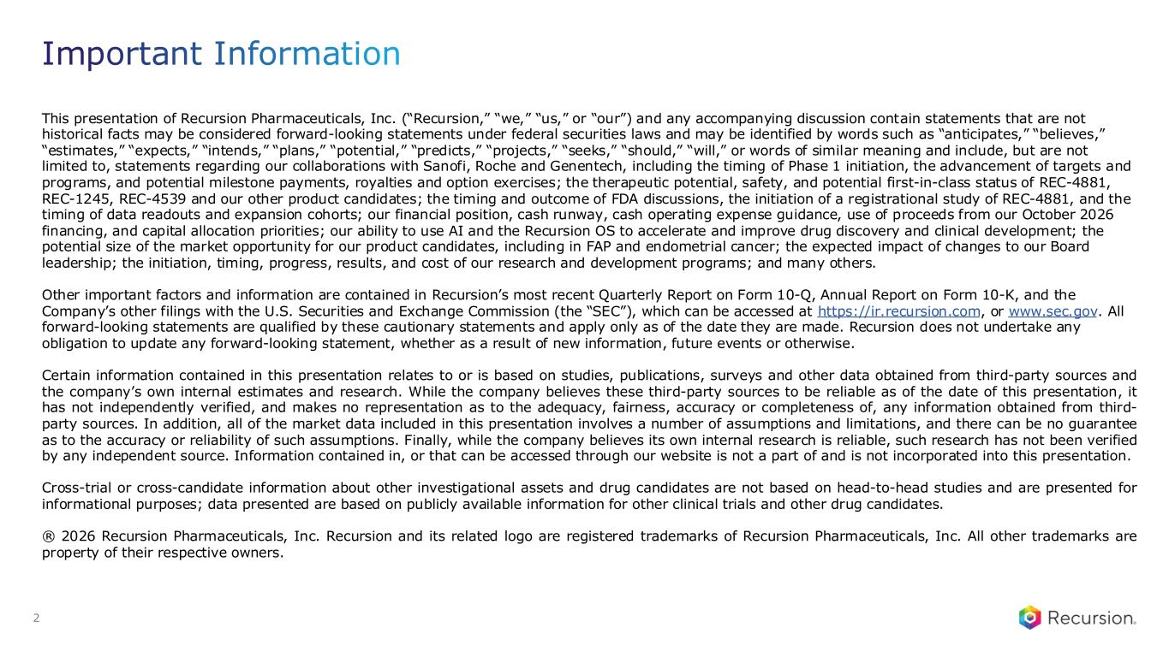
This presentation of Recursion Pharmaceuticals, Inc. (“Recursion,” “we,” “us,” or “our”) and any accompanying discussion contain statements that are not historical facts may be considered forward-looking statements under federal securities laws and may be identified by words such as “anticipates,” “believes,” “estimates,” “expects,” “intends,” “plans,” “potential,” “predicts,” “projects,” “seeks,” “should,” “will,” or words of similar meaning and include, but are not limited to, statements regarding our collaborations with Sanofi, Roche and Genentech, including the timing of Phase 1 initiation, the advancement of targets and programs, and potential milestone payments, royalties and option exercises; the therapeutic potential, safety, and potential first-in-class status of REC-4881, REC-1245, REC-4539 and our other product candidates; the timing and outcome of FDA discussions, the initiation of a registrational study of REC-4881, and the timing of data readouts and expansion cohorts; our financial position, cash runway, cash operating expense guidance, use of proceeds from our October 2026 financing, and capital allocation priorities; our ability to use AI and the Recursion OS to accelerate and improve drug discovery and clinical development; the potential size of the market opportunity for our product candidates, including in FAP and endometrial cancer; the expected impact of changes to our Board leadership; the initiation, timing, progress, results, and cost of our research and development programs; and many others. Other important factors and information are contained in Recursion’s most recent Quarterly Report on Form 10-Q, Annual Report on Form 10-K, and the Company’s other filings with the U.S. Securities and Exchange Commission (the “SEC”), which can be accessed at https://ir.recursion.com, or www.sec.gov. All forward-looking statements are qualified by these cautionary statements and apply only as of the date they are made. Recursion does not undertake any obligation to update any forward-looking statement, whether as a result of new information, future events or otherwise. Certain information contained in this presentation relates to or is based on studies, publications, surveys and other data obtained from third-party sources and the company’s own internal estimates and research. While the company believes these third-party sources to be reliable as of the date of this presentation, it has not independently verified, and makes no representation as to the adequacy, fairness, accuracy or completeness of, any information obtained from third- party sources. In addition, all of the market data included in this presentation involves a number of assumptions and limitations, and there can be no guarantee as to the accuracy or reliability of such assumptions. Finally, while the company believes its own internal research is reliable, such research has not been verified by any independent source. Information contained in, or that can be accessed through our website is not a part of and is not incorporated into this presentation. Cross-trial or cross-candidate information about other investigational assets and drug candidates are not based on head-to-head studies and are presented for informational purposes; data presented are based on publicly available information for other clinical trials and other drug candidates. ® 2026 Recursion Pharmaceuticals, Inc. Recursion and its related logo are registered trademarks of Recursion Pharmaceuticals, Inc. All other trademarks are property of their respective owners. Important Information 2

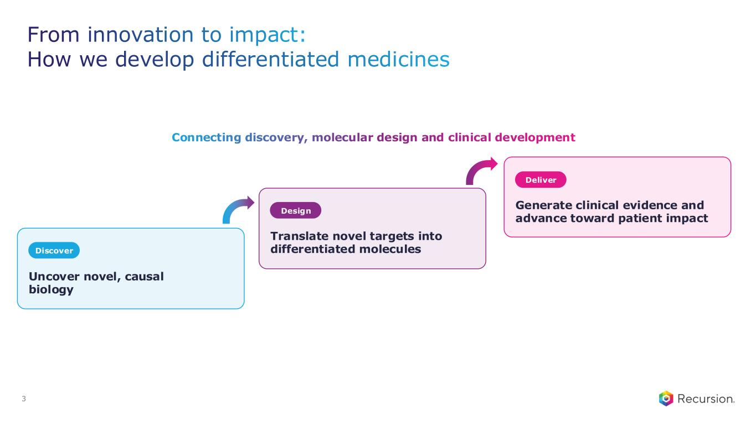
3 Uncover novel, causal biology Discover Design Deliver Translate novel targets into differentiated molecules Generate clinical evidence and advance toward patient impact Connecting discovery, molecular design and clinical development From innovation to impact: How we develop differentiated medicines

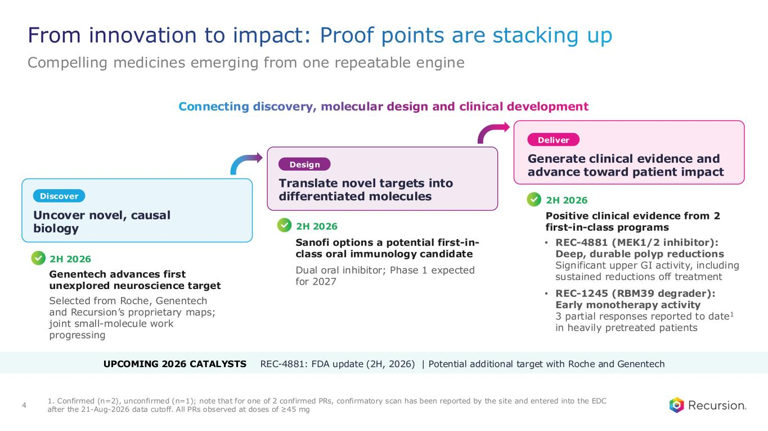
From innovation to impact: Proof points are stacking up Compelling medicines emerging from one repeatable engine 4 1. Confirmed (n=2), unconfirmed (n=1); note that for one of 2 confirmed PRs, confirmatory scan has been reported by the site and entered into the EDC after the 21-Aug-2026 data cutoff. All PRs observed at doses of ≥45 mg UPCOMING 2026 CATALYSTS REC-4881: FDA update (2H, 2026) | Potential additional target with Roche and Genentech Uncover novel, causal biology Discover Design Deliver Translate novel targets into differentiated molecules Generate clinical evidence and advance toward patient impact Selected from Roche, Genentech and Recursion’s proprietary maps; joint small-molecule work progressing Dual oral inhibitor; Phase 1 expected for 2027 2H 2026 Genentech advances first unexplored neuroscience target 2H 2026 Sanofi options a potential first-in- class oral immunology candidate Positive clinical evidence from 2 first-in-class programs • REC-4881 (MEK1/2 inhibitor): Deep, durable polyp reductions Significant upper GI activity, including sustained reductions off treatment • REC-1245 (RBM39 degrader): Early monotherapy activity 3 partial responses reported to date1 in heavily pretreated patients 2H 2026 Connecting discovery, molecular design and clinical development

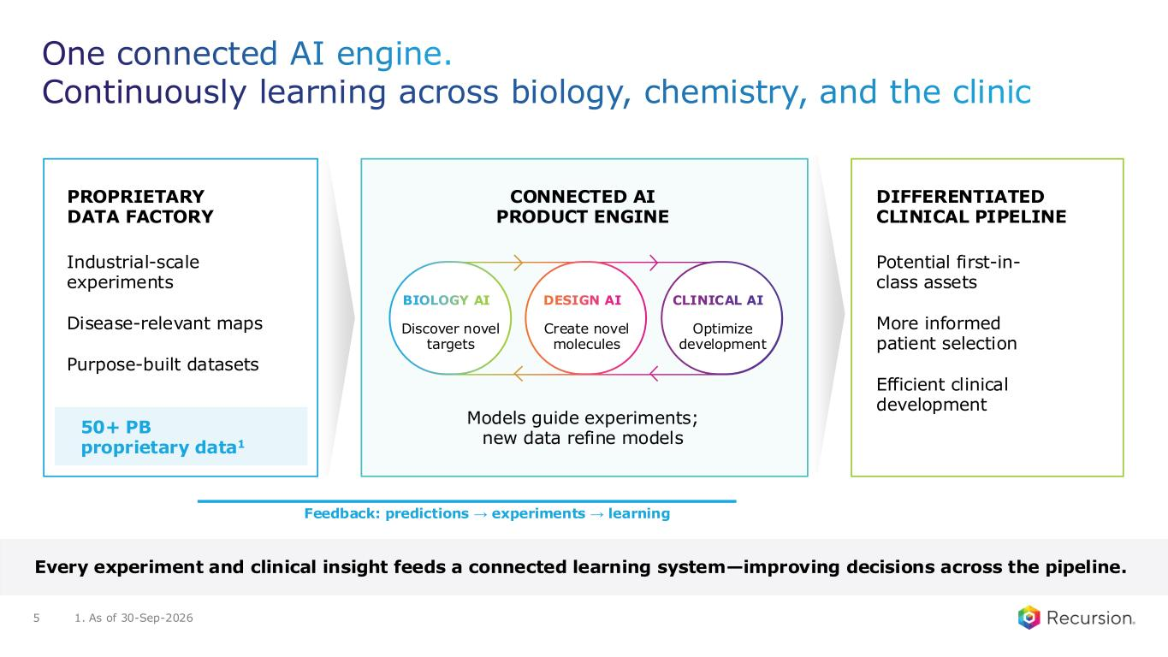
One connected AI engine. Continuously learning across biology, chemistry, and the clinic 5 PROPRIETARY DATA FACTORY Industrial-scale experiments Disease-relevant maps Purpose-built datasets 50+ PB proprietary data1 CONNECTED AI PRODUCT ENGINE Models guide experiments; new data refine models DIFFERENTIATED CLINICAL PIPELINE Potential first-in- class assets More informed patient selection Efficient clinical development Feedback: predictions → experiments → learning Every experiment and clinical insight feeds a connected learning system—improving decisions across the pipeline. BIOLOGY AI Discover novel targets DESIGN AI Create novel molecules CLINICAL AI Optimize development 1. As of 30-Sep-2026

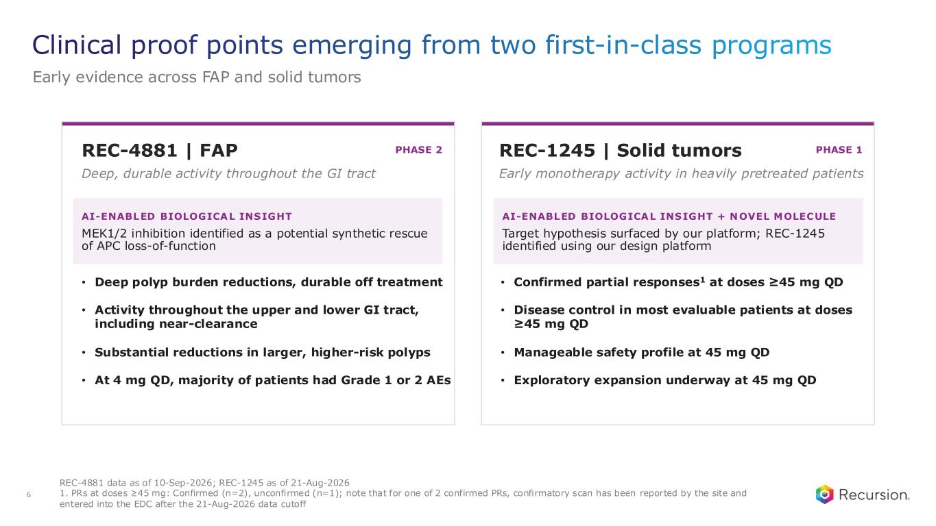
Clinical proof points emerging from two first-in-class programs Early evidence across FAP and solid tumors 6 REC-4881 data as of 10-Sep-2026; REC-1245 as of 21-Aug-2026 1. PRs at doses ≥45 mg: Confirmed (n=2), unconfirmed (n=1); note that for one of 2 confirmed PRs, confirmatory scan has been reported by the site and entered into the EDC after the 21-Aug-2026 data cutoff REC-4881 | FAP PHASE 2 Deep, durable activity throughout the GI tract AI-ENABLED BIOLOGICAL INSIGHT MEK1/2 inhibition identified as a potential synthetic rescue of APC loss-of-function • Deep polyp burden reductions, durable off treatment • Activity throughout the upper and lower GI tract, including near-clearance • Substantial reductions in larger, higher-risk polyps • At 4 mg QD, majority of patients had Grade 1 or 2 AEs REC-1245 | Solid tumors PHASE 1 Early monotherapy activity in heavily pretreated patients AI-ENABLED BIOLOGICAL INSIGHT + NOVEL MOLECULE Target hypothesis surfaced by our platform; REC-1245 identified using our design platform • Confirmed partial responses1 at doses ≥45 mg QD • Disease control in most evaluable patients at doses ≥45 mg QD • Manageable safety profile at 45 mg QD • Exploratory expansion underway at 45 mg QD

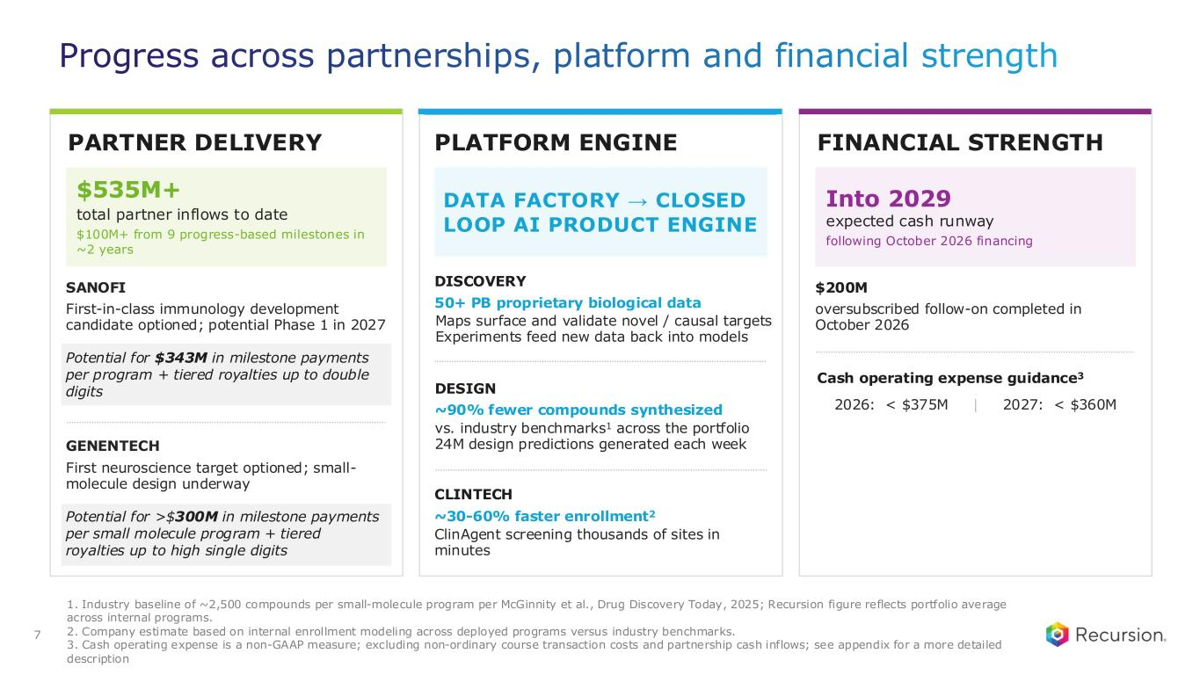
Progress across partnerships, platform and financial strength PARTNER DELIVERY $535M+ total partner inflows to date $100M+ from 9 progress-based milestones in ~2 years SANOFI First-in-class immunology development candidate optioned; potential Phase 1 in 2027 Potential for $343M in milestone payments per program + tiered royalties up to double digits GENENTECH First neuroscience target optioned; small- molecule design underway Potential for >$300M in milestone payments per small molecule program + tiered royalties up to high single digits PLATFORM ENGINE FINANCIAL STRENGTH Into 2029 expected cash runway following October 2026 financing $200M oversubscribed follow-on completed in October 2026 Cash operating expense guidance3 2026: < $375M | 2027: < $360M DATA FACTORY → CLOSED LOOP AI PRODUCT ENGINE DISCOVERY 50+ PB proprietary biological data Maps surface and validate novel / causal targets Experiments feed new data back into models DESIGN ~90% fewer compounds synthesized vs. industry benchmarks1 across the portfolio 24M design predictions generated each week CLINTECH ~30-60% faster enrollment2 ClinAgent screening thousands of sites in minutes 7 1. Industry baseline of ~2,500 compounds per small-molecule program per McGinnity et al., Drug Discovery Today, 2025; Recursion figure reflects portfolio average across internal programs. 2. Company estimate based on internal enrollment modeling across deployed programs versus industry benchmarks. 3. Cash operating expense is a non-GAAP measure; excluding non-ordinary course transaction costs and partnership cash inflows; see appendix for a more detailed description

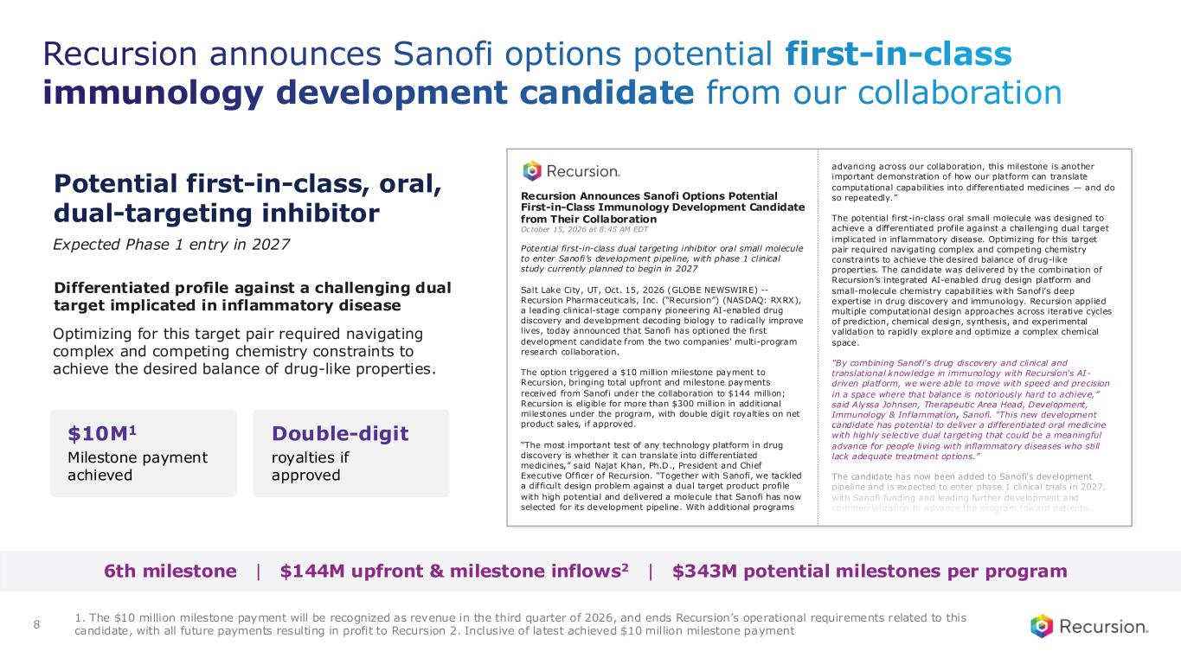
Recursion announces Sanofi options potential first-in-class immunology development candidate from our collaboration 1. The $10 million milestone payment will be recognized as revenue in the third quarter of 2026, and ends Recursion’s operational requirements related to this candidate, with all future payments resulting in profit to Recursion 2. Inclusive of latest achieved $10 million milestone payment 8 6th milestone | $144M upfront & milestone inflows2 | $343M potential milestones per program Potential first-in-class, oral, dual-targeting inhibitor $10M1 Milestone payment achieved Double-digit royalties if approved Expected Phase 1 entry in 2027 Differentiated profile against a challenging dual target implicated in inflammatory disease Optimizing for this target pair required navigating complex and competing chemistry constraints to achieve the desired balance of drug-like properties. Recursion Announces Sanofi Options Potential First-in-Class Immunology Development Candidate from Their Collaboration October 15, 2026 at 8:45 AM EDT Potential first-in-class dual targeting inhibitor oral small molecule to enter Sanofi’s development pipeline, with phase 1 clinical study currently planned to begin in 2027 Salt Lake City, UT, Oct. 15, 2026 (GLOBE NEWSWIRE) -- Recursion Pharmaceuticals, Inc. (“Recursion”) (NASDAQ: RXRX), a leading clinical-stage company pioneering AI-enabled drug discovery and development decoding biology to radically improve lives, today announced that Sanofi has optioned the first development candidate from the two companies’ multi-program research collaboration. The option triggered a $10 million milestone payment to Recursion, bringing total upfront and milestone payments received from Sanofi under the collaboration to $144 million; Recursion is eligible for more than $300 million in additional milestones under the program, with double digit royalties on net product sales, if approved. “The most important test of any technology platform in drug discovery is whether it can translate into differentiated medicines,” said Najat Khan, Ph.D., President and Chief Executive Officer of Recursion. “Together with Sanofi, we tackled a difficult design problem against a dual target product profile with high potential and delivered a molecule that Sanofi has now selected for its development pipeline. With additional programs advancing across our collaboration, this milestone is another important demonstration of how our platform can translate computational capabilities into differentiated medicines — and do so repeatedly.” The potential first-in-class oral small molecule was designed to achieve a differentiated profile against a challenging dual target implicated in inflammatory disease. Optimizing for this target pair required navigating complex and competing chemistry constraints to achieve the desired balance of drug-like properties. The candidate was delivered by the combination of Recursion’s integrated AI-enabled drug design platform and small-molecule chemistry capabilities with Sanofi’s deep expertise in drug discovery and immunology. Recursion applied multiple computational design approaches across iterative cycles of prediction, chemical design, synthesis, and experimental validation to rapidly explore and optimize a complex chemical space. "By combining Sanofi's drug discovery and clinical and translational knowledge in immunology with Recursion's AI- driven platform, we were able to move with speed and precision in a space where that balance is notoriously hard to achieve,” said Alyssa Johnsen, Therapeutic Area Head, Development, Immunology & Inflammation, Sanofi. “This new development candidate has potential to deliver a differentiated oral medicine with highly selective dual targeting that could be a meaningful advance for people living with inflammatory diseases who still lack adequate treatment options.” The candidate has now been added to Sanofi’s development pipeline and is expected to enter phase 1 clinical trials in 2027, with Sanofi funding and leading further development and commercialization to advance the program toward patients.

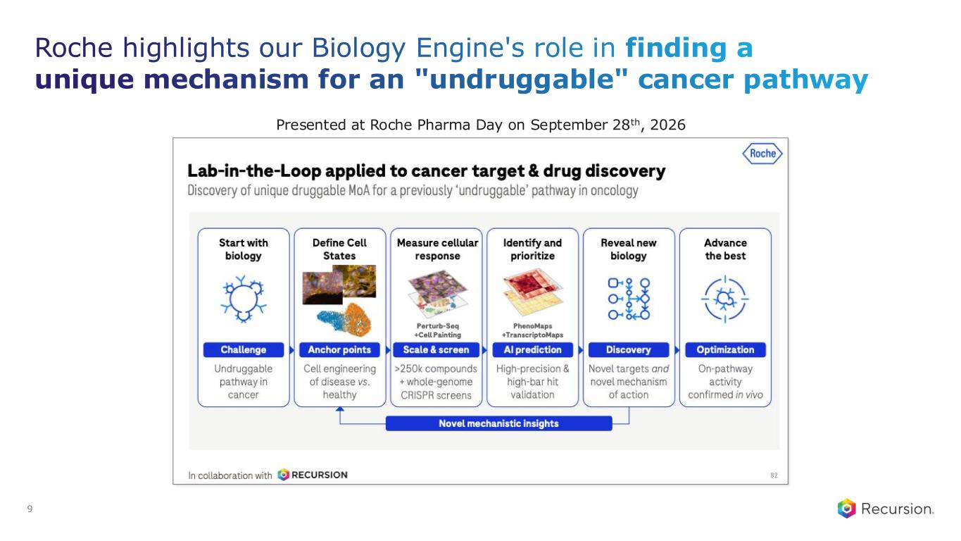
Roche highlights our Biology Engine's role in finding a unique mechanism for an "undruggable" cancer pathway Presented at Roche Pharma Day on September 28th, 2026 9

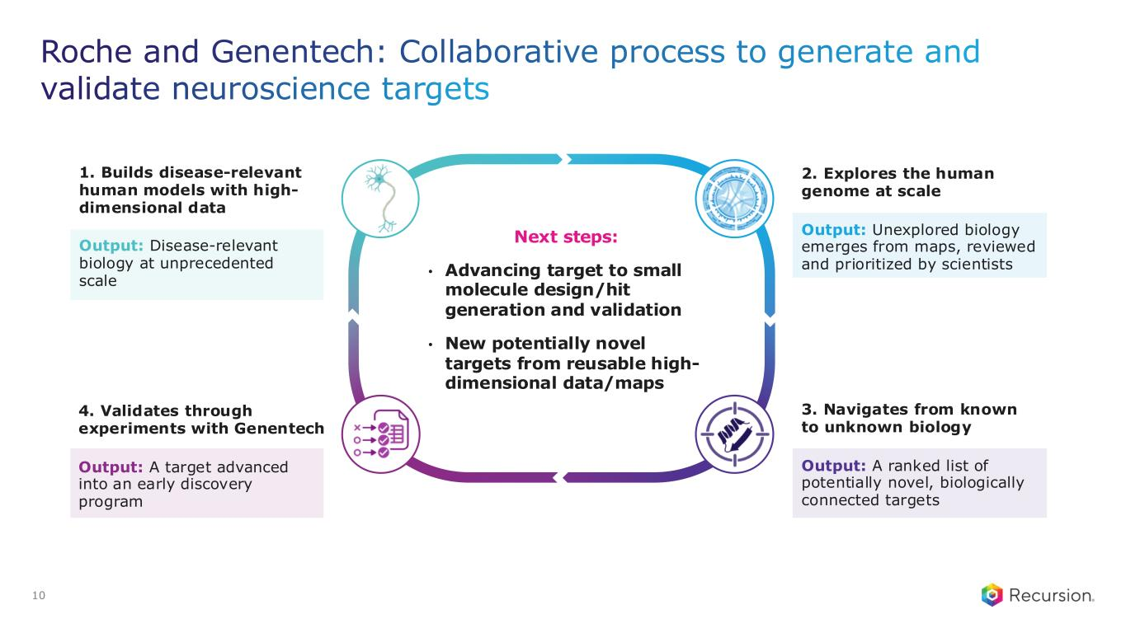
Roche and Genentech: Collaborative process to generate and validate neuroscience targets 10 1. Builds disease-relevant human models with high- dimensional data Output: Disease-relevant biology at unprecedented scale 4. Validates through experiments with Genentech Output: A target advanced into an early discovery program 2. Explores the human genome at scale Output: Unexplored biology emerges from maps, reviewed and prioritized by scientists 3. Navigates from known to unknown biology Output: A ranked list of potentially novel, biologically connected targets Next steps: • Advancing target to small molecule design/hit generation and validation • New potentially novel targets from reusable high- dimensional data/maps

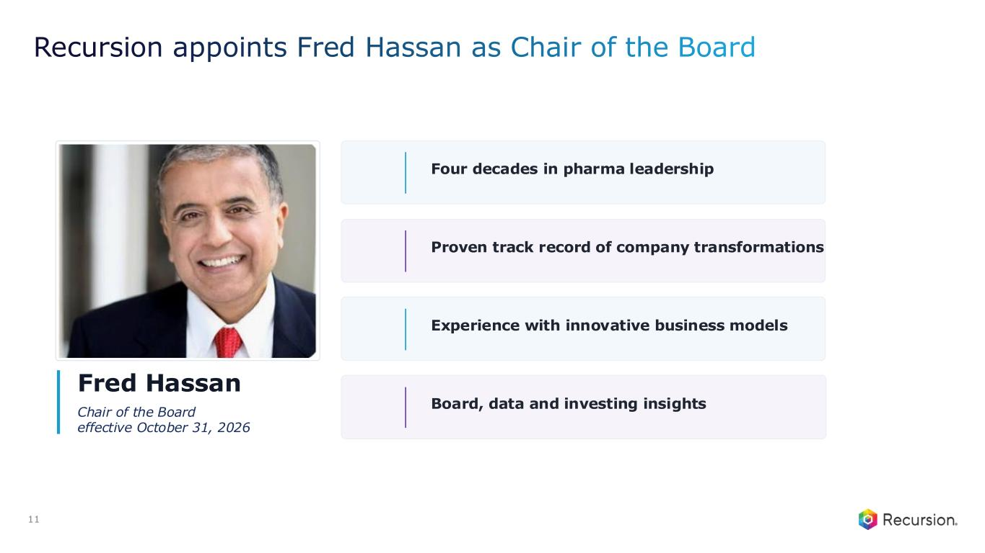
Recursion appoints Fred Hassan as Chair of the Board Fred Hassan Chair of the Board effective October 31, 2026 Four decades in pharma leadership Proven track record of company transformations Experience with innovative business models Board, data and investing insights 11


Internal Pipeline Today’s news

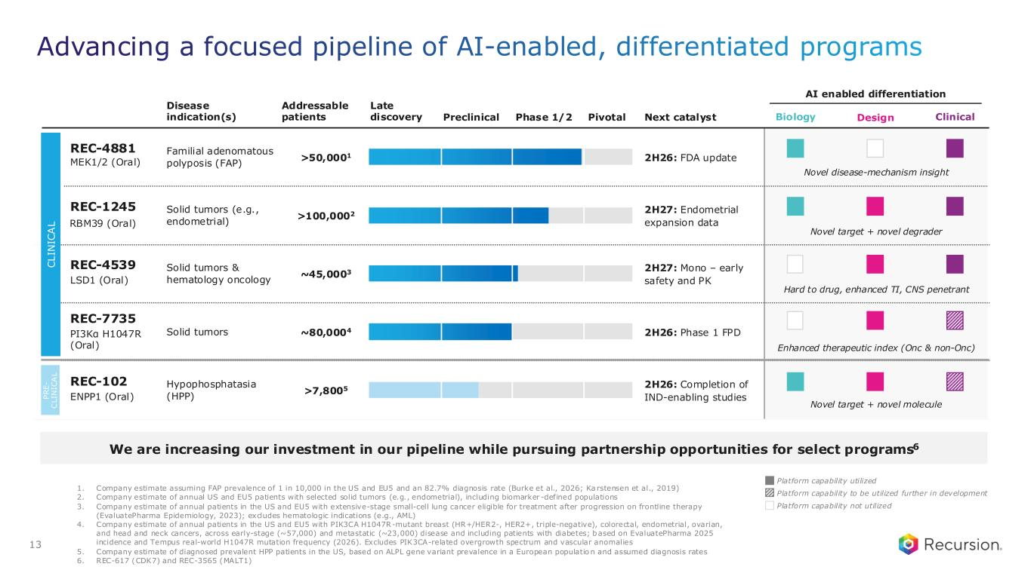
Advancing a focused pipeline of AI-enabled, differentiated programs 13 Platform capability utilized Platform capability not utilized Platform capability to be utilized further in development Disease indication(s) Addressable patients Next catalyst AI enabled differentiation Late discovery Preclinical Phase 1/2 Pivotal Familial adenomatous polyposis (FAP) >50,0001 2H26: FDA update Solid tumors (e.g., endometrial) >100,0002 2H27: Endometrial expansion data Solid tumors & hematology oncology ~45,0003 2H27: Mono – early safety and PK Solid tumors ~80,0004 2H26: Phase 1 FPD Hypophosphatasia (HPP) >7,8005 2H26: Completion of IND-enabling studies C L IN IC A L P R E - C L IN IC A L Design Clinical REC-4881 MEK1/2 (Oral) REC-1245 RBM39 (Oral) REC-4539 LSD1 (Oral) REC-7735 PI3Kα H1047R (Oral) REC-102 ENPP1 (Oral) Biology Novel disease-mechanism insight Novel target + novel degrader Hard to drug, enhanced TI, CNS penetrant Enhanced therapeutic index (Onc & non-Onc) Novel target + novel molecule We are increasing our investment in our pipeline while pursuing partnership opportunities for select programs6 1. Company estimate assuming FAP prevalence of 1 in 10,000 in the US and EU5 and an 82.7% diagnosis rate (Burke et al., 2026; Ka rstensen et al., 2019) 2. Company estimate of annual US and EU5 patients with selected solid tumors (e.g., endometrial), including biomarker -defined populations 3. Company estimate of annual patients in the US and EU5 with extensive-stage small-cell lung cancer eligible for treatment after progression on frontline therapy (EvaluatePharma Epidemiology, 2023); excludes hematologic indications (e.g., AML) 4. Company estimate of annual patients in the US and EU5 with PIK3CA H1047R-mutant breast (HR+/HER2-, HER2+, triple-negative), colorectal, endometrial, ovarian, and head and neck cancers, across early-stage (~57,000) and metastatic (~23,000) disease and including patients with diabetes; based on EvaluatePharma 2025 incidence and Tempus real-world H1047R mutation frequency (2026). Excludes PIK3CA-related overgrowth spectrum and vascular anomalies 5. Company estimate of diagnosed prevalent HPP patients in the US, based on ALPL gene variant prevalence in a European populatio n and assumed diagnosis rates 6. REC-617 (CDK7) and REC-3565 (MALT1)


REC-4881 MEK1/2 Translating proof to products

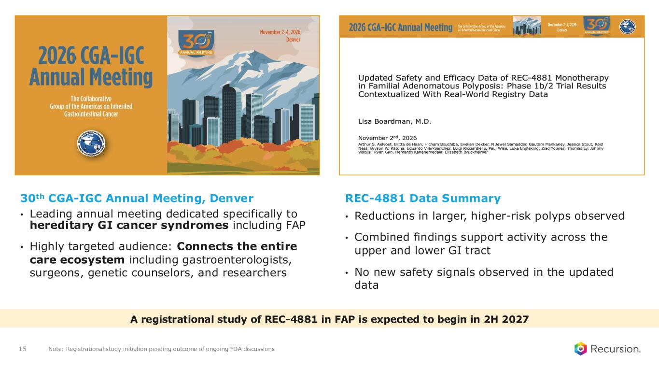
15 A registrational study of REC-4881 in FAP is expected to begin in 2H 2027 Note: Registrational study initiation pending outcome of ongoing FDA discussions 30th CGA-IGC Annual Meeting, Denver • Leading annual meeting dedicated specifically to hereditary GI cancer syndromes including FAP • Highly targeted audience: Connects the entire care ecosystem including gastroenterologists, surgeons, genetic counselors, and researchers REC-4881 Data Summary • Reductions in larger, higher-risk polyps observed • Combined findings support activity across the upper and lower GI tract • No new safety signals observed in the updated data

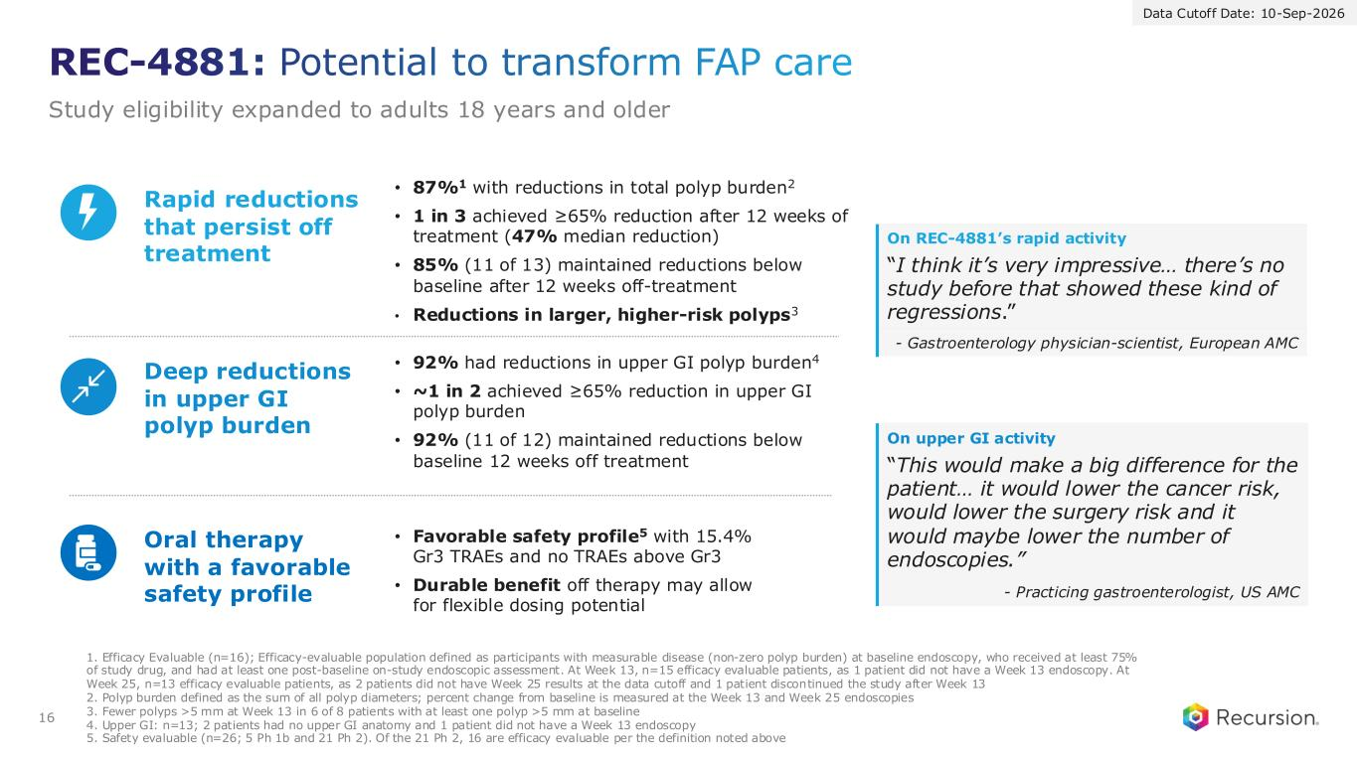
REC-4881: Potential to transform FAP care Study eligibility expanded to adults 18 years and older 16 • Favorable safety profile5 with 15.4% Gr3 TRAEs and no TRAEs above Gr3 • Durable benefit off therapy may allow for flexible dosing potential Oral therapy with a favorable safety profile • 87%1 with reductions in total polyp burden2 • 1 in 3 achieved ≥65% reduction after 12 weeks of treatment (47% median reduction) • 85% (11 of 13) maintained reductions below baseline after 12 weeks off-treatment • Reductions in larger, higher-risk polyps3 Rapid reductions that persist off treatment On REC-4881’s rapid activity “I think it’s very impressive… there’s no study before that showed these kind of regressions.” - Gastroenterology physician-scientist, European AMC • 92% had reductions in upper GI polyp burden4 • ~1 in 2 achieved ≥65% reduction in upper GI polyp burden • 92% (11 of 12) maintained reductions below baseline 12 weeks off treatment Deep reductions in upper GI polyp burden On upper GI activity “This would make a big difference for the patient… it would lower the cancer risk, would lower the surgery risk and it would maybe lower the number of endoscopies.” - Practicing gastroenterologist, US AMC 1. Efficacy Evaluable (n=16); Efficacy-evaluable population defined as participants with measurable disease (non-zero polyp burden) at baseline endoscopy, who received at least 75% of study drug, and had at least one post-baseline on-study endoscopic assessment. At Week 13, n=15 efficacy evaluable patients, as 1 patient did not have a Week 13 endoscopy. At Week 25, n=13 efficacy evaluable patients, as 2 patients did not have Week 25 results at the data cutoff and 1 patient discontinued the study after Week 13 2. Polyp burden defined as the sum of all polyp diameters; percent change from baseline is measured at the Week 13 and Week 25 endoscopies 3. Fewer polyps >5 mm at Week 13 in 6 of 8 patients with at least one polyp >5 mm at baseline 4. Upper GI: n=13; 2 patients had no upper GI anatomy and 1 patient did not have a Week 13 endoscopy 5. Safety evaluable (n=26; 5 Ph 1b and 21 Ph 2). Of the 21 Ph 2, 16 are efficacy evaluable per the definition noted above Data Cutoff Date: 10-Sep-2026

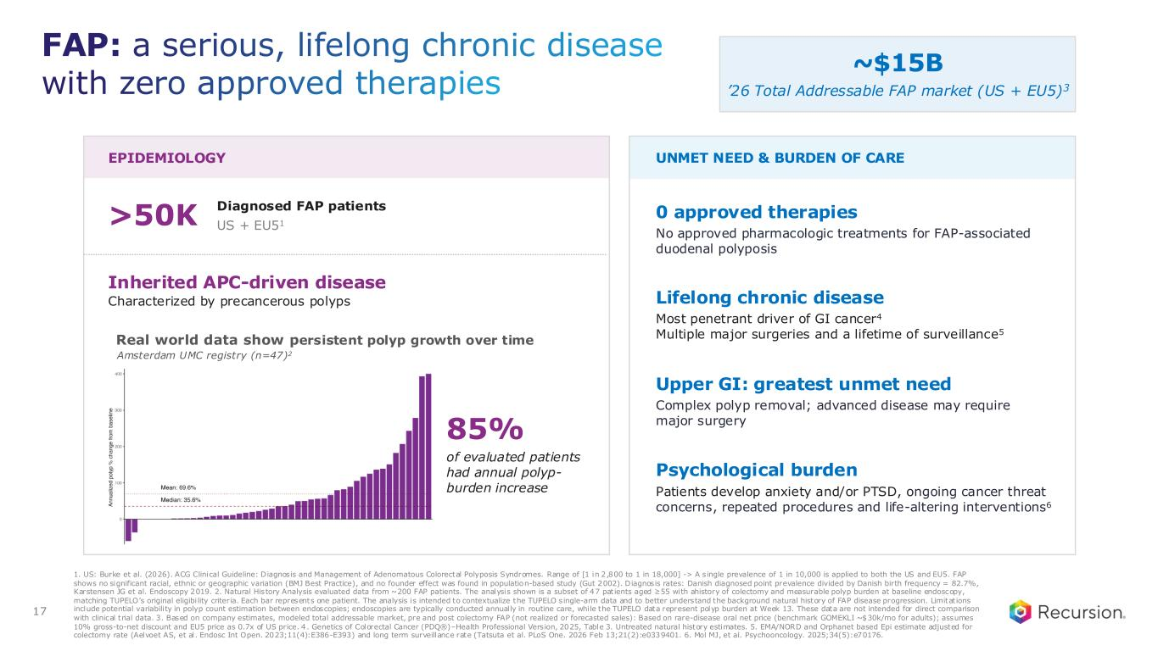
EPIDEMIOLOGY UNMET NEED & BURDEN OF CARE >50K Diagnosed FAP patients US + EU51 Inherited APC-driven disease Characterized by precancerous polyps Real world data show persistent polyp growth over time 0 approved therapies No approved pharmacologic treatments for FAP-associated duodenal polyposis Lifelong chronic disease Most penetrant driver of GI cancer4 Multiple major surgeries and a lifetime of surveillance5 Upper GI: greatest unmet need Complex polyp removal; advanced disease may require major surgery Psychological burden Patients develop anxiety and/or PTSD, ongoing cancer threat concerns, repeated procedures and life-altering interventions6 Amsterdam UMC registry (n=47)2 85% of evaluated patients had annual polyp- burden increase 1. US: Burke et al. (2026). ACG Clinical Guideline: Diagnosis and Management of Adenomatous Colorectal Polyposis Syndromes. Range of [1 in 2,800 to 1 in 18,000] -> A single prevalence of 1 in 10,000 is applied to both the US and EU5. FAP shows no significant racial, ethnic or geographic variation (BMJ Best Practice), and no founder effect was found in population-based study (Gut 2002). Diagnosis rates: Danish diagnosed point prevalence divided by Danish birth frequency = 82.7%, Karstensen JG et al. Endoscopy 2019. 2. Natural History Analysis evaluated data from ~200 FAP patients. The analysis shown is a subset of 47 patients aged ≥55 with a history of colectomy and measurable polyp burden at baseline endoscopy, matching TUPELO’s original eligibi lity criteria. Each bar represents one patient. The analysis is intended to contextualize the TUPELO single-arm data and to better understand the background natural history of FAP disease progression. Limitations include potential variability in polyp count estimation between endoscopies; endoscopies are typically conducted annually in routine care, while the TUPELO data represent polyp burden at Week 13. These data are not intended for direct comparison with clinical trial data. 3. Based on company estimates, modeled total addressable market, pre and post colectomy FAP (not realized or forecasted sales): Based on rare-disease oral net price (benchmark GOMEKLI ~$30k/mo for adults); assumes 10% gross-to-net discount and EU5 price as 0.7x of US price. 4. Genetics of Colorectal Cancer (PDQ®)–Health Professional Version, 2025, Table 3. Untreated natural history estimates. 5. EMA/NORD and Orphanet based Epi estimate adjusted for colectomy rate (Aelvoet AS, et al. Endosc Int Open. 2023;11(4):E386-E393) and long term surveillance rate (Tatsuta et al. PLoS One. 2026 Feb 13;21(2):e0339401. 6. Mol MJ, et al. Psychooncology. 2025;34(5):e70176. ~$15B ’26 Total Addressable FAP market (US + EU5)3 FAP: a serious, lifelong chronic disease with zero approved therapies 17

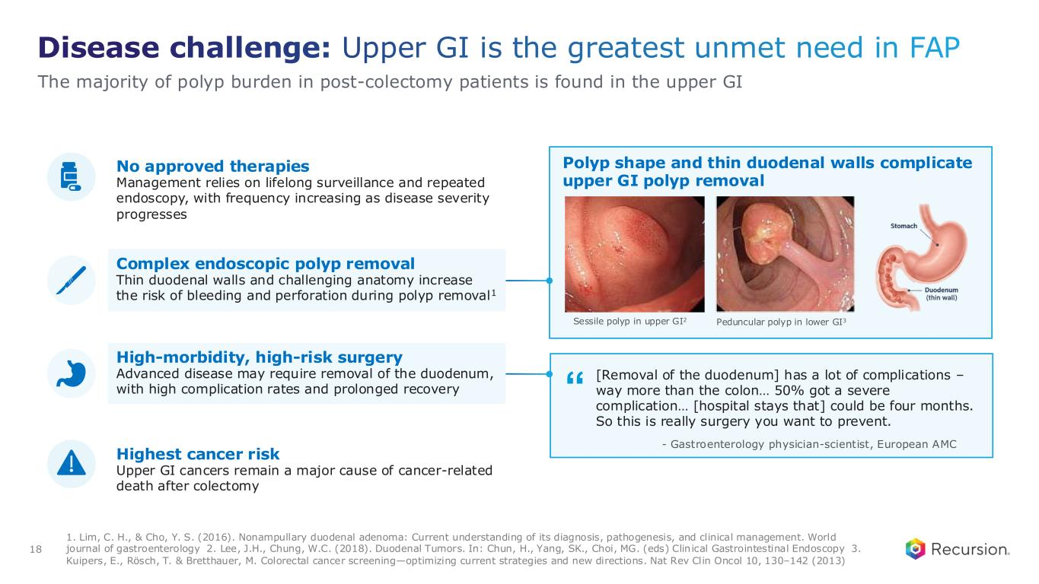
“ Disease challenge: Upper GI is the greatest unmet need in FAP 1. Lim, C. H., & Cho, Y. S. (2016). Nonampullary duodenal adenoma: Current understanding of its diagnosis, pathogenesis, and clinical management. World journal of gastroenterology 2. Lee, J.H., Chung, W.C. (2018). Duodenal Tumors. In: Chun, H., Yang, SK., Choi, MG. (eds) Clinical Gastrointestinal Endoscopy 3. Kuipers, E., Rösch, T. & Bretthauer, M. Colorectal cancer screening—optimizing current strategies and new directions. Nat Rev Clin Oncol 10, 130–142 (2013) No approved therapies Management relies on lifelong surveillance and repeated endoscopy, with frequency increasing as disease severity progresses Complex endoscopic polyp removal Thin duodenal walls and challenging anatomy increase the risk of bleeding and perforation during polyp removal1 High-morbidity, high-risk surgery Advanced disease may require removal of the duodenum, with high complication rates and prolonged recovery Highest cancer risk Upper GI cancers remain a major cause of cancer-related death after colectomy Polyp shape and thin duodenal walls complicate upper GI polyp removal Sessile polyp in upper GI2 Peduncular polyp in lower GI3 [Removal of the duodenum] has a lot of complications – way more than the colon… 50% got a severe complication… [hospital stays that] could be four months. So this is really surgery you want to prevent. - Gastroenterology physician-scientist, European AMC The majority of polyp burden in post-colectomy patients is found in the upper GI 18

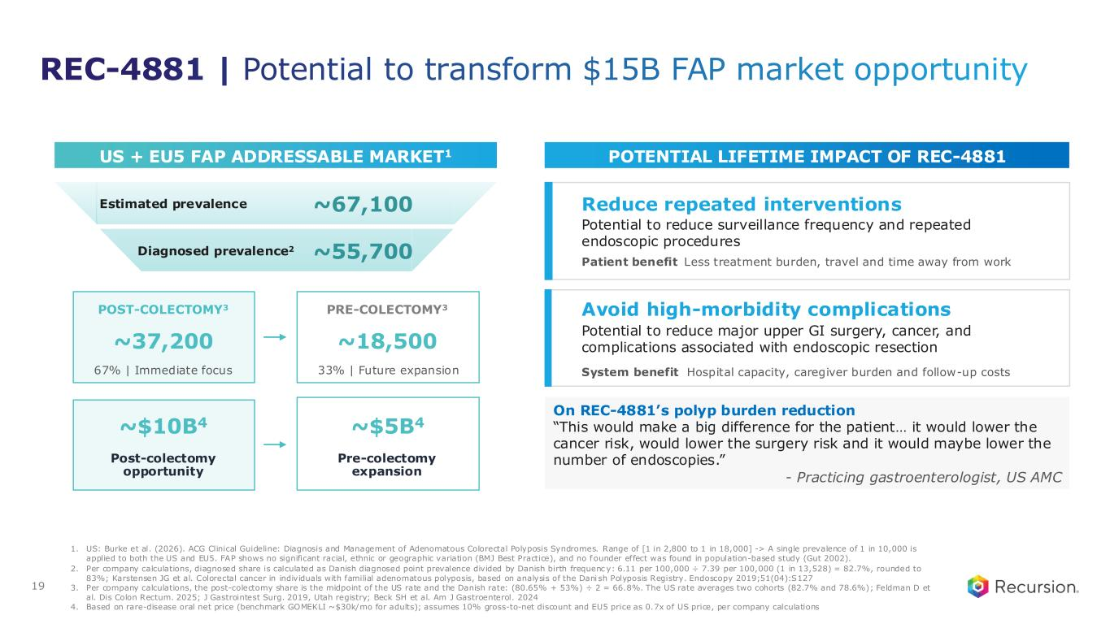
US + EU5 FAP ADDRESSABLE MARKET1 POTENTIAL LIFETIME IMPACT OF REC-4881 Reduce repeated interventions Potential to reduce surveillance frequency and repeated endoscopic procedures Patient benefit Less treatment burden, travel and time away from work Avoid high-morbidity complications Potential to reduce major upper GI surgery, cancer, and complications associated with endoscopic resection System benefit Hospital capacity, caregiver burden and follow-up costs 1. US: Burke et al. (2026). ACG Clinical Guideline: Diagnosis and Management of Adenomatous Colorectal Polyposis Syndromes. Range of [1 in 2,800 to 1 in 18,000] -> A single prevalence of 1 in 10,000 is applied to both the US and EU5. FAP shows no significant racial, ethnic or geographic variation (BMJ Best Practice), and no f ounder effect was found in population-based study (Gut 2002). 2. Per company calculations, diagnosed share is calculated as Danish diagnosed point prevalence divided by Danish birth frequenc y: 6.11 per 100,000 ÷ 7.39 per 100,000 (1 in 13,528) = 82.7%, rounded to 83%; Karstensen JG et al. Colorectal cancer in individuals with familial adenomatous polyposis, based on analysis of the Dani sh Polyposis Registry. Endoscopy 2019;51(04):S127 3. Per company calculations, the post-colectomy share is the midpoint of the US rate and the Danish rate: (80.65% + 53%) ÷ 2 = 66.8%. The US rate averages two cohorts (82.7% and 78.6%); Feldman D et al. Dis Colon Rectum. 2025; J Gastrointest Surg. 2019, Utah registry; Beck SH et al. Am J Gastroenterol. 2024 4. Based on rare-disease oral net price (benchmark GOMEKLI ~$30k/mo for adults); assumes 10% gross-to-net discount and EU5 price as 0.7x of US price, per company calculations Estimated prevalence ~67,100 Diagnosed prevalence2 ~55,700 POST-COLECTOMY3 ~37,200 67% | Immediate focus PRE-COLECTOMY3 ~18,500 33% | Future expansion ~$10B4 Post-colectomy opportunity ~$5B4 Pre-colectomy expansion On REC-4881’s polyp burden reduction “This would make a big difference for the patient… it would lower the cancer risk, would lower the surgery risk and it would maybe lower the number of endoscopies.” - Practicing gastroenterologist, US AMC REC-4881 | Potential to transform $15B FAP market opportunity 19

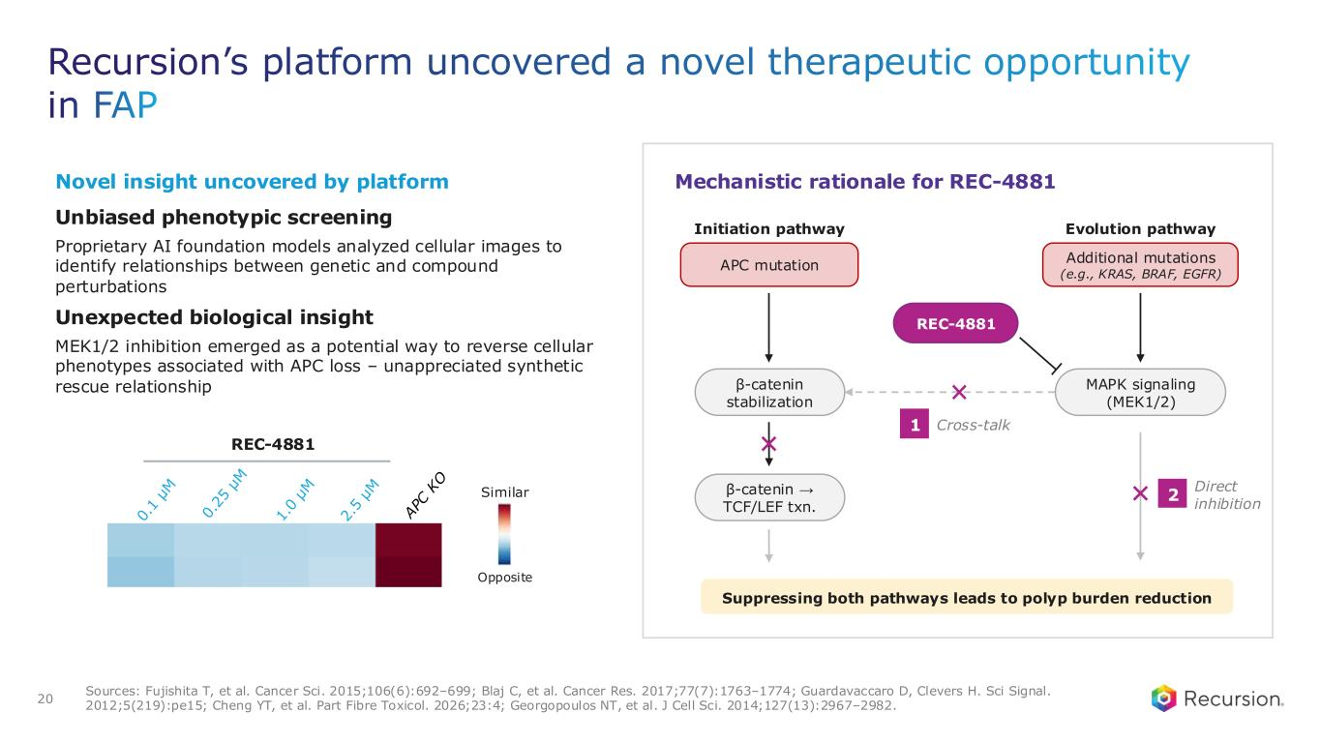
Recursion’s platform uncovered a novel therapeutic opportunity in FAP 20 Sources: Fujishita T, et al. Cancer Sci. 2015;106(6):692–699; Blaj C, et al. Cancer Res. 2017;77(7):1763–1774; Guardavaccaro D, Clevers H. Sci Signal. 2012;5(219):pe15; Cheng YT, et al. Part Fibre Toxicol. 2026;23:4; Georgopoulos NT, et al. J Cell Sci. 2014;127(13):2967–2982. REC-4881 Similar Opposite Unbiased phenotypic screening Proprietary AI foundation models analyzed cellular images to identify relationships between genetic and compound perturbations Novel insight uncovered by platform Suppressing both pathways leads to polyp burden reduction Initiation pathway APC mutation β-catenin stabilization β-catenin → TCF/LEF txn. Evolution pathway Additional mutations (e.g., KRAS, BRAF, EGFR) MAPK signaling (MEK1/2) REC-4881 Cross-talk1 Direct inhibition 2 Mechanistic rationale for REC-4881 Unexpected biological insight MEK1/2 inhibition emerged as a potential way to reverse cellular phenotypes associated with APC loss – unappreciated synthetic rescue relationship

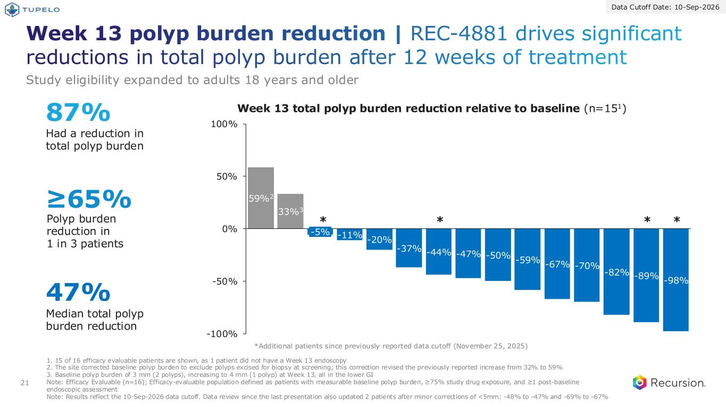
Week 13 polyp burden reduction | REC-4881 drives significant reductions in total polyp burden after 12 weeks of treatment 21 -11% -20% -37% -44% -47% -50% -59% -67% -70% -82% -89% -98% -100% -50% 0% 50% 100% -5% 59%2 33%3 87% Had a reduction in total polyp burden ≥65% Polyp burden reduction in 1 in 3 patients 47% Median total polyp burden reduction Week 13 total polyp burden reduction relative to baseline (n=151) 1. 15 of 16 efficacy evaluable patients are shown, as 1 patient did not have a Week 13 endoscopy 2. The site corrected baseline polyp burden to exclude polyps excised for biopsy at screening; this correction revised the previously reported increase from 32% to 59% 3. Baseline polyp burden of 3 mm (2 polyps), increasing to 4 mm (1 polyp) at Week 13, all in the lower GI Note: Efficacy Evaluable (n=16); Efficacy-evaluable population defined as patients with measurable baseline polyp burden, ≥75% study drug exposure, and ≥1 post-baseline endoscopic assessment Note: Results reflect the 10-Sep-2026 data cutoff. Data review since the last presentation also updated 2 patients after minor corrections of <5mm: -48% to -47% and -69% to -67% *** * *Additional patients since previously reported data cutoff (November 25, 2025) Study eligibility expanded to adults 18 years and older Data Cutoff Date: 10-Sep-2026

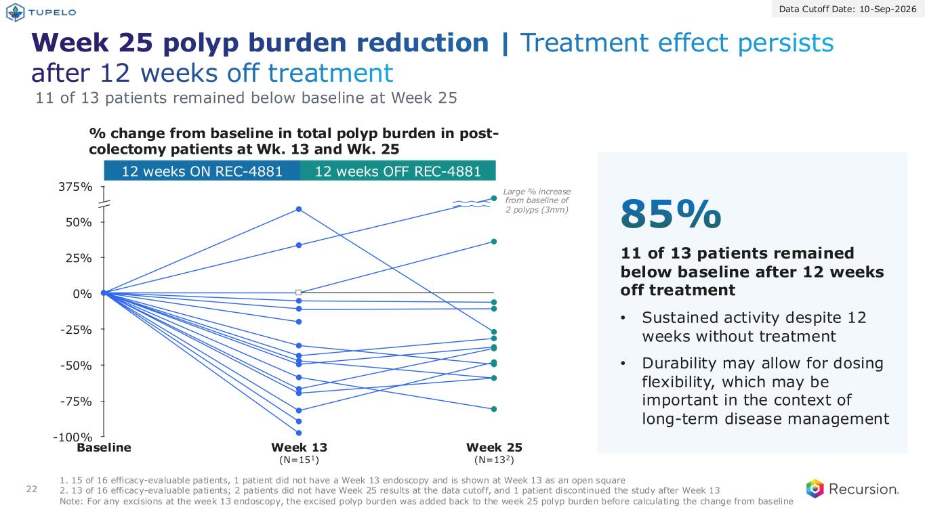
Week 25 polyp burden reduction | Treatment effect persists after 12 weeks off treatment 22 12 weeks ON REC-4881 12 weeks OFF REC-4881 % change from baseline in total polyp burden in post- colectomy patients at Wk. 13 and Wk. 25 1. 15 of 16 efficacy-evaluable patients, 1 patient did not have a Week 13 endoscopy and is shown at Week 13 as an open square 2. 13 of 16 efficacy-evaluable patients; 2 patients did not have Week 25 results at the data cutoff, and 1 patient discontinued the study after Week 13 Note: For any excisions at the week 13 endoscopy, the excised polyp burden was added back to the week 25 polyp burden before calculating the change from baseline -100% 0% -75% -50% -25% 25% 50% 375% Baseline Week 13 (N=151) Week 25 (N=132) 11 of 13 patients remained below baseline at Week 25 Large % increase from baseline of 2 polyps (3mm) 11 of 13 patients remained below baseline after 12 weeks off treatment • Sustained activity despite 12 weeks without treatment • Durability may allow for dosing flexibility, which may be important in the context of long-term disease management 85% Data Cutoff Date: 10-Sep-2026

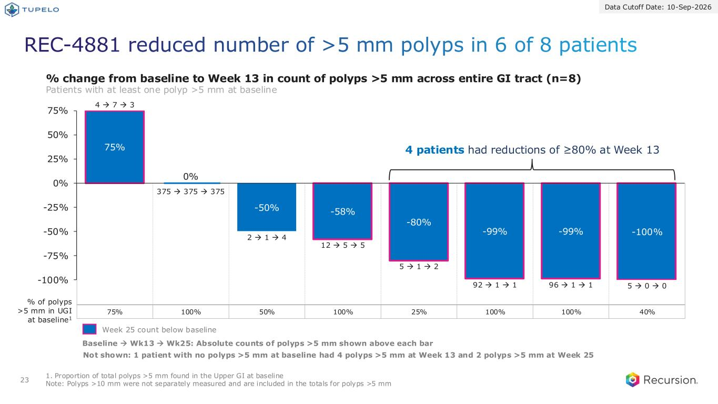
75% 100% 50% 100% 25% 100% 100% 40% REC-4881 reduced number of >5 mm polyps in 6 of 8 patients 23 Data Cutoff Date: 10-Sep-2026 75% -50% -58% -80% -99% -99% -100% -100% -75% -50% -25% 0% 25% 50% 75% 4 → 7 → 3 2 → 1 → 4 12 → 5 → 5 5 → 1 → 2 92 → 1 → 1 96 → 1 → 1 5 → 0 → 0 % change from baseline to Week 13 in count of polyps >5 mm across entire GI tract (n=8) Patients with at least one polyp >5 mm at baseline 1. Proportion of total polyps >5 mm found in the Upper GI at baseline Note: Polyps >10 mm were not separately measured and are included in the totals for polyps >5 mm Baseline → Wk13 → Wk25: Absolute counts of polyps >5 mm shown above each bar % of polyps >5 mm in UGI at baseline1 Week 25 count below baseline 4 patients had reductions of ≥80% at Week 13 375 → 375 → 375 0% Not shown: 1 patient with no polyps >5 mm at baseline had 4 polyps >5 mm at Week 13 and 2 polyps >5 mm at Week 25

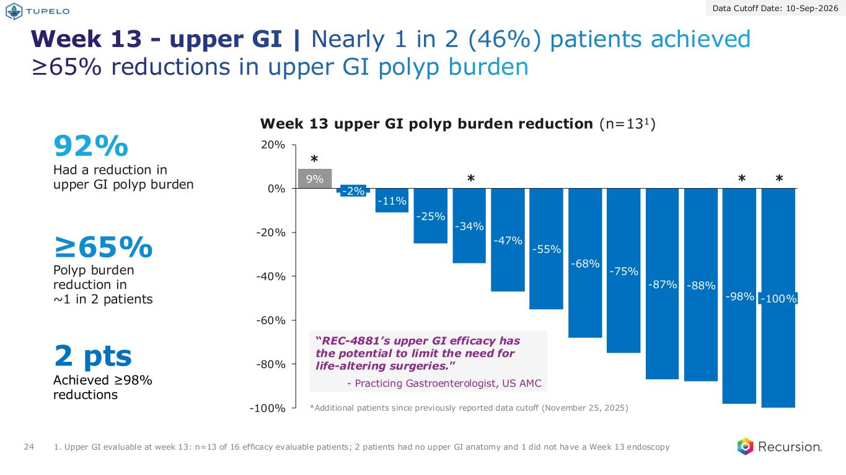
Week 13 - upper GI | Nearly 1 in 2 (46%) patients achieved ≥65% reductions in upper GI polyp burden 24 9% -11% -25% -34% -47% -55% -68% -75% -87% -88% -98% -100% -80% -60% -40% -20% 0% 20% -2% -100% Week 13 upper GI polyp burden reduction (n=131) “REC-4881’s upper GI efficacy has the potential to limit the need for life-altering surgeries.” - Practicing Gastroenterologist, US AMC *** * 92% Had a reduction in upper GI polyp burden ≥65% Polyp burden reduction in ~1 in 2 patients 2 pts Achieved ≥98% reductions 1. Upper GI evaluable at week 13: n=13 of 16 efficacy evaluable patients; 2 patients had no upper GI anatomy and 1 did not have a Week 13 endoscopy *Additional patients since previously reported data cutoff (November 25, 2025) Data Cutoff Date: 10-Sep-2026

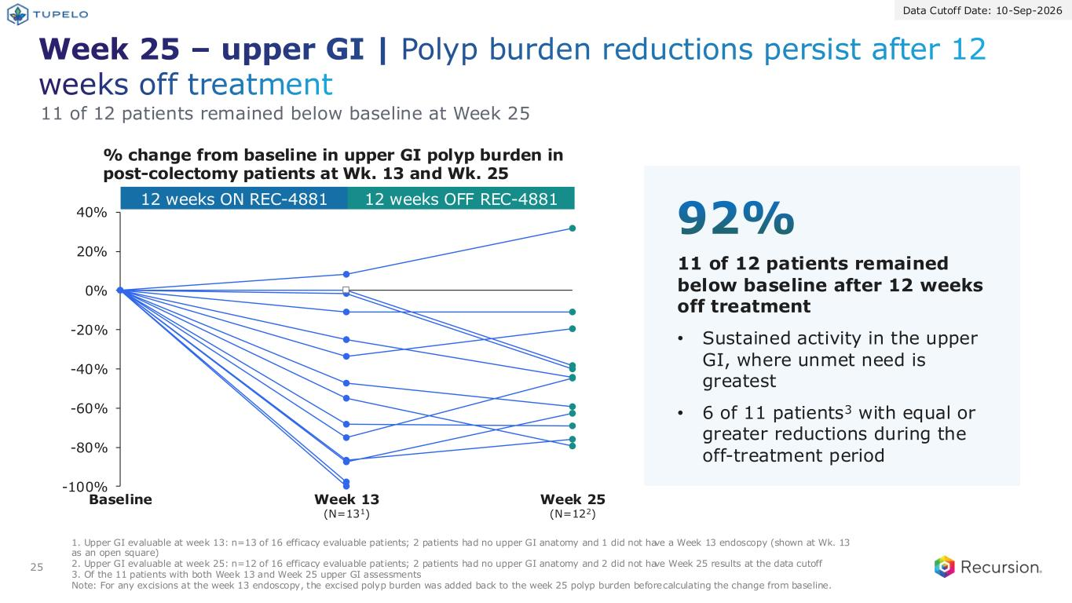
25 Week 25 – upper GI | Polyp burden reductions persist after 12 weeks off treatment -100% -80% -60% -40% -20% 0% 20% 40% Baseline Week 13 (N=131) Week 25 (N=122) 11 of 12 patients remained below baseline at Week 25 11 of 12 patients remained below baseline after 12 weeks off treatment • Sustained activity in the upper GI, where unmet need is greatest • 6 of 11 patients3 with equal or greater reductions during the off-treatment period 92% 12 weeks ON REC-4881 12 weeks OFF REC-4881 % change from baseline in upper GI polyp burden in post-colectomy patients at Wk. 13 and Wk. 25 Data Cutoff Date: 10-Sep-2026 1. Upper GI evaluable at week 13: n=13 of 16 efficacy evaluable patients; 2 patients had no upper GI anatomy and 1 did not have a Week 13 endoscopy (shown at Wk. 13 as an open square) 2. Upper GI evaluable at week 25: n=12 of 16 efficacy evaluable patients; 2 patients had no upper GI anatomy and 2 did not have Week 25 results at the data cutoff 3. Of the 11 patients with both Week 13 and Week 25 upper GI assessments Note: For any excisions at the week 13 endoscopy, the excised polyp burden was added back to the week 25 polyp burden before calculating the change from baseline.

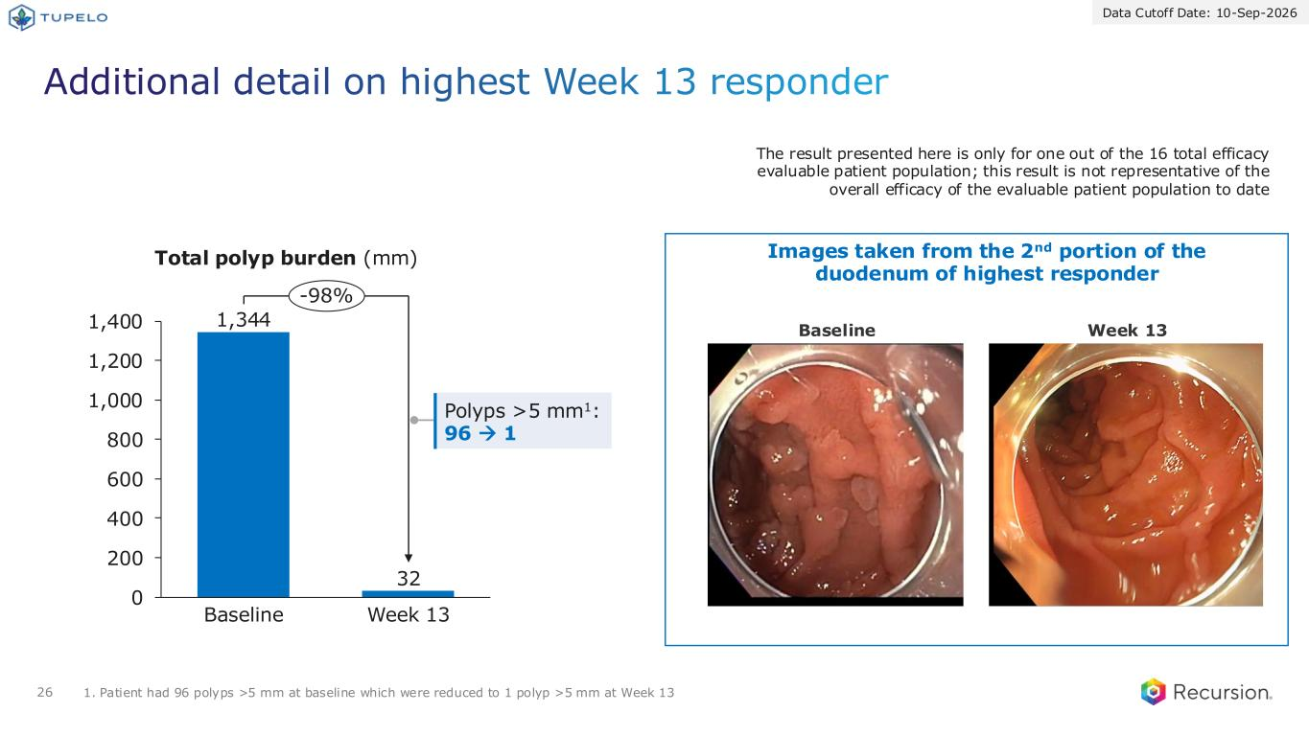
Additional detail on highest Week 13 responder Data Cutoff Date: 10-Sep-2026 26 The result presented here is only for one out of the 16 total efficacy evaluable patient population; this result is not representative of the overall efficacy of the evaluable patient population to date Images taken from the 2nd portion of the duodenum of highest responder Total polyp burden (mm) 1. Patient had 96 polyps >5 mm at baseline which were reduced to 1 polyp >5 mm at Week 13 Baseline Week 13 1,344 32 0 200 400 600 800 1,000 1,200 1,400 Baseline Week 13 -98% Polyps >5 mm1: 96 → 1

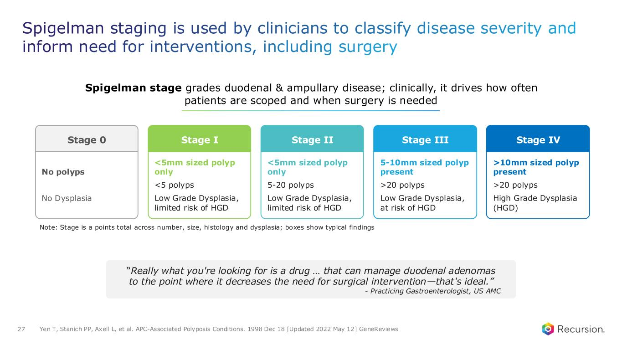
Spigelman staging is used by clinicians to classify disease severity and inform need for interventions, including surgery 27 “Really what you're looking for is a drug … that can manage duodenal adenomas to the point where it decreases the need for surgical intervention—that's ideal.” - Practicing Gastroenterologist, US AMC Spigelman stage grades duodenal & ampullary disease; clinically, it drives how often patients are scoped and when surgery is needed >10mm sized polyp present >20 polyps High Grade Dysplasia (HGD) Stage IV 5-10mm sized polyp present >20 polyps Low Grade Dysplasia, at risk of HGD Stage III <5mm sized polyp only 5-20 polyps Low Grade Dysplasia, limited risk of HGD Stage II <5mm sized polyp only <5 polyps Low Grade Dysplasia, limited risk of HGD Stage I Yen T, Stanich PP, Axell L, et al. APC-Associated Polyposis Conditions. 1998 Dec 18 [Updated 2022 May 12] GeneReviews No polyps No Dysplasia Stage 0 Note: Stage is a points total across number, size, histology and dysplasia; boxes show typical findings

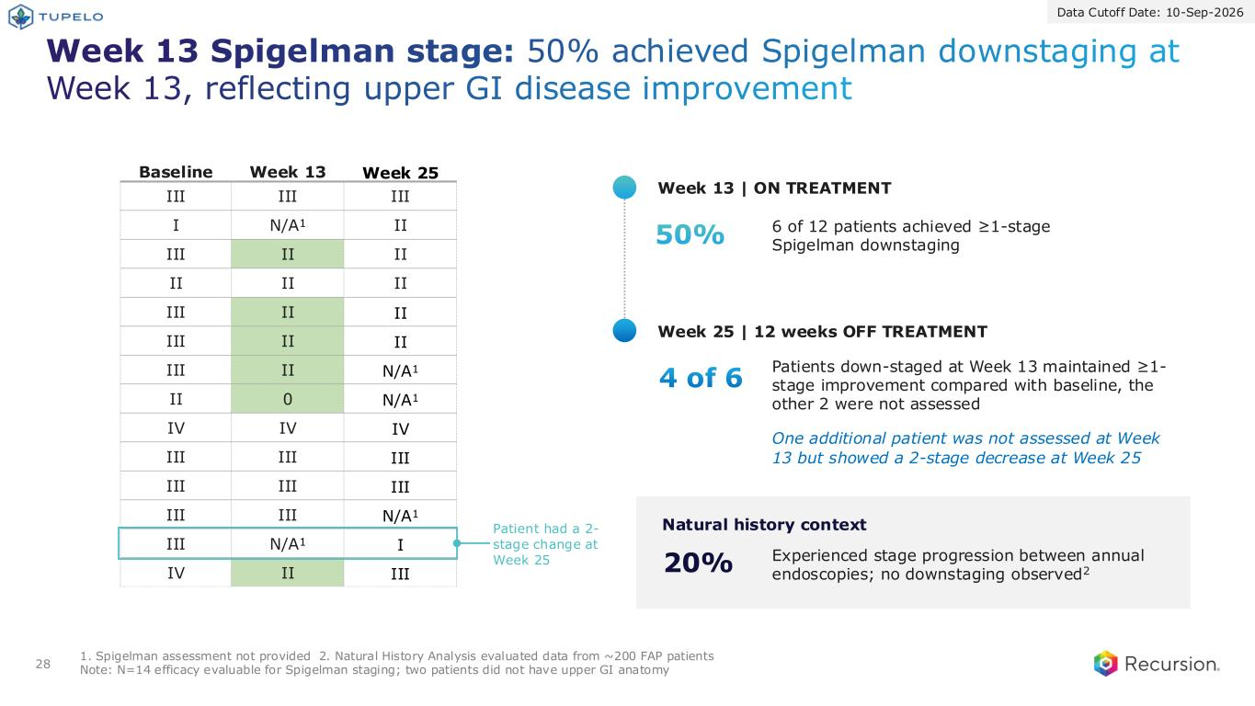
Week 13 Spigelman stage: 50% achieved Spigelman downstaging at Week 13, reflecting upper GI disease improvement 28 1. Spigelman assessment not provided 2. Natural History Analysis evaluated data from ~200 FAP patients Note: N=14 efficacy evaluable for Spigelman staging; two patients did not have upper GI anatomy 50% 4 of 6 Baseline Week 13 Week 25 III III III I N/A1 II III II II II II II III II II III II II III II N/A1 II 0 N/A1 IV IV IV III III III III III III III III N/A1 III N/A1 I IV II III 6 of 12 patients achieved ≥1-stage Spigelman downstaging Patients down-staged at Week 13 maintained ≥1- stage improvement compared with baseline, the other 2 were not assessed One additional patient was not assessed at Week 13 but showed a 2-stage decrease at Week 25 20% Experienced stage progression between annual endoscopies; no downstaging observed2 Patient had a 2- stage change at Week 25 Week 13 | ON TREATMENT Week 25 | 12 weeks OFF TREATMENT Natural history context Data Cutoff Date: 10-Sep-2026

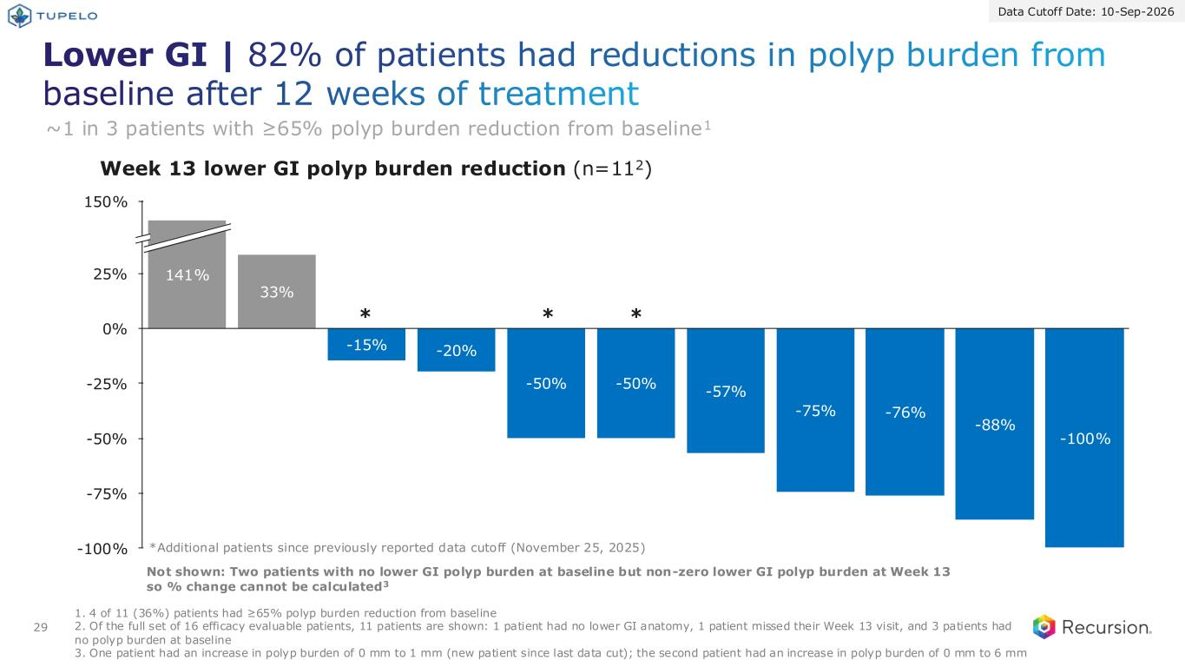
Lower GI | 82% of patients had reductions in polyp burden from baseline after 12 weeks of treatment 29 33% -15% -20% -50% -50% -57% -75% -76% -88% -100% -100% -75% -50% -25% 0% 25% 150% 141% *Additional patients since previously reported data cutoff (November 25, 2025) * ** 1. 4 of 11 (36%) patients had ≥65% polyp burden reduction from baseline 2. Of the full set of 16 efficacy evaluable patients, 11 patients are shown: 1 patient had no lower GI anatomy, 1 patient missed their Week 13 visit, and 3 patients had no polyp burden at baseline 3. One patient had an increase in polyp burden of 0 mm to 1 mm (new patient since last data cut); the second patient had an increase in polyp burden of 0 mm to 6 mm Week 13 lower GI polyp burden reduction (n=112) ~1 in 3 patients with ≥65% polyp burden reduction from baseline1 Data Cutoff Date: 10-Sep-2026 Not shown: Two patients with no lower GI polyp burden at baseline but non-zero lower GI polyp burden at Week 13 so % change cannot be calculated3

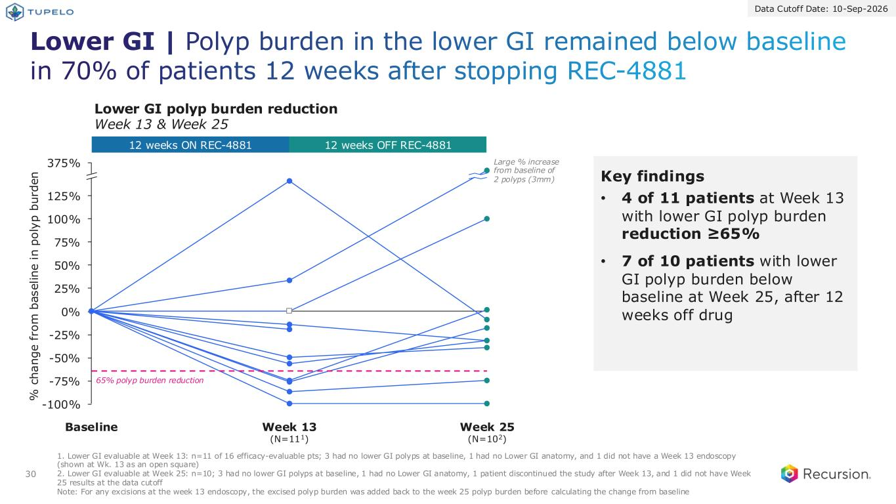
Lower GI | Polyp burden in the lower GI remained below baseline in 70% of patients 12 weeks after stopping REC-4881 30 12 weeks ON REC-4881 12 weeks OFF REC-4881 % c h a n g e f ro m b a s e li n e i n p o ly p b u rd e n Data Cutoff Date: 10-Sep-2026 65% polyp burden reduction 1. Lower GI evaluable at Week 13: n=11 of 16 efficacy-evaluable pts; 3 had no lower GI polyps at baseline, 1 had no Lower GI anatomy, and 1 did not have a Week 13 endoscopy (shown at Wk. 13 as an open square) 2. Lower GI evaluable at Week 25: n=10; 3 had no lower GI polyps at baseline, 1 had no Lower GI anatomy, 1 patient discontinued the study after Week 13, and 1 did not have Week 25 results at the data cutoff Note: For any excisions at the week 13 endoscopy, the excised polyp burden was added back to the week 25 polyp burden before calculating the change from baseline 100% 50% 75% 25% 0% -25% 125% -50% 375% -75% -100% Baseline Week 13 (N=111) Week 25 (N=102) Lower GI polyp burden reduction Week 13 & Week 25 Large % increase from baseline of 2 polyps (3mm) Key findings • 4 of 11 patients at Week 13 with lower GI polyp burden reduction ≥65% • 7 of 10 patients with lower GI polyp burden below baseline at Week 25, after 12 weeks off drug

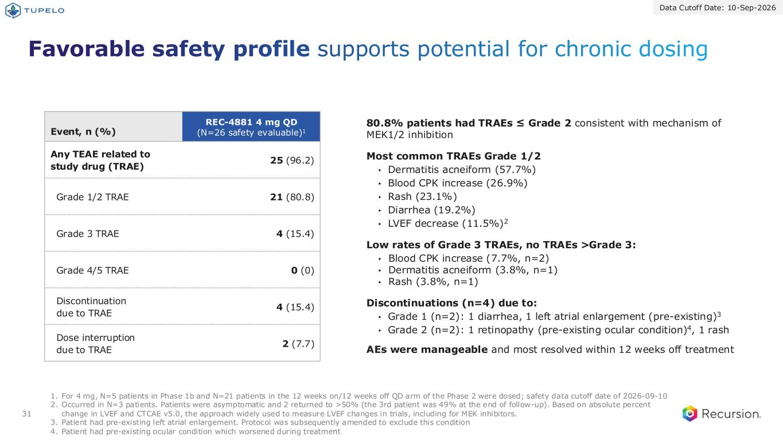
Favorable safety profile supports potential for chronic dosing 31 80.8% patients had TRAEs ≤ Grade 2 consistent with mechanism of MEK1/2 inhibition Most common TRAEs Grade 1/2 • Dermatitis acneiform (57.7%) • Blood CPK increase (26.9%) • Rash (23.1%) • Diarrhea (19.2%) • LVEF decrease (11.5%)2 Low rates of Grade 3 TRAEs, no TRAEs >Grade 3: • Blood CPK increase (7.7%, n=2) • Dermatitis acneiform (3.8%, n=1) • Rash (3.8%, n=1) Discontinuations (n=4) due to: • Grade 1 (n=2): 1 diarrhea, 1 left atrial enlargement (pre-existing)3 • Grade 2 (n=2): 1 retinopathy (pre-existing ocular condition)4, 1 rash AEs were manageable and most resolved within 12 weeks off treatment Event, n (%) REC-4881 4 mg QD (N=26 safety evaluable)1 Any TEAE related to study drug (TRAE) 25 (96.2) Grade 1/2 TRAE 21 (80.8) Grade 3 TRAE 4 (15.4) Grade 4/5 TRAE 0 (0) Discontinuation due to TRAE 4 (15.4) Dose interruption due to TRAE 2 (7.7) 1. For 4 mg, N=5 patients in Phase 1b and N=21 patients in the 12 weeks on/12 weeks off QD arm of the Phase 2 were dosed; safety data cutoff date of 2026-09-10 2. Occurred in N=3 patients. Patients were asymptomatic and 2 returned to >50% (the 3rd patient was 49% at the end of follow-up). Based on absolute percent change in LVEF and CTCAE v5.0, the approach widely used to measure LVEF changes in trials, including for MEK inhibitors. 3. Patient had pre-existing left atrial enlargement. Protocol was subsequently amended to exclude this condition 4. Patient had pre-existing ocular condition which worsened during treatment Data Cutoff Date: 10-Sep-2026

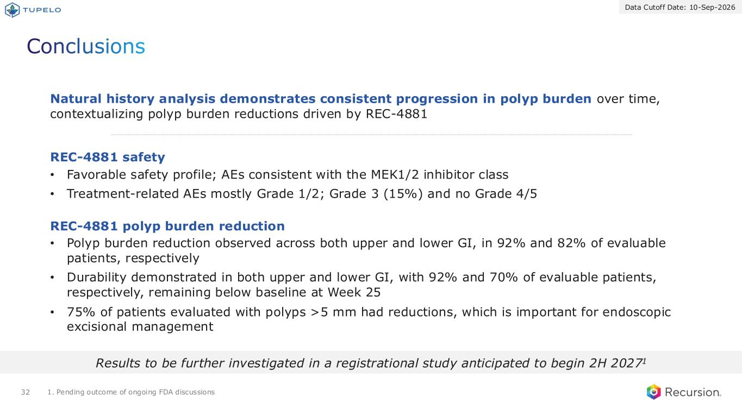
Conclusions 32 REC-4881 safety • Favorable safety profile; AEs consistent with the MEK1/2 inhibitor class • Treatment-related AEs mostly Grade 1/2; Grade 3 (15%) and no Grade 4/5 REC-4881 polyp burden reduction • Polyp burden reduction observed across both upper and lower GI, in 92% and 82% of evaluable patients, respectively • Durability demonstrated in both upper and lower GI, with 92% and 70% of evaluable patients, respectively, remaining below baseline at Week 25 • 75% of patients evaluated with polyps >5 mm had reductions, which is important for endoscopic excisional management Results to be further investigated in a registrational study anticipated to begin 2H 20271 1. Pending outcome of ongoing FDA discussions Natural history analysis demonstrates consistent progression in polyp burden over time, contextualizing polyp burden reductions driven by REC-4881 Data Cutoff Date: 10-Sep-2026


FAP Deep Dive Today’s news

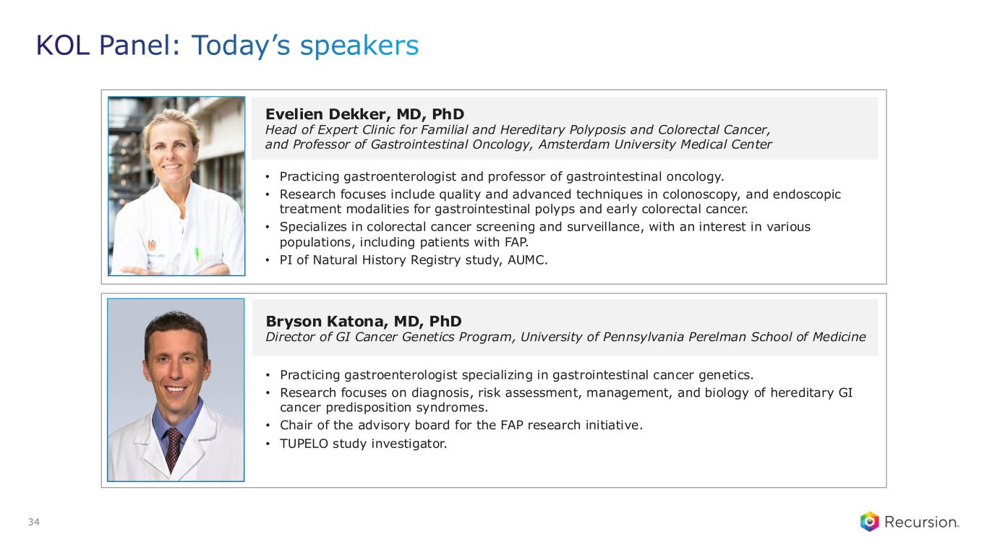
KOL Panel: Today’s speakers Evelien Dekker, MD, PhD Head of Expert Clinic for Familial and Hereditary Polyposis and Colorectal Cancer, and Professor of Gastrointestinal Oncology, Amsterdam University Medical Center Bryson Katona, MD, PhD Director of GI Cancer Genetics Program, University of Pennsylvania Perelman School of Medicine • Practicing gastroenterologist specializing in gastrointestinal cancer genetics. • Research focuses on diagnosis, risk assessment, management, and biology of hereditary GI cancer predisposition syndromes. • Chair of the advisory board for the FAP research initiative. • TUPELO study investigator. • Practicing gastroenterologist and professor of gastrointestinal oncology. • Research focuses include quality and advanced techniques in colonoscopy, and endoscopic treatment modalities for gastrointestinal polyps and early colorectal cancer. • Specializes in colorectal cancer screening and surveillance, with an interest in various populations, including patients with FAP. • PI of Natural History Registry study, AUMC. 34

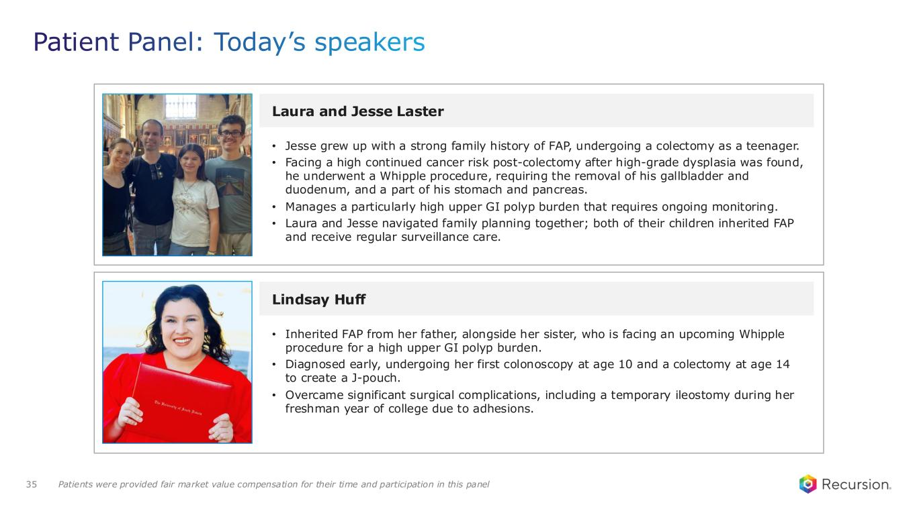
Patient Panel: Today’s speakers Laura and Jesse Laster Lindsay Huff • Inherited FAP from her father, alongside her sister, who is facing an upcoming Whipple procedure for a high upper GI polyp burden. • Diagnosed early, undergoing her first colonoscopy at age 10 and a colectomy at age 14 to create a J-pouch. • Overcame significant surgical complications, including a temporary ileostomy during her freshman year of college due to adhesions. • Jesse grew up with a strong family history of FAP, undergoing a colectomy as a teenager. • Facing a high continued cancer risk post-colectomy after high-grade dysplasia was found, he underwent a Whipple procedure, requiring the removal of his gallbladder and duodenum, and a part of his stomach and pancreas. • Manages a particularly high upper GI polyp burden that requires ongoing monitoring. • Laura and Jesse navigated family planning together; both of their children inherited FAP and receive regular surveillance care. Patients were provided fair market value compensation for their time and participation in this panel35


REC-1245 First-in-class RBM39 degrader Translating proof to products

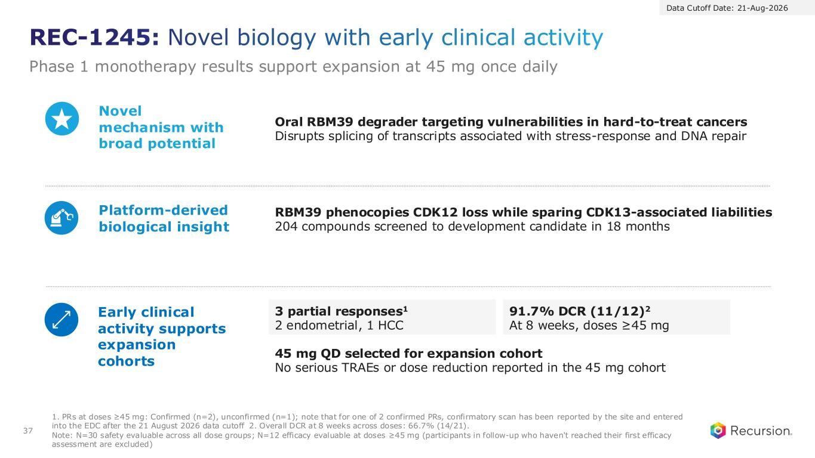
REC-1245: Novel biology with early clinical activity Phase 1 monotherapy results support expansion at 45 mg once daily 37 Oral RBM39 degrader targeting vulnerabilities in hard-to-treat cancers Disrupts splicing of transcripts associated with stress-response and DNA repair 3 partial responses1 2 endometrial, 1 HCC Novel mechanism with broad potential Platform-derived biological insight Early clinical activity supports expansion cohorts 1. PRs at doses ≥45 mg: Confirmed (n=2), unconfirmed (n=1); note that for one of 2 confirmed PRs, confirmatory scan has been reported by the site and entered into the EDC after the 21 August 2026 data cutoff 2. Overall DCR at 8 weeks across doses: 66.7% (14/21). Note: N=30 safety evaluable across all dose groups; N=12 efficacy evaluable at doses ≥45 mg (participants in follow-up who haven't reached their first efficacy assessment are excluded) 91.7% DCR (11/12)2 At 8 weeks, doses ≥45 mg 45 mg QD selected for expansion cohort No serious TRAEs or dose reduction reported in the 45 mg cohort Data Cutoff Date: 21-Aug-2026 RBM39 phenocopies CDK12 loss while sparing CDK13-associated liabilities 204 compounds screened to development candidate in 18 months

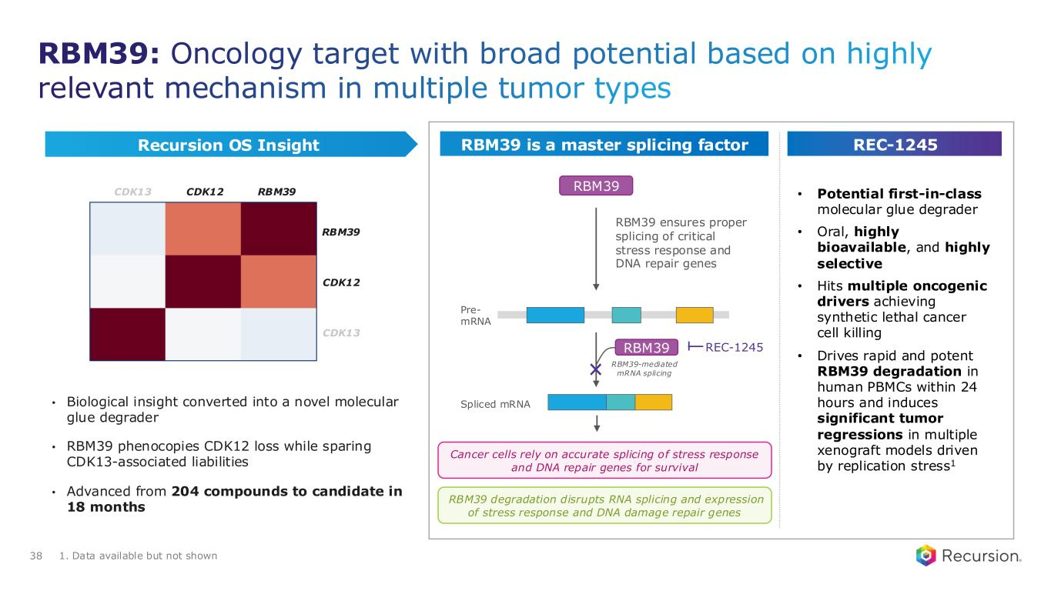
• Potential first-in-class molecular glue degrader • Oral, highly bioavailable, and highly selective • Hits multiple oncogenic drivers achieving synthetic lethal cancer cell killing • Drives rapid and potent RBM39 degradation in human PBMCs within 24 hours and induces significant tumor regressions in multiple xenograft models driven by replication stress1 RBM39 Pre- mRNA RBM39-mediated mRNA splicing Spliced mRNA Cancer cells rely on accurate splicing of stress response and DNA repair genes for survival RBM39 ensures proper splicing of critical stress response and DNA repair genes RBM39 RBM39: Oncology target with broad potential based on highly relevant mechanism in multiple tumor types • Biological insight converted into a novel molecular glue degrader • RBM39 phenocopies CDK12 loss while sparing CDK13-associated liabilities • Advanced from 204 compounds to candidate in 18 months 38 Recursion OS Insight RBM39 is a master splicing factor REC-1245 RBM39 degradation disrupts RNA splicing and expression of stress response and DNA damage repair genes 1. Data available but not shown CDK12 RBM39CDK13 RBM39 CDK12 CDK13 REC-1245

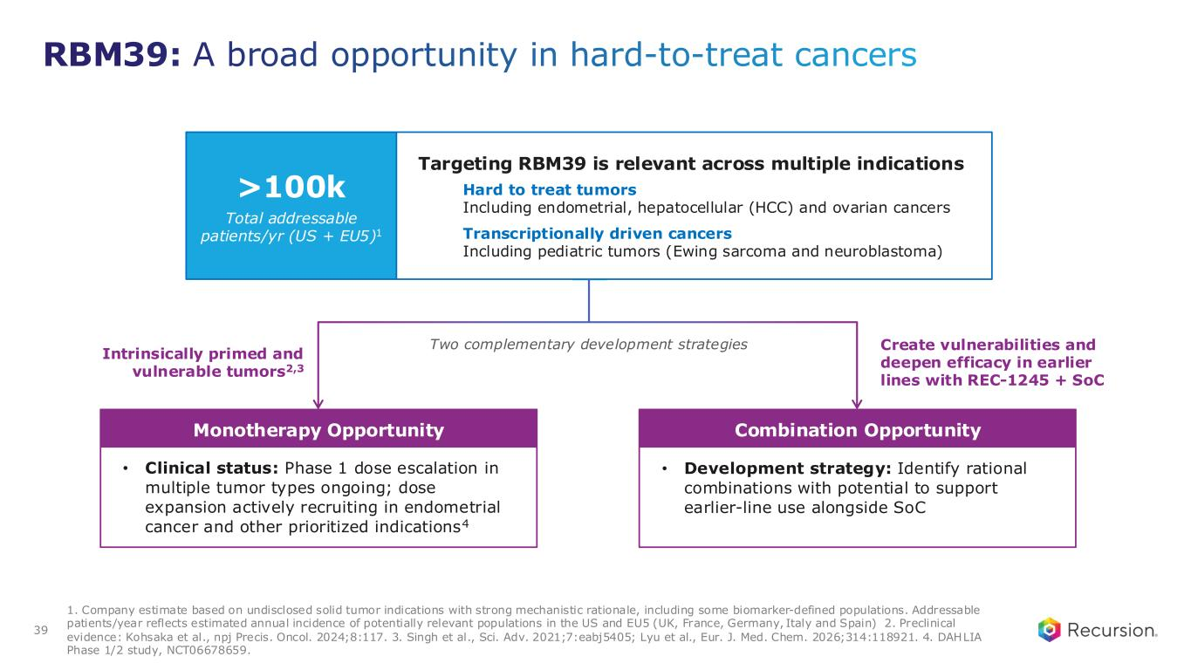
Monotherapy Opportunity Combination Opportunity RBM39: A broad opportunity in hard-to-treat cancers Targeting RBM39 is relevant across multiple indications Hard to treat tumors Including endometrial, hepatocellular (HCC) and ovarian cancers Transcriptionally driven cancers Including pediatric tumors (Ewing sarcoma and neuroblastoma) >100k Total addressable patients/yr (US + EU5)1 Two complementary development strategies Intrinsically primed and vulnerable tumors2,3 Create vulnerabilities and deepen efficacy in earlier lines with REC-1245 + SoC • Clinical status: Phase 1 dose escalation in multiple tumor types ongoing; dose expansion actively recruiting in endometrial cancer and other prioritized indications4 • Development strategy: Identify rational combinations with potential to support earlier-line use alongside SoC 1. Company estimate based on undisclosed solid tumor indications with strong mechanistic rationale, including some biomarker-defined populations. Addressable patients/year reflects estimated annual incidence of potentially relevant populations in the US and EU5 (UK, France, Germany, Italy and Spain) 2. Preclinical evidence: Kohsaka et al., npj Precis. Oncol. 2024;8:117. 3. Singh et al., Sci. Adv. 2021;7:eabj5405; Lyu et al., Eur. J. Med. Chem. 2026;314:118921. 4. DAHLIA Phase 1/2 study, NCT06678659. 39

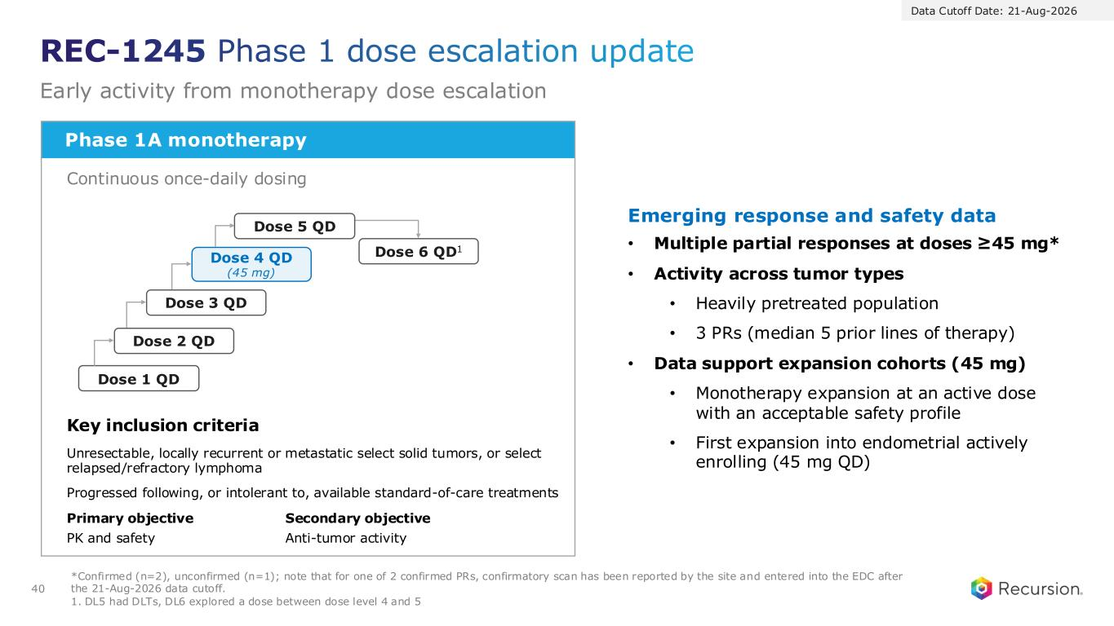
Phase 1A monotherapy Continuous once-daily dosing Key inclusion criteria Unresectable, locally recurrent or metastatic select solid tumors, or select relapsed/refractory lymphoma Progressed following, or intolerant to, available standard-of-care treatments Primary objective PK and safety Secondary objective Anti-tumor activity *Confirmed (n=2), unconfirmed (n=1); note that for one of 2 confirmed PRs, confirmatory scan has been reported by the site and entered into the EDC after the 21-Aug-2026 data cutoff. 1. DL5 had DLTs, DL6 explored a dose between dose level 4 and 5 REC-1245 Phase 1 dose escalation update Early activity from monotherapy dose escalation 40 Emerging response and safety data • Multiple partial responses at doses ≥45 mg* • Activity across tumor types • Heavily pretreated population • 3 PRs (median 5 prior lines of therapy) • Data support expansion cohorts (45 mg) • Monotherapy expansion at an active dose with an acceptable safety profile • First expansion into endometrial actively enrolling (45 mg QD) Dose 1 QD Dose 2 QD Dose 3 QD Dose 4 QD (45 mg) Dose 6 QD1 Dose 5 QD Data Cutoff Date: 21-Aug-2026

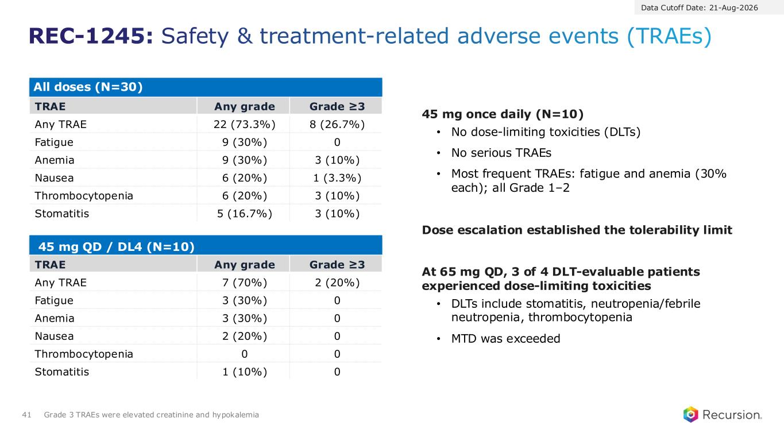
All doses (N=30) TRAE Any grade Grade ≥3 Any TRAE 22 (73.3%) 8 (26.7%) Fatigue 9 (30%) 0 Anemia 9 (30%) 3 (10%) Nausea 6 (20%) 1 (3.3%) Thrombocytopenia 6 (20%) 3 (10%) Stomatitis 5 (16.7%) 3 (10%) 45 mg QD / DL4 (N=10) TRAE Any grade Grade ≥3 Any TRAE 7 (70%) 2 (20%) Fatigue 3 (30%) 0 Anemia 3 (30%) 0 Nausea 2 (20%) 0 Thrombocytopenia 0 0 Stomatitis 1 (10%) 0 REC-1245: Safety & treatment-related adverse events (TRAEs) 41 Grade 3 TRAEs were elevated creatinine and hypokalemia 45 mg once daily (N=10) • No dose-limiting toxicities (DLTs) • No serious TRAEs • Most frequent TRAEs: fatigue and anemia (30% each); all Grade 1–2 Dose escalation established the tolerability limit At 65 mg QD, 3 of 4 DLT-evaluable patients experienced dose-limiting toxicities • DLTs include stomatitis, neutropenia/febrile neutropenia, thrombocytopenia • MTD was exceeded Data Cutoff Date: 21-Aug-2026

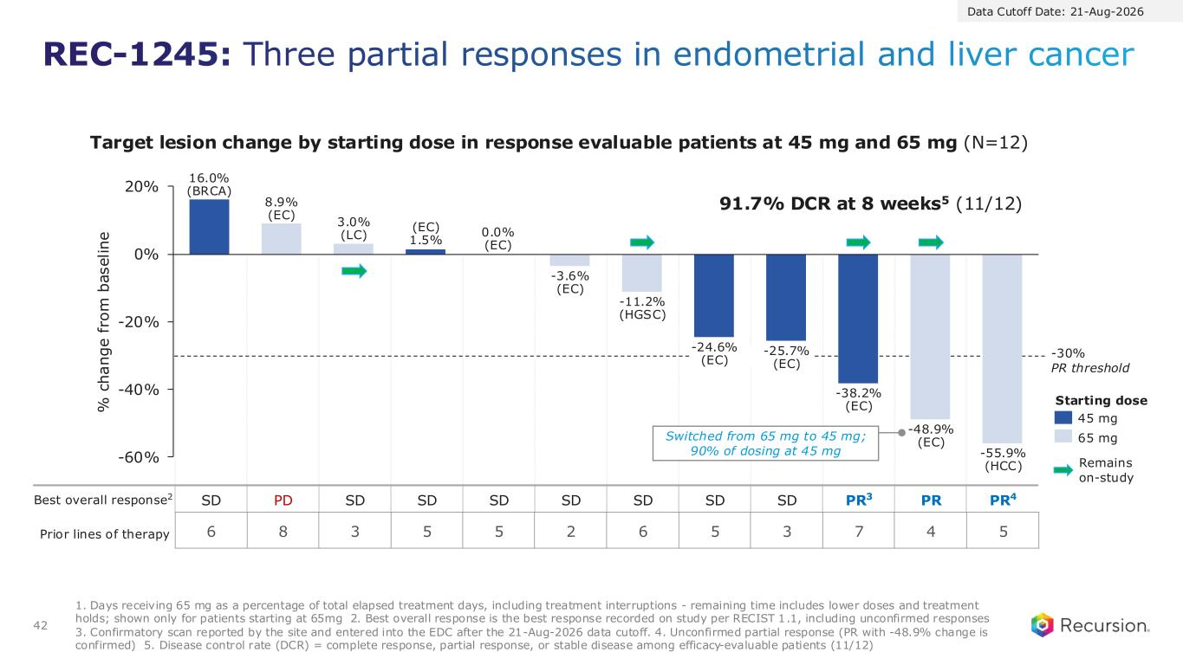
Best overall response2 SD PD SD SD SD SD SD SD SD PR3 PR PR4 REC-1245: Three partial responses in endometrial and liver cancer 42 -60% -40% -20% 0% 20% 16.0% (BRCA) 8.9% (EC) 3.0% (LC) (EC) 1.5% 0.0% (EC) -3.6% (EC) -11.2% (HGSC) -24.6% (EC) -25.7% (EC) -38.2% (EC) -48.9% (EC) -55.9% (HCC) 45 mg 65 mg % c h a n g e f ro m b a s e li n e Remains on-study Target lesion change by starting dose in response evaluable patients at 45 mg and 65 mg (N=12) -30% PR threshold 1. Days receiving 65 mg as a percentage of total elapsed treatment days, including treatment interruptions - remaining time includes lower doses and treatment holds; shown only for patients starting at 65mg 2. Best overall response is the best response recorded on study per RECIST 1.1, including unconfirmed responses 3. Confirmatory scan reported by the site and entered into the EDC after the 21-Aug-2026 data cutoff. 4. Unconfirmed partial response (PR with -48.9% change is confirmed) 5. Disease control rate (DCR) = complete response, partial response, or stable disease among efficacy-evaluable patients (11/12) 91.7% DCR at 8 weeks5 (11/12) Switched from 65 mg to 45 mg; 90% of dosing at 45 mg Starting dose 6 8 3 5 5 2 6 5 3 7 4 5Prior lines of therapy Data Cutoff Date: 21-Aug-2026

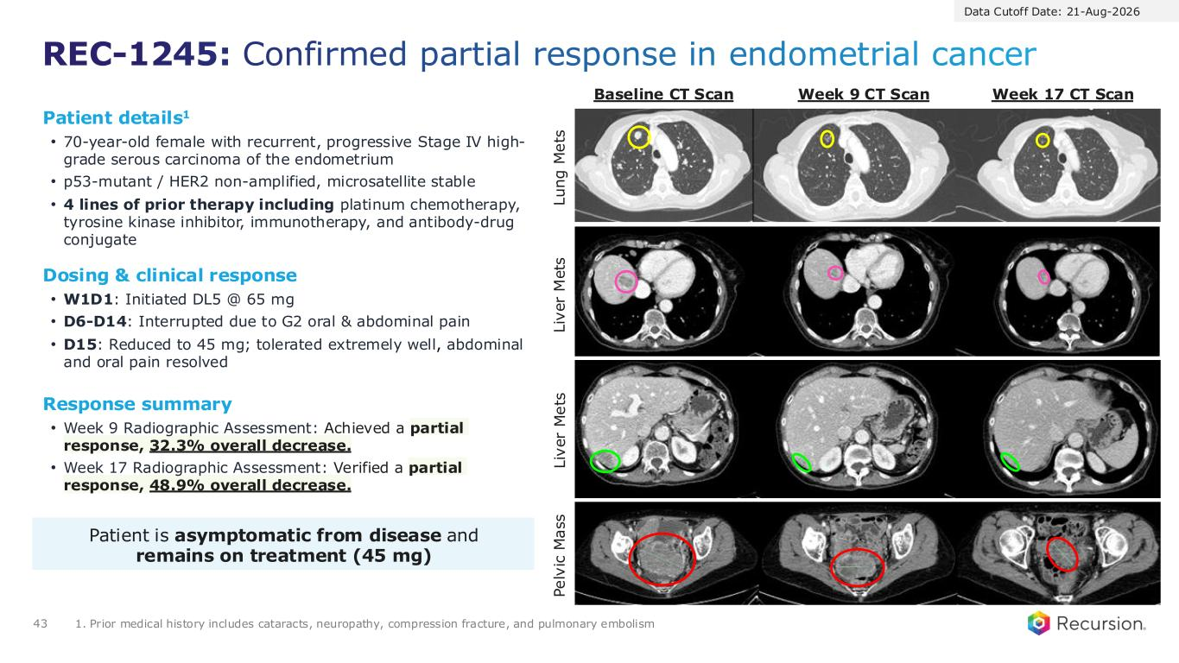
REC-1245: Confirmed partial response in endometrial cancer 43 1. Prior medical history includes cataracts, neuropathy, compression fracture, and pulmonary embolism Response summary • Week 9 Radiographic Assessment: Achieved a partial response, 32.3% overall decrease. • Week 17 Radiographic Assessment: Verified a partial response, 48.9% overall decrease. Patient details1 • 70-year-old female with recurrent, progressive Stage IV high- grade serous carcinoma of the endometrium • p53-mutant / HER2 non-amplified, microsatellite stable • 4 lines of prior therapy including platinum chemotherapy, tyrosine kinase inhibitor, immunotherapy, and antibody-drug conjugate Dosing & clinical response • W1D1: Initiated DL5 @ 65 mg • D6-D14: Interrupted due to G2 oral & abdominal pain • D15: Reduced to 45 mg; tolerated extremely well, abdominal and oral pain resolved Patient is asymptomatic from disease and remains on treatment (45 mg) L iv e r M e ts P e lv ic M a s s L u n g M e ts L iv e r M e ts Baseline CT Scan Week 9 CT Scan Week 17 CT Scan Data Cutoff Date: 21-Aug-2026

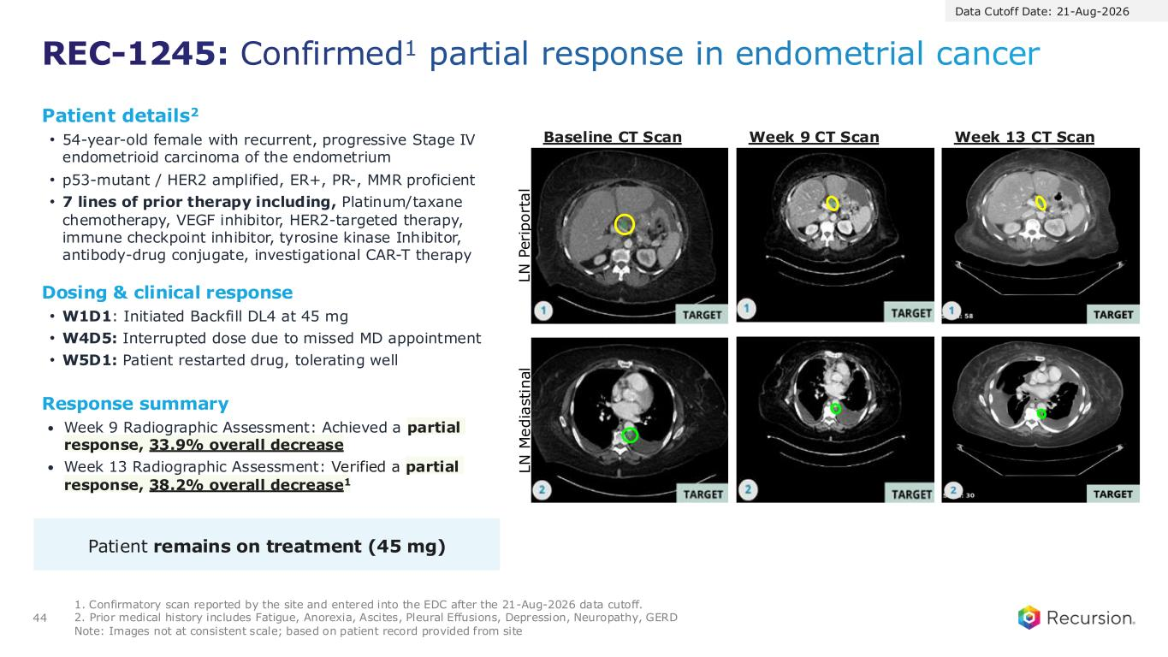
REC-1245: Confirmed1 partial response in endometrial cancer 44 1. Confirmatory scan reported by the site and entered into the EDC after the 21-Aug-2026 data cutoff. 2. Prior medical history includes Fatigue, Anorexia, Ascites, Pleural Effusions, Depression, Neuropathy, GERD Note: Images not at consistent scale; based on patient record provided from site Response summary • Week 9 Radiographic Assessment: Achieved a partial response, 33.9% overall decrease • Week 13 Radiographic Assessment: Verified a partial response, 38.2% overall decrease1 Patient details2 • 54-year-old female with recurrent, progressive Stage IV endometrioid carcinoma of the endometrium • p53-mutant / HER2 amplified, ER+, PR-, MMR proficient • 7 lines of prior therapy including, Platinum/taxane chemotherapy, VEGF inhibitor, HER2-targeted therapy, immune checkpoint inhibitor, tyrosine kinase Inhibitor, antibody-drug conjugate, investigational CAR-T therapy Dosing & clinical response • W1D1: Initiated Backfill DL4 at 45 mg • W4D5: Interrupted dose due to missed MD appointment • W5D1: Patient restarted drug, tolerating well Patient remains on treatment (45 mg) L N P e ri p o rt a l L N M e d ia s ti n a l Baseline CT Scan Week 9 CT Scan Week 13 CT Scan Data Cutoff Date: 21-Aug-2026

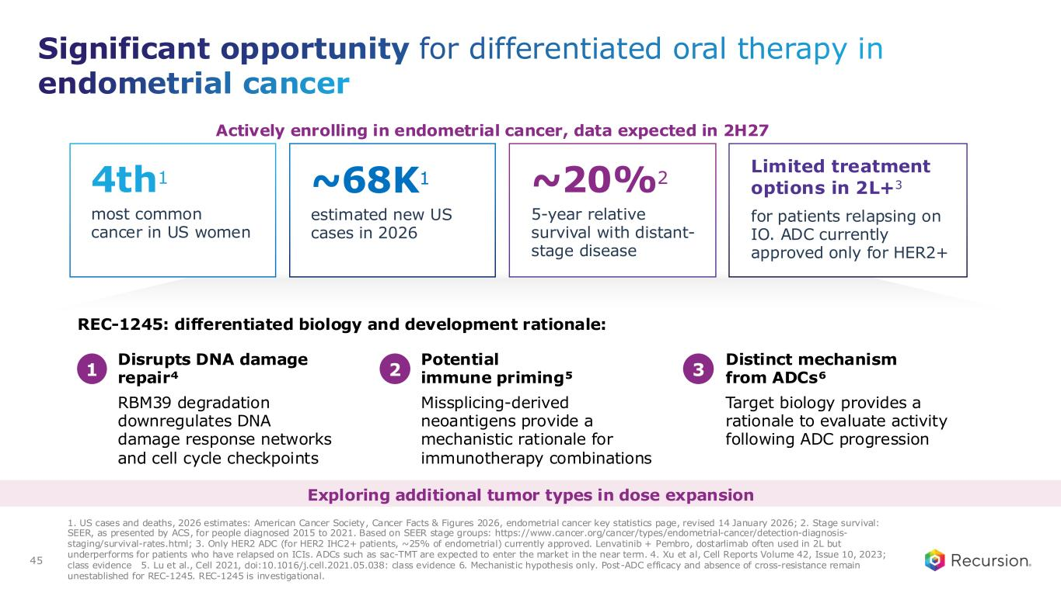
most common cancer in US women REC-1245: differentiated biology and development rationale: Disrupts DNA damage repair⁴ Potential immune priming⁵ Distinct mechanism from ADCs⁶ RBM39 degradation downregulates DNA damage response networks and cell cycle checkpoints Missplicing-derived neoantigens provide a mechanistic rationale for immunotherapy combinations Target biology provides a rationale to evaluate activity following ADC progression 1. US cases and deaths, 2026 estimates: American Cancer Society, Cancer Facts & Figures 2026, endometrial cancer key statistics page, revised 14 January 2026; 2. Stage survival: SEER, as presented by ACS, for people diagnosed 2015 to 2021. Based on SEER stage groups: https://www.cancer.org/cancer/types/endometrial-cancer/detection-diagnosis- staging/survival-rates.html; 3. Only HER2 ADC (for HER2 IHC2+ patients, ~25% of endometrial) currently approved. Lenvatinib + Pembro, dostarlimab often used in 2L but underperforms for patients who have relapsed on ICIs. ADCs such as sac-TMT are expected to enter the market in the near term. 4. Xu et al, Cell Reports Volume 42, Issue 10, 2023; class evidence 5. Lu et al., Cell 2021, doi:10.1016/j.cell.2021.05.038: class evidence 6. Mechanistic hypothesis only. Post-ADC efficacy and absence of cross-resistance remain unestablished for REC-1245. REC-1245 is investigational. Significant opportunity for differentiated oral therapy in endometrial cancer 45 4th1 estimated new US cases in 2026 ~68K1 5-year relative survival with distant- stage disease ~20%2 for patients relapsing on IO. ADC currently approved only for HER2+ Limited treatment options in 2L+3 1 2 3 Actively enrolling in endometrial cancer, data expected in 2H27 Exploring additional tumor types in dose expansion


Financials & Looking ahead

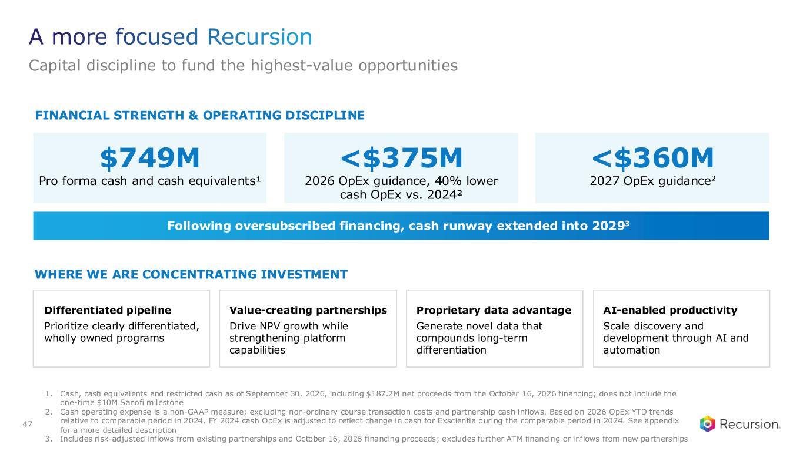
FINANCIAL STRENGTH & OPERATING DISCIPLINE $749M Pro forma cash and cash equivalents¹ <$375M 2026 OpEx guidance, 40% lower cash OpEx vs. 2024² Following oversubscribed financing, cash runway extended into 20293 WHERE WE ARE CONCENTRATING INVESTMENT Differentiated pipeline Prioritize clearly differentiated, wholly owned programs Value-creating partnerships Drive NPV growth while strengthening platform capabilities Proprietary data advantage Generate novel data that compounds long-term differentiation AI-enabled productivity Scale discovery and development through AI and automation A more focused Recursion Capital discipline to fund the highest-value opportunities 47 1. Cash, cash equivalents and restricted cash as of September 30, 2026, including $187.2M net proceeds from the October 16, 2026 financing; does not include the one-time $10M Sanofi milestone 2. Cash operating expense is a non-GAAP measure; excluding non-ordinary course transaction costs and partnership cash inflows. Based on 2026 OpEx YTD trends relative to comparable period in 2024. FY 2024 cash OpEx is adjusted to reflect change in cash for Exscientia during the comparable period in 2024. See appendix for a more detailed description 3. Includes risk-adjusted inflows from existing partnerships and October 16, 2026 financing proceeds; excludes further ATM financing or inflows from new partnerships <$360M 2027 OpEx guidance2

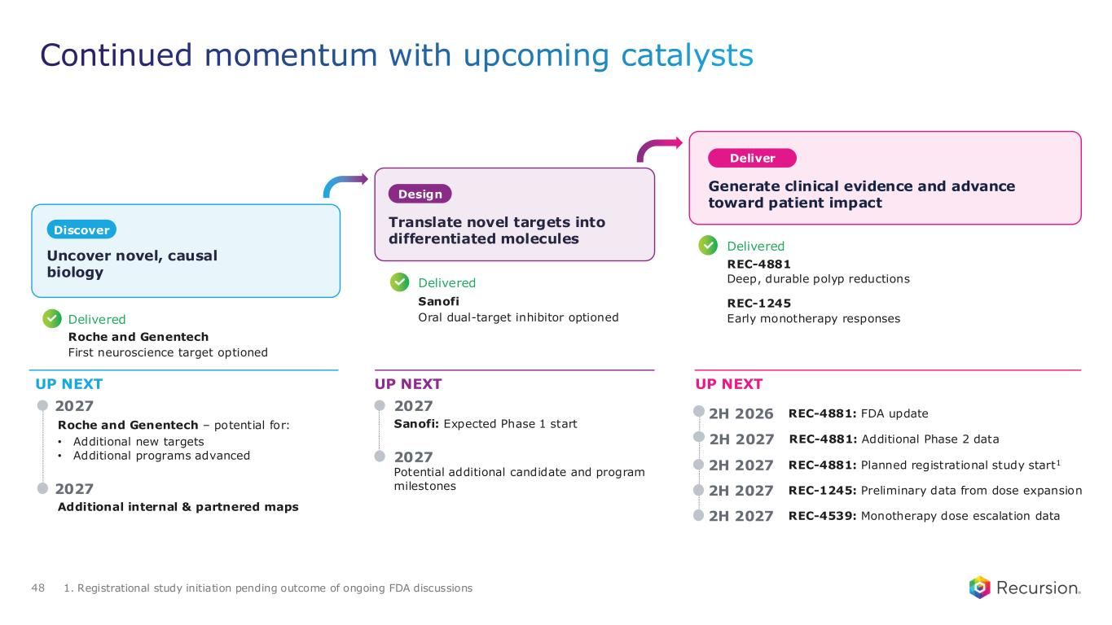
Sanofi: Expected Phase 1 start Continued momentum with upcoming catalysts 1. Registrational study initiation pending outcome of ongoing FDA discussions UP NEXT UP NEXT UP NEXT 2027 2027 2027 Potential additional candidate and program milestones 2H 2026 REC-4881: FDA update 2H 2027 REC-4881: Additional Phase 2 data 2H 2027 REC-4881: Planned registrational study start1 2H 2027 REC-1245: Preliminary data from dose expansion 2H 2027 REC-4539: Monotherapy dose escalation data Delivered Roche and Genentech First neuroscience target optioned Delivered Sanofi Oral dual-target inhibitor optioned Delivered REC-4881 Deep, durable polyp reductions REC-1245 Early monotherapy responses Uncover novel, causal biology Discover Design Translate novel targets into differentiated molecules Deliver Generate clinical evidence and advance toward patient impact Roche and Genentech – potential for: • Additional new targets • Additional programs advanced Additional internal & partnered maps 2027 48


49


50 THANK YOU



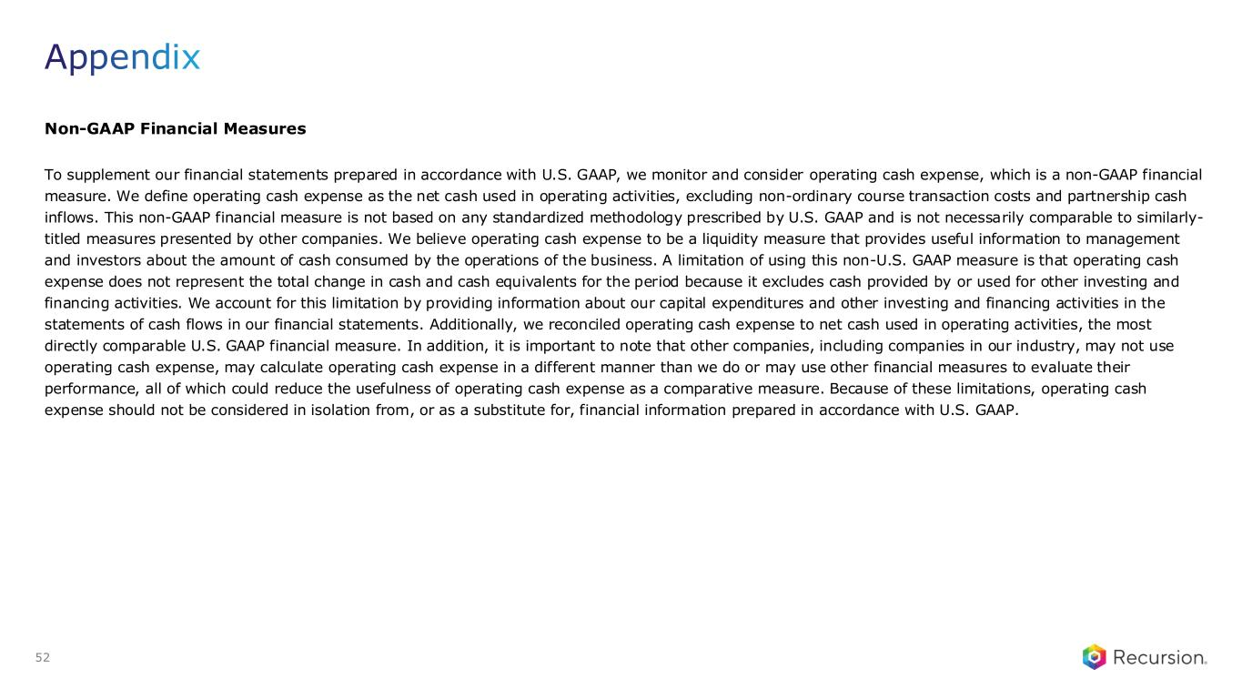
Non-GAAP Financial Measures To supplement our financial statements prepared in accordance with U.S. GAAP, we monitor and consider operating cash expense, which is a non-GAAP financial measure. We define operating cash expense as the net cash used in operating activities, excluding non-ordinary course transaction costs and partnership cash inflows. This non-GAAP financial measure is not based on any standardized methodology prescribed by U.S. GAAP and is not necessarily comparable to similarly- titled measures presented by other companies. We believe operating cash expense to be a liquidity measure that provides useful information to management and investors about the amount of cash consumed by the operations of the business. A limitation of using this non-U.S. GAAP measure is that operating cash expense does not represent the total change in cash and cash equivalents for the period because it excludes cash provided by or used for other investing and financing activities. We account for this limitation by providing information about our capital expenditures and other investing and financing activities in the statements of cash flows in our financial statements. Additionally, we reconciled operating cash expense to net cash used in operating activities, the most directly comparable U.S. GAAP financial measure. In addition, it is important to note that other companies, including companies in our industry, may not use operating cash expense, may calculate operating cash expense in a different manner than we do or may use other financial measures to evaluate their performance, all of which could reduce the usefulness of operating cash expense as a comparative measure. Because of these limitations, operating cash expense should not be considered in isolation from, or as a substitute for, financial information prepared in accordance with U.S. GAAP. Appendix 52

