UNITED STATES

SECURITIES AND EXCHANGE COMMISSION

Washington, D.C. 20549

FORM 10-K

(Mark One)

- ANNUAL REPORT PURSUANT TO SECTION 13 OR 15(d) OF THE SECURITIES EXCHANGE ACT OF 1934 For the fiscal year ended December 31, 2023
or

- TRANSITION REPORT PURSUANT TO SECTION 13 OR 15(d) OF THE SECURITIES EXCHANGE ACT OF 1934 For the transition period from to

Commission File Number: 001-40323

Recursion Pharmaceuticals, Inc.

(Exact name of registrant as specified in its charter)

Delaware___________________________________________________ 46-4099738

(State or other jurisdiction of incorporation or organization)______________________ (I.R.S. Employer Identification No.)

41 S Rio Grande Street
Salt Lake City, UT 84101
(Address of principal executive offices) (Zip code)
(385) 269 - 0203

(Registrant’s telephone number, including area code)

Securities registered pursuant to Section 12(b) of the Act:

Title of each class | Trading symbol(s) | Name of each exchange on which registered
Class A Common Stock, par value $0.00001 | RXRX | Nasdaq Global Select Market

Securities registered pursuant to section 12(g) of the Act: None

_____________________________________________________________________________________________________

(Title of class)

Indicate by check mark if the registrant is a well-known seasoned issuer, as defined in Rule 405 of the Securities Act.
Yes x No o
Indicate by check mark if the registrant is not required to file reports pursuant to Section 13 or Section 15(d) of the Act.
Yes o No x

Indicate by check mark whether the registrant (1) has filed all reports required to be filed by Section 13 or 15(d) of the Securities Exchange Act of 1934 during the preceding 12 months (or for such shorter period that the registrant was required to file such reports), and (2) has been subject to such filing requirements for the past 90 days.

Yes x No ☐

Indicate by check mark whether the registrant has submitted electronically every Interactive Data File required to be submitted pursuant to Rule 405 of Regulation S-T (§232.405 of this chapter) during the preceding 12 months (or for such shorter period that the registrant was required to submit such files).

Yes x No ☐

Indicate by check mark whether the registrant is a large accelerated filer, an accelerated filer, a non-accelerated filer, a smaller reporting company, or an emerging growth company. See the definitions of “large accelerated filer,” “accelerated filer,” “smaller reporting company,” and "emerging growth company" in Rule 12b-2 of the Exchange Act.

Large accelerated filer

x

Non-accelerated filer ☐

Accelerated filer

☐

Smaller reporting company ☐

Emerging growth company ☐

If an emerging growth company, indicate by check mark if the registrant has elected not to use the extended transition period for complying with any new or revised financial accounting standards provided pursuant to Section 13(a) of the Exchange Act. ☐

Indicate by check mark whether the registrant has filed a report on and attestation to its management’s assessment of the effectiveness of its internal control over financial reporting under Section 404(b) of the Sarbanes-Oxley Act (15 U.S.C. 7262(b)) by the registered public accounting firm that prepared or issued its audit report. ☒

If securities are registered pursuant to Section 12(b) of the Act, indicate by check mark whether the financial statements of the registrant included in the filing reflect the correction of an error to previously issued financial statements. ☐

Indicate by check mark whether any of those error corrections are restatements that required a recovery analysis of incentive-based compensation received by any of the registrant’s executive officers during the relevant recovery period pursuant to §240.10D-1(b). ☐

Indicate by check mark whether the registrant is a shell company (as defined in Rule 12b-2 of the Exchange Act). Yes ☐ No ☒

The aggregate market value of the 124,546,642 shares of Class A common voting stock held by non-affiliates of the Registrant, computed by reference to the closing price as reported on the Nasdaq Stock Exchange, as of the last business day of the registrant’s most recently completed second fiscal quarter (June 30, 2023) was $930.4 million.

As of January 31, 2024, there were 227,143,401 and 7,509,871 shares of the registrant’s Class A and B common stock, respectively, par value $0.00001 per share outstanding, respectively.

DOCUMENTS INCORPORATED BY REFERENCE

Portions of the definitive proxy statement for use in connection with the registrant’s 2024 Annual Meeting of Stockholders to be filed hereafter are incorporated by reference into Part III of this report.

A Letter from Our Co-Founder and CEO

Dear current or prospective shareholder,

Recursion celebrated its tenth anniversary in 2023, and as I reflect back on the past decade of building and look forward to the next decade, it feels increasingly clear that we are in the midst of a tremendous technology and AI-driven transition in our society.

Knowledge workers are on the precipice of a massive transformation in their work; much of the toil embedded into the processes, systems and delivery today will give way to higher efficiency, more creativity and smart risk-taking with new tools that will enable rapid and deep experimentation and fast failure. For many, embracing this evolving landscape of work will be tumultuous, but for those who are open to the possibilities technology brings, an exciting new future awaits.

Like all major past shifts in society, we will face many new challenges and obstacles as we come to terms with the risks and opportunities of the new tools that are becoming increasingly available at our fingertips.

The broad transformations in society will be mirrored in the life sciences with the evolution of BioTech into TechBio over the coming decade. The digitization of biology and chemistry will enable us to predict ways to map and navigate it, allowing us to design rather than discover better medicines faster with less failure. Advancements in laboratory automation, biological tools and quantified human health will allow for the emergence of massive datasets of human health and disease that will feed the AI-driven insights transforming life sciences.

Of course, the idea that an AI ‘black-box’ will pop out new cures at scale in the coming 12-24 months is a fallacy and we have to be careful not to be caught up in that sort of hype. Drug discovery is too complex, has too many steps and has too long of a feedback loop for that sort of ‘overnight’ shift. But looking back at how far we have come and the compounding improvements we see today, I believe that our industry will shift more in the coming decade than it ever has before.

THE WORLD HAS GENERATED MORE DATA IN THE PAST 24 MONTHS than in all of human history before that

A common argument from skeptics is that biology is too complex and healthcare too complicated for such a disruptive technological transformation to be possible. But like in prior industrial revolutions, a new technology (or technologies) has set in motion a current that will fundamentally reshape the forces and assumptions that drive various fields, including our own. Here are a few facts that signal this transformation is happening right now:

Data & Compute:

- The world has generated more data in the past 24 months than in all of human history before that
- The world has consumed more computational cycles in the last 12 months than in all of human history before that

Biological Tools:

- CRISPR-based gene editing has, in just the last five years, enabled for the first time arrayed genome-wide genetic screens
- Innovations in induced pluripotent stem cells allow us to generate high-quality, differentiated human cells at massive scale

Automation and Reagents:

- Robotic laboratory systems and software enable highly standardized and quality-controlled high-throughput screening to generate relatable data at scale



FIVE PHASE 2 CLINICAL-STAGE PROGRAMS with multiple upcoming data readouts expected

What’s more, the signs of AI-enabled point-solutions are already plentiful across our industry:
- Protein folding

- Scaled protein-ligand interaction prediction

- Generative AI for chemistry for tractable targets

- The FDA is already discussing the use of LLMs for program review

- Major pharma companies are drafting regulatory filings like INDs by LLMs

These facts lay out a clear future where efficiencies and improvements across the many current AI-enabled point-solutions will begin to combine into integrated ‘tech-stacks’ and workflows that will result in compounding improvements in our ability to drug historically undruggable targets, understand the underlying networks of biology with increasing fidelity, fast-follow newly validated biology, characterize disease in increasingly robust ways and ultimately deliver more, better medicines to patients to alleviate suffering at scale. The question is no longer whether this sort of future is before us, but when and who will lead it.

Looking Back at 2023 and Before

Reflecting back on late 2013 when Recursion was founded and how far we have come, it is simultaneously incredible and unsurprising to see where we are today. Recursion was then a Utah-based startup founded by two graduate students and a professor. Our first office was a conference room in the nearby University Research Park and our first laboratory was a converted storage room. Today, Recursion is a multinational, clinical-stage company leading the transition of BioTech into TechBio. We have over 500 employees, five clinical stage programs, one of the world’s largest biological and chemical datasets and two of the largest discovery collaborations in the industry with Roche/Genentech and Bayer.

And in 2023, the opportunity ahead feels so much greater than it did in 2013, that in some ways it still feels like we are just getting started. In fact, from an internal perspective, 2023 felt like one of the best years in our history. In 2023 we achieved a lot of important milestones, and a lot of things we’ve been working to build, in some cases for years, really seemed to start hitting their stride, including:

Pipeline

- Five phase 2 clinical-stage programs with multiple upcoming data readouts expected, including REC-994 in cerebral cavernous malformation (CCM) in Q3 2024, REC-2282 in neurofibromatosis type 2 (NF2) in Q4 2024, REC-4881 in familial adenomatous polyposis (FAP) in H1 2025, and REC-4881 in AXIN1 or APC mutant solid tumors in H1 2025

- Completed a Phase 1 study for REC-3964 in healthy volunteers for the potential treatment of Clostridioides difficile (C. difficile) infection with a favorable safety and tolerability profile

- Advanced our RBM39 program in homologous recombination proficient ovarian cancer and other solid tumors to IND-enabling studies

- In-licensed a program (Target Epsilon) that emerged from our fibrosis collaboration with Bayer that represents a novel approach to treating fibrotic diseases with compelling early data

Our Collaborators

Roche and Genentech

Bayer

NVIDIA

Tempus

Enamine

LOWE (LARGE LANGUAGE MODEL-ORCHESTRATED WORKFLOW ENGINE)
is connecting wet-lab and dry-lab components of the Recursion OS using a natural language interface to streamline complex drug discovery tasks

>1 Trillion

HUMAN INDUCED PLURIPOTENT

STEM CELL (hiPSC)-derived neuronal cells produced since 2022

Partnership

- Made significant progress against both the gastrointestinal-oncology and neuroscience portions of our collaboration with Roche and Genentech, including Roche exercising its Small Molecule Validated Hit Option to further advance our first partnership program in GI-oncology

- Updated our collaboration with Bayer to focus on challenging oncology indications with high unmet need, commensurate with higher per program milestone payments

- Entered into a collaboration with NVIDIA to accelerate the construction, optimization and deployment of foundation models for biology and chemistry as well as host Recursion-built computational and data tools on BioNeMo (NVIDIA’s drug discovery platform) – additionally, NVIDIA invested $50 million in Recursion via a private placement

- Entered into a collaboration with Tempus giving Recursion access to over 20 petabytes of proprietary de-identified, multimodal patient oncology data for the purpose of training causal AI models for the discovery of novel therapeutic hypotheses, biomarker strategies and patient cohort selection

- Entered into a partnership with Enamine to generate enriched screening libraries with insights from Recursion’s protein-ligand interaction predictions spanning across Enamine’s massive library of approximately 36 billion compounds

Recursion OS

- Built, scaled and industrialized multiple tools and technologies to heavily automate workflows across the drug discovery process, creating one of the most complete full-stack TechBio solutions

- Created LOWE (Large Language Model-Orchestrated Workflow Engine) connecting wet-lab and dry-lab components of the Recursion OS using a natural language interface to streamline complex drug discovery tasks

- Deployed large language models (LLMs) to map scientific literature in conjunction with our internally derived proprietary maps for the purpose of autonomously identifying novel opportunities in areas of unmet need

- Deployed Phenom-1, a vision transformer utilizing hundreds of millions of parameters trained on billions of biological images from our proprietary data, which we believe to be the world’s largest phenomics foundation model at this time

- Deployed new digital chemistry tools to predict the ligand-protein interactions for approximately 36 billion compounds in the Enamine REAL Space, reported to be the largest synthesizable chemical library

- Produced over 1 trillion human induced pluripotent stem cell (hiPSC)-derived neuronal cells since 2022, likely making Recursion one of the world’s largest producers of neuronal cells

- Began training causal AI models leveraging over 20 petabytes of multi-modal precision oncology patient data from Tempus to support the discovery of potential biomarker-enriched therapeutics at scale

ACQUIRED CYCLICA AND VALENCE DISCOVERY TO BOLSTER digital chemistry and generative AI capabilities


Company Building

- Acquired Cyclica and Valence Discovery to bolster digital chemistry and generative AI capabilities

- Expanded our operations in Salt Lake City and Montréal and opened our Canadian headquarters in Toronto with a focus on growing our machine learning and digital chemistry teams

- Committed to quadrupling the capacity of our supercomputer, BioHive-1, to support our pipeline, partnerships and the construction of foundation models across the multiple modalities of biology, chemistry and patient-centric data – we believe that this expansion should make our supercomputer a top 50 supercomputer across any industry according to the TOP500 list

As one of the leading TechBio companies, Recursion has played a critical role in driving the pace and scale of adoption of new TechBio tools across the industry. And while I am very proud of how our team delivered in 2023, the most important shift for our business happened outside our walls this year. We finally found the ideas embedded in TechBio, and in particular the belief in the utility of AI in our industry, finding mainstream support among some of the larger and more traditional companies in the space.

While there is no doubt there will be massive short-term volatility in the space, there is an increasing consensus among leaders in BioPharma that ML and AI are going to play a very important role over the coming decade. While we have incredible work before us, it feels as if we are no longer sailing into the wind, but now the wind is starting to shift to our backs. And I believe that there is no team in the world better prepared to sail fast in this new environment and continue to put deep blue water between us and many of our competitors as we look out over the coming years.

Looking Out at 2024 and Beyond

You could almost taste the shift in sentiment around TechBio at the J.P. Morgan Healthcare Conference at the beginning of this year when compared to years prior. While some skepticism still prevails, it no longer carries the room in most places as a shift towards cautious optimism permeates the executive teams and boards of the most powerful companies in our space.

Following the announcement of our partnership with NVIDIA in 2023, we co-hosted an event with them at the JP Morgan conference. We brought together members of the executive teams and boards of many of the largest biopharma companies in the world, many of the CEOs of leading TechBio companies, executives of leading tech companies, and investors and analysts who either already invest in or cover this convergence or are tempted to do so.

That evening, attendees heard from life science luminaries like Scott Gottlieb, Aviv Regev and Amy Abernethy as well as Jensen Huang, the CEO of NVIDIA. They heard conviction from those leaders about how clearly the trend of ML and AI will impact our industry going forward. What I found most interesting was how fluent the tech leaders among the group were in speaking the language of biopharma. Far more fluent, I would argue, than the leaders of biopharma are in speaking ‘tech.’ And that presents a risk for biopharma and an opportunity for companies like Recursion that are positioned as leaders in TechBio.



"We are a company building a platform to deliver many medicines over time."

But despite all the excitement around our space, we are part of an industry with a mission to alleviate suffering by bringing new, better medicines to patients. That is how we ultimately measure our impact. And as I look ahead to the next 18 months, Recursion will take meaningful steps toward that goal as we read out our first four phase 2 studies.

This is incredibly exciting as it represents the first opportunity for us to demonstrate utility for the patients we aim to serve. But it is also important to come into these initial readouts with a focus on how they can help us learn and tune our platform.

The trials that will read out this year are from the earliest iterations of our Recursion OS. They represent repurposing opportunities in rare genetic diseases we modeled using challenging tools like siRNA. New generations of our operating system using more and more powerful biology tools, chemistry tools and AI tools are leading us to identify and advance more exciting programs with some even already moving to the clinic.

The industry average success rate for Phase 2 readouts is approximately 20-30%. This suggests that if even one of our upcoming four readouts demonstrates a useful signal, we are on the right track to developing meaningful potential treatments for patients. And while we hope to do better than that, for the good of all the patients we seek to treat, we are in this for the long-run and we will use every piece of data, positive or negative, to learn and feedback into the Recursion OS so that we can maximize our long term impact.

It is important to understand that we are not a company who built a platform to deliver a handful of medicines; we are a company who is building a platform to deliver many medicines over time. And if our thesis holds, our system should improve over time with decreasing rates of late-stage failures. We believe we have built an operating system capable of discovering and developing many medicines, both within our own pipeline and via partnerships with others in the industry.

And beyond the excitement we all have for all we will learn from our first generation of programs reading out in the near term, we are also tremendously excited to be helping the rest of the industry adopt tools and technologies that can help them put the power of our operating system at their fingertips.

We announced LOWE (Large Language Model Orchestrated Workflow Engine) at JP Morgan via a live software demonstration at the conference. Together with the audience we started a mock oncology program, from leveraging Recursion’s proprietary data to identify a target of interest in oncology, to designing and ordering potential small molecule modulators of the target, to scheduling follow-up experiments on our platform to evaluate the molecules in a first cycle of SAR. You can view a version of this demonstration and our software tool LOWE here: https://www.youtube.com/watch? v=Hf1bb9rPQtE

While this was a fun and exciting way to engage with the audience at JPM, we are actively discussing making LOWE available to various potential partners for deployment within their own R&D engine. While we don’t know exactly what the future holds for LOWE, this represents an exciting new opportunity for Recursion to help accelerate the industry and the broader adoption of TechBio by integrating portions of our RecursionOS into the engine of other companies in the space.

“From our perspective there are two key drivers that will determine the winners in this race: data and execution.”


The Differentiator Will Be Data and Execution

Extending our view out beyond the near term and over the next decade, it feels possible, and even probable, that there will be a small number of very powerful companies in TechBio who may supplant much of what we call BioTech today. Who will these companies be and how will they win?

While compute is supply-constrained right now, it has also never been anywhere near as abundant as it is today. Table-stakes in this race over the next few years will be access to dedicated compute and robust ML/AI and software engineering teams. That is why Recursion has continued investing in BioHive-1, our on-premise supercomputer. We announced in late 2023 an expansion of the computer with our partners at NVIDIA that is likely to make it the fastest supercomputer wholly owned and operated by any biopharma company on Earth, including all the big ones. We also have an incredible, talented and growing team of ML researchers and engineers working to leverage this compute to advance the OS. We’ve grown both organically on these teams and by acquisition when needed. But as I said, these are table stakes.

From our perspective there are two key drivers that will determine the winners in this race: data and execution.

There is a divergence of opinions on what sort of data to use. There are those who believe that much of the data needed to solve the biggest problems in drug discovery and development exist today, either publicly or in the hands of large pharmaceutical companies. There is some evidence to support this idea; for example, the incredible progress in protein folding has been driven by sophisticated compute applied to the Protein Data Bank (PDB), a publicly available dataset. But there are few other examples in our field of data as robustly and carefully annotated as in the PDB. In fact, it is well-understood that the majority of data in the published literature cannot be recapitulated by other laboratories.

Turning to large pharmaceutical companies, who obviously have large quantities of data from their longstanding operations in drug discovery and development, we find more headwinds. First, few if any of these large datasets were built for the purpose of machine-learning. And while that doesn’t mean machine learning and AI cannot be a useful tool, the unimodal nature of the data in these sources and the lack of inter-experiment controls, especially from preclinical and clinical sides, will make it challenging to extract enough value. Further, the success of large language models trained across the internet and the subsequent lawsuits we are beginning to see from content purveyors whose data was used to train these models (e.g., https://www.nytimes.com/2023/12/27/business/media/new-york-times-open-ai-microsoft-lawsuit.html) should be making it clear to large pharma companies that they must be cautious about sharing these data.

For all of the reasons above, at Recursion we have always believed that generating and aggregating large-scale, iterative many-modal data will be the fastest path to achieving our mission to decode biology. We have now done more than 200 million experiments across multiple -omics modalities. We have also signed our first data aggregation partnership with Tempus, where we now have access to the DNA and RNA-sequencing data of over 100K oncology patients on which we can train causal-AI models. And while each layer of our data is powerful, the true magic is found when we combine them together to train more general models of biology spanning massive cellular -omics data, animal omics data and human patient omics data. We believe this deeply enough that you can expect us to continue investing deeply in building data across new layers and partnering to aggregate the proprietary datasets we believe are key to our long-term ambition.

Finally, while it seems obvious to state that execution will be a differentiator in our space, the type of execution and the perspective from which decisions are made matters deeply here. The scale of the opportunity before us is so great that we are making decisions at Recursion which we believe are most likely to increase the probability of success that we are the first company to build a general utility AI model of biology. That is, to achieve our mission by decoding biology such that we can predict or simulate how any perturbation might affect not only a human cell, but a human patient. And while realization of that mission may take another decade or two, if a company were to achieve it well-ahead of other companies in the space or alongside a small set of other companies, there could be an opportunity to aggregate much of the multi-trillion dollar value of biopharma across one or a handful of companies, as opposed to the broad distribution of valuable companies we see in biopharma today (e.g. there are about a dozen public biopharma companies with market caps solidly above $100B as of writing this note). As such, we will make decisions that we believe increase the probability we will be one of a handful of big winners in this space versus decisions that increase the probability we achieve intermediate successes.


The next decade is going to be absolutely incredible for biopharma, where the pace of change will be much higher than at any point in our past. While there is much more work to do to best take advantage of the creative destruction that is ahead, I cannot imagine many other teams who are more ready to take this on and prepared to win.

Thank you,
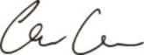

Chris Gibson, Ph.D.

Co-Founder and Chief Executive Officer

Table of Contents

 |  |  |  |  |  |  |  |  |  |  |  |  |  |  |  |  | TABLE OF CONTENTS
 |  |  |  |  |  |  |  |  |  |  |  |  |  |  |  |  |  |  |  |  |  |  |  |  |  |  |  | Page
 | Part I
 | Item 1. |  |  |  |  | Business |  |  |  |  |  |  |  |  |  |  |  |  |  |  |  |  |  |  |  |  |  |  | 10
 | Item 1A. |  |  |  |  | Risk Factors |  |  |  |  |  |  |  |  |  |  |  |  |  |  |  |  |  |  |  |  |  | 98
 | Item 1B. |  |  |  |  | Unresolved Staff Comments |  |  |  |  |  |  |  |  |  |  |  |  |  |  |  |  |  |  |  |  |  | 146
 | Item IC. |  |  |  |  | Cybersecurity |  |  |  |  |  |  |  |  |  |  |  |  |  |  |  |  |  |  |  |  |  | 146
 | Item 2. |  |  |  |  | Properties |  |  |  |  |  |  |  |  |  |  |  |  |  |  |  |  |  |  |  |  |  | 147
 | Item 3. |  |  |  |  | Legal Proceedings |  |  |  |  |  |  |  |  |  |  |  |  |  |  |  |  |  |  |  |  |  | 147
 | Item 4. |  |  |  |  | Mine Safety Disclosures |  |  |  |  |  |  |  |  |  |  |  |  |  |  |  |  |  |  |  |  |  | 147
 | Part II
 | Item 5. |  |  |  |  | Market for Registrant's Common Equity, Related Stockholder Matters and Issuer Purchases of Equity Securities |  |  |  |  |  |  |  |  |  |  |  |  |  |  |  |  |  |  |  |  |  | 148
 | Item 6. |  |  |  |  | [Reserved] |  |  |  |  |  |  |  |  |  |  |  |  |  |  |  |  |  |  |  |  |  | 150
 | Item 7 |  |  |  |  | Management's Discussion and Analysis of Financial Condition and Results of Operations |  |  |  |  |  |  |  |  |  |  |  |  |  |  |  |  |  |  |  |  |  | 152
 | Item 7A. |  |  |  |  | Quantitative and Qualitative Disclosures About Market Risk |  |  |  |  |  |  |  |  |  |  |  |  |  |  |  |  |  |  |  |  |  | 161
 | Item 8. |  |  |  |  | Financial Statements and Supplementary Data |  |  |  |  |  |  |  |  |  |  |  |  |  |  |  |  |  |  |  |  |  | 164
 | Item 9. |  |  |  |  | Changes in and Disagreements With Accountants on Accounting and Financial Disclosures |  |  |  |  |  |  |  |  |  |  |  |  |  |  |  |  |  |  |  |  |  | 196
 | Item 9A. |  |  |  |  | Controls and Procedures |  |  |  |  |  |  |  |  |  |  |  |  |  |  |  |  |  |  |  |  |  | 196
 | Item 9B. |  |  |  |  | Other Information |  |  |  |  |  |  |  |  |  |  |  |  |  |  |  |  |  |  |  |  |  | 197
 | Item 9C. |  |  |  |  | Disclosure Regarding Foreign Jurisdictions that Prevent Inspections |  |  |  |  |  |  |  |  |  |  |  |  |  |  |  |  |  |  |  |  |  | 197
 | Part III
 | Item 10. |  |  |  |  | Directors, Executive Officers and Corporate Governance |  |  |  |  |  |  |  |  |  |  |  |  |  |  |  |  |  |  |  |  |  | 198
 | Item 11. |  |  |  |  | Executive Compensation |  |  |  |  |  |  |  |  |  |  |  |  |  |  |  |  |  |  |  |  |  | 198
 | Item 12. |  |  |  |  | Security Ownership of Certain Beneficial Owner and Management and Related Stockholder Matters |  |  |  |  |  |  |  |  |  |  |  |  |  |  |  |  |  |  |  |  |  | 198
 | Item 13. |  |  |  |  | Certain Relationships and Related Transactions and Director Independence |  |  |  |  |  |  |  |  |  |  |  |  |  |  |  |  |  |  |  |  |  | 198
 | Item 14. |  |  |  |  | Principal Accounting Fees and Services |  |  |  |  |  |  |  |  |  |  |  |  |  |  |  |  |  |  |  |  |  | 198
 | Part IV
 | Item 15. |  |  |  |  | Exhibits and Financial Statement Schedules |  |  |  |  |  |  |  |  |  |  |  |  |  |  |  |  |  |  |  |  |  | 199
 | Item 16. |  |  |  |  | Form 10-K Summary |  |  |  |  |  |  |  |  |  |  |  |  |  |  |  |  |  |  |  |  |  | 201
 |  |  |  |  |  | Signatures |  |  |  |  |  |  |  |  |  |  |  |  |  |  |  |  |  |  |  |  |  | 202
 |  |  |  |  |  |  |  |  | 3

Table of Contents

PART I

RISK FACTOR SUMMARY

Below is a summary of the principal factors that make an investment in the common stock of Recursion Pharmaceuticals, Inc. (Recursion, the Company, we, us, or our) risky or speculative. This summary does not address all of the risks we face. Additional discussion of the risks summarized below, and other risks that we face, can be found in the section titled “Item 1A. Risk Factors” in this Annual Report on Form 10-K.

Risks Related to Our Limited Operating History, Financial Position, and Need for Additional Capital
- We are a clinical-stage biotechnology company with a limited operating history and no products approved by regulators for commercial sale, which may make it difficult to evaluate our current and future business prospects

- We have incurred significant operating losses since our inception and anticipate that we will incur continued losses for the foreseeable future.

- We will need to raise substantial additional funding. If we are unable to raise capital when needed, we would be forced to delay, reduce, or eliminate at least some of our product development programs, business development plans, strategic investments, and potential commercialization efforts, and to possibly cease operations.

- Raising additional capital and issuing additional securities may cause dilution to our stockholders, restrict our operations, require us to relinquish rights to our technologies or drug candidates, and divert management’s attention from our core business.

- We are engaged in strategic collaborations and we intend to seek to establish additional collaborations, including for the clinical development or commercialization of our drug candidates. If we are unable to establish collaborations on commercially reasonable terms or at all, or if current and future collaborations are not successful, we may have to alter our development and commercialization plans.

- We have no products approved for commercial sale and have not generated any revenue from product sales. We or our current and future collaborators may never successfully develop and commercialize our drug candidates, which would negatively affect our results of operation and our ability to continue our business operations.

- If we engage in future acquisitions or strategic partnerships, this may increase our capital requirements, dilute our stockholders’
equity, cause us to incur debt or assume contingent liabilities, and subject us to other risks.
Risks Related to the Discovery and Development of Drug Candidates
- Our approach to drug discovery is unique and may not lead to successful drug products for various reasons, including, but not limited to, challenges identifying mechanisms of action for our candidates.

- Our drug candidates are in preclinical or clinical development, which are lengthy and expensive processes with uncertain outcomes and the potential for substantial delays.

- If we experience delays or difficulties in the enrollment of patients in clinical trials, our receipt of necessary regulatory approvals could be delayed or prevented.

- Our planned clinical trials, or those of our current and potential future collaborators, may not be successful or may reveal significant adverse events not seen in our preclinical or nonclinical studies, which may result in a safety profile that could inhibit regulatory approval or market acceptance of any of our drug candidates.

- We conduct clinical trials for our drug candidates outside the United States, and the FDA and similar foreign regulatory authorities may not accept data from such trials.

- It is difficult to establish with precision the incidence and prevalence for target patient populations of our drug candidates. If the market opportunities for our drug candidates are smaller than we estimate, or if any approval that we obtain is based on a narrower definition of the patient population, our revenue and ability to achieve profitability will be adversely affected, possibly materially.

- We may never realize a return on our investment of resources and cash in our drug discovery collaborations.
- We face substantial competition, which may result in others discovering, developing, or commercializing products before, or more successfully than, we do.

- Because we have multiple programs and drug candidates in our development pipeline and are pursuing a variety of target indications

and treatment modalities, we may expend our limited resources to pursue a particular drug candidate and fail to capitalize on development opportunities or drug candidates that may be more profitable or for which there is a greater likelihood of success.
Risks Related to Our Platform and Data
- We have invested, and expect to continue to invest, in research and development efforts to further enhance our drug discovery platform, which is central to our mission. If the return on these investments is lower or develops more slowly than we expect, our business and operating results may suffer.

- Our information technology systems and infrastructure may fail or experience security breaches and incidents that could adversely impact our business and operations and subject us to liability.

4

Table of Contents

- Interruptions in the availability of server systems or communications with internet or cloud-based services, or failure to maintain the security, confidentiality, accessibility, or integrity of data stored on such systems, could harm our business.
- Our solutions utilize third-party open source software (OSS), which presents risks that could adversely affect our business and subject us to possible litigation.

- Issues relating to the use of artificial intelligence and machine learning in our offerings could adversely affect our business and operating results.

- Even if any drug candidates we develop receive marketing approval, they may fail to achieve the degree of market acceptance by physicians, patients, healthcare payors, and others in the medical community necessary for commercial success.
- If we are unable to establish sales and marketing capabilities or enter into agreements with third parties to sell and market any drug candidates we may develop, we may not be successful in commercializing those drug candidates, if and when they are approved.

- We are subject to regulatory and operational risks associated with the physical and digital infrastructure at both our internal facilities and those of our external service providers.

- Our success significantly depends on our ability to obtain and maintain patents of adequate scope covering our proprietary technology and drug candidate products. Obtaining and maintaining patent assets is inherently challenging, and our pending and future patent applications may not issue with the scope we need, if at all.

- Our current proprietary position for certain drug product candidates depends upon our owned or in-licensed patent filings covering components of such drug product candidates, manufacturing-related methods, formulations, and/or methods of use, which may not adequately prevent a competitor or other third party from using the same drug candidate for the same or a different use.

- We may not be able to protect our intellectual property and proprietary rights throughout the world.
- If we do not obtain patent term extension and data exclusivity for any drug product candidates we may develop, our business may be materially harmed.

- We may need to license certain intellectual property from third parties, and such licenses may not be available or may not be available on commercially reasonable terms.

- Changes in U.S. patent law could diminish the value of patents in general, thereby impairing our ability to protect our products.
- Issued patents covering our drug product candidates and proprietary technology that we have developed or may develop in the

future could be found invalid or unenforceable if challenged in court or before administrative bodies in the United States or abroad. Risks Related to Government Regulation

- Even if we receive FDA or other regulatory approval for any of our drug candidates, we will be subject to ongoing regulatory obligations and other conditions that may result in significant additional expense, as well as the potential recall or market withdrawal of an approved product if unanticipated safety issues are discovered.

- Though we have been granted orphan drug designation for certain of our drug candidates, we may be unsuccessful or unable to maintain the benefits associated with such a designation, including the potential for market exclusivity.

- We are subject to U.S. and foreign laws regarding privacy, data protection, and data security that could entail substantial compliance costs, while the failure to comply could subject us to significant liability.

- Regulatory and legislative developments related to the use of AI could adversely affect our use of such technologies in our products, services, and business.

- Third parties that perform some of our research and preclinical testing or conduct our clinical trials may not perform satisfactorily or their agreements may be terminated.
- Third parties that manufacture our drug candidates for preclinical development, clinical testing, and future commercialization may not provide sufficient quantities of our drug candidates or products at an acceptable cost, which could delay, impair, or prevent our development or commercialization efforts.

- We may not realize all of the anticipated outcomes and benefits of our Acquisitions.
- Our future success depends on our ability to retain key executives and experienced scientists, and to attract, retain, and motivate qualified personnel.

- We have identified a material weakness in our internal control over financial reporting.

5

Cautionary Note Regarding Forward-Looking Statements

This Annual Report on Form 10-K contains “forward-looking statements” about us and our industry within the meaning of Section 27A of the Securities Act of 1933, as amended, and Section 21E of the Securities Exchange Act of 1934, as amended. All statements other than statements of historical facts are forward-looking statements. In some cases, you can identify forward-looking statements by terms such as “may,” “will,” “should,” “would,” “expect,” “plan,” “anticipate,” “could,” “intend,” “target,” “project,” “contemplate,” “believe,” “estimate,” “predict,” “potential,” or “continue” or the negative of these terms or other similar expressions. Forward-looking statements contained in this report may include without limitation those regarding:

- our research and development programs;

- the initiation, timing, progress, results, and cost of our current and future preclinical and clinical studies, including statements regarding the design of, and the timing of initiation and completion of, studies and related preparatory work, as well as the period during which the results of the studies will become available;

- the ability of our clinical trials to demonstrate the safety and efficacy of our drug candidates, and other positive results;

- the ability and willingness of our collaborators to continue research and development activities relating to our development candidates and investigational medicines;
- future agreements with third parties in connection with the commercialization of our investigational medicines and any other approved product;
- the timing, scope, and likelihood of regulatory filings and approvals, including the timing of Investigational New Drug applications and final approval by the U.S. Food and Drug Administration, or FDA, of our current drug candidates and any other future drug candidates, as well as our ability to maintain any such approvals;

- the timing, scope, or likelihood of foreign regulatory filings and approvals, including our ability to maintain any such approvals;

- the size of the potential market opportunity for TechBio companies;

- the size of the potential market opportunity for our drug candidates, including our estimates of the number of patients who suffer from the diseases we are targeting;
- our ability to identify viable new drug candidates for clinical development and the rate at which we expect to identify such candidates, whether through an inferential approach or otherwise;
- our expectation that the assets that will drive the most value for us are those that we will identify in the future using our datasets and tools;
- our ability to develop and advance our current drug candidates and programs into, and successfully complete, clinical studies;

- our ability to reduce the time or cost or increase the likelihood of success of our research and development relative to the traditional drug discovery paradigm;
- our ability to improve, and the rate of improvement in, our infrastructure, datasets, biology, technology tools, and drug discovery platform, and our ability to realize benefits from such improvements;
- our ability to effectively use machine learning and artificial intelligence in our drug development process;

- our ability to use the assets acquired in recent acquisitions to expand our technology-enabled drug discovery process and accelerate our digital chemistry capabilities;
- our ability to leverage our collaborations and partnerships to develop our products and grow our business;

- our expectations related to the performance and benefits of our BioHive-1 supercomputer, Recursion OS, and our digital chemistry platform;
- our ability to realize a return on our investment of resources and cash in our drug discovery collaborations;
- our ability to sell or license assets and re-invest proceeds into funding our long-term strategy;

- our ability to scale like a technology company and to add more programs to our pipeline each year;

- our ability to successfully compete in a highly competitive market;

- our manufacturing, commercialization, and marketing capabilities and strategies;

- our plans relating to commercializing our drug candidates, if approved, including the geographic areas of focus and sales strategy;

- our expectations regarding the approval and use of our drug candidates in combination with other drugs;

- the rate and degree of market acceptance and clinical utility of our current drug candidates, if approved, and other drug candidates we may develop;
- our competitive position and the success of competing approaches that are or may become available;

- our estimates of the number of patients that we will enroll in our clinical trials and the timing of their enrollment;

- the beneficial characteristics, safety, efficacy, and therapeutic effects of our drug candidates;

- our plans for further development of our drug candidates, including additional indications we may pursue;

6

- our ability to adequately protect and enforce our intellectual property and proprietary technology, including the scope of protection we are able to establish and maintain for intellectual property rights covering our current drug candidates and other drug candidates we may develop, receipt of patent protection, the extensions of existing patent terms where available, the validity of intellectual property rights held by third parties, the protection of our trade secrets, and our ability not to infringe, misappropriate or otherwise violate any third-party intellectual property rights;

- the impact of any intellectual property disputes and our ability to defend against claims of infringement, misappropriation, or other violations of intellectual property rights;
- our ability to keep pace with new technological developments;

- our ability to utilize third-party open source software and cloud-based infrastructure, on which we are dependent;

- the adequacy of our insurance policies and the scope of their coverage;

- the potential impact of a pandemic, epidemic, or outbreak of an infectious disease, such as COVID-19, or natural disaster, global political instability, or warfare, and the effect of such outbreak or natural disaster, global political instability, or warfare on our business and financial results;

- our ability to achieve net-zero greenhouse gas emissions across our operations;

- our ability to maintain our technical operations infrastructure to avoid errors, delays, or cybersecurity breaches;

- our continued reliance on third parties to conduct additional clinical trials of our drug candidates, and for the manufacture of our drug candidates for preclinical studies and clinical trials;
- our ability to obtain, and negotiate favorable terms of, any collaboration, licensing or other arrangements that may be necessary or desirable to research, develop, manufacture, or commercialize our platform and drug candidates;
- the pricing and reimbursement of our current drug candidates and other drug candidates we may develop, if approved;

- our estimates regarding expenses, future revenue, capital requirements, and need for additional financing;

- our financial performance;

- the period over which we estimate our existing cash and cash equivalents will be sufficient to fund our future operating expenses and capital expenditure requirements;
- our ability to raise substantial additional funding;

- the impact of current and future laws and regulations, and our ability to comply with all regulations that we are, or may become, subject to;
- the need to hire additional personnel and our ability to attract and retain such personnel;

- the impact of any current or future litigation, which may arise during the ordinary course of business and be costly to defend;

- our expectations regarding the period during which we will qualify as an emerging growth company under the JOBS Act;

- our ability to maintain effective internal control over financial reporting and disclosure controls and procedures, including our ability to remediate the material weakness in internal control over financial reporting;
- our anticipated use of our existing resources and the net proceeds from our initial public offering; and

- other risks and uncertainties, including those listed in the section titled “Risk Factors.”

We have based these forward-looking statements largely on our current expectations and projections about our business, the industry in which we operate, and financial trends that we believe may affect our business, financial condition, results of operations, and prospects. These forward-looking statements are not guarantees of future performance or development. These statements speak only as of the date of this report and are subject to a number of risks, uncertainties and assumptions described in the section titled “Risk Factors” and elsewhere in this report. Because forward-looking statements are inherently subject to risks and uncertainties, some of which cannot be predicted or quantified, you should not rely on these forward-looking statements as predictions of future events. The events and circumstances reflected in our forward-looking statements may not be achieved or occur and actual results could differ materially from those projected in the forward-looking statements. Except as required by applicable law, we undertake no obligation to update or revise any forward-looking statements contained herein, whether as a result of any new information, future events, or otherwise.

In addition, statements that “we believe” and similar statements reflect our beliefs and opinions on the relevant subject. These statements are based upon information available to us as of the date of this report. While we believe such information forms a reasonable basis for such statements, the information may be limited or incomplete, and our statements should not be read to indicate that we have conducted an exhaustive inquiry into, or review of, all

7

potentially available relevant information. These statements are inherently uncertain and you are cautioned not to unduly rely upon them.

8



Table of Contents

Item 1. Business.

Business Overview

Recursion is a leading clinical stage TechBio company decoding biology to industrialize drug discovery. Central to our mission is the Recursion Operating System (OS), a platform built across diverse technologies that enables us to map and navigate trillions of biological, chemical, and patient-centric relationships across over 50 petabytes of proprietary data. We frame this integration of the physical and digital components as iterative loops, where scaled ‘wet-lab’ biology, chemistry, and patient-centric experimental data are organized by ‘dry-lab’ computational tools in order to identify, validate, and translate therapeutic insights. We believe Recursion’s unbiased, data-driven approach to understanding biology will bring more, new, and better medicines at higher scale and lower cost to patients.

There are three key value-drivers at Recursion:

- An expansive pipeline of internally developed clinical and preclinical programs focused on precision oncology and genetically driven rare diseases with significant unmet need and market opportunities that could potentially exceed $1 billion in annual sales in some cases

- Transformational partnerships with leading biopharma and technology companies to map and navigate intractable areas of biology, identify novel targets, and develop potential new medicines by using advanced computational and data resources
- An industry-leading dataset intentionally designed to capitalize on computational tools and accelerate value created through our pipeline, partnerships and technology products

Key Achievements in 2023

Pipeline

- Five phase 2 clinical-stage programs with multiple upcoming data readouts expected, including REC-994 in cerebral cavernous malformation (CCM) in Q3 2024, REC-2282 in neurofibromatosis type 2 (NF2) in Q4 2024, REC-4881 in familial adenomatous polyposis (FAP) in H1 2025, and REC-4881 in AXIN1 or APC mutant solid tumors in H1 2025

- Completed a Phase 1 study for REC-3964 in healthy volunteers for the potential treatment of Clostridioides difficile (C. difficile) infection with a favorable safety and tolerability profile
- Advanced our RBM39 program in homologous recombination proficient ovarian cancer and other solid tumors to IND-enabling studies
- In-licensed a program (Target Epsilon) that emerged from our fibrosis collaboration with Bayer that represents a novel approach to treating fibrotic diseases with compelling early data

Partnership

- Made significant progress against both the gastrointestinal-oncology and neuroscience portions of our collaboration with Roche and Genentech, including Roche exercising its Small Molecule Validated Hit Option to further advance our first partnership program in GI-oncology

- Updated our collaboration with Bayer to focus on challenging oncology indications with high unmet need, commensurate with higher per program milestone payments
- Entered into a collaboration with NVIDIA to accelerate the construction, optimization and deployment of foundation models for biology and chemistry as well as host Recursion-built computational and data tools on BioNeMo (NVIDIA’s drug discovery platform) – additionally, NVIDIA invested $50 million in Recursion via a private placement

- Entered into a collaboration with Tempus giving Recursion access to over 20 petabytes of proprietary deidentified, multimodal patient oncology data for the purpose of training causal AI models for the discovery of novel therapeutic hypotheses, biomarker strategies and patient cohort selection

- Entered into a partnership with Enamine to generate enriched screening libraries with insights from Recursion’s protein-ligand interaction predictions spanning across Enamine’s massive library of approximately 36 billion compounds

10

Table of Contents

Recursion OS

- Built, scaled and industrialized multiple tools and technologies to heavily automate workflows across the drug discovery process, creating one of the most complete full-stack TechBio solutions

- Created LOWE (Large Language Model-Orchestrated Workflow Engine) connecting wet-lab and dry-lab components of the Recursion OS using a natural language interface to streamline complex drug discovery tasks
- Deployed large language models (LLMs) to map scientific literature in conjunction with our internally derived proprietary maps for the purpose of autonomously identifying novel opportunities in areas of unmet need
- Deployed Phenom-1, a vision transformer utilizing hundreds of millions of parameters trained on billions of biological images from our proprietary data, which we believe to be the world’s largest phenomics foundation model at this time
- Deployed new digital chemistry tools to predict the ligand-protein interactions for approximately 36 billion compounds in the Enamine REAL Space, reported to be the largest synthesizable chemical library
- Produced over 1 trillion human induced pluripotent stem cell (hiPSC)-derived neuronal cells since 2022, likely making Recursion one of the world’s largest producers of neuronal cells
- Began training causal AI models leveraging over 20 petabytes of multimodal precision oncology patient data from Tempus to support the discovery of potential biomarker-enriched therapeutics at scale

Company Building

- Acquired Cyclica and Valence Discovery to bolster digital chemistry and generative AI capabilities

- Expanded our operations in Salt Lake City and Montréal and opened our Canadian headquarters in Toronto with a focus on growing our machine learning and digital chemistry teams
- Committed to quadrupling the capacity of our supercomputer, BioHive-1, to support our pipeline, partnerships and the construction of foundation models across the multiple modalities of biology, chemistry and patient-centric data – we believe that this expansion should make our supercomputer a top 50 supercomputer across any industry according to the TOP500 list

Vision, Mission, People and Culture

Human biology is an incredibly complex system for which human intelligence alone is insufficient to fully comprehend it. Our world is transiting its next industrial revolution based on extraordinary progress in automation, computation, machine learning (ML), and artificial intelligence (AI). This progress is apparent through the rapid rise of LLMs, generative AI, and accessible applications like ChatGPT. Undoubtedly, remarkable shifts in perception occurred in 2023 amongst technology and biopharma companies as well as among regulators and policymakers, who highlight the utility of AI/ML for broad drug discovery and development from novel target discovery through next-generation manufacturing.

However, a key lesson from numerous other industries is that computational sophistication alone is rarely sufficient to create disruptive change. It is when computational sophistication is paired with the right data, typically in an iterative process of ongoing learning, prediction, and refinement, that outsized change is created.

11

Table of Contents
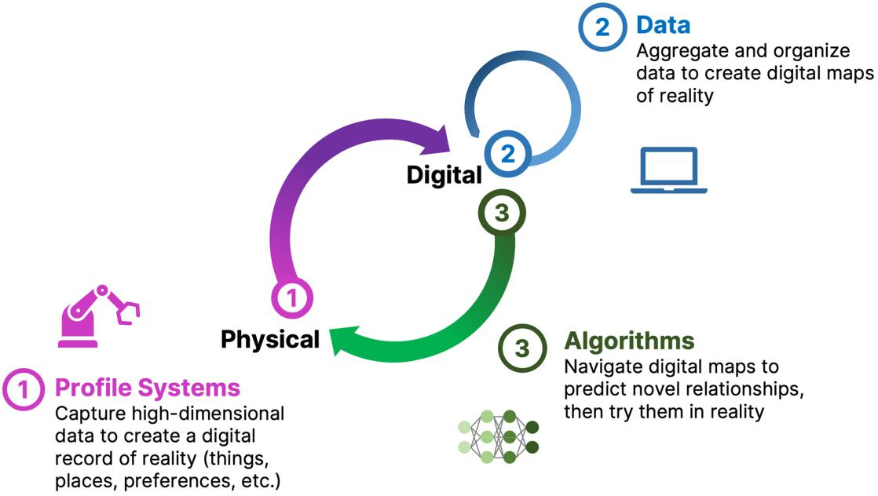

Figure 1. A simple formula is used across technology industries to map and navigate complex systems. First, high-dimensional data is generated, aggregated and organized to create digital representations. Then, AI/ML algorithms make predictions about that system that can be tested in reality. The result is a virtuous cycle of learning and iteration.

Recursion was founded in 2013 with a vision to capitalize on the convergence of advancements in computation and machine learning to address the decreasing efficiency of drug discovery and development. We believe that this opportunity represents one of the most positively impactful applications of ML and AI. Our vision is to leverage technology to map and navigate biology, chemistry, and patient-centric outcomes in order to increasingly transition the process of developing medicines from discovery to design. We believe that neither advanced computational approaches, massive datasets, nor human intelligence alone can fundamentally shift the efficiency curve of drug discovery and development; instead, we believe that those companies that augment their teams with sophisticated computational tools and focus deeply on generating and aggregating the right datasets will have a significant advantage. Our success and the success of the burgeoning TechBio sector has the promise to drive more, new, and better medicines to patients at higher scale and lower prices in the coming decades. We are working to not only lead this space but define it.

12

Table of Contents
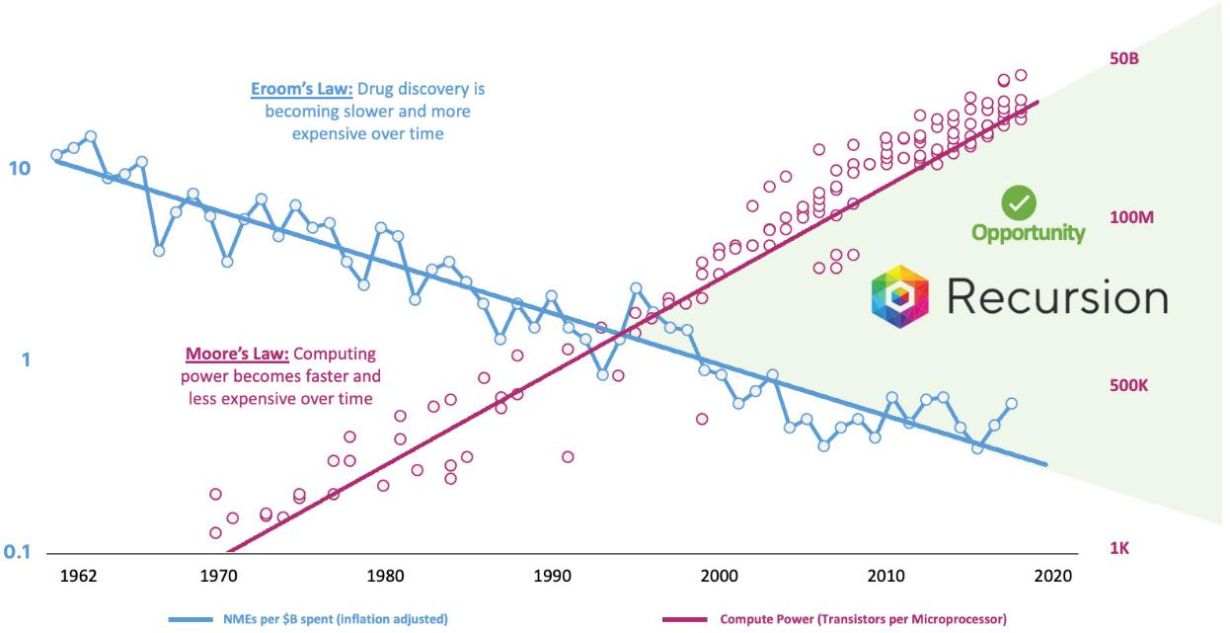

Figure 2. Eroom’s Law observes that while technology advancements have made many processes faster and less expensive over the years, drug

discovery is becoming slower and more expensive.^{1,2} Recursion was created to take advantage of the discontinuity between these fields and harness the power of accelerating technological innovations to improve the efficiency of drug discovery and development.

Our mission at Recursion, Decoding Biology to Radically Improve Lives, flows naturally from our vision. We interpret our mission expansively and believe it to be a durable direction and source of inspiration for our team. We started pioneering, scaling, and industrializing phenomics (data based on images of cellular structures) over a decade ago, but we recognize that drug discovery is made up of many steps, and a point solution targeting one or two steps is insufficient to generate efficiencies across the entire process. To decode biology, we must construct a full-stack technology platform capable of integrating and industrializing many complex workflows. Success in decoding biology implies our ability to predict ways to navigate it. The ability to predictably navigate biology may enable us to build an expansive pipeline of medicines, either by ourselves, with partners, or both. As part of that work, we seek not only to radically improve the lives of patients who could benefit from the medicines we help to deliver, but the lives of those who care for those patients, the lives of our employees and their families, as well as the communities in which we operate our company.

- Adapted from Scannell, J et al (2012). Diagnosing the decline in pharmaceutical R&D efficiency. Nat Rev Drug Discov, 11, 191-200.
² Adapted from Roser, M et al. (2013). Technological Change. OurWorldInData.org.

13

Table of Contents
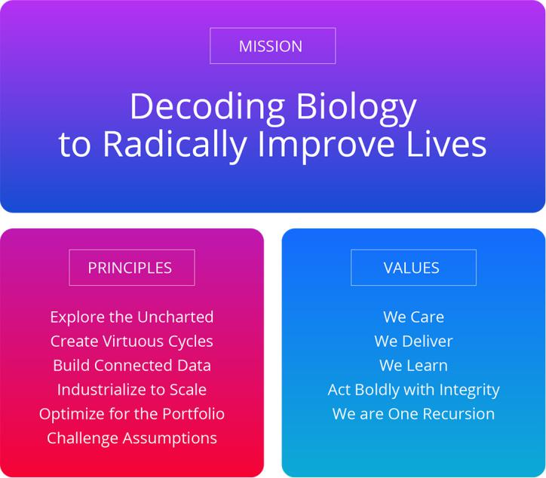

Figure 3: Recursion’s Founding Principles and Values support our ambitious mission. Together, these elements shape Recursion’s culture by guiding our people to high-impact decision-making and behaviors.

Our culture at Recursion is intentionally designed to fuel our mission. We believe culture drives delivery. Essential to decoding biology in our context is the Recursion Mindset, a deep commitment to achieving impact at unprecedented scale through pioneering new industrialized approaches. To decode biology, we intentionally source talent from an incredible breadth of fields from multiple industries. For all of our employees, Recursion is a new kind of company. The guideposts for teaching our people to successfully transition to TechBio and deliver our mission are our Founding Principles and Values. They are the essential shape of our culture. Our Founding Principles direct us in making scientific and technical decisions that further our mission. Our Values define the day-to-day behaviors that further our mission.
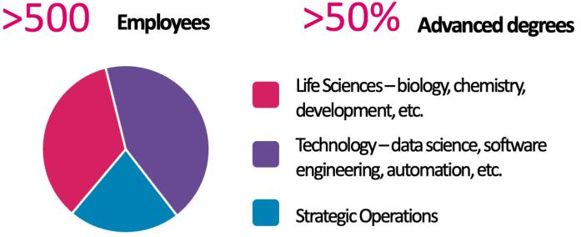

Figure 4. Recursion’s team requires operating at the interface of many diverse fields. Building a TechBio company requires fluency in operating at the interface of many disciplines and fields not previously attuned to working as closely in traditional biopharma.

How Recursion is Industrializing the Drug Discovery Process

The traditional drug discovery and development process is characterized by substantial financial risks, with increasing and long-term capital outlays for development programs that often fail to reach patients as marketed products. Historically, it has taken over ten years and an average capitalized R&D cost of approximately $2 billion per approved medicine to move a drug discovery project from early discovery to an approved therapeutic. Such productivity outcomes have culminated in a rapidly declining internal rate of return for the biopharma industry.

14

Table of Contents
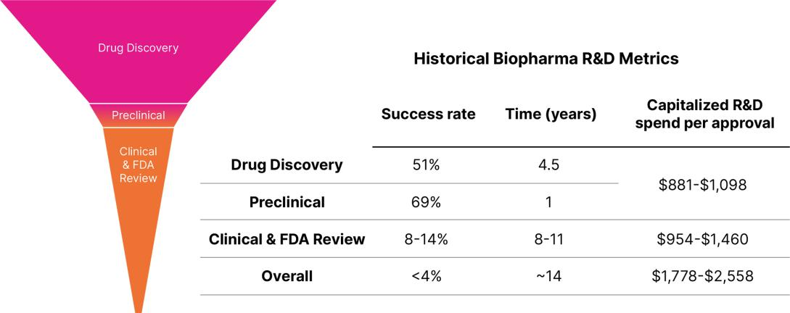

Figure 5. Historical biopharma industry R&D metrics. The primary driver of the cost to discover and develop a new medicine is clinical failure. Less than 4% of drug discovery programs that are initiated result in an approved therapeutic, resulting in a risk-adjusted cost of approximately $1.8 to $2.6 billion per new drug launched.^{3,4,5,6,7}

Despite significant investment and brilliant scientists, these metrics point to the need to evolve a more efficient drug discovery process and explore new tools. Traditional drug discovery relies on basic research discoveries from the scientific community to elucidate disease-relevant pathways and targets to interrogate. Coupled with biology’s incredible complexity, this approach has forced the industry to rely on reductionist hypotheses of the critical drivers of complex diseases, which can create a ‘herd mentality’ as multiple parties chase a limited number of therapeutic targets. The situation has been exacerbated by human bias (e.g., confirmation bias and sunk-cost fallacy). Accentuating this problem, the sequential nature of current drug discovery activities and the challenges with aggregation and relatability of data across projects, teams and departments lead to frequent replication of work and long timelines to discharge the scientific risk of such hypotheses. Despite decades of accumulated knowledge, the result is that drug discovery has unintentionally created hurdles for innovation.

Simultaneously, exponential improvements in computational speed and reductions in data storage costs driven by the technology industry, coupled with the rapid rise of large language models, generative AI and other ML tools, have transformed complex industries from media to transportation to e-commerce. Historically, the biopharma sector has been slow to embrace such innovations. Within the past 18 months, there have been remarkable shifts in perception among technology and biopharma companies as well as among regulators and policymakers, who highlight the utility of AI/ML for broad drug discovery and development from novel target discovery through next-generation manufacturing. We believe this rapid acceleration and adoption of these technologies demonstrates the growing consensus that AI/ML is a catalyst for substantial leaps in drug discovery.

At Recursion, we are pioneering the integration of innovations across biology, chemistry, automation, data science and engineering to industrialize drug discovery in a full-stack solution across dozens of key workflows and processes critical in discovering and developing a drug. For example, by combining advances in high content microscopy with arrayed CRISPR genome editing techniques, we can rigorously

profile massive, high-dimensional biological and chemical perturbation libraries in multiple human cellular contexts to create digital ‘maps’ of

human biology. Leveraging advances in scaled computation, we can conduct massive virtual screens to predict the protein targets for billions of chemical compounds. Similarly, data generated from our automated DMPK module and InVivomics platform enables us to predict ADME properties and identify toxicity signals, respectively, significantly faster than traditional methods. We believe that by harnessing advances in technology to industrialize drug discovery, we can derive novel biological insights not previously described by scientific researchers, reduce the effects of human bias inherent in discovery biology and reduce translational risk at the program outset.

- Zhou, S. and Johnson, R. (2018). Pharmaceutical Probability of Success. Alacrita Consulting, 1-42
- Steedman M, and Taylor K. (2020). Ten years on: Measuring the return from pharmaceutical innovation. Deloitte. 1-44.
- DiMasi et al. (2016). Innovation in the pharmaceutical industry: New estimates of R&D costs. Journal of Health Economics. 47, 20-33.
- Paul, et al. (2010). How to improve R&D productivity: the pharmaceutical industry’s grand challenge. Nature Reviews Drug Discovery. 9,203-214
⁷ Martin et al. (2017). Clinical trial cycle times continue to increase despite industry efforts. Nature Reviews Drug Discovery. 16, 157

15

Table of Contents
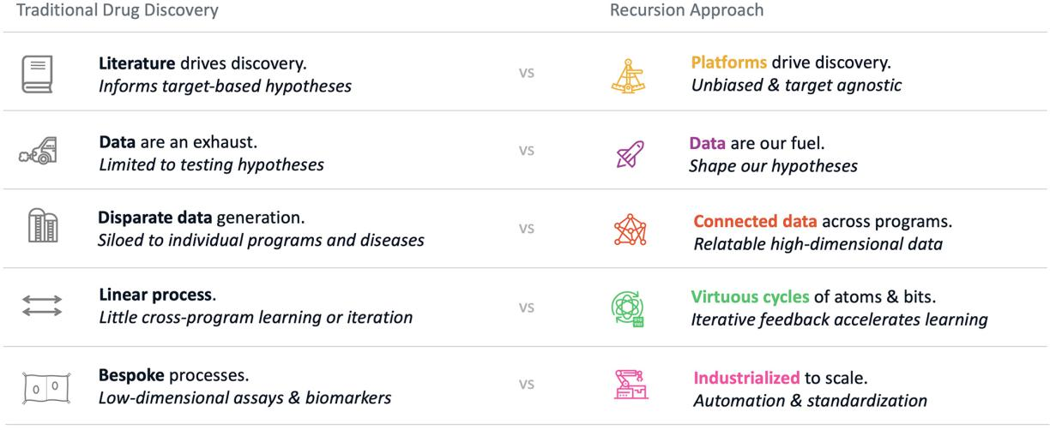

Figure 6. Recursion’s approach to drug discovery. We utilize our Founding Principles on the right to build datasets which are scalable, reliable and relatable in order to elucidate novel biological and chemical insights and industrialize the drug discovery process.

We have used our approach to generate, aggregate, and integrate one of the largest biological, chemical, and patient-centric datasets in the world at over 50 petabytes at the end of 2023. This dataset includes proprietary phenomics, transcriptomics, predicted protein-ligand binding interactions, InVivomics, ADME data, and more across many biological and chemical contexts as well as preferred access to over 20 petabytes of multimodal oncology patient data from Tempus. Additionally, we have built a proprietary suite of software applications within the Recursion OS which has identified over 5 trillion predicted biological and chemical relationships. With our approach, we endeavor to turn drug discovery into a search problem where we map and navigate biology in an unbiased manner to discover new insights and translate them into potential new medicines at scale.

Business Strategy and Value Drivers

While most small to medium-sized biopharma companies are focused on a narrow slice of biology or a single therapeutic area, the Recursion OS allows us to discover and translate at scale across biology. However, we are cognizant that building disease-area expertise, especially in clinical development, is essential. We have developed a multi-pronged, capital-efficient business model focused on key value-drivers that enable us to demonstrate our progress over time while continuing to invest in the development of the Recursion OS, which we believe is the engine of value creation in the long-term. While our mapping and navigating tools have the plasticity to be applied across therapeutic areas and modalities, our business model is tailored to maximize value and advance programs cost-effectively based on the nature of market and regulatory dynamics associated with our three value drivers (internal pipeline, transformational partnerships, and fit-for-purpose proprietary biological, chemical, and patient-centric data).

16

Table of Contents
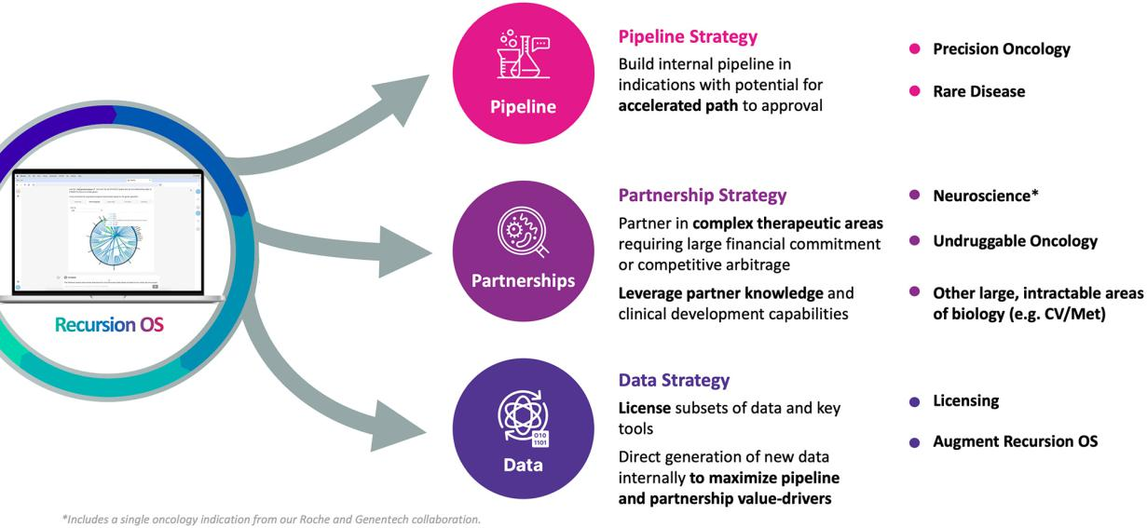

Figure 7. We harness the value and scale of our Recursion OS using a capital efficient business strategy. Our business strategy is segmented into our following value-drivers: (i) internally developed programs in capital-efficient therapeutic areas; (ii) partnered programs in resource-intensive therapeutic areas; and (iii) proprietary, fit-for-purpose data and models. *Includes a single oncology indication from our Roche and Genentech collaboration.

Value Driver 1 - Internally Developed Programs in Capital Efficient Therapeutic Areas

We believe that the primary currency of any biotechnology company today is clinical-stage assets. These programs can be valued using a variety of models by stakeholders in the biopharma ecosystem and most importantly, present the potential to meet critical patient needs. For Recursion, these assets have a variety of additional benefits, including: (i) validation of key elements of the Recursion OS, (ii) growing our expertise in clinical development and (iii) building in-house processes to facilitate smooth interaction with regulatory agencies and advance medicines towards the market. If the Recursion OS evolves as designed, then it will continuously improve with more iterations such that future programs could be more novel and potentially more valuable than today’s programs. Operating as a vertically integrated TechBio company that leverages technology at every step from target discovery through clinical development (and even marketing and distribution) may be the long-term business model with the most upside for our stakeholders, including both investors and patients. We may be opportunistic about selling or licensing assets after they achieve key value-inflection milestones so that we can re-invest in our long-term strategy.

Value Driver 2 - Partnered Programs in Resource Intensive Therapeutic Areas

We believe that in its current form, our Recursion OS is already capable of delivering many more therapeutic insights than we would be able to shepherd alone today. As such, we have chosen to partner with experienced, top-tier biopharma companies like Bayer, Roche, and Genentech to explore intractable and resource-intensive areas of biology. The key advantages of these partnerships are that: (i) we are able to deploy the Recursion OS to turn latent value into tangible value in areas of biology where it would be challenging for us to do so alone; (ii) the clinical development paths for these large therapeutic areas are often resource-intensive and highly complex; and (iii) we are able to learn from our colleagues at these top-tier companies such that it could give us a competitive advantage in the industry over the longer term. This strategy also embeds us in the discovery process of large pharmaceutical companies and gives rise to an alternative long-term business model whereby we become a valued partner of many such companies. Based on how value is ascribed across our industry today, this model alone is not yet feasible to maximize our business impact. However, we feel that due to shifts within the biopharma industry there is some potential for this portion of our business model to accrete notable value over the long-term.

17

Table of Contents

Value Driver 3 - Proprietary, Fit-for-Purpose Training Data and Models

As has been demonstrated in many other industries, a value driver and competitive advantage can be generated from the creation of a proprietary dataset. At Recursion, we have generated what we believe to be one of the largest fit-for-purpose, relatable biological, chemical, and patient-centric datasets on Earth. Spanning multiple omics technologies and more than 200 million unique experiments, the over 50 petabytes of data that Recursion generates, aggregates, and integrates has the fundamental purpose of being used to train machine learning models. Through intensive internal work, Recursion uses this data and our own models, algorithms, and software to advance our own internal pipeline of medicines (Value Driver 1) as well as in partnership with our collaborators to advance additional discovery programs (Value Driver 2). As our field increasingly recognizes the potential for a technology-driven revolution in drug discovery, our data has increasing potential to drive value directly. We increasingly see the potential to license select models and subsets of our data to a growing universe of collaborators for which internal efforts would be minimal, but value could be significant.

Competitive Landscape and Differentiation

There are a few key factors that differentiate Recursion from other technology-enabled drug discovery companies.

- Recursion utilizes many biology, chemistry, and patient-centric proprietary datasets and modular tools to industrialize drug discovery, while most other competitor companies rely on a point solution to solve one important step in drug discovery. We recognize that drug discovery is made up of many steps, and a point solution is insufficient to generate efficiencies across the entire process. To decode biology, we must construct a full-stack technology platform capable of integrating and industrializing many complex workflows. In part, Recursion’s LOWE (LLM-Orchestrated Workflow Engine) is a natural progression of workflow automation. In the future, we believe the Recursion OS will also utilize large population genetics datasets and data from payer and healthcare systems to drive greater efficiencies and more precision medicine solutions for patients.

- Recursion integrates wet-lab and dry-lab capabilities in-house to create a virtuous cycle of iteration. Fit-for-purpose wet-lab experimental data are translated by dry-lab digital tools into in silico hypotheses and testable predictions, which in turn generates more wet-lab data from which improved predictions can be made. Recursion is well positioned compared to companies of a similar stage either focused more specifically on the wet-lab only (traditional biotech or pharma companies) or dry-lab only (companies facing rapidly commoditized algorithms and a challenge differentiating on non-proprietary data).

- Recursion has achieved a significant scale with respect to its scientific, technological, and business endeavors. With five clinical-stage programs, an exciting preclinical pipeline, two of the largest discovery partnerships in the biopharma industry with Roche/Genentech and Bayer, and three technology-focused partnerships, Recursion has achieved a scale, level of integration, and stage that few other TechBio companies have.

The Recursion OS

The creation of virtuous cycles of physical experiments and in silico models has been a competitive advantage for leaders in many industries outside of biopharma. In drug discovery, virtuous cycles of experimentation (wet-lab assays) and machine learning (dry-lab predictions) is an approach to efficiently mapping and navigating biology and chemistry at unparalleled scale and efficiency. Critically, by closely integrating the wet-lab and dry-lab in an iterative manner, one can create cycles of virtuous learning, where large fit-for-purpose wet-lab datasets support better in silico model generation and enable more focused future wet-lab experiments.

18

Table of Contents
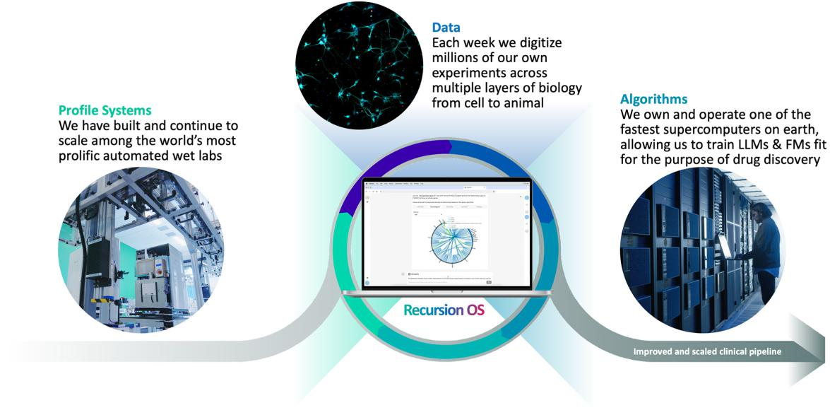

Figure 8. Recursion’s virtuous cycle of wet-lab and dry-lab. (1) Profile biological and chemical systems using automation to scale a small number of data-rich assays, including phenomics, transcriptomics, InVivomics, and ADME to generate massive, high quality empirical data; (2) aggregate and analyze the resultant data using a variety of in-house software tools; and (3) map and navigate leveraging proprietary software tools to infer relationships between biology and chemistry. These inferred relationships serve as the basis of our ability to predict how to navigate between biological states using chemical or biological perturbations, which we can then validate in our automated laboratories, completing a virtuous cycle of learning and iteration.

The Recursion OS is composed of many wet and dry-lab modules. Each module is both a capability as well as a set of standardized workflows that have been scaled and automated, in some cases, to a very high degree. In order to drive greater efficiency, these modules have been industrialized so that they can be plugged into drug discovery and development activities related to both our internal pipeline as well as large pharma partnerships. Connecting standardized workflows together can be thought of like modular programming but in a biological and chemical context. The general connected modular framework for carrying out industrialized, unbiased drug discovery and development is the Recursion OS.

19

Table of Contents
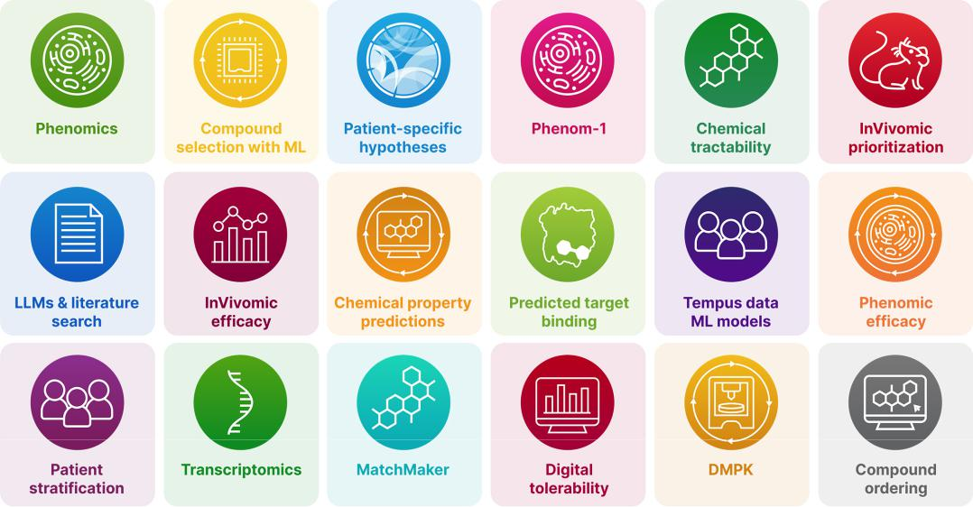

Figure 9. The Recursion OS is composed of many wet- and dry-lab modules that can be connected to carry out industrialized, unbiased drug discovery and development. Each module is both a capability as well as a set of standardized workflows that have been scaled and automated, in some cases, to a very high degree.
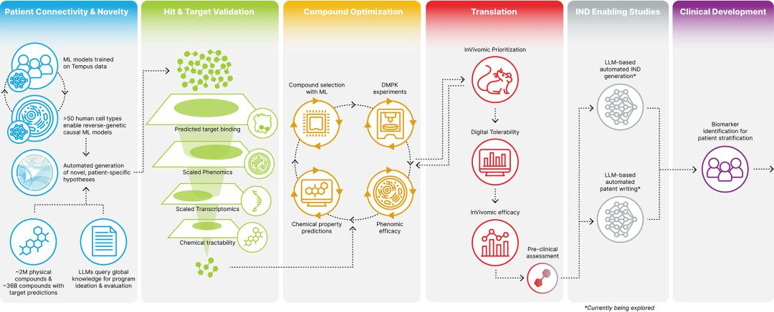

Figure 10. The Recursion OS is meant to industrialize the drug discovery and development process through multiple cycles of learning and iteration. The Recursion OS is built on biologically native cycles of wet-lab and dry-lab modules leveraging phenomics, transcriptomics and InVivomics to drive discovery and validation of targets and compounds, while chemically native cycles of predictive ADME drive optimization of validated hits towards development candidates suitable for human clinical trials.

Wet Lab (Physical)

In order to create large and relatable datasets, standardization and scale are two critical requirements that can be best achieved through automation. Standardization means that the experiment is executed consistently every time, day after day, year after year - and that any deviations can be detected, tracked, and quantified. It involves meticulous metadata collection, prospective/retrospective experiment execution analysis, standard results storage, quantitative quality control and more. At the same time, massive scale, with millions of experiments executed per week, requires execution of multi-step assays processed rapidly and in a tightly orchestrated manner. This combination of precise repetition, high speed and massive volumes favors relying on robots over highly trained scientists, whose time is better spent on context-specific problems. In addition, automation of high-dimensional experiment readouts at scale enables cost reductions in the large high-dimensional digital datasets that can underpin today’s cutting-edge opportunities in machine learning.

20

Table of Contents

Data utilized by the Recursion OS spans staining and multi-timepoint live-cell phenomics (brightfield), transcriptomics, proteomics, InVivomics, ADME assays, as well as predicted protein-ligand relationships. Recursion also has a physical library of over 1.7 million compounds, including over 1 million new chemical entity (NCE) starting point substances, a large library of known chemical entities which can serve as guideposts, and more than 500,000 compounds belonging to our collaborators. Further, Recursion has generated a custom whole-genome arrayed CRISPR guide library. Together, these tools allow Recursion to explore millions of different biological perturbations in our own wet labs. We have executed over 200 million phenomics and over 700,000 whole transcriptomics experiments across different biological and chemical contexts in multiple human cell types. In 2023, with the completion of our automated DMPK module, we have now conducted tens of thousands of ADME experiments. Our tissue culture facility has scaled the production of over 50 human cell types and has also enabled work at scale in co-cultures and complex iPSC-derived cell types. Since 2022, for example, Recursion generated more than 1 trillion hiPSC-derived neuronal cells for our partnered work with Roche and Genentech - a scale achieved by few other companies in the world.
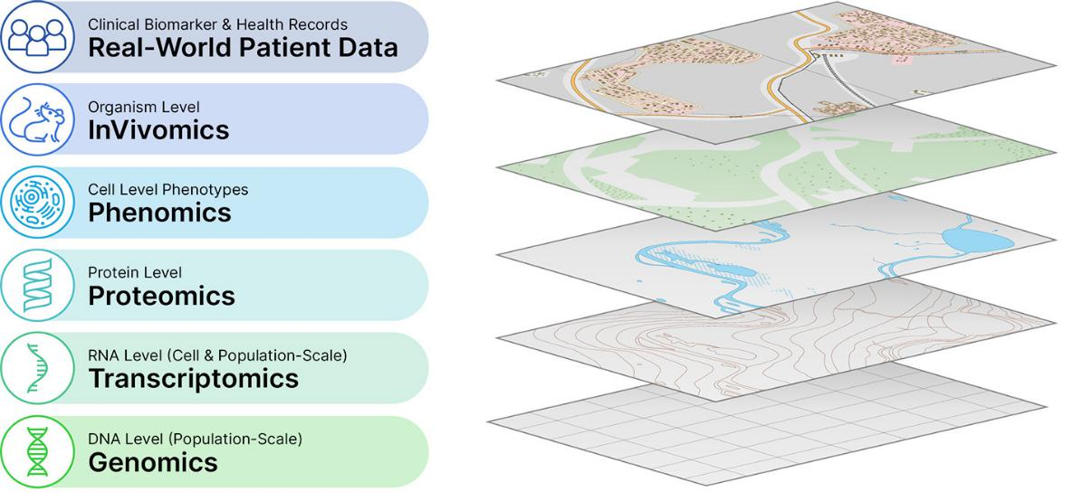

Figure 11. Diverse datasets utilized by the Recursion OS are highly complementary and add useful context, like the different layers of digital maps of Earth. Multiple data modalities help identify connections within and between layers to enable decoding biology at scale.

Automation

While we do not consider ourselves to be hardware innovators, we have leveraged a significant team of automation scientists to assemble and synchronize advanced but widely-available robotic components, such as liquid dispensers, plate washers, incubation stations, automated HPLC, mass spectrometry and automated microscopy camera systems, to efficiently execute millions of experiments per week across a variety of data-rich outputs with only a small team overseeing the process at any given time. These robotic systems are modular by design and easily configurable to allow us to create complex and variable workflows. Furthermore, we have recently operationalized a fully integrated system that processes plates continuously through all steps in our primary experimental workflows. This fully integrated system is interoperable with the existing batch processing work cells but provides greater walk-away time for our operators and greater throughput in a smaller footprint.

21

Table of Contents
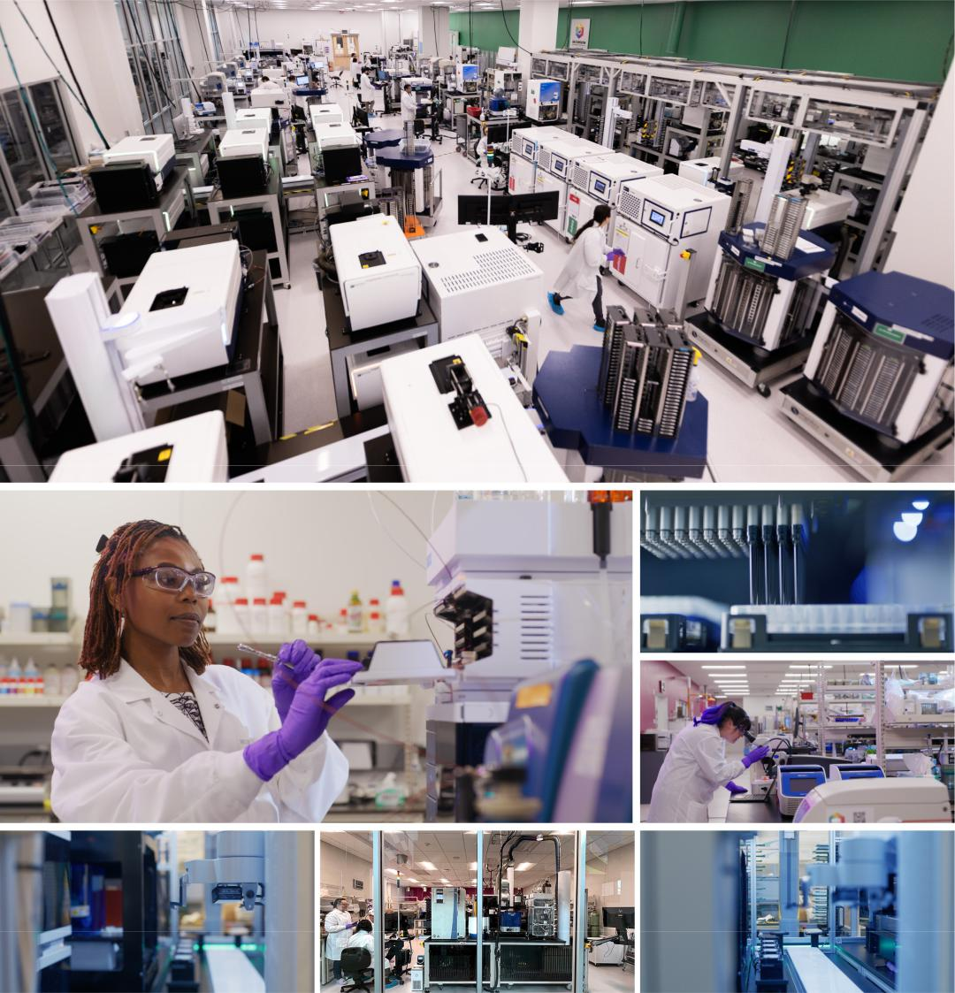

Figure 12. Our high-throughput automation platforms make our labs look more like sophisticated manufacturing facilities than biology R&D laboratories. Our high throughput phenomics platform (top) can execute up to 2.2 million experiments each week with high quality to enable downstream analyses. We are increasingly automating many other of our assays at Recursion.

Cell Culture and Cell Differentiation Tools

We have built a state-of-the-art cell culture facility to consistently produce high-quality, primary mammalian cells, such as vein, kidney, lung, liver, skin and immune cell subsets, as well as stem cell-derived and cancer cell lines. In total, over 50 cell types have been onboarded to our high-throughput discovery systems. In 2022, we greatly expanded our cell culture facility footprint to perform work using human induced pluripotent stem cell (hiPSC) lines. Specifically, we have developed protocols using CRISPR genome editing technologies to generate knock-out or knock-in lines. We have developed protocols to differentiate hiPSCs into several distinct cell types using 3D and 2D differentiation methods. Furthermore, we have developed internal capabilities to characterize these cells using standardized and partly automated methods. Lastly, we have developed a scalable platform to produce 50-100 billion cells of interest per week and cryopreserve cells in assay-ready frozen format. Since 2022, our team produced over 1 trillion hiPSC-derived cells of interest to support various ongoing projects.

22

Table of Contents
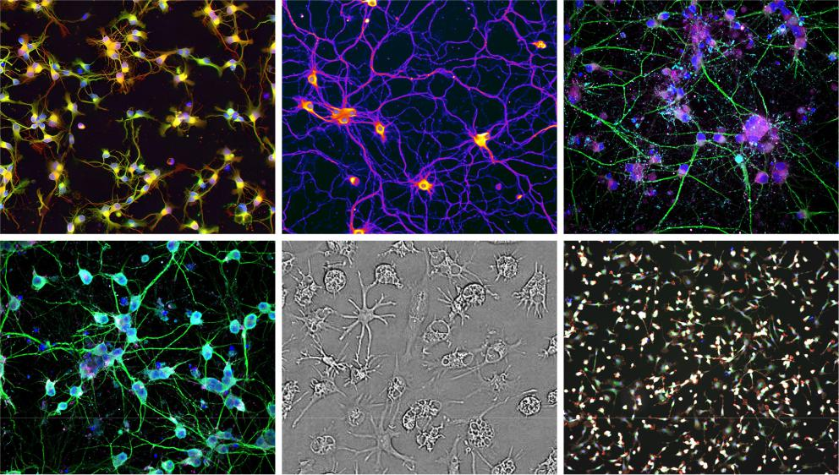

Figure 13. Various cells grown at scale for phenomics assays in-house by Recursion. These cells represent a variety of iPSC-derived neuronal cell types to support our neuroscience research.

Phenomics

Cellular morphology is a holistic measure of cellular state that integrates changes from underlying layers of cell biology, including gene expression, protein production and modification and cell signaling, into a single, powerful readout. Image-based -omics can be two to four orders of magnitude more data-dense per dollar than other -omics datasets that focus on these more proximal readouts, enabling us to generate far more data per dollar spent to inform our drug discovery efforts. We currently generate up to 13.2 million images or 110 terabytes of new data per week across up to 2.2 million experiments. Our phenomics approach builds on the recent explosion of powerful computer vision and ML approaches driven by the technology industry over the last decade. Modern ML tools can be trained to identify the most salient features of images without relying on any pre-selected, disease-specific subject matter expertise, even if these features are imperceptible to the human eye. Using these tools, we can capture the aggregate cellular response induced by a disease-causing perturbation or therapeutic and quantify these changes in an unbiased manner, freeing us from human bias. In contrast, traditional drug discovery relies on presumptive target hypotheses and bespoke biological signaling assays that only capture narrow, pre-determined biology and thus limit the scope of biological exploration.


Figure 14. AI/ML models can detect cellular phenotypes that are indistinguishable to the human eye. Most morphological differences within our images are too subtle for the human eye to detect, but AI models like Phenom-1 deployed in our Recursion OS can readily distinguish between them. The heatmap of similarities shown here between learned embeddings of these images shows clear separation where even well-trained cell biologists or pathologists would be hard-pressed to describe consistent differences.

Imaging data that we generate can be broadly and consistently used across various biological and chemical contexts to create vast, relatable datasets rather than creating data islands of custom one-off imaging readouts. Previously, most of our phenomics data consisted of fluorescent microscopy images that capture composite

23

Table of Contents

changes in cellular morphology. This protocol, consisting of six subcellular dyes imaged in six different channels, has been optimized to capture a wide array of biology across nearly any adherent human cell type that can be cultured and perturbed in laboratory conditions. In 2023, we expanded how we gather phenomics data and started capturing dynamic timepoint information from our cells throughout an assay using brightfield imaging. This technique offers the benefit of being able to capture data within the same well over time and across assays (e.g., we can capture a transcriptomic endpoint from the same experimental well in which we imaged cells over time after a perturbation of interest). Brightfield imaging, which increasingly comprises our phenomics experiments, enables faster, more cost-effective image analysis across multiple timepoints and modalities. With these broadly applicable approaches, we can capture the effects of a wide range of biological and pharmacological phenomena of interest, including phenotypic changes induced by small molecules, genetic gain- and loss-of-function, toxins, secreted factors, cytokines, infectious agents, or any combination of the above.
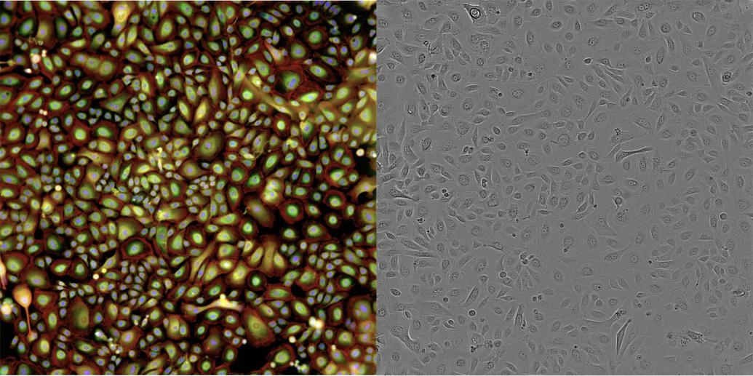

Figure 15. A cellular image leveraging our fluorescent staining protocol (left) compared to a brightfield cellular image (right), both of which capture multiple levels of information about the cellular state. Brightfield imaging, which increasingly comprises our phenomics experiments, enables faster, more cost-effective image analysis across multiple timepoints and modalities.
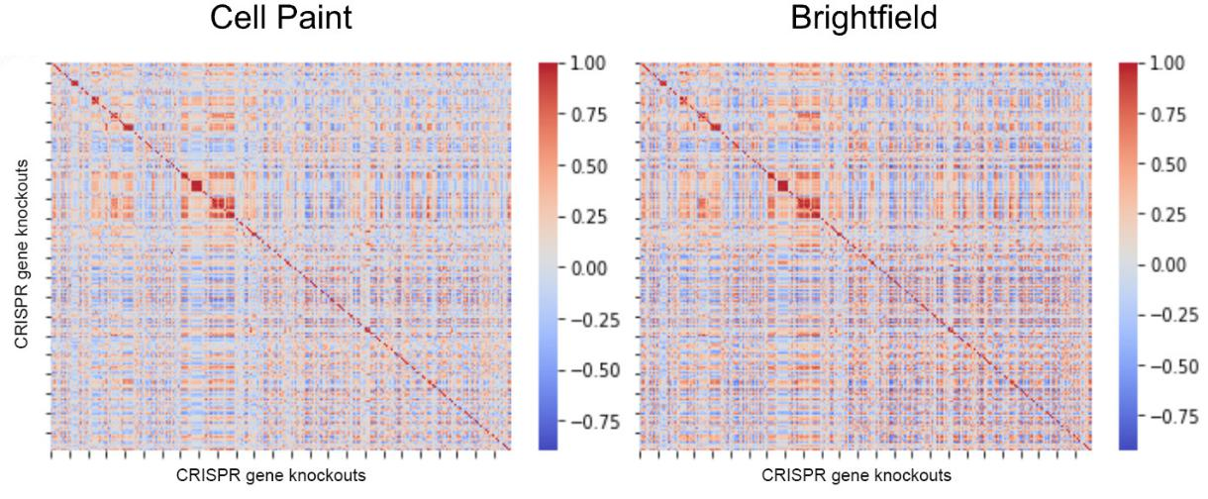

Figure 16. Maps made with phenomics data from both Cell Paint and Brightfield techniques demonstrate highly similar results. Heatmaps reveal relationships between genes that span a wide variety of well-documented cellular systems.

24

Table of Contents

Transcriptomics

We have developed an in-house transcriptomics laboratory platform, complete with walk up automation and push button digital data processing, capable of profiling up to 25,000 samples per week covering expression of nearly 20,000 genes from samples drawn from any of our biological modules. At the end of 2023, we had leveraged our transcriptomics platform to sequence over 700,000 individual transcriptome samples to improve our biological understanding of many of our programs and to begin to create another layer of orthogonal biological mapping data to complement our phenomics mapping data. In 2024, we intend to further scale and automate this capacity to enable more hits identified from our phenomics platform to be confirmed using an orthogonal, transcriptomic readout as part of our industrialized program generation workflows and we expect to be able to approach whole-genome scale mapping in this data-layer as well. This approach of combining high dimensional, large scale data layers from the Recursion OS, across phenomics and transcriptomics allows us to increase our confidence around which insights to prioritize for scientist follow-up, while at the same time minimizing cost and human effort. Similar to how we scaled transcriptomics to complement phenomics, we expect to scale additional data types like proteomics, metabolomics, lipidomics, and others.
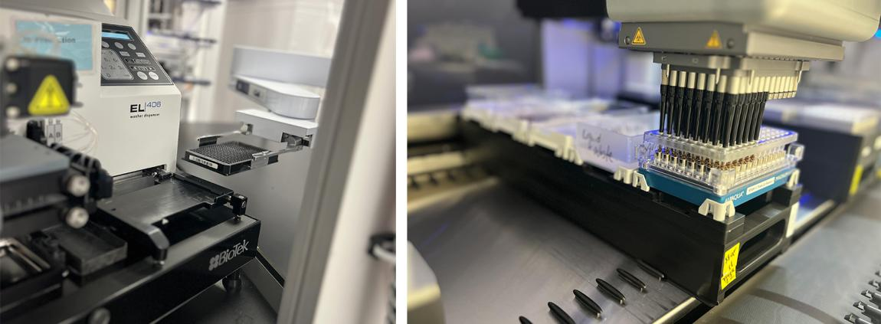

Figure 17. Recursion utilizes an adapted transcriptomic experimental process to leverage industry-standard sequencing systems at vastly reduced cost per sample.

InVivomics

In vivo studies are an important tool for assessing efficacy and safety of a compound within the context of a complete, complex whole-organism system. Like other steps in the drug discovery and development process, conventional in vivo studies are fraught with human bias and limited in the post-study endpoints that they measure. Using our In Vivo Data Collection Infrastructure (which we call InVivomics), we can collect more holistic measurements of an individual animal’s behavior and physiological state using continuous video feeds and sensor technology (e.g., temperature), surveilling animals uninterrupted in their home environment and analyzing readouts live throughout studies in progress across days, weeks, or even months.

In 2023, our Digital Vivarium consisted of over one-thousand digital mouse cage units. These support digital tolerability studies, which allow us to identify phenotypic responses unique to different modes of toxicity and prioritize which compounds and doses should be used in efficacy studies. We also conduct InVivomic efficacy studies to evaluate treatment effects early based on whole-animal digital observations. We have also initiated the expansion of our InVivomics tolerability studies into rats to leverage the advantages of whole-animal digital observations for exploratory non-GLP toxicology studies.

25

Table of Contents


Figure 18. Our proprietary, scalable Smart Housing System for in vivo studies automatically collects and analyzes video and sensor data from all cages continuously.

ADME Data

In 2023 Recursion’s custom-built high-throughput robotic ADME experimentation platform entered production. High quality, reproducible data is evaluated against a rigorously designed set of standard controls and QC metrics to ensure data quality. This data is included in our warehousing system that connects experimental data. We will be deploying this fast-growing dataset to build predictive models for the microsomal stability, plasma protein binding, microsomal protein binding and passive permeability outcomes. These predictive models aim to ultimately prioritize the acquisition of high-quality compounds into the Recursion collection to accelerate our programs. We have also built an analytical laboratory equipped with state-of-the-art liquid chromatography-mass spectrometry equipment. Our analytical chemistry team supports work throughout the lifecycle of our programs, including assessing compound identity and purity for quality control, bioanalysis of compound concentration in plasma and tissue samples from in vivo studies, and biomarker identification and validation activities in support of preclinical and clinical translational efforts.
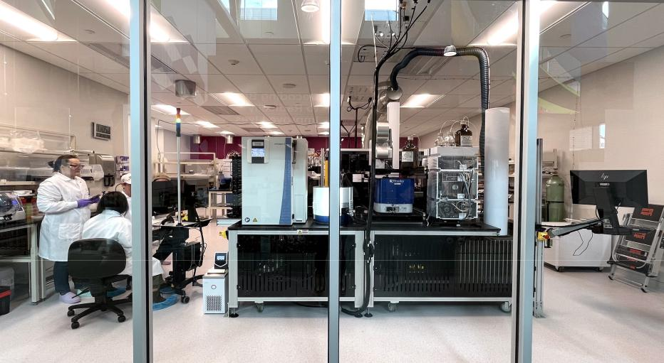

Figure 19. Recursion’s automated DMPK module allows for automated assay execution across plasma protein binding, microsomal stability and cell permeability studies at scale and in both human and rodent cells to advance programs while generating state-of-the-art training data for ML

and AI algorithm development. The system has been designed to potentially add new modules into the automated workflow, such as additional in vitro absorption, distribution, metabolism, excretion, and toxicity (ADMET) testing.

26

Table of Contents

Chemistry

Our in-house chemistry tools include physical compound collections, state-of-the-art compound storage and handling infrastructure and high-precision analytical equipment. The physical capabilities paired with our cutting-edge computational and digital chemistry platforms combine to accelerate hit identification and progression through virtuous cycles of potency and property optimization to deliver differentiated drug candidates. We have a total in-house chemical library of over 1.7 million small molecules from a combination of commercial, semi-proprietary, proprietary, and partner sources and use this library to identify chemical starting points for discovery campaigns. Over 1 million of these compounds reside within the Recursion’s novel chemical entity library curated by our computational and medicinal chemists and designed for highly druggable chemical properties while avoiding undesirable chemical properties, such as poor solubility and permeability. While this library has been constructed to maximize chemical diversity, we have ensured that several analogs of many compound cores are included to help identify emergent SAR for early hits and to enable rapid hit expansion into readily available analogs. Additionally, we have curated a selection of approximately 10,000 clinical-stage and preclinical compounds from public forums or filings, covering approximately 1,000 unique mechanisms of action, for which an abundance of existing data and annotations currently exist. These well-characterized molecules are frequently used as tool compounds within our work and may be advanced as therapeutic programs if the Recursion OS reveals unique and previously undisclosed biological activity.
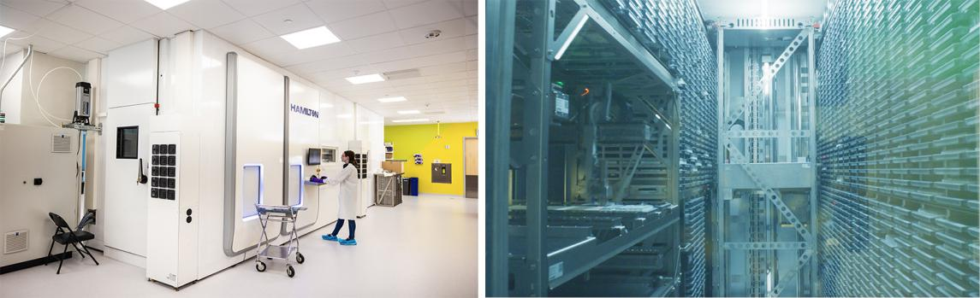

Figure 20. Our state-of-the-art compound storage and handling infrastructure. These tools provide the potential to store up to more than 60 million compounds (in plated formats) onsite.

In December 2023, we entered into a collaboration with Enamine to generate and design enriched compound libraries for the global drug discovery industry. By leveraging Recursion’s MatchMaker AI model, a product added to Recursion after the acquisition of Cyclica in 2023, to identify compounds in the Enamine REAL Space predicted to bind to high-value targets, we believe we can generate more powerful compound libraries for drug discovery purposes. Recursion is expanding our chemical libraires by leveraging MatchMaker and other Recursion-developed predictive ML models to select compounds that represent tractable starting points and have an increased probability of exhibiting biological activity on our phenomics platform. We believe that the scale of our total in-house chemical library is comparable to the scale of chemical libraries curated by some large pharmaceutical companies. We plan to substantially increase the size and diversity of our NCE library over the coming years through a combination of partnerships and investments in automated chemical microsynthesis in order to more fully understand novel biological and chemical relationships. With the completion of our recent wet-laboratory expansion, we now have the potential capability to store up to more than 60 million compounds (in plated formats) onsite.

27

Table of Contents
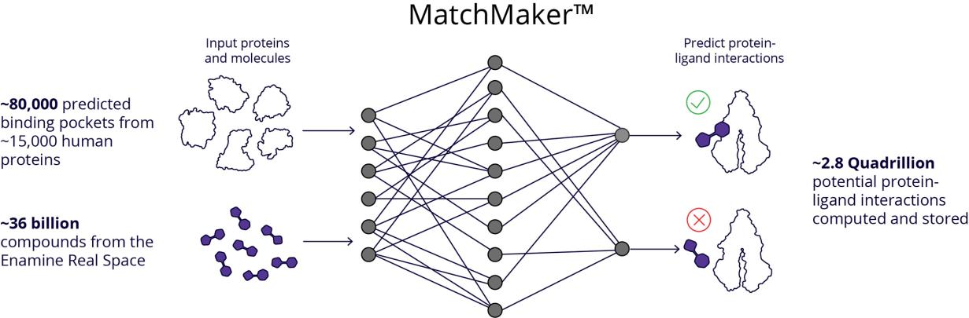

Figure 21. Our MatchMaker technology predicted the protein target(s) for ~36 billion chemical compounds in the Enamine REAL Space, reported to be the world’s largest searchable chemical library. We use the predicted interactions as a complementary data layer in our multiomics dataset for honing mechanistic predictions from our wet-labs and for accelerating SAR cycles through better predictions for our internal pipeline and within our partnerships.

Patient-Centric Genomics Data

In 2023, we entered into a collaboration with Tempus giving Recursion access to over 20 petabytes of proprietary deidentified, multimodal patient oncology data, spanning DNA and RNA tumor sequencing data, imaging, and health records collected from the diagnostic profiling of hundreds of thousands of cancer patients. We believe this data gives Recursion a unique opportunity to fuse the “reverse genetics” approach of our wet-lab platform (identifying cellular phenotypes associated with particular genetic perturbations) with a patient-centric “forward genetics” dataset (identifying genotypes associated with disease-related phenotypes including but not limited to cancer type, progression, response, and survival). In particular, we intend to use this dataset to train causal AI models making use of both patient data and Recursion-proprietary experimental data to go beyond mere correlations or associations in patient data to improve the speed, precision, and scale of therapeutic development in oncology by identifying superior therapeutic targets and well-calibrated populations to accelerate our oncology clinical trials.
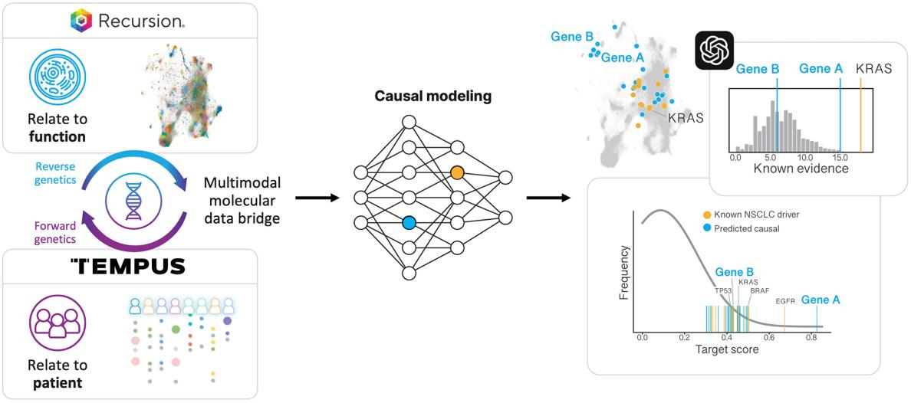

Figure 22. Integration of Recursion reverse-genetics and Tempus forward-genetics data. New potential causal nodes beyond known drivers in lung cancer. At top right, a distribution of potential genetic targets in lung cancer prioritized based on literature-derived evidence. At bottom right, re-ranking of these genes making use of joint Recursion-Tempus evidence using our causal discovery workflow discovers several novel targets with therapeutic impact potentially comparable to known non-small-cell lung cancer drivers.

28

Table of Contents

Dry Lab

Processing and Data Storage Infrastructure

The Recursion OS is built on top of a core technology stack that is highly scalable and flexible. We have adopted a hybrid-cloud strategy, leveraging the benefits of both public and private cloud infrastructure depending on the context and our needs.

Public Cloud. The public cloud is our default choice for production workloads and applications. The scale, elasticity of compute and storage, and economies of scale offered by public cloud computing providers enable us to cost-effectively execute our strategy. We benefit from large capital and investments from cloud service providers to utilize at-scale technologies that would otherwise be cost-prohibitive to build on our own.

Private Cloud. We make use of owned infrastructure to orchestrate the activities in our labs and transfer the data to the public cloud. We also own and operate GPU-based high-performance computing to train our state-of-the-art machine learning models. Owning this infrastructure is critical both for resiliency (on-premises laboratories) and for availability (GPUs) at a time when GPU availability continues to be at a premium.

BioHive-1 and High-Performance Computing in a Private Cloud. Much of our deep learning model training and research happens with our world-class supercomputer named BioHive-1. BioHive-1 is built on NVIDIA’s DGX SuperPod architecture and as of November 2023 is ranked #157 on the TOP500 list of the world’s most powerful supercomputers. In November 2023, we committed to working with NVIDIA to expand BioHive-1 to increase the computational capacity by over 4X. We project that upon completion and benchmarking, BioHive-1 will be in the top 50 most powerful supercomputers in the world across any industry (according to the TOP500 list) and will be the most powerful supercomputer owned and operated by any biopharma company. We believe that a combination of compute, data and talent will enable us to train industry leading AI/ML foundation models.
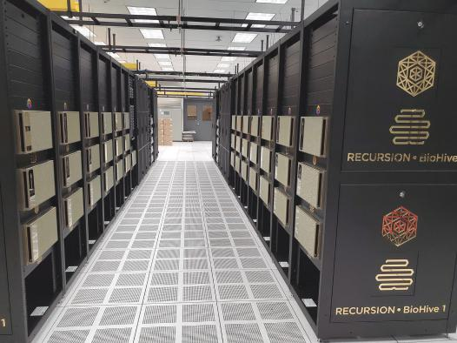

Figure 23. We believe BioHive-1 is one of the most powerful supercomputers dedicated to drug discovery. In November 2023, we committed to adding over 500 NVIDIA H100 Tensor Core GPUs to the more than 300 NVIDIA A100 Tensor Core GPUs already in place, which will increase our computational capacity by more than 4X.

29

Table of Contents

The Recursion Data Universe

Modern approaches to drug discovery are built on significant datasets, in both structured and unstructured forms, as well as from various sources, proprietary, licensed, and public. Recursion enables access to the Data Universe through a combination of modern Data Lake / Warehouse tools for our structured data, and proprietary tools for managing our large volume of unstructured data. Recursion combines these data sources as part of The Recursion Data Universe, which compromises the following data sets, among others:

- Proprietary, Unstructured: This represents the data we generate from our scientific platforms, and consists of high-resolution images from our phenomics assays, sequence readouts from our transcriptomics assays, mass spectrometry data from our DMPK module, and video data from our InVivomics assays.

- Proprietary, Structured: To enable access to all this data, Recursion keeps significant metadata and structured data related to the outcomes from our experiments. This includes the embeddings output from our deep learning models, as well as various analyses of the data from our assays. Our unique use of high dimensional readouts from our assays enables comparison over time in ways not otherwise possible in industry.

- Licensed, Structured and Unstructured: In 2023, we entered into a collaboration with Tempus giving Recursion access to over 20 petabytes of proprietary deidentified, patient-centric, multimodal oncology data for the purpose of training causal AI models. We are adding this data to our Data Universe and enabling further data layers to our drug discovery workflows.

- Public, Structured: We regularly make use of public datasets as part of the Recursion Data Universe to expand our understanding of biology and chemistry. Sources include the UK Biobank, TCGA and DepMap from the Broad Institute of MIT and Harvard.

Mapping and Navigating to Drive Insights and Outcomes

The Recursion Data Universe spans many petabytes of biological, chemical, and patient-centric data, relatable across years of experiment execution and data types. We have also built a rapidly growing suite of in-house software applications designed to process and translate this data into rapidly actionable insights. Increasingly, these tools and data are joined in automated workflows to rapidly prosecute drug discovery programs.

A core part of the Recursion Data Universe is our maps of biology and chemistry: massive in silico datasets created from our physical assays (e.g., phenomics) as well as in silico models (e.g., MatchMaker). Our maps predict relationships and interactions and allow Recursion to be extremely efficient in what studies to prioritize for a given drug discovery opportunity. By layering different maps from different technical modalities or from different biological or chemical spaces, we create a drug discovery “atlas” in which insights are further strengthened and understood by looking across map layers in an unbiased manner (e.g., characterizing a compound across phenomics, transcriptomics, ligand-target binding, in vitro and in vivo ADMET, etc.).

Collectively, our phenotypic maps contain over 5 trillion inferred relationships generated by ML tools without human bias, spanning across genetic perturbations as well as a large number of small- and large-molecule perturbations. Our ability to query the relationships between any perturbations in our phenotypic maps changes drug discovery from an iterative trial-and-error process into a computationally driven search problem. Unlike a traditional high-throughput screen, in which many compounds are profiled for their activity against a single target at a time, our mapping and navigating approach enables every compound we profile to be analyzed not just for its activity against a single target, but for its inferred activity against all possible targets in our arrayed CRISPR library, as well as its similarity to every compound we have previously analyzed – producing a super-linear growth in biological and chemical relationships.

30

Table of Contents
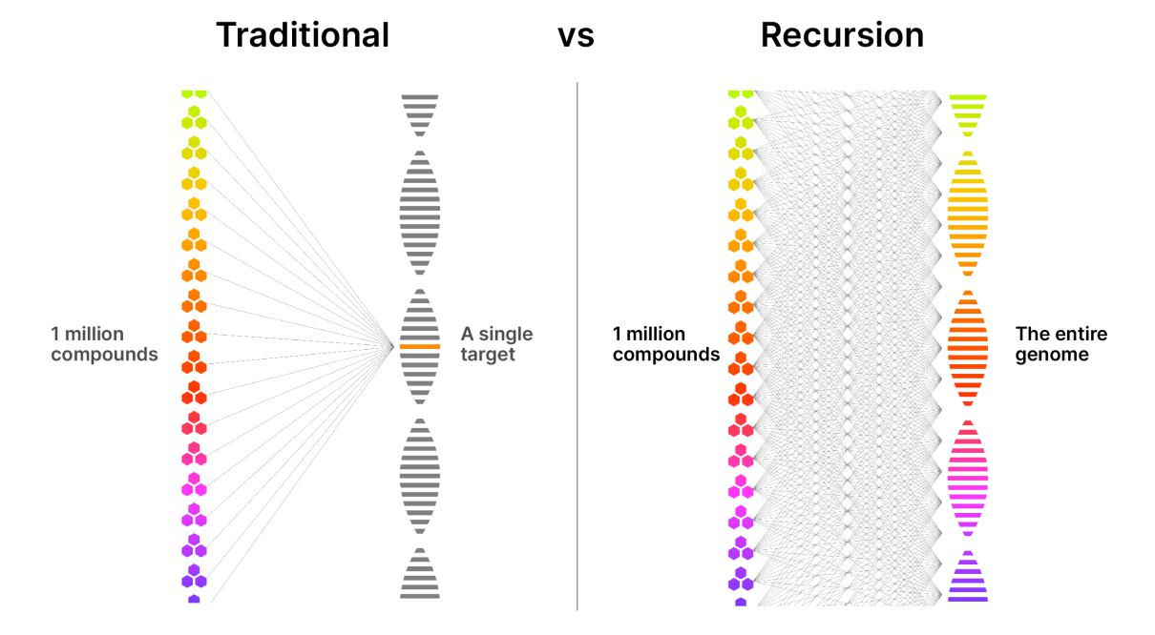

Figure 24. Mapping and navigating enable simultaneous genome-wide screening. Traditional pharma high-throughput screening methods (left) screen thousands to millions of compounds simultaneously against single targets, but little or no information about other targets. Recursion’s mapping and navigating approach (right) enables us, in a single experiment, to infer the activity of a compound against all potential targets in our arrayed CRISPR knockout screen.

LOWE: Large-Language Model (LLM) Orchestrated Workflow Engine

The growing number of AI tools and datasets at Recursion – comprised of many wet-lab and dry-lab modules that can be connected – increases the complexity of our early drug discovery workflows. Moreover, each module often requires specific expertise to operate and is only accessible to highly trained data scientists or machine learning engineers. LOWE is an LLM agent designed to orchestrate complex drug discovery workflows using a natural language interface. These workflows chain together a variety of steps and tools, from finding significant relationships within Recursion’s maps of biology and chemistry to generating novel compounds and scheduling them for synthesis and experimentation. Through its natural language interface and interactive graphics, LOWE puts state-of-the-art AI tools into the hands of every drug discovery scientist at Recursion in a simple and scalable way.

LOWE not only represents the next evolution of the Recursion OS, but also how we believe drug discovery will be done at every company in the next 5 to 10 years. Today, LOWE is directed by scientists who formulate hypotheses and ask questions. In the future, we believe LOWE could be combined with additional AI agents capable of formulating hypotheses and learning from results, effectively thinking like a biologist or chemist. LOWE is a first step towards the development of autonomous ‘AI scientists’ for therapeutic discovery.

31

Table of Contents
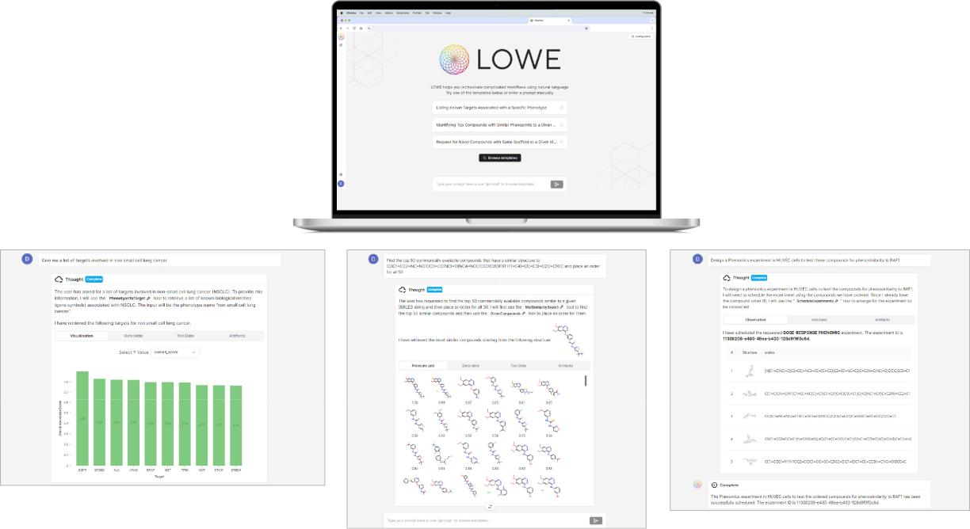

Figure 25. LOWE can orchestrate both wet-lab and dry-lab complex drug discovery tasks using natural language. In the examples above, LOWE has i) identified a list of targets involved in non-small cell lung cancer, ii) identified the top 50 commercially available compounds that have a similar structure to an initial hit, and iii) designed a phenomics experiment to test the compounds for phenosimilarity to a given target.

Because LOWE deploys via a web-based application, the most up to date versions of data and modules are automatically propagated for usage so that version control is not an issue. At Recursion, we are working on an autonomous agent that interfaces with a set of drug discovery modules, whereby a human scientist would review a set of potential programs for further advancement. Whether running via human prompts or autonomously, LOWE maintains a precise record of the commands being made, versions of the data and modules being called, and results being relayed so that workflows could be replicated in the future and computational and experimental results can be collected as evidence for the progression of programs for our internal pipeline, external partners, or regulatory groups.

Other Enabling Software Tools and LLMs

Additional internal software tools drive efficiency by enabling us to map and navigate data spanning more than 5 trillion predicted biological and chemical relationships, prioritize disease, target, and compound opportunities, design large experimental layouts, and automatically execute and continuously monitor experimental protocols. For example, MapApp enables scientists to explore relationships using several visualizations, statistical measurements and data layers including known information about compounds or known relationships between genes and diseases to rapidly distinguish novel insights. Other tools monitor real-time onsite reagent supplies, enable consistent control strategies, and design standards that make each week’s data relatable across time. Additionally, these tools automatically flag experiments or processes which miss quality requirements or stall at some point in the process and notify the appropriate personnel.

32

Table of Contents
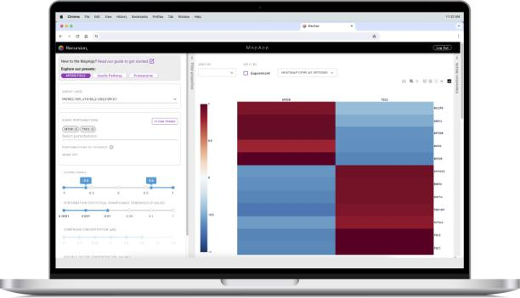

Figure 26. Our MapApp tool allows scientists to simultaneously view multiple relationships between genes and compounds.

Large Language Model (LLM) Cataloging of Scientific Literature. To efficiently initiate programs from our maps of biology, we use a proprietary in-house workflow that incorporates LLMs. This automated approach allows us to rapidly search for and prioritize the most promising opportunities from the large number of insights in our maps. In service to this process, we deploy LLMs to map the corpus of scientific literature against our internally derived proprietary maps in order to automatically surface critical data arbitrages. By layering these LLM-derived maps of scientific literature onto our proprietary maps, we can focus our work on novel and emerging biological, chemical, and patient-centric opportunities rather than the well-trodden and highly competitive diseases and targets the rest of the industry are focused on.

Computational Tools and Foundation Models in Biology

To understand, explore and relate new or existing data, we must normalize, transform and analyze that data. Our tools in this layer manage the streaming of our data at scale to the appropriate public and private cloud, the transformation of data into mathematical representations through our in-house proprietary foundation models, and the analyses performed on our data as parameterized and requested by users. Anomalies are flagged to the team for fast resolution.

Phenom-1. Our phenomics-based foundation model, Phenom-1, is a large vision transformer utilizing hundreds of millions of parameters trained on billions of cellular images from our proprietary phenomics library. Phenom-1 demonstrated the scaling hypothesis within a biological context, namely that larger models trained on larger datasets lead to improved performance. Also, Phenom-1 performed up to 28% better at recapitulating known biological relationships.⁸

- Kraus, O et al. (2023). Masked Autoencoders are Scalable Learners of Cellular Morphology. NeurIPS 2023 Generative AI and Biology (GenBio) Workshop

33

Table of Contents
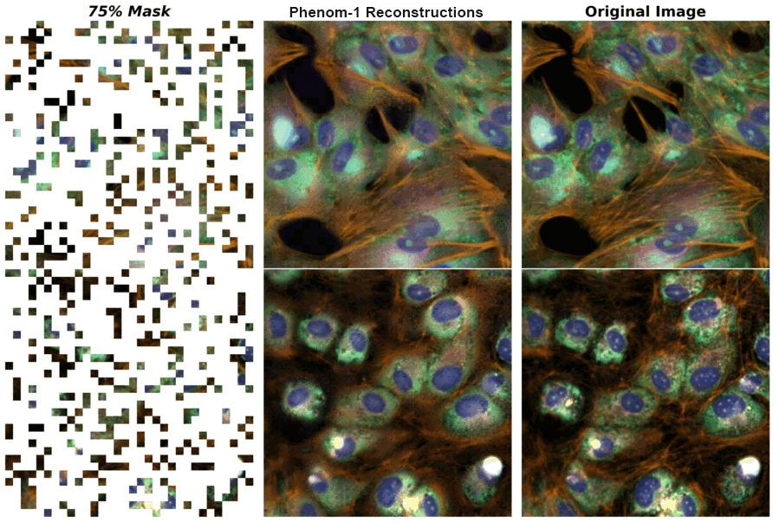

Figure 27. Image reconstruction tasks demonstrate impressive visual results of Phenom-1, our phenomics foundation model. Reconstructing partially masked images was the training task which has enabled emergent capabilities of the model in drug discovery tasks such as detecting biological relationships.

Forward- and Reverse-Genetics Causal AI Models. We invested in deepening the translational potential of the Recursion OS by incorporating patient-relevant, forward-genetics data through our collaboration with Tempus. Recursion’s maps of biology represent a “reverse genetics” strategy, in which we identify and relate to each other the cellular phenotypes induced by genetic and chemical perturbations. Patient genomic datasets like those from Tempus represent a “forward genetics” strategy, cataloging genetic factors associating with patient phenotypes, including cancer type, progression, and more factors ascertainable from the health record. We seek to combine these forward genetics datasets with Recursion’s experimental capabilities to build causal AI models that may better predict which programs are likely to translate therapeutic benefits for patients and which patients are more likely to benefit from such treatments.

Other Foundation Models. With the vast patient-centric data from Tempus and our own growing proprietary multiomics datasets, we anticipate the construction and application of more foundation models, including large language models, across biology, chemistry and translation. When specific foundation models are combined, we believe that a grand canonical foundation model which incorporates in-cellular insights through in-patient causal outcomes could drive a more deterministic and holistic understanding of biology, chemistry, and patient-centric care. We believe these increasingly sophisticated models will enable us to develop more, new, and better medicines at higher scale and lower cost to patients.

34

Table of Contents
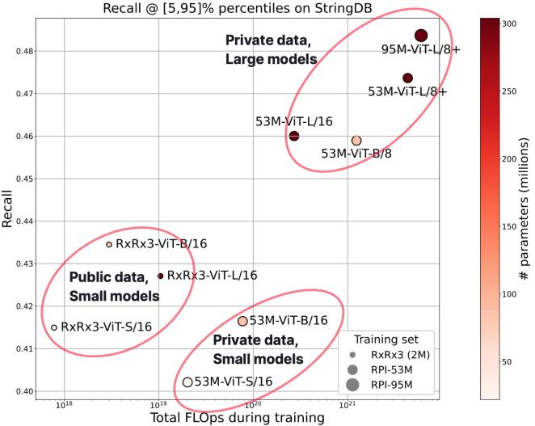

Figure 28. Phenom-1 demonstrates that the scaling hypothesis holds within a biological system. This scaling plot illustrates how increasing the compute power (X-axis), which is required for dataset size and model complexity, improved the model's ability to recapitulate known biological relationships (Y-axis). This observed improvement was not directed as part of the training, but rather emerged as a result of scaling the model.

Computational Tools and Foundation Models in Chemistry

The acquisitions of Cyclica and Valence in May 2023 added industry-leading capabilities in digital chemistry, machine learning, and artificial intelligence to Recursion’s existing small molecule drug discovery capabilities. We are leveraging these capabilities to advance our internal and partnership drug discovery programs.

MatchMaker, a tool acquired during the Cyclica acquisition, is an AI-enabled deep learning engine that uses both AlphaFold2 structures and homology models to predict the polypharmacology of small molecules across the proteome. We utilized MatchMaker to successfully predict the protein target interactions of several commercially available libraries, including the 36 billion compound Enamine REAL Space collection. Predicting the proteome profiling of 36 billion molecules was a massive computational exercise involving the in-silico evaluation of over 2.8 quadrillion molecule-target pairs. Achieving this exercise was an important step in bridging the gap between the protein universe and the chemical universe and enabling us to intelligently search vast chemical libraries to identify molecules for profiling in our wet-lab platforms.

MolE, developed in-house by Recursion, is a self-supervised foundation model for chemistry. MolE learns generalizable, graph-based representations of compounds and transforms them into robust, task-specific ML models via fine-tuning. Fine-tuned MolE models span endpoints related to drug efficacy and safety. MolE models are trained across a wide array of public and private datasets, including the massive-scale data generated by Recursion’s phenomics and DMPK platforms.⁹

Our digital chemistry platform is a core part of Recursion’s software ecosystem, comprising an integrated suite of proprietary and commercial tools, enabling our medicinal and computational chemistry team to scale and advance programs from hit to candidate. Key aspects of this platform include: (i) unified access to and visualization of chemical structures and assay data, including internally generated high or low-dimensional assay data, externally generated in vitro or in vivo data, and ADME data; (ii) integrated predictive modeling, chemical search and computational chemistry capabilities; and (iii) molecular design and collaboration. We intend to further invest in predictive and digital chemistry capabilities across three domains: (i) chemistry-centric ML model development, (ii) chemistry-centric data generation and (iii) digital and physical chemistry process development to drive the Design-Make-Test-Analyze cycle of chemistry optimization more efficiently, including the roll-out of industrialized workflows that integrate chemistry and biological assay steps autonomously.

- Méndez-Lucio, O et al. (2022). MolE: a molecular foundation model for drug discovery. Presented at NeurIPS 2022.

35

Table of Contents

Bridging Insights to Program Advancement with the Recursion OS

The Recursion OS is an integrated, multi-faceted system for iteratively mapping and navigating massive biological and chemical datasets that contain trillions of inferred relationships between disease-causative perturbations and potentially therapeutic compounds. Collectively, the components of the Recursion OS can be joined together in a modular way to identify, validate and advance a broad portfolio of novel therapeutic programs quickly, cost-effectively and with minimal human intervention and bias - industrializing drug discovery. We use standardized, automated workflows to identify programs and advance them through key stages of the drug discovery and development process which includes:

- Patient Connectivity and Novelty (i.e., program initiation)

- Hit and Target Validation

- Compound Optimization

- Translation

- IND Enabling Studies

- Clinical Development

Late-stage clinical failures are the primary driver of costs in today’s pharmaceutical R&D model. Reducing the rate of costly, late-stage failures and accelerating the timeline from hit to a clinical candidate would create a more sustainable R&D model. To achieve this more sustainable model, we believe that in its ideal state, a drug discovery funnel would morph from the being shaped like the letter ‘V’ to being shaped like the letter ‘T,’ where a broad set of possible therapeutics could be narrowed rapidly to the best candidate, which would advance through subsequent steps of the process quickly and with no attrition. Recursion’s goal is to leverage technology to reshape the typical drug discovery funnel towards its ideal state by moving failure as early as possible to rapidly narrowing the funnel into programs with the highest probability of success.
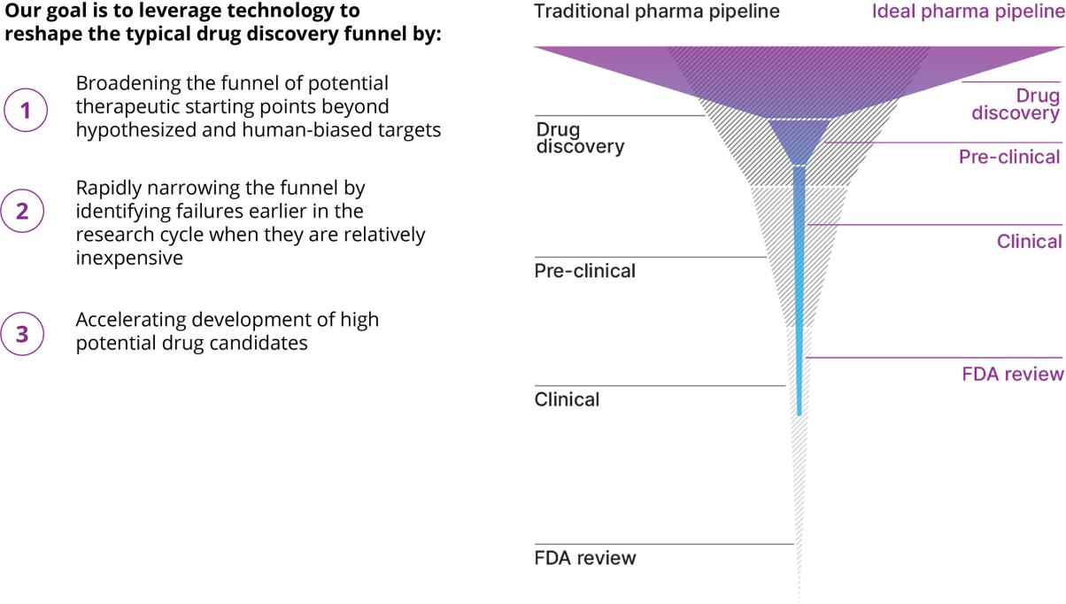

Figure 29. Reshaping the drug discovery funnel. Recursion’s goal is to leverage technology to reshape the typical drug discovery funnel towards its ideal state by moving failure as early as possible to rapidly narrowing the funnel into programs with the highest probability of success.

36

Table of Contents

We believe we have made progress in reshaping the traditional drug discovery funnel in the following ways:

- Broaden the funnel of therapeutic starting points. Our flexible and scalable mapping tools and infrastructure enable us to infer trillions of relationships between human cellular disease models and therapeutic candidates based on real empirical data from our own wet labs.

- Identify failures earlier when they are relatively inexpensive. Our proprietary navigation tools enable us to explore our massive biological, chemical, and patient-centric datasets to validate more and varied hypotheses rapidly. While this strategy results in an increase in early-stage attrition, the system is designed to rapidly prioritize programs with a higher likelihood of downstream success because they have been explored in the context of high-dimensional, systems-biology data. Over time, and as our OS improves, we expect that moving failure earlier in the pipeline will result in an overall lower cost of drug development.

- Accelerate delivery of high-potential drug candidates to the clinic. The Recursion OS contains chemistry tools that enable highly efficient exploration of chemical space as well as translational tools that improve the robustness and utility of in vivo studies.

By leveraging our Recursion OS to explore and advance our programs, we have shown leading indicators of improvement when compared to the traditional drug discovery process, particularly with respect to cost and time. Across all Recursion programs from late 2017 through 2023, the average amount of time to reach the validated lead stage is approximately 11 months. By the end of 2024, we believe that Recursion programs could reach the validated lead stage in about half that time or less. Ultimately, we believe that future iterations of the Recursion OS will enable even greater improvements minimizing the total dollar-weighted failure and maximizing the likelihood of success.
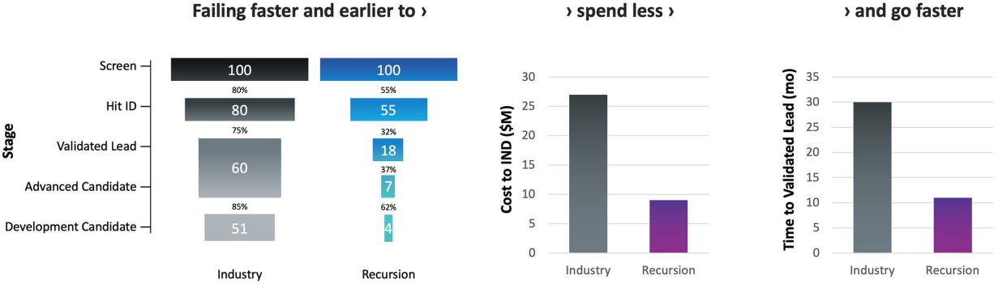

Figure 30. The trajectory of our drug discovery funnel mirrors the ‘ideal’ pharmaceutical drug discovery funnel. We believe that, compared to industry averages, our approach enables us to: (i) identify low-viability programs earlier in the research cycle, (ii) spend less per program and (iii) rapidly advance programs to a validated lead candidate. All industry data has been adapted from Paul, et al. Nature Reviews Drug Discovery. (2010) 9, 203–214. The cost to IND has been inflation-adjusted using the US Consumer Price Index (CPI). The Recursion data shown for the transition stages and time to validated lead is the average of all Recursion programs since late 2017 through 2023. The Recursion data shown for cost to IND pertains to the actual and projected costs for a novel chemical entity to reach IND.

The Recursion OS has not only improved speed and cost, but also led us to explore novel targets which could give us a competitive advantage where multiple parties often simultaneously pursue a limited number of similar target hypotheses. Below one can see quantitative measures for how we prioritize programs characterized by (i) strong genetically driven biological evidence and (ii) differentiated novel biology.

37

Table of Contents
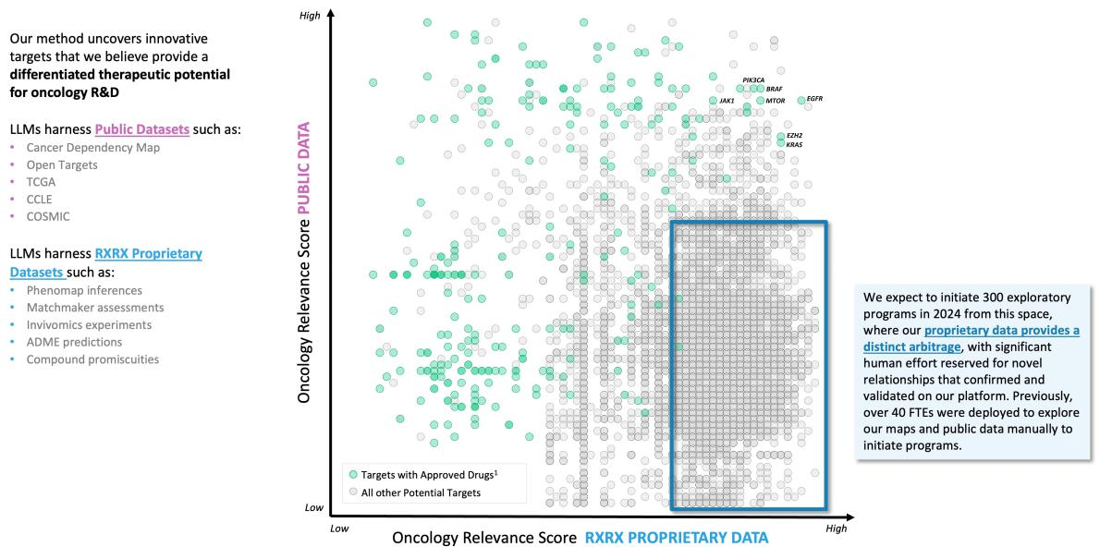

Figure 31. We use LLMs to organize relationships within public data as well as our own proprietary data and software tools to identify starting points for all of our internal programs. We prioritize programs at scale by focusing on targets where our proprietary data provides a distinct arbitrage that suggests we can drive towards novel target identification and selection in oncology. Each circle represents a gene that can be searched by the Recursion OS across a number of biological and pharmacological factors. Circles in green reflect targets for drugs that have obtained regulatory approval for the treatment of specific diseases and are adapted from Ochoa, D. et al. Nucleic Acids Research. (2023).

Our Pipeline

All of the programs in our internal pipeline are built on unique biological insights surfaced through the Recursion OS where: (i) the etiology of the disease is well defined but the subsequent impacts of the disease are generally obscure, the primary targets are typically considered undruggable, or the primary targets are extensively recognized in association with a particular disease and (ii) there is a high unmet medical need, no approved therapies, or significant limitations to existing treatments. Several of our internal pipeline programs could have potential market opportunities of more than $1 billion in annual sales. We currently have five programs in or planning to initiate Phase 2 clinical studies and we are preparing to submit an IND for a sixth program in H2 2024. In addition to our clinical stage programs, we are actively developing dozens of preclinical and discovery programs.

Clinical Programs

- REC-994 for the potential treatment of cerebral cavernous malformation, or CCM — SYCAMORE, a Phase 2, randomized, double-blind, placebo-controlled, safety, tolerability and exploratory efficacy study is underway. Orphan Drug Designation has been granted in the US and EU. We expect to share Phase 2 data in Q3 2024. This trial was fully enrolled in June 2023 and the vast majority of participants who completed 12 months of treatment continue to elect to enter the long-term extension study.

- REC-2282 for the potential treatment of neurofibromatosis type 2, or NF2 — POPLAR, an adaptive, Phase 2/3, randomized, multicenter study is underway. Enrollment of Phase 2 is expected to complete in H1 2024. Orphan Drug Designation in the US and EU as well as Fast Track Designation in the US have been granted. We expect to share Phase 2 safety and preliminary efficacy data in Q4 2024.

- REC-4881 for the potential treatment of familial adenomatous polyposis, or FAP — TUPELO, a Phase 1b/2, open label, multicenter study is underway with Part 1 complete. FPI for Part 2 is anticipated in H1 2024. Orphan Drug Designation in the US and EU as well as Fast Track Designation in the US have been granted. We expect to share Phase 2 safety and preliminary efficacy data in H1 2025.

38

Table of Contents

- REC-4881 for the potential treatment of AXIN1 or APC mutant cancers — LILAC, a Phase 2 open label, multicenter study in solid tumors initiated at the end of 2023 with FPI anticipated in Q1 2024. We expect to share Phase 2 safety and preliminary efficacy data in H1 2025.

- REC-3964 for the prevention of recurrent Clostridioides difficile infection — a Phase 1 study in healthy volunteers completed in Q3 of 2023. REC-3964 was well tolerated with no serious adverse events (SAEs) reported. We expect to initiate a Phase 2 study in 2024.

We believe that the number of potential programs we can generate with our Recursion OS is key to the future of our company, as a greater volume of validated programs has a higher likelihood of creating value. Additionally, we believe that our large number of potential programs makes us an attractive partner for larger pharmaceutical companies. The static or declining level of R&D output at several large pharmaceutical companies indicates an ongoing requirement for new projects to sustain their product pipelines.
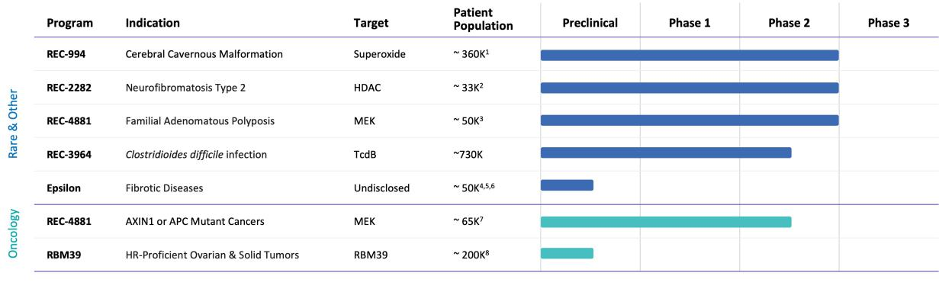

Figure 32. The power of our Recursion OS as exemplified by our expansive therapeutic pipeline. All populations defined above are US and EU5 incidence unless otherwise noted. EU5 is defined as France, Germany, Italy, Spain and UK.¹ Prevalence for hereditary and sporadic symptomatic population.² Annual US and EU5 incidence for all NF2-driven meningiomas.³ Prevalence for adult and pediatric population. Our program has the potential to address several indications.⁴ We have not finalized a target product profile for a specific indication.⁵ Incidence for US only.⁶ 2L drug-treatable population.⁷ 2L drug-treatable population comprising ovarian, prostate, breast and pancreatic cancers with no HRR mutations.⁸

REC-994 for Cerebral Cavernous Malformation – Phase 2

REC-994 is an orally bioavailable, superoxide scavenger small molecule currently under development for the treatment of symptomatic CCM. CCM is among the largest rare disease opportunities and has no approved therapies to date. REC-994 demonstrated excellent tolerability and suitability for chronic dosing in Phase 1 SAD and MAD trials in healthy volunteers directed and executed by Recursion. SYCAMORE, a Phase 2 randomized, double-blind, placebo-controlled, safety, tolerability and exploratory efficacy study is underway, and Orphan Drug Designation has been granted in the US and EU. We expect to share Phase 2 data in Q3 2024. This trial was fully enrolled in June 2023, with the vast majority of participants who completed 12 months of treatment electing to enter the long-term extension portion of the study.

Disease Overview

CCM is a neurovascular condition that impacts approximately 360,000 symptomatic individuals in the US and EU5. Yet, with only around 30% of patients exhibiting noticeable symptoms, the disease is severely underdiagnosed, potentially affecting over 1 million patients. CCM originates from genetic mutations in any of three genes involved in endothelial function: CCM1, CCM2, or CCM3 and approximately 20% of patients inherit a familial form of CCM in an autosomal dominant pattern. Sporadic disease in the remaining population is caused by somatic mutations that arise in the same genes. CCM manifests as vascular malformations of the spinal cord and brain characterized by abnormally enlarged capillary cavities without intervening brain parenchyma. Patients with CCM lesions are at substantial risk for seizures, headaches, progressive neurological deficits, and potentially fatal hemorrhagic stroke. Current non-pharmacologic treatments include microsurgical resection and stereotactic radiosurgery. Given the

39

Table of Contents

invasive and risky nature of these interventions, these options are reserved for a subset of patients with significant symptomatology and/or easily accessible lesions. Rebleeds and other negative sequelae of treatment further limit the effectiveness of these interventions. There is no approved pharmacological treatment that affects the rate of growth of CCM lesions or their propensity to bleed or otherwise induce symptoms. Hence, CCM remains a serious health condition resulting in progressive neurologic impairment and a high risk of death due to hemorrhagic stroke.
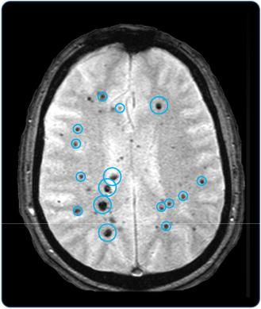

Figure 33. Vascular malformations (cavernomas) in the brain of a CCM patient.¹⁰

Insight from Recursion OS

CCM2 knock-down in human endothelial cells revealed pronounced structural and functional phenotypes that are distinct from healthy cells. We hypothesized that these observed structural changes could be used to enable unbiased drug discovery. Fluorescent microscopy and automated cellular quantification and profiling software enabled high throughput analysis. More than 2,000 commercially available and known chemical entities were rapidly evaluated with this strategy based on the hypothesis that hits from this library could be more quickly translated to the clinic. The novel use of REC-994 for CCM was discovered leveraging this early form of the Recursion OS. The exciting aspect of this novel, unbiased approach was that the drug candidates chosen using automated software analysis outperformed those chosen by human analysis in subsequent orthogonal screens.
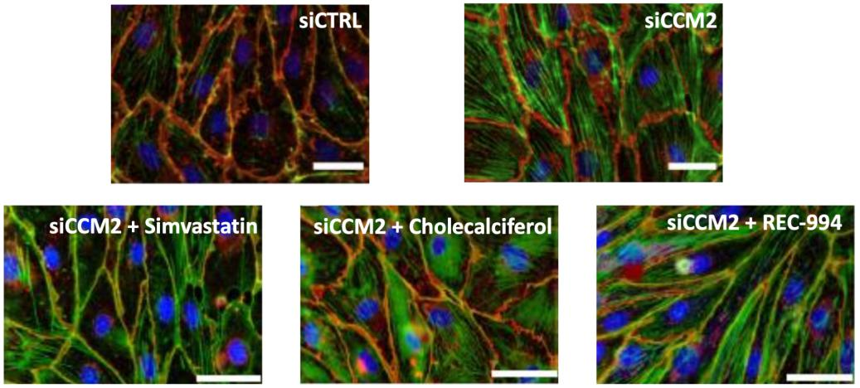

Figure 34: Rescue of structural phenotypes associated with loss of CCM2. Immunofluorescence images of endothelial cells treated with siCTRL, siCCM2, or siCCM2 treated with REC-994, Simvastatin, or Cholecalciferol stained for DNA (blue), actin (green) and VE-cadherin (red). According to a machine learning classifier trained on images, REC-994 shows image-based rescue.

- Cooper, AD. et al. (2008). Susceptibility-weighted imaging in familial cerebral cavernous malformations. Neurology, 71, 382.

40

Table of Contents

REC-994 is a small molecule therapeutic designed to alleviate neurological symptoms associated with CCM and potentially reduce the accumulation of new lesions. REC-994 is an orally bioavailable superoxide scavenger with pharmacokinetics supporting once-daily dosing in humans. The putative mechanism of action of REC-994 is through reduction of reactive oxygen species and decreased oxidative stress that leads to stabilization of endothelial barrier function. In addition, REC-994 exhibits anti-inflammatory properties which could be beneficial in reducing disease-associated pathology.
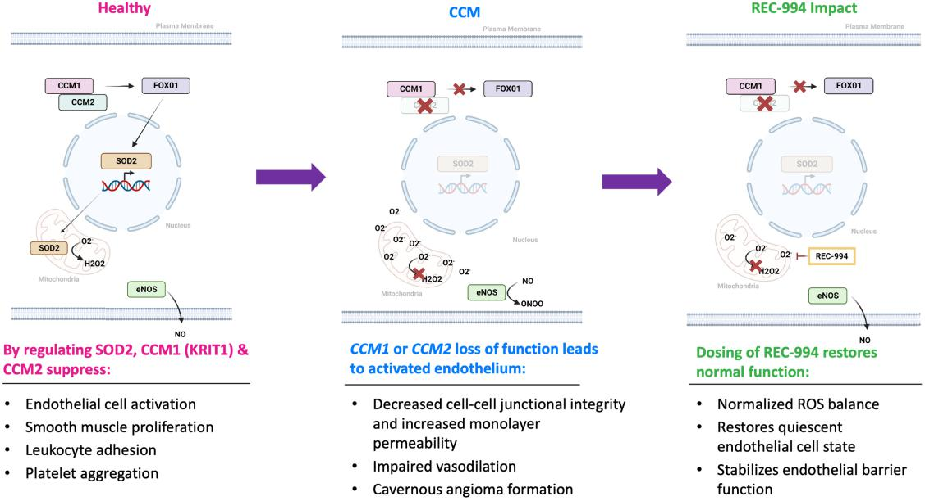

Figure 35. REC-994 mechanism of action and proposed potential therapeutic impact.

Preclinical

The activity of REC-994 as a potential treatment for CCM was further confirmed in orthogonal functional assays and in acute and chronic in vivo models. REC-994 demonstrated benefit on acute to subacute disease-relevant hemodynamic parameters such as vascular dynamics and vascular permeability. Chronic administration of REC-994 was also tested in two endothelial-specific knockout mouse models for the two most prevalent genetic causes, CCM1 and CCM2. These mouse models faithfully recapitulate the CNS cavernous malformations of the human disease. Mice treated with REC-994 demonstrated a decrease in lesion number and/or size compared to vehicle treated controls. Notably, 24-hour circulating plasma levels of REC-994 in this in vivo experiment were consistent with exposures seen in humans at a 200 mg daily dose.

41

Table of Contents
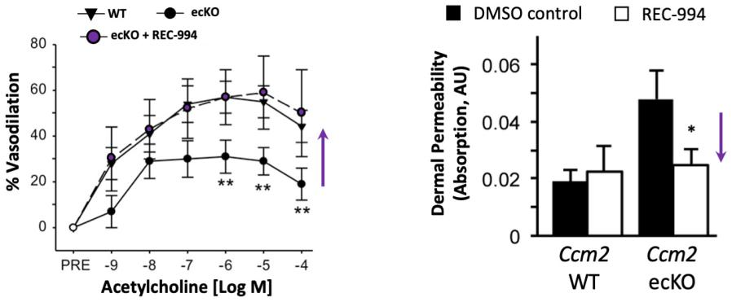

Figure 36. REC-994 rescues acetylcholine-induced vasodilation defect and dermal permeability defect in Ccm2 endothelial specific knockout mice.¹¹
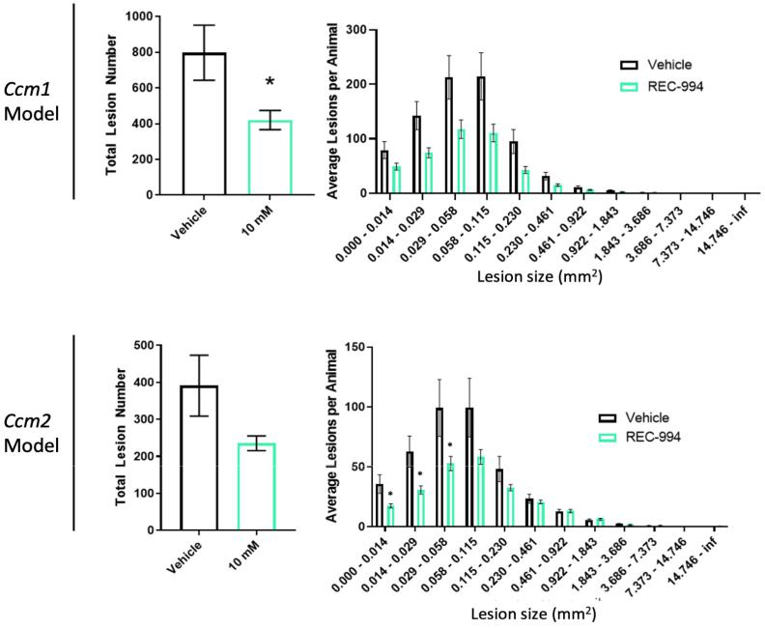

Figure 37. REC-994 reduces lesion severity in chronic mouse models of CCM Disease. Mice treated with REC-994 demonstrated a statistically significant decrease in the number of small-size lesions, with a trend toward a decrease in the number of mid-size lesions.¹¹

Clinical

We conducted a Phase 1 Single Ascending Dose (SAD) study in 32 healthy human volunteers using active pharmaceutical ingredients with no excipients in a powder-in-bottle (PIB) dosage form. Results showed that systemic exposure (C_{max} and AUC) generally increased in proportion to REC-994 dose after both single and multiple doses. Median T_{max} and t_{1/2} appeared to be independent of dose. There were no deaths or SAEs reported during this study and no TEAEs that led to the withdrawal of subjects from the study. These data supported a MAD study in healthy human volunteers.

- Gibson, et al. (2015). Strategy for identifying repurposed drugs for the treatment of cerebral cavernous malformation. Circulation, 131(3), 289-99.

42

Table of Contents

A subsequent Phase 1 Multiple Ascending Dose (MAD) study was conducted in 52 healthy human volunteers and was designed to investigate the safety, tolerability, and PK of multiple oral doses of REC-994, to bridge from the PIB dosage form to a tablet dosage form, as well as to assess the effect of food on PK following a single oral dose. Overall, multiple oral doses of REC-994 were well tolerated in healthy male and female subjects at each dose level administered in this study. There appeared to be no dose-related trends in TEAEs, vital signs, ECGs, pulse oximetry, physical examination findings, or neurological examination findings. Pharmacokinetic results support once-daily oral dosing with tablet formulation.
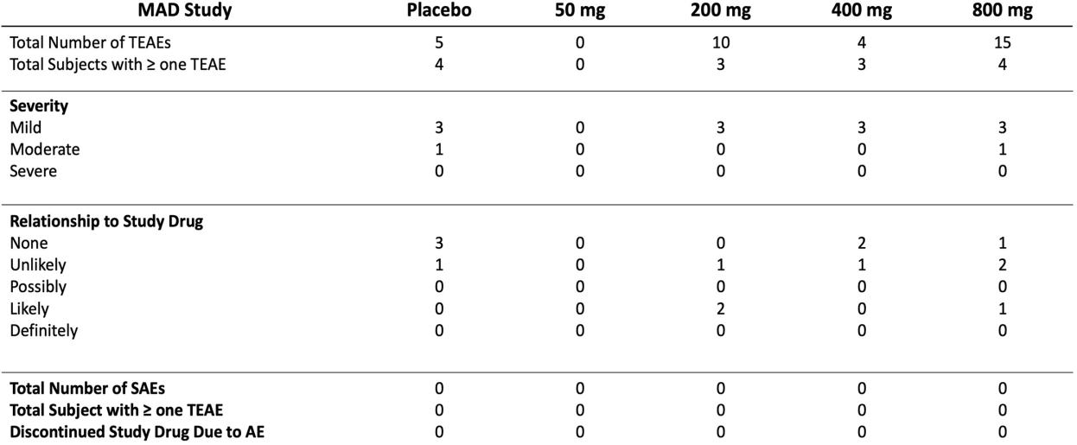

Table 1. Summary of Adverse Events from Phase 1 Multiple Ascending Dose Study. AE=adverse event; MAD=multiple ascending dose; SAE=serious adverse event; TEAE=treatment-emergent adverse event.

Recursion initiated the SYCAMORE study, a two-part Phase 2 trial in CCM patients in Q1 2022. Part 1 is a randomized, double-blind, placebo-controlled trial to investigate the safety, efficacy, and PK of daily doses of REC-994 (200 mg and 400 mg) compared to placebo in participants with symptomatic CCM over a treatment period of 12 months. Part 2 is an optional, double-blind, long-term extension (LTE) study of daily doses of REC-994 (200 mg and 400 mg) for participants completing Part 1 of the study. Currently, there is no regulatory precedent or registrational pathway for CCM drug development. Results from the ongoing Phase 2 study are expected to inform a pivotal trial design with guidance from the FDA.

43

Table of Contents
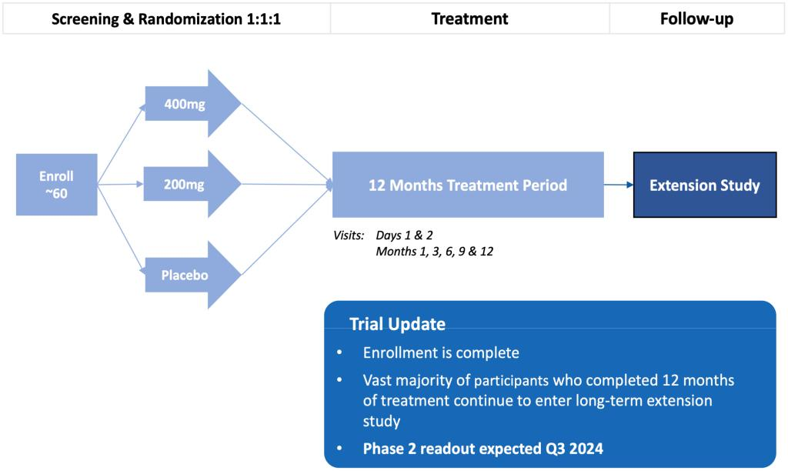

Figure 38. Phase 2 study schema for REC-994. Phase 2 trial design to assess the efficacy and safety of REC-994 in patients with symptomatic CCM. Enrollment criteria includes MRI-confirmed lesion(s), diagnosis of familial or sporadic CCM, and having symptoms directly related to CCM. Primary outcome measures are safety and tolerability. Secondary measures are focused on efficacy, including clinician-measured outcomes, imaging of CCM lesions, acute stroke scales and patient reported outcomes.This trial was fully enrolled in June 2023 and the vast majority of participants who completed 12 months of treatment continue to enter the long-term extension study.

Competitors

To our knowledge, the REC-994 program is the first industry sponsored therapeutic program in clinical trials for CCM. If approved, REC-994 would be the first pharmacologic disease-modifying treatment for CCM, one of the largest areas of unmet need in the rare disease space. There are currently three other active programs in clinical development for CCM.

- OV-888, a ROCK2 inhibitor from Ovid Therapeutics, is currently in Phase 1, with a signal-finding trial expected to initiate in H2 2024.

- NRL-1049, a ROCK inhibitor from Neurelis in-licensed from BioAxone BioSciences, is currently in Phase 1.

- Atorvastatin, a competitive HMG-CoA reductase inhibitor, is being studied in an investigator sponsored Phase 1/2 study in CCM patients with a recent history of symptomatic bleeds.

REC-2282 for Neurofibromatosis Type 2 - Phase 2/3

REC-2282 is a small molecule HDAC inhibitor currently under development for the treatment of NF2-mutant meningiomas. In prior clinical trials, the molecule was well tolerated, including in patients dosed for multiple years. In contrast to approved HDAC inhibitors, REC-2282 is both CNS-penetrant and orally bioavailable. An adaptive, Phase 2/3, randomized, multicenter study is underway with enrollment of Phase 2 expected to complete in H1 2024. Orphan Drug Designation in the US and EU as well as Fast Track Designation in the US have been granted. We expect to share Phase 2 safety and preliminary efficacy data in Q4 2024.

Disease Overview

Neurofibromatosis type 2 (NF2) is an autosomal dominant, inherited, rare, tumor syndrome that predisposes affected individuals to multiple nervous system tumors, the most common of which are bilateral vestibular schwannomas, intracranial meningiomas, spinal meningiomas and other spine tumors such as ependymomas.

44

Table of Contents

Approximately one-half of individuals with NF2 have meningiomas and most of these individuals will have multiple meningiomas. In patients with NF2 the incidence of meningiomas increases with age, and lifetime risk may be as high as 75%. Combined, we believe NF2-driven meningiomas occur in approximately 33,000 patients per year in the US and EU5. Patients with NF2 are diagnosed typically in their late teens or early 20s and present with hearing loss which is usually unilateral at the time of onset, focal neurological deficits, and symptoms relating to increasing intracranial pressure.

Although most meningiomas are benign, their location often makes complete resection untenable, and subsequently patients with NF2 experience loss of hearing, facial paralysis, poor balance, and visual difficulty. Spinal tumors can result in weakness and disability and some patients become wheelchair bound. Many patients with multi-tumor disease die in early adulthood. Due to the catastrophic nature of the disease and lack of non-surgical options for management, new approaches to treatment are needed, particularly those directed toward shrinking tumor burden.

Insight from Recursion OS

We selected REC-2282 for our NF2 program through the application of a brute-force approach by developing a high content phenotypic screen to identify cellular and structural changes associated with the genetic knockdown of NF2 by siRNA in HUVEC cells. Transfected NF2-deficient cells were treated with thousands of compounds to discover molecules that restored the structural defects associated with loss of NF2. REC-2282 reversed this complex cellular phenotype back to a healthy state (wildtype) in four independent screens at concentrations between 0.1 to 1 μM, in line with efficacious concentration levels in our preclinical experiments. Additionally, REC-2282 failed to exhibit the same level of dose dependent rescue in the evaluation of hundreds of other tumor suppressor or oncogene knockdown models, providing further evidence of a selective effect in the specific context of NF2 loss of function. Together, these experiments demonstrated robust and reproducible activity in disease relevant settings suggesting the therapeutic potential of REC-2282 in treating NF2-mutant tumors.
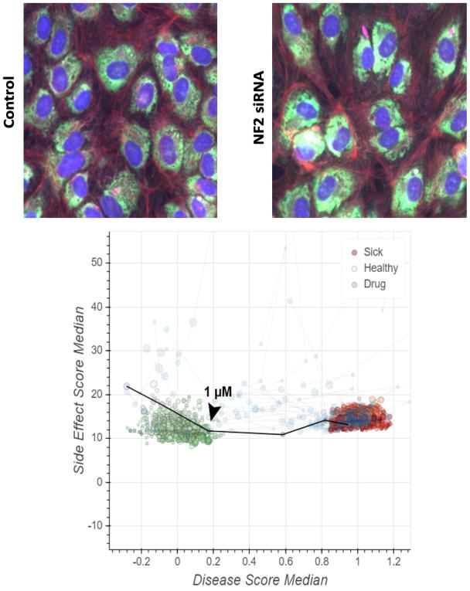

Figure 39. REC-2282 rescued the loss of NF2. A) Immunofluorescent images of human endothelial cells treated with siRNA control or siRNA NF2. B) REC-2282 rescued the high-dimensional disease phenotype as evidenced with a left shift from the disease to the healthy state. HUVEC, human umbilical vein endothelial cells; NF2, neurofibromatosis type 2; siRNA, small interfering RNA.

45

Table of Contents

REC-2282, is an orally bioavailable, CNS-penetrating, pan-histone deacetylase, or HDAC, inhibitor with PI3K/AKT/mTOR pathway modulatory activity. By comparison to marketed HDAC inhibitors, REC-2282 is uniquely suited for patients with NF2 and NF2-mutant CNS tumors, due to its oral bioavailability, CNS-exposure, and as of yet undocumented cardiovascular liabilities.
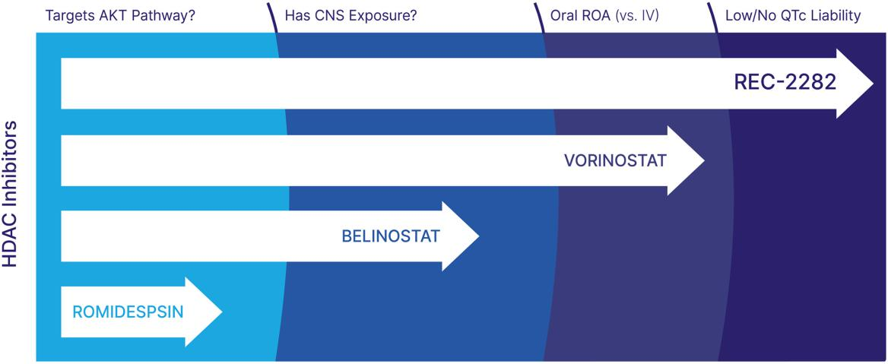

Figure 40. REC-2282 would be a first-in-class HDAC inhibitor for the potential treatment of NF2 meningiomas. We believe REC-2282 is well suited for NF2 vs other HDAC inhibitors due to its oral bioavailability and CNS-exposure.^{12,13,14}

NF2 disease is driven by mutations in the NF2 gene, which encodes an important cell signaling modulator, merlin. Loss of merlin results in activation of multiple signaling pathways converging on PI3K/AKT/mTOR among others and results in enhanced cell proliferation. Anti-neoplastic effects of HDAC inhibitors, like REC-2282, are thought to derive primarily via disruption of the protein phosphatase 1 (PP1)-HDAC interaction, and the subsequent inhibition of PI3K/AKT signaling leading to growth arrest and apoptosis of cancer cells.

- Sborov, D.W et al. (2017) A phase 1 trial of the HDAC inhibitor AR-42 in patients with multiple myeloma and T- and B-cell lymphomas. Leuk Lymphoma, 58(10), 2310-2318.
- Collier KA, et al. (2021). A phase 1 trial of the histone deacetylase inhibitor AR-42 in patients with neurofibromatosis type 2-associated tumors and advanced solid malignancies. Cancer Chemother Pharmacol. 87(5), 599-611.
- Prescribing Information of Vorinostat/Belinostat/Romidepsin respectively.

46

Table of Contents
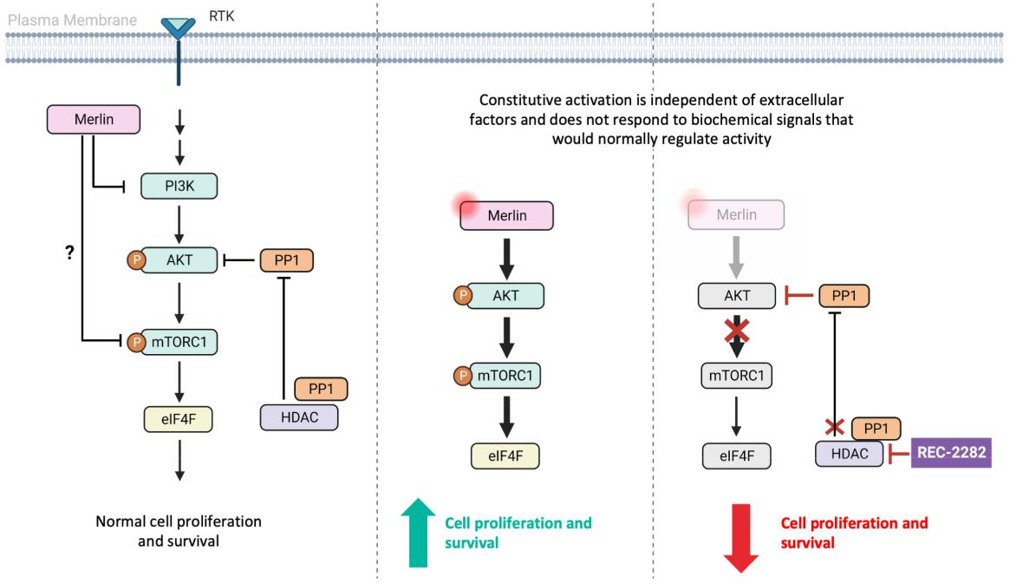

Figure 41. REC-2282 acts on an important pathway in tumor development to inhibit the growth of tumor cells. A potential mechanism of action of REC-2282 in NF2.¹⁵

Preclinical

After we discovered the novel use of REC-2282 for NF2 using our platform, we performed a literature search to better understand the molecule and validate its activity in disease relevant preclinical models. REC-2282 has been shown to be pharmacologically active in various human cancer cell lines and human cancer xenograft models. REC-2282 had been shown to inhibit in vitro proliferation of vestibular schwannoma, or VS, and meningioma cells by inducing cell cycle arrest and apoptosis at doses that correlate with AKT inactivation. In preclinical models, REC-2282 inhibited the growth of primary human VS and Nf2-deficient mouse schwannoma cells, as well as primary patient-derived meningioma cells and the benign meningioma cell line, Ben-Men-1.

In animal models of NF2, REC-2282 suppressed in vivo tumor growth of an Nf2-deficient mouse vestibular schwannoma allograft. In addition, REC-2282 suppressed in vivo tumor growth of human vestibular schwannoma xenograft models in mice fed chow formulated to deliver 25 mg/kg/day REC-2282 for 45 days. REC-2282 also suppressed the growth of meningioma cells in an orthotopic mouse model of NF2-deficient meningioma that contained luciferase-expressing Ben-Men-1 meningioma cells. These animal data served as a functional and orthogonal validation of our platform findings.

- Adapted from Petrilli and Fernández-Valle. (2016). Role of Merlin/NF2 inactivation in tumor biology. Oncogene, 35(5), 537-48.

47

Table of Contents
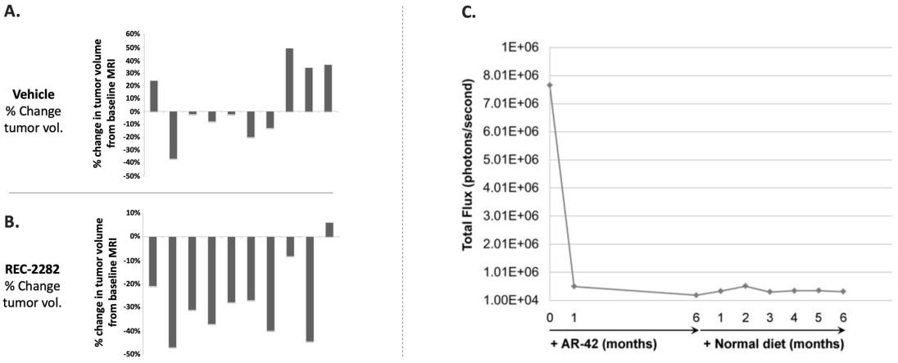

Figure 42. REC-2282 shrinks vestibular schwannoma xenografts in SCID-ICR mice and prevents growth & regrowth of tumors in the NF2-deficient meningioma mouse model. (A) Change in VS tumor volume for each control mouse, demonstrating a mean 6% increase. (B) REC-2282 significantly reduces the mean size of VS tumor volume by ~28% across SCID-ICR mice implanted with VS xenografts. Error bars shown are the 95% CI. P=0.006. C) REC-2282 also suppressed the growth of Ben-Men-1-LucB tumor xenografts as measured by tumor bioluminescence.^{16,17}

Clinical

Four Investigator-Sponsored Trials (ISTs) of REC-2282 (previously referred to as AR-42) have been completed. In study AR-42-001, REC-2282 was administered as monotherapy. In the other 3 trials, REC-2282 was administered in combination with anti-neoplastic agents: decitabine (AR-42-002), pazopanib (AR-42-003) and pomalidomide (AR 42 004), respectively. In these studies, REC-2282 was given to 77 patients with solid or hematological malignancies in doses ranging from 20 mg to 80 mg three times a week for three weeks followed by one week off-treatment in four-week cycles. Multiple patients were treated for multiple years using this dosing regimen at the 60 mg dose and the longest recorded treatment duration is 4.4 years at the 40 mg dose. The majority of adverse events were transient cytopenia that did not result in dose reduction or stoppage. The MTD in patients with solid tumors was determined to be 60 mg. The REC-2282 plasma exposure in patients with hematological malignancies and solid tumors generally increased with increasing doses. There were no consistent signs of plasma REC-2282 accumulation across a 19-day administration period nor obvious differences in PK between hematologic and solid tumor patients.

In another early Phase 1 pharmacodynamic IST conducted by Ohio State University, it appeared that REC-2282 suppressed aberrant activation of ERK, AKT and S6 pathways in vestibular schwannomas from adult patients undergoing tumor resection. These results may be difficult to achieve with single pathway inhibitors of ALK or MEK.

Recursion is currently enrolling patients in POPLAR, an adaptive, Phase 2/3, randomized, multicenter study to evaluate the efficacy and safety of REC-2282 in patients with progressive NF2-mutated meningiomas with underlying NF2 disease and sporadic meningiomas with documented NF2 mutations. The study is designed to accelerate the path to potential product registration by allowing for initiation of a confirmatory Phase 3 study prior to full completion of Phase 2. This is a two-staged Phase 2/3 with enrollment done in two parts. Cohort A is a signal seeking Phase 2 in which 20 adult subjects and up to nine adolescent subjects will begin treatment on two active dose arms. Subject safety will be monitored by an independent Data Monitoring Committee, which will apply dose modification and stopping rules as indicated. After all 20 adult subjects have completed six months of treatment, an interim analysis will be performed for the purpose of 1) determination of go/no-go criteria for Cohort B, or the Phase 3 portion of the study, 2) selection of the dose(s) to carry forward, 3) re-estimation of sample size for the planned Phase 3 and 4) agreement from FDA to initiate the Phase 3. Subjects in the Phase 2 portion will continue treatment for up to 26 months total and then have the option to enroll in an Extension study. The Phase 3 portion currently requires recruitment of an additional 60 subjects (adult and potentially adolescent subjects), who will receive treatment for up to 26 months. The planned primary endpoint is Progression-Free Survival (PFS).

- Adapted from Jacob A, et al. (2012). Triological Society Thesis Preclinical Validation of AR42, a Novel Histone Deacetylase Inhibitor, as Treatment for Vestibular Schwannomas. Laryngoscope, 122(1), 174-189.
- Burns SS, et al. (2013). Histone Deacetylase Inhibitor AR-42 Differentially Affects Cell-cycle Transit in Meningeal and Meningioma Cells, Potently Inhibiting NF2-Deficient Meningioma Growth. Cancer Res; 73(2), 792-803.

48

Table of Contents
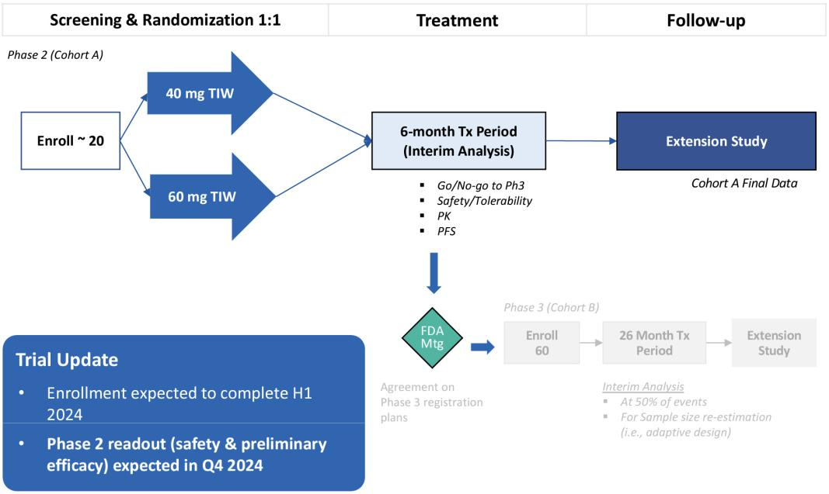

Figure 43. Phase 2/3 study schema for REC-2282. Phase 2/3 two-staged study design to assess the safety, tolerability, and preliminary efficacy of REC-2282 in patients with progressive NF2-mutated meningiomas. Enrollment criteria include MRI-confirmed progressive meningioma and either (1) sporadic meningiomas with confirmed NF2 mutation or (2) confirmed diagnosis of NF2 disease. The primary outcome measure for the Phase 2 portion of the study is progression-free survival (PFS) rate at 6 months.

Competitors

There are currently eight active programs in clinical development targeting NF2-driven brain tumors.

- Brigatinib, an approved ALK inhibitor for NSCLC from Takeda Pharmaceuticals, is in Phase 2 for NF2 disease meningioma, vestibular schwannoma, and ependymoma.

- Neratinib, an approved HER2 inhibitor for HER2+ breast cancer after trastuzumab-based therapy from Puma Biotechnology, is in Phase 2 for NF2 disease meningioma, vestibular schwannoma, and ependymoma

- Crizotinib, an ALK/ROS1 inhibitor, is being studied in an investigator sponsored Phase 2 study in progressive vestibular schwannoma in NF2 patients.

- Selumetinib, a MEK inhibitor from AstraZeneca, is being studied in a Phase 2 study for NF2 related tumors.

- GSK2256098, a FAK inhibitor from GlaxoSmithKline, is being studied in a basket Phase 2 for meningiomas with a variety of targeted therapies and genetic alterations, including NF2 mutation.

- IK-930, a TEAD inhibitor from Ikena Oncology, is being studied in a basket Phase 1 for advanced solid tumors driven by hippo signaling, including patients with NF2 mutations.

- VT-3989, a TEAD inhibitor from Vivace Therapeutics, is being studied in a basket Phase 1 for advanced malignant mesothelioma and other tumors with NF2 mutations, including meningiomas.

- IAG933, a TEAD inhibitor from Novartis, is being studied in a basket Phase 1 for advanced malignant mesothelioma and other tumors with NF2 mutations, including meningiomas.

49

Table of Contents

REC-4881 for Familial Adenomatous Polyposis (FAP) - Phase 1b/2

REC-4881 is an orally bioavailable, non-ATP-competitive, allosteric small molecule inhibitor of MEK1 and MEK2 currently under development to reduce polyp burden and progression to adenocarcinoma in FAP patients. REC-4881 was well tolerated in prior clinical studies, demonstrating dose dependent increases in exposure and pharmacological activity. Recursion is currently enrolling patients in TUPELO, a Phase 1b/2, open label, multicenter study with FPI in the Part 2 portion anticipated in H1 2024. Orphan Drug Designation in the US and EU as well as Fast Track Designation in the US have been granted. We expect to share Phase 2 safety and preliminary efficacy data in H1 2025.

Disease Overview

FAP is a rare tumor predisposition syndrome affecting approximately 50,000 patients in the US and EU5 with no approved therapies. FAP is a genetic disorder resulting from a heterogeneous spectrum of point mutations in the adenomatous polyposis coli (APC) gene. The APC gene is a tumor suppressor gene which encodes a negative regulator of the Wnt signaling pathway.

FAP is characterized by progressive development of hundreds to thousands of adenomatous polyps in the lower gastrointestinal tract, mainly in the colon and rectum, and is associated with up to a 100% lifetime risk of colorectal cancer before age 40 if left untreated. The standard of care for patients with FAP is colectomy in late teenage years. Without surgical intervention, affected patients will progress to colorectal cancer by early adulthood. Post-colectomy, patients receive endoscopic surveillance every 6-12 months to monitor disease progression given the ongoing risk of malignant transformation.

Despite removing the main at-risk organ, approximately 50% of patients will develop adenomatous lesions in the neo-rectum. Once endoscopic management is no longer sufficient, additional surgical procedures are required. Similarly, these patients also develop duodenal (particularly ampullary) adenomas which also require endoscopic management. In the presence of larger adenomas and evidence of carcinoma, patients require additional localized surgery, including radical Whipple procedures. There are currently no approved therapies for FAP.

Insights from Recursion OS

The novel use of REC-4881 for FAP was discovered by leveraging knock-down of the FAP disease gene APC in human cells using the Recursion OS. To select REC-4881 as a potential therapeutic for FAP, Recursion developed a high content phenotypic screen to identify cellular and structural changes associated with knockdown of APC using small interfering RNA (siRNA) in osteosarcoma U2OS cells. Using machine vision and automated analysis software, Recursion quantified hundreds of cellular parameters associated with APC knockdown. This complex phenotype was used as the basis for a chemical screen of more than 3,000 known drugs and bioactive compounds, revealing several RAF and MEK inhibitors, including REC-4881, which reversed the structural defects associated with loss of APC. REC-4881 exhibited highly specific and potent reversal of cellular phenotypes when compared to the MEK inhibitors selumetinib and binimetinib.

50

Table of Contents
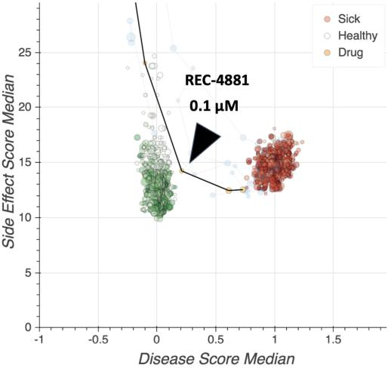

Figure 44. REC-4881 rescued phenotypic defects of cells with APC knockdown. Compared to thousands of other molecules tested, REC-4881 rescued phenotypic defects substantially better (including better rescue than other MEK inhibitors) for APC-specific knockdown.

REC-4881 is an orally bioavailable, non-ATP-competitive, allosteric small molecule inhibitor of MEK1 and MEK2 (IC50 2-3 nM and 3-5 nM, respectively) that is being developed to reduce polyp burden and progression to adenocarcinoma in FAP patients.

FAP is driven by loss of function of APC, which is a critical component of the β-catenin destruction complex, leading to aberrant activation of the Wnt pathway. This Wnt-on state can lead to RAS stabilization, activation of the RAS/ERK pathway and the activation of MYC, leading to cell proliferation and survival - including the growth of adenomas seen in FAP. REC-4881 inhibits MEK1/2 thereby inhibiting ERK activation, decreasing MYC activity, restoring cells back to a Wnt-off state and inhibiting cell proliferation.

Lending further support for the use of MEK inhibitors in FAP, studies have shown that ERK signaling is activated in adenoma epithelial cells and tumor stromal cells, including fibroblasts and vascular endothelial cells. In addition, genomic events resulting in alteration of mitogen-activated protein kinase signaling, such as activating mutations in KRAS, are frequent somatic events that promote the growth of adenomas in FAP. Overall, suppression of aberrant MAPK signaling in adenomas of FAP with REC-4881 has the potential to regress or slow the growth of these tumors by acting on core pathways driving their growth.

51

Table of Contents
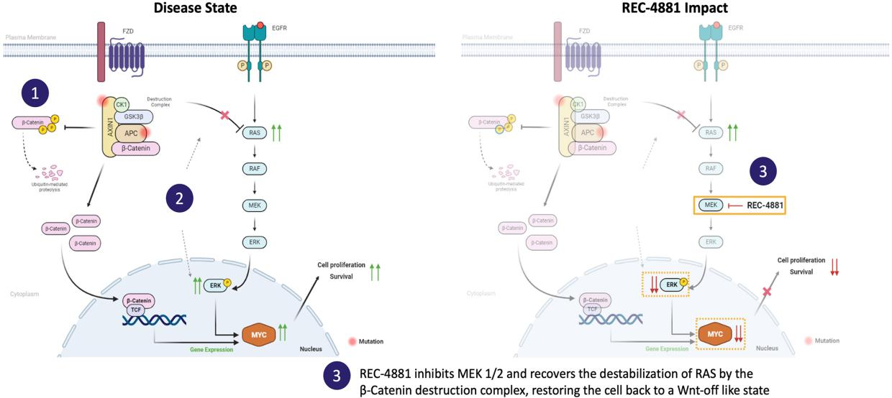

Figure 45. REC-4881 inhibits APC-mutation induced MAPK signaling to block cell proliferation in the context of FAP. A potential mechanism of action of REC-4881 in cells with loss of function mutations in APC.¹⁸

Preclinical

We validated the findings from the initial phenotypic screens using tumor cell lines and spheroids grown from human epithelial tumor cells with a mutation in APC. REC-4881 inhibited both the growth and organization of spheroids in these models and, in tumor cell lines, had well over a 1,000-fold selectivity range in cells harboring APC mutations.

We subsequently evaluated REC-4881 in a disease relevant preclinical model of FAP. Mice harboring truncated Apc, or Apc^{Min}, were treated with multiple oral daily doses of REC-4881 or celecoxib (as a comparator) over an eight-week period. Mice treated with celecoxib had approximately 30% fewer polyps than did those treated with vehicle, whereas mice treated with 1 mg/kg or 3 mg/kg REC-4881 exhibited approximately 50% fewer polyps than vehicle-treated mice. Mice that were treated with 10 mg/kg REC-4881, the highest dose tested, exhibited an approximately 70% reduction in total polyps.

In FAP, polyps arising from mutations in APC may progress to high-grade adenomas through accumulation of additional mutations and eventually to malignant cancers. To evaluate the activity of REC-4881 on both benign polyps and advanced adenomas, gastrointestinal tissues from mice treated with REC-4881 were histologically evaluated and polyps were classified as either benign or high-grade adenomas. While celecoxib reduced the growth of benign polyps in the model, a large proportion of polyps that remained were dysplastic. By contrast, treatment with REC-4881 specifically reduced not only benign polyps, but also precancerous high-grade adenomas, a finding with the potential for translational significance.

- Jeon, WJ, et al. (2018). Interaction between Wnt/β-catenin and RAS-ERK pathways and an anti-cancer strategy via degradations of β-catenin and RAS by targeting the Wnt/ β-catenin pathway. npj Precision Oncology, 2(5).

52

Table of Contents
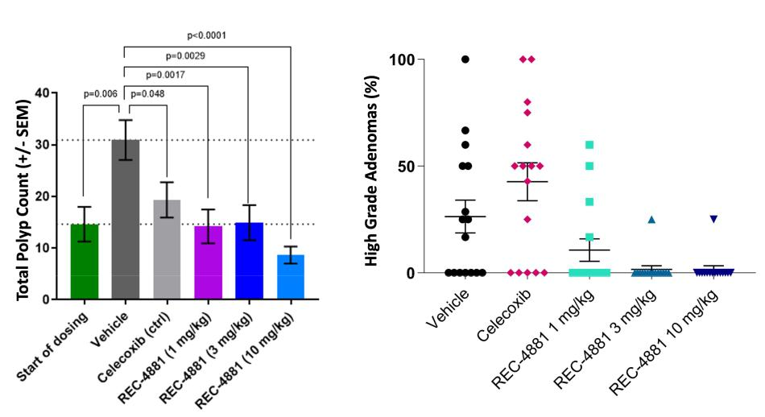

Figure 46. REC-4881 reduces GI polyp count and high-grade adenomas in the Apc^{Min} mouse model of FAP. GI polyp count (left panel) and the percent of high-grade adenomas (right panel) after oral administration of indicated dose of REC-4881, celecoxib, or vehicle control for 8 weeks. Polyp count at the start of dosing reflects animals sacrificed at the start of study (15 weeks of age). P < 0.001 for all REC-4881 treatment groups versus vehicle control. Quantification of high-grade adenomas versus total polyps was based on blinded histological review by a pathologist. While celecoxib reduces benign polyps, the majority of remaining lesions are high grade adenomas. By contrast, REC-4881 reduces both polyps and high-grade adenomas.

Clinical

In the Phase 1 dose escalation study previously conducted by Millenium Pharmaceuticals in 51 participants with non-hematologic malignancies (Study C20001), TAK-733 (REC-4881) was administered in the dose range of 0.2 mg QD to 22 mg QD for 21 days. The maximum tolerated dose (MTD) was determined to be 16 mg QD in this study. In this study, REC 4881 exposures increased in a less than dose-proportional manner.

The most commonly reported AEs were rashes, with rash of any type reported in 34 participants (67%); 4 of the 7 participants who discontinued study drug treatment due to an AE discontinued for rash or some type of skin condition. Fourteen (27%) participants experienced at least 1 treatment-emergent SAE; the only SAEs that occurred in more than 1 participant were metastatic melanoma (3 participants; 6%), pulmonary embolism (2; 4%) and anemia (2; 4%). Five participants died during the study; all deaths were due to disease progression.

REC-4881-101 was a safety and PK study conducted by Recursion in healthy volunteers to confirm comparability of REC-4881 with TAK-

- Twenty-five (25) healthy participants, separated into 2 cohorts, were exposed to single doses of REC-4881 4 mg and 8 mg (under fed and fasting conditions) and single doses of REC-4881 12 mg (under fasting conditions). Each cohort received single doses of study drug across 3 study periods with each period separated by 14 days.

REC-4881 was generally well tolerated. No deaths or SAEs were reported during the study. For both cohorts, the percentage of participants reporting TEAEs was comparable between participants who received REC-4881 and placebo. No apparent relationship with the dose of REC-4881 or food conditions was observed. All TEAEs were assessed by the Investigator as being of Grade 1 severity except 1 (blurred vision reported with 4 mg REC-4881/fed). Two additional participants reported treatment-related eye disorders (blurred vision in both eyes in 1 participant with 8 mg REC-4881/fasted and vitreous floaters in 1 participant with 12 mg REC-4881/fasted). In all instances, the symptoms resolved. Notably, no instance of QTcF abnormality (change from baseline or prolongation) was noted in these healthy participants.

Recursion is currently enrolling patients in TUPELO, a Phase 1b/2, open label, multicenter study to evaluate efficacy, safety, pharmacokinetics, and pharmacodynamics of REC-4881 in patients with FAP. The study is being conducted in two parts. Part 1 evaluated the PK, safety, tolerability, and PD in participants with FAP following administration of REC-4881 in single and multiple doses. Five FAP patients received single dose and 14 days of

53

Table of Contents

REC-4881 treatment at 4 mg QD. 4 mg QD was generally well tolerated with a safety profile consistent with other MEK inhibitors. Preliminary PD data suggests the 4 mg dose may be pharmacologically active in FAP patients. Part 2 will assess the efficacy, safety, PK, and PD following administration of once daily doses of REC-4881 to participants with FAP who have previously undergone a colectomy/proctocolectomy and have a confirmed germline APC mutation. Study drug will be administered orally for 3 months.
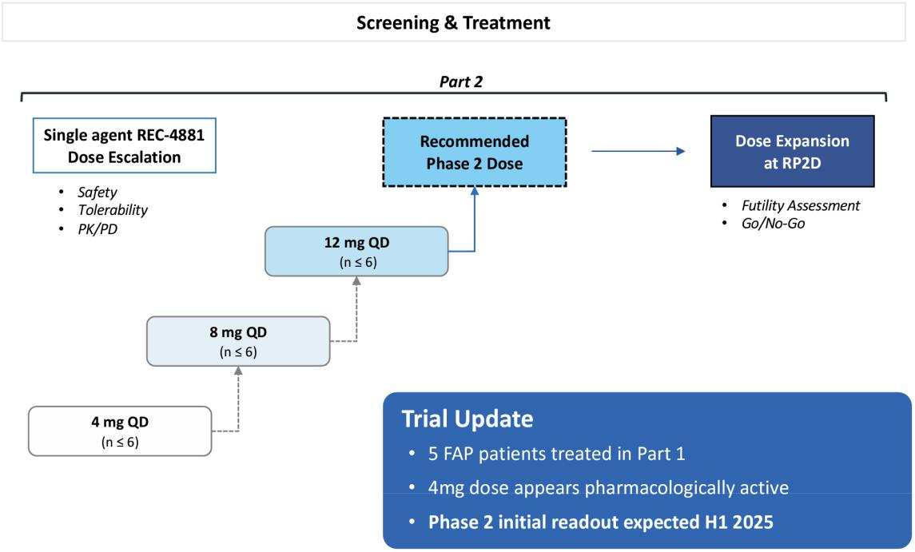

Figure 47. Phase 1b/2 study schema for REC-4881 in FAP. Phase 1b/2 clinical study to assess the efficacy, safety, and pharmacokinetics of REC-4881 in patients with classical FAP. Enrollment criteria include (1) Confirmed APC mutation; (2) ≥ 55 years of age; (3) Post-colectomy/proctocolectomy; (4) No GI cancer; (5) Polyps in duodenum (including ampulla of Vater and/or rectum/pouch). Outcome measures: PK, safety, tolerability, preliminary efficacy (change from baseline in polyp burden, histological grade, extent of desmoid disease).

Competitors

There are currently three active programs in clinical development for FAP.

- ALFA, also known as eicosapentaenoic acid from SLA Pharma, is currently in Phase 3 for FAP patients that harbor a pathogenic APC mutation and have had a previous colectomy.

- Flynpovi, a combination of CPP-1X and sulindac from Panbela, is currently in Phase 3 for FAP patients with a focus on lower GI disease. Further guidance on a regulatory path forward is expected in H2 2024.

- eRapa, an mTORC1 inhibitor also known as encapsulated rapamycin from Emtora Biosciences, is currently in Phase 2 for FAP patients.

REC-4881 for AXIN1 or APC Mutant Cancers - Phase 2

REC-4881 is an orally bioavailable, non-ATP competitive, allosteric small molecule inhibitor of MEK1 and MEK2 being developed for the treatment of AXIN1 or APC mutant cancers. REC-4881 was well tolerated in prior clinical studies, demonstrating dose dependent increases in exposure and pharmacological activity. Recursion initiated LILAC, a Phase 2 study in AXIN1 or APC mutant cancers at the end of 2023, and FPI is anticipated in Q1 2024. We expect to share safety and preliminary efficacy data in H1 2025.

54

Table of Contents

Disease Overview

AXIN1 and APC function as critical tumor suppressors that form part of the beta-catenin destruction complex, directly and indirectly regulating beta-catenin and RAS levels, respectively, in the cell. Aberrant activation of the Wnt and RAS pathways through inactivating mutations in AXIN1 or APC appear frequently across a wide variety of human cancers with an estimated 65,000 patients in the US and EU5 eligible for treatment in the second line. These tumors are often considered clinically aggressive and less sensitive to treatments with chemotherapies and/or immunotherapies, representing a heavily refractory population. Accordingly, there is a substantial need for developing therapeutics for patients harboring mutations in AXIN1 or APC, as these mutations are considered undruggable. There are no treatments specifically approved for AXIN1 or APC mutant cancers.

Insight from Recursion OS

The REC-4881 program for AXIN1 or APC mutant cancers is our first program nominated solely based on our inferential search approach. In our HUVEC map, we discovered that REC-4881 exhibited a phenotypically opposite relationship across clinically relevant doses to the gene knockout of AXIN1, in addition to the previously uncovered relationship with APC. We interpreted this relationship as a second novel insight around this molecule and that the use of REC-4881 could potentially restore the biological consequences driven by AXIN1 or APC loss, found in many cancers.

Two additional insights provided us with conviction in this interpretation:

- AXIN1 and APC are central components of the beta-catenin destruction complex. This destruction complex physiologically regulates the levels of beta-catenin and RAS in cells. As AXIN1 and APC exist together in a complex, they are considered functionally related. Our map revealed a strong degree of phenotypic similarity between the gene knockout of AXIN1 and APC, suggesting that this axis of biology is recapitulated in our high dimensional embedding space.

- Our Phase 1b/2 program for REC-4881 in FAP was initiated using our brute-force screen approach where we discovered a concentration dependent cellular restoration from a modeled disease state (APC gene knockdown by siRNA) to a modeled healthy state (wildtype) in the U2OS cell type. Our map imputed a similar phenotypic effect with REC-4881 across concentrations in HUVEC, suggesting alignment between the brute-force approach and the inferential search approach. These discoveries arose from two different cell contexts, were conducted at different points in time, and under different conditions, robustly validating our interpretation.
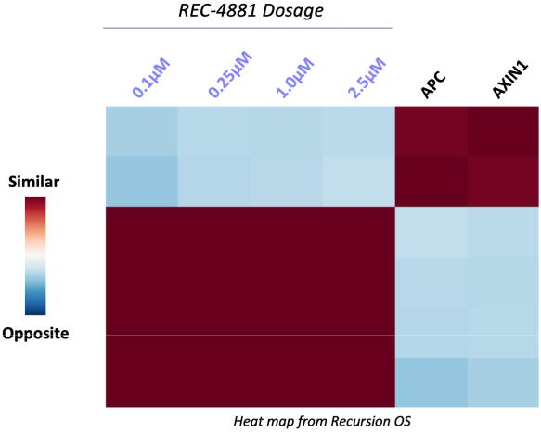

Figure 48. Insights from Recursion OS. REC-4881 displays a phenotypic opposite relationship across clinically relevant doses to genetic knockout of AXIN1 and APC in HUVEC.

55

Table of Contents

Preclinical

On the basis of our inference generation from our Recursion OS, we advanced REC-4881 into two PDX mouse studies, focusing on HCC and Ovarian tumors. A PDX clinical trial (PCT) is a population study with PDX models that can be used to assess efficacy and predict responders to treatment in the preclinical setting. Across 29 total PDX models, treatment with single-agent REC-4881 resulted in a significantly better response in AXIN1 or APC mutant models versus wildtype models. These responses led to a significant benefit in PFS (modeled as the time of tumor doubling from baseline), observed specifically in AXIN1 or APC mutant models, providing further evidence of a biomarker driven effect.
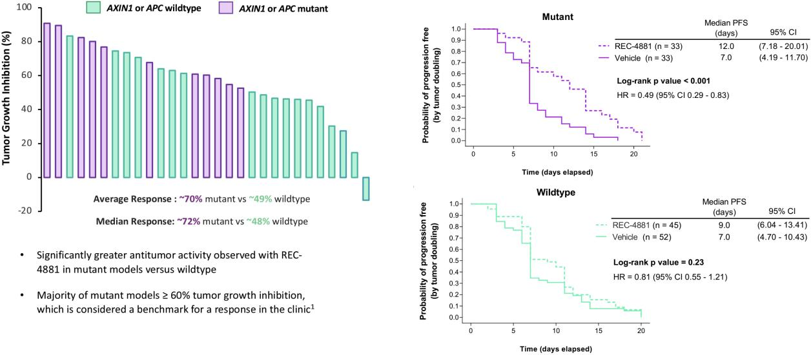

Figure 49. Tumor growth inhibition and PFS across 29 PDX mouse models. REC-4881 shows enhanced activity in mouse models with AXIN1 or APC mutant tumors. Tumor volumes were measured three per week after randomization in two dimensions using a caliper, and the volume was expressed in mm3 using the formula: V = (L x W x W)/2, where V is tumor volume, L is tumor length (the longest tumor dimension), and W is tumor width (the longest tumor dimension perpendicular to L). %TGI was calculated using the formula %TGI = (TV vehicle - TV treatment) / (TV vehicle – TV initial) *100 for all mice (Wong, H, et al. Clin Cancer Res., 2012, 18(14): 3846-3855).

Clinical

LILAC, a Phase 2 open label, multicenter study in select tumor types initiated towards the end of 2023 with FPI anticipated in Q1 2024. This phase 2, open label, multicenter study is designed to evaluate the safety, tolerability, PK, PD, and preliminary anti-tumor activity of REC-4881 administered orally (PO) at an initial dose of 12 mg on a once daily (QD) schedule in participants with unresectable locally advanced or metastatic cancer harboring AXIN1 or APC mutations. Participants must have progressed on at least one prior line of therapy in order to be eligible for the trial.

The study will consist of two arms – an AXIN1 cohort and an APC cohort and two parts. In Part 1, a maximum of 20 participants will be enrolled in a 1:1 allocation across each arm. In Part 2, up to 20 additional patients may be enrolled in each arm. Once the first six cumulative participants have enrolled in Part 1, enrollment will be briefly paused, and a safety assessment will be conducted by a Safety Review Committee to review the completion of the first four weeks of study drug. The study will follow a Bayesian design with futility analysis after the first 10 participants have been enrolled in each arm of the trial. Study drug may be administered for up to 2 years. Disease status will be evaluated every eight weeks, for the first 24 weeks, and then every 12 weeks, until treatment discontinuation or withdrawal. The primary endpoints for this study are safety, tolerability, and preliminary anti-tumor activity as measured by Objective Response Rate (ORR). We expect to share safety and preliminary efficacy data in H1 2025.

56

Table of Contents
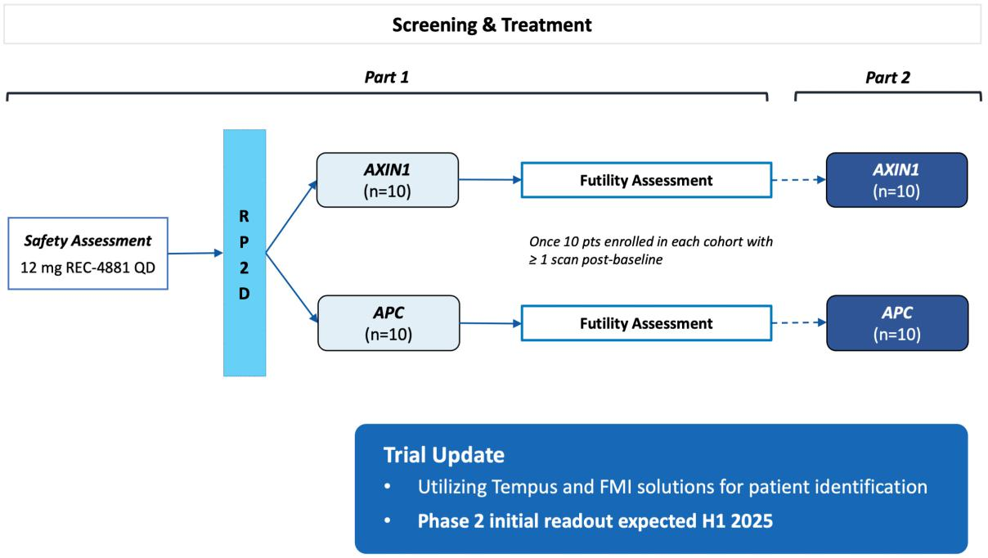

Figure 50. Phase 2 study schema for REC-4881 in AXIN1 or APC mutant cancers. Phase 2 open label, multicenter clinical study to assess the efficacy, safety, and pharmacokinetics of REC-4881 in patients with AXIN1 or APC mutant cancers. Enrollment criteria include (1) unresectable, locally advanced, or metastatic cancers; (2) ≥ 55 years of age; (3) confirmed AXIN1 or APC mutation by NGS (tissue or blood); (4) no MEK inhibitor treatment within 2 months of initial dose; (5) ≥ 1 prior line of therapy; and (6) ECOG PS 0-1. The primary endpoints are safety, tolerability, and preliminary anti-tumor activity as measured by Objective Response Rate (ORR).

Competitors

There are currently 3 active programs in clinical development for AXIN1 or APC mutant cancers.

- FOG-001, a TCF-blocking β-catenin inhibitor from FogPharma, is being studied in a Phase 1/2 trial in patients with locally advanced or metastatic solid tumors with Wnt activating mutations, including AXIN1 or APC.

- Tegavivint, a TBL1 inhibitor from Iterion Therapeutics, is being studied in a Phase 1/2 trial in combination with pembrolizumab in patients with advanced hepatocellular carcinoma harboring mutations in either CTNNB1 or AXIN1.

- DKN-01, an anti-DKK1 monoclonal antibody from Leap Therapeutics, is being studied in a Phase 2 trial in combination with pembrolizumab in patients with advanced or recurrent endometrial cancer harboring Wnt activating mutations, including AXIN1 or
APC.

REC-3964 for Clostridioides difficile Infection - Phase 2

REC-3964 is an orally bioavailable, small molecule inhibitor of C. difficile glucosyltransferase. This molecule has the potential to prevent recurrent disease and be used as secondary prophylaxis therapy in high-risk patients with C. difficile infections, a leading cause of antibiotic-induced diarrhea and a major cause of morbidity and mortality. A Phase 1 study in healthy volunteers completed in Q3 2023 and demonstrated that REC-3964 was well tolerated with no serious adverse events (SAEs) reported. We expect to initiate a Phase 2 study in 2024.

57

Table of Contents

Disease Overview

C. difficile-induced diarrhea is a leading cause of antibiotic-induced diarrhea and arises from the disruption of normal bacterial flora in the colon. Toxins A, or TcdA, and B, or TcdB, secreted by the bacterium are responsible for considerable morbidity, including severe diarrhea, colitis, toxic megacolon, sepsis, extended hospital stays and potentially, death. More than 730,000 patients are diagnosed in the US and EU5 each year. Recurrence of disease occurs in 20-30% of patients treated with standard of care. Standard of care includes antibiotic therapies which can further impair gut flora and lead to relapse.

Insight Recursion OS

REC-3964 is a new chemical entity that was identified with our brute-force approach which utilized phenomics to identify cellular and structural changes in epithelial cells associated with the pathological changes resulting from exposure to C. difficile toxins. Structure-activity-relationship (SAR) was driven through the Recursion OS to identify structural series that restored structural defects resulting from C. difficile toxins’ effects. REC-3964 was identified from a lead benzodiazepinedione structural series that confers selective antagonism against the C. difficile toxins’ effects with nanomolar potency on our platform, and dose dependent cellular restoration to a modeled healthy state in human endothelial cells.
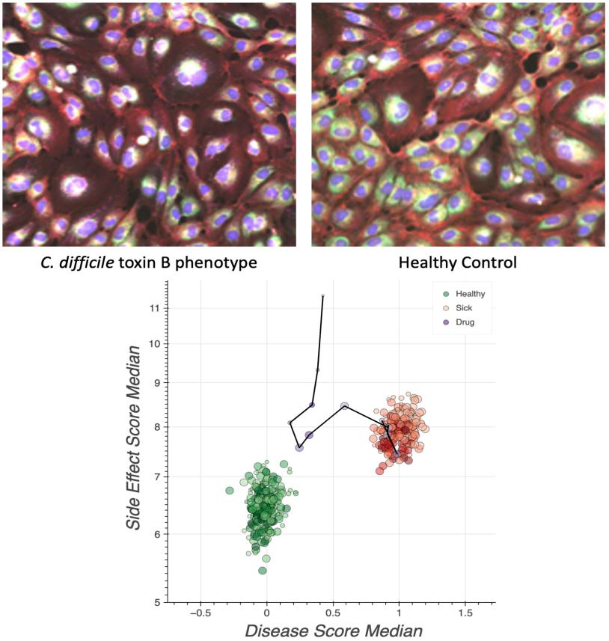

Figure 51. REC-3964 rescued the phenotype of human epithelial cells treated with C. difficile toxin. REC-3964 was identified as demonstrating concentration-responsive rescue in HUVEC cells treated with C. difficile toxin B on Recursion’s phenomics platform.

Preclinical

REC-3964 was validated in orthogonal functional assays including the Electrical Cell-substrate Impedance Sensing (ECIS) assay where it demonstrated concentration-dependent activity in blocking toxin-mediated barrier disruption.

58

Table of Contents

We have shown in a target-based validation assay that REC-3964 selectively inhibits the toxin’s innate glucosyltransferase (IC50 = 4.7-9 nM), suggesting suppression of toxin-induced glycosylation of Rho-GTPases in host cells as the most likely mode of action. REC-3964 has negligible off-target activity, does not target the host’s glucosyltransferases, produces favorable gut and plasma exposure levels following oral dosing, and is non-mutagenic. Further, in an in vivo hamster model of C. difficile infection, treatment with REC-3964 significantly prolonged the survival of animals relative to bezlotoxumab and vehicle treated controls.
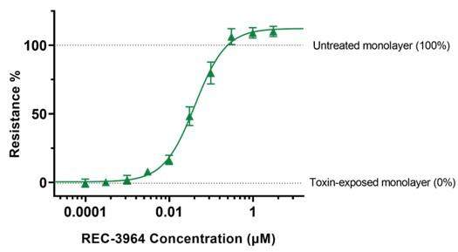

Figure 52. REC-3964 blocks C. difficile Toxin B-mediated endothelial barrier disruption. Transendothelial resistance was quantified with ECIS after incubation of HUVEC cells with 10ng/mL TcdB from C. difficile in the presence of REC-3964. Barrier resistance is shown on a normalized scale with 0% representing the resistance in the absence of REC-3964, and 100% representing the resistance of healthy monolayers that were not exposed to toxin B. Data are presented as Mean ± SEM, N≥3 independent experiments.
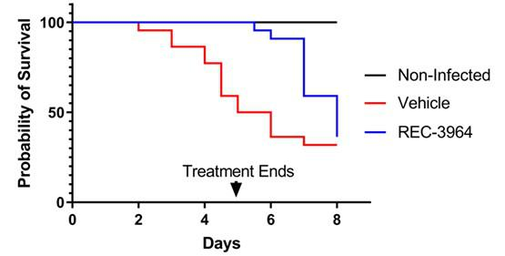

Figure 53. C. difficile infected model hamsters treated with REC-3964 survive longer than vehicle treated animals. REC-3964 was administered by oral gavage twice daily for 5 consecutive days along with groups for vehicle and vancomycin (50 mg/kg, QD). N=5 in untreated and vancomycin treated animals and N=10 in vehicle and REC-3964 treated animals.

59

Table of Contents
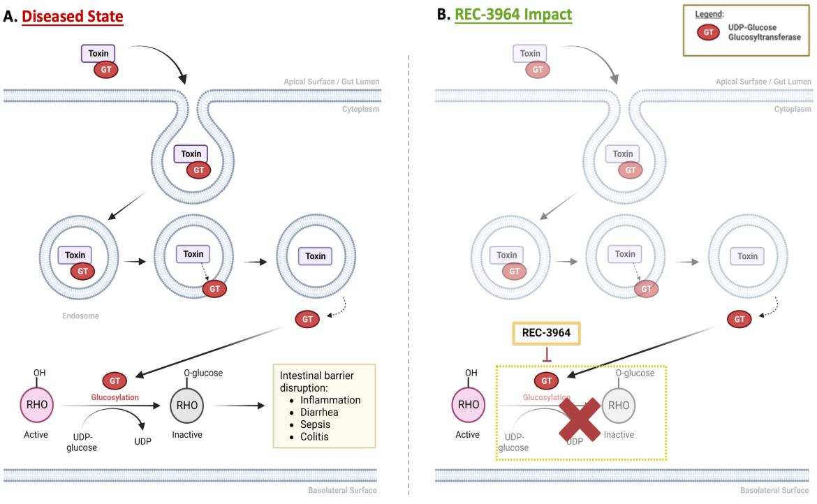

Figure 54. REC-3964 selectively inhibits the toxin’s innate UDP-glucose glucosyltransferase. (A) Autocatalytic event releases C. difficile toxin’s glucosyltransferase enzymatic domain into the infected cell, which locks Rho family GTPases in the inactive state. Inactivation of Rho GTPases alters cytoskeletal dynamics, induces apoptosis and impairs barrier function which drives the pathological effects of C. difficile infection. (B) REC-3964 binds and blocks catalytic activity of the toxin’s innate glucosyltransferase with no effect on the host protein.¹⁹
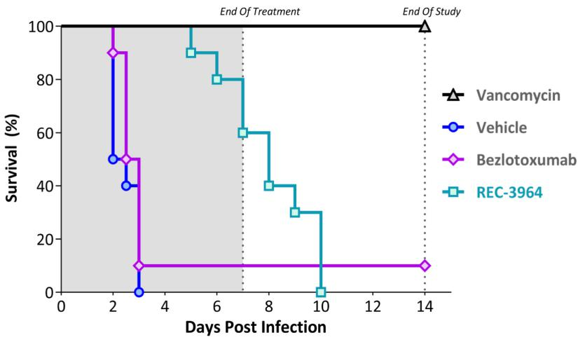

Figure 55. REC-3964 significantly extended survival over the standard of care, bezlotoxumab, in a human disease relevant CDI hamster model. REC-3964 was administered at 200 mg/kg by oral gavage twice daily for 7 consecutive days along with groups for vehicle and vancomycin (50 mg/kg, QD). Bezlotoxumab was administered at 10 mg/kg BID 2 days prior to inoculation with C. difficile (strain 630). N=10 hamsters per group. Clinical observations were conducted from Day 0 to Day 7, with surviving animals monitored until Day 14. REC-3964 demonstrated a significant difference in the probability of survival vs bezlotoxumab at the end of treatment (p<0.001, log-rank test).

- Awad, MM. et al. (2014). Clostridium difficile virulence factors: Insights into an anaerobic spore-forming pathogen. Gut Microbes. 5(5), 579-593.

60

Table of Contents

Clinical

We conducted a Phase 1 healthy volunteer study to evaluate the safety, tolerability, and PK of REC-3964 at increasing oral doses in comparison with placebo. A total of 90 healthy subjects participated in this study with 48 subjects in the Single Ascending Dose (SAD) study and 42 subjects in the Multiple Ascending Dose (MAD) study. The SAD study included a cohort of healthy elderly subjects (age > 65 years). REC-3964 monotherapy was safe and well tolerated at single doses up to 1200 mg (SAD) and multiple doses (MAD) up to 900 mg.

In the SAD study, the most frequently reported TEAE with REC-3964 was contact dermatitis (4 subjects, 11.1%). All TEAEs were mild in severity and the only TEAE that was considered related to REC-3964 was a single TEAE of fatigue. There were no serious adverse events (SAEs), deaths, or TEAEs that led to discontinuation. In the MAD study, the most frequently reported TEAEs with REC-3964 were fatigue and headache (6 subjects each, 17.6%). All TEAEs were mild in severity. For subjects receiving REC-3964, 11.8% (n=4) had TEAEs considered to be related to treatment, consisting of abdominal distension (3 subjects) and flatulence (1 subject). Abdominal distension was also considered to be related to the study drug for 25% (n=2) of subjects who received placebo. There were no serious adverse events (SAEs), deaths, or TEAEs that led to discontinuation.

PK analysis demonstrated that exposures (AUC) increased approximately dose-proportionally across the dose ranges tested and the half-life ranged from approximately 7 to 10 hours. The peak and systemic exposure to REC-3964 was comparable between healthy elderly subjects and subjects aged ≤ 65 years. As a result, BID dosing is expected to reach targeted trough concentrations.

There were no clinically meaningful trends or clinically significant abnormalities in hematology and chemistry and no clinically relevant effects on ECG parameters (including QTcF) or vital signs after administration of single or multiple doses of REC-3964.

We plan to initiate a Phase 2 open label, multicenter study in 2024 to evaluate the safety, tolerability, efficacy, and PK of REC-3964 at doses of either 250 mg or 500 mg both administered orally (PO) twice a day (BID) over a 28-day period compared to an observational cohort after an initial cure with vancomycin. The primary endpoints for this study will be safety, tolerability, and preliminary efficacy as assessed by the rate of recurrent Clostridioides difficile infection (rCDI).
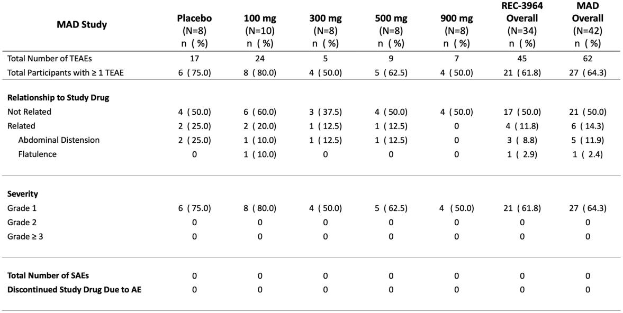

Table 2. Summary of Adverse Events from Phase 1 Multiple Ascending Dose Study. AE=adverse event; MAD=multiple ascending dose; SAE=serious adverse event; TEAE=treatment-emergent adverse event.

61

Table of Contents
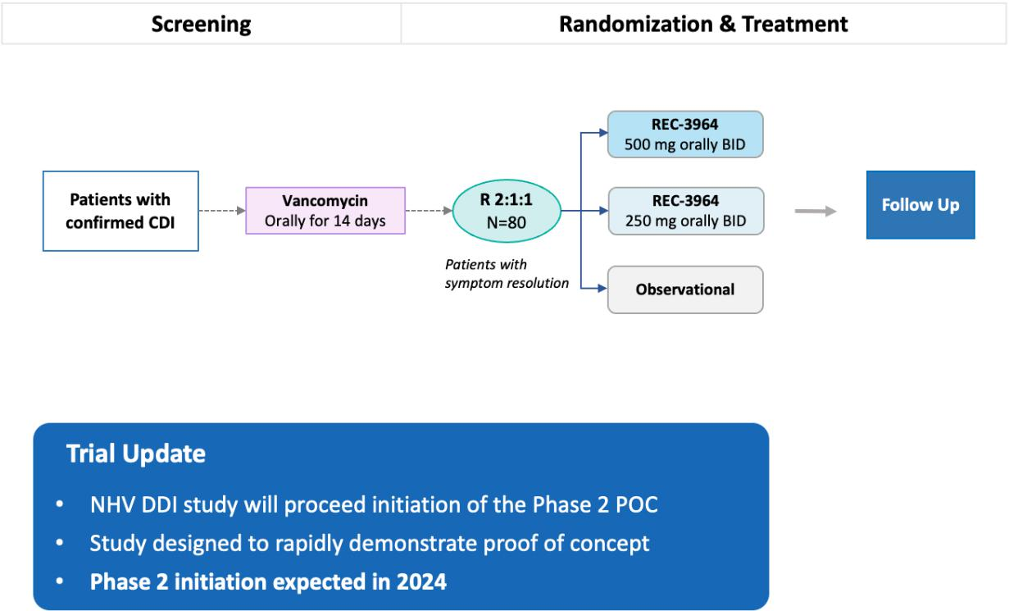

Figure 56. Planned Phase 2 study schema of REC-3964 for prevention of rCDI. Phase 2 open-label, multicenter clinical study to assess the safety, tolerability, PK, and efficacy of REC-3964 at two dose levels. Enrollment criteria include (1) High risk for rCDI; (2) C. difficile associated diarrhea with confirmation of toxin positivity (3) No fulminant CDI; (4) No history of chronic diarrheal illness due to other causes. The primary endpoints are safety, tolerability, and efficacy as determined by the rate of reduction of rCDI after initial clinical cure with vancomycin.

Competitors

There are a number of approved drugs for the treatment and prevention of C. difficile infection.

- Antibiotics are the main treatment for C. difficile infection with vancomycin and fidaxomicin as the two most commonly prescribed. Metronidazole may also be prescribed for severe cases. However, the efficacy of antibiotic therapy decreases with each recurrence.

- Bezlotoxumab is a human monoclonal antibody against C. difficile toxin B approved for reducing CDI recurrence in patients receiving antibiotics who are at high-risk for CDI recurrence.

- Stool derived microbiome products are used to prevent recurrent C. difficile infection with RBX2660 and SER-109 approved for this indication, following antibiotic treatment for recurrent CDI.

There are currently 2 active programs in clinical development for the prevention of recurrent C. difficile infection.

- VE303, an oral microbiome therapeutic from Vedanta Biosciences, is being studied in a Phase 3 trial in patients with ≥ 1 prior occurrence of CDI, including a high-risk for recurrence population.

- LMN-201, an oral biologic from Lumen Bioscience, is being studied in a Phase 2 trial in patients newly diagnosed with CDI planning to receive antibiotic treatment.

To our knowledge, REC-3964 is the first orally bioavailable, non-antibiotic, C. difficile toxin inhibitor that selectively targets bacterial toxin while sparing the host.

62

Table of Contents

Selected Preclinical Programs

- Novel CDK12-adjacent target, RBM39, for the potential treatment of HR-proficient ovarian cancers and other Solid Tumors (previously identified as Target Gamma).

- Potential first-in-class novel chemical entity for the treatment of an undisclosed indication in Fibrosis (Target Epsilon)

HR-Proficient Ovarian Cancers and other Solid Tumors (Previously Identified as Target Gamma)

Using inferential search, we identified compounds that inhibit RBM39 and phenocopy the loss of CDK12, but not CDK13. We further optimized these molecules to generate lead candidates with oral bioavailability capable of single agent activity in homologous recombination proficient (HR-proficient) ovarian cancers and other solid tumors. There are approximately 200,000 drug-treatable patients per year in the US and EU5 whose tumors lack mutations in the homologous recombination repair (HRR) pathway and who have progressed on frontline therapies. While PARP inhibitors have significantly improved outcomes for patients with HR-deficient cancers, patients with HR-proficient tumors have poorer prognosis and unfavorable outcomes. We expect to submit an IND for this program in H2 2024.

Disease Overview

Mutations in DNA repair pathways and genomic instability are a fundamental hallmark of cancer. Large-scale genomic datasets highlight cancers such as ovarian, breast, prostate, pancreatic, non-small cell lung, and small-cell lung cancers harboring molecular alterations within the DDR repair network. Cancers with genetic alterations in the DDR pathway such as homologous recombination (HR) can often be treated with DDR inhibitors, such as PARP inhibitors. However, patients with HR-proficient tumors do not derive significant clinical benefit from PARP inhibitors. Accordingly, there is a high unmet need for developing therapeutics that can regulate DNA repair mechanisms for the treatment of HR-proficient cancers, including ovarian cancer.

Insight from Recursion OS

Reports suggest that genetic or pharmacologic depletion of CDK12 can reduce the expression of several genes involved in the homologous recombination repair pathway such as BRCA1 and BRCA2, inducing a BRCA-like phenotype and DDR response. Thus, CDK12 has received considerable interest as a therapeutic target and tumor biomarker for HR-proficient cancers. Despite reports of functional redundancy, we observed that the genetic knockout of CDK12 could be clearly distinguished phenotypically from that of CDK13. Using map-based inference to characterize and relate cellular phenotypes, we identified RBM39 as an alternative target that selectively mimics CDK12 loss, but not CDK13, providing a novel approach for targeting CDK12 biology while circumventing any toxicities that may arise due to CDK13. We subsequently discovered REC-1170204 as an RBM39 molecular glue degrader that closely mimics the phenotypic loss of CDK12 and RBM39, but not CDK13. Functionally, REC-1170204 treatment globally impacts the expression of many DDR genes but does so in a CDK12 independent manner.

63

Table of Contents
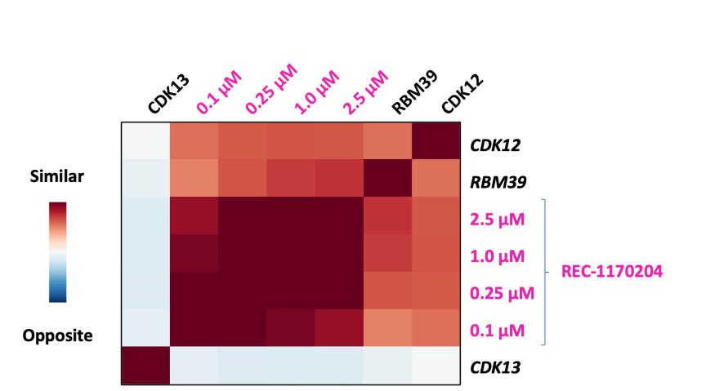

Figure 57: Inferred map relationships between CDK12, CDK13, RBM39 and REC-1170204. Map representation demonstrating a high degree of phenotypic similarity between CDK12, RBM39 and multiple concentrations of REC-1170204. CDK13 shows little or no functional similarity to CDK12, RBM39 or any concentration of REC-1170204.

Product Concept

We aim to discover and develop novel, orally bioavailable, small molecules that drive de novo sensitivity in HR-proficient tumors. While the biological and clinical evidence supporting CDK12 as a therapeutic target is promising, the high homology of CDKs makes targeting a single homolog difficult and prone to off-target toxicity. Mimicking the effects of CDK12 inhibition via alternative novel targets could be a route to treating HR-proficient tumors. We intend to position our lead candidate as a single agent for the potential treatment of HR-proficient ovarian cancers and other HR-proficient solid tumors.

Preclinical

In vivo efficacy studies evaluated REC-1170204 as a single agent and in combination with niraparib in OV0273, an ovarian BRCA proficient patient derived xenograft (PDX) model. We observed statistically significant responses in both single agent REC-1170204 and combination versus either niraparib or vehicle arms. REC-1170204 also demonstrated a significant survival benefit as a monotherapy, or in combination with niraparib at >30 days post final dose. As a result of our strategic collaboration with Tempus, we are leveraging genomic data across all tumor types to identify clinical biomarkers for patient expansion. We are advancing our lead candidate through IND-enabling studies with IND submission expected in H2 2024.
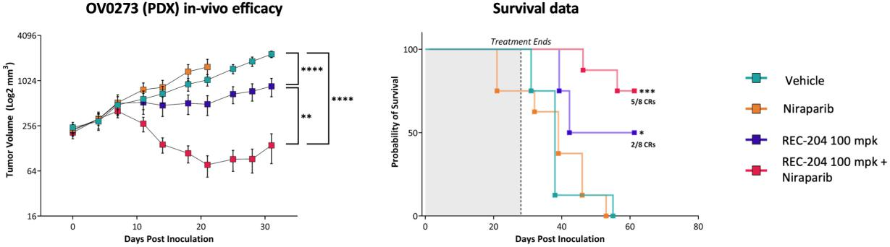

Figure 58. REC-1170204 ± niraparib inhibits tumor growth in the OV0273 PDX mouse model. In the OV0273 PDX model, mice were treated with a

representative lead molecule REC-1170204 (100 mg/kg, BID, PO) ± niraparib (40 mg/kg, QD, PO) for 28 days. Single agent REC-1170204 or in combination with niraparib resulted in a statistically significant response vs either

64

Table of Contents

niraparib or vehicle arms, where the reduction in tumor volume is plotted using a logarithmic scale (y-axis). In addition, there was a statistically significant improvement in survival > 30 days post final dose. *p<0.05, ** p<0.01, **** p<0.0001.

Undisclosed Indication in Fibrosis – Target Epsilon

Phenotypic screening of human PBMCs was used to identify novel and structurally diverse small molecules that reverse the phenotypic features of disease-state fibrocyte cells into those of healthy-state cells. The power of the Recursion OS revealed a relationship between the small molecule hits and a novel target that could impact fibrotic diseases. The most promising hit compounds were confirmed as potent inhibitors of this novel target (Target Epsilon) in validation experiments. Optimized hit compounds were found to be effective in an in vivo mouse model of fibrosis. This program is now entering IND-enabling studies.

Disease Overview

Fibrotic diseases carry a high, mostly unmet clinical need and can afflict all major organs. Patients across fibrotic disease indications may benefit from the modulation of common pathways and cells involved in driving pathogenesis of fibrosis. Immune cells, particularly monocyte-derived cell populations including fibrocytes closely associated with collagen producing myofibroblasts, can drive a fibrotic response exceeding what is necessary for injury repair. Monocyte-derived cells produce growth factors that promote the continued activation of mesenchymal populations. Molecules that modulate this immuno-mesenchymal interface may enable a shift towards a pro-resolution and tissue repair response. Despite the important role these cell types play in fibrotic processes there are no current therapies to effectively target the accumulation and differentiation of these pathogenic cell populations. With limited treatment options, two approved anti-fibrotics, patients need greater therapeutic efficacy to address this burden.

Insight from Recursion OS

With the critical role that monocyte-derived immune cells play in fibrotic disease, we developed a phenotypic screening assay from hPBMC-derived fibrocytes that could capture key features of disease in this important cell type. Human recombinant pentraxin-2 (PTX-2) is a constitutive, anti-inflammatory, innate immune plasma protein whose circulating level is decreased in chronic human fibrotic diseases. PTX-2 has an impact on monocyte differentiation to fibrocytes and macrophage polarization state, which elicit tissue repair and reduce fibrosis. Leveraging Recursion’s phenotypic screening platform, we identified multiple structurally diverse and novel small molecules that were able to phenotypically mimic the morphological effects of PTX-2 on hPBMC-derived fibrocytes and macrophages. The hPBMC-fibrocyte reversal assay was also leveraged for optimization of the identified compounds. Using inferential search of Recursion’s HUVEC phenomap, we identified a putative binding target (Epsilon) for the small molecules which was later confirmed through biochemical binding assays with the isolated protein. The identified target represents a novel approach to modulating immuno-mesenchymal cell populations in fibrosis.
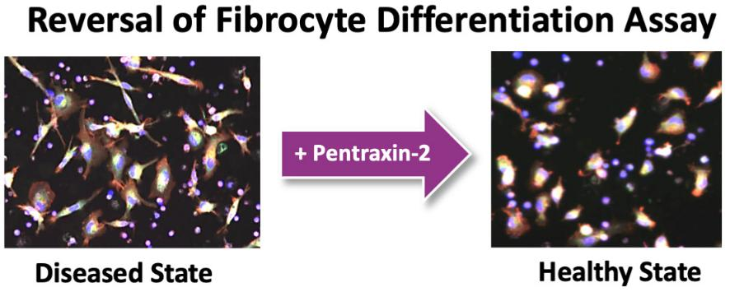

Figure 59: Phenotypic screening assay. Differentiation of human PBMCs into fibrocytes can be reversed by Pentraxin-2, a tissue repair protein, to mimic a healthy state. Small molecules are identified which rescue disease state to healthy state.

65

Table of Contents
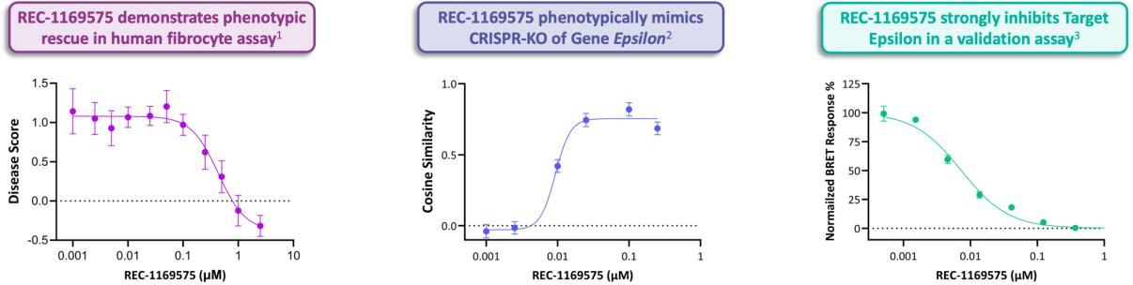

Figure 60: Target and compound identification and validation related to Target Epsilon. (1) Disease Score of 1.0 reflects “disease state” while disease score of 0.0 reflects “healthy state”; (2) cosine similarity between REC-1169575 and genetic knockout of Epsilon is the cosine of the angle between the two vectors in high-dimensional space. Values near 1.0 suggest the angle between perturbations is near 0° and is interpreted as directionally phenosimilar; and

(3) Target Epsilon NanoBRET assay.

Product Concept

We aim to discover and develop an orally bioavailable immuno-mesenchymal modulator offering a novel mechanism of action designed to treat fibro-inflammatory diseases. We are targeting a small molecule with single agent efficacy that reverses fibrosis by modulating fibrocytes, fibrotic macrophages, and adaptive immune cells. Discovered using Recursion’s phenomics platform, our lead molecule has shown promise in both in vitro and in vivo models of fibrosis, suggesting that it might restore immuno-mesenchymal homeostasis and tissue integrity by targeting immune and mesenchymal cell populations. It exhibits a unique profile with immunomodulatory effects on multiple cell types and shows anti-fibrotic effects, with the possibility of differentiating from current treatment options.

Preclinical

We identified multiple structurally distinct small molecules capable of imparting the desired phenotypic rescue of the fibrocyte disease model. REC-1169575, a representative lead molecule, is a potent compound with an EC₅₀ of 0.40 µM in the fibrocyte reversal assay and an IC₅₀ of 12nM at target Epsilon. In digital tolerability, REC-1169575 was well-tolerated in C57BL/6 mice at all doses (30, 200, and 300 mg/kg/day, PO x 6 days). REC-1169575 did not significantly affect the body weight, breathing rate, motion, or body temperature of the mice. In a rodent in vivo efficacy model of fibrosis, REC-1169575 significantly reduced collagen, an important histological marker of fibrosis.

66

Table of Contents
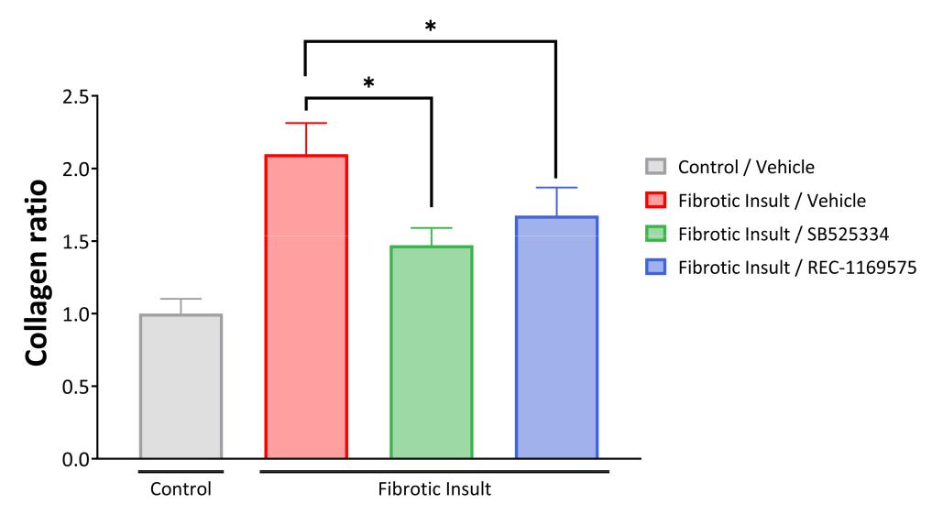

Figure 61: REC-1169575 reduces collagen in a mouse model of fibrosis. There was a statistically significant reduction in collagen ratio, a marker of fibrosis, in both our representative lead molecule REC-1169575 (50 mg/kg BID, PO) and a control molecule known to inhibit fibrosis, SB525334, a selective inhibitor of TGF-beta receptor type 1 compared to fibrosis-induced vehicle treated mice. *p<0.05 (Kruskal-Wallis test)

Therapeutics Partnerships

We have and in the future may collaborate with third parties to broadly explore diverse disease domains (such as fibrosis, neuroscience, oncology, immunology and inflammation) in order to identify novel target insights and potential therapeutics that may include small molecules, large molecules, gene therapies and cell therapies. We may also explore a communal asset-type strategy where we license search results from our phenomaps to partners.

The goal of every partnership is to create therapeutics, yet the approach may take multiple forms:

- Novel Therapeutics. Without any presumptive target hypothesis, we can identify differentiated therapeutics by rapidly evaluating large compound libraries within our maps of human cellular biology.

- Novel Targets. By profiling diverse biological perturbations (such as genetic factors) on our platform, we may be able to identify novel druggable targets that we can then exploit with partners to generate therapeutic candidates.

Roche & Genentech Collaboration and License Agreement

On December 5, 2021, we entered into a Collaboration and License Agreement with Genentech, Inc. and F. Hoffmann-La Roche Ltd, pursuant to which we will construct, using our imaging technology and proprietary machine learning algorithms, unique maps of the inferred relationships amongst perturbation phenotypes in a given cellular context and together with Roche and Genentech will create multimodal models and maps to further expand and refine such inferred relationships, in both cases with the goal to discover and develop therapeutic small molecule programs in a gastrointestinal cancer indication and in key areas of neuroscience.

Upfront Payment. In January 2022, Roche paid us an upfront cash payment of $150.0 million.

Phenomap Creation, Acceptance and Access. Under the Collaboration Agreement, we are responsible for creating a certain number of phenomaps in each of the Exclusive Fields. We will also provide Roche with limited access to our pre-existing human umbilical vein endothelial cells (HUVEC) phenomap. Roche will have specified rights to query or access the phenomaps to generate novel inferences that may lead to the discovery or development of therapeutic products.

67

Table of Contents

Phenomap-Related Options. Each of the phenomaps requested by Roche and created by Recursion may be subject to either an initiation fee, acceptance fee or both. Such fees could exceed $250.0 million for sixteen (16) accepted phenomaps. In addition, for a period of time after Roche’s acceptance of certain phenomaps, Roche will have the option to obtain, subject to payment of an exercise fee, rights to use outside the collaboration the raw images generated in the course of creating those phenomaps. If Roche exercises its External Use Option for all twelve (12) eligible phenomaps, Roche’s associated exercise fee payments to Recursion could exceed $250.0 million.

Collaboration Programs and Roche Options. Roche and Recursion will collaborate to select certain novel inferences with respect to small molecules or targets generated from the phenomaps for further validation and optimization as collaboration programs. Roche and Recursion may also combine sequencing datasets from Roche with Recursion’s phenomaps and collaborate to generate new algorithms to produce multimodal maps from which additional collaboration programs may be initiated. For every collaboration program that successfully identifies potential therapeutic small molecules or validates a target, Roche will have an option to obtain an exclusive license to develop and commercialize such potential therapeutic small molecules or to exploit such target in the applicable Exclusive Field. In October 2023, Roche exercised its Small Molecule Validated Hit Option to further advance our first partnership program in GI-oncology.

Payments if Roche Exercises Option for a Collaboration Program. Under the collaboration, Roche may initiate up to forty (40) small molecule collaboration programs. Each small molecule collaboration program, if optioned and successfully developed and commercialized by Roche, could yield more than $300.0 million in research, development, commercialization and net sales milestones for Recursion, as well as mid- to high-single digit tiered royalties on net sales. Recursion is also eligible for research, development, commercialization and net sales milestones for target collaboration programs optioned by Roche.

Recursion Programs. If Roche does not exercise its options in the Collaboration Agreement for certain collaboration programs, we may, with Roche’s prior consent, choose to independently validate, develop and commercialize products in a limited number of such programs, subject to agreed milestones and royalties to Roche. Roche will have rights to obtain an exclusive license to exploit such products by providing notice and paying us an opt-in fee and economics exceeding those that would otherwise be applicable if Roche had exercised its option for such program.

Exclusivity. During an agreed period of time after the Collaboration Agreement’s effective date, we are subject to certain exclusivities that limit our ability to conduct certain research and development activities with respect to compounds and targets in the Exclusive Fields, other than pursuant to the collaboration with Roche. However, we may continue pursuing products that we are researching and developing in the Exclusive Fields as of the effective date of the Collaboration Agreement.

Termination. The Collaboration Agreement includes standard termination provisions, including for material breach or insolvency and for Roche’s convenience. Certain of these termination rights can be exercised with respect to a particular Exclusive Field or exclusive license, as well as with respect to the entire Collaboration Agreement.
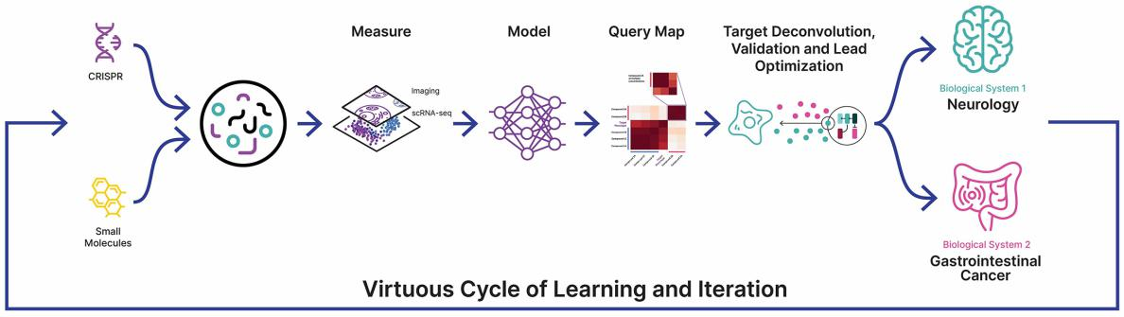

Figure 62. Under our collaboration with Roche & Genentech, we are creating multimodal maps of cellular biology to elucidate novel targets and starting points.

68

Table of Contents

Bayer AG Amended and Restated Research Collaboration and Option Agreement

On August 28, 2020, Recursion and Bayer entered into a Research Collaboration and Option Agreement, which was subsequently expanded on December 1, 2021, for research and collaboration on a certain number of projects related to fibrosis. On November 8, 2023, the parties amended and restated the original Bayer Agreement to re-align the collaboration with Bayer’s strategic shift in focus to oncology. As a result, the parties wound down their joint work in fibrosis and the exclusivities with respect to the field of fibrosis were terminated.

Under the Restated Agreement, Recursion will collaborate with Bayer for the remainder of the five-year period under the original Agreement (extendable by up to 2 years to enable completion of certain research activities), to initiate up to seven programs in oncology. During certain agreed time periods within the collaboration term, Recursion is prohibited from conducting certain research and development activities with respect to certain identified genes of relevance in oncology outside of the collaboration, either by itself or together with third parties. However, Recursion may continue research and development activities for any such identified genes that it has initiated prior to the date of identification of such gene.

Under each oncology project, Recursion will work with Bayer to identify potential lead candidates for development. Under the Restated Agreement, Bayer has the first option to license potential candidates; each such license could potentially result in option exercise fees and development and commercial milestones paid to Recursion with an aggregate value of up to approximately $210.0 million for one license and up to approximately $1.5 billion if each program is licensed, as well as tiered royalties for each such license, ranging from low- to mid-single digit percentages of sales, depending on commercial success. Royalty periods for each license are on a country-by-country basis, and the duration of each such period is tied to the duration of patent or regulatory exclusivity in each country (with a minimum term of 10 years each).

If Bayer does not exercise its option with respect to a lead candidate or otherwise discontinues a project prior to completion, within a specified period of time, Recursion may exercise an option to negotiate with Bayer in good faith to obtain an exclusive license under Bayer’s interest in any lead series developed pursuant to the project and backup compounds related thereto, as well as a non-exclusive license under Bayer’s background intellectual property necessary for Recursion’s use of the project results related to such compounds.

Bayer may terminate the collaboration at any time without cause. Either party may terminate the agreement for a material breach by the other party. The term of each license agreement continues on a product-by-product and country-by-country basis until the later of (a) the expiration of the last to expire valid claim of the licensed patents covering such product in such country, (b) the expiration of any applicable regulatory exclusivity period for such product in such country and (c) ten years after the first commercial sale of such product in such country. Bayer may terminate each such license agreement at any time without cause. Either party may terminate each such license agreement for the other party’s uncured material breach.

Technology Partnerships

While we focus on the generation and utilization of the Recursion Data Universe to maximize our pipeline and partnership value-drivers, we are exploring ways to make small, select data layers and foundation models externally available to drive additional value and technology and data collaborations that strengthen our platform. Large datasets generated for training AI models are rare and valuable, especially with respect to biology and chemistry, where most data generated is siloed and not relatable across experimental contexts. The Recursion OS has generated, and continues to generate, highly relatable and reliable datasets used to train foundation models. Our collaborations with NVIDIA, Tempus and Enamine highlight how data, foundation models and compute are integral value drivers in the TechBio space and for Recursion.

NVIDIA

In July 2023, we entered a strategic collaboration with NVIDIA to accelerate the development of our groundbreaking AI foundation models for biology and chemistry using our supercomputer, BioHive-1, and priority access on NVIDIA DGX™ Cloud. We intend to optimize and distribute these models for internal use in addition to possible commercial license or release on BioNeMo, NVIDIA’s cloud service for generative AI in drug discovery. During the JP Morgan

69

Table of Contents

Healthcare Conference in 2024 we released, with NVIDIA, Phenom-Beta on the BioNeMo platform. Phenom-Beta is a smaller, yet still powerful, version of the Phenom-1 model discussed above. In November 2023, we committed to working with NVIDIA to expand BioHive-1, increasing the computational capacity by over 4X. We project that upon completion and benchmarking, BioHive-1 will be in the top 50 most powerful supercomputers in the world across any industry (according to the TOP500 list) and will be the most powerful supercomputer owned and operated by any biopharma company.

Tempus

In November 2023, we entered a collaboration with Tempus to gain preferred access to one of the world’s largest proprietary, de-identified, patient-centric oncology datasets, spanning DNA, RNA, health records and more to support the discovery of potential biomarker-enriched therapeutics at scale through the training of causal AI models. By combining the forward genetics approach of Tempus with the reverse genetics approach at Recursion, we believe we have an opportunity to improve the speed, precision, and scale of therapeutic development in oncology.

Enamine

In December 2023, we entered a collaboration with Enamine to generate and design enriched compound libraries for the global drug discovery industry. By leveraging Recursion’s MatchMaker, an AI model, to identify compounds in the Enamine REAL Space predicted to bind to high-value targets, we believe we can generate more powerful compound libraries for drug discovery purposes. Enamine may offer the resulting libraries to customers for purchase and will co-brand any libraries under both the Enamine and Recursion’s MatchMaker trademarks. This collaboration is an example of how select data layers can drive value in novel ways.

People and Culture

Essential to leading and defining TechBio is our team of over 500 Recursionauts, balanced between life scientists such as chemists and biologists (approximately 35% of employees) and computational and technical experts such as data scientists and software engineers (approximately 40% of employees). This kind of functional balance intentionally stands in contrast to traditional biotechnology companies. Together our team creates an environment where empirical data, statistical rigor and creative thinking is brought to bear on the problems we address. While we are united in a common mission, Decoding Biology to Radically Improve Lives, our strength lies in our differences: expertise, gender, race, disciplines, experience and perspectives. Deliberately building and cultivating this culture is critical to achieving our audacious goals.

70

Table of Contents
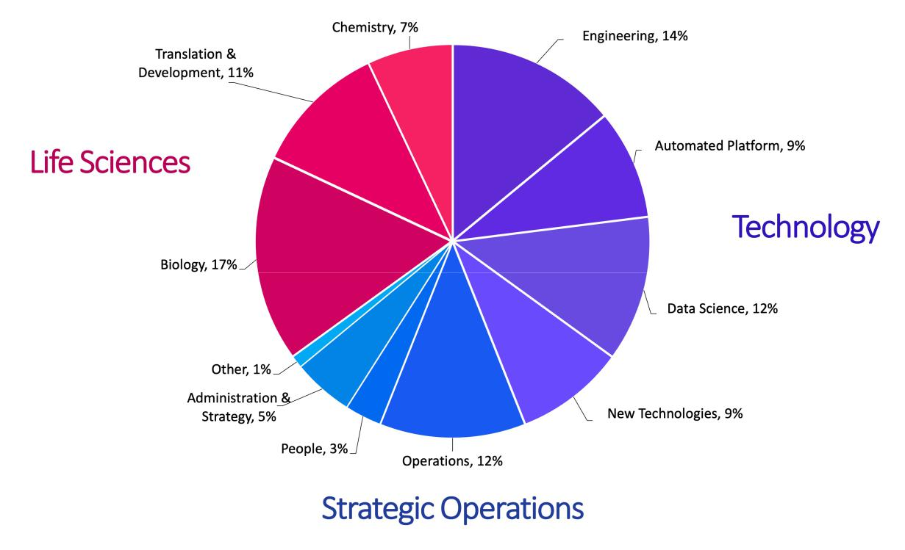

Figure 63. Breakdown of Recursion’s over 500 employees across life sciences, technology and strategic operations.

One of the most critical elements supporting Recursion’s leadership in TechBio is what we call the Recursion Mindset – a deep belief and commitment to industrialization through automation, systems-thinking, algorithms and data to deliver our mission. Broadly at the company we apply this mindset to eliminate toil and inefficiency creating space for our creative energy to be pointed at Recursion’s hardest problems. The Recursion Mindset is made manifest through our Founding Principles and supported by our Culture and Values. Our Founding Principles are the guideposts to our approach to technical and scientific decision-making. Our Values are the core behaviors that define our Culture and are the simplest definition of how we will achieve our mission. Combined they are the shape of our culture and guide us to reimagine how medicines are made on the path to delivering our mission.

71

Table of Contents

Figure 64. Recursion’s Founding Principles. These six founding principles differentiate our approach from nearly every other biopharma company, enable us to lead TechBio and form the foundation for a mindset we teach and enrich for at Recursion.
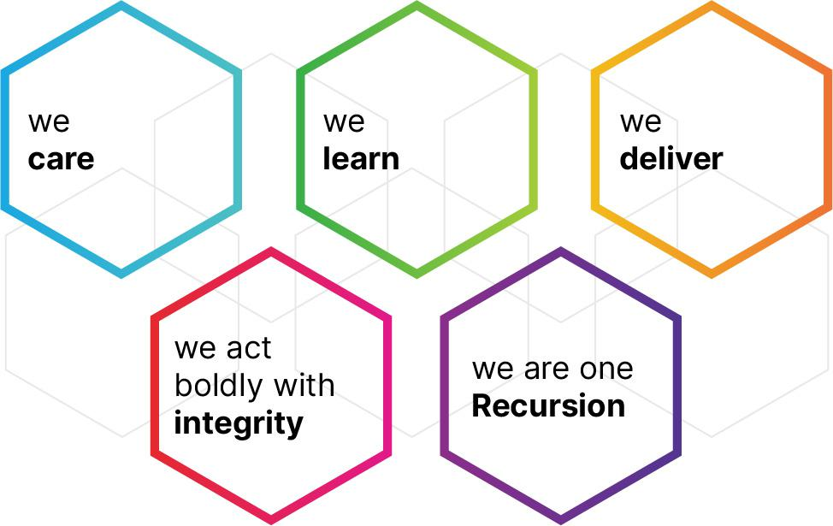

Figure 65. Recursion’s Values. These five values support our founding principles and guide our culture at Recursion.

Diversity, Equity, Inclusion and Belonging

At Recursion, we believe in the moral and business case for diversity. The research-based evidence is unequivocal that diverse perspectives support better complex decision-making, foster greater innovation and ultimately result in greater company performance and success. We seek the best talent by maximizing diversity at the top of the recruiting funnel and then mitigating bias through objective decision-making throughout the hiring process. We foster an environment of inclusion for candidates and employees to unleash the strength of our differences. Lastly, acknowledging the breadth of societal injustice and inequities we pursue fair and equitable outcomes across all people-decisions through process design and supported by analytics.

Employee Recruitment, Development and Training

We take a design-thinking approach to building the employee experience at Recursion. It is a fit-for-purpose system that finds, grows and retains top talent to deliver our mission. Our people are mission-driven, humble, bright, generous of spirit and constructively dissatisfied with the status quo. We employ a targeted approach to identify, attract and hire diverse employees across highly technical scientific disciplines including: biology, chemistry, data science, machine learning, engineering, robotics, clinical development and more. We seek people that are a fit for our commitment to industrialization as defined by our Recursion Mindset, which is manifested in our Founding Principles and Values.

Culturally, we instill an expectation to be constantly learning and teaching in pursuit of growing ourselves as fast as Recursion. Most notable is a 2-day experience offered year-round to all employees called Decoding Recursion. It is an opportunity for close interaction with senior leaders who teach the Recursion Mindset through stories. The need to learn is reinforced throughout our performance system which creates accountability for our learning, delivery and impact on others.

People stay at Recursion because of the opportunity to impact the world and grow in a place where they feel challenged, supported and connected. Throughout the employee experience we create moments, rituals, programs and spaces that inspire ambition, reward contributions and growth and foster belonging.

72

Table of Contents

Employee Health and Safety

We have dedicated Standard Operating Procedures to manage occupational health and safety, safety training and injury and illness and incident reporting. Every employee is responsible to ensure these procedures and policies are followed. We offer extensive training to ensure understanding and compliance. Compliance is mandatory for all laboratory employees per requirements of the Occupational Safety and Health Administration standard on Hazardous Chemicals in Laboratories. Our Co-Founder and CEO is the Director of Public Safety at the company and has the ultimate responsibility for chemical hygiene within the organization. Our Chemical Hygiene Officer and Lab Manager oversees the day-to-day management of institutional chemical hygiene.

Read more about how we invest in and motivate our people to achieve our mission in Recursion’s latest Environmental, Social and Governance Report, available at our corporate website.

Facilities

Headquarters

Our United States headquarters is in downtown Salt Lake City, Utah where we lease 105,419 square feet of office and laboratory space. The lease for this space expires in May 2028. In November 2022, we expanded into 103,634 square feet of office and laboratory space adjacent to our headquarters under a lease that expires in May 2032. Our modern headquarters is a draw for local, national and international talent.

73

Table of Contents
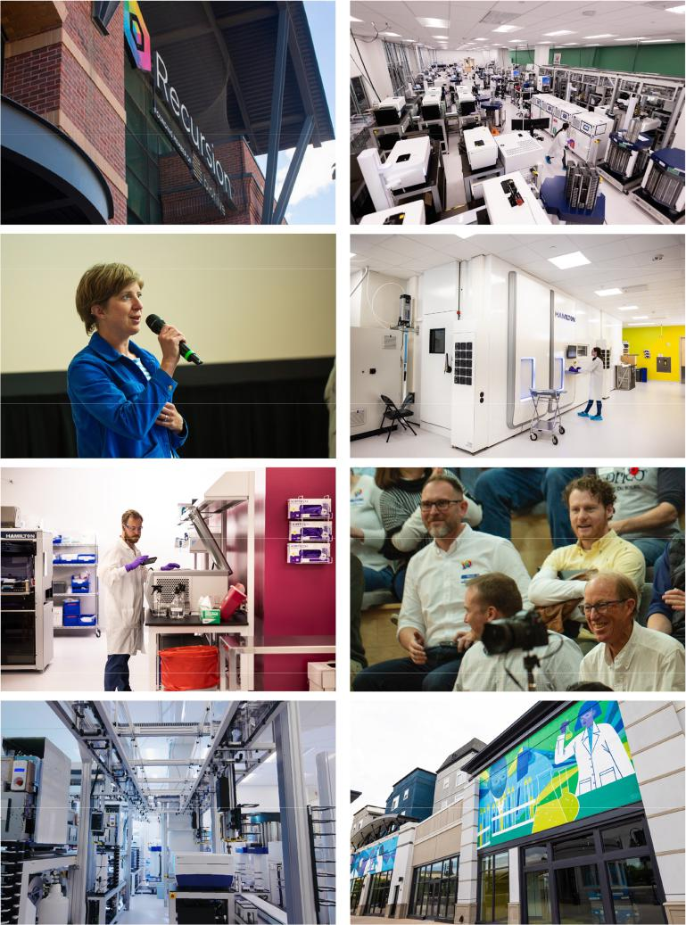

Figure 66. Our headquarters is centrally located in downtown Salt Lake City, Utah. We are a proud founding member of BioHive, the branding effort of the life science hub of Utah. Working with state and local government, we are helping to create a burgeoning life science ecosystem around a downtown cluster of companies centered around our headquarters.

Satellite Offices and Facilities

Toronto and Montréal. In June 2023, we celebrated the opening of our 28,110 square foot Toronto site, which serves as the headquarters for Recursion Canada. The lease for this space expires in November 2032. The new site represents Recursion’s significant growth in Canada and our continued investment in the local economy. Following the acquisition of Cyclica, we consolidated our Toronto based teams into our new headquarters. In addition to our Recursion Canada headquarters we have a site in Montréal that houses our semi-autonomous artificial intelligence research engine, Valence Labs, which is located in the world-renowned artificial intelligence and machine learning hub MILA.

74

Table of Contents


Figure 67. Recursion’s satellite offices and facilities. Left panel: Mila, the Quebec Artificial Intelligence Institute, is recognized worldwide for its major contributions to AI. Right panel: Government and biotech leaders celebrate the opening of our Toronto office, home to Recursion’s Canadian headquarters and our largest site outside of our global headquarters in Salt Lake City, Utah. This site, along with the Mila Montreal office, serves as multidisciplinary hubs across data science and machine learning.

Digital Vivarium. We lease a property that serves as a rodent vivarium. This lease expires in May 2028. We use this facility to conduct drug-discovery enabling pharmacokinetic, pharmacodynamic and exploratory safety studies. The facility is equipped with proprietary, digitally enabled cage technology.

Corporate Social Responsibility

We believe that to achieve our mission, we must act like the company we aim to be, which means we must be a good corporate citizen. In recognition of our commitment to excellence in environmental, social and governance stewardship, Recursion received a Prime Rating in 2023 for ESG performance from Institutional Shareholder Services (ISS). The ISS ESG Corporate Rating provides an assessment of a company's environmental, social and governance activity. A Prime Rating is awarded to companies with ESG performance above a sector-specific threshold and is defined by ISS as "absolute best in class". Additionally, as of January 2024, Recursion was ranked 16 out of over 900 companies (approximately top 2%) in the pharmaceutical category by Morningstar Sustainalytics²⁰ which gives an in-depth analysis of a company’s ESG performance and compares it to industry peers. This ranking places Recursion in Sustainalytics’ 2024 Top-Rated ESG Companies List.

To date, we have focused our community efforts in areas of impact that are aligned with our Values and our strengths, including: (i) diversity, equity and inclusion in technology and biotechnology (e.g., in 2020 the Recursion Foundation launched Altitude Lab, a life science incubator and accelerator for diverse health care entrepreneurs); (ii) the growth and sustainability of our local life science and technology ecosystems (e.g., Recursion is a founding member of BioHive, a Utah life science collective); and (iii) the promotion of sustainable environmental practices (e.g., Recursion aims to achieve net-zero greenhouse gas emissions across our operations by the year 2030). We believe that through these principles of community engagement, we can extend our mission of radically improving lives to those in our communities.

Read more about how we are delivering on that belief in Recursion’s Environmental, Social and Governance Report.

- Copyright © 2023 Morningstar Sustainalytics. All rights reserved. This section contains information developed by Sustainalytics (www.sustainalytics.com). Such information and data are proprietary of Sustainalytics and/or its third-party suppliers (Third Party Data) and are provided for informational purposes only. They do not constitute an endorsement of any product or project, nor an investment advice and are not warranted to be complete, timely, accurate or suitable for a particular purpose. Their use is subject to conditions available at https://www.sustainalytics.com/legal-disclaimers

75

Table of Contents

Commercialization

We may retain significant development and commercial rights to some of our drug candidates. If marketing approval is obtained, we may commercialize our drug candidates on our own, or potentially with a partner, in the United States and other geographies. We currently have no sales, marketing, or commercial product distribution capabilities. Decisions to create this infrastructure and capability will be made following further advancement of our drug candidates and based on our assessment of our ability to build the necessary capabilities and infrastructure with competitive advantage. Clinical data, the size of the addressable patient population, the size of the commercial infrastructure, manufacturing needs and major trends as to how value is accrued in the industry may all influence or alter our commercialization plans.

Manufacturing

We currently utilize contract development and manufacturing organizations to produce drug substance and investigational drug product in support of the assets within our pipeline. To date, we have obtained drug substance and drug product for our drug candidates from third party contract manufacturers. We are in the process of developing our supply chain for each of our drug candidates on a project-by-project basis based on our development needs.

Strategic Agreements

To achieve our mission, we may partner with leading biotechnology companies, pharmaceutical companies and academic research institutions to access datasets, molecules, or other intellectual property.

Tempus Master Agreement

On November 3, 2023, Recursion Pharmaceuticals, Inc., or the Company, and Tempus Labs, Inc., or Tempus entered into a Master Agreement, or the Tempus Agreement pursuant to which Tempus may provide certain services and deliverables to the Company and/or license certain data to the Company. The term of the Tempus Agreement is five years from the effective date of the Tempus Agreement, or the Term.

Under the terms of the Tempus Agreement, the Company is granted a limited right to access Tempus’s proprietary database of de-identified clinical and molecular data for certain therapeutic product development purposes, including to develop, train, improve, modify, and create derivative works of the Company’s machine learning/artificial intelligence models for the purposes of therapeutic product development. The Company is permitted to download a maximum number of de-identified records at any one time, subject to an aggregate cap in the total unique records that can be downloaded over the course of the Term, and to retain each downloaded record for a period of 180 days from the date of download. After such 180-day period, The Company may elect to license such downloaded records for a longer period subject to additional terms and the payment of additional fees.

In exchange for these rights, the Company will pay Tempus an initial license fee in an amount equal to $22.0 million, or the Initial License Fee and annual license fees during the Term ranging between $22.0 million and $42.0 million, which, together with the Initial License Fee, totals up to $160.0 million over the Term, subject to the Company’s early termination, which may be triggered only following the third anniversary of the Master Agreement’s effective date, and payment by the Company of an early termination fee (as further discussed below). The Initial License Fee and each annual license fee shall be payable at the Company’s option either in the form of (x) cash, (y) shares of Class A Common Stock of the Company or (z) a combination of cash and shares of Class A Common Stock in such proportion as is determined by the Company in its sole discretion; provided that (a) the aggregate number of shares of Class A Common Stock that the Company may issue in connection with all payments under this Agreement shall not exceed 19.9% of the aggregate total of shares of Class A Common Stock and the Company’s Class B Common Stock outstanding on November 2, 2023 or the date immediately preceding the date of any shares of Class A Common Stock issued pursuant to the Tempus Agreement, whichever is less (the “Share Maximum”).

In the event that all or any portion of the Initial License Fee or any annual license fee is payable in the form of shares of Class A Common Stock, the Company shall, subject to the Share Maximum, issue to Tempus a number of

76

Table of Contents

shares of Class A Common Stock equal to (1) the amount of such fee divided by (2) the volume weighted average price of Class A Common Stock for the seven trading day period ending on the trading day immediately preceding (and including) the date that is five business days before the date on which such fee is paid (any shares so issued, the “Tempus Shares”).

The Company has agreed to use commercially reasonable efforts to prepare and file a registration statement (or a prospectus supplement to an effective registration statement on Form S-3ASR that will become automatically effective upon filing with the SEC pursuant to Rule 462(e)) with the Securities and Exchange Commission as soon as practicable but in no event later than 30 days after each issuance of Tempus Shares under the Tempus Agreement, and to use its commercially reasonable efforts to have the registration statement declared effective as promptly as possible but in any event within 30 days following initially filing (or up to 90 days in the event of full SEC review). After such registration, the Company has agreed to use commercially reasonable efforts to keep such registration statement effective until such date that all Tempus Shares covered by such registration statement have been sold thereunder or may be sold without restriction or volume limitation under Rule 144 as promulgated by the SEC under the Securities Act of 1933, as amended.

The Tempus Agreement also grants the Company the right to access and use Tempus’ LENS software that permits the viewing and analysis of clinical, molecular, and other health data maintained by Tempus. Company will pay Tempus a six-figure annual license fee for the duration of the Term for the use of such software.

In addition to mutual rights to terminate for an uncured breach of the Tempus Agreement, the Company may terminate the Tempus Agreement for convenience after three years upon 90 days prior notice, subject to payment by the Company of an early termination fee equal to (a) an amount per unique record that Company has downloaded prior to termination less (b) the sum of any annual license fees paid prior to termination, which could result in early payment of the aggregate annual license fees contemplated by the Tempus Agreement to the extent all records made available under the Tempus Agreement have been downloaded.

Either party may assign its rights under the Tempus Agreement subject to limited restrictions, but the Company may not assign the Tempus Agreement without Tempus’s consent if the proposed assignee is a large pharmaceutical company.

REC-994: University of Utah Research Foundation Agreements

In February 2016, we entered into an Amended and Restated License Agreement with the University of Utah Research Foundation, or UURF, pursuant to which we obtained an exclusive license under certain patents and a non-exclusive license under certain know-how, in each case controlled by UURF and related to the drug tempol, or REC-994, to make, have made, use, offer to sell, sell, import and distribute products incorporating REC-994 worldwide for the treatment of cerebral cavernous malformation, or CCM. In partial consideration for the license rights, we issued UURF equity in our company. In addition, we agreed to reimburse UURF for a specified portion of costs associated with the filing, maintenance and prosecution of the licensed patent rights. The Amended and Restated License Agreement will expire on a country-by-country basis upon the expiration of the last-to-expire patent within the patent rights in the applicable country. UURF may terminate the agreement for an uncured material breach, if we cease commercially diligent efforts to develop or commercialize a licensed product or service, or our bankruptcy or insolvency.

REC-2282: Ohio State Innovation Foundation In-License

In December 2018, we entered into an Exclusive License Agreement with the Ohio State Innovation Foundation, or OSIF, pursuant to which we obtained an exclusive, sublicensable, non-transferable, royalty-bearing license under certain patents and fully-paid up, royalty-free, nonexclusive license under certain know-how, in each case controlled by OSIF and related to the pan-histone deacetylase inhibitor, OSU-HDAC42, or REC-2282, to develop, make, have made, use, sell, offer for sale and import products incorporating OSU-HDAC42 worldwide. OSIF also assigned certain assets to us, relating to the pharmaceutical composition known as AR-42. OSIF retains the right to use and allow other academic, nonprofit and government institutions to use the licensed intellectual property for research, non-commercial and educational purposes. OSIF shall not practice, have practiced, or transfer such reserved rights for any clinical purpose other than completion of the existing clinical trials at the time of the license agreement without our prior written consent. We are developing REC-2282 for the treatment of NF2 and are evaluating the utility of the compound in additional disease states using our platform.

77

Table of Contents

Pursuant to the agreement, we must use commercially reasonable efforts to commercialize licensed products and are required to meet certain diligence milestones within two years following the execution of the agreement, including the initiation of clinical trials. The license agreement is also limited by and made subject to certain rights and regulations of the government, including the Bayh-Dole Act.

In consideration for the license, we paid OSIF an upfront payment of $2.0 million dollars and are obligated to pay OSIF certain milestones, totaling up to $20.0 million dollars, as well as mid-single digit royalties on net sales of the licensed products. In addition, we owe 25% of any non-royalty sublicensing consideration prior to a Phase II clinical trial or 15% of such sublicensing consideration after initiation of a Phase II clinical trial, provided that milestone payments are creditable against these sublicensing fees. In 2022 we paid OSIF $1.0 million dollars upon dosing of the first patient in the Phase 2 study of REC-2282 for the treatment of NF2.

The agreement expires on the expiration of the last valid claim within the licensed patents. We may terminate this agreement on 90 days prior written notice to OSIF. Either party may terminate the agreement on 60 days prior written notice for an uncured, material breach by the other party, or bankruptcy or insolvency of the other party.

REC-4881: Takeda License Agreement

In May 2020, we entered into a License Agreement, or the Takeda In-License, with Takeda Pharmaceutical Company Limited, or Takeda, pursuant to which we obtained an exclusive (even as to Takeda and its affiliates), worldwide, sublicensable under certain conditions, transferable, royalty-bearing license to certain Takeda patents, know-how and materials related to develop, manufacture and commercialize Takeda’s clinical-stage compound known as TAK-733, a non-ATP-competitive allosteric inhibitor of MEK1 and MEK2, subject to a non-exclusive, royalty-free, irrevocable, fully paid up, license back to Takeda to use the licensed compounds for non-clinical research purposes. We are currently developing the compound REC-4881 for the treatment of FAP, and patients with spontaneous APC-mutant tumors. We are also evaluating the utility of the compound in additional disease states using our platform.

We are required to use commercially reasonable efforts to develop and commercialize at least one licensed product in each of (a) the US, (b) at least three of the following European countries: the United Kingdom, France, Germany, Italy and Spain and (c) Japan.

Upon execution of the agreement, we paid an upfront fee of $1.5 million to Takeda. Under the Takeda In-License, we are obligated to pay Takeda milestones amounts totaling up to $39.5 million upon achievement of specified development and regulatory milestone events. In addition, we are obligated to pay Takeda low-to-mid single-digit royalties based on net sales of products containing the licensed compounds by us, our affiliates or sublicensees, subject to specified reductions. Our obligation to pay royalties continues on a country-by-country basis until the latest of expiration of the last to expire patent licensed by Takeda that covers the product, expiration of any regulatory exclusivity period for the product and ten years after the first commercial sale of the product, in such country. As of the date of this filing, we have not made any milestone or royalty payments to Takeda.

Each party has the right to terminate the license agreement for the other party’s material uncured breach, insolvency or bankruptcy. In addition, we may terminate the agreement without cause any time after May 2023, and Takeda may terminate the agreement if we have not conducted any material activities in support of the development or commercialization of the licensed compounds or any product containing a licensed compound and have not demonstrated that we used commercially reasonable efforts towards the development of such compounds or products for a period of 12 consecutive months and such failure is not due to events beyond our reasonable control. Further, Takeda may terminate the license agreement if we challenge the validity or enforceability of a licensed patent. Upon termination for any reason other than for Takeda’s breach of the license agreement, upon Takeda’s request we are obligated to negotiate in good faith, for a period of 120 days, terms and conditions of a license to Takeda under certain technology developed by us during the term of the agreement for the purpose of developing, commercializing and otherwise exploiting the licensed compounds and products containing the licensed compounds.

78

Table of Contents

Target Epsilon: Bayer License Agreement

In December 2023, we entered into a License Agreement with Bayer, the Bayer License Agreement, pursuant to which we obtained (a) an assignment of certain compounds, know-how and inventions related primarily to fibrosis, and (b) an exclusive, sublicensable and royalty-bearing license under certain project know-how related to fibrosis to research, develop, manufacture and commercialize products as independent research tools in all fields worldwide, subject to a non-exclusive, royalty-free license back to Bayer to use such licensed project know-how solely for internal research and development purposes.

We are required to use commercially reasonable efforts to develop and commercialize at least one product in one of the following countries:

(a) the US, (b) Japan, or (c) a country of the European Union.

Under the Bayer License Agreement, we are obligated to pay Bayer milestone amounts totaling up to approximately $34 million upon achievement of specified development, regulatory and sales milestones. In addition, we are obligated to pay Bayer low single-digit royalties based on net sales of products containing certain compounds by us, our affiliates, or sublicensees, subject to specified reductions. Our obligation to pay royalties continues on a product-by-product and country-by-country basis until the latest of: (a) expiration of the last to expire patent filed by us, our affiliates or sublicensees that covers the product, and (b) ten years after the first commercial sale of the product in such country. As of the date of this filing, we have not made any milestone or royalty payments to Bayer.

Each party has the right to terminate the license agreement for the other party’s material uncured breach. In addition, we may terminate the agreement without cause. Upon termination by us without cause or by Bayer for our breach, Bayer would have the right to use, practice, develop and exploit (including the right to sublicense) certain assigned know-how solely for Bayer’s internal research and development purposes.

Competition

Our efforts to date have resulted in several clinical-stage programs, an expansive pipeline of differentiated programs in early discovery and preclinical development, several partnerships with large pharma and technology companies, as well as an intellectual property portfolio comprising patents, trademarks, software and trade secrets. We believe that our differentiated approach provides us with a significant competitive advantage. We are a hybrid company, competing within multiple categories of the pharmaceutical, biotechnology, and technology industries where companies are similarly working to integrate rapidly advancing technologies into their drug discovery and development activities and/or are creating scalable scientific platforms. Notable competitors include:

- TechBio Companies. Such companies apply computational tools to unlock novel insights or accelerate drug discovery and development across different points in the value chain. Representative examples include Relay Therapeutics, Exscientia, Isomorphic Labs, Schrodinger, and AbCellera.

- Scalable Platform Companies. Such companies are applying novel scientific approaches or engineering novel therapeutic modalities with the potential to seed large numbers of therapeutic candidates. These companies may compete directly with our pipeline of predominantly small molecule therapeutics. Representative companies include Moderna, BioNTech, and Roivant Sciences.

- Traditional Biopharma Companies. Such companies, while primarily engaged in late-stage clinical development and product commercialization, are increasingly making their own investments in the application of ML and advanced computational tools across the drug discovery and development value chain. Such investments may include partnerships with other biotechnology companies (including Recursion) from which we may benefit. Representative companies include Janssen (a subsidiary of Johnson & Johnson), Merck, and Pfizer.

- Large Technology Companies. Large technology companies constantly seek growth opportunities. Technology-enabled drug discovery may represent a compelling opportunity for these companies, some of which have research groups or subsidiaries focused on drug discovery and others of which have signed large technology partnerships with biopharma companies. Representative companies include Alphabet, Microsoft, and Amazon.

79

Table of Contents

Intellectual Property

Our intellectual property focus is the industrialization of phenomics, a new class of -omics data, and have applied industry knowledge to date to continue to build out and expand a variety of other cutting-edge technologies. Further, we have generated algorithmic, software and statistical insights in the course of our work. Within the burgeoning field of technology-enabled drug discovery, we seek to protect our innovations, with a combination of patents and trade secrets and for each novel technology or improvement we develop, we consider the appropriate course of intellectual property protection.

Our commercial success depends in part on our ability to obtain, maintain, enforce and defend intellectual property rights owned or licensed by us that are directed to our current and future drug product candidates and methods of their use, drug development and product development technologies, and know how, without infringing, misappropriating or otherwise violating the intellectual property and proprietary rights of others, and to prevent others from infringing, misappropriating or otherwise violating our intellectual property and proprietary rights. We seek to protect our proprietary position by, among other methods, filing or licensing U.S. and foreign patents and patent applications related to our proprietary technology, inventions and improvements that are important to the development and implementation of our business. We also rely on trademarks, trade secrets, know-how, continuing technological innovation and potential in-licensing opportunities to develop and maintain our proprietary position.

As for our current and future drug product candidates that we are developing and seeking to commercialize, we have and will continue to pursue composition of matter and therapeutic method of use patents, dosage formulation patents, therapeutic use patents on novel indications, and other relevant aspects of our current or future drug product candidates, where available. In addition, we have and will continue to pursue patents with respect to our proprietary drug discovery platform and drug development technologies. We may also continue to seek patent protection, either alone or jointly with our collaborators, as our collaboration agreements may dictate.

We believe in the benefits of open-source science and that open-source data sharing drives value for us and society as a whole. For example, we have published certain key findings and datasets derived from our platform around COVID-19 under terms designed to allow anyone to make use of the data, in the hope that the data would be useful in fighting the global pandemic. We have also released some of the largest open-sourced biological datasets in the world under terms that allow for broad academic and non-commercial use.

Patents

As of February 2024, we currently own or license at least 300 patents or patent applications worldwide, including over 170 issued patents or allowed patent applications in the US and other strategic markets, covering all aspects of our business, including Platform IP and Program IP.

- Platform IP: Approximately one-third of the patents and patent applications that we own or license worldwide relate to the Recursion platform, including patents and applications related to the Recursion OS IP, as well as many other inventions related to cell perturbations, gene editing, drug discovery, drug development and hardware solutions. Through our acquisition of Cyclica Inc., we obtained approximately 4 patent families related to drug discovery. We also pursue a strategy of seeking patent protection on smaller discrete inventions throughout the breadth of our pipeline, ranging from experiment design, operations within our labs, data collection and analysis (including deep learning insights).

- Recursion Program IP: A breakdown of our Program IP portfolio is below:

  - REC-2282: We exclusively license OSIF’s interest in patents and patent applications related to REC-2282 from OSIF; these patents and patent applications relate to composition of matter and methods of use for REC-2282. Currently, we expect our licensed issued patents related to REC-2282 to generally expire between 2024 and 2035, excluding any patent term extension, or other mechanisms for effecting patent term, and assuming payment of all appropriate maintenance, renewal, annuity or other governmental fee. With respect to NF-2, orphan drug exclusivity in the U.S. would run seven years from marketing authorization.

  - REC-994: We exclusively license UURF’s interest in patents and patent applications related to use of REC-994 for treatment or prevention of CCM from UURF. Currently, we expect our licensed

80

Table of Contents

issued patents related to REC-994 to generally expire in 2035, excluding any patent term extension, or other mechanisms for effecting patent term, and assuming payment of all appropriate maintenance, renewal, annuity or other governmental fee. With respect to CCM, orphan drug exclusivity in the U.S. would run seven years from marketing authorization.

- REC-4881: We own patent applications, or exclusively license Takeda’s interest in patents and patent applications from Takeda, related to composition of matter and methods of use for REC-4881. Currently, we expect our licensed issued patents related to REC-4881 to generally expire in 2029, excluding any patent term extension, or other mechanisms for effecting patent term, and assuming payment of all appropriate maintenance, renewal, annuity or other governmental fee. With respect to FAP, orphan drug exclusivity in the U.S. would run seven years from marketing authorization.

- REC-3964: We own patent applications, including an allowed US patent application, related to the composition of matter and methods of use of REC-3964. Upon issuance, we expect our patents resulting from these patent applications will expire no earlier than 2042, excluding any patent term adjustment or patent term extension, or other mechanisms for effecting patent term, and assuming payment of all appropriate maintenance, renewal, annuity or other governmental fee.

The patent positions of companies like ours are generally uncertain and involve complex legal and factual questions. No consistent policy regarding the scope of claims allowable in patents in the field of biotechnology has emerged in the United States and in Europe, among other countries. Changes in the patent laws and rules, either by legislation, judicial decisions, or regulatory interpretation in other countries may diminish our ability to protect our inventions and enforce our intellectual property rights, and more generally could affect the value of our intellectual property. In particular, our ability to stop third parties from making, using, selling, offering to sell, importing, or otherwise commercializing any of our patented inventions, either directly or indirectly, will depend in part on our success in obtaining, defending and enforcing patent claims that cover our technology, inventions and improvements. With respect to both licensed and company-owned intellectual property, we cannot be sure that patents will be granted with respect to any of our pending patent applications or with respect to any patent applications filed by us in the future, nor can we be sure that any of our existing patents or any patents that may be granted to us in the future will be commercially useful in protecting our platform and drug candidates and the methods used to manufacture them. Moreover, our issued patents and those that may issue in the future may not guarantee us the right to practice our technology in relation to the commercialization of our drug product candidates. The area of patent and other intellectual property rights in biotechnology is an evolving one with many risks and uncertainties, which may prevent us from commercializing our drug candidates and future drug candidates and practicing our proprietary technology.

Our issued patents and those that may issue in the future may be challenged, narrowed, circumvented, or invalidated, which could limit our ability to stop competitors from marketing related platforms or drug candidates or limit the length of the term of patent protection that we may have for our drug candidates, future drug candidates and platforms. In addition, the rights granted under any issued patents may not provide us with complete protection or competitive advantages against competitors with similar technology. Furthermore, our competitors may independently develop similar technologies that achieve similar outcomes but with different approaches. For these reasons, we may have competition for our drug candidates. Moreover, the time required for the development, testing and regulatory review of our candidate products may shorten the length of effective patent protection following commercialization. For this and other risks related to our proprietary technology, inventions, improvements, platforms and drug candidates, please see the section titled “Risk Factors—Risks Related to Our Intellectual Property.”

Our commercial success will also depend in part on not infringing upon the intellectual property and proprietary rights of third parties. It is uncertain whether the issuance of any third -party patent would require us to alter our development or commercial strategies for our products or processes or to obtain licenses or cease certain activities. Our breach of any license agreements or failure to obtain a license to proprietary rights that we may require to develop or commercialize our future products may have an adverse impact on us. If third parties prepare and file patent applications in the United States that also claim technology to which we have rights, we may have to participate in interference or derivation proceedings in the USPTO to determine priority of invention. For more information, please see “Risk Factors— Risks Related to Our Intellectual Property.”

81

Table of Contents

Some of our pending patent applications in the United States are provisional patent applications. Provisional patent applications are not eligible to become issued patents until, among other things, we file a non-provisional patent application within 12 months of filing of one or more of our related provisional patent applications. If we do not timely file any non-provisional patent applications, we may lose our priority date with respect to our provisional patent applications and any patent protection on the inventions disclosed in our provisional patent applications. While we intend to timely file non-provisional patent applications relating to our provisional patent applications, we cannot predict whether any such patent applications will result in the issuance of patents that provide us with any competitive advantage.

The term of individual patents depends upon the legal term of the patents in the countries in which they are obtained. In most countries in which we file, the patent term is 20 years from the earliest date of filing a nonprovisional patent application related to the patent. However, the actual protection afforded by a patent varies on a product-by-product basis, from country to country, and depends upon many factors, including the type of patent, the scope of its coverage, the availability of regulatory-related extensions, the availability of legal remedies in a particular country, and the validity and enforceability of the patent. A U.S. patent also may be accorded patent term adjustment, or PTA, under certain circumstances to compensate for delays in obtaining the patent from the USPTO. In some instances, such a PTA may result in a U.S. patent term extending beyond 20 years from the earliest date of filing a non-provisional patent application related to the U.S. patent. In addition, in the United States, the term of a U.S. patent that covers an FDA-approved drug may also be eligible for patent term extension (PTE), which permits patent term restoration as compensation for the patent term lost during the FDA regulatory review process. However, with respect to patent term extensions granted as a result of the FDA regulatory review period, the restoration period cannot be longer than five years, the total patent term including the restoration period must not exceed 14 years following FDA approval, only one patent applicable to each regulatory review period may be extended and only those issued claims covering the approved drug or a method for using it may be extended. We may not receive an extension if we fail to exercise due diligence during the testing phase or regulatory review process, fail to apply within applicable deadlines, fail to apply prior to expiration of relevant patents or otherwise fail to satisfy applicable requirements. Moreover, the length of the extension could be less than we request. There can be no assurance that we will benefit from any patent term extension or favorable adjustment to the term of any of our patents.

Rapidly evolving patent laws in the United States and elsewhere make it difficult to predict the breadth of claims that may be allowed or enforced in our patents. Moreover, patent offices in general can require that patent applications concerning pharmaceutical and/or biotechnology-related inventions be limited or narrowed substantially to cover only the specific innovations exemplified in the patent application, thereby limiting the scope of protection against competitive challenges. Thus, even if we are able to obtain patents, the patents may be substantially narrower than anticipated.

Our ability to maintain and defend our intellectual property and proprietary position for our drug product candidates, methods of their use, and other proprietary technologies will depend on our success in obtaining effective claims and enforcing those claims once granted. We do not know whether any of the patent applications that we may file or license from third parties will result in the issuance of any patents. The issued patents that we own, may receive in the future, or license from third parties may be challenged, invalidated, held unenforceable, narrowed or circumvented, and the rights granted under any issued patents may not provide us with proprietary protection or competitive advantages against third parties, including our competitors, with similar technology. Furthermore, third parties, including our competitors, may be able to independently develop and commercialize similar drugs or products, or duplicate our technology, business model or strategy without infringing our patents.

Trademarks

As of February 2024, our trademark portfolio comprises more than 70 registered trademarks or active trademark applications worldwide, among which we have issued trademarks in the U.S. for “Recursion” and “Recursion Pharmaceuticals.”

Trade Secrets

In addition to our reliance on patent protection for our inventions, drug candidates and programs, we also rely on trade secrets, know-how, confidentiality agreements and continuing technological innovation to develop and maintain our competitive position. For example, some elements of manufacturing processes, proprietary assays,

82

Table of Contents

analytics techniques and processes, knowledge gained through clinical experience such as approaches to dosing and administration and management of patients, as well as computational-biological algorithms, and related processes and software, are based on unpatented trade secrets and know-how that are not publicly disclosed. Although we take steps to protect our proprietary information and trade secrets, including through contractual means with our employees, advisors and consultants, these agreements may be breached, and we may not have adequate remedies for any breach. In addition, third parties may independently develop substantially equivalent proprietary information and techniques or otherwise gain access to our trade secrets or disclose our technology. As a result, we may not be able to meaningfully protect our trade secrets. It is our policy to require our employees, consultants, outside scientific collaborators, sponsored researchers and other advisors to execute confidentiality agreements upon the commencement of employment or consulting relationships with us. These agreements provide that all confidential information concerning our business or financial affairs developed or made known to the individual or entity during the course of the party’s relationship with us is to be kept confidential and not disclosed to third parties except in specific circumstances. In the case of employees, the agreements provide that all inventions conceived of by the individual during the course of employment, and which relate to or are reasonably capable or being used in our current or planned business or research and development are our exclusive property. In addition, we take other appropriate precautions, such as physical and technological security measures, to guard against the misappropriation of our proprietary technology by third parties. However, such agreements and policies may be breached, and we may not have adequate remedies for such breaches. For more information regarding the risks related to our intellectual property, see “Risk Factors—Risks Related to Our Intellectual Property.”

Government Regulation

Government authorities in the United States at the federal, state and local level and in other countries regulate, among other things, the research, development, testing, manufacture, quality control, approval, labeling, packaging, storage, record-keeping, promotion, advertising, distribution, post-approval monitoring and reporting, marketing and export and import of drug and biological products. Generally, before a new drug can be marketed, considerable data demonstrating its quality, safety and efficacy must be obtained, organized into a format specific for each regulatory authority, submitted for review and approved by the relevant regulatory authority.

U.S. Drug Development

In the United States, the FDA regulates drugs under the Federal Food, Drug, and Cosmetic Act, or FDCA. Drugs also are subject to other federal, state and local statutes and regulations. The process of obtaining regulatory approvals and the subsequent compliance with appropriate federal, state, local and foreign statutes and regulations requires the expenditure of substantial time and financial resources. Failure to comply with the applicable United States requirements at any time during the product development process, approval process or post-market may subject an applicant to administrative or judicial sanctions. These sanctions could include, among other actions, the FDA’s refusal to approve pending applications, withdrawal of an approval, a clinical hold, untitled or warning letters, product recalls or market withdrawals, product seizures, total or partial suspension of production or distribution, injunctions, fines, refusals of government contracts, restitution, disgorgement and civil or criminal penalties. Any agency or judicial enforcement action could have a material adverse effect on us.

- Our drug candidates are considered small molecule drugs and must be approved by the FDA through the new drug application, or NDA, process before they may be legally marketed in the United States. The process generally involves the following: completion of extensive preclinical studies in accordance with applicable regulations, including studies conducted in accordance with good laboratory practice, or GLP;

- submission to the FDA of an investigational new drug, or IND, application, which must become effective before human clinical trials in the U.S. may begin;

- approval by an independent institutional review board, or IRB, or ethics committee at each clinical trial site before each trial may be initiated;

- performance of adequate and well-controlled human clinical trials in accordance with applicable IND regulations, good clinical practice, or GCP, requirements and other clinical trial-related regulations to establish substantial evidence of the safety and efficacy of the investigational product for each proposed indication;

83

Table of Contents

- submission to the FDA of an NDA;

- a determination by the FDA within 60 days of its receipt of an NDA to accept the filing for review;

- satisfactory completion of an FDA pre-approval inspection of the manufacturing facility or facilities where the drug will be produced to assess compliance with cGMP requirements to assure that the facilities, methods and controls are adequate to preserve the drug’s identity, strength, quality and purity;

- potential FDA audit of the preclinical study and/or clinical trial sites that generated the data in support of the NDA filing;

- payment of user fees for FDA review of the NDA;

- FDA review and approval of the NDA, including consideration of the views of any FDA advisory committee, prior to any commercial marketing or sale of the drug in the United States; and

- compliance with any post-approval requirements, including the potential requirement to implement a Risk Evaluation and Mitigation Strategy, or REMS, and the potential requirement to conduct post-approval studies.

The data required to support an NDA is generated in two distinct developmental stages: preclinical and clinical. The preclinical and clinical testing and approval process requires substantial time, effort and financial resources, and we cannot be certain that any approvals for any current and future drug candidates will be granted on a timely basis, or at all.

Preclinical Studies and IND

Before testing any drug product candidate in humans, the product candidate must undergo rigorous preclinical testing. The conduct of preclinical studies is subject to federal regulations and requirements, including GLP and ICH regulations for safety/toxicology studies. The preclinical developmental stage generally involves laboratory evaluations of drug chemistry, formulation and stability, as well as studies to evaluate toxicity in animals, which support subsequent clinical testing. The sponsor must submit the results of the preclinical studies, together with manufacturing information, analytical data, any available clinical data or literature and a proposed clinical protocol, to the FDA as part of the IND. An IND is a request for authorization from the FDA to administer an investigational product to humans and must become effective before human clinical trials may begin.

Preclinical studies include laboratory evaluation of product chemistry and formulation, as well as in vitro and animal studies to assess the potential for adverse events and in some cases to establish a rationale for therapeutic use. The conduct of preclinical studies is subject to federal regulations and requirements, including GLP regulations for safety/toxicology studies. An IND sponsor must submit the results of the preclinical tests, together with manufacturing information, analytical data, any available clinical data or literature and plans for clinical studies, among other things, to the FDA as part of an IND. Some long-term preclinical testing, such as animal tests of reproductive adverse events and carcinogenicity, may continue after the IND is submitted. An IND automatically becomes effective 30 days after receipt by the FDA, unless before that time the FDA raises concerns or questions related to one or more proposed clinical trials and places the trial on clinical hold. In such a case, the IND sponsor and the FDA must resolve any outstanding concerns before the clinical trial can begin. As a result, submission of an IND may not result in the FDA allowing clinical trials, which are generally required for FDA approval of an NDA, to commence. A separate submission to an existing IND must also be made for each successive clinical trial conducted during product development along with any subsequent changes to the investigational plan. Some long-term nonclinical testing, such as animal tests of reproductive adverse events and carcinogenicity, may continue after the IND is submitted.

Clinical Trials

The clinical stage of development involves the administration of the investigational product to healthy volunteers or patients under the supervision of qualified investigators, generally physicians not employed by or under the trial sponsor’s control, in accordance with GCP requirements, which include the requirement that all research subjects

84

Table of Contents

provide their informed consent for their participation in any clinical trial. Clinical trials are conducted under protocols detailing, among other things, the objectives of the clinical trial, dosing procedures, subject selection and exclusion criteria and the parameters to be used to monitor subject safety and assess efficacy. Each protocol, and any subsequent amendments to the protocol, must be submitted to the FDA as part of the IND. Furthermore, each clinical trial must be reviewed and approved by an IRB for each institution at which the clinical trial will be conducted to ensure that the risks to individuals participating in the clinical trials are minimized and are reasonable in relation to anticipated benefits. The IRB must also approve the informed consent form that must be provided to each clinical trial subject or his or her legal representative and must monitor the clinical trial until completed. There also are requirements governing the reporting of ongoing clinical trials and completed clinical trial results to public registries.

A sponsor who wishes to conduct a clinical trial outside of the United States may, but need not, obtain FDA authorization to conduct the clinical trial under an IND. If a foreign clinical trial is not conducted under an IND, the sponsor may submit data from the clinical trial to the FDA in support of an NDA. The FDA will generally accept a well-designed and well-conducted foreign clinical trial not conducted under an IND if the trial was conducted in accordance with GCP and GMP requirements, and the FDA is able to validate the data through an onsite inspection, if deemed necessary, and the practice of medicine in the foreign country is consistent with the United States.

Clinical trials in the United States generally are conducted in three sequential phases, known as Phase 1, Phase 2 and Phase 3, and may overlap.

- Phase 1 clinical trials generally involve a small number of healthy volunteers or disease-affected patients who are initially exposed to a single dose and then multiple doses of the drug candidate. The primary purpose of these clinical trials is to assess the metabolism, pharmacologic action, tolerability and safety of the drug, the side effects associated with increasing doses, and if possible to gain early evidence on effectiveness.

- Phase 2 clinical trials involve studies in disease-affected patients to determine the dose and dosing schedule required to produce the desired benefits. At the same time, safety and further pharmacokinetic and pharmacodynamic information are collected, possible adverse effects and safety risks are identified, and a preliminary evaluation of efficacy is conducted.

- Phase 3 clinical trials generally involve a large number of patients at multiple sites and are designed to provide the data necessary to demonstrate the effectiveness of the product for its intended use, its safety in use and to establish the overall benefit/risk relationship of the product and provide an adequate basis for product approval. These trials may include comparisons with placebo and/or other comparator treatments. The duration of treatment is often extended to mimic the actual use of a product during marketing.

Post-approval trials, sometimes referred to as Phase 4 clinical trials, are conducted after initial marketing approval. These trials are used to gain additional experience from the treatment of patients in the intended therapeutic indication. In certain instances, the FDA may mandate the performance of Phase 4 clinical trials as a condition of approval of an NDA.

Progress reports detailing the results of the clinical trials, among other information, must be submitted at least annually to the FDA. The sponsor is also responsible for submitting written IND safety reports, including reports of serious and unexpected suspected adverse events, findings from other studies suggesting a significant risk to humans exposed to the drug, findings from animal or in vitro testing that suggest a significant risk for human subjects, and any clinically significant increase in the rate of a serious suspected adverse reaction over that listed in the protocol or investigator brochure.

Phase 1, Phase 2 and Phase 3 clinical trials may not be completed successfully within any specified period, if at all. The FDA or the sponsor may suspend or terminate a clinical trial at any time on various grounds, including a finding that the research subjects or patients are being exposed to an unacceptable health risk. Similarly, an IRB can suspend or terminate approval of a clinical trial at its institution if the clinical trial is not being conducted in accordance with the IRB’s requirements or if the drug has been associated with unexpected serious harm to patients. Additionally, some clinical trials are overseen by an independent group of qualified experts organized by the clinical trial sponsor, known as a data safety monitoring board or committee. This group provides authorization for whether a trial may move forward at designated checkpoints based on access to certain data from the trial.

85

Table of Contents

Concurrent with clinical trials, companies usually complete additional animal safety studies and also must develop additional information about the chemistry and physical characteristics of the drug as well as finalize a process for manufacturing the product in commercial quantities in accordance with cGMP requirements. The manufacturing process, as performed by the manufacturing facility, must be capable of consistently producing quality batches of our drug candidates. Additionally, appropriate packaging must be selected and tested, and stability studies must be conducted to demonstrate that our drug candidates do not undergo unacceptable deterioration over their labeled shelf life.

NDA Review Process

Following completion of the clinical trials, data is analyzed to assess whether the investigational product is safe and effective for the proposed indicated use or uses. The results of preclinical studies and clinical trials are then submitted to the FDA as part of an NDA, along with proposed labeling, chemistry, and manufacturing information to ensure product quality and other relevant data. In short, the NDA is a request for approval to market the drug in the United States for one or more specified indications and must contain proof of safety and efficacy for a drug.

The application must include both negative and ambiguous results of preclinical studies and clinical trials, as well as positive findings. Data may come from company-sponsored clinical trials intended to test the safety and efficacy of a product’s use or from a number of alternative sources, including studies initiated by investigators. To support marketing approval, the data submitted must be sufficient in quality and quantity to establish the safety and efficacy of the investigational product to the satisfaction of the FDA. FDA approval of an NDA must be obtained before a drug may be legally marketed in the United States.

Under the Prescription Drug User Fee Act, or PDUFA, as amended, each NDA must be accompanied by a user fee. FDA adjusts the PDUFA user fees on an annual basis. PDUFA also imposes an annual program fee for each marketed human drug. Fee waivers or reductions are available in certain circumstances, including a waiver of the application fee for the first application filed by a small business. Additionally, no user fees are assessed on NDAs for products designated as orphan drugs, unless the product also includes a non-orphan indication.

The FDA reviews all submitted NDAs before it accepts them for filing and may request additional information rather than accepting the NDA for filing. The FDA must make a decision on accepting an NDA for filing within 60 days of receipt. Once the submission is accepted for filing, the FDA begins an in-depth review of the NDA. Under the goals and policies agreed to by the FDA under PDUFA, the FDA has ten months, from the filing date, in which to complete its initial review of a new molecular-entity NDA and respond to the applicant, and six months from the filing date of a new molecular-entity NDA designated for priority review. The FDA does not always meet its PDUFA goal dates for standard and priority NDAs, and the review process is often extended by FDA requests for additional information or clarification.

Before approving an NDA, the FDA will conduct a pre-approval inspection of the manufacturing facilities for the new product to determine whether they comply with cGMP requirements. The FDA will not approve the product unless it determines that the manufacturing processes and facilities are in compliance with cGMP requirements and adequate to assure consistent production of the product within required specifications. The FDA also may audit data from clinical trials to ensure compliance with GCP requirements. Additionally, the FDA may refer applications for novel drug products or drug products which present difficult questions of safety or efficacy to an advisory committee, typically a panel that includes clinicians and other experts, for review, evaluation and a recommendation as to whether the application should be approved and under what conditions, if any. The FDA is not bound by recommendations of an advisory committee, but it considers such recommendations when making decisions on approval. The FDA likely will reanalyze the clinical trial data, which could result in extensive discussions between the FDA and the applicant during the review process. After the FDA evaluates an NDA, it will issue an approval letter or a Complete Response Letter. An approval letter authorizes commercial marketing of the drug with specific prescribing information for specific indications. A Complete Response Letter indicates that the review cycle of the application is complete, and the application will not be approved in its present form. A Complete Response Letter usually describes all of the specific deficiencies in the NDA identified by the FDA. The Complete Response Letter may require additional clinical data, additional pivotal Phase 3 clinical trial(s) and/or other significant and time-consuming requirements related to clinical trials, preclinical studies and/or manufacturing. If a Complete Response Letter is issued, the applicant may either resubmit the NDA, addressing all of the deficiencies identified in the letter, or withdraw the application. Even if such data and information are submitted, the FDA may decide that the NDA

86

Table of Contents

does not satisfy the criteria for approval. Data obtained from clinical trials are not always conclusive and the FDA may interpret data differently than we interpret the same data.

Under the Pediatric Research Equity Act, or PREA, NDAs or supplements to NDAs must contain data to assess the safety and effectiveness of the drug for the claimed indications in all relevant pediatric subpopulations and to support dosing and administration for each pediatric subpopulation for which the drug is safe and effective. The FDA may grant full or partial waivers, or deferrals, for submission of data.

The Best Pharmaceuticals for Children Act, or BPCA, provides NDA holders a six-month extension of any exclusivity—patent or non-patent— for a drug if certain conditions are met. Conditions for exclusivity include the FDA’s determination that information relating to the use of a new drug in the pediatric population may produce health benefits in that population, the FDA making a written request for pediatric studies and the applicant agreeing to perform, and reporting on, the requested studies within the statutory timeframe. Applications under the BPCA are treated as priority applications, with all of the benefits that designation confers.

Orphan Drugs

Under the Orphan Drug Act, the FDA may grant an orphan designation to a drug or biological product intended to treat a rare disease or condition, which is generally a disease or condition that affects fewer than 200,000 individuals in the United States, or more than 200,000 individuals in the United States and for which there is no reasonable expectation that the cost of developing and making the product available in the United States for this type of disease or condition will be recovered from sales of the product.

Orphan drug designation must be requested before submitting an NDA. After the FDA grants orphan drug designation, the identity of the therapeutic agent and its potential orphan use are disclosed publicly by the FDA. Orphan drug designation does not convey any advantage in or shorten the duration of the regulatory review and approval process.

If a product that has orphan designation subsequently receives the first FDA approval for the disease or condition for which it has such designation, the product is entitled to orphan drug exclusivity, which means that the FDA may not approve any other applications to market the same drug for the same indication for seven years from the date of such approval, except in limited circumstances, such as a showing of clinical superiority to the product with orphan exclusivity by means of greater effectiveness, greater safety, or providing a major contribution to patient care or in instances of drug supply issues. However, competitors may receive approval of either a different product for the same indication or the same product for a different indication but that could be used off-label in the orphan indication. Orphan drug exclusivity also could block the approval of one of our products for seven years if a competitor obtains approval before we do for the same product, as defined by the FDA, for the same indication we are seeking approval, or if a drug candidate is determined to be contained within the scope of the competitor’s product for the same indication. If one of our products designated as an orphan drug receives marketing approval for an indication broader than that which is designated, it may not be entitled to orphan drug exclusivity. Orphan drug status in the European Union has similar, but not identical, requirements and benefits.

Expedited Development and Review Programs

The FDA has a fast track program that is intended to expedite or facilitate the process for reviewing new drugs that meet certain criteria. Specifically, new drugs are eligible for fast track designation if they are intended to treat a serious or life-threatening condition and preclinical or clinical data demonstrate the potential to address unmet medical needs for the condition. Fast track designation applies to both the product and the specific indication for which it is being studied. The sponsor can request the FDA to designate the product for fast track status any time before receiving NDA approval, but ideally no later than the pre-NDA meeting with the FDA.

Any product submitted to the FDA for marketing, including under a fast track program, may be eligible for other types of FDA programs intended to expedite development and review, such as priority review and accelerated approval. Any product is eligible for priority review if it treats a serious or life-threatening condition and, if approved, would provide a significant improvement in safety and effectiveness compared to available therapies.

A product may also be eligible for accelerated approval, if it treats a serious or life-threatening condition and generally provides a meaningful advantage over available therapies. In addition, it must demonstrate an effect on a

87

Table of Contents

surrogate endpoint that is reasonably likely to predict clinical benefit or on a clinical endpoint that can be measured earlier than irreversible morbidity or mortality, or IMM, which is reasonably likely to predict an effect on IMM or other clinical benefit. As a condition of approval, the FDA may require that a sponsor of a drug receiving accelerated approval perform adequate and well-controlled post-marketing clinical trials. FDA may withdraw drug approval or require changes to the labeled indication of the drug if confirmatory post-market trials fail to verify clinical benefit or do not demonstrate sufficient clinical benefit to justify the risks associated with the drug. If the FDA concludes that a drug shown to be effective can be safely used only if distribution or use is restricted, it may require such post-marketing restrictions as it deems necessary to assure safe use of the product.

Additionally, a drug may be eligible for designation as a breakthrough therapy if the product is intended, alone or in combination with one or more other drugs or biologics, to treat a serious or life-threatening condition and preliminary clinical evidence indicates that the product may demonstrate substantial improvement over currently approved therapies on one or more clinically significant endpoints. The benefits of breakthrough therapy designation include the same benefits as fast track designation, plus intensive guidance from the FDA to ensure an efficient drug development program. Fast track designation, priority review, accelerated approval and breakthrough therapy designations do not change the standards for approval, but may expedite the development or approval process.

Post-approval Requirements

Following approval of a new product, the manufacturer and the approved product are subject to continuing regulation by the FDA, including, among other things, monitoring and record-keeping requirements, requirements to report adverse events and comply with promotion and advertising requirements, which include restrictions on promoting drugs for unapproved uses or patient populations, known as “off-label promotion,” and limitations on industry-sponsored scientific and educational activities. Although physicians may prescribe legally available drugs for off-label uses, manufacturers may not market or promote such uses. Prescription drug promotional materials must be submitted to the FDA in conjunction with their first use. Further, if there are any modifications to the drug, including changes in indications, labeling, or manufacturing processes or facilities, the applicant may be required to submit and obtain FDA approval of a new NDA or NDA supplement, which may require the development of additional data or preclinical studies and clinical trials.

The FDA may also place other conditions on approvals including the requirement for REMS, to assure the safe use of the product. A REMS could include medication guides, physician communication plans or elements to assure safe use, such as restricted distribution methods, patient registries and other risk minimization tools. Any of these limitations on approval or marketing could restrict the commercial promotion, distribution, prescription or dispensing of products. Product approvals may be withdrawn for non-compliance with regulatory standards or if problems occur following initial marketing.

FDA regulations require that products be manufactured in specific approved facilities and in accordance with cGMP regulations. Manufacturers must comply with cGMP regulations that require, among other things, quality control and quality assurance, the maintenance of records and documentation, and the obligation to investigate and correct any deviations from cGMP. Manufacturers and other entities involved in the manufacture and distribution of approved drugs are required to register their establishments with the FDA and certain state agencies, and are subject to periodic unannounced inspections by the FDA and certain state agencies for compliance with cGMP requirements and other laws. Accordingly, manufacturers must continue to expend time, money and effort in the area of production and quality control to maintain cGMP compliance. The discovery of violative conditions, including failure to conform to cGMP regulations, could result in enforcement actions, and the discovery of problems with a product after approval may result in restrictions on a product, its manufacturer or the NDA holder, including recalls.

The FDA may withdraw approval if compliance with regulatory requirements and standards is not maintained or if problems occur after the product reaches the market. Later discovery of previously unknown problems with a product, including adverse events of unanticipated severity or frequency, or with manufacturing processes, or failure to comply with regulatory requirements, may result in revisions to the approved labeling to add new safety information; imposition of post-market studies or clinical studies to assess new safety risks or imposition of distribution restrictions or other restrictions under a REMS program. Other potential consequences include, among other things:

- restrictions on the marketing or manufacturing of the product, complete withdrawal of the product from the market, or product recalls; 88

Table of Contents

- fines, warning letters, or holds on post-approval clinical studies;

- refusal of the FDA to approve pending applications or supplements to approved applications;

- suspension or revocation of product approvals;

- product seizure or detention;

- refusal to permit the import or export of products; or

- injunctions or the imposition of civil or criminal penalties.

The FDA strictly regulates marketing, labeling, advertising and promotion of products that are placed on the market. Drugs may be promoted only for the approved indications and in accordance with the provisions of the approved label. The FDA and other agencies actively enforce the laws and regulations prohibiting the promotion of off-label uses, and a company that is found to have improperly promoted off-label uses may be subject to significant liability.

FDA Regulation of Companion Diagnostics

Safe and effective use of a therapeutic product may rely upon an in vitro companion diagnostic for use in selecting the patients that will be more likely to respond to that therapy. If an in vitro diagnostic is essential to the safe and effective use of the therapeutic product and if the manufacturer wishes to market or distribute such diagnostic for use as a companion diagnostic, then the FDA will require separate approval or clearance of the diagnostic as a companion diagnostic to the therapeutic product. According to FDA guidance, an unapproved or uncleared companion diagnostic device used to make treatment decisions in clinical trials of a drug generally will be considered an investigational medical device unless it is employed for an intended use for which the device is already approved or cleared. If used to make critical treatment decisions, such as patient selection, the diagnostic device generally will be considered a significant risk device under the FDA’s Investigational Device Exemption, or IDE, regulations. The sponsor of the diagnostic device will be required to comply with the IDE regulations for clinical studies involving the investigational diagnostic device. According to the guidance, if a diagnostic device and a drug are to be studied together to support their respective approvals, both products can be studied in the same clinical trial, if the trial meets both the requirements of the IDE regulations and the IND regulations. The guidance provides that depending on the details of the clinical trial protocol, the investigational product(s), and subjects involved, a sponsor may seek to submit an IDE alone (e.g., if the drug has already been approved by FDA and is used consistent with its approved labeling), or both an IND and an IDE.

Pursuing FDA approval/clearance of an in vitro companion diagnostic would require either a pre-market notification, also called 510(k) clearance, or a pre-market approval, or PMA, or a de novo classification for that diagnostic. The review of companion diagnostics involves coordination of review with the FDA’s Center for Devices and Radiological Health.

510(k) clearance process

To obtain 510(k) clearance, a pre-market notification is submitted to the FDA demonstrating that the proposed device is substantially equivalent to a previously cleared 510(k) device or a device that was in commercial distribution before May 28, 1976 for which the FDA has not yet required the submission of a PMA application. The FDA’s 510(k) clearance process may take three to 12 months from the date the application is submitted and filed with the FDA, but may take longer if FDA requests additional information, among other reasons. In some cases, the FDA may require clinical data to support substantial equivalence. In reviewing a pre-market notification submission, the FDA may request additional information, which may significantly prolong the review process. Notwithstanding compliance with all these requirements, clearance is never assured.

After a device receives 510(k) clearance, any subsequent modification of the device that could significantly affect its safety or effectiveness, or that would constitute a major change in its intended use, will require a new 510(k) clearance or require a PMA. In addition, the FDA may make substantial changes to industry requirements, including which devices are eligible for 510(k) clearance, which may significantly affect the process.

89

Table of Contents

De novo classification process

If a new medical device does not qualify for the 510(k) pre-market notification process because no predicate device to which it is substantially equivalent can be identified, the device is automatically classified into Class III. The Food and Drug Administration Modernization Act of 1997 established a different route to market for low to moderate risk medical devices that are automatically placed into Class III due to the absence of a predicate device, called the “Request for Evaluation of Automatic Class III Designation,” or the de novo classification process. This process allows a manufacturer whose novel device is automatically classified into Class III to request down-classification of its medical device into Class I or Class II on the basis that the device presents a low or moderate risk, rather than requiring the submission and approval of a PMA. If the manufacturer seeks reclassification into Class II, the manufacturer must include a draft proposal for special controls that are necessary to provide a reasonable assurance of the safety and effectiveness of the medical device. The FDA may reject the reclassification petition if it identifies a legally marketed predicate device that would be appropriate for a 510(k) or determines that the device is not low to moderate risk and requires PMA or that general controls would be inadequate to control the risks and special controls cannot be developed.

Obtaining FDA marketing authorization, de novo down-classification, or approval for medical devices is expensive and uncertain, may take several years and generally requires significant scientific and clinical data.

PMA process

The PMA process, including the gathering of clinical and nonclinical data and the submission to and review by the FDA, can take several years or longer. The applicant must prepare and provide the FDA with reasonable assurance of the device’s safety and effectiveness, including information about the device and its components regarding, among other things, device design, manufacturing and labeling. PMA applications are subject to an application fee. In addition, PMAs for medical devices must generally include the results from extensive preclinical and adequate and well-controlled clinical trials to establish the safety and effectiveness of the device for each indication for which FDA approval is sought. In particular, for a diagnostic, the applicant must demonstrate that the diagnostic produces reproducible results. As part of the PMA review, the FDA will typically inspect the manufacturer’s facilities for compliance with the Quality System Regulation, or QSR, which imposes extensive testing, control, documentation and other quality assurance and GMP requirements.

After a device is placed on the market, it remains subject to significant regulatory requirements. Among other requirements, medical devices may be marketed only for the uses and indications for which they are cleared or approved, device manufacturers must establish registration and device listings with the FDA and a medical device manufacturer’s manufacturing processes and those of its suppliers are required to comply with the applicable portions of the Quality System Regulation, or QSR, which cover the methods and documentation of the design, testing, production, processes, controls, quality assurance, labeling, packaging and shipping of medical devices. Domestic facility records and manufacturing processes are subject to periodic unscheduled inspections by the FDA and the FDA also may inspect foreign facilities that export products to the U.S.

Other U.S. Regulatory Matters

- Our current and future arrangements with healthcare providers, third-party payors, customers and others may expose us to broadly applicable fraud and abuse and other healthcare laws and regulations, which may constrain the business or financial arrangements and relationships through which we research, as well as, sell, market and distribute any products for which we obtain marketing approval. The applicable federal, state and foreign healthcare laws and regulations that may affect our ability to operate include, but are not limited to: the federal Anti-Kickback Statute, which makes it illegal for any person, including a prescription drug or medical device manufacturer (or a party acting on its behalf), to knowingly and willfully solicit, receive, offer or pay any remuneration that is intended to induce or reward referrals, including the purchase, recommendation, order or prescription of a particular drug, for which payment may be made under a federal healthcare program, such as Medicare or Medicaid. Moreover, the ACA (as defined below) provides that the government may assert that a claim including items or services resulting from a violation of the federal Anti-Kickback Statute constitutes a false or fraudulent claim for purposes of the civil False Claims Act;

- The federal criminal False Claims Act and Civil Monetary Penalties Laws, and the civil False Claims Act that can be enforced by private citizens through civil whistleblower or qui tam actions, prohibit individuals or

90

Table of Contents

entities from, among other things, knowingly presenting, or causing to be presented, to the federal government, claims for payment that are false or fraudulent or making a false statement to avoid, decrease or conceal an obligation to pay money to the federal government and/or impose exclusions from federal health care programs and/or penalties for parties who engage in such prohibited conduct;

- The Federal Health Insurance Portability and Accountability Act of 1996, or HIPAA, prohibits, among other things, executing or attempting to execute a scheme to defraud any healthcare benefit program or making false statements relating to healthcare matters;

- HIPAA, as amended by the Health Information Technology for Economic and Clinical Health Act, and their implementing regulations also impose obligations on covered entities such as health insurance plans, healthcare clearinghouses and certain health care providers and their respective business associates, including mandatory contractual terms, with respect to safeguarding the privacy, security and transmission of individually identifiable health information;

- federal consumer protection and unfair competition laws, which broadly regulate marketplace activities and activities that potentially harm consumers;

- the FD&C Act, which prohibits, among other things, the adulteration or misbranding of drugs, biologics and medical devices;

- The federal Physician Payments Sunshine Act requires applicable manufacturers of covered drugs, devices, biologics and medical supplies for which payment is available under Medicare, Medicaid or the Children’s Health Insurance Program, with specific exceptions, to annually report to Centers for Medicare & Medicaid Services, or CMS, information regarding certain payments and other transfers of value to physicians and teaching hospitals as well as information regarding ownership and investment interests held by physicians and their immediate family members; and

- Analogous state and foreign laws and regulations, such as state anti-kickback and false claims laws which may apply to sales or marketing arrangements and claims involving healthcare items or services reimbursed by non-governmental third-party payors, including private insurers, state laws that require biotechnology companies to comply with the biotechnology industry’s voluntary compliance guidelines and the relevant compliance guidance promulgated by the federal government; state and local laws that require drug manufacturers to report information related to payments and other transfers of value to physicians and other healthcare providers or marketing expenditures and require the registration of their sales representatives, state laws that require biotechnology companies to report information on the pricing of certain drug products and state and foreign laws that govern the privacy and security of health information in some circumstances, many of which differ from each other in significant ways and often are not preempted by HIPAA, thus complicating compliance efforts.

Pricing and rebate programs must also comply with the Medicaid rebate requirements of the U.S. Omnibus Budget Reconciliation Act of 1990 and more recent requirements in the Affordable Care Act of 2010, as amended by the Health Care and Education Reconciliation Act of 2010 (collectively, the “ACA”). If products are made available to authorized users of the Federal Supply Schedule of the General Services Administration, additional laws and requirements apply. Manufacturing, sales, promotion and other activities also are potentially subject to federal and state consumer protection and unfair competition laws. In addition, the distribution of pharmaceutical and/or medical device products is subject to additional requirements and regulations, including extensive record-keeping, licensing, storage and security requirements intended to prevent the unauthorized sale of pharmaceutical and/or medical device products. Products must meet applicable child-resistant packaging requirements under the U.S. Poison Prevention Packaging Act as well as other applicable consumer safety requirements.

The failure to comply with any of these laws or regulatory requirements subjects firms to possible legal or regulatory action. Depending on the circumstances, failure to meet applicable regulatory requirements can result in significant civil, criminal and administrative penalties, including damages, fines, disgorgement, imprisonment, exclusion from participation in government funded healthcare programs, such as Medicare and Medicaid, integrity oversight and reporting obligations, contractual damages, reputational harm, diminished profits and future earnings, injunctions, requests for recall, seizure of products, total or partial suspension of production, denial or withdrawal of product approvals or refusal to allow a firm to enter into supply contracts, including government contracts.

91

Table of Contents

U.S. Patent-Term Restoration and Marketing Exclusivity

Depending upon the timing, duration and specifics of FDA approval of any future drug candidates, some of our U.S. patents may be eligible for limited patent term extension under the Hatch-Waxman Act. The Hatch-Waxman Act permits restoration of the patent term of up to five years as compensation for patent term lost during product development and FDA regulatory review process. Patent-term restoration, however, cannot extend the remaining term of a patent beyond a total of 14 years from the product’s approval date. The patent-term restoration period is generally one-half the time between the effective date of an IND or the issue date of the patent, whichever is later, and the submission date of an NDA plus the time between the submission date of an NDA or the issue date of the patent, whichever is later, and the approval of that application, except that the review period is reduced by any time during which the applicant failed to exercise due diligence. Only one patent applicable to an approved drug, a method for using it, or a method of manufacturing it, is eligible for the extension and the application for the extension must be submitted prior to the expiration of the patent. The USPTO, in consultation with the FDA, reviews and approves the application for any patent term extension or restoration. In the future, if and when our products receive FDA approval, we may apply for restoration of patent term for our currently owned or licensed patents covering products eligible for patent term extension to add patent life beyond its current expiration date, depending on the expected length of the clinical trials and other factors involved in the filing of the relevant NDA. Similar provisions are available in Europe and certain other jurisdictions to extend the term of a patent that covers an approved drug. We may seek patent term extension for any of our issued or licensed patents in any jurisdiction where these are available; however, there is no guarantee that the applicable authorities, including the FDA in the United States, will agree with our assessment of whether such extensions should be granted, and if granted, the length of such extensions.

Market exclusivity provisions under the FDCA also can delay the submission or the approval of certain applications. The FDCA provides a five-year period of non-patent marketing exclusivity within the United States to the first applicant to gain approval of an NDA for an NCE. A drug is an NCE if the FDA has not previously approved any other new drug containing the same active moiety, which is the molecule or ion responsible for the action of the drug substance. During the exclusivity period, the FDA may not accept for review an abbreviated new drug application, or ANDA, or a 505(b)(2) NDA submitted by another company for a generic version of such drug where the applicant does not own or have a legal right of reference to all the data required for approval. However, an application may be submitted after four years if it contains a certification of patent invalidity or non-infringement. The FDCA also provides three years of marketing exclusivity for an NDA, 505(b)(2) NDA or supplement to an existing NDA if new clinical investigations, other than bioavailability studies, that were conducted or sponsored by the applicant are deemed by the FDA to be essential to the approval of the application, for example, new indications, dosages or strengths of an existing drug. This three-year exclusivity covers only the conditions of use associated with the new clinical investigations and does not prohibit the FDA from approving ANDAs for drugs containing the original active agent. Five-year and three-year exclusivity will not delay the submission or approval of a full NDA. However, an applicant submitting a full NDA would be required to conduct or obtain a right of reference to all of the preclinical studies and adequate and well-controlled clinical trials necessary to demonstrate safety and effectiveness or generate such data themselves.

European Union Drug Development

Similar to the United States, the various phases of preclinical and clinical research in the European Union are subject to significant regulatory controls. Although the EU Clinical Trials Directive 2001/20/EC has sought to harmonize the EU clinical trials regulatory framework, setting out common rules for the control and authorization of clinical trials in the EU, the EU Member States have transposed and applied the provisions of the Directive differently. This has led to significant variations in the member state regimes. Under the current regime, before a clinical trial can be initiated, it must be approved in each of the EU countries where the trial is to be conducted by two distinct bodies: the National Competent Authority, NCA, and one or more Ethics Committees, or ECs. Under the current regime all suspected unexpected serious adverse reactions to the investigated drug that occur during the clinical trial have to be reported to the NCA and ECs of the Member State where they occurred.

The EU clinical trials legislation currently is undergoing a transition process mainly aimed at harmonizing and streamlining clinical-trial authorization, simplifying adverse-event reporting procedures, improving the supervision of clinical trials and increasing their transparency. Recently enacted Clinical Trials Regulation EU No 536/2014

92

Table of Contents

ensures that the rules for conducting clinical trials in the EU will be identical. In the meantime, Clinical Trials Directive 2001/20/EC continues to govern all clinical trials performed in the EU.

European Union Drug Review and Approval

In the European Economic Area, or EEA, which is composed of the 28 Member States of the European Union and three European Free Trade Association States (Norway, Iceland and Liechtenstein), medicinal products can only be commercialized after obtaining a Marketing Authorization, or MA. There are two types of marketing authorizations.

- The Community MA is issued by the European Commission through the Centralized Procedure, based on the opinion of the Committee for Medicinal Products for Human Use, or CHMP, of the EMA, and is valid throughout the entire territory of the EEA. The Centralized Procedure is mandatory for certain types of products, such as biotechnology medicinal products, orphan medicinal products, advanced-therapy medicines such as gene-therapy, somatic cell-therapy or tissue-engineered medicines and medicinal products containing a new active substance indicated for the treatment of HIV, AIDS, cancer, neurodegenerative disorders, diabetes, auto-immune and other immune dysfunctions and viral diseases. The Centralized Procedure is optional for products containing a new active substance not yet authorized in the EEA, or for products that constitute a significant therapeutic, scientific, or technical innovation or which are in the interest of public health in the EU.

- National MAs, which are issued by the competent authorities of the Member States of the EEA and only cover their respective territory, are available for products not falling within the mandatory scope of the Centralized Procedure. Where a product has already been authorized for marketing in a Member State of the EEA, this National MA can be recognized in another Member States through the Mutual Recognition Procedure. If the product has not received a National MA in any Member State at the time of application, it can be approved simultaneously in various Member States through the Decentralized Procedure. Under the Decentralized Procedure an identical dossier is submitted to the competent authorities of each of the Member States in which the MA is sought, one of which is selected by the applicant as the Reference Member State, or RMS. The competent authority of the RMS prepares a draft assessment report, a draft summary of the product characteristics, or SOPC, and a draft of the labeling and package leaflet, which are sent to the other Member States (referred to as the Member States Concerned) for their approval. If the Member States Concerned raise no objections, based on a potential serious risk to public health, to the assessment, SOPC, labeling or packaging proposed by the RMS, the product is subsequently granted a national MA in all the Member States (i.e., in the RMS and the Member States Concerned).

Under the above described procedures, before granting the MA, EMA or the competent authorities of the Member States of the EEA make an assessment of the risk-benefit balance of the product on the basis of scientific criteria concerning its quality, safety and efficacy. Similar to the U.S. patent term-restoration, Supplementary Protection Certificates, or SPCs, serve as an extension to a patent right in Europe for up to five years. SPCs apply to specific pharmaceutical products to offset the loss of patent protection due to the lengthy testing and clinical trials these products require prior to obtaining regulatory marketing approval.

Coverage and Reimbursement

Sales of our products will depend, in part, on the extent to which our products will be covered by third-party payors, such as government health programs, commercial insurance and managed healthcare organizations. There is significant uncertainty related to third-party payor coverage and reimbursement of newly approved products. In the United States, for example, principal decisions about reimbursement for new products are typically made by CMS. CMS decides whether and to what extent a new product will be covered and reimbursed under Medicare, and private third-party payors often follow CMS’s decisions regarding coverage and reimbursement to a substantial degree. However, no uniform policy of coverage and reimbursement for drug products exists. Accordingly, decisions regarding the extent of coverage and amount of reimbursement to be provided for any of our products will be made on a payor-by-payor basis.

Increasingly, third-party payors are requiring that drug companies provide them with predetermined discounts from list prices and are challenging the prices charged for medical products. Further, such payors are increasingly challenging the price, examining the medical necessity and reviewing the cost effectiveness of medical drug candidates. There may be especially significant delays in obtaining coverage and reimbursement for newly

93

Table of Contents

approved drugs. Third-party payors may limit coverage to specific drug candidates on an approved list, known as a formulary, which might not include all FDA-approved drugs for a particular indication. We may need to conduct expensive pharmaco-economic studies to demonstrate the medical necessity and cost effectiveness of our products. As a result, the coverage determination process is often a time-consuming and costly process that will require us to provide scientific and clinical support for the use of our products to each payor separately, with no assurance that coverage and adequate reimbursement will be obtained.

In addition, companion diagnostic tests require coverage and reimbursement separate and apart from the coverage and reimbursement for their companion pharmaceutical or biological products. Similar challenges to obtaining coverage and reimbursement, applicable to pharmaceutical or biological products, will apply to companion diagnostics.

In addition, in most foreign countries, the proposed pricing for a drug must be approved before it may be lawfully marketed. The requirements governing drug pricing and reimbursement vary widely from country to country. For example, the European Union provides options for its member states to restrict the range of medicinal products for which their national health insurance systems provide reimbursement and to control the prices of medicinal products for human use. A member state may approve a specific price for the medicinal product or it may instead adopt a system of direct or indirect controls on the profitability of the company placing the medicinal product on the market. There can be no assurance that any country that has price controls or reimbursement limitations for pharmaceutical products will allow favorable reimbursement and pricing arrangements for any of our products. Historically, products launched in the European Union do not follow the price structures of the United States and generally prices tend to be significantly lower.

Healthcare Reform

The Medicare Prescription Drug, Improvement, and Modernization Act of 2003, or MMA, established the Medicare Part D program to provide a voluntary prescription drug benefit to Medicare beneficiaries. Under Part D, Medicare beneficiaries may enroll in prescription drug plans offered by private entities that provide coverage of outpatient prescription drugs. Unlike Medicare Part A and B, Part D coverage is not standardized. While all Medicare drug plans must give at least a standard level of coverage set by Medicare, Part D prescription drug plan sponsors are not required to pay for all covered Part D drugs, and each drug plan can develop its own drug formulary that identifies which drugs it will cover and at what tier or level. However, Part D prescription drug formularies must include drugs within each therapeutic category and class of covered Part D drugs, though not necessarily all the drugs in each category or class. Any formulary used by a Part D prescription drug plan must be developed and reviewed by a pharmacy and therapeutic committee. Government payment for some of the costs of prescription drugs may increase demand for products for which we receive marketing approval. However, any negotiated prices for our products covered by a Part D prescription drug plan likely will be lower than the prices we might otherwise obtain. Moreover, while the MMA applies only to drug benefits for Medicare beneficiaries, private third-party payors often follow Medicare coverage policy and payment limitations in setting their own payment rates.

The United States government, state legislatures and foreign governments have shown significant interest in implementing cost containment programs to limit the growth of government-paid healthcare costs, including price-controls, restrictions on reimbursement and requirements for substitution of generic products for branded prescription drugs. For example, the Patient Protection and Affordable Care Act of 2010, as amended by the Health Care and Education Reconciliation Act of 2010, or collectively, the ACA, was passed which substantially changed the way healthcare is financed by both the government and private insurers, and significantly impacts the U.S. pharmaceutical industry. The ACA contains provisions that may reduce the profitability of drug products through increased rebates for drugs reimbursed by Medicaid programs, extension of Medicaid rebates to Medicaid managed care plans, mandatory discounts for certain Medicare Part D beneficiaries and annual fees based on pharmaceutical companies’ share of sales to federal health care programs. The Medicaid Drug Rebate Program requires pharmaceutical manufacturers to enter into and have in effect a national rebate agreement with the U.S. Department of Health and Human Services, or HHS, Secretary as a condition for states to receive federal matching funds for the manufacturer’s outpatient drugs furnished to Medicaid patients. The ACA made several changes to the Medicaid Drug Rebate Program, including increasing pharmaceutical manufacturers’ rebate liability by raising the minimum basic Medicaid rebate on most branded prescription drugs from 15.1% of average manufacturer price, or AMP, to 23.1% of AMP and adding a rebate calculation for “line extensions” (i.e., new formulations, such as extended release formulations) of solid oral dosage forms of branded products, as well as potentially impacting their rebate liability by modifying the statutory definition of AMP. The ACA also expanded the universe of Medicaid

94

Table of Contents

utilization subject to drug rebates by requiring pharmaceutical manufacturers to pay rebates on Medicaid managed care utilization and by enlarging the population potentially eligible for Medicaid drug benefits. Additionally, for a drug product to receive federal reimbursement under the Medicaid or Medicare Part B programs or to be sold directly to U.S. government agencies, the manufacturer must extend discounts to entities eligible to participate in the 340B drug pricing program. The required 340B discount on a given product is calculated based on the AMP and Medicaid rebate amounts reported by the manufacturer.

Congress has considered legislation that would repeal or repeal and replace all or part of the ACA. While Congress has not passed comprehensive repeal legislation, two bills affecting the implementation of certain taxes under the ACA have passed.

On November 20, 2020, the HHS Office of Inspector General (“OIG”) issued a final rule eliminating the federal Anti-Kickback Statute safe harbors for rebates paid by manufacturers to Medicare Part D plan sponsors, Medicaid managed care organizations, and those entities’ pharmacy benefit managers, the purpose of which is to further reduce the cost of drug products to consumers. OIG created two safe harbors for certain point-of-sale reductions in price on prescription pharmaceutical products and certain pharmacy benefit manager service fees. On December 2, 2020, OIG and CMS each issued a final rule that set forth modifications to the federal Anti-Kickback Statute, Civil Monetary Penalties Law and Physician Self-Referral Law (or the Stark Law) (respectively) regulations to remove regulatory barriers to value-based care arrangements. CMS’s final rule also clarifies and updates certain long-standing terms that appear throughout the Stark Law regulations.

Other legislative changes have been proposed and adopted in the United States since the ACA was enacted. These changes included aggregate reductions to Medicare payments to providers of up to 2% per fiscal year, effective April 1, 2013, which, due to subsequent legislative amendments, will stay in effect through 2029 unless additional congressional action is taken. The American Taxpayer Relief Act of 2012 was signed into law, which, among other things, reduced Medicare payments to several providers and increased the statute of limitations period for the government to recover overpayments to providers from three to five years. These laws may result in additional reductions in Medicare and other healthcare funding, which could have a material adverse effect on customers for our drugs, if approved, and accordingly, our financial operations.

Additionally, there has been heightened governmental scrutiny recently over the manner in which drug manufacturers set prices for their marketed products, which has resulted in several Congressional inquiries and proposed and enacted federal and state legislation designed to, among other things, bring more transparency to product pricing, review the relationship between pricing and manufacturer patient programs and reform government program reimbursement methodologies for drug products. For example, the federal Inflation Reduction Act, signed into law on August 16, 2022, contains multiple provisions that could have an adverse effect on our ability to generate revenue, attain profitability, or commercialize our drug candidates if approved, as the statute includes provisions intended to reduce the cost of prescription drugs under Medicare. In addition to the direct impact of the IRA on federal drug reimbursement, the statute may also lead to similar reductions in payments from private payers. Various members of the current U.S. Congress have indicated that lowering drug prices continues to be a legislative and political priority, and some have introduced other proposals aimed at drug pricing. Similarly, at the state level, legislatures have increasingly passed legislation and implemented regulations designed to control pharmaceutical and biological product pricing, including price or patient reimbursement constraints, discounts, restrictions on certain product access and marketing cost disclosure and transparency measures, and, in some cases, designed to encourage importation from other countries and bulk purchasing.

Available Information

Our principal executive office is located at 41 S Rio Grande Street, Salt Lake City, UT 84101. Our telephone number is (385) 269-0203.

Our annual reports on Form 10-K, quarterly reports on Form 10-Q, current reports on Form 8-K and all amendments to those reports filed or furnished pursuant to Section 13(a) or 15(d) of the Securities Exchange Act of 1934, or the Exchange Act, are available free of charge on our website as soon as reasonably practicable after they are electronically filed with, or furnished to, the SEC. Our website is www.recursion.com. Investors and others should note that we announce material financial and other information to our investors using our investor relations website (https://ir.recursion.com/), SEC filings, press releases, public conference calls and webcasts. We use these

95

Table of Contents

channels as well as social media and blogs to communicate with our stakeholders and the public about our company, our services and other issues. It is possible that the information we post on social media and blogs could be deemed to be material information. Therefore, we encourage investors, the media and others interested in our company to review the information we post on the social media channels and blogs listed on our investor relations website. Information contained in, or that can be accessed through, our website is not a part of, and is not incorporated into, this report.

This report includes citations to information published by third parties, including academic and industry research, publications, surveys, and studies. While we believe that such information is reliable, we have not separately verified such information, and such information is not a part of, and is not incorporated into, this report.

96



Table of Contents

Item 1A. Risk Factors.

You should carefully consider the risks and uncertainties described below, together with all of the other information contained in this Annual Report on Form 10-K and our other public filings with the SEC, before making investment decisions regarding our common stock. The risks described below are not the only risks we face. The occurrence of any of the following risks, or of additional risks and uncertainties not presently known to us or that we currently believe to be immaterial, could cause our business, prospects, operating results, and financial condition to be materially and adversely affected.

RISKS RELATED TO OUR LIMITED OPERATING HISTORY, FINANCIAL POSITION, AND NEED FOR ADDITIONAL CAPITAL

We are a clinical-stage biotechnology company with a limited operating history and no products approved by regulators for commercial sale, which may make it difficult to evaluate our current and future business prospects.

Since our inception in November 2013, we have focused substantially all of our efforts and financial resources on building our drug discovery platform and developing our initial drug candidates. All of our drug candidates are still in the discovery, preclinical development, or clinical stages. Before we can commercialize our drug candidates, they require, among other steps, clinical success; development of internal or external manufacturing capacity and marketing expertise; and regulatory approval by the U.S. Food and Drug Administration (FDA) and other applicable jurisdictions. We have no products approved for commercial sale and we can provide no assurance that we will obtain regulatory approvals to market and sell any drug products in the future. We therefore have never generated any revenue from drug product sales, and we do not expect to generate any revenue from drug product sales in the foreseeable future. Until we successfully develop and commercialize drug candidates, which may never occur, we expect to finance our operations through a combination of equity offerings, debt financings, and strategic collaborations or similar arrangements. Biopharmaceutical product development is a highly speculative undertaking and involves a substantial degree of risk. For these and other reasons discussed elsewhere in this Risk Factors section, it may be difficult to evaluate our current business and our future prospects.

We have incurred significant operating losses since our inception and anticipate that we will incur continued losses for the foreseeable future.

We have incurred net losses in each year since our inception. We had an accumulated deficit of $967.6 million as of December 31, 2023. Substantially all of our operating losses have resulted from costs incurred in connection with research and development efforts, including clinical studies, and from general and administrative costs associated with our operations. We expect our operating expenses to significantly increase as we continue to invest in research and development efforts and the commencement and continuation of clinical trials of our existing and future drug candidates. We also continue to incur additional costs associated with operating as a public company. As a result, we expect to continue to incur substantial and increasing operating losses for the foreseeable future. Our prior losses, combined with expected future losses, have had, and will continue to have, an adverse effect on our stockholders’ deficit and working capital. Because of the numerous risks and uncertainties associated with developing pharmaceutical products and new technologies, we are unable to predict the extent of any future losses or when we will become profitable, if at all. Even if we do become profitable, we may not be able to sustain or increase our profitability on a quarterly or annual basis.

We will need to raise substantial additional funding. If we are unable to raise capital when needed, we would be forced to delay, reduce, or eliminate at least some of our product development programs, business development plans, strategic investments, and potential commercialization efforts, and to possibly cease operations.

Our mission, decoding biology to radically improve lives, is broad, expensive to achieve, and will require substantial additional capital in the future. We have programs throughout the stages of development including clinical, preclinical, late discovery and early discovery. We expect our expenses to increase in connection with our ongoing activities as we continue the research and development of, initiate clinical trials of, and potentially seek marketing approval for, our current drug candidates, and as we add to our pipeline what we believe will be an accelerating number of additional programs. Preclinical and clinical testing is expensive and can take many years, so we will need supplemental funding to complete these undertakings. If our drug candidates are eventually

98

Table of Contents

approved by regulators, we will require significant additional funding in order to launch and commercialize our products.

Our future capital requirements will depend on, and could increase significantly as a result of, many factors, including but not limited to the following:

- the number of drug candidates that we pursue and their development requirements;

- the scope, progress, results, and costs of our current and future preclinical and clinical trials;

- the costs, timing, and outcome of regulatory review of our drug candidates;

- if we obtain marketing approval for any current or future drug candidates, expenses related to product sales, marketing, manufacturing, and distribution;
- our ability to establish and maintain collaborations, licensing, and other strategic arrangements on favorable terms, and the success of such collaborations, licensing, and strategic arrangements;
- the impact of any business interruptions to our operations or to the operations of our manufacturers, suppliers, or other vendors, including the timing and enrollment of participants in our planned clinical trials, resulting from global supply chain issues or other force majeure events;

- the extent to which we acquire or invest in businesses, products, and technologies;

- the costs of preparing, filing, and prosecuting patent and other applications covering our intellectual property; maintaining, protecting, and enforcing our intellectual property rights; and defending intellectual property-related claims of third parties;
- our headcount growth and associated costs as we expand our business operations and our research and development activities, including into new geographies and through acquisitions;
- the increase in salaries and wages and the extension of benefits required to retain, attract and motivate qualified personnel;

- the increases in costs of components necessary for our business;

- inflation;

- the costs of any commitments to become carbon neutral by 2030 and other environmental, social and governance goals; and

- the costs of operating as a public company.

We historically have financed our operations primarily through private placements of our capital stock, through the net proceeds from our initial public offering and from our “at-the market” offerings under our Open Market Sales Agreement (the “Sales Agreement”) with Jefferies LLC (the “Sales Agent”), that provides for the offering, issuance and sale of up to an aggregate amount of $300.0 million of our Class A common stock from time to time in. We expect that our existing cash position and short-term investments as of the date of this Annual Report on Form 10-K will be sufficient to fund our operating expenses and capital expenditures for at least the next 12 months. However, identifying potential drug candidates and conducting preclinical development testing and clinical trials is a time-consuming, expensive, and uncertain process that takes years to complete, and we may never generate the necessary data or results required to obtain marketing approval and achieve product sales. In addition, our drug candidates, even if approved, may not achieve commercial success. We do not anticipate that our commercial revenues, if any, will be derived from sales of products for at least several years. Accordingly, we will need to continue to rely on additional financing to achieve our business objectives, and we may need to raise substantial additional funds sooner than expected.

Until such time, if ever, as we can generate substantial revenues, we expect to finance our cash needs potentially through a combination of private and public equity offerings and debt financings, as well as strategic collaborations, partnerships, and licensing arrangements. We do not have any committed external source of funds other than amounts payable by Takeda Pharmaceutical Company Limited (Takeda), by Bayer AG (Bayer) under and by Genentech, Inc. and F. Hoffmann-La Roche Ltd (together, Roche Genentech), under collaboration agreements. Disruptions in the financial markets in general, due to the COVID-19 or other potential pandemics, U.S. debt ceiling and budget deficit concerns, and other geo-political issues such as the Ukraine/Russia conflict, the Israel-Hamas war, and political and trade uncertainties in the greater China region, may make equity and debt financing more difficult to obtain. We cannot be certain that future financing will be available in sufficient amounts or on terms acceptable to us, if at all. If we are unable to raise additional funds through equity or debt financings, or strategic collaborations or similar arrangements, on a timely basis and satisfactory terms, we may be required to significantly curtail, delay, or discontinue one or more of our research and development programs or the future commercialization of any drug candidate, or we may be unable to expand our operations or otherwise capitalize on

99

Table of Contents

our business opportunities as desired. Any of these circumstances could materially and adversely affect our business and results of operationsand may cause us to cease operations.

Raising additional capital and issuing additional securities may cause dilution to our stockholders, restrict our operations, require us to relinquish rights to our technologies or drug candidates, and divert management’s attention from our core business.

The terms of any financing we obtain may adversely affect the holdings or rights of our stockholders, and the issuance of additional securities, whether equity or debt, or the possibility of such issuance, may cause the market price of our shares to decline. To the extent that we raise additional capital or otherwise issue additional securities through the sale of Class A common stock or securities convertible or exchangeable into Class A common stock, our stockholders’ ownership interests will be diluted.

For example, in October 2022, we issued 15.3 million shares of our Class A common stock for gross proceeds of $150 million and in July 2023, we issued 7.7 million shares of our Class A common stock for gross proceeds of $50 million. Additionally, in August 2023, we entered into the Sales Agreement to provide for the offering, issuance and sale of up to an aggregate amount of $300.0 million of our Class A common stock from time to time in “at-the-market” offerings. In addition to capital raising issuances, in connection with the acquisitions of Cyclica Inc. (Cyclica) and Valence Discovery Inc. (Valence) in May 2023, we issued 12.4 million shares of our Class A common stock or securities convertible or exchangeable into Class A common stock and we issued 3.2 million shares of our Class A common stock in November 2023 to Tempus Labs, Inc. (Tempus) in payment for the initial license fee under the terms of that certain Master Agreement entered into by and between us and Tempus (the Tempus Agreement) and may issue additional shares in the future under the Tempus Agreement. Sales of a substantial number of shares of our outstanding Class A common stock in the public market could occur at any time. These sales, or the perception in the market that the holders of a large number of shares of our Class A common stock intend to sell shares, could reduce the market price of our common stock.

Moreover, as a condition to providing additional funds to us, future investors may demand, and may be granted, favorable terms that may include liquidation, preferences, dividend payments, voting rights or other preferences that materially and adversely affect the rights of common stockholders. Debt financing, if available, would result in increased fixed payment obligations. In addition, we may be required to agree to certain restrictive covenants, which could adversely impact our ability to make capital expenditures, declare dividends, or otherwise conduct our business. We also may need to raise funds through additional strategic collaborations, partnerships, or licensing arrangements with third parties at an earlier stage than would be desirable. Such arrangements could require us to relinquish rights to some of our technologies or drug candidates, future revenue streams, or research programs, or otherwise agree to terms unfavorable to us. Fundraising efforts have the potential to divert our management’s attention from our core business or create competing priorities, which may adversely affect our ability to develop and commercialize our drug candidates and technologies.

We are engaged in strategic collaborations and we intend to seek to establish additional collaborations, including for the clinical development or commercialization of our drug candidates. If we are unable to establish collaborations on commercially reasonable terms or at all, or if current and future collaborations are not successful, we may have to alter our development and commercialization plans.

Our product development programs and the potential commercialization of our drug candidates will require substantial additional cash to fund expenses. To date our operating revenue has primarily been generated through funded research and development agreements with Roche Genentech, Takeda, and Bayer. For example, in December 2021, we entered into a Collaboration and License Agreement with Roche Genentech (the Roche Genentech Agreement) for discovery of small molecule drug candidates with the potential to treat key areas of neuroscience and an oncology indication, under which we received a non-refundable upfront payment of $150.0 million in January 2022 and an option fee for a single molecule validation program in oncology of $3M in October 2023. We intend to seek additional strategic collaborations, partnerships, and licensing arrangements with pharmaceutical and biotechnology companies. In the near term, the value of our company will depend in part on the number and quality of the collaborations and similar arrangements that we negotiate. Whether we reach a definitive agreement for a collaboration will depend, among other things, on our assessment of the collaborator’s resources and expertise, the terms and conditions of the proposed collaboration, and the potential collaborator’s evaluation of a number of factors. Those factors may include, among others, (i) our technologies and capabilities; (ii) our intellectual property position with respect to the

100

Table of Contents

subject drug candidate; (iii) the design or results of clinical trials; (iv) the likelihood of approval by the FDA and similar regulatory authorities outside the U.S.; (v) the potential market for the subject drug candidate; (vi) potential competing products; and (vii) industry and market conditions generally. In addition, the significant number of business combinations among large pharmaceutical companies has reduced the number of potential future collaborators with whom we can partner.

Collaborations and similar arrangements are complex and time-consuming to negotiate and document. We may have to relinquish valuable rights to our product candidates, intellectual property, or future revenue streams, or grant licenses on terms that are not favorable to us or in instances where it would have been more advantageous for us to retain sole development and commercialization rights. We may be restricted under collaboration agreements from entering into future agreements on certain terms with other potential collaborators. In addition, management of our relationships with collaborators requires (i) significant time and effort from our management team; (ii) coordination of our marketing and research and development programs with the marketing and research and development priorities of our collaborators; and (iii) effective allocation of our resources across multiple projects.

Collaborations and similar arrangements may never result in the successful development or commercialization of drug candidates or the generation of sales revenue. The success of these arrangements will depend heavily on the efforts and activities of our collaborators. Collaborators generally have significant discretion in determining the efforts and resources that they will apply to these collaborations, and they may not pursue or prioritize the development and commercialization of partnered drug candidates in a manner that is in our best interests. Product revenues arising from collaborations are likely to be lower than if we directly marketed and sold products. Disagreements with collaborators regarding clinical development or commercialization matters can lead to delays in the development process or commercialization of the applicable drug candidate and, in some cases, the termination of the collaboration arrangement. These disagreements can be difficult to resolve if neither of the parties has final decision-making authority. Collaboration agreements are typically terminable by the collaborator, and any such termination or expiration would adversely affect us financially and could harm our business reputation. If we were to become involved in arbitration or litigation with any of our collaborators, it would consume time and divert management resources away from operations, damage our reputation, impact our ability to enter into future collaboration agreements, and may further result in substantial payments from us to our collaborators to settle those disputes.

We may not be able to establish additional strategic collaborations and similar arrangements on a timely basis, on acceptable terms, or at all, and to maintain and successfully conclude them. Collaborative relationships with third parties could cause us to expend significant resources and incur substantial business risk with no assurance of financial return. If we are unable to establish or maintain strategic collaborations and similar arrangements on terms favorable to us and realize the intended benefits of those partnering arrangements, our research and development efforts and potential to generate revenue may be limited and our business and operating results could be materially and adversely impacted.

We have no products approved for commercial sale and have not generated any revenue from product sales. We or our current and future collaborators may never successfully develop and commercialize our drug candidates, which would negatively affect our results of operation and our ability to continue our business operations.

Our ability to become profitable depends upon our ability to generate substantial revenue in an amount necessary to offset our expenses. As of December 31, 2023, we have not generated any revenue from our drug candidates or technologies, other than limited grant revenues, as well as payments under collaboration agreements, including the Roche Genentech Agreement. We expect to continue to derive most of our revenue in the near future from collaborations. We do not expect to generate significant revenue unless and until we progress our drug candidates through clinical trials and obtain marketing approval of, and begin to sell, one or more of our drug candidates, or we otherwise receive substantial licensing or other payments under our collaborations. Even if we obtain market approval for our drug candidates, one or more of them may not achieve commercial success.

Commercialization of our drug candidates depends on a number of factors, including but not limited to our ability to:

- successfully complete preclinical studies;

- obtain approval of Investigational New Drug (IND) applications by the FDA and similar regulatory approvals outside the U.S., allowing us to commence clinical trials;

101

Table of Contents

- successfully enroll subjects in, and complete, clinical trials;

- receive regulatory approvals from applicable regulatory authorities;

- establish commercial manufacturing capabilities or make arrangements with third-party manufacturers for clinical supply and commercial manufacturing;
- obtain patent and trade secret protection or regulatory exclusivity for our drug candidates, and maintain, protect, defend, and enforce such intellectual property rights;
- launch commercial sales of our drug products, whether alone or in collaboration with other parties;

- obtain and maintain acceptance of our drug products by patients, the medical community, and third-party payors, and effectively compete with other therapies;
- obtain and maintain coverage of and adequate reimbursement for our drug products, if and when approved, by medical insurance providers; and
- demonstrate a continued acceptable safety profile of drug products following marketing approval.

If we do not achieve one or more of these factors in a timely manner or at all, we could experience significant delays or an inability to successfully commercialize our drug candidates, which would materially harm our business.

Our current or future collaborators would similarly need to be effective in the above activities as they pertain to the collaborators in order to successfully develop drug candidates. We and they may never succeed in developing and commercializing drug candidates. And even if we do, we may never generate revenues that are significant enough to achieve profitability; or even if our collaborators do, we may not receive option fees, milestone payments, or royalties from them that are significant enough for us to achieve profitability. Even if we achieve profitability, we may not be able to sustain or increase profitability on a quarterly or annual basis. Our failure to become and remain profitable would eventually depress our value and could impair our ability to raise capital, expand our business, maintain our research and development efforts, develop a pipeline of drug candidates, enter into collaborations, or even continue our operations.

Our quarterly and annual operating results may fluctuate significantly due to a variety of factors and could fall below our expectations or the expectations of investors or securities analysts, which may cause our stock price to fluctuate or decline.

The amount of our future losses, and when we might achieve profitability, is uncertain, and our quarterly and annual operating results may fluctuate significantly for various reasons, including, but not limited to, the following:

- the timing of, and our levels of investment in, research and development activities relating to our drug candidates;

- the timing of, and status of staffing and enrollment for, clinical trials;

- the results of clinical trials for our drug candidates, including whether there are any unexpected health or safety concerns with our drug candidates and whether we receive marketing approval for them;
- commercialization of competing drug candidates or any other change in the competitive landscape of our industry, including consolidation among our competitors or partners;
- the timing and cost of manufacturing our drug candidates;

- additions and departures of key personnel;

- the level of demand for our drug candidates should they receive approval, which may vary significantly;

- changes in the regulatory environment or market or general economic conditions;

- the increase in salaries and wages and the extension of benefits required to retain, attract and motivate qualified personnel;

- the increases in costs of components necessary for our business; and

- inflation.

The occurrence of one or more of these or other factors could result in large fluctuations and unpredictability in our quarterly and annual operating results. As a result, comparing our operating results on a period-to-period basis may not be meaningful. This variability and unpredictability could also result in our failing to meet any forecasts we provide to the market, or the expectations of industry or financial analysts or investors, for any period. If one or more of these events occur, the price of our Class A common stock could decline substantially.

102

Table of Contents

If we engage in future acquisitions or strategic partnerships, this may increase our capital requirements, dilute our stockholders’ equity, cause us to incur debt or assume contingent liabilities, and subject us to other risks.

We have engaged and may in the future engage in acquisitions and strategic partnerships, including by licensing or acquiring complementary products, intellectual property rights, technologies, or businesses. Any acquisition or strategic partnership may entail numerous risks, including but not limited to the following:

- increased operating expenses and cash requirements;

- the assumption of indebtedness or contingent liabilities;

- the issuance of our equity securities, which would result in dilution to our stockholders’ equity;

- difficulties in assimilating operations, intellectual property, products, and drug candidates of an acquired company, and with integrating new personnel;
- the diversion of our management’s attention from our existing product programs and initiatives, even if we are unable to complete such proposed transaction;
- our ability to retain key employees and maintain key business relationships;

- uncertainties associated with the other party to such a transaction, including the prospects of that party and their existing products or drug candidates and ability to obtain regulatory approvals; and
- our inability to generate revenue from acquired intellectual property, technology, and/or products sufficient to meet our objectives or even to offset the associated transaction and maintenance costs.

In addition, if we undertake such a transaction, we may assume or incur debt obligations, incur a large one-time expense, or acquire intangible assets, which could result in significant future amortization expenses and adversely impact our results of operations.

Costs of materials necessary for our business increasing more rapidly could increase our net losses.

The costs of materials necessary for our business have risen in recent years and will likely continue to increase given stringency of demands. Competition and fixed price contracts may limit our ability to maintain existing operating margins. Costs increasing more rapidly than market prices may increase our net losses and may have a material adverse impact on our business and results of operations.

RISKS RELATED TO THE DISCOVERY AND DEVELOPMENT OF DRUG CANDIDATES

Our approach to drug discovery is unique and may not lead to successful drug products for various reasons, including, but not limited to, challenges identifying mechanisms of action for our candidates.

We image cells and use cell morphology to understand how a diseased cell responds to drugs and if or when it appears normal. If studying the shape, structure, form, and size of cells does not prove to be an accurate way to better understand diseases or does not lead to the biological insights or viable drug candidates we anticipate, our drug discovery platform may not be useful or may not lead to successful drug products, or we may have to move to a new business model, any of which could have an adverse effect on our reputation and results of operations. If the mechanism of action of a drug candidate is unknown, it may be more difficult to choose the best lead to optimize from an efficacy standpoint and to avoid potential off-target side effects that could affect safety. Such uncertainty could make it more difficult to form partnerships with larger pharmaceutical companies, as the expenses involved in late-phase clinical trials increase the level of risk related to potential efficacy and/or safety concerns and may pose challenges to IND and/or New Drug Application (NDA) approval by the FDA or other regulatory agencies.

Our drug candidates are in preclinical or clinical development, which are lengthy and expensive processes with uncertain outcomes and the potential for substantial delays.

Our current drug candidates are in preclinical or clinical development. Before we can bring any drug candidate to market, we must, among other things, successfully complete preclinical studies, have the candidate manufactured to appropriate specifications, conduct extensive clinical trials to demonstrate safety and efficacy in humans, and obtain marketing approval from the FDA and other appropriate regulatory authorities, which we have not yet demonstrated our ability to do. Clinical testing is expensive, difficult to design and implement, can take many years to complete, and is uncertain as to outcome. A failure of a clinical trial can occur at any stage of testing. The outcome of preclinical development testing and early clinical trials may not be predictive of the success of later

103

Table of Contents

clinical trials, and interim results of a clinical trial do not necessarily predict final results. We may accelerate development from cell models in our drug discovery platform directly to patients without validating results through animal studies or validate results in animal studies at the same time as we conduct Phase 1 clinical trials. This approach could pose additional risks to our success if the effect of certain of our drug candidates on diseases has not been tested in animals prior to testing in humans.

We have several clinical-stage drug candidates and we anticipate filing IND applications with the FDA or other regulators for Phase 1 or Phase 2 studies, as applicable, for these drug candidates. We may not be able to file such INDs, or INDs for any other drug candidates, and begin such studies, on the timelines we expect, if at all, and any such delays could impact any additional product development timelines. Moreover, we cannot be sure that submission of an IND will result in the FDA or other regulators allowing further clinical trials to begin or that, once begun, issues will not arise that require us to suspend or terminate these trials. Commencing each of these clinical trials is subject to finalizing the trial design based on discussions with the FDA and other regulatory authorities. The requirements imposed by these regulatory authorities, or their governing statutes, could change at any time, which may result in stricter approval conditions than we currently expect and/or necessitate completion of additional or longer clinical trials. Successful completion of our clinical trials is a prerequisite to submitting NDAs to the FDA, as well as Marketing Authorization Applications (MAAs) to the European Medicines Agency (EMA) and the Medicines and Healthcare Products Regulatory Agency (MHRA) for each drug candidate and, consequently, to the ultimate approval and commercial marketing of each drug candidate. We do not know whether any of our future clinical trials will begin on time or be completed on schedule, if at all.

We have experience, and may in the future experience delays in completing our preclinical studies and initiating or completing clinical trials, or numerous unforeseen events during, or as a result of, any clinical trials, that could require us to incur additional costs or delay or prevent our ability to receive marketing approval or to commercialize our drug candidates, including but not limited to those related to one or more of the following:

- regulators, Institutional Review Boards (IRBs), or ethics committees may not authorize us or our investigators to commence a clinical trial or to conduct a clinical trial at prospective trial sites;

- we may have difficulty reaching, or fail to reach, agreement on acceptable terms with prospective trial sites and prospective Contract Research Organizations (CROs), the terms of which can be subject to extensive negotiation and may vary significantly among different CROs and trial sites;

- the number of participants required for clinical trials of our drug candidates may be larger than we anticipate, enrollment in these clinical trials may be slower than we anticipate, or participants may drop out of clinical trials or fail to return for post-treatment follow-up at a higher rate than we anticipate;

- we or our third-party contractors may fail to comply with regulatory requirements, fail to meet their contractual obligations to us in a timely manner or at all, deviate from the clinical trial protocol, or drop out of a trial, which may require that we add new clinical trial sites or investigators;

- the supply or quality of our drug candidates or the other materials necessary to conduct clinical trials of our drug candidates may be insufficient, delayed, or inadequate;
- the occurrence of delays in the manufacturing of our drug candidates;

- reports may arise from preclinical or clinical testing of other therapies that raise safety, efficacy, or other concerns about our drug candidates; and
- clinical trials may produce inconclusive, mixed, or negative results about our drug candidates, including determinations that candidates have undesirable side effects or other unexpected characteristics, in which event, we may decide – or our investigators or regulators, IRBs, or ethics committees may require us — to suspend or terminate the trials.

From time to time as we move through the stages of development, we have published and expect in the future to publish interim top-line or preliminary data from our clinical trials. Interim data from clinical trials are subject to the risk that one or more of the clinical outcomes may materially change as enrollment of participants continues and more data become available. Preliminary or top-line data also remain subject to audit and verification procedures that may result in the final data being materially different from the preliminary data we previously published. As a result, interim and preliminary data should be viewed with caution until the final data are available. Adverse differences between preliminary or interim data and final data could significantly harm our business prospects.

Our product development costs will increase if we experience delays in testing or regulatory approvals. We do not know whether any of our future clinical trials will begin as planned, or whether any of our current or future clinical trials will need to be restructured or will be completed on schedule, if at all. If we decide or are

104

Table of Contents

required to suspend or terminate a clinical trial, we may elect to abandon product development for that program. Significant preclinical study or clinical trial delays could also shorten any periods during which we may have the exclusive right to commercialize our drug candidates or could allow our competitors to bring products to market before we do and impair our ability to successfully commercialize our drug candidates. Any delays in or unfavorable outcomes from our preclinical or clinical development programs may significantly harm our business, operating results, and prospects.

If we experience delays or difficulties in the enrollment of patients in clinical trials, our receipt of necessary regulatory approvals could be delayed or prevented.

We may not be able to initiate, continue, and complete clinical trials for current or future drug candidates if we are unable to locate and timely enroll a sufficient number of eligible participants in these trials as required by the FDA or similar regulatory authorities outside the United States. The process of finding potential participants may prove more costly than currently expected and our ability to enroll eligible participants may be limited or may result in slower enrollment than we anticipate due to a number of factors, including but not limited to the following:

- the severity of the disease under investigation;

- the eligibility criteria for the clinical trial in question, such as requirements that participants have specific characteristics or diseases;

- the availability of an appropriate genomic screening test;

- the perceived risks and benefits of the drug candidate under study;

- difficulties in identifying, recruiting, and enrolling a sufficient number of participants to complete our clinical studies;

- our ability to recruit clinical trial investigators with the appropriate competencies and experience;

- the referral practices of physicians;

- whether competitors are conducting clinical trials for drug candidates that treat the same indications as ours, and the availability and efficacy of competing therapies;
- our ability to monitor participants adequately during and after the trial and to maintain participant informed consent and privacy;

- the proximity and availability of clinical trial sites for prospective participants;

- pandemics or other public health crises such as the COVID-19 pandemic, natural disasters, global political instability, warfare, or other external events that may limit the availability of participants, principal investigators, study staff, or clinical sites; and
- the risk that enrolled participants will not complete a clinical trial.

If individuals are unwilling to participate in or complete our studies for any reason, or we experience other difficulties with enrollment or participation, the timeline for recruiting participants, conducting studies, and obtaining regulatory approval of potential products may be delayed.

Our planned clinical trials, or those of our current and potential future collaborators, may not be successful or may reveal significant adverse events not seen in our preclinical or nonclinical studies, which may result in a safety profile that could inhibit regulatory approval or market acceptance of any of our drug candidates.

Before obtaining regulatory approvals for the commercial sale of any products, we must demonstrate through preclinical studies and clinical trials that our drug candidates are both safe and effective for use in each target indication. Failure can occur at any time during the clinical trial process. The results of preclinical studies and early clinical trials of our drug candidates may not be predictive of the results of later-stage clinical trials, and initial success in clinical trials may not be indicative of results that will be obtained when such trials are completed. An extremely high rate of drug candidates fail as they proceed through clinical trials. Drug candidates in later stages of clinical trials also may fail to show the desired safety and efficacy profile despite having progressed through nonclinical studies and initial clinical trials. A number of companies in the biopharmaceutical industry have suffered significant setbacks in advanced clinical trials due to lack of efficacy or unacceptable safety issues, notwithstanding promising results in earlier trials. Most drug candidates that commence clinical trials are never approved for marketing, and there can be no assurance that any of our current or future clinical trials will ultimately be successful or support further clinical development of any of our drug candidates.

105

Table of Contents

As is the case with many treatments for rare diseases and other conditions, there have been, and it is likely that in the future there may be, side effects associated with the use of our drug candidates. If significant adverse events or other side effects are observed in any of our current or future drug candidates, we may have difficulty recruiting participants in our clinical trials, they may drop out of our trials, or we may be required to abandon the trials or our development efforts of one or more drug candidates altogether. Moreover, if we develop drug candidates in combination with one or more disease therapies, it may be more difficult to accurately predict side effects. We, the FDA, other applicable regulatory authorities, or an IRB may suspend or terminate clinical trials of a drug candidate at any time for various reasons, including a belief that subjects in such trials are being exposed to unacceptable health risks or adverse side effects. Some potential therapeutics developed in the biotechnology industry that initially showed therapeutic promise in early-stage trials were later found to cause side effects that prevented their further development. Even if the side effects do not preclude the product from obtaining or maintaining marketing approval, undesirable side effects may inhibit market acceptance of the approved product due to its tolerability versus other therapies. Any of these developments could materially harm our business, operating results, and prospects.

We conduct clinical trials for our drug candidates outside the United States, and the FDA and similar foreign regulatory authorities may not accept data from such trials.

We have conducted clinical trials outside the United States, including in the United Kingdom and the Netherlands, and may in the future choose to conduct additional clinical trials outside the United States in locations that may include Australia, Europe, Asia, or other jurisdictions. FDA acceptance of trial data from clinical trials conducted outside the United States requires that all of FDA’s clinical trial requirements be met. In addition, in cases where data from clinical trials conducted outside the United States are intended to serve as the sole basis for marketing approval in the United States, the FDA will generally not approve the application on the basis of foreign data alone unless (i) the data are applicable to the United States population and United States medical practice; (ii) the trials are performed by clinical investigators of recognized competence; and (iii) the data may be considered valid without the need for an on-site inspection by the FDA or, if the FDA considers such an inspection to be necessary, the FDA is able to validate the data through an on-site inspection or other appropriate means. Many foreign regulatory bodies have similar approval requirements, and such foreign trials would be subject to the applicable local laws of the foreign jurisdictions where the trials are conducted. There can be no assurance that the FDA or any similar foreign regulatory authority will accept data from trials conducted outside of the United States or the applicable jurisdiction. If the FDA or any similar foreign regulatory authority does not accept such data, it would result in the need for additional trials, which would be costly and time-consuming and delay aspects of our business plan, and which may result in our drug candidates not receiving approval or clearance for commercialization in the applicable jurisdiction.

Following the United Kingdom’s departure from the EU (referred to as Brexit) on January 31, 2020, and the end of the “transition period” on December 31, 2020, the EU and the United Kingdom entered into a trade and cooperation agreement that governs certain aspects of their future relationship, including the assurance of tariff-free trade for certain goods and services. As the regulatory framework for pharmaceutical products in the United Kingdom is derived from EU directives and regulations, Brexit will materially impact the future regulatory regime that applies to products and the approval of drug candidates in the United Kingdom. Longer term, the United Kingdom is likely to develop its own legislation that diverges from that in the EU, which may delay or preclude marketing approval for our drug candidates in one or both jurisdictions.

It is difficult to establish with precision the incidence and prevalence for target patient populations of our drug candidates. If the market opportunities for our drug candidates are smaller than we estimate, or if any approval that we obtain is based on a narrower definition of the patient population, our revenue and ability to achieve profitability will be adversely affected, possibly materially.

Even if approved for commercial sale, the total addressable market for our drug candidates will ultimately depend upon, among other things, (i) the indications and diagnostic criteria included in the final label; (ii) acceptance by the medical community; and (iii) patient access, product pricing, and reimbursement by third-party payors. The number of patients targeted by our drug candidates may turn out to be lower than expected, patients may not be amenable to treatment with our products, or new patients may become increasingly difficult to identify or access, all of which would adversely affect our results of operations and our business. Due to our limited resources and access to capital or for other reasons, we must prioritize development of certain drug candidates, which may prove to be the wrong choices and may adversely affect our business.

106

Table of Contents

Although we intend to explore other therapeutic opportunities in addition to the drug candidates that we are currently developing, we may fail to identify viable new drug candidates for clinical development for a number of reasons.

Research programs to pursue the development of our existing and planned drug candidates for additional indications, and to identify new drug candidates and disease targets, require substantial technical, financial, and human resources whether or not they are ultimately successful. For example, under the Roche Genentech Agreement, we are collaborating with Roche Genentech to develop various projects related to the discovery of small molecule drug candidates with the potential to treat “key areas” of neuroscience and an oncology indication. There can be no assurance that we will find potential targets using this approach, that the conditions targeted will be tractable, or that clinical trials will be successful. Our research programs may initially show promise in identifying potential indications and/or drug candidates, yet fail to yield results for clinical development for a number of reasons, including but not limited to the following:

- the research methodology used may not be successful in identifying potential indications and/or drug candidates, including as a result of the limited patient sample represented in our databases and the validity of extrapolating based on insights from a particular cellular context that may not apply to other, more relevant cellular contexts;

- potential drug candidates may, after further study, be shown to have harmful side effects or other characteristics that indicate they are unlikely to be effective products; or
- it may take greater human and financial resources than we can allocate to identify additional therapeutic opportunities for our drug candidates or to develop suitable potential drug candidates through internal research programs, thereby limiting our ability to develop, diversify, and expand our product portfolio.

Because we have limited financial and human resources, we will have to prioritize and focus on certain research programs, drug candidates, and target indications while forgoing others. As a result, we may forgo or delay pursuit of opportunities with other drug candidates or for other indications that later prove to have greater commercial potential or a greater likelihood of success. Our resource allocation decisions may cause us to fail to capitalize on viable commercial products or profitable market opportunities.

Accordingly, there can be no assurance that we will ever be able to identify additional therapeutic opportunities for our drug candidates or to develop suitable potential drug candidates through internal research programs, which could materially adversely affect our future growth and prospects.

If we are unable to obtain, or if there are delays in obtaining, required regulatory approvals for our drug candidates in the U.S. or other jurisdictions, or if approval is subject to limitations, we will be unable to commercialize, or will be delayed or limited in commercializing, the drug candidates in such jurisdiction and our ability to generate revenue may be materially impaired.

Our drug candidates and the activities associated with their development and commercialization — including their design, testing, manufacture, safety, efficacy, recordkeeping, labeling, storage, approval, advertising, promotion, sale, distribution, import, and export — are subject to comprehensive regulation by the FDA and other regulatory agencies in the United States and by comparable authorities in other countries. Before we can commercialize any of our drug candidates, we must obtain marketing approval. As of December 31, 2023, all of our drug candidates are in development, and we have not received approval to market any of our drug candidates from regulatory authorities in any jurisdiction. It is possible that our current and future drug candidates will never obtain regulatory and marketing approval.

We have only limited experience in filing and supporting applications to regulatory authorities and expect to rely on CROs and/or regulatory consultants to assist us in this process. Securing regulatory approval requires the submission of extensive preclinical and clinical data and supporting information to the various regulatory authorities for each therapeutic indication to establish the drug candidate’s safety and efficacy. It also requires the submission of information about the product manufacturing process to, and inspection of manufacturing facilities by, the relevant regulatory authority. Given our novel approach to drug discovery that uses our platform to generate data, regulatory authorities may not approve any of our drug candidates derived from our platform. They may also elect to inspect our platform and facilities and manufacturing and research practices, which may uncover regulatory deficiencies that must be addressed and remedied before research or market authorizations may occur.

107

Table of Contents

The process of obtaining regulatory approvals, both in the United States and abroad, is expensive and often takes many years. If the FDA or a comparable foreign regulatory authority requires that we perform additional preclinical or clinical trials, then approval may be delayed, if obtained at all. The FDA and comparable regulatory authorities in other countries have substantial discretion in the approval process and may refuse to accept any application, or they may decide that our data are insufficient for approval and require additional preclinical, clinical, or other studies. Our drug candidates could be delayed in receiving, or fail to receive, regulatory approval for many reasons, including but not limited to the following:

- the FDA or comparable foreign regulatory authorities may disagree with the design or implementation of our clinical trials;

- we may not be able to enroll a sufficient number of patients in our clinical studies;

- we may be unable to demonstrate to the satisfaction of the FDA or comparable foreign regulatory authorities that a drug candidate is safe and effective for its proposed indication or that a related companion diagnostic is suitable to identify appropriate patient populations;

- a drug candidate may be only moderately effective or may have undesirable or unintended side effects, toxicities, or other characteristics;

- the results of clinical trials may not meet the level of statistical significance required by the FDA or comparable foreign regulatory authorities for approval;

- we may be unable to demonstrate that a drug candidate’s clinical and other benefits outweigh its safety risks;

- the FDA or comparable foreign regulatory authorities may disagree with our interpretation of data from preclinical studies or clinical trials;
- the data collected from clinical trials of our drug candidates may not be sufficient or of sufficient quality to support the submission of an NDA or other submission or to obtain regulatory approval in the United States or elsewhere;
- the FDA or comparable foreign regulatory authorities may find deficiencies with, or fail to approve, our manufacturing processes or facilities, or those of third-party manufacturers with which we contract, for clinical and commercial supplies; and
- the approval policies or regulations of the FDA or comparable foreign regulatory authorities may significantly change such that our clinical or manufacturing data are insufficient for approval.

Even if we obtain approval, regulatory authorities may approve any of our drug candidates for fewer or more limited indications than we request, thereby narrowing the commercial potential of the drug candidate. In addition, regulatory authorities may grant approval contingent on the performance of costly post-marketing clinical trials or may approve a drug candidate with a label that does not include the labeling claims necessary or desirable for the successful commercialization of that drug candidate.

If we are unable to obtain, or experience delays in obtaining, approval of our current and future drug candidates in the U.S. or other jurisdictions, or if approval is subject to limitations, the commercial prospects for the drug candidates may be harmed, and our reputation and ability to generate revenues may be materially impaired.

We may never realize a return on our investment of resources and cash in our drug discovery collaborations.

We conduct drug discovery activities for or with collaborators who are also engaged in drug discovery and development, which include pre-commercial biotechnology companies and large pharmaceutical companies. Under these collaborations, we typically provide, among other resources, the benefit of our drug discovery platform and platform experts who identify molecules that have activity against one or more specified targets. In consideration, we have received, and expect to receive in the future, (i) equity investments; (ii) upfront fees; and/or (iii) the right to receive option fees, cash milestone payments upon the achievement of specified development, regulatory, or commercial sales milestones for the drug discovery targets, and potential royalties. Our ability to receive fees and payments and realize returns from our drug discovery collaborations in a timely manner, or at all, is subject to a number of risks, including but not limited to the following:

- our collaborators may incur unanticipated costs or experience delays in completing, or may be unable to complete, the development and commercialization of any drug candidates;

108

Table of Contents

- collaborators have significant discretion in determining the amount and timing of efforts and resources that they will apply to our collaborations and may not perform their obligations as currently expected;

- collaborators may decide not to pursue development or commercialization of drug candidates for various reasons, including results of clinical trials or other studies, changes in the collaborator’s strategic focus or available funding, their desire to develop products that compete directly or indirectly with our drug candidates, or external factors (such as an acquisition or industry slowdown) that divert resources or create competing priorities;

- existing collaborators and potential future collaborators may begin to perceive us to be a competitor more generally, particularly as we advance our internal drug discovery programs, and therefore may be unwilling to continue existing collaborations, or enter into new collaborations, with us;

- a collaborator may fail to comply with applicable regulatory requirements regarding the development, manufacture, distribution, or marketing of a drug candidate or product;
- disagreements with collaborators, including disagreements over intellectual property or proprietary rights, contract interpretation, or the preferred course of development, might cause delays or terminations of the research, development, or commercialization of drug candidates, or might result in litigation or arbitration;

- collaborators may not properly obtain, maintain, enforce, defend, or protect our intellectual property or proprietary rights, or they may use our proprietary information in such a way as to potentially lead to disputes or legal proceedings that could jeopardize or invalidate our or their intellectual property or proprietary rights;

- collaborators may infringe, misappropriate, or otherwise violate the intellectual property or proprietary rights of third parties, which may expose us to litigation and potential liability; and
- drug discovery collaborations may be terminated prior to our receipt of any significant value.

In addition, we may be over-reliant on our partners to provide information for molecules that we in-license, or such molecules may no longer be well-protected because the composition of matter patents that once protected them become expired. Moreover, we may have difficulty obtaining the quality and quantity of active pharmaceutical ingredients (API) for use in drug candidates, or we may be unable to ensure the stability of the molecule, all of which is needed to conduct clinical trials or bring a drug candidate to market. For those molecules that we are attempting to repurpose for other indications, our collaboration partners may not have sufficient data, may have poor quality data, or may not be able to help us interpret data, any of which could cause our collaboration to fail.

If any drug discovery collaborations that we enter into do not result in the successful development and commercialization of drug products that result in option fees, milestone payments, royalties, or other payments to us as expected, we may not receive an adequate return on the resources we have invested in such collaborations, which would have an adverse effect on our business, results of operations and prospects. Further, we may not have access to, or may be restricted from disclosing, certain information regarding development and commercialization of our collaborators’ drug candidates and, consequently, may have limited ability to inform our stockholders about the status of, and likelihood of achieving, option fees, milestone payments or royalties under such collaborations.

We face substantial competition, which may result in others discovering, developing, or commercializing products before, or more successfully than, we do.

The development and commercialization of new products in the biopharmaceutical and related industries is highly competitive. There are other companies focusing on technology-enabled drug discovery to identify and develop new chemical entities (NCEs) that have not previously been investigated in clinical trials and/or known chemical entities (KCEs) that have been previously investigated. Some of these competitive companies are employing scientific approaches that are the same as or similar to our approach, and others are using entirely different approaches. These companies include large pharmaceutical companies, specialty pharmaceutical companies, and biotechnology companies of various sizes worldwide. Smaller or early-stage companies may also prove to be significant competitors, particularly through collaborative arrangements with large, established companies. Potential competitors also include academic institutions, government agencies, and other public and private research organizations. Many of the companies that we compete against, or which we may compete against in the future, have significantly greater financial resources and expertise in research and development, manufacturing, preclinical testing, conducting clinical trials, obtaining regulatory approvals, and marketing approval of products than we do. They may also compete with us in recruiting and retaining qualified scientific and management personnel, in establishing clinical trial sites and patient recruitment for clinical trials, as well as in acquiring technologies complementary to, or necessary for, developing our programs.

109

Table of Contents

Within the field of technology-enabled drug discovery, we believe that our approach utilizing a combination of wet-lab biology to generate our proprietary dataset, and the in silico tools in our closed-loop system, sets us apart and affords us a competitive advantage in initiating and advancing drug development programs. We further believe that the principal competitive factors to our business include (i) the accuracy of our computations and predictions; (ii) the ability to integrate experimental and computational capabilities; (iii) the ability to successfully transition research programs into clinical development; (iv) the ability to raise capital; and (v) the scalability of our platform, pipeline, and business.

Any drug candidates that we successfully develop and commercialize will compete with currently-approved therapies, and new therapies that may become available in the future, from segments of the pharmaceutical, biotechnology, and other related industries. The key competitive factors affecting the success of all of our drug candidates, if approved, are likely to be (i) their efficacy, safety, convenience, and price; (ii) the level of non-generic and generic competition; and (iii) the availability and amount of reimbursement from government healthcare programs, commercial insurance plans, and other third-party payors. Our commercial opportunity could be reduced or eliminated if competing products are more effective, have fewer or less severe side effects, are more convenient, or are less expensive than products that we or our collaborators may develop, or if competitors obtain FDA or other regulatory approval more rapidly than us and are able to establish a strong market position before we or our collaborators are able to enter the market.

If our proprietary tools and technology and other competitive advantages do not remain in place and evolve appropriately as barriers to entry in the future, or if we and our collaboration partners are not otherwise able to effectively compete against existing and potential competitors, our business and results of operations may be materially and adversely affected.

Because we have multiple programs and drug candidates in our development pipeline and are pursuing a variety of target indications and treatment modalities, we may expend our limited resources to pursue a particular drug candidate and fail to capitalize on development opportunities or drug candidates that may be more profitable or for which there is a greater likelihood of success.

We currently focus on the development of drug candidates regardless of the treatment modality or the particular target indication. Because we have limited financial and personnel resources, we may forgo or delay pursuit of opportunities with potential target indications or drug candidates that later prove to have greater commercial potential than our current and planned development programs and drug candidates. Our resource allocation decisions may cause us to fail to capitalize on viable commercial products or profitable market opportunities. Our spending on current and future research and development programs and other future drug candidates for specific indications may not yield any future drug candidates that are commercially viable.

We and our collaborators may not achieve projected discovery and development milestones and other anticipated key events in the time frames that we or they announce, which could have an adverse impact on our business and could cause our stock price to decline.

From time to time we have made, and in the future are likely to make, public statements regarding the expected timing of certain milestones and key events, such as the commencement and completion of preclinical and clinical studies in our internal drug discovery programs as well as developments and milestones under our collaborations. Our collaborators, such as Roche Genentech, have also made public statements regarding expectations for the development of programs under collaborations with us and may in the future make additional statements about their goals and expectations for collaborations with us. The actual timing of these events can vary dramatically due to a number of factors, such as (i) delays or failures in our, or our current and future collaborators’, drug discovery and development programs; (ii) the amount of time, effort, and resources committed by us and our current and future collaborators; and (iii) the numerous uncertainties inherent in the development of drugs. As a result, there can be no assurance that our, or our current and future collaborators’, programs will advance or be completed in the time frames we or they announce or expect. If we or any collaborators fail to achieve one or more of these milestones or other key events as planned and announced, our business and reputation could be materially adversely affected.

RISKS RELATED TO OUR PLATFORM AND DATA

110

Table of Contents

We have invested, and expect to continue to invest, in research and development efforts to further enhance our drug discovery platform, which is central to our mission. If the return on these investments is lower or develops more slowly than we expect, our business and operating results may suffer.

Our drug discovery platform is central to our mission to decode biology by integrating technological innovations across biology, chemistry, automation, data science, and engineering. The platform includes the Recursion Operating System, which combines an advanced infrastructure layer to generate proprietary biological and chemical datasets, and the Recursion Map, a suite of custom software, algorithms, and machine learning tools. Our platform depends upon the continuous, effective, and reliable operation of our software, hardware, databases, and related tools and functions, as well as the integrity of our data. Our ability to develop drug candidates and increase revenue depends in large part on our ability to enhance and improve our platform. The success of any enhancement to our platform depends on several factors, including (i) innovation in hardware solutions; (ii) increased computational storage and processing capacity; (iii) development of more advanced algorithms; and (iv) generation of additional biological and chemical data, such as that which is necessary to our ability to identify important and emerging use cases and quickly develop new and effective innovations to address those use cases.

We have invested, and expect to continue to invest, in research and development efforts, acquisitions, and licensing agreements that further enhance our platform. These investments may involve significant time, risks, and uncertainties, including the risks that any new software or hardware enhancement or the integration of software or hardware from an acquired company or third party licensor may not be introduced in a timely or cost-effective manner; may not keep pace with technological developments; or may not achieve the functionality necessary to generate significant revenues.

Our proprietary software tools, hardware, and data sets are inherently complex. We have from time to time found defects, vulnerabilities, or other errors in our software and hardware that produce the data sets we use to discover new drug candidates, and new errors with our software and hardware may be detected in the future. The risk of errors is particularly significant when new software or hardware is first introduced or when new versions or enhancements of existing software or hardware are implemented. Errors may also result from the interface of our proprietary software and hardware tools with our data or with third-party systems and data.

If we are unable to successfully enhance our drug discovery platform, or if there are any defects or disruptions in our platform that are not timely resolved, our ability to develop new innovations and ultimately gain market acceptance of our products and discoveries could be materially and adversely impacted, and our reputation, business, operating results and prospects could be materially harmed.

Our information technology systems and infrastructure may fail or experience security breaches and incidents that could adversely impact our business and operations and subject us to liability.

We have experienced significant growth in the complexity of our data and the software tools that our hardware infrastructure supports. We rely significantly upon information technology systems and infrastructure owned and maintained by us or by third party providers to generate, collect, store, and transmit confidential and proprietary information and data (including but not limited to intellectual property, proprietary business information, and personal information) and to operate our business. We also outsource elements of our operations to, and obtain products and services from, third parties and engage in collaborations for drug discovery with third parties, each of which has or could have access to our confidential or proprietary information.

We deploy and operate an array of technical and procedural controls to reduce the risks to our information technology systems, infrastructure and data and to work to maintain the availability, confidentiality and integrity of our data, and we expect to continue to incur significant costs on such detection and prevention efforts. Despite these measures, our information technology and other internal infrastructure systems face the risk of failures, interruptions, security breaches and incidents, or other harm from various causes or sources, and third parties with whom we share confidential or proprietary information face similar risks and may experience similar events that materially impact us. These causes or sources include but are not limited to the following:

- service interruptions;

- system malfunctions;

- computer viruses and other malicious code;

- natural disasters;

- global political instability;

111

Table of Contents

- warfare;

- telecommunication and electrical failures;

- inadvertent or intentional actions by our employees or third-party providers; and

- cyber-attacks by malicious third parties, including the deployment of ransomware and malware, denial-of-service attacks, social engineering, and other means to affect service reliability and threaten the confidentiality, integrity, and availability of information.

With respect to cyber-attacks, the techniques used by cyber criminals change frequently, may not be recognized until launched, and can originate from a wide variety of sources, including outside groups and individuals with a range of motives (including industrial espionage) and expertise, such as organized crime affiliates, terrorist organizations, or hostile foreign governments or agencies. These risks may be heightened in connection with geopolitical events such as the conflict between Russia and Ukraine. The costs to us to investigate and mitigate actual and suspected cybersecurity breaches and incidents could be significant. We may not be able to anticipate all types of security threats and implement preventive measures effective against all such threats. In addition, an increased amount of work is occurring remotely, including through the use of mobile devices. This could increase our cybersecurity risk, create data accessibility concerns, and make us more susceptible to communication disruptions.

We have experienced, and may continue to experience, cyber-attacks, security breaches and incidents, and other system failures, although to our knowledge we have not experienced any material interruption or incident as of December 31, 2023. The loss, corruption, unavailability of, or damage to our data would interfere with and undermine the insights we draw from our platform and could impair the integrity of our clinical trial data, leading to regulatory delays or the inability to get our drug candidates approved. If we do not accurately predict and identify our infrastructure requirements and failures and timely enhance our infrastructure, or if our remediation efforts are not successful, it could result in a material disruption of our business operations and development programs, including the loss or unauthorized disclosure of our trade secrets, individuals’ personal information, or other proprietary or sensitive data. A security breach or incident that leads to unauthorized acquisition, disclosure, or other processing of our intellectual property or other proprietary information could also affect our intellectual property rights and enable competitors to compete with us more effectively. Likewise, as we rely on third parties for the manufacture of our drug candidates and to conduct clinical trials, similar events relating to their systems and operations could also have a material adverse effect on our business and lead to regulatory agency actions.

Moreover, any security breach or other event that leads to loss of, unauthorized access to, disclosure of, or other processing of personal information, including personal information regarding clinical trial subjects, contractors, directors, or employees, or the perception any of these has occurred, could harm our reputation, compel us to comply with federal and/or state notification laws and foreign law equivalents, subject us to mandatory corrective action, and otherwise subject us to liability under laws and regulations that protect the privacy and security of personal information. For more information see “Risk Factors— We are subject to U.S. and foreign laws regarding privacy, data protection, and data security that could entail substantial compliance costs, while the failure to comply could subject us to significant liability” set forth below.

Failures, disruptions, security breaches and incidents, cyber-attacks, and other harmful events impacting data processed or maintained in our business, or information technology systems or infrastructure used in our business, including those resulting in a loss of or damage to our information technology systems or infrastructure, or the loss of or inappropriate acquisition, disclosure, or other processing of confidential, proprietary, or personal information, or the perception any of these has occurred, could expose us to a risk of loss, enforcement measures, regulatory agency investigations, proceedings, and other actions, penalties, fines, indemnification claims, litigation, potential civil or criminal liability, collaborators’ loss of confidence, damage to our reputation, and other consequences, which could materially adversely affect our business and results of operations. While we maintain insurance coverage for certain expenses and liabilities related to failures or breaches of our information technology systems, it may not be adequate to cover all losses associated with such events. In addition, such insurance may not be available to us in the future on satisfactory terms or at all. Furthermore, if the information technology systems of third parties with whom we do business become subject to disruptions or security breaches or incidents, we may have insufficient recourse against them.

Interruptions in the availability of server systems or communications with internet or cloud-based services, or failure to maintain the security, confidentiality, accessibility, or integrity of data stored on such systems, could harm our business.

112

Table of Contents

We rely on third-party data centers and telecommunications solutions, including cloud infrastructure services such as Google Cloud and Amazon Web Services, to host substantial portions of our technology platforms and to support our business operations. We have no control over these cloud-based service or other third-party providers, although we attempt to reduce risk by minimizing reliance on any single third party or its operations. We have experienced, and expect we may in the future again experience, system interruptions, outages, or delays due to a variety of factors, including infrastructure changes, human or software errors, website hosting disruptions, and capacity constraints. A prolonged service disruption affecting our cloud-based solutions could damage our reputation or otherwise materially harm our business.

Further, if the security measures of our third-party data center or cloud infrastructure providers are breached by cyber-attacks or other means and unauthorized access to our information technology systems or data occurs, it could result in interruptions to our operations and the loss of proprietary or confidential information, which could damage our reputation, cause us to incur substantial costs, divert our resources from other tasks, and subject us to significant legal and financial exposure and liabilities, any one of which could materially adversely affect our business, results of operations, and prospects. Such third-party providers may also be subject to natural disasters, global political instability, warfare, power losses, telecommunications failures, or other disruptive events that could negatively affect our business and require us to incur significant costs to secure alternate cloud-based solutions. In addition, any changes in our third-party providers’ service levels or features that we utilize or a termination of our agreements could also adversely affect our business.

Our solutions utilize third-party open source software (OSS), which presents risks that could adversely affect our business and subject us to possible litigation.

Our solutions include software that is licensed from third parties under open source licenses, and we expect to continue to incorporate such OSS in our solutions in the future. We cannot ensure that we have effectively monitored our use of OSS, validated the quality or source of such software, or are in compliance with the terms of the applicable open source licenses or our policies and procedures. Use of OSS may entail greater risks than use of third-party commercial software because open source licensors generally do not provide support, updates, or warranties or other contractual protections regarding infringement claims or the quality of the code. OSS may also be more susceptible to security vulnerabilities. Third-party OSS providers could experience service outages, data loss, privacy breaches, cyber-attacks, and other events relating to the applications and services they provide, which could diminish the utility of these services and harm our business. We also could be subject to lawsuits by third parties claiming that what we believe to be licensed OSS infringes such parties’ intellectual property rights, which could be costly for us to defend and require us to devote additional research and development resources to change our solutions.

Issues relating to the use of artificial intelligence and machine learning in our offerings could adversely affect our business and operating results.

We incorporate artificial intelligence and machine learning (“AI”) solutions into our platform, in applications that are important to our operations and our drug discovery processes. There are significant risks involved in utilizing AI. Issues relating to the use of new and evolving technologies such as AI and machine learning may cause us to experience brand or reputational harm, competitive harm, legal liability, and new or enhanced governmental or regulatory scrutiny, and we may incur additional costs to resolve such issues. Known risks of AI currently include inaccuracy, bias, toxicity, intellectual property infringement or misappropriation, data privacy and cybersecurity issues, and data provenance disputes. Perceived or actual technical, legal, compliance, privacy, security, ethical or other issues relating to the use of AI may cause public confidence in AI to be undermined, which could slow our customers’ adoption of our products and services that use AI. In addition, litigation or government regulation related to the use of AI may also adversely impact our and others’ abilities to develop and offer products that use AI, as well as increase the cost and complexity of doing so. See the section titled “—Regulatory and legislative developments related to the use of AI could adversely affect our use of such technologies in our products, services, and business.” Developing, testing and deploying AI systems may also increase the cost profile of our product offerings due to the nature of the computing costs involved in such systems, which could impact our project margin and adversely affect our business and operating results. In addition, AI may have or produce errors or inadequacies that are not easily detectable. If the data used to train AI or the content, analyses, or recommendations that AI applications assist in producing are or are alleged to be deficient, inaccurate, incomplete, overbroad or biased, our business, financial condition, and results of operations may be adversely affected. The legal landscape and subsequent legal protection for the use of AI remains uncertain, and development of the law in this area could impact our ability to enforce our proprietary rights or protect against infringing uses. If we do not have sufficient rights to collect or use

113

Table of Contents

the data on which our AI relies or to the outputs produced by AI applications, we may incur liability through the alleged violation of certain laws, third-party privacy rights, online terms of service, or other contracts to which we or our data providers are a party. Our use of AI applications may also, in the future, result in cybersecurity incidents that implicate the personal data of customers or patients. Any such cybersecurity incidents related to our use of AI applications could adversely affect our reputation and results of operations.

RISKS RELATED TO OUR OPERATIONS/COMMERCIALIZATION

Even if any drug candidates we develop receive marketing approval, they may fail to achieve the degree of market acceptance by physicians, patients, healthcare payors, and others in the medical community necessary for commercial success.

The commercial success of our drug candidates that receive marketing approval will depend upon their degree of market acceptance by physicians, patients, third-party payors, and others in the medical community. The degree of market acceptance will depend on a number of factors, including but not limited to the following:

- their efficacy and safety as demonstrated in pivotal clinical trials and published in peer-reviewed journals;

- their potential and perceived advantages compared to alternative treatments, including any similar generic treatments;

- the prevalence and severity of any side effects or adverse events;

- our ability to offer these products for sale at competitive prices;

- our ability to offer appropriate patient access programs, such as co-pay assistance;

- their convenience and ease of dosing and administration compared to alternative treatments;

- the clinical indications for which the drug candidate is approved by the FDA or comparable regulatory authorities;

- product labeling or product insert requirements of the FDA or other comparable foreign regulatory authorities, including any limitations, contraindications, or warnings;
- restrictions on how the product is distributed;

- the timing of market introduction of competitive products;

- publicity concerning these products or competing products and treatments;

- the strength of marketing and distribution support; and

- favorable third-party coverage and sufficient reimbursement.

Sales of medical products also depend on the willingness of physicians to prescribe treatment with our drug products, which is likely to be based on a determination by these physicians that the products are safe, therapeutically effective, and cost effective. In addition, the inclusion or exclusion of products from treatment guidelines established by various physician groups, as well as the viewpoints of influential physicians, can affect the willingness of other physicians to prescribe treatment with our drug products. We cannot predict whether physicians, physicians’ organizations, hospitals, other healthcare providers, government agencies, or private insurers will determine that any product we may develop is safe, therapeutically effective and cost effective as compared with competing treatments. If any drug candidates we develop do not achieve an adequate level of acceptance, we may not generate significant product revenue, and we may not become profitable.

If we are unable to establish sales and marketing capabilities or enter into agreements with third parties to sell and market any drug candidates we may develop, we may not be successful in commercializing those drug candidates, if and when they are approved.

We do not have a sales or marketing infrastructure and have little experience in the sale, marketing, or distribution of pharmaceutical products. To achieve commercial success for any approved product for which we retain sales and marketing responsibilities, we must either develop a sales and marketing organization, develop sales and marketing software solutions, or outsource these functions to third parties. In the future, we may choose to build a focused sales, marketing, and commercial support infrastructure to market and sell our drug candidates, if and when they are approved. We may also elect to enter into collaborations or strategic partnerships with third parties to engage in commercialization activities with respect to selected drug candidates, indications, or geographic territories, including territories outside the United States, although there is no guarantee we will be able to enter into these arrangements.

There are risks involved with both establishing our own commercial capabilities and entering into arrangements with third parties to perform these services. For example, recruiting and training a sales force or reimbursement

114

Table of Contents

specialists is expensive and time-consuming and could delay any product launch. If the commercial launch of a drug candidate for which we recruit a sales force and establish marketing and other commercialization capabilities is delayed or does not occur for any reason, we would have prematurely or unnecessarily incurred these commercialization expenses. This may be costly, and our investment would be lost if we cannot retain or reposition commercialization personnel. Factors that may inhibit our efforts to commercialize any approved product on our own include but are not limited to the following:

- the inability to recruit and retain adequate numbers of effective sales, marketing, reimbursement, customer service, medical affairs, and other support personnel;

- the inability of sales personnel or software tools to obtain access to physicians or persuade adequate numbers of physicians to prescribe any future approved products;
- the inability of reimbursement professionals to negotiate arrangements for formulary access, reimbursement, and other acceptance by payors;
- the inability to price products at a sufficient price point to enable an adequate and attractive level of profitability;

- restricted or closed distribution channels that make it difficult to distribute our products to segments of the patient population;

- the lack of complementary products to be offered by sales personnel, which may put us at a competitive disadvantage relative to companies with more extensive product lines; and
- unforeseen costs and expenses associated with creating an independent commercialization organization.

If we enter into arrangements with third parties to perform sales, marketing, commercial support, and distribution services, they may also experience many of the above challenges. In addition, our product revenue or the profitability of product revenue may be lower than if we were to market and sell any products we may develop internally. We may not be successful in entering into such arrangements, or we may be unable to do so on terms that are favorable to us or them. We also may have little control over such third parties, and any of them may fail to devote the necessary resources and attention to sell and market our products effectively, or they may expose us to legal and regulatory risk by not adhering to regulatory requirements and restrictions governing the sale and promotion of prescription drug products, including those restricting off-label promotion. If we do not establish commercialization capabilities successfully, either on our own or in collaboration with third parties, we will not be successful in commercializing any future approved drug candidates.

We are subject to regulatory and operational risks associated with the physical and digital infrastructure at both our internal facilities and those of our external service providers.

Our facilities in Salt Lake City, Utah have not been reviewed or pre-approved by any regulatory agency, such as the FDA. An inspection by the FDA could disrupt our ability to generate data and develop drug candidates. Our laboratory facilities are designed to incorporate a significant level of automation of equipment, with integration of several digital systems to improve efficiency of research operations. We have attempted to achieve a high level of digitization for a research operation relative to industry standards. While this is meant to improve operational efficiency, this may pose additional risk of equipment malfunction and even overall system failure or shutdown due to internal or external factors including, but not limited to, design issues, system compatibility, or potential cybersecurity breaches. This may lead to delay in potential drug candidate identification or a shutdown of our facility. Any disruption in our data generation capabilities could cause delays in advancing new drug candidates into our pipeline, advancing existing programs, or enhancing the capabilities of our platform, including expanding our data, the occurrence of which could have a material adverse effect on our business, financial condition, results of operations, and prospects.

In the future, we may manufacture drug substances or products at our facilities for preclinical and clinical use, and we may face risks arising from our limited prior manufacturing capability and experience.

We do not currently have the infrastructure or capability internally to manufacture drug substances or products for preclinical, clinical, or commercial use. If, in the future, we decide to produce drug substances or products for preclinical and clinical use, the costs of developing suitable facilities and infrastructure and implementing appropriate manufacturing processes may be greater than expected. We may also have difficulty implementing the full operational state of the facility, causing delays to preclinical or clinical supply or the need to rely on third-party service providers, resulting in unplanned expenses.

115

Table of Contents

Recursion, or the third parties upon whom we depend, may be adversely affected by natural disasters, and our business continuity plans and insurance coverage may not be adequate.

Our current operations are located in Salt Lake City, Utah; Milpitas, California; and Montreal, Canada. A natural disaster or other serious unplanned event, such as flood, fire, explosion, earthquake, extreme weather condition, pandemic (including COVID-19), power shortage, telecommunications failure, global political instability, warfare, or man-made incident, could result in us being unable to fully utilize our facilities, delays in the development of our drug candidates, interruption of our business operations, or unexpected increased costs, which may have a material and adverse effect on our business. Our collaboration partners, as well as suppliers to us or our collaboration partners, and our third-party service providers and vendors, are similarly subject to some or all of these events. If a natural disaster, power outage, or other event occurs that (i) prevents us from using all or a significant portion of our headquarters or our datacenters; (ii) damages critical infrastructure or our equipment, such as our research facilities or the manufacturing facilities of our third-party contract manufacturers; or (iii) otherwise significantly disrupts operations, it may be difficult, or in certain cases impossible, for us to continue our business for a substantial period of time.

Furthermore, the disaster recovery and business continuity plans we have in place may prove inadequate in the event of a serious disaster or similar event. We may incur substantial expenses, business interruptions, and harm to our research and development programs as a result of the limited nature of our disaster recovery and business continuity plans. As part of our risk management policy, we maintain insurance coverage at levels that we believe are appropriate for our business to the extent it is available on commercially reasonable terms. However, in the event of an accident or incident at these facilities, the amounts of insurance may not be sufficient to cover all of our damages and losses.

In addition, our facilities in Salt Lake City, Utah are located in a busy downtown area. Although we believe we have taken the necessary steps to ensure our operations are safe to the surrounding area, there could be a risk to the public if we were to conduct hazardous material research, including use of flammable chemicals and materials, at our facilities. If the surrounding community perceives our facility as unsafe, it could have a material and adverse effect on our reputation, operations, and prospects.

If we fail to comply with environmental, health and safety, or other laws and regulations, we could become subject to fines, penalties, or personal injury or property damages.

We are subject to numerous environmental, health and safety, and other laws and regulations, including those governing laboratory procedures and the handling, use, storage, treatment, and disposal of hazardous materials and wastes. Our operations involve the use of hazardous and flammable materials, including chemicals and biological and radioactive materials. Our operations also produce hazardous waste products. We generally contract with third parties for the disposal of these materials and wastes. We cannot eliminate the risk of contamination or injury from these materials. In the event of contamination or injury resulting from our use of hazardous materials, we could be held liable for significant damages for harm to persons or property, as well as civil or criminal fines and penalties. Although we maintain workers’ compensation insurance to cover costs and expenses arising from injuries to our employees resulting from the use of hazardous materials, this insurance may not provide adequate coverage against all such potential liabilities.

Our insurance policies are expensive and protect us only from some business risks, which leaves us exposed to significant uninsured liabilities.

We do not carry insurance for all categories of risk that our business may encounter and insurance coverage is becoming increasingly expensive. We do not know if we will be able to maintain existing insurance with adequate levels of coverage in the future, and any liability insurance coverage we acquire in the future may not be sufficient to reimburse us for any expenses or losses we may suffer. If we obtain marketing approval for any drug candidates that we or our collaborators may develop, we intend to acquire insurance coverage to include the sale of commercial products, but we may be unable to obtain such insurance on commercially reasonable terms or in adequate amounts. The coverage or coverage limits currently maintained under our insurance policies may not be adequate. If our losses exceed our insurance coverage, our financial condition would be adversely affected. Clinical trials or regulatory approvals for any of our drug candidates could be suspended, which could adversely affect our results of operations and business, including by preventing or limiting the development and commercialization of any drug candidates that we or our collaborators may identify. Additionally, operating as a public company has made

116

Table of Contents

it more expensive for us to obtain directors and officers liability insurance. If we do not maintain adequate levels of directors and officers liability insurance, it may be more difficult for us to attract and retain qualified individuals to serve on our board of directors and in our executive team.

Our ability to utilize our net operating loss carryforwards and certain other tax attributes may be limited.

We have substantial federal net operating loss (NOL) carryforwards. To the extent that we continue to generate taxable losses as expected, unused losses will carry forward to offset future taxable income, if any, until such unused losses expire, except the federal NOLs generated during and after fiscal year 2018 are carried forward indefinitely. Under Section 382 of the Internal Revenue Code of 1986, as amended, if a corporation undergoes an “ownership change,” its ability to use pre-change NOL carryforwards and certain other pre-change tax attributes (such as research tax credits) to offset its post-change income could be subject to an annual limitation. An “ownership change” is generally defined as a greater than 50% change by value in the ownership of the corporation’s equity by one or more 5% shareholders over a three-year period. Such annual limitation could result in the expiration of a portion of our NOL carryforwards before full utilization thereof. We may have experienced ownership changes within the meaning of Section 382 in the past and we may experience some ownership changes in the future as a result of subsequent shifts in our stock ownership, such as a result of our follow-on offerings or subsequent shifts in our stock ownership (some of which shifts are outside our control). We have not yet conducted a study to assess whether an ownership change has occurred. Future legislative or regulatory changes could also negatively impact our ability to utilize our NOL carryforwards or other tax attributes. Provisions of state tax law may also suspend or otherwise limit our ability to use NOLs and accumulated state tax attributes. As a result, if we attain profitability, we may be unable to use all or a material portion of our NOL carryforwards and other tax attributes for federal and state tax purposes, which could result in increased tax liability and adversely affect our future cash flows.

Changes in tax laws or regulations that are applied adversely to us may have a material adverse effect on our business, cash flow, financial condition or results of operations.

New income, sales, use or other tax laws or regulations could be enacted at any time, which could affect our tax profile and our business and financial performance. Further, existing tax laws, statutes, rules, regulations or ordinances could be interpreted, changed, modified or applied adversely to us. For example, the Tax Cuts and Jobs Act of 2017 (TCJA) eliminated the option to deduct research and development expenditures currently and requires taxpayers to capitalize and amortize them over five or fifteen years pursuant to Code Section 174, beginning in 2022. Further, the Inflation Reduction Act of 2022 (IRA), among other changes, imposes a one-percent excise tax on stock repurchases made on or after January 1, 2023. Any further changes in tax laws or regulations that are applied adversely to us could have a material adverse effect on our business, cash flow, financial condition or results of operations.

If our estimates or judgments relating to our critical accounting policies prove to be incorrect, or financial reporting standards or interpretations change, our results of operations could be adversely affected.

The preparation of financial statements in conformity with generally accepted accounting principles in the United States (U.S. GAAP) requires management to make estimates and assumptions that affect the amounts reported in the consolidated financial statements and accompanying notes. We base our estimates on historical experience, known trends and events, and various other factors that we believe to be reasonable under the circumstances, as provided in “Management’s Discussion and Analysis of Financial Condition and Results of Operations—Critical Accounting Policies and Use of Estimates.” The results of these estimates form the basis for making judgments about the carrying values of assets and liabilities that are not readily apparent from other sources. Significant assumptions and estimates used in preparing our consolidated financial statements include stock-based compensation and valuation of our equity investments in early-stage biotechnology companies. Our results of operations may be adversely affected if our assumptions change or if actual circumstances differ from those in our assumptions.

Additionally, we regularly monitor our compliance with applicable financial reporting standards and review new pronouncements and drafts thereof that are relevant to us. As a result of new standards, changes to existing standards, or changes in their interpretation, we might be required to change our accounting policies, alter our operational policies, and implement new or enhanced systems so that they reflect new or amended financial

117

Table of Contents

reporting standards, or we may be required to restate our published financial statements, which may have an adverse effect on our financial position and reputation.

Product liability lawsuits could cause us to incur substantial liabilities and could limit commercialization of any drug candidates that we may develop.

We face an inherent risk of product liability exposure related to the testing of drug candidates in human clinical trials, and we will face an even greater risk if we commercially sell any medicines that we may develop. If we cannot successfully defend ourselves against claims that our drug candidates or medicines caused injuries, we could incur substantial damages or settlement liability. Regardless of merit or eventual outcome, liability claims may also result in adverse effects including but not limited to the following:

- decreased demand for any drug candidates or therapeutics that we may develop;

- injury to our reputation and significant negative media attention;

- withdrawal of clinical trial participants;

- significant costs to defend the litigation;

- substantial monetary awards to trial participants or patients;

- loss of revenue; and

- the inability to commercialize our drug candidates.

Although we maintain product liability insurance, including coverage for clinical trials that we sponsor, it may not be adequate to cover all liabilities that we may incur. We anticipate that we will need to increase our insurance coverage as we commence additional clinical trials and if we successfully commercialize any drug candidates. The market for insurance coverage can be challenging, and the costs of insurance coverage will increase as our clinical programs increase in size. We may not be able to maintain insurance coverage at a reasonable cost and with adequate limits to satisfy any and all liability that may arise.

RISKS RELATED TO OUR RELIANCE ON THIRD PARTIES

Third parties that perform some of our research and preclinical testing or conduct our clinical trials may not perform satisfactorily or their agreements may be terminated.

We currently rely, and expect to continue to rely, on third parties to conduct some aspects of research and preclinical testing and clinical trials. The third parties include CROs, clinical data management organizations, medical institutions, and principal investigators. Any of these third parties may fail to fulfill their contractual obligations, including by not meeting deadlines for the completion of research, testing, or trials, or we or they may terminate their engagements with us. If any of our relationships with these third parties terminate, we may not be able to enter into arrangements with alternative third parties on commercially reasonable terms, or at all. If we need to enter into alternative arrangements, such negotiations could delay product development activities.

Our reliance on third parties for research and development activities reduces our control over these activities, but does not relieve us of our responsibilities. For example, we remain responsible for ensuring that each of our respective clinical trials is conducted in accordance with the general investigational plan and protocols for the trial, as well as applicable legal, regulatory, and scientific standards. We also are required to register ongoing clinical trials and post the results of completed clinical trials on a government-sponsored database within certain timeframes. In addition, the FDA and comparable foreign regulatory authorities require compliance with good clinical practices (GCP) guidelines for conducting, recording, and reporting the results of clinical trials to assure that data and reported results are credible, reproducible, and accurate, and that the rights, integrity, and confidentiality of trial participants are protected. Regulatory authorities enforce GCP compliance through periodic inspections of trial sponsors, principal investigators, and trial sites.

If we or any of the third parties fail to comply with applicable GCP regulations, some or all of the clinical data generated in our clinical trials may be deemed unreliable, and the FDA or comparable foreign regulatory authorities may require us to perform additional nonclinical or clinical trials or to enroll additional patients before approving our marketing applications. In addition, if we or the third parties fail to comply with our stated protocols or applicable laws and regulations during the conduct of clinical trials, we or the third parties could be subject to warning letters or enforcement actions by the FDA and comparable foreign regulatory authorities, which could result in civil penalties or criminal prosecution, as well as adverse publicity that harms our business.

118

Table of Contents

We also will not be able to obtain, or may be delayed in obtaining, marketing approvals for any drug candidates we may develop if these third parties do not successfully carry out their contractual duties, meet expected deadlines, or conduct clinical trials in accordance with our stated protocols or regulatory requirements. As a result, we may be delayed or unable to successfully commercialize our drug candidates.

Third parties that manufacture our drug candidates for preclinical development, clinical testing, and future commercialization may not provide sufficient quantities of our drug candidates or products at an acceptable cost, which could delay, impair, or prevent our development or commercialization efforts.

We do not currently own or operate any manufacturing facilities and have no manufacturing personnel. We rely, and expect to continue to rely, on third parties for drug supplies for our clinical trials, the manufacture of many of our drug candidates for preclinical development and clinical testing, as well as the commercial manufacture of our products if any of our drug candidates receive marketing approval. We may be unable to establish necessary agreements with third-party manufacturers or to do so on acceptable terms. This reliance on third parties increases the risk that we will not have sufficient quantities of our drug candidates or products, or will not have sufficient quantities at an acceptable cost or quality, which could delay, impair, or prevent our development or commercialization efforts.

In addition, the facilities used by our contract manufacturers to manufacture our drug candidates must be inspected by the FDA pursuant to pre-approval inspections that will be conducted after we submit our marketing applications to the FDA. We do not expect to control the manufacturing process of, and will be completely dependent on, our contract manufacturers for compliance with current good manufacturing practice guidelines (cGMP) in connection with the manufacture of our drug candidates in the near to intermediate term, or possibly the long term. If our contract manufacturers cannot maintain adequate quality control and qualified personnel to successfully manufacture material that conforms to our specifications and the strict regulatory requirements of the FDA or others, including cGMP guidelines, they will not be able to pass regulatory inspections and/or maintain regulatory compliance for their manufacturing facilities.

If the FDA or a comparable foreign regulatory authority finds deficiencies with, does not approve, or withdraws approval of these facilities for the manufacture of our drug candidates, we may need to find alternative manufacturing facilities, which would significantly impact our timelines and ability to develop, obtain regulatory approval for, or market our drug candidates, if approved. There are a limited number of manufacturers that operate under cGMP regulations and that might be capable of manufacturing for us. Our drug candidates and any other products that we may develop may compete with the drug candidates and approved products of other companies for access to manufacturing facilities or capacity, which may further restrict our ability to secure alternative manufacturing sites.

Further, our failure, or the failure of our third-party manufacturers, to comply with applicable regulations could result in sanctions being imposed on us, including clinical holds, fines, injunctions, civil penalties, delays, suspension or withdrawal of approvals, license revocation, seizures or recalls of drug candidates or products that may be approved, operating restrictions, and criminal prosecutions, any of which could significantly and adversely affect our business, supplies of our drug candidates, and prospects.

Even if we are able to establish agreements with third-party manufacturers, reliance on third-party manufacturers entails additional risks, including but not limited to the following:

- reliance on the third party for regulatory compliance and quality assurance;

- the possible breach of the manufacturing agreement by the third party;

- the possible misappropriation of our proprietary information, including our trade secrets and know-how; and

- the possible termination or nonrenewal of the agreement by the third party at a time that is costly or inconvenient for us.

•

Any performance failure on the part of our existing or future third-party manufacturers could delay clinical development or marketing approval. If it is necessary to replace any such third-party manufacturer, we may incur added costs and delays in identifying and qualifying any a replacement. In addition, any performance failure on the part of our distributors could delay clinical development or marketing approval of any drug candidates we may develop or seek to commercialize, producing additional losses and depriving us of product revenue.

119

Table of Contents

Our current and anticipated future dependence upon others for the manufacture and distribution of our drug candidates or products may adversely affect our future profit margins and our ability to commercialize any products that receive marketing approval on a timely and competitive basis, if at all.

If we are unable to adequately source clinical and commercial supplies, equipment, and active pharmaceutical ingredients (API) from third party vendors as our drug development pipeline matures, our business could be significantly harmed.

We procure raw materials, components, parts, consumables, reagents, and equipment used in the development and operation of our platform and the development of our drug candidates from third party vendors. We also rely on third party vendors to perform quality testing. Particular risks to our platform include reliance on third-party equipment and instrument suppliers and consumable and reagent suppliers. As we increase development of drug products and commence clinical testing and commercialization, we will require expanded capacity across our supply chain. We face risks regarding our sourcing of products and quality-testing services, including but not limited to the following:

- the inability of suppliers and service providers to grow their capacity to meet demand, whether from us or other drug manufacturers, particularly if the field of technology-enabled drug discovery continues to expand;

- termination or non-renewal of supply and service agreements with third parties in a manner or at a time that is costly or damaging to us;

- disruptions to the operations of these suppliers and service providers caused by conditions unrelated to our business or operations, including the bankruptcy of the supplier or service provider or force majeure events, such as public health crises, global political instability, natural disasters, supply chain issues, or warfare; and

- inspections of third-party facilities by regulatory authorities that could have a negative outcome and result in delays in, or termination of, their ability to meet our requirements.

Moreover, certain of our specialized equipment, as well as the API used in our drug candidates, are obtained from single-source suppliers. Our ability to successfully develop our drug candidates, and to ultimately supply our commercial products in quantities sufficient to meet the market demand, depends in part on our ability to obtain equipment and the API for these products in accordance with regulatory requirements and in sufficient quantities for clinical testing and commercialization. We do not currently have arrangements in place for a redundant or second-source supply of any such equipment or ingredients in the event any of our current suppliers fails or is unable to meet our requirements. While our single-source suppliers have generally met our demand for their products on a timely basis in the past, we are not certain that they will be able to meet our future demand, whether due to any of the above factors, the nature of our agreements with those suppliers, our limited experience with those suppliers, our relative importance as a customer, or any other reason. For all of our drug candidates, we intend to identify and qualify additional vendors and manufacturers, as available, to provide such equipment and API prior to our submission of an NDA to the FDA and/or an MAA to the EMA, which may require additional regulatory inspection or approval and result in further delay.

Any interruption or delay in the supply of components, materials, specialized equipment, API, and quality-testing sources at acceptable prices and in a timely manner could impede, delay, limit, or prevent our development efforts, which could harm our business, results of operations, and prospects.

RISKS RELATED TO OUR INTELLECTUAL PROPERTY

Our success significantly depends on our ability to obtain and maintain patents of adequate scope covering our proprietary technology and drug candidate products. Obtaining and maintaining patent assets is inherently challenging, and our pending and future patent applications may not issue with the scope we need, if at all.

Our commercial success depends in significant part on our ability and the ability of our licensors and collaborators to obtain and maintain patent protection and other intellectual property rights in the United States and other countries relating to our drug product candidates and our core proprietary technologies important to the development and implementation of our business.

Patent prosecution is a complex, expensive, and lengthy process, with no guarantee that a patent will issue in a timely fashion or at all, or with sufficiently broad claims to protect our drug product candidates and proprietary technologies. Further, the laws and regulations for obtaining and maintaining patents are subject to change by legislative or judicial action in the relevant jurisdictions. The patent positions of pharmaceutical, biotechnology, and

120

Table of Contents

other life sciences companies in particular can be highly uncertain and involve complex legal and factual questions for which important legal principles remain unresolved. No consistent policy regarding the breadth of claims allowed in biotechnology patents has emerged to date in the U.S., and tests used for determining the patentability of patent claims in all technologies are in flux. The pharmaceutical, biotechnology, and other life sciences patent laws and regulations outside the U.S. can be even more uncertain. The U.S. Patent and Trademark Office (USPTO) and patent offices in other jurisdictions have often required that patent applications concerning pharmaceutical and/or biotechnology-related inventions be limited or narrowed substantially to cover only the specific innovations exemplified in the patent application, thereby limiting the scope of protection against competitive challenges.

The issuance of a patent is not conclusive as to its inventorship, scope, validity, or enforceability, and our owned and licensed patents may be challenged in the patent offices and courts in the United States and abroad. Third parties may invent, publish, or file patents of their own in ways which overlap or conflict with our patent rights. Moreover, even if unchallenged, our owned patent portfolio and any patent portfolio we license may not provide us with any meaningful protection or prevent competitors from designing around our patent claims to circumvent our owned or licensed patents by developing similar or alternative technologies or products in a non-infringing manner. For example, a third party may develop a competitive product that provides benefits similar to one or more of our drug candidates, but that has a different composition that falls outside the scope of our patent protection. In addition, patents have a limited lifespan. In the United States, the natural expiration of a patent is generally 20 years after its first effective, non-provisional filing date, and patents protecting drug candidates might expire before or shortly after the candidates are commercialized given the amount of time required for development, testing, and regulatory review. The various governmental patent agencies also require compliance with extensive rules and fee obligations. Failure to do so can, under certain circumstances, result in the abandonment of a patent application or the termination of patent rights. Non-compliance events that could result in abandonment or lapse of a patent or patent application include a failure to respond to official actions within prescribed time limits, non-payment of fees, and failure to properly legalize and submit formal documents.

We have patent applications pending before the USPTO and other patent offices, and we plan to file new applications in the future. Patent offices may require us to significantly narrow our claims based upon prior art discovered by the USPTO or through third-party submissions. Moreover, we do not always have the right to control the preparation, filing, prosecution, and maintenance of licensed patents and applications under arrangements with collaborators or licensors. We may become involved in procedural challenges, including inter partes review, which could result in the narrowing or elimination of our patent rights or those of our licensors. This could limit our ability to stop others from freely using or commercializing similar or identical technology and products, or limit the duration of the patent protection covering our technology and drug candidates. Such challenges may also result in our inability to manufacture or commercialize our drug candidates without infringing third-party patent rights. Further, inadvertent or intentional public disclosures of our inventions prior to the filing of a patent application have precluded us, and in the future may preclude us, from obtaining patent protection in certain jurisdictions. We also could fail to identify patentable aspects of our technology and research and development output in time to obtain patent protection.

We also currently own a number of U.S. provisional patent applications. These provisional applications are not eligible to become issued patents until, among other things, we file a non-provisional patent application within 12 months of filing one or more of our related provisional patent applications. If we do not timely file any non-provisional patent applications, we may lose our priority dates with respect to our provisional patent applications and any patent protection on the inventions disclosed in such applications.

Our current patent portfolio contains a limited number of patents and patent applications, some of which are in-licensed from third parties, related to our drug product candidates and methods of their use. We do not currently own or license any issued U.S. composition of matter patents for REC-994 or REC-3964. While we license composition of matter patents for REC-4881 and REC-2282, we expect these patents to expire prior to commercial launch. We cannot be certain that any non-provisional patent applications we or our licensors may file will result in issued patent claims covering the composition of matter of REC-994, REC-2282, REC-4881, and REC-3964.

We cannot provide any assurances that any of our or our licensors’ pending or future patent applications will issue, or that any pending or future patent applications that mature into issued patents will include claims with a scope sufficient to protect our drug candidates from competition. If we fail to obtain and maintain adequate intellectual property protection covering any technology, invention, or improvement that is important to our business, or if the scope of the patent protection obtained is not sufficiently broad, we may not be able to prevent third parties from

121

Table of Contents

launching generic versions of our products, from using our proprietary technologies, or from marketing products that are very similar or identical to ours. If the breadth or strength of protection provided by our patents and patent applications are threatened, it could also dissuade companies from collaborating with us to license, develop, or commercialize current or future drug candidates. This could have a material, adverse effect on our ability to successfully commercialize our technology and products, and on our business, results of operations, and prospects.

Our current proprietary position for certain drug product candidates depends upon our owned or in-licensed patent filings covering components of such drug product candidates, manufacturing-related methods, formulations, and/or methods of use, which may not adequately prevent a competitor or other third party from using the same drug candidate for the same or a different use.

Composition of matter patent protection is generally considered to be desirable for drug products because it provides protection without regard to any particular method of use or manufacturing, or formulation. For some of the molecules that we in-license from our collaboration partners, we cannot rely on composition of matter patent protection as the term on those patents has already expired or is close to expiring.

Method of use patents protect the use of a product for the specified method and formulation patents cover formulations to deliver therapeutics. While we file applications covering method of use for our programs at appropriate times in the development process, we cannot be certain that claims in any future patents issuing from these applications will cover all commercially-relevant applications of molecules in competing uses. These types of patents do not prevent a competitor or other third party from developing, marketing, or commercializing a similar or identical product for an indication that is outside the scope of the patented method, or from developing a different formulation that is outside the scope of the patented formulation. Moreover, with respect to method of use patents, even if competitors or other third parties do not actively promote their product for our targeted indications or uses for which we may obtain patents, physicians may recommend that patients use these products off-label, or patients may do so themselves. Although off-label use may infringe or contribute to the infringement of method of use patents, the practice is common and this type of infringement is difficult to prevent or enforce. Additionally, some commercially-relevant jurisdictions do not allow for patents covering a new method of use of an otherwise-known molecule. Consequently, we may not be able to prevent third parties from practicing our inventions in the United States or abroad, which may have a material adverse effect on our business.

We may not be able to protect our intellectual property and proprietary rights throughout the world.

Filing, prosecuting, maintaining, and defending patents related to our drug product candidates or other proprietary technologies we may develop in all countries throughout the world would be prohibitively expensive, and the laws of foreign countries may not protect our rights to the same extent as the laws of the United States. Consequently, we may not be able to prevent third parties from practicing our inventions in all countries outside the United States, or from selling or importing products made using our inventions in and into the United States or other jurisdictions. Competitors may use our technologies in jurisdictions where we have not obtained patent protection to develop their own products and, further, may export otherwise infringing products to territories where we have patent protection, but enforcement is not as strong as that in the United States. These products may compete with our products, and our patent rights or other intellectual property rights may not be effective or sufficient to prevent them from competing.

Many companies have encountered significant problems in protecting and defending intellectual property rights in foreign jurisdictions. The legal systems of certain countries, such as certain developing countries, do not favor the enforcement of patents, trade secrets and other intellectual property protection, particularly those relating to biotechnology products, which could make it difficult for us to stop the infringement of our patent rights or marketing of competing products in violation of our intellectual property and proprietary rights generally. In addition, some jurisdictions, such as Europe, Japan and China, may have a higher standard for patentability than in the United States, including, for example, the requirement of claims having literal support in the original patent filing and the limitation on using supporting data that is not in the original patent filing. Under those heightened patentability requirements, we may not be able to obtain sufficient patent protection in certain jurisdictions even though the same or similar patent protection can be secured in the U.S. and other jurisdictions.

Proceedings to enforce our intellectual property and proprietary rights in foreign jurisdictions could result in substantial costs and divert our efforts and attention from other aspects of our business, could put our patent rights at risk of being invalidated or interpreted narrowly, could put our owned or in-licensed patent applications at risk of not issuing and could provoke third parties to assert claims against us. We may not prevail in any lawsuits that we initiate, and the damages or other remedies awarded, if any, may not be commercially meaningful. Accordingly, our

122

Table of Contents

efforts to enforce our intellectual property and proprietary rights around the world may be inadequate to obtain a significant commercial advantage from the intellectual property that we develop or license.

Many countries have compulsory licensing laws under which a patent owner may be compelled to grant licenses to third parties. In addition, many countries limit the enforceability of patents against government agencies or government contractors. In these countries, the patent owner may have limited remedies, which could materially diminish the value of such patent. If we or any of our licensors are forced to grant a license to third parties with respect to any patents relevant to our business, our competitive position may be impaired, and our business, financial condition, results of operations and prospects may be adversely affected.

In 2012, the European Patent Package, or EU Patent Package, regulations were passed with the goal of providing a single pan-European Unitary Patent and a new European Unified Patent Court, or UPC, for litigation involving European patents. Implementation of the EU Patent Package began in June 2023, when the UPC opened for business. Under the UPC, all European patents, including those issued prior to ratification of the European Patent Package, will by default automatically fall under the jurisdiction of the UPC. The UPC provides our competitors with a new forum to centrally revoke our European patents and allow for the possibility of a competitor to obtain pan-European injunctions. It will be several years before we will understand the scope of patent rights that will be recognized and the strength of patent remedies that will be provided by the UPC. Under the EU Patent Package, we have the right to opt our patents out of the UPC over the first seven years of the court’s existence, but doing so may preclude us from realizing the benefits of the new unified court.

If we do not obtain patent term extension and data exclusivity for any drug product candidates we may develop, our business may be materially harmed.

Depending upon the timing, duration, and specifics of any FDA marketing approval of any drug candidates we may develop, one or more of our U.S. patents may be eligible for limited patent term extension under the Drug Price Competition and Patent Term Restoration Action of 1984, referred to as the Hatch-Waxman Amendments. The Hatch-Waxman Amendments permit a patent extension term of up to five years as compensation for patent term lost during the FDA regulatory review process. A patent term extension cannot extend the remaining term of a patent beyond 14 years from the date of product approval. Only one patent may be extended and only those claims covering the approved drug, a method for using it, or a method for manufacturing it may be extended. However, we may not be granted an extension because of, for example, failing to exercise due diligence during the testing phase or regulatory review process, failing to apply within applicable deadlines, failing to apply prior to expiration of relevant patents, or otherwise failing to satisfy applicable requirements. Moreover, the applicable time period or the scope of patent protection afforded could be less than we request. If we are unable to obtain patent term extension or the term of any such extension is less than we request, our competitors may obtain approval of competing products following our patent expiration, and our business, financial condition, results of operations and prospects could be materially harmed.

We may need to license certain intellectual property from third parties, and such licenses may not be available or may not be available on commercially reasonable terms.

The growth of our business may depend in part on our ability to acquire, in-license or use third-party intellectual property and proprietary rights. A third party may hold intellectual property that is important or necessary to the development of our products. It may be necessary for us to use the patented or proprietary technology of third parties to commercialize our products, in which case we would be required to obtain a license from these third. For example, when we explore repurposing molecules owned by our collaboration partners or other third parties, we in-license the rights to use those molecules for our use. In addition, our drug product candidates may require specific formulations to work effectively and efficiently, we may develop product candidates containing our compounds and pre-existing pharmaceutical compounds, or we may be required by the FDA or comparable foreign regulatory authorities to provide a companion diagnostic test or tests with our product candidates, any of which could require us to obtain rights to use intellectual property held by third parties. In addition, with respect to any patent or other intellectual property rights we may co-own with third parties, we may require licenses to such co-owners’ interest to such patent or other intellectual property rights. We may be unable to acquire or in-license any compositions, methods of use, processes or other third-party intellectual property rights from third parties that we identify as necessary or important to our business operations. In addition, we may fail to obtain any of these licenses at a reasonable cost or on commercially reasonable terms, if at all. Were that to happen, we may need to cease use of the compositions or methods covered by those third-party intellectual property rights, and may need to seek to develop alternative approaches that do not infringe, misappropriate or otherwise violate those intellectual property rights, which may entail additional costs and development delays, even if we were able to develop such

123

Table of Contents

alternatives, which may not be feasible. Even if we are able to obtain a license, it may be non-exclusive, which means that our competitors may also receive access to the same technologies licensed to us. In that event, we may be required to expend significant time and resources to develop or license replacement technology.

If we are not able to obtain a license, or to obtain one on commercially reasonable terms and with sufficient breadth to cover the intended use of third-party intellectual property, our business could be materially harmed.

The licensing and acquisition of third-party intellectual property rights is a competitive area, and companies that may be more established or have greater resources than we do may also be pursuing strategies to license or acquire third-party intellectual property rights that we may consider necessary or attractive in order to commercialize our product candidates. More established companies may have a competitive advantage over us due to their size, resources and greater clinical development and commercialization capabilities. In addition, companies that perceive us to be a competitor may be unwilling to assign or license rights to us. There can be no assurance that we will be able to successfully complete these types of negotiations and ultimately acquire the rights to the intellectual property related to the products or product candidates that we may seek to develop or market. If we are unable to successfully obtain rights to required third-party intellectual property or to maintain the existing intellectual property rights we have, we may have to abandon development of certain programs and our business, financial condition, results of operations and prospects could suffer.

Changes in U.S. patent law could diminish the value of patents in general, thereby impairing our ability to protect our products.

Changes in either the patent laws or interpretation of the patent laws in the United States could increase the uncertainties and costs surrounding the prosecution of patent applications and the enforcement or defense of issued patents. Assuming that other requirements for patentability are met, prior to March 2013, in the United States, the first to invent the claimed invention was entitled to the patent, while outside the United States, the first to file a patent application was entitled to the patent. After March 2013, under the Leahy-Smith America Invents Act (the America Invents Act) enacted in September 2011, the United States transitioned to a first inventor to file system in which, assuming that other requirements for patentability are met, the first inventor to file a patent application will be entitled to the patent on an invention regardless of whether a third party was the first to invent the claimed invention. A third party that files a patent application in the USPTO after March 2013, but before us could therefore be awarded a patent covering an invention of ours even if we had made the invention before it was made by such third party. This will require us to be cognizant going forward of the time from invention to filing of a patent application. Since patent applications in the United States and most other countries are typically not published until 18 months after filing or until issuance, or in some cases not at all, we cannot be certain that we were the first to either (i) file any patent application related to our therapeutic and diagnostic programs and other proprietary technologies we may develop or (ii) invent any of the inventions claimed in our owned or in-licensed patent applications.

The America Invents Act also includes a number of significant changes that affect the way patent applications will be prosecuted and also may affect patent litigation. These include allowing third party submission of prior art to the USPTO during patent prosecution and additional procedures to attack the validity of a patent by USPTO administered post-grant proceedings, including post-grant review, inter partes review and derivation proceedings. Because of a lower evidentiary standard in USPTO proceedings compared to the evidentiary standard in United States federal courts necessary to invalidate a patent claim, a third party could potentially provide evidence in a USPTO proceeding sufficient for the USPTO to hold a claim invalid even though the same evidence would be insufficient to invalidate the claim if first presented in a district court action. Accordingly, a third party may attempt to use the USPTO procedures to invalidate our patent claims that would not have been invalidated if first challenged by the third party as a defendant in a district court action. Therefore, the America Invents Act and its implementation could increase the uncertainties and costs surrounding the prosecution of our owned or in-licensed patent applications and the enforcement or defense of patents issuing from those patent applications, all of which could have a material adverse effect on our business, financial condition, results of operations and prospects.

In addition, the patent positions of companies in the development and commercialization of pharmaceuticals are particularly uncertain. Recent U.S. Supreme Court rulings have narrowed the scope of patent protection available in certain circumstances and weakened the rights of patent owners in certain situations. For example, U.S. Supreme Court rulings, such as Amgen Inc. v. Sanofi, 598 U.S. 594, 143 S. Ct.

1243 (2023), may limit the breadth of certain genus patent claims covering composition of matter of pharmaceutical products if enough compounds with shared claimed features are not provided. As such, we cannot guarantee that we will be able to obtain patents covering our

124

Table of Contents

drug product candidates. These cases and others like them have created uncertainty with respect to the validity and enforceability of patents, once obtained. Depending on future actions by the U.S. Congress, the federal courts and the USPTO, the laws and regulations governing patents could change in unpredictable ways. In addition, the complexity and uncertainty of European patent laws have also increased in recent years. Any of the foregoing could have a material adverse effect on our owned and in-licensed patent portfolio and our ability to protect and enforce our intellectual property in the future.

Issued patents covering our drug product candidates and proprietary technology that we have developed or may develop in the future could be found invalid or unenforceable if challenged in court or before administrative bodies in the United States or abroad.

Our patent rights may be subject to priority, validity, inventorship and enforceability disputes. Legal proceedings relating to intellectual property claims, with or without merit, are unpredictable and generally expensive and time-consuming and likely to divert significant resources from our core business, including distracting our management and scientific personnel from their normal responsibilities and generally harm our business. If we or our licensors are unsuccessful in any of these proceedings, such patents and patent applications may be narrowed, invalidated or held unenforceable, we may be required to obtain licenses from third parties, which may not be available on commercially reasonable terms or at all, or we may be required to cease the development, manufacture or commercialization of our product candidates. Any of the foregoing could have a material adverse effect on our business, financial condition, results of operations and prospects.

If we or one of our licensors initiated legal proceedings against a third party to enforce a patent covering our drug product candidates or methods of their use, or other proprietary technologies, we may develop, the defendant could counterclaim that such patent is invalid or unenforceable. In patent litigation in the United States, defendant counterclaims alleging invalidity or unenforceability are commonplace. Grounds for a validity challenge could be an alleged failure to meet any of several statutory requirements, including lack of novelty, obviousness or non-enablement. Grounds for an unenforceability assertion could be an allegation that someone connected with prosecution of the patent withheld relevant information from the USPTO, or made a misleading statement, during prosecution. Third parties may raise claims challenging the validity or enforceability of a patent before administrative bodies in the United States or abroad, even outside the context of litigation. Such mechanisms include re-examination, post-grant review, inter partes review, derivation proceedings, and equivalent proceedings in foreign jurisdictions (e.g., opposition proceedings). Such proceedings could result in the revocation of, cancellation of or amendment to our patent rights in such a way that they no longer cover our drug product candidates or methods of their use, and other proprietary technologies we may develop. The outcome following legal assertions of invalidity and unenforceability is unpredictable. With respect to the validity question, for example, we cannot be certain that there is no invalidating prior art, of which we or our licensing partners and the patent examiner were unaware during prosecution. If a third party were to prevail on a legal assertion of invalidity or unenforceability, we would lose at least part, and perhaps all, of the patent protection on our drug product candidates or methods of their use, or other proprietary technologies, that we may develop. Such a loss of patent protection would have a material adverse impact on our business, financial condition, results of operations and prospects.

We may be subject to claims challenging the inventorship of our owned or in-licensed patent rights and other intellectual property.

We may be subject to claims that former employees, collaborators or other third parties have an interest in our patent rights, trade secrets, or other intellectual property as an inventor or co-inventor. For example, we may have inventorship disputes arise from conflicting obligations of consultants or others who are involved in developing our therapeutic and diagnostic programs and other proprietary technologies we may develop. Litigation may be necessary to defend against these and other claims challenging inventorship or our patent rights, trade secrets or other intellectual property. If we fail in defending any such claims, in addition to paying monetary damages, we may lose valuable intellectual property rights, such as exclusive ownership of, or right to use, intellectual property that is important to our therapeutic and diagnostic programs and other proprietary technologies we may develop. Even if we are successful in defending against such claims, litigation could result in substantial costs and be a distraction to our management and other employees. Any of the foregoing could have a material adverse effect on our business, financial condition, results of operations and prospects.

Intellectual property rights do not necessarily address all potential threats.

125

Table of Contents

The degree of future protection afforded by our intellectual property rights, and particularly those arising from patents, is uncertain because these rights have limitations and may not adequately protect our business or permit us to maintain our competitive advantage. Examples where our intellectual property rights may not further our competitive advantage include but are not limited to the following:

- others may be able to duplicate or utilize similar technology in a manner that infringes our patents but is undetectable or done in a jurisdiction where we have not secured, or cannot secure or enforce, patent rights;

- we, or our licensing partners or collaborators, might not have been the first to make the inventions covered by our owned or licensed current or future patent applications;
- we, or our licensing partners or collaborators, might not have been the first to file patent applications covering our or their inventions;
- others may independently develop similar or alternative technologies or duplicate any of our technologies without infringing our owned or licensed intellectual property rights;
  - it is possible that our owned or licensed current or future patent applications will not lead to issued patents;

  - any patent issuing from our owned or licensed current or future patent applications may be held invalid or unenforceable, including as a result of legal challenges by our competitors or other third parties, or may not provide us with any competitive advantages;
- our competitors or other third parties might conduct research and development activities in countries where we do not have patent rights and then use the information learned from such activities to develop competitive products for sale in our major commercial markets;

- it is possible that there are prior public disclosures that could invalidate our or our licensors’ patents;

- we may not develop additional proprietary technologies that are patentable;

- the patents or pending or future patent applications of others, if issued, may harm our business; and

- we may choose not to file a patent in order to maintain certain trade secrets or know-how, and a third party may subsequently file a patent covering such intellectual property.

Should any of these events occur, they could have a material, adverse effect on our business, results of operations, and prospects.

If we are unable to protect the confidentiality of our trade secrets and know-how, our business and competitive position may be harmed.

In addition to the protection afforded by patents, we rely on trade secret protection and contractual arrangements to protect proprietary know-how, information, and technology that is not covered by our patents. With respect to curating our data and our library of small molecules generally, we consider trade secrets and know-how to be our primary intellectual property. Unpatented proprietary rights, including trade secrets and know-how, can be difficult to protect and may lose their value if their secrecy is lost or if they are independently developed by a third party.

We seek to protect our proprietary technology and processes, in part, by entering into non-disclosure and confidentiality agreements with parties that have access to them, including our collaborators, scientific advisors, employees, and consultants. We cannot guarantee that we have entered into such agreements with each party that may have or have had access to our trade secrets or proprietary technology and processes. Our agreements with our employees and consultants also require them to acknowledge ownership by us of inventions they may conceive as a result of their work for us and to perfect such ownership by assignment. However, we may not be able to prevent the unauthorized disclosure or use of our trade secrets or other confidential information through these agreements or other preventative measures. In addition, third parties, including our competitors, could independently develop and lawfully use the same or substantially equivalent trade secrets and know-how. Enforcing a claim that a party illegally disclosed or misappropriated a trade secret is difficult, expensive and time-consuming, and the outcome is unpredictable. In addition, some courts inside and outside the United States are less willing or unwilling to protect trade secrets. If any of our trade secrets were to be lawfully obtained or independently developed by a competitor or other third party, we would have no right to prevent them from using that technology or information to compete with us. Any loss of trade secret protection or other unpatented proprietary rights could harm our business, results of operations, financial condition, and prospects.

We may be subject to claims that third parties have an ownership interest in our trade secrets. For example, we may have disputes arise from conflicting obligations of our employees, consultants or others who are involved in developing our product candidate. Litigation may be necessary to defend against these and other claims

126

Table of Contents

challenging ownership of our trade secrets. If we fail in defending any such claims, in addition to paying monetary damages, we may lose valuable trade secret rights, such as exclusive ownership of, or right to use, trade secrets that are important to our therapeutic programs and other proprietary technologies we may develop. Such an outcome could have a material adverse effect on our business. Even if we are successful in defending against such claims, litigation could result in substantial costs and be a distraction to our management and other employees. Any of the foregoing could have a material adverse effect on our business, financial condition, results of operations and prospects.

We may not identify relevant third-party patents or may incorrectly interpret the relevance, scope or expiration of a third-party patent, which might adversely affect our ability to develop and market our drug product candidates.

We cannot guarantee that any of our patent searches or analyses, including the identification of relevant patents, the scope of patent claims or the expiration of relevant patents, are complete or thorough, nor can we be certain that we have identified each and every third-party patent and pending patent application in the United States and abroad that is relevant to or necessary for the commercialization of our current and future products and product candidates in any jurisdiction. The scope of a patent claim is determined by an interpretation of the law, the written disclosure in a patent and the patent’s prosecution history. Our interpretation of the relevance or the scope of a patent or a pending patent application may be incorrect, which may negatively impact our ability to market our products. We may incorrectly determine that our drug product candidates are not covered by a third-party patent or may incorrectly predict whether a third party’s pending patent application will issue with claims of relevant scope. Our determination of the expiration date of any patent in the United States or abroad that we consider relevant may be incorrect, and we may incorrectly conclude that a third-party patent is invalid and unenforceable. Our failure to identify and correctly interpret relevant patents may negatively impact our ability to develop and market our drug product candidates. Any of the foregoing could have a material adverse effect on our business, financial condition, results of operations and prospects.

We may be subject to claims that we or our employees have wrongfully used or disclosed alleged trade secrets of third parties or are in breach of their non-competition or non-solicitation agreements with third parties.

We take efforts intended to ensure that our employees and consultants do not use the intellectual property, proprietary information, know-how, or trade secrets of others in their work for us, or breach any applicable non-competition or non-solicitation agreement. However, we may in the future be subject to claims that we or these individuals have, inadvertently or otherwise, used or disclosed the alleged trade secrets or other proprietary information of a third party, including a former employer or competitor, or that we caused an employee or contractor to breach the terms of their non-competition or non-solicitation agreement with a third party. In addition, while it is our policy to require our employees and contractors who may be involved in the conception or development of intellectual property to execute agreements assigning such intellectual property to us, we may be unsuccessful in obtaining such agreements or an assignment of rights to us.

Litigation may be necessary to defend against or enforce these claims, which may be costly, a distraction to management, and of uncertain outcome. If we are found liable for disclosure or misuse of a third party’s proprietary information, or if we are unable to secure rights to intellectual property developed by an employee or contractor a court could prohibit us from using technologies or features that may be essential to our drug candidates that incorporate or are derived from such proprietary information, in addition to awarding damages. Moreover, any such litigation could also adversely affect our ability to hire or retain employees or contractors. If we are unable to establish our rights to valuable intellectual property or retain key personnel, this failure may prevent us from successfully commercializing our drug candidates and have an adverse effect on our business, financial condition, and results of operation.

Litigation to defend against third party claims of intellectual property infringement, misappropriation or other violations against us or our collaborators, or to enforce our intellectual property rights or the intellectual property rights of our collaborators, presents numerous risks.

The biotechnology and pharmaceutical industries are characterized by extensive and frequent litigation regarding patents and other intellectual property rights. Intellectual property litigation or other legal proceedings, with or without merit, is generally expensive and time consuming, potentially distracting to technical and management

127

Table of Contents

personnel, and subject to uncertain outcomes. We may not have sufficient financial or other resources to adequately conduct such litigation or proceedings. Some of our competitors may be able to sustain the costs of such litigation or proceedings more effectively than we can because of their greater financial resources and more mature and developed intellectual property portfolios.

Our commercial success depends upon our ability, and the ability of our collaborators, to develop, manufacture, market, and sell our drug product candidates, and to use our proprietary technologies, without infringing, misappropriating, or otherwise violating the intellectual property or proprietary rights of third parties. Given the vast and continually increasing number of patents in our field of technology, we cannot be certain that we do not infringe existing patents or that we will not infringe patents granted in the future. We may in the future become party to, or threatened with, litigation or adversarial proceedings initiated by our competitors or other third parties alleging that our products or technologies are covered by their patents.

Many companies have obtained patents or filed patent applications in areas important to our business, including artificial intelligence and deep learning, technology-aided drug discovery, CRISPR, high-throughput screening, and combinations of any or all of these fields. For example, we sublicense CRISPR-Cas9 gene editing technology from a licensed vendor, which provides critical tools upon which portions of our drug discovery process relies. CRISPR-Cas9 gene editing is a field that is highly active for patent filings and there are ongoing disputes between third parties, which we are not party to, regarding the ownership of and licensing rights related to the technology. The extensive patent filings related to CRISPR and Cas make it difficult for us to assess the full extent of relevant patents and pending applications that may cover this technology, and there may be third-party patents, or pending patent applications with claims that may issue in the future, covering our use of CRISPR-Cas9.

If we or our collaborators are found to infringe a third party’s patent or other intellectual property rights, such determination could result in significant damages and costs including treble damages and attorneys’ fees for willful infringement or royalties. In the event of a successful infringement claim against us or our collaborators, we may have to redesign the infringing products or technologies, which may be impossible or require substantial time and monetary expenditure. In addition, we could be required to obtain a license from such third party to continue developing and marketing our drug product candidates or other proprietary technology, which may not be available on commercially reasonable terms or at all, or to cease developing and commercializing the infringing technology or drug product candidates altogether. If we are prevented from commercializing our drug product candidates or forced to cease some of our business operations, this restriction could materially harm our reputation and have a significant adverse impact on our business, results of operations, and prospects.

We may initiate litigation, or file counterclaims, to protect or enforce our patents and other intellectual property rights if we believe competitors or other third parties have infringed, misappropriated, or otherwise violated our intellectual property rights or the intellectual property rights of our collaborators in certain circumstances. Our ability to enforce our intellectual property rights or the intellectual property rights of our collaborators is subject to litigation risks, including that the opposing party may seek counterclaims against us, as well as uncertainty as to the protection and enforceability of those rights in some countries. If we seek to enforce our patents or the patents of our collaborators, we may be subject to findings that these patents should be interpreted narrowly and do not cover the technology at issue, or that these patents are invalid or unenforceable. If we are unable to enforce and protect our intellectual property rights or the intellectual property rights of our collaborators, or if they are circumvented, invalidated, or rendered obsolete by the rapid pace of technological change, it could have an adverse impact on our competitive position, business, financial position, and prospects.

Competing products may also be sold in other countries in which our patent coverage might not exist or might not be as strong. The legal systems of some countries do not favor the enforcement of patents and other intellectual property rights, and other jurisdictions may have limited enforcement rights for patent holders. This could make it difficult for us to stop the infringement of our patents, if obtained, or the misappropriation of our other intellectual property rights in other countries. Consequently, we and our licensors or collaborators may have limited remedies in those foreign countries if patents are infringed, or we or our licensors may be compelled to grant a license to a third party, which could materially diminish the value of those patents and could limit our potential revenue opportunities. In addition, competitors may use our technologies to develop their own products that compete with ours in jurisdictions where we have not obtained patent protection or where we have patent protection but limited enforcement rights. Accordingly, our efforts to protect our intellectual property rights in such countries may be inadequate to obtain a significant commercial advantage from the intellectual property that we own or license.

128

Table of Contents

Even if resolved in our favor, the foregoing proceedings could be very expensive, particularly for a company of our size, and time-consuming. Such proceedings could substantially increase our operating losses and reduce the resources available for development activities or any future sales, marketing or distribution activities. We may not have sufficient financial or other resources to conduct such proceedings adequately. Some of our competitors may be able to sustain the costs of litigation or administrative proceedings.

If we fail to comply with our obligations in the agreements under which we collaborate with or license intellectual property rights from third parties, if the licenses are terminated, if a dispute regarding these licenses arises, or we otherwise experience disruptions to our business relationships with our collaborators or licensors, we could lose rights that are important to our business.

We license certain intellectual property that is important to our business and, in the future, we may enter into additional agreements that provide us with licenses to valuable intellectual property or technology. Our current license agreements impose, and we expect our future license agreements will impose, various development, diligence, commercialization, and other obligations on us in order to maintain the licenses. In spite of our efforts, a licensor might conclude that we have materially breached our obligations under a license agreement and seek to terminate the agreement, thereby removing or limiting our ability to develop and commercialize products and technology covered by the agreement. If these in-licenses are terminated, or if the underlying patent rights licensed thereunder fail to provide the intended exclusivity, competitors or other third parties would have the freedom to seek regulatory approval of, and to market, products identical to ours and we may be required to cease development and commercialization of certain of our drug candidates. Any of the foregoing could have a material adverse effect on our competitive position, business, financial conditions, results of operations, and prospects.

Moreover, disputes may arise regarding intellectual property subject to a licensing agreement, including but not limited to the following:

- the scope of rights granted under the license agreement and other interpretation-related issues;

- whether and the extent to which our technology and processes infringe, misappropriate or otherwise violate intellectual property of the licensor that is not subject to the licensing agreement;
- the sublicensing of patent and other rights under our collaborative development relationships;

- our diligence obligations under the license agreement and what activities satisfy those diligence obligations;

- the inventorship and ownership of inventions and know-how resulting from the joint creation or use of intellectual property by our licensors and us and our partners;
- our right to transfer or assign the license agreement; and

- the priority of invention of patented technology.

The agreements under which we license intellectual property or technology from third parties are, and future agreements are likely to be, complex, and certain provisions in such agreements may be susceptible to multiple interpretations. The resolution of any contract interpretation disagreement that may arise could narrow what we believe to be the scope of our rights to the relevant intellectual property or technology, or it could increase what we believe to be our financial or other obligations under the relevant agreement, either of which could have a material adverse effect on our business, financial condition, results of operations, and prospects. Moreover, if disputes over intellectual property that we have licensed prevent or impair our ability to maintain our licensing arrangements on commercially acceptable terms, we may be unable to successfully develop and commercialize the affected drug candidates, which could have a material adverse effect on our business, financial conditions, results of operations, and prospects.

These and similar issues may arise with respect to our collaboration agreements, such as the Bayer Agreement and the Roche Genentech Agreement. The Bayer Agreement and the Roche Genentech Agreement are two of our key collaborations, and there is no assurance that these collaborations will continue past their current terms, on favorable terms or at all, or that at any time while the collaborations are in effect the parties will operate under the agreements without disputes.

Some of our intellectual property has been, and in the future may be, discovered through government-funded programs and thus may be subject to federal regulations such as “march-in” rights, certain reporting requirements, and a preference for U.S.-based companies, and compliance with such regulations may limit our exclusive rights and our ability to contract with non-U.S. manufacturers.

129

Table of Contents

Our intellectual property rights may be subject to a reservation of rights by one or more third parties. For example, certain intellectual property rights that we have licensed, or may in the future license, have been generated through the use of U.S. government funding. As a result, the U.S. government may have certain rights to intellectual property embodied in our current or future processes and related products and services. These U.S. government rights include a non-exclusive, non-transferable, irrevocable worldwide license to use inventions for any governmental purpose. In addition, the U.S. government has the right, under certain limited circumstances, to require the licensor to grant exclusive, partially exclusive, or non-exclusive licenses to any of these inventions to a third party if the U.S. government determines that (1) adequate steps have not been taken to commercialize the invention and achieve practical application of the government-funded technology, (2) government action is necessary to meet public health or safety needs, (3) government action is necessary to meet requirements for public use under federal regulations or (4) we have failed to meet requirements of federal regulations (also collectively referred to as “march-in rights”).

The U.S. government also has the right to take title to these inventions if we or our licensors fail to disclose the invention to the government or fail to file an application to register the intellectual property within specified time limits. These rights may permit the U.S. government to disclose our confidential information to third parties. In addition, our rights in such inventions may be subject to requirements to manufacture products embodying such inventions in the United States. Intellectual property generated under a government-funded program is also subject to certain reporting requirements, compliance with which may require us to expend substantial resources.

Any exercise by the U.S. government of such rights could have a material adverse effect on our competitive position, business, results of operations, financial condition, and prospects.

If our trademarks and trade names are not adequately protected, then we may not be able to build name recognition in our markets of interest and our business may be adversely affected.

Our registered or unregistered trademarks or trade names may be challenged, infringed, circumvented, declared generic, or determined to be infringing on other marks. We may not be able to protect our rights to these trademarks and trade names, which we need to build name recognition among potential collaborators or customers in our markets of interest. At times, competitors may adopt trade names or trademarks similar to ours, thereby impeding our ability to build brand identity and possibly leading to market confusion. In addition, there could be potential trade name or trademark infringement claims brought by owners of other trademarks or trademarks that incorporate variations of our registered or unregistered trademarks or trade names. Over the long term, if we are unable to establish name recognition based on our trademarks and trade names, then we may not be able to compete effectively and our business may be adversely affected. Our efforts to enforce or protect our proprietary rights related to our intellectual property may be ineffective and could result in substantial costs and diversion of resources and could adversely affect our business, financial condition, results of operations, and prospects.

RISKS RELATED TO ACQUISITIONS

We may not realize all of the anticipated outcomes and benefits of our Acquisitions.

The benefits we expect to achieve as a result of our acquisitions of Cyclica and Valence in May 2023 and any future acquisitions will depend, in part, on our ability to realize anticipated growth opportunities and cost synergies. Our success in realizing these growth opportunities and cost synergies, and the timing of this realization, depends on the successful integration of Cyclica’s and Valence’s, and any future acquisition targets’, business and operations with our business and operations. Even if we are able to integrate our business with Cyclica’s and Valence’s businesses successfully, this integration may not result in the realization of the outcomes and benefits, growth opportunities and cost synergies we currently expect within the anticipated time frame or at all. Moreover, we have incurred, and anticipate that we will incur additional substantial expenses in connection with the integration of Cyclica’s and Valence’s businesses with our business. While we anticipate that certain expenses will be incurred, such expenses are difficult to estimate accurately, and may exceed current estimates.

Accordingly, the outcomes and benefits from our acquisitions of Cyclica and Valence may be offset by costs incurred or delays in integrating the companies, which could cause the outcomes and benefits we anticipate to be inaccurate or not realized.

130

Table of Contents

Exchange rate fluctuations could result in significant foreign currency gains and losses and affect our business results.

Because the results of both Cyclica and Valence are reported in Canadian dollars, which we then translate to U.S. dollars for inclusion in our consolidated financial statements, we are exposed to more significant currency translation risk as a result of the acquisitions. As a result, changes between the foreign exchange rates, in particular the Canadian dollar and the U.S. dollar, affect the amounts we record for our foreign assets, liabilities, revenues and expenses, and could have a negative effect on our financial results. We currently do not enter into hedging arrangements to minimize the impact of foreign currency fluctuations.

RISKS RELATED TO GOVERNMENT REGULATION

Even if we receive FDA or other regulatory approval for any of our drug candidates, we will be subject to ongoing regulatory obligations and other conditions that may result in significant additional expense, as well as the potential recall or market withdrawal of an approved product if unanticipated safety issues are discovered.

Even if the FDA or a comparable foreign regulatory authority approves any of our drug candidates, the manufacturing processes, labeling, packaging, distribution, adverse event reporting, storage, advertising, promotion, and recordkeeping for the product will be subject to extensive and ongoing regulatory requirements. These requirements also include submission of safety and other post-marketing information and reports, establishment registration and listing, as well as continued compliance with cGMPs for manufacturing processes and GCPs for any clinical trials that we conduct post-approval. Any regulatory approvals that we receive for our drug candidates may also be subject to limitations on the approved indicated uses for which the product may be marketed or to the conditions of approval, or they may contain requirements for potentially costly post-marketing studies and surveillance to monitor the safety and efficacy of the drug product.

Any failure to comply with regulatory requirements, or any discovery of previously unknown problems with a drug product — including adverse events of unanticipated severity or frequency — or with our third-party manufacturers or manufacturing processes, may result in, among other things:

- restrictions on the marketing or manufacturing of the drug product, withdrawal of the product from the market, or voluntary or mandatory product recalls;

- clinical trial holds;

- fines, warning letters or other regulatory enforcement action;

- refusal by the FDA to approve pending applications or supplements to approved applications filed by us;

- product seizure or detention, or refusal to permit the import or export of drug products; and

- injunctions or the imposition of civil or criminal penalties.

The occurrence of any of the foregoing actions could materially and adversely affect our reputation, business, results of operation, and prospects.

Though we have been granted orphan drug designation for certain of our drug candidates, we may be unsuccessful or unable to maintain the benefits associated with such a designation, including the potential for market exclusivity.

As part of our business strategy, we have sought orphan drug designation for certain of our drug candidates and may do so for other drug candidates in the future. Regulatory authorities in some jurisdictions, including the United States and Europe, may designate drugs for relatively small patient populations as orphan drugs. The FDA may designate a drug as an orphan drug if it is intended to treat a rare disease or condition. In the United States, orphan drug designation entitles a party to financial incentives such as opportunities for grant funding towards clinical trial costs, tax advantages and user-fee waivers.

Similarly in Europe, the European Commission, upon the recommendation of the EMA’s Committee for Orphan Medicinal Products, grants orphan drug designation for drugs intended for the diagnosis, prevention, or treatment of a life-threatening, seriously debilitating or serious and chronic condition when, without incentives, it is unlikely that sales of the drug in Europe would be sufficient to justify the necessary investment in developing the drug. In Europe, orphan drug designation entitles a party to financial incentives such as reduction of fees or fee waivers. We have received orphan drug designation from the FDA and European Commission for REC-4881 for the potential

131

Table of Contents

treatment of FAP and REC-994 for the potential treatment of CCM, but we may be unsuccessful with respect to other drug candidates in the future.

Generally, if a drug with an orphan drug designation subsequently receives the first marketing approval for the indication for which it has such designation, the drug is entitled to a period of marketing exclusivity, which precludes the FDA or the EMA from approving another marketing application for the same drug and indication for that time period, except in limited circumstances. The applicable period is seven years in the United States and ten years in Europe. The European exclusivity period can be reduced to six years if a drug no longer meets the criteria for orphan drug designation or if the drug is sufficiently profitable so that market exclusivity is no longer justified.

Even if we obtain orphan drug exclusivity for a drug, that exclusivity may not effectively protect the drug from competition because different drugs can be approved for the same condition. Even after an orphan drug is approved, the FDA can subsequently approve a different drug for the same condition if the FDA concludes that the later drug is clinically superior in that it is shown to be safer, more effective, or makes a major contribution to patient care. In addition, a designated orphan drug may not receive orphan drug exclusivity if it is approved for a use that is broader than the indication for which it received orphan designation. Moreover, orphan drug exclusive marketing rights in the United States may be lost if the FDA later determines that the request for designation was materially defective or if the manufacturer is unable to assure sufficient quantity of the drug to meet the needs of patients with the rare disease or condition or if another drug with the same active part of the molecule is determined to be safer, more effective, or represents a major contribution to patient care. Orphan drug designation neither shortens the development time or regulatory review time of a drug, nor gives the drug any advantage in the regulatory review or approval process. While we may seek orphan drug designation for our drug candidates, we may never receive such designations. Even if we do receive such designations, there is no guarantee that we will enjoy the benefits of those designations.

Obtaining and maintaining regulatory approval of our drug candidates in one jurisdiction does not mean that we will be successful in obtaining regulatory approval of our drug candidates in other jurisdictions.

We may submit marketing applications in countries other than the United States. Regulatory authorities in jurisdictions outside of the United States have requirements for approval of drug candidates with which we must comply prior to marketing in those jurisdictions. For example, our trials to date have consisted of small patient populations and some international regulatory filings may require larger patient populations or additional nonclinical studies or clinical trials.

Obtaining foreign regulatory approvals and compliance with foreign regulatory requirements could result in significant delays, difficulties, and costs for us and could delay or prevent the introduction of our products in certain countries. If we fail to comply with the regulatory requirements in international markets and/or fail to receive applicable marketing approvals, our target market will be reduced and our ability to realize the full market potential of our drug candidates will be harmed.

Obtaining and maintaining regulatory approval of our drug candidates in one jurisdiction does not guarantee that we will be able to obtain or maintain regulatory approval in any other jurisdiction, although a failure or delay in obtaining regulatory approval in one jurisdiction may have a negative effect on the regulatory approval process in others. For example, even if the FDA grants marketing approval of a drug candidate, comparable regulatory authorities in foreign jurisdictions must also approve the manufacturing, marketing, and promotion of the drug candidate in those countries. Approval procedures vary among jurisdictions and can involve requirements and administrative review periods different from, and greater than, those in the United States. These may include additional nonclinical studies and clinical trials since clinical trials conducted in one jurisdiction may not be accepted by regulatory authorities in other jurisdictions. In short, the foreign regulatory approval process involves all of the risks associated with FDA approval. In many jurisdictions outside the United States, a drug candidate must be approved for reimbursement before it can be approved for sale in that jurisdiction. In some cases, the price that we may intend to charge for our drug products will also be subject to regulatory approval.

As we expand our operations outside the United States, we will be exposed to various risks related to the global regulatory environment.

We have expanded our operations into Canada and use service providers in many regions outside the U.S. and expect our foreign activities to increase in the future. If we continue expanding our operations outside of the United States, we must dedicate additional resources to comply with U.S. laws governing activities in other countries, as well as numerous laws and regulations in each jurisdiction in which we plan to operate, such as the U.S. Foreign

132

Table of Contents

Corrupt Practices Act (FCPA) and U.S. and foreign anti-money laundering, export control, sanctions, and other trade laws and regulations (collectively, Trade Laws).

Compliance with the FCPA is expensive and difficult, particularly in countries in which corruption is a recognized problem. In addition, the FCPA presents particular challenges in the pharmaceutical industry, because, in many countries, hospitals are operated by the government, and doctors and other hospital employees are considered foreign officials. Certain payments to hospitals in connection with clinical trials and other work have been deemed to be improper payments to government officials and have led to FCPA enforcement actions.

Violations of Trade Laws can result in substantial consequences. We have direct or indirect interactions with officials and employees of governmental agencies or government-affiliated hospitals, universities or other organizations. We plan to engage third parties for clinical trials and/or to obtain necessary permits, licenses, patent registrations, and other regulatory approvals and we can be held liable for the corrupt or other illegal activities of our personnel, agents, or partners, even if we do not explicitly authorize or have prior knowledge of such activities.

Changing, inconsistent, or conflicting laws, rules and regulations governing international business practices, and ambiguities in their interpretation and application, create uncertainty and challenges. The failure to comply with any such laws or regulations may result in substantial civil and criminal penalties and suspension or debarment from government contracting. The SEC also may suspend or bar issuers from trading securities on U.S. exchanges for violations of the FCPA’s accounting provisions.

Though we have been granted priority review designation for certain drug candidates, such designation may not lead to a faster regulatory review or regulatory approval process, and we might not receive such designation for additional drug candidates in the future.

If the FDA determines that a drug candidate offers a treatment for a serious condition and, if approved, the drug product would provide a significant improvement in safety or effectiveness, the FDA may designate the drug candidate for priority review. The FDA has broad discretion with respect to whether or not to grant priority review status to a drug candidate, so even if we believe a particular drug candidate is eligible for such designation or status, the FDA may decide not to grant it. While we have been granted priority review designation for REC-4881 for the potential treatment of FAP, a priority review designation does not necessarily result in an expedited regulatory review or regulatory approval process or necessarily confer any advantage with respect to regulatory approval compared to conventional FDA procedures. Receiving priority review from the FDA does not guarantee regulatory approval within the six-month review cycle or at all. We may request priority review for additional drug candidates from time to time.

Breakthrough therapy designation and fast track designation by the FDA, even if granted for any of our drug candidates, may not lead to a faster development, regulatory review, or regulatory approval process, and each designation does not increase the likelihood that any of our drug candidates will receive marketing approval in the United States.

We may seek a breakthrough therapy designation for some of our drug candidates. A breakthrough therapy is defined as a drug that is intended, alone or in combination with one or more other drugs, to treat a serious or life-threatening disease or condition, and preliminary clinical evidence indicates that the drug may demonstrate substantial improvement over existing therapies on one or more clinically significant endpoints, such as substantial treatment effects observed early in clinical development. For drugs that have been designated as breakthrough therapies, interaction and communication between the FDA and the sponsor of the trial can help to identify the most efficient path for clinical development while minimizing the number of patients placed in ineffective control regimens. Drugs designated as breakthrough therapies by the FDA may also be eligible for priority review and accelerated approval. Designation as a breakthrough therapy is within the discretion of the FDA. Accordingly, even if we believe one of our drug candidates meets the criteria for designation as a breakthrough therapy, the FDA may disagree and instead determine not to make such designation. In any event, the receipt of a breakthrough therapy designation for a drug candidate may not result in a faster development process, review or approval compared to therapies considered for approval under conventional FDA procedures and does not assure ultimate approval by the FDA. In addition, even if one or more of our drug candidates qualify as breakthrough therapies, the FDA may later decide that such drug candidates no longer meet the conditions for qualification or decide that the time period for FDA review or approval will not be shortened.

133

Table of Contents

We may seek fast track designation for some of our drug candidates from time to time. If a drug candidate is intended for the treatment of a serious or life-threatening condition and the drug candidate demonstrates the potential to address unmet medical needs for this condition, the drug sponsor may apply for fast track designation. The FDA has broad discretion whether or not to grant this designation, so even if we believe a particular drug candidate is eligible for this designation, we cannot ensure that the FDA would decide to grant it. Even if we do receive fast track designation, we may not experience a faster development process, regulatory review or regulatory approval compared to conventional FDA procedures. The FDA may withdraw fast track designation if it believes that the designation is no longer supported by data from our clinical development program. Fast track designation alone does not guarantee qualification for the FDA’s priority review procedures.

The FDA, EMA, and other regulatory authorities may implement additional regulations or restrictions on the development and commercialization of our drug candidates.

The FDA, other agencies at both the federal and state level, and U.S. Congressional committees have expressed interest in further regulating the small molecule pharmaceutical industry, as have the EMA and regulatory authorities in other countries. Such action may delay or prevent commercialization of some or all of our drug candidates. Adverse developments in clinical trials conducted by others may cause the FDA or other oversight bodies to change the requirements for regulatory approval of any of our drug candidates. These regulatory review agencies and committees, and any new requirements or guidelines they promulgate, may lengthen the regulatory review process, require us to perform additional studies or trials, increase our development costs, lead to changes in regulatory positions and interpretations, delay or prevent regulatory approval and commercialization of our drug candidates, or lead to significant post-approval limitations or restrictions. As we advance our drug candidates, we will be required to consult with these regulatory authorities and comply with applicable regulatory requirements and guidelines. If we fail to do so, we may be required to delay or discontinue development of such drug candidates. These additional processes may result in a review and approval process that is longer than we otherwise would have expected. Delays as a result of a more stringent or lengthier regulatory approval process, or further restrictions on the development of our drug candidates, could be costly and could negatively impact our ability to complete clinical trials and commercialize our current and future drug candidates in a timely manner, if at all.

Healthcare legislative reform measures in the U.S. and abroad, such as changes in healthcare spending and policy, may have a material adverse effect on our business, results of operations, and prospects.

We operate in a highly regulated industry, and new laws and regulations, or new interpretations of laws and regulations by regulatory authorities or the courts, related to healthcare availability and the method of delivery of, or payment for, healthcare products and services could negatively impact our business. The U.S. and many foreign jurisdictions have enacted or proposed legislative and regulatory changes affecting the healthcare system that could impact our clinical trials; prevent or delay marketing approval of our current or future drug candidates; restrict or regulate potential post-approval activities; and/or affect our ability to profitably sell a drug product for which we obtain marketing approval. For any of our drug candidates that receive marketing approval, such laws and regulations could require, for example, (i) changes to our manufacturing arrangements; (ii) additions or modifications to drug product labeling; (iii) the recall or discontinuation of our drug products; and/or (iv) additional record-keeping and data transfer requirements.

There have been, and likely will continue to be, legislative and regulatory proposals at the U.S. federal and state levels and abroad directed at increasing the availability of healthcare and containing or lowering healthcare costs. For example, the Affordable Care Act (ACA) substantially changed the way healthcare is financed by both governmental and private insurers in the U.S., and significantly impacted the pharmaceutical industry. The ACA, among other things, (i) subjected biological products to potential competition by lower-cost biosimilars; (ii) addressed a new methodology by which rebates owed by manufacturers under the Medicaid Drug Rebate Program are calculated for drugs that are inhaled, infused, instilled, implanted, or injected; (iii) increased the minimum Medicaid rebates owed by manufacturers under the Medicaid Drug Rebate Program and extended the rebate program to individuals enrolled in Medicaid managed care organizations; (iv) established annual fees and taxes on manufacturers of certain branded prescription drugs; and (v) created a new Medicare Part D coverage gap discount program, in which manufacturers must agree to offer specified point-of-sale discounts off negotiated prices of applicable brand drugs to eligible beneficiaries during their coverage gap period as a condition for the manufacturer’s outpatient drugs to be covered under Medicare Part D. Since the ACA was enacted, there continue to be changes to certain aspects of the law by Congress, Executive Order and court decisions.

134

Table of Contents

There also have been U.S. Congressional inquiries and proposed federal and state legislation designed to, among other things, (i) bring more transparency to drug pricing, including that of specialty drugs; (ii) reduce the cost of prescription drugs under Medicare, which may result in a similar reduction in payments from private payors; (iii) review the relationship between pricing and manufacturer patient programs; and (iv) reform government program reimbursement methodologies for drugs. For example, the recently enacted federal Inflation Reduction Act (IRA) contains provisions that could have an adverse effect on our ability to generate revenue, attain profitability, or commercialize our drug candidates if approved, as the statute includes provisions intended to reduce the cost of prescription drugs under Medicare. In addition to the direct impact of the IRA on federal drug reimbursement, the statute may also lead to similar reductions in payments from private payors. The continuing efforts of the government, insurance companies, managed care organizations, and other payors of healthcare services to contain or reduce costs of healthcare and/or impose price controls may adversely affect, among other things:

- the demand for our current or future drug candidates if we obtain regulatory approval;

- our ability to set a price that we believe is fair for our drug products;

- our ability to obtain coverage and reimbursement approval for a drug product;

- our ability to generate revenue and achieve or maintain profitability;

- the level of taxes that we are required to pay; and

- the availability of capital.

Any such legislative or other reform measures and changes in healthcare spending and policy could result in increased costs to us, reduced demand for our current or future drug candidates, and additional pricing pressures, which could have a material adverse effect on our business, results of operations, and prospects.

Our relationships with healthcare providers, other customers, and third-party payors will be subject to applicable anti-kickback, fraud and abuse, and other healthcare laws and regulations, which could expose us to criminal sanctions, civil penalties, exclusion from government healthcare programs, contractual damages, reputational harm, and diminished profits and future earnings.

Although we do not currently have any drug products on the market, once we begin commercializing our drug candidates, we will be subject to additional healthcare statutory and regulatory requirements and enforcement by the federal government and the states and foreign governments in which we conduct our business. Healthcare providers, physicians, and third-party payors play a primary role in the recommendation and prescription of any drug candidates for which we obtain marketing approval. Our future arrangements with third-party payors and customers may expose us to broadly applicable fraud and abuse and other healthcare laws and regulations that may constrain the business or financial arrangements and relationships through which we market, sell, and distribute our drug candidates for which we obtain marketing approval. Restrictions under applicable federal and state healthcare laws and regulations include, but are not limited to, the Anti-Kickback Statute, the False Claims Act, the Health Insurance Portability and Accountability Act (HIPAA), and the Health Information Technology for Economic and Clinical Health Act of 2009 (HITECH Act).

Efforts to ensure that our future business arrangements with third parties comply with applicable healthcare laws and regulations could involve substantial costs and may require us to undertake or implement additional policies or measures. We may face claims and proceedings by private parties, and claims, investigations and other proceedings by governmental authorities, relating to allegations that our business practices do not comply with statutes, regulations or case law involving applicable fraud and abuse, privacy or data protection, or other healthcare laws and regulations, and it is possible that courts or governmental authorities may conclude that we have not complied with them, or that we may find it necessary or appropriate to settle any such claims or other proceedings. In connection with any such claims, proceedings, or settlements, we may be subject to significant civil, criminal, and administrative penalties, damages, fines, other damages, imprisonment, exclusion from government funded healthcare programs, such as Medicare and Medicaid, and the curtailment or restructuring of our operations. If any of the physicians or other providers or entities with whom we expect to do business is found not to be in compliance with applicable laws, they may be subject to criminal, civil or administrative sanctions, including exclusions from government funded healthcare programs.

We are subject to U.S. and foreign laws regarding privacy, data protection, and data security that could entail substantial compliance costs, while the failure to comply could subject us to significant liability.

135

Table of Contents

Privacy, data protection, and data security have become significant issues in the U.S., Europe, and other jurisdictions where we conduct or may in the future conduct our operations. The regulatory framework for the collection, use, safeguarding, sharing, and transfer of health and other personal information is rapidly evolving worldwide and is likely to remain in flux for the foreseeable future. The scope and interpretation of the laws that are or may be applicable to us are often uncertain, subject to differing interpretations, and may be inconsistent among different jurisdictions.

In the U.S., HIPAA, as amended by the HITECH Act, imposes on covered entities certain requirements relating to the privacy, security, and transmission of individually identifiable health information. The legislation also increased the civil and criminal penalties that may be assessed for violations and gave state attorneys general the authority to file civil actions in federal courts to enforce the HIPAA rules. In addition, for clinical trials conducted in the U.S., any personal information that is collected is further regulated by the Federal Policy for the Protection of Human Subjects. Privacy laws are also being enacted or considered at the state level, including significant new legislation in California, the California Consumer Privacy Act, as amended by the California Privacy Rights Act. While there is currently an exception for protected health information subject to HIPAA and clinical trial regulations, these and other state privacy laws may impact our business activities, and there continues to be uncertainty about how these laws will be interpreted and enforced. Other states have passed privacy legislation, including general privacy legislation similar to the CCPA, and legislation such as Washington’s My Health, My Data Act, that also may impact our business activities, in the future and additional states are evaluating similar legislation.

In the event we enroll subjects in clinical trials in the European Union (EU) or other jurisdictions, or otherwise acquire or process personal data of individuals in those jurisdictions, we may be subject to additional restrictions and obligations relating to the collection, use, storage, transfer, and other processing of this data. Clinical trial activities in the European Economic Area (EEA), for example, are governed by the EU General Data Protection Regulation (GDPR).

We may need to take additional steps, such as new contractual negotiations or modifications to our policies or practices relating to cross-border transfers of personal data, to comply with these restrictions and obligations. More generally, laws and regulations governing privacy and data protection exist in many other countries around the world, and these laws (which are evolving and expanding) create complicated and potentially inconsistent obligations that may impact our business.

The increasing number, complexity, and potential inconsistency of current and future laws and regulations relating to privacy, data protection, and data security in the U.S. and other countries make our compliance obligations more difficult and costly. This is particularly true with respect to healthcare data or other personal information acquired as a result of our research activities and clinical trials. If we fail to comply with applicable laws and regulations or experience a breach of security that results in unauthorized disclosure of personal information – or if a third party with whom we share personal information or who processes such information for us fails to comply with applicable requirements or experiences a security breach or incident– or if any of these is reported or perceived to have occurred, it could lead to government investigations, enforcement actions, and other proceedings, as well as civil claims and litigation against us. We could incur substantial costs to defend against any such claims or proceedings and may also be held liable for significant fines, penalties, and monetary judgments. Any of the foregoing could have a material adverse effect on our business, results of operations, reputation, and prospects.

Regulatory and legislative developments related to the use of AI could adversely affect our use of such technologies in our products, services, and business.

We use AI throughout our business, including in our drug discovery processes and technology. As the regulatory framework for AI (including generative AI) evolves, our business, financial condition and results of operations may be adversely affected. The regulatory framework for AI and similar technologies is changing rapidly. It is possible that new laws and regulations will be adopted in the United States and in non-U.S. jurisdictions, or that existing laws and regulations may be interpreted in ways that would affect the operation of our drug discovery platform and data analytics and the way in which we use AI and similar technologies. We may not be able to adequately anticipate or respond to these evolving laws and regulations, and we may need to expend additional resources to adjust our offerings in certain jurisdictions if applicable legal frameworks are inconsistent across jurisdictions. In addition, because these technologies are themselves highly complex and rapidly developing, it is not possible to predict all of the legal or regulatory risks that may arise relating to our use of such technologies. Further, the cost to comply with such laws or regulations could be significant and would increase our operating expenses, which could adversely affect our business, financial condition and results of operations.

136

Table of Contents

For example, in Europe, on December 8, 2023, the Council of the EU European Parliament and European Commission reached provisional agreement on a revised draft of the AI Act which is currently expected to be enacted in early 2024. The current draft of the AI Act, if enacted, would establish a risk-based governance framework for regulating high-risk AI systems operating in or being used by the EU market. The AI Act could impact our products, business, and use of AI, even if we do not have a direct presence in the EU. This framework would categorize AI systems based on the risks associated with such AI systems’ intended purposes as creating “unacceptable”, “high” or “limited” risks. While the AI Act has not been enacted or enforced, there is a risk that our current or future AI-powered software or applications may be categorized as “high” risk or “limited” risk, obligating us to comply with the applicable requirements of the AI Act, which may impose additional costs on us, increase our risk of liability, or adversely affect our business. For example, “high” risk AI systems are required, amongst other things, to implement and maintain certain risk and quality management systems, conduct certain conformity and risk assessments, use appropriate data governance and management practices, including in development and training, and meet certain standards related to testing, technical robustness, transparency, human oversight, and cybersecurity. Even if our AI systems are not categorized as “high” risk we may be subject to additional transparency and other obligations for “low” risk AI system providers. The AI Act sets forth certain penalties, including fines of the greater of EUR 35 million or 7% of worldwide annual turnover (as defined in the AI Act) for the prior year for violations related to offering prohibited AI-systems or data governance, fines of the greater of EUR 15 million or 3% of worldwide annual turnover for the prior year for violations related to the requirements for “high” risk AI systems, and fines of the greater of EUR 7.5 million or 1.5% of worldwide annual turnover for the prior year for violations related to supplying incorrect, incomplete or misleading information to the EU and member state authorities. If enacted in this form or a similar form, this regulatory framework is expected to have a material impact on the way AI is regulated in the EU, and together with developing guidance and/or decisions in this area, may affect our use of AI and our ability to provide and to improve our services, require additional compliance measures and changes to our operations and processes, result in increased compliance costs and potential increases in civil claims against us, and could adversely affect our business, financial condition and results of operations.

Our employees, independent contractors, consultants, and vendors may engage in misconduct or other improper activities, including non-compliance with regulatory standards and requirements and insider trading laws, which could cause significant liability for us and harm our reputation.

We are exposed to the risk of fraud or other misconduct by our employees, independent contractors, CROs, consultants, and vendors. Misconduct by these parties could include intentional, reckless, or negligent conduct that causes us to fail to comply with, among other things, FDA regulations or similar regulations of comparable foreign regulatory authorities, drug manufacturing standards, and healthcare fraud and abuse laws. Such misconduct could also involve the improper use of information obtained in the course of clinical trials, as well as violations of HIPAA and other privacy laws in the U.S and foreign jurisdictions, including the GDPR. We are also exposed to risks in connection with potential insider trading violations by employees or others affiliated with us. It is not always possible to identify and deter employee or other individual misconduct. The precautions we take to detect and prevent this activity may not be effective in controlling unknown or unmanaged risks or losses, or in protecting us from governmental investigations or other actions or lawsuits stemming from noncompliance with applicable laws, standards, regulations, or codes of conduct. If any such actions are instituted against us, whether with or without merit, and we are not successful in defending ourselves or asserting our rights, they may result in damages, fines, and other sanctions that could materially and adversely affect our business, results of operations, and reputation.

We are exposed to the risk of fraud or other misconduct by our employees, independent contractors, CROs, consultants, and vendors. Misconduct by these parties could include intentional, reckless, and/or negligent conduct that causes us to fail to comply with FDA regulations or similar regulations of comparable foreign regulatory authorities, provide accurate information to the FDA or comparable foreign regulatory authorities, comply with manufacturing standards, comply with federal and state healthcare fraud and abuse laws and regulations and similar laws and regulations established and enforced by comparable foreign regulatory authorities, report financial information or data accurately, or disclose unauthorized activities to us. Employee misconduct could also involve the improper use of information obtained in the course of clinical trials, which could result in regulatory sanctions and serious harm to our reputation. This could include violations of HIPAA, other U.S. federal and state law, and requirements of foreign jurisdictions, including the GDPR. We are also exposed to risks in connection with any insider trading violations by employees or others affiliated with us, including inadvertent violations such as a sale of pledged shares by a lender when the pledgor is in possession of material nonpublic information.

137

Table of Contents

It is not always possible to identify and deter employee misconduct, and the precautions we take to detect and prevent this activity may not be effective in controlling unknown or unmanaged risks or losses or in protecting us from governmental investigations or other actions or lawsuits stemming from a failure to be in compliance with such laws, standards, regulations, guidance, or codes of conduct. Additionally, we are subject to the risk that a person could allege such fraud or other misconduct, even if none occurred and our employees may, from time to time, bring lawsuits against us for employment issues, including injury, discrimination, wage and hour disputes, sexual harassment, hostile work environment, or other employment issues. If any such actions are instituted against us, and we are not successful in defending ourselves or asserting our rights, those actions could have a significant impact on our business, including the imposition of civil, criminal and administrative penalties, damages, monetary fines, possible exclusion from participation in Medicare, Medicaid and other federal healthcare programs, contractual damages, reputational harm, diminished profits and future earnings, and curtailment of our operations, any of which could adversely affect our ability to operate our business, results of operations, financial condition, reputation, and prospects.

Climate change-related risks and uncertainties and legal or regulatory responses to climate change could negatively impact our results of operations, financial condition and/or reputation.

We are subject to increasing climate-related risks and uncertainties, many of which are outside of our control. Climate change may result in more frequent severe weather events, potential changes in precipitation patterns, and extreme variability in weather patterns, which can disrupt our operations as well as those of our vendors, suppliers, and collaborators.

The transition to lower greenhouse gas emissions technology, the effects of carbon pricing, and changes in public sentiment, regulations, taxes, public mandates, or requirements and increases in climate-related lawsuits, insurance premiums, and implementation of more robust disaster recovery and business continuity plans could increase costs to maintain or resume our operations or achieve any sustainability commitments we make, which would negatively impact our results of operations.

We are reviewing our impact on climate change and determining if it is economically feasible for us to be carbon neutral by 2030. We are also working on other environmental, social and governance goals. Execution and achievement of any future commitments or goals are subject to risks and uncertainties. Given the focus on sustainable investing and corporate and social responsibility, if we fail to make a climate change commitment by 2030 and adopt policies and practices to enhance environmental, social and governance initiatives, our reputation and our customer and other stakeholder relationships could be negatively impacted and it may be more difficult for us to compete effectively or gain access to financing on acceptable terms when needed, which would have an adverse effect on our results of operations, financial condition, reputation and prospects.

RISKS RELATED TO EMPLOYEE MATTERS AND MANAGING GROWTH

Our future success depends on our ability to retain key executives and experienced scientists, and to attract, retain, and motivate qualified personnel.

We are highly dependent on the research and development, clinical, and business development expertise of our executive, management, scientific, technological, and clinical teams. Although we have entered into employment agreements with our executive officers, any of them may terminate their employment with us at any time or may not be able to perform the services we need in the future.

Recruiting and retaining qualified scientific, clinical, manufacturing, and sales and marketing personnel is also critical to our success. For example, we rely on our employees to help operate and repair our equipment, and on consultants and advisors, including scientific and clinical advisors, to assist us in formulating our research and development and commercialization strategies. Because of the specialized scientific nature of our business, we are highly dependent upon attracting and retaining qualified scientific, technical, and managerial personnel. While we strive to reduce the impact of the potential loss of existing employees by having an established organizational talent review process that identifies successors and potential talent needs, there is still significant competition for qualified personnel in the pharmaceutical and biotechnology fields. Therefore, we may not be able to attract and retain the qualified personnel necessary for the continued development of our business. The loss of the services of existing personnel, as well as the failure to recruit and train additional key scientific,

138

Table of Contents

technical, and managerial personnel in a timely manner, could harm our business, results of operations, financial condition, and prospects.

The loss of the services of our executive officers or other key employees or consultants could impede our ability to successfully implement our business strategy. Replacing executive officers and key employees may be difficult and may take an extended period of time because of the limited number of individuals in our industry with the breadth of skills and experience required to successfully develop, gain regulatory approval of, and commercialize drug products, and because of the competition among numerous pharmaceutical and biotechnology companies for similar personnel. In addition, our consultants and advisors may have commitments or non-competition obligations under consulting or advisory contracts with other entities that may limit their availability to us. We may also experience difficulties recruiting scientific and clinical personnel from universities and research institutions. If one or more of our clinical trials are unsuccessful, it may become more challenging to recruit and retain qualified scientific personnel.

In addition, increases in salaries and wages, extensions of personal and other leave policies, other governmental regulations affecting labor costs, and a diminishing pool of potential qualified personnel when the unemployment rate falls could significantly increase our labor costs and make it more difficult to retain, attract, and motivate qualified personnel, which could materially adversely affect our business, financial performance, and cash reserves. As a result of inflationary pressures and other initiatives, our net losses may increase and we may need to raise capital sooner than otherwise anticipated. Because we employ a large workforce, any salary or wage increase and/or expansion of benefits mandates will have a particularly significant impact on our labor costs. Our vendors, contractors and business partners are similarly impacted by wage and benefit cost inflation, and many have or will increase their price for goods, construction and services in order to offset their increasing labor costs.

Some of the employees we may want to hire in the future may not reside in Salt Lake City, Utah or other areas where we have operations and may not want to relocate. In addition, many of the other pharmaceutical and biotechnology companies that we compete against for qualified personnel have greater financial and other resources, different risk profiles, and a longer history in the industry than we do. They also may provide more diverse opportunities and better chances for career advancement.

If we are unable to hire, retain, and motivate highly qualified senior executives and personnel, the rate and success with which we can discover and develop drug candidates, our ability to pursue our growth strategy, and our business may be adversely impacted.

We expect to expand our development and regulatory capabilities and potentially implement sales, marketing, and distribution capabilities, and as a result, we may encounter difficulties in managing our growth, which could disrupt our operations.

We expect to experience growth in the number of employees and the scope of our operations. To manage our anticipated future growth, we must continue to implement and improve our managerial, operational, and financial systems; expand our facilities; and continue to recruit and train additional qualified personnel. Due to our limited financial resources and the limited experience of our management team in managing a company with such anticipated growth, we may not be able to effectively manage the expansion of our operations or recruit and train additional qualified personnel. The expansion of our operations may lead to significant costs and may divert our management and business development resources. Any inability to manage growth could delay the execution of our business plans or disrupt our operations.

We may acquire additional businesses or products, form strategic alliances, or create joint ventures with third parties that we believe will complement or augment our existing business. If we acquire businesses with promising markets or technologies, we may not be able to realize the benefit of acquiring such businesses if we are unable to successfully integrate them with our existing operations and company culture. We may encounter numerous difficulties in developing, manufacturing, and marketing any new products resulting from a strategic alliance or acquisition that delay or prevent us from realizing their expected benefits or enhancing our business. We cannot ensure that, following any such acquisition, we will achieve the expected synergies to justify the transaction.

RISKS RELATED TO THE SECURITIES MARKETS AND OWNERSHIP OF OUR CLASS A COMMON STOCK

139

Table of Contents

The dual-class structure of our common stock affects the concentration of voting power, which limits our Class A common stockholders’ ability to influence the outcome of matters submitted to our stockholders for approval, including the election of our board of directors, the adoption of amendments to our certificate of incorporation and bylaws, and the approval of any merger, consolidation, sale of all or substantially all of our assets, or other major corporate transactions.

Our Class A common stock, the class of our common stock listed on The Nasdaq Stock Market, has one vote per share, and our Class B common stock has 10 votes per share. As of December 31, 2023, Dr. Gibson, our CEO and a member of our board of directors, and his affiliates held 343,704 shares of our Class A common stock and all of the issued and outstanding shares of our Class B common stock, representing approximately 25% of the voting power of our outstanding capital stock, which voting power may increase over time as Dr. Gibson exercises or vests in equity awards. If all such equity awards held by Dr. Gibson had been exercised or vested and exchanged for shares of Class B common stock as of December 31, 2023, Dr. Gibson and his affiliates would hold approximately 26% of the voting power of our outstanding capital stock.

As a result, Dr. Gibson may be able to significantly influence any action requiring the approval of our stockholders, including the election of our board of directors, the adoption of amendments to our certificate of incorporation and bylaws, and the approval of any merger, consolidation, sale of all or substantially all of our assets, or other major corporate transaction. Dr. Gibson may have interests that differ from our Class A common stockholders and may vote in a way with which our Class A stockholders disagree and which may be adverse to our Class A stockholders’ interests. The concentrated control of Dr. Gibson may have the effect of delaying, preventing, or deterring a change in control of our company, could deprive our stockholders of an opportunity to receive a premium for their capital stock as part of a sale in our company, and, thus, may affect the market price of our Class A common stock.

Future transfers by the holders of Class B common stock will generally result in those shares automatically converting into shares of Class A common stock, subject to limited exceptions, such as certain transfers for estate planning. Transfers or exchanges of shares of Class B common stock may result in the issuance of additional shares of Class A common stock and such issuances will be dilutive to holders of our Class A common stock. In addition, each share of Class B common stock will convert automatically into one share of Class A common stock upon the earliest of (i) April 16, 2028; (ii) the date specified by written consent or agreement of the holders of 66 2⁄3% of our then outstanding shares of Class B common stock; (iii) nine months after Dr. Gibson ceases to hold any positions as an officer or director with us; or (iv) nine months after the death or disability of Dr. Gibson. We refer to the date on which such final conversion of all outstanding shares of Class B common stock pursuant to the terms of amended and restated certificate of incorporation occurs as the Final Conversion Date.

Our principal stockholders and management own a significant percentage of our stock and will be able to exert significant control over matters subject to stockholder approval.

As of December 31, 2023, our executive officers, directors, holders of 5% or more of our capital stock, and their respective affiliates, including Dr. Gibson and his affiliates, beneficially owned shares representing more than 50% of our voting power. These stockholders, acting together, may be able to impact matters requiring stockholder approval, including the elections of directors; amendments of our organizational documents; and approval of any merger, sale of all or substantially all of our assets, or other major corporate transaction. This concentrated control may also have the effect of deterring, delaying, or preventing unsolicited acquisition proposals or offers for our capital stock that other stockholders may feel are in their best interest. The interests of this group of stockholders may not always coincide with each other’s interests or the interests of other stockholders, and this group may act in a manner that advances its best interests and not necessarily those of other stockholders generally, including seeking a premium value for their common stock, which might therefore affect the market price for our common stock.

The price of our Class A common stock may be volatile and fluctuate substantially, which could result in substantial losses for holders of our common stock.

The trading price of our Class A common stock has been volatile since our initial public offering and it is likely that the price will fluctuate substantially in the future. The stock price may be influenced by many factors, a number of which are beyond our control, which factors include but are not limited to the following:

- the success of competitive products or technologies;

- results of clinical trials of our drug candidates or those of our competitors;

140

Table of Contents

- regulatory or legal developments in the United States and other countries;

- developments or disputes concerning patent applications, issued patents, or other proprietary rights;

- the recruitment or departure of key personnel;

- the level of expenses related to any of our drug candidates or clinical development programs;

- the results of our efforts to discover, develop, acquire, or in-license additional drug candidates or drug products;

- actual or anticipated changes in estimates as to financial results, development timelines, or recommendations by securities analysts;

- variations in our financial results or those of companies that are perceived to be similar to us;

- changes in the structure of healthcare payment systems;

- inflation, general supply chain matters, global political instability, or warfare;

- performance of the overall stock market and shares of biotechnology companies in particular, as well as general economic conditions; and
- the other factors described in this “Risk Factors” section.

As a result of this volatility, holders of our Class A common stock may not be able to sell their stock at or above the price they originally paid for it, which could result in the loss of a part or all of their investment.

Sales of a substantial number of shares of our Class A common stock in the public market could cause our stock price to fall.

Sales of a substantial number of shares of our Class A common stock in the public market could occur at any time. These sales, or the perception in the market that one or more holders of a large number of shares intend to sell their shares, could cause the market price of our Class A common stock to decline.

Also, shares of Class A common stock that are either subject to outstanding options and warrants or that are reserved for future issuance under our equity compensation plans are eligible for sale in the public market to the extent permitted by the provisions of various vesting schedules and Rule 144 and Rule 701 under the Securities Act. Some holders of shares of our Class A common stock issued and issuable upon conversion of Class B common stock are entitled to rights with respect to the registration of their shares under the Securities Act. Registration of these shares under the Securities Act would result in the shares becoming freely tradable without restriction under the Securities Act, except for shares purchased by affiliates.

In the future we may also issue our securities in connection with any financings, investments, or acquisitions, and the number of shares issued could constitute a material portion of our then-outstanding common stock. For example, in connection with the May 2023 acquisition of Valence, we entered into a registration rights agreement with certain shareholders of Valence that required us to prepare and file a registration statement, which permits the resale by shareholders of approximately 8.1 million shares of our Class A common stock. Such resale prospectus supplement was filed on May 30, 2023. In connection with the May 2023 acquisition of Cyclica, we entered into a registration rights agreement with certain shareholders of Cyclica that required us to prepare and file a resale prospectus supplement to the automatic shelf registration statement filed May 10, 2022, which permits the resale by the shareholders of approximately 6 million shares of our Class A common stock. Such resale prospectus supplement was filed on June 9, 2023. In connection with our July 2023 private placement, we entered into a registration rights agreement with the private placement investor that required us to prepare and file a resale prospectus supplement to the automatic shelf registration statement filed May 10, 2022, which permits the resale by the private placement investor of approximately 7.7 million shares of our Class A common stock. Such resale prospectus supplement was filed on August 8, 2023. In December 2023, the we filed a prospectus supplement to the automatic shelf registration statement filed May 10, 2022, to register for resale approximately 3.2 million shares of our Class A common stock that were issued to Tempus in payment for the initial license fee under the terms of the Tempus Agreement.

The sale of a significant number of shares of our Class A common stock under any of the above circumstances, or otherwise, in the public market at any time, or the perception that they may be sold, could have a material adverse effect on the market price of our Class A common stock. In that event, holders of our Class A common stock may not be able to sell their stock at or above the price they originally paid for it, which could result in the loss of part or all of their investment.

Our amended and restated certificate of incorporation and amended and restated bylaws designate the Court of Chancery of the State of Delaware as the sole and exclusive forum for certain types of actions and

141

Table of Contents

proceedings that may be initiated by our stockholders, which could limit our stockholders’ ability to obtain a favorable judicial forum for disputes with us or our directors, officers, employees or agents.

Our amended and restated bylaws provide that the Court of Chancery of the State of Delaware and the federal district courts of the United States of America is the exclusive forums for substantially all disputes between us and our stockholders, which could limit our stockholders’ ability to obtain a favorable judicial forum for disputes with us or our directors, officers or employees.

Our amended and restated bylaws provide that the Court of Chancery of the State of Delaware or, if the Court of Chancery does not have jurisdiction, another State court in Delaware or the federal district court for the District of Delaware, is the exclusive forum for the following, except for any claim as to which such court determines that there is an indispensable party not subject to the jurisdiction of such court, and the indispensable party does not consent to the personal jurisdiction of such court within 10 days following such determination, which is vested in the exclusive jurisdiction of a court or forum other than such court or for which such court does not have subject matter jurisdiction:

- any derivative action or proceeding brought on our behalf;

- any action asserting a claim of breach of fiduciary duty;

- any action asserting a claim against us arising under the Delaware General Corporation Law, our amended- and restated certificate of incorporation or our amended and restated bylaws; and
- any action asserting a claim against us that is governed by the internal-affairs doctrine.

This provision would not apply to suits brought to enforce a duty or liability created by the Securities Exchange Act of 1934, as amended (the "Exchange Act") or any other claim for which the U.S. federal courts have exclusive jurisdiction. Our amended and restated bylaws further provide that the federal district courts of the United States of America will be the exclusive forum for resolving any complaint asserting a cause of action arising under the Securities Act.

These exclusive-forum provisions may limit a stockholder’s ability to bring a claim in a judicial forum that it finds favorable for disputes with us or our directors, officers or other employees, and may result in increased costs to stockholders of bringing a claim, each of which may discourage lawsuits against us and our directors, officers and other employees. Any person or entity purchasing or otherwise acquiring any interest in any of our securities shall be deemed to have notice of and consented to these provisions. There is uncertainty as to whether a court would enforce such provisions, and the enforceability of similar choice of forum provisions in other companies’ charter documents has been challenged in legal proceedings. It is possible that a court could find these types of provisions to be inapplicable or unenforceable, and if a court were to find either exclusive-forum provision in our amended and restated bylaws to be inapplicable or unenforceable in an action, we may incur additional costs associated with resolving the dispute in other jurisdictions, which could seriously harm our business.

Provisions in our amended and restated certificate of incorporation and amended and restated bylaws and Delaware law might discourage, delay, or prevent a change in control of our company or changes in our management and, therefore, depress the market prices of our Class A common stock.

Our amended and restated certificate of incorporation and amended and restated bylaws contain provisions that could depress the market prices of our Class A common stock by acting to discourage, delay or prevent a change in control of our company or changes in our management that the stockholders of our company may deem advantageous. These provisions, among other things:

- establish a classified board of directors so that not all members of our board are elected at one time;

- permit only the board of directors to establish the number of directors and fill vacancies on the board;

- authorize the issuance of “blank check” preferred stock that our board could use to implement a stockholder rights plan (also known as a “poison pill”);
- eliminate the ability of our stockholders to call special meetings of stockholders;

- prohibit stockholder action by written consent, which requires all stockholder actions to be taken at a meeting of our stockholders;

- prohibit cumulative voting;

- authorize our board of directors to amend the bylaws;

- establish advance notice requirements for nominations for election to our board or for proposing matters that can be acted upon by stockholders at annual stockholder meetings; and

142

Table of Contents

• require a super-majority vote of stockholders to amend some provisions described above.

In addition, Section 203 of the General Corporation Law of the State of Delaware (DGCL) prohibits a publicly-held Delaware corporation from engaging in a business combination with an interested stockholder, generally a person which together with its affiliates owns, or within the last three years has owned, 15% of our voting stock, for a period of three years after the date of the transaction in which the person became an interested stockholder, unless the business combination is approved in a prescribed manner.

Any provision of our amended and restated certificate of incorporation, amended and restated bylaws, or DGCL that has the effect of delaying or preventing a change in control could limit the opportunity for our stockholders to receive a premium for their shares of Class A common stock and could also affect the price that some investors are willing to pay for our stock.

Our actual operating results may differ significantly from any guidance that we provide.

From time to time, we may provide guidance in our quarterly earnings releases, or otherwise, regarding our future performance that represents our management’s estimates as of the date of release. This guidance, which would include forward-looking statements, would be based on projections prepared by our management. Neither our registered public accountants nor any other independent expert or outside party would compile or examine the projections. Accordingly, no such person would express any opinion or any other form of assurance with respect to the projections.

Projections are based upon a number of assumptions and estimates that, while presented with numerical specificity, are inherently subject to significant business, economic, and competitive uncertainties and contingencies, many of which are beyond our control and are based upon specific assumptions with respect to future business decisions, some of which will change. The principal reason that we would release guidance is to provide a basis for our management to discuss our business outlook with analysts and investors. We do not accept any responsibility for any projections or reports published by any such third parties. Guidance is necessarily speculative in nature, and it can be expected that some or all of the assumptions underlying any guidance furnished by us will not materialize or will vary significantly from actual results. Accordingly, our guidance would be only an estimate of what management believes is realizable as of the date of release. Actual results may vary from our guidance and the variations may be material.

As a public company, we are obligated to develop and maintain a proper and effective system of disclosure controls and internal controls over financial reporting. Any failure to maintain the adequacy of this system and these internal controls may adversely affect investor confidence in our company and, as a result, the value of our Class A common stock.

We are subject to the reporting requirements of the Exchange Act, the Sarbanes-Oxley Act and the rules and regulations of the applicable listing standards of The Nasdaq Stock Market. We expect that the requirements of these rules and regulations will continue to increase our legal, accounting, and financial compliance costs; make some activities more difficult, time-consuming, and costly; and place significant strain on our personnel, systems, and resources.

The Sarbanes-Oxley Act requires, among other things, that we maintain effective disclosure controls and procedures and internal control over financial reporting. We are continuing to develop and refine our disclosure controls and other procedures that are designed to ensure that information required to be disclosed by us in the reports that we will file with the SEC is recorded, processed, summarized, and reported within the time periods specified in SEC rules and forms and that information required to be disclosed in reports under the Exchange Act is accumulated and communicated to our principal executive and financial officers. We are also continuing to improve our internal control over financial reporting. In order to maintain and improve the effectiveness of our disclosure controls and procedures and internal control over financial reporting, we have expended, and anticipate that we will continue to expend, significant resources, including accounting-related costs and significant management oversight.

Our current controls and any new controls that we develop may become inadequate because of changes in conditions in our business. In addition, changes in accounting principles or interpretations could also challenge our internal controls and require that we establish new business processes, systems, and controls to accommodate such changes. We have limited experience with implementing the systems and controls that are necessary to operate as a public company, as well as adopting changes in accounting principles or interpretations mandated by

143

Table of Contents

the relevant regulatory bodies. Our chief financial officer has only been the chief financial officer of a publicly traded company since our initial public offering and our chief executive officer has only been the chief executive officer of a publicly traded company since our initial public offering. Neither has been involved in the long-term operations of a public company. Additionally, if these new systems, controls, or standards and the associated process changes do not give rise to the benefits that we expect or do not operate as intended, it could adversely affect our financial reporting systems and processes, our ability to produce timely and accurate financial reports, or the effectiveness of internal control over financial reporting. Moreover, our business may be harmed if we experience problems with any new systems and controls that result in delays in their implementation or increased costs to correct any post-implementation issues that may arise.

Pursuant to Section 404 of the Sarbanes-Oxley Act, we are required to furnish a report by our management on our internal control over financial reporting. This assessment must include disclosure of any material weaknesses identified by our management in our internal control over financial reporting. During our evaluation of our internal controls, if we identify one or more material weaknesses in our internal control over financial reporting, we will be unable to assert that our internal control over financial reporting is effective. For example, in connection with the audit of our consolidated financial statements as of and for the year ended December 31, 2023, our management and auditors identified a material weakness related to the Company’s processes to estimate costs used to calculate revenue related to its revenue license agreement. See “—We have identified material weaknesses in our internal control over financial reporting. If we fail to maintain effective internal controls, we may be unable to produce timely and accurate financial statements, and we may conclude that our internal control over financial reporting is not effective, which could adversely impact our investors’ confidence and our stock price.” We cannot assure you that we will be able to remediate such material weakness or that there will not be material weaknesses or significant deficiencies in our internal control over financial reporting in the future.

Any failure to maintain effective disclosure controls and internal control over financial reporting could severely inhibit our ability to accurately report our financial condition, or results of operations. If at any time we are unable to conclude that our disclosure controls and internal control over financial reporting are effective, or if our independent registered public accounting firm determines we have a material weakness or significant deficiency in our internal control over financial reporting, or if we are unable to remediate any existing weaknesses or deficiencies in a timely manner or at all, we could lose investor confidence in the accuracy and completeness of our financial reports, the market price of shares of our Class A common stock could decline, and we could be subject to sanctions or investigations by the Nasdaq Stock Market, the SEC, or other regulatory authorities. Failure to remedy any material weakness in our internal control over financial reporting, or to implement or maintain other effective control systems required of public companies, could also restrict our future access to the capital markets.

We have identified a material weakness in our internal control over financial reporting. If we are unable to remediate this material weakness, or if we identify additional material weakness in the future or otherwise fail to maintain effective internal controls, we may be unable to produce timely and accurate financial statements, which could adversely impact our investors’ confidence and our stock price.

In connection with the audit of our consolidated financial statements as of and for the year ended December 31, 2023, management identified a material weakness related to the Company’s management review process over the estimated costs and time to completion and controls to validate completeness and accuracy of information used to calculate revenue and unearned revenue related to our license agreement. A material weakness is a deficiency, or combination of deficiencies, in internal control over financial reporting such that there is a reasonable possibility that a material misstatement of our annual or interim consolidated financial statements will not be prevented or detected on a timely basis.

Although we are taking steps to improve our internal control over financial reporting and remediate these material weaknesses, we cannot assure you that the measures we have taken to date will be sufficient to avoid potential future material weaknesses.

If we identify new material weaknesses in our internal control over financial reporting, if we are unable to comply with the requirements of Section 404 of the Sarbanes-Oxley Act, if we are unable to conclude that our internal control over financial reporting is effective, or if our independent registered public accounting firm is unable to express an opinion that our internal control over financial reporting is effective in future periods, investors may lose confidence in the accuracy and completeness of our financial reports and the market price of our common stock could be negatively affected. As a result of such failures, we could also become subject to investigations by Nasdaq, the SEC or other regulatory authorities, and become subject to litigation from investors and stockholders, which

144

Table of Contents

could harm our reputation and financial condition or divert financial and management resources from our regular business activities.

GENERAL RISKS

Unfavorable global economic conditions could adversely affect our business.

Our results of operations could be adversely affected by general conditions in the global economy and in the global financial markets. For example, global political instability, supply chain issues, and inflation have caused significant volatility and uncertainty in U.S. and international markets. Uncertainty in the U.S. regarding the federal government’s debt ceiling and related budgetary matters may also cause volatility and uncertainty in the global markets. A severe or prolonged economic downturn could result in a variety of risks to our business, including weakened demand for our drug candidates and impaired ability to raise additional capital when needed on acceptable terms, if at all. A weak or declining economy could also strain our suppliers or result in supply disruption. Any of the foregoing could harm our business and we cannot anticipate all of the ways in which the current economic climate and financial market conditions could adversely impact our business, results of operations, financial condition, and prospects.

We are subject to the risks of litigation that may arise in the ordinary course of our business, which could be costly and time-consuming to pursue or defend.

We periodically are, and in the future may be, involved in legal proceedings or claims that arise in the ordinary course of business, such as those regarding commercial or contractual disputes, intellectual property rights, employment matters, product liability, or data privacy.

As a public company, we and our directors and officers are also subject to potential securities class action litigation, particularly if the market price of our Class A common stock is volatile. The stock market in general, and Nasdaq-listed and biotechnology companies in particular, experience significant price and volume fluctuations from time to time that often are unrelated or disproportionate to the operating performance of these companies. In the past, companies that have experienced volatility in the market price of their stock have been subject to securities class action lawsuits, and we may be the target of such litigation in the future.

Litigation, whether with or without merit, may be expensive to pursue or defend; divert management’s attention; result in adverse judgments for damages, injunctive relief, penalties, and fines; and harm our business and reputation. Some third parties may be able to sustain the costs of litigation more effectively than we can because they have substantially greater resources. Insurance may not cover all claims or may cover only a portion of our expenses and losses, and may not continue to be available on terms acceptable to us.

If securities analysts do not publish research or reports about our business or if they publish negative evaluations of our stock, the price of our stock could decline.

The trading market for our Class A common stock relies, in part, on the research and reports that industry or financial analysts publish about us or our business. If only a small number of analysts maintain coverage of us, the trading price of our stock would likely decrease. If an analyst covering our stock downgrade their evaluations of our stock, the price of our stock could decline. If one or more of these analysts cease to cover our stock, we could lose visibility in the market for our stock, which in turn could cause our stock price to decline.

145

Table of Contents

Item 1B. Unresolved Staff Comments.

None.

Item 1C. Cybersecurity.

We believe cybersecurity is a critical component of our enterprise risk management function. Our strategy regarding Information Security (“InfoSec”) includes a comprehensive, proactive, and sustainable risk-based approach, assessing the risk posed to the Company at the strategic, operational, financial, and reputational levels. We take appropriate preventive, detective, and response measures to mitigate these risks on a continuing basis.

Risk Management Process

Recursion’s approach to InfoSec is informed by the National institute of Standards and Technology (“NIST”) Cybersecurity Framework

(“CSF”), which is a broad standards framework that provides direction and guidance to assess the Company’s InfoSec risk and implement InfoSec capabilities, and also provides measures of progress in areas that are relevant for the organization’s business objectives.

Risk Identification and Assessment

We have a dedicated InfoSec team that regularly reviews threat intelligence from various sources, including third-party InfoSec consultants, assesses the applicability of known threats and threat actor behavior and tactics to the Company, and assesses whether these threats pose risks to the Company. The InfoSec team then evaluates potentially appropriate administrative, technical, and physical controls to mitigate and reduce these risks within the appropriate business context and applies such controls where appropriate. We also have implemented a process to identify and mitigate risks from cybersecurity threats related to our use of third-party service providers.

These mitigation measures are detailed in the Company’s InfoSec Roadmap. Progress against this Roadmap and potential incidents are reviewed with management and the Company’s Audit Committee.

Risk Assurance

Our InfoSec team tests relevant controls and maintains industry standard attestations, including reports prepared by an independent AICPA-accredited auditor.

We also run regular cybersecurity exercises, such as penetration tests, to test the effectiveness of our controls. We use the results of these exercises to identify, evaluate, and prioritize potential areas of improvement through the InfoSec Roadmap.

Consequence Mitigation

We also test the Company’s InfoSec’s Incident Response control effectiveness through tabletop exercises facilitated by a third party. These exercises test the Company’s ability to detect and respond to cybersecurity incidents in a timely manner with a goal to reduce the impact of the cybersecurity incidents. Our InfoSec policies, processes and procedures are tested for completion and accuracy through these exercises. We use the results of these exercises to identify, evaluate, and prioritize potential areas of improvement identified through the InfoSec Roadmap.

We, like any technology company in the current environment, have experienced cybersecurity incidents in the past, but we have not experienced a cybersecurity incident which has been determined to be material. For additional information regarding whether any risks from cybersecurity threats are reasonably likely to materially affect our company, including our business strategy, results of operations, or financial condition, please refer to Item 1A, “Risk Factors,” in this annual report on Form 10-K, including the risk factors entitled “Risks Related to Our Platform and Data.”

Cybersecurity Governance

Our cybersecurity processes are overseen by the Audit Committee of the Board of Directors. The Audit Committee, through its charter, has

express oversight of the Company’s cybersecurity processes, controls, and procedures and is responsible for monitoring and reviewing the Company’s mitigation efforts. The Audit Committee receives

146

Table of Contents

quarterly briefings from senior leadership, including our Chief Information Security Officer, regarding information security risk, strategy, and effectiveness and progress of the InfoSec program. The Audit Committee also reviews with management significant information security incidents for the period and associated remediation plans, and new or emerging information security risks. The Board of Directors is also provided an update quarterly on the Company’s cybersecurity risk, processes, and mitigation efforts.

The execution of the Company’s cybersecurity processes is overseen by a committee that includes our Chief Information Security Officer, Chief Financial Officer, Chief Operating Officer, General Counsel and Chief Technology Officer. This committee is responsible for the overall cybersecurity strategy and approving the cybersecurity processes, policies, and procedures, including the InfoSec Roadmap. The committee receives regular reports on the InfoSec strategy, risks, and mitigation efforts. It is also informed of any potential reportable information security incidents and is responsible for assessing the impact and approving remediation plans, as well as escalating to the Audit Committee or Board of Directors. Overall implementation of the cybersecurity strategy is executed across the enterprise by Recursion’s InfoSec team, which is supervised by the Chief Information Security Officer.

Item 2. Properties.

Recursion’s corporate headquarters are located at 41 S Rio Grande Street, Salt Lake City, Utah 84101 where we lease 99,172 square feet of office, dry and wet laboratory space. The laboratories include both traditional and automated laboratories for drug research. The current term of our lease expires in May 2028. We have entered into a lease for an additional 103,634 square feet of office, research and laboratory space adjacent to our corporate headquarters under a lease that expires in May 2032.

Recursion’s Canadian operations are headquartered at 336 Queen Street West, Toronto CA M5V 2A2, where we lease 28,110 square feet of office space. The current term expires in November 2032. In addition to our Canada headquarters in Toronto, we also have two leases in Montreal that house our semi-autonomous artificial intelligence engine, Valence Labs. Valence Labs leases an 8,367 square foot office and

dry laboratory space located at 6666 Rue Saint-Urbain, Montreal CA H2S3H1 that expires in March 2029. Valence also has a research lounge located in the world renowned artificial intelligence and machine learning hub MILA. This office space hosts academic researchers.

We believe our facilities are adequate and suitable for our current needs and that, should it be needed, suitable additional or alternative space will be available to accommodate our operations.

Item 3. Legal Proceedings.

The Company may, from time to time, be involved in various legal proceedings arising in the normal course of business. An unfavorable resolution of any such matter could materially affect the Company’s future financial position, results of operations or cash flows. For more information pertaining to legal proceedings, see Part II, Item 8, Note 7, “Commitments and Contingencies,” which is incorporated herein by reference.

Item 4. Mine Safety Disclosures.

Not applicable.

147

Table of Contents

PART II

Item 5. Market for Registrant's Common Equity, Related Stockholder Matters and Issuer Purchases of Equity Securities.

Principal market

The principal market for Recursion’s Class A common stock is the Nasdaq Global Select Market (Symbol: RXRX). Our common stock began trading on April 16, 2021. Prior to that date, there was no public market for our common stock.

Recursion’s Class B and Exchangeable common stock are not listed on any stock exchange nor traded on any public market.

Stock performance graph

The following graph compares the cumulative total returns of Recursion, the Nasdaq Composite Index and the Nasdaq Biotechnology Index from our April 16, 2021 closing stock price (the date on which our common stock first began trading on the Nasdaq Global Select Market) through December 31, 2023. This graph assumes $ 100 was invested and the reinvestment of dividends, if any. The comparisons shown in the graph below are based upon historical data and are not necessarily indicative of future performance.
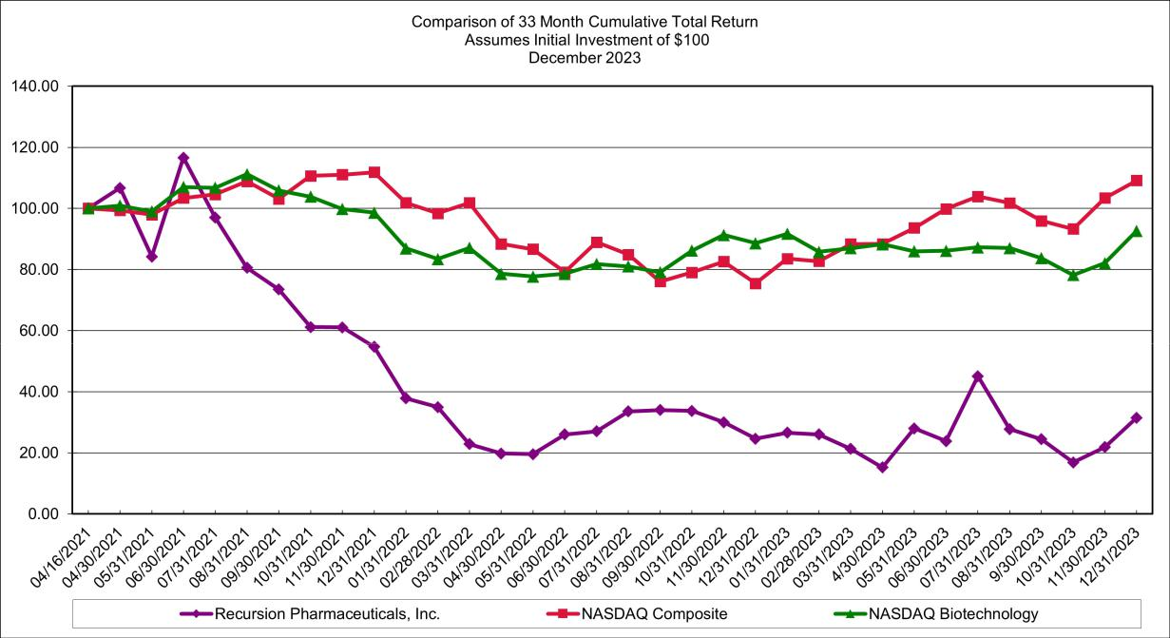

This performance graph is furnished and shall not be deemed "filed" with the SEC or subject to Section 18 of the Securities Exchange Act of 1934, as amended, nor shall it be deemed incorporated by reference in any of Recursion’s filings under the Securities Act of 1933, as amended.

Stockholders

There were 74 stockholders of record of Recursion Class A common stock as of January 31, 2024. The actual number of stockholders of our Class A common stock is greater than this number of record holders and includes stockholders who are beneficial owners but whose shares are held in street name by brokers and other nominees.

148

Table of Contents

Dividend policy

We have never declared or paid any cash dividends on our capital stock. We currently intend to retain any future earnings and do not expect to pay any dividends in the foreseeable future. Any future determination to declare cash dividends will be made at the discretion of our Board of Directors, subject to applicable laws, and will depend on a number of factors, including our financial condition, results of operations, capital requirements, contractual restrictions, general business conditions, and other factors that our Board of Directors may deem relevant, including restrictions in our current and future debt instruments, our future earnings, capital requirements, financial condition, prospects, and applicable Delaware law, which provides that dividends are only payable out of surplus or current net profits.

Securities authorized for issuance under equity compensation plans

Information about our equity compensation plans in Item 12 of Part III of this Annual Report on Form 10-K is incorporated herein by reference.

Recent sales of unregistered securities

(a) Sales of Unregistered Securities

Acquisitions

In May 2023, the Company entered into an agreement to acquire Cyclica. The aggregate upfront consideration for the acquisition of Cyclica consisted of 5.8 million shares of Recursion Class A common stock, cash payments, 1.0 million shares issuable upon exercise of stock options held by Cyclica equity award holders and deferred liabilities. Approximately 182 thousand of the aforementioned Class A common stock consideration had not yet been issued as of December 31, 2023. A prospectus supplement to a registration statement (File No. 333-264845) was subsequently filed pursuant to Rule 424(b) on June 9, 2023, to register the resale of certain of such shares and the issuance of shares issuable upon exercise of certain such stock options. In addition, a registration statement on Form S-8 (File No. 333-272282) was filed on May 30, 2023 to register the issuance of shares issuable upon exercise of certain of such stock options.

Also in May 2023, the Company entered into an agreement to acquire Valence. The aggregate upfront consideration for the acquisition of Valence consisted of 2.2 million shares of Recursion Class A common stock, 4.4 million shares of a subsidiary of Recursion, exchangeable for shares of Recursion’s Class A common stock, 792 thousand shares issuable upon the exercise of stock options held by Valence equity award holders and deferred liabilities. A registration statement on Form S-3ASR (File No. 333-272281) was subsequently filed on May 30, 2023, to register the resale of certain of such shares and to register the issuance of shares issuable upon exercise of certain of such stock options and of shares issuable upon exchange of exchangeable shares. In addition, a registration statement on Form S-8 (File No. 333-272027) was filed on May 18, 2023 to register the issuance of shares issuable upon exercise of certain of such stock options.

NVIDIA Private Placement

On July 11, 2023, the Company issued an aggregate of 7.7 million shares (the “NVIDIA Shares”) of the Company’s Class A common stock at a purchase price of $6.49 per share in a private placement to NVIDIA Corporation for net proceeds of approximately $49.9 million (the “NVIDIA Private Placement”). The sale was made pursuant to the exemption from registration contained in Section 4(a)(2) of the Securities Act. In connection with the NVIDIA Private Placement, the Company and NVIDIA Corporation entered into a registration rights agreement, dated July 11, 2023, providing for the registration for resale of the NVIDIA Shares. A prospectus supplement to a registration statement (File No. 333-264845) was subsequently filed pursuant to Rule 424(b) on August 8, 2023, to register the resale of the NVIDIA Shares by NVIDIA Corporation.

Tempus Private Placement

In November 2023, the Company entered into a Master Agreement (the “Tempus Agreement”) with Tempus Labs, Inc. (“Tempus”) pursuant to which Tempus will provide certain services and deliverables to the Company and/or license certain data to the Company. Pursuant to the Tempus Agreement, on November 30, 2023, the Company issued to Tempus an aggregate of 3.2 million shares of the Company’s Class A Common Stock, (the “Tempus Shares”), in lieu of a cash payment of $22.0 million for the initial license fee owed to Tempus in exchange for the rights granted to the Company under the Tempus Agreement (the “Tempus Private Placement”). The sale was made

149

Table of Contents

pursuant to the exemption from registration contained in Section 4(a)(2) of the Securities Act. Pursuant to the terms of the Tempus Agreement, the Company subsequently filed a prospectus supplement to a registration statement (File No. 333-264845) pursuant to Rule 424(b) on December 15, 2023, to register the resale of the Tempus Shares by Tempus.

Stock Option Exercises

For the year ended December 31, 2023, we issued 242,000 shares of our Class A common stock to our employees, advisors and consultants upon the exercise of stock options under our Key Personnel Incentive Stock Plans for aggregate consideration of approximately $43,000, in reliance on the exemption provided by Rule 701(b)(2) promulgated under the Securities Act, or pursuant to Section 4(a)(2) under the Securities Act, relative to transactions by an issuer not involving any public offering, to the extent an exemption from such registration was required.

(b) Issuer Purchases of Equity Securities

None.

Item 6. [Reserved]

150



Table of Contents

Item 7. Management’s Discussion and Analysis of Financial Condition and Results of Operations.

The following is a discussion and analysis of the financial condition of Recursion Pharmaceuticals, Inc. (Recursion, the Company, we, us or our) and the results of our operations. This commentary should be read in conjunction with the Consolidated Financial Statements and accompanying notes appearing in Item 8, “Financial Statements.” This discussion, particularly information with respect to our future results of operations or financial condition, business strategy and plans and objectives of management for future operations, includes forward-looking statements that involve risks and uncertainties as described under the heading "Note About Forward-Looking Statements" in this Annual Report on Form 10-K. You should review the disclosure under the heading "Risk Factors" in our Annual Report on Form 10-K for a discussion of important factors that could cause our actual results to differ materially from those anticipated in these forward-looking statements.

Overview

Recursion is a leading clinical stage TechBio company decoding biology to industrialize drug discovery. Central to our mission is the Recursion Operating System (OS), a platform built across diverse technologies that enables us to map and navigate trillions of biological, chemical and patient-centric relationships across over 50 petabytes of proprietary data. We frame this integration of the physical and digital components as iterative loops, where scaled ‘wet-lab’ biology, chemistry and patient-centric experimental data are organized by ‘dry-lab’ computational tools in order to identify, validate and translate therapeutic insights. We believe Recursion’s unbiased, data-driven approach to understanding biology will bring more, new and better medicines at higher scale and lower cost to patients.

There are three key value-drivers at Recursion:

- An expansive pipeline of internally developed clinical and preclinical programs focused on precision oncology and genetically driven rare diseases with significant unmet need and market opportunities that could potentially exceed $1 billion in annual sales in some cases

- Transformational partnerships with leading biopharma and technology companies to map and navigate intractable areas of biology, identify novel targets, and develop potential new medicines by using advanced computational and data resources

- An industry-leading dataset intentionally designed to capitalize on computational tools and accelerate value created through our pipeline, partnerships and technology products

We drive value by scaling and leveraging the Recursion OS to generate, aggregate and integrate over 50 petabytes of data spanning large language model derived disease relevance and target-compound relationships, predicted protein-ligand binding interactions for ~36 billion compounds, over 200 million total staining and multi-timepoint live-cell (brightfield) phenomics experiments, over 700 thousand whole transcriptomics experiments, tens of thousands of ADME experiments using our automated DMPK module, InVivomics and multimodal precision oncology patient data. This dataset has been curated using over 50 human cell types, our cell manufacturing facility which has

152

Table of Contents

produced over 1 trillion hiPSC-derived neuronal cells since 2022, our in-house chemical library of over 1.7 million compounds, an in silico library of over 1 trillion small molecules and other capabilities. We have built proprietary software applications and AI/ML models within the Recursion OS which predict and navigate over 5 trillion biological and chemical relationships. With our approach and our team of over 500 Recursionauts that is balanced between life scientists and computational and technical experts, we endeavor to turn drug discovery into a search problem, where we map and navigate biology in an unbiased manner in order to translate insights into more, new and better medicines at higher scale and lower cost to patients.
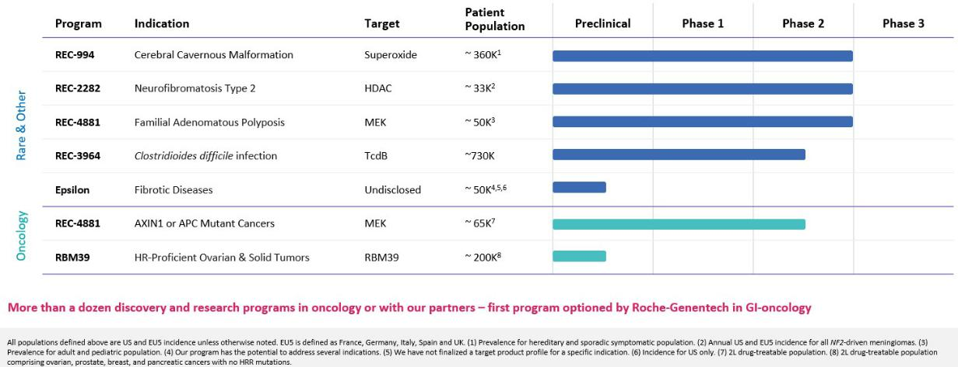

Summary of Business Highlights

Platform

- Causal AI Modeling and Additional Datasets: We have been training causal AI models leveraging over 20 petabytes of multimodal precision oncology patient data from Tempus to support the discovery of potential biomarker-enriched therapeutics at scale. By combining the forward genetics approach of Tempus with the reverse genetics approach at Recursion, we believe we have an opportunity to improve the speed, precision, and scale of therapeutic development in oncology. This work has already resulted in a directed-oncology program against a novel gene/disease relationship in a large oncology indication. Recursion intends to operate both as a data generator and multimodal data aggregator. In the future, we intend to augment our dataset and hone the Recursion OS with germline genetic data, organoid technologies, and automated nano-synthesis technologies.

- LOWE (Large Language Model-Orchestrated Workflow Engine): LOWE is an LLM agent that represents the next evolution of the Recursion OS. LOWE supports drug discovery programs by orchestrating complex wet and dry-lab workflows via natural language prompts. These workflows are the steps and tools available in the Recursion OS, from finding significant relationships across biology, chemistry, and patient-centric data to generating novel compounds and scheduling them for synthesis and experimentation. Through its natural language interface and interactive graphics, LOWE can put state-of-the-art AI tools into the hands of every drug discovery scientist.

Pipeline

- Cerebral Cavernous Malformation (CCM) (REC-994): Our Phase 2 SYCAMORE clinical trial is a randomized, double-blind, placebo-controlled, safety, tolerability and exploratory efficacy study of REC-994 in participants with CCM. This trial was fully enrolled in June 2023 with 62 participants and the vast majority of participants who completed 12 months of treatment continue to elect to enter the long-term extension study. We expect to share Phase 2 data in Q3 2024.

- Neurofibromatosis Type 2 (NF2) (REC-2282): Our adaptive Phase 2/3 POPLAR clinical trial is a randomized, two part study of REC-2282 in participants with progressive NF2-mutated meningiomas. Part 1 of the study is ongoing and is exploring two doses of REC-2282 in approximately 23 adults and 9

153

Table of Contents

adolescents, with enrollment in adults expected to complete in H1 2024. We expect to share Phase 2 safety and preliminary efficacy data in Q4 2024.

- Familial Adenomatous Polyposis (FAP) (REC-4881): Our Phase 1b/2 TUPELO clinical trial is an open label, multicenter, two part study of REC-4881 in participants with FAP. Part 1 is complete with FPI for Part 2 anticipated in H1 2024. We expect to share Phase 2 safety and preliminary efficacy data in H1 2025.
- AXIN1 or APC Mutant Cancers (REC-4881): Our Phase 2 LILAC clinical trial is an open label, multicenter study of REC-4881 in participants with unresectable, locally advanced or metastatic cancer with AXIN1 or APC mutations. This study was initiated at the end of 2023, with FPI anticipated in Q1 2024. We expect to share Phase 2 safety and preliminary efficacy data in H1 2025.

- Clostridioides difficile Infection (REC-3964): We conducted a Phase 1 healthy volunteer study to evaluate the safety, tolerability and PK of REC-3964 at increasing oral doses in comparison with placebo. REC-3964 was safe and well tolerated and there were no serious adverse events, deaths or TEAEs that led to discontinuation. REC-3964 is a first-in-class C.difficile toxin inhibitor and the first new chemical entity developed by Recursion, with promising preclinical efficacy data seen in relevant models (superiority versus bezlotoxumab). We expect to initiate a Phase 2 study in 2024.
- RBM39 HR-Proficient Ovarian Cancers and Other Solid Tumors: RBM39 is a novel CDK12-adjacent target identified by the Recursion OS. We intend to position our lead candidate as a single agent for the potential treatment of HR-proficient ovarian cancers and other HR-proficient solid tumors. As a result of our strategic collaboration with Tempus, we are leveraging genomic data across all tumor types to identify clinical biomarkers for patient expansion. We are advancing our lead candidate through IND-enabling studies with IND submission expected in H2 2024.

- Undisclosed Indication in Fibrosis (Target Epsilon): Phenotypic screening of human PBMCs identified novel and structurally diverse small molecules that reverse the phenotypic features of disease-state fibrocyte cells into those of healthy-state cells. The most promising compounds were confirmed as potent inhibitors of a novel target for fibrosis. This program originated under our initial fibrosis collaboration with Bayer and we have since in-licensed from Bayer all rights to this program which is now entering IND-enabling studies.

Partnerships

- Transformational Collaborations: We continue to advance efforts to discover potential new therapeutics with our strategic partners in the areas of undruggable oncology (Bayer) as well as neuroscience and a single indication in gastrointestinal oncology (Roche-Genentech). In the near-term, there is the potential for option exercises associated with partnership programs, option exercises associated with map building initiatives or data sharing, and additional partnerships in large, intractable areas of biology or technological innovation.

- Enamine: In December 2023, we entered a collaboration with Enamine to generate and design enriched compound libraries for the global drug discovery industry. By leveraging MatchMaker, a Recursion AI model, to identify compounds in the Enamine REAL Space (~36 billion chemical compounds) predicted to bind to high-value targets, we believe we can generate more powerful compound libraries for drug discovery purposes. Enamine may offer the resulting libraries to customers for purchase and will co-brand any libraries under both the Enamine and Recursion’s trademarks. This collaboration is an example of how select data layers can drive value in novel ways.

Financing and Operations

We were incorporated in November 2013. In April 2021, we closed our Initial Public Offering (IPO) and issued 27.9 million shares of Class A common stock at a price of $18.00 per share, raising net proceeds of $462.4 million. Prior to our IPO, we had raised $448.9 million in equity financing from investors in addition to $ 30.0 million in an upfront payment from our collaboration with Bayer AG (Bayer). In January 2022, we received an upfront payment of $150.0 million from our collaboration with Roche. See Note 9, “Collaborative Development Contracts” to the Consolidated Financial Statements for additional information on the collaborations. In October 2022, we issued 15.3 million shares of our Class A common stock at a purchase price of $9.80 per share in the 2022 private placement to qualified institutional buyers and institutional accredited investors (the Purchasers) for net proceeds of $143.7 million, after deducting fees and offering costs of $6.6 million. In July 2023, we issued an aggregate of 7.7 million shares of our Class A common stock at a purchase price of $6.49 per share in the 2023 Private Placement with

154

Table of Contents

NVIDIA Corporation for net proceeds of approximately $50.0 million. See Note 8, “Common Stock” to the Consolidated Financial Statements for additional information on the private placements. During the year ended December 31, 2023, Recursion entered into an Open Market Sales Agreement (the “Sales Agreement”) with Jefferies LLC (the “Sales Agent”). For the year ended December 31, 2023, the Company has sold 12.0 million shares and received net proceeds of $78.2 million under the agreement. See Note 8, “Common Stock” to the Consolidated Financial Statements for additional information on the Sales Agreement.

We use the capital we have raised to fund operating and investing activities across platform research operations, drug discovery, clinical development, digital and other infrastructure, creation of our portfolio of intellectual property and administrative support. We do not have any products approved for commercial sale and have not generated any revenues from product sales. We had cash and cash equivalents of $391.6 million as of December 31, 2023. Based on our current operating plan, we believe that our cash and cash equivalents will be sufficient to fund our operations for at least the next twelve months.

Since inception, we have incurred significant operating losses. Our net losses were $328.1 million, $239.5 million and $186.5 million during the years ended December 31, 2023, 2022 and 2021, respectively. As of December 31, 2023, our accumulated deficit was $967.6 million.

We anticipate that we will need to raise additional financing in the future to fund our operations, including the potential commercialization of any approved product candidates. Until such time, if ever, as we can generate significant product revenue, we expect to finance our operations with our existing cash and cash equivalents, any future equity or debt financings and upfront, milestone and royalty payments, if any, received under current or future license or collaboration agreements. We may not be able to raise additional capital on terms acceptable to us or at all. If we are unable to raise additional capital when desired, our business, results of operations and financial condition may be adversely affected.

Results of Operations

The following table summarizes our results of operations:

 |  | Years ended December 31, |  |  |  |  |  |  | 2023 compared to 2022 |  | 2022 compared to 2021
(in thousands, except percentages) |  | 2023 |  | 2022 |  | 2021 |  |  | $ | % | $ | %
Revenue
Operating revenue | $ | 43,876 | $ | 39,681 | $ | 10,000 |  | $ | 4,195 | 10.6 % $ | 29,681 | >100%
Grant revenue |  | 699 |  | 162 |  | 178 |  |  | 538 | >100% | (16) | (9.0)%
Total revenue |  | 44,575 |  | 39,843 |  | 10,178 |  |  | 4,733 | 11.9 % | 29,665 | >100%
Operating costs and expenses
Cost of revenue |  | 42,587 |  | 48,275 |  | — |  |  | (5,688) | (11.8)% | 48,275 | n/m
Research and development |  | 241,226 |  | 155,696 |  | 135,271 |  |  | 85,530 | 54.9 % | 20,425 | 15.1 %
General and administrative |  | 110,822 |  | 81,599 |  | 57,682 |  |  | 29,224 | 35.8 % | 23,917 | 41.5 %
Total operating costs and expenses |  | 394,635 |  | 285,570 |  | 192,953 |  |  | 109,066 | 38.2 % | 92,617 | 48.0 %
Loss from operations |  | (350,060) |  | (245,727) |  | (182,775) |  |  | (104,333) | 42.5 % | (62,952) | 34.4 %
Other income (loss), net |  | 17,932 |  | 6,251 |  | (3,704) |  |  | 11,681 | >100% | 9,955 | n/m
Loss before income tax benefit |  | (332,128) |  | (239,476) |  | (186,479) |  |  | (92,652) | 38.7 % | (52,997) | 28.4 %
Income tax benefit |  | 4,062 |  | — |  | — |  |  | 4,062 | n/m | — | n/m
Net loss | $ | (328,066) | $ | (239,476) | $ | (186,479) |  | $ | (88,590) | 37.0 % $ | (52,997) | 28.4 %

n/m = Not meaningful

155

Table of Contents

Summary

Our financial performance during the year ended December 31, 2023 compared to 2022 included an increase in research and development costs due to increased platform costs as we have expanded and upgraded our capabilities, additionally for the year ended December 31, 2022 platform costs decreased due to a reallocation of spending to cost of revenue for our strategic partnerships.

Our financial performance during the year ended December 31, 2022 compared to 2021 included: (i) a decrease in platform research and development costs due to a reallocation of spending to cost of revenue for our strategic partnerships; (ii) an increase in revenue recognized due to our partnership with Roche; and (iii) the incurrence of cost of revenue due to our strategic partnerships. Additionally, our financial results reflected added funding to support our emerging early- and mid-stage pipeline assets.

Revenue

The following table summarizes our components of revenue:

 |  | Years ended December 31, |  |  |  |  |  |  | 2023 compared to 2022 |  | 2022 compared to 2021
(in thousands, except percentages) |  | 2023 |  | 2022 |  | 2021 |  |  | $ | % | $ | %
Revenue
Operating revenue | $ | 43,876 | $ | 39,681 | $ | 10,000 |  | $ | 4,195 | 10.6 % $ | 29,681 | >100%
Grant revenue |  | 699 |  | 162 |  | 178 |  |  | 538 | >100% | (16) | (9.0)%
Total revenue | $ | 44,575 | $ | 39,843 | $ | 10,178 |  | $ | 4,733 | 11.9 % $ | 29,665 | >100%

Operating revenue is generated through partnerships in which we perform research and development activities for customers. Generally, those arrangements provide our customers with certain rights related to the results of those research and development activities. We may also retain certain rights related to the results of those activities. Our revenue to-date relates primarily to the recognition over time of amounts received at inception of the partnerships. In addition, we are entitled to receive variable consideration as certain milestones are achieved. The timing of revenue recognition is not directly correlated to the timing of cash receipts.

For the year ended December 31, 2023, the increase in revenue compared to prior year was due to revenue recognized from our partnership with Roche, which has progressed from primarily cell type evaluation work to inference-based Phenomap building and additional cell type evaluation work. For the year ended December 31, 2022, the increase in revenue compared to prior year was due to revenue recognized from our partnership with Roche, which commenced in January 2022.

Cost of Revenue

The following table summarizes our cost of revenue:

 |  | Years ended December 31, |  |  |  |  |  | 2023 compared to 2022 |  | 2022 compared to 2021
(in thousands, except percentages) |  | 2023 |  | 2022 | 2021 | $ |  |  | % | $ | %
Total cost of revenue | $ | 42,587 | $ | 48,275 | $ | — |  | $ (5,688) | (11.8)% $ | 48,275 | n/m

n/m = Not meaningful

Cost of revenue consists of the Company’s costs to provide services for drug discovery required under performance obligations with partnership customers. These primarily include materials costs, service hours performed by our employees and depreciation of property and equipment.

For the year ended December 31, 2023, the decrease in cost of revenue compared to prior year was due to our partnership with Bayer, for which less brute-force work was required. For the year ended December 31, 2022, the increase in cost of revenue compared to prior year was due to our strategic partnerships. For the year ended

156

Table of Contents

December 31, 2021, cost of revenue was insignificant and was included within “Research and development” in the Consolidated Statement of Operations.

Research and Development

The following table summarizes our components of research and development expense:

 |  | Years ended December 31, |  |  |  |  |  |  | 2023 compared to 2022 |  | 2022 compared to 2021
(in thousands, except percentages) |  | 2023 |  | 2022 |  | 2021 |  |  | $ | % | $ | %
Research and development expenses
Platform | $ | 96,796 | $ | 41,765 | $ | 55,959 |  | $ | 55,031 | >100% $ | (14,194) | (25.4)%
Discovery |  | 62,142 |  | 52,358 |  | 48,984 |  |  | 9,784 | 18.7 % | 3,374 | 6.9 %
Clinical |  | 57,564 |  | 46,820 |  | 21,841 |  |  | 10,744 | 22.9 % | 24,979 | >100%
Stock based compensation |  | 22,761 |  | 10,524 |  | 4,979 |  |  | 12,237 | >100% | 5,545 | >100%
Other |  | 1,963 |  | 4,229 |  | 3,508 |  |  | (2,266) | (53.6)% | 721 | 20.6 %
Total research and development expenses | $ | 241,226 | $ | 155,696 | $ | 135,271 |  | $ | 85,530 | 54.9 % $ | 20,425 | 15.1 %

Research and development expenses account for a significant portion of our operating expenses. These expenses arise from research and development activities that are not performed pursuant to a customer contract. We recognize research and development expenses as they are incurred. Research and development expenses consist of costs incurred in performing activities including:

- costs to develop and operate our platform;

- costs of discovery efforts which may lead to development candidates, including research materials and external research;

- costs for clinical development of our investigational products;

- costs for materials and supplies associated with the manufacture of active pharmaceutical ingredients, investigational products for preclinical testing and clinical trials;
- personnel-related expenses, including salaries, benefits, bonuses and stock-based compensation for employees engaged in research and development functions;
- costs associated with operating our digital infrastructure; and

- other direct and allocated expenses incurred as a result of research and development activities, including those for facilities, depreciation, amortization and insurance.

We recognize expenses associated with third-party contracted services as they are incurred. Upon termination of contracts with third parties, our financial obligations are generally limited to costs incurred or committed to date. Any advance payments for goods or services to be used or rendered in future research and product development activities pursuant to a contractual arrangement are classified as prepaid expenses until such goods or services are rendered.

Significant components of research and development expense include the following allocated by development phase: Platform, which refers primarily to expenses related to screening of product candidates through hit identification; Discovery, which refers primarily to expenses related to hit identification through development of candidates; and Clinical, which refers primarily to expenses related to development of candidates and beyond.

For the year ended December 31, 2023, the increase in research and development expenses compared to the prior year was primarily due to increased platform costs as we have expanded and upgraded our capabilities in platform including our chemical technology, machine learning and transcriptomics platform.

For the year ended December 31, 2022, the increase in research and development expenses compared to the prior year was primarily due to increased clinical costs as studies progressed. The Company initiated three Phase 2 or Phase 2/3 studies and two Phase 1 studies in 2022, which includes a Phase 1 study for REC-4881. These increases were partially offset by a decrease in platform costs due to a reallocation of spending to cost of revenue for our strategic partnerships.

157

Table of Contents

General and Administrative Expense

The following table summarizes our general and administrative expense:

 | Years ended December 31, |  |  |  |  |  |  | 2023 compared to 2022 |  | 2022 compared to 2021
(in thousands, except percentages) | 2023 |  | 2022 |  | 2021 |  |  | $ | % | $ | %
Total general and administrative expenses | $ 110,822 | $ | 81,599 | $ | 57,682 |  | $ | 29,223 | 35.8 % $ | 23,917 | 41.5 %

We expense general and administrative costs as incurred. General and administrative expenses consist primarily of salaries; including employee benefits and stock-based compensation. General and administrative expenses also include facilities, depreciation, information technology, professional fees for auditing and tax, legal fees for corporate and patent matters and insurance costs.

For the year ended December 31, 2023, the increase in general and administrative expense compared to the prior year was primarily driven by an increase in salaries and wages of $12.4 million and increases in legal, software and depreciation expense.

For the year ended December 31, 2022, the increase in general and administrative expense compared to prior year was due to the growth in size of the Company’s operations including increased salaries and wages of $14.3 million, a fixed asset write-down of $2.8 million, increased rent expense of $2.4 million and increases in other administrative costs associated with operating a growing company.

Other Income (Loss), Net

The following table summarizes our components of other income (loss), net:

 |  | Years ended December 31, |  |  |  |  |  |  | 2023 compared to 2022 |  | 2022 compared to 2021
(in thousands, except percentages) |  | 2023 |  | 2022 |  | 2021 |  |  | $ | % | $ | %
Interest expense | $ | (97) | $ | (55) | $ | (2,952) |  | $ | (43) | 78.4 % $ | 2,897 | (98.1)%
Interest income |  | 19,116 |  | 6,254 |  | 73 |  |  | 12,862 | >100% | 6,181 | >100%
Loss on debt extinguishment |  | — |  | — |  | (827) |  |  | — | n/m | 827 | (100.0)%
Other |  | (1,087) |  | 52 |  | 2 |  |  | (1,139) | (2174.7)% | 51 | >100%
Other income (loss), net | $ | 17,932 | $ | 6,251 | $ | (3,704) |  | $ | 11,680 | >100% $ | 9,956 | n/m

n/m = Not meaningful

For the year ended December 31, 2023, the increase in other income (loss), net compared to the prior year was driven by an increase in interest income related to earnings on cash and cash equivalents in money market funds.

For the year ended December 31, 2022, the increase in other income (loss), net compared to the prior year was driven by a decrease in interest expense from a loan settlement and an increase in interest income from earnings on cash and cash equivalents in money market funds.

Liquidity and Capital Resources

Sources of Liquidity

We have not yet commercialized any products and do not expect to generate revenue from the sales of any product candidates for at least several years. Cash and cash equivalents totaled $391.6 million and $549.9 million as of December 31, 2023 and 2022, respectively.

We have incurred operating losses and experienced negative operating cash flows and we anticipate that the Company will continue to incur losses for at least the foreseeable future. Our net loss was $328.1 million, $239.5 million and $186.5 million during the years ended December 31, 2023, 2022 and 2021, respectively. As of December 31, 2023, we had an accumulated deficit of $967.6 million.

158

Table of Contents

We have financed our operations through the private placements of preferred stock and Class A common stock issuances. As of December 31, 2023, we have received net proceeds of $448.9 million from the sale of preferred stock and $734.2 million from Class A common stock issuances. See Note 8, “Common Stock” to the Consolidated Financial Statements for additional details on Class A common stock issuances. Additionally, as of December 31, 2023, we have received proceeds of $183.0 million from our strategic partnerships. See Note 9, “Collaborative Development Contracts” to the Consolidated Financial Statements for additional details on the partnerships.

Cash Flows

The following table is a summary of the Consolidated Statements of Cash Flows:

 |  | Years ended December 31,
(in thousands) |  | 2023 |  | 2022 |  | 2021
Cash used in operating activities | $ | (287,780) | $ | (83,524) | $ | (158,614)
Cash provided by (used in) investing activities |  | (10,228) |  | 193,249 |  | (271,744)
Cash provided by financing activities |  | 140,133 |  | 154,345 |  | 458,540

Operating Activities

Cash used by operating activities increased during the year ended December 31, 2023 as a result of an upfront payment of $150.0 million from our strategic partnership with Roche received during the year ended December 31, 2022.

Cash used by operating activities during the year ended December 31, 2022 included an upfront payment of $150.0 million from our strategic partnership with Roche. That cash inflow was offset by cash used for cost of revenue, research and development and general and administrative expenses.

Cash used by operating activities during the year ended December 31, 2021 increased compared to the prior year as a result of higher costs incurred for research and development and general and administrative expenses due to the Company’s growth.

Investing Activities

Cash used by investing activities during the year ended December 31, 2023 consisted primarily of purchases of property and equipment of $12.0 million, which includes $1.7 million for a project to upgrade the BioHive supercomputer and lab equipment purchases. The cash used was partially offset by $1.8 million of net cash acquired in the acquisition of a business.

Cash provided by investing activities during the year ended December 31, 2022 was driven by sales and maturities of investments of $230.6 million, partially offset by the purchases of property and equipment of $37.1 million.

Cash used by investing activities during the year ended December 31, 2021 primarily consisted of investment purchases of $301.1 million and property and equipment purchases of $39.8 million, which included $17.9 million for the purchase of a Dell EMC supercomputer. The cash outflows were partially offset by proceeds of $69.2 million from the sales and maturities of investments.

Financing Activities

Cash provided by financing activities during the year ended December 31, 2023 primarily included proceeds of $128.1 million from common stock issuances. Financing inflows also included proceeds from equity incentive plans of $12.8 million.

Cash provided by financing activities during the year ended December 31, 2022 primarily included $143.7 million of net proceeds from the 2022 Private Placement. Financing cash flows also included proceeds from equity incentive plans of $10.7 million.

Cash provided by financing activities during the year ended December 31, 2021 primarily included $462.4 million of net proceeds from the IPO. Financing cash flows also included an outflow of $12.7 million for the repayment of long-term debt.

159

Table of Contents

Critical Accounting Estimates and Policies

Our management’s discussion and analysis of financial condition and results of operations is based on our financial statements, which have been prepared in accordance with U.S. generally accepted accounting principles (GAAP). The preparation of our consolidated financial statements and related disclosures requires us to make estimates and assumptions that affect the reported amounts of assets and liabilities and expenses in our financial statements. We base our estimates on historical experience, known trends and events and various other factors that we believe are reasonable under the circumstances, the results of which form the basis for making judgments about the carrying values of assets and liabilities that are not readily apparent from other sources. We evaluate our estimates and assumptions on an ongoing basis. Our actual results may differ from these estimates under different assumptions or conditions.

While our significant accounting policies are described in more detail in the notes to our consolidated financial statements, we believe that the following accounting policies are those most critical to the judgments and estimates used in the preparation of our consolidated financial statements.

Revenue Recognition

We have generated revenue from our contracts with partners. Our partnerships often contain multiple components, including research and development services, licenses, options to obtain development and commercialization rights and options to obtain additional research and development services. Such arrangements may provide for various types of payments to us, including upfront fees, technical, development, regulatory and commercial milestone payments, licensing fees, option exercise fees and royalty and milestone payments on product sales. Determining how to recognize revenue from these partnerships involves judgment about whether promised goods and services are distinct from one another or should be accounted for as combined performance obligations, how to estimate and allocate various payment streams to performance obligations and how to measure performance on each performance obligation. Because of these judgments, payments are often not commensurate with the timing of revenue recognition.

Our operating revenue has primarily been generated through research and development agreements. Revenue from research and development agreements is recognized as the Company satisfies the performance obligation by transferring the promised services to the customer. The Company recognizes revenue over time by measuring the progress toward complete satisfaction of the relevant performance obligation using an appropriate input or output method based on the services promised to the customer. This method of recognizing revenue requires the Company to make estimates to determine the progress towards completion. A significant change in these estimates could have a material effect on the timing and amount of revenue recognized in future periods.

Valuation of Goodwill and Intangible Assets

Recursion has acquired and may continue to acquire significant intangible assets and goodwill in connection with business combinations. Amounts allocated to intangible assets and goodwill are based upon fair value estimates. We make estimates of fair value based upon assumptions believed to be reasonable and that of a market participant. These estimates are based on available historical information as well as future expectations and the estimates are inherently uncertain. The use of alternative estimates and assumptions could increase or decrease the estimated fair values, the amounts allocated to identifiable intangible assets acquired, future amortization expense and the value of goodwill.

Accrued Research and Development Expenses

As part of the process of preparing our financial statements, we are required to estimate our expenses resulting from our obligations under contracts with vendors and clinical research organizations. The financial terms of these contracts are subject to negotiations, which vary from contract to contract and may result in payment terms that do not match the periods over which materials or services are provided under such contracts. Our objective is to reflect the appropriate expenses in our financial statements by matching those expenses with the period in which services are performed and efforts are expended. We account for these expenses according to the timing of various aspects of the expenses and determine accrual estimates by taking into account discussions with applicable personnel and outside service providers as to the progress of clinical trials, or the services completed. During the course of a

160

Table of Contents

clinical trial, we adjust our clinical expense recognition if actual results differ from estimates. We make estimates of our accrued expenses as of each balance sheet date based on the facts and circumstances known to us at that time. Our clinical trial accruals are dependent upon the timely and accurate reporting of contract research organizations and other third-party vendors. Although we do not expect estimates to be materially different from amounts actually incurred, our understanding of the anticipated status and timing of services performed relative to the actual status and timing of services performed may vary and may result in reporting amounts that are too high or too low for any particular period.

Stock-Based Compensation

We measure stock options and other stock-based awards granted to employees, directors and non-employees based on their fair value on the date of grant and recognize the compensation expense over the requisite service period. We recognize the impact of forfeitures on stock-based compensation expenses as forfeitures occur. We generally apply the straight-line method of expense recognition to awards.

The grant date fair value of stock options is estimated using the Black-Scholes option-pricing model, which requires inputs for the expected term, stock price volatility, dividend yield and the risk-free interest rate of the options. If any assumptions used in the Black-Scholes option-pricing model change significantly, stock-compensation for future awards may differ materially compared with the awards granted previously.

Contractual Obligations

The Company’s material cash requirements include the following contractual obligations:

As of December 31, 2023, the Company had $1.1 million of debt outstanding. This balance is related to notes payable for tenant improvement allowances and the financing agreement for the supercomputer upgrade project. See Note 2, “Summary of Significant Accounting Policies” to the Consolidated Financial Statements for additional details.

As of December 31, 2023, the Company had $66.2 million of future lease commitments. See Note 5 “Leases” to the Consolidated Financial Statements for additional detail on future lease commitments.

As of December 31, 2023, the Company had $229.3 million of future purchase obligations, $91.3 million of which are expected to be payable within the next year. These commitments primarily related to third-party research services, materials and supplies for research and development activities.

Recently Issued and Adopted Accounting Pronouncements

See Note 2, “Summary of Significant Accounting Policies” to the Consolidated Financial Statements for information regarding recently issued and adopted accounting pronouncements.

Item 7a. Quantitative and Qualitative Disclosures About Market Risk.

Interest rate risk

We are exposed to market risk related to changes in interest rates of our investment portfolio of cash and cash equivalents. As of

December 31, 2023, our cash and cash equivalents consisted of money market funds. Our primary exposure to market risk is interest income sensitivity, which is affected by changes in U.S. interest rates. A hypothetical 100 basis point decrease in interest rates as of December 31, 2023 would have an insignificant effect on net loss in the ensuring year.

Foreign currency exchange risk

Our employees and our operations are primarily located in the United States and Canada and our expenses are generally denominated in U.S. and Canadian dollars. We also have entered into a limited number of contracts with vendors for research and development services that have underlying payment obligations denominated in foreign currencies. We are subject to foreign currency transaction gains or losses on our contracts denominated in foreign currencies. To date, foreign currency transaction gains and losses have not been material to our financial statements, and we do not have a formal hedging program with respect to foreign currency. A 10% increase or

161

Table of Contents

decrease in current exchange rates would not have had a material effect on our financial results during the years ended December 31, 2023, 2022 and 2021.

162



Table of Contents

Item 8. Financial Statements and Supplementary Data.

Report of Independent Registered Public Accounting Firm

To the Shareholders and the Board of Directors of Recursion Pharmaceuticals, Inc.

Opinion on the Financial Statements

We have audited the accompanying consolidated balance sheets of Recursion Pharmaceuticals, Inc. (the Company) as of December 31, 2023 and 2022, the related consolidated statements of operations, comprehensive loss, convertible preferred stock and stockholders’ equity and cash flows for each of the three years in the period ended December 31, 2023, and the related notes (collectively referred to as the “consolidated financial statements”). In our opinion, the consolidated financial statements present fairly, in all material respects, the financial position of the Company at December 31, 2023 and 2022, and the results of its operations and its cash flows for each of the three years in the period ended December 31, 2023, in conformity with U.S. generally accepted accounting principles.

We also have audited, in accordance with the standards of the Public Company Accounting Oversight Board (United States) (PCAOB), the Company's internal control over financial reporting as of December 31, 2023, based on criteria established in Internal Control-Integrated Framework issued by the Committee of Sponsoring Organizations of the Treadway Commission (2013 framework) and our report dated February 29, 2024 expressed an adverse opinion thereon.

Basis for Opinion

These financial statements are the responsibility of the Company’s management. Our responsibility is to express an opinion on the Company’s financial statements based on our audits. We are a public accounting firm registered with the PCAOB and are required to be independent with respect to the Company in accordance with the U.S. federal securities laws and the applicable rules and regulations of the Securities and Exchange Commission and the PCAOB.

We conducted our audits in accordance with the standards of the PCAOB. Those standards require that we plan and perform the audit to obtain reasonable assurance about whether the financial statements are free of material misstatement, whether due to error or fraud. Our audits included performing procedures to assess the risks of material misstatement of the financial statements, whether due to error or fraud, and performing procedures that respond to those risks. Such procedures included examining, on a test basis, evidence regarding the amounts and disclosures in the financial statements. Our audits also included evaluating the accounting principles used and significant estimates made by management, as well as evaluating the overall presentation of the financial statements. We believe that our audits provide a reasonable basis for our opinion.

Critical Audit Matter

The critical audit matter communicated below is a matter arising from the current period audit of the financial statements that was communicated or required to be communicated to the audit committee and that: (1) relates to accounts or disclosures that are material to the financial statements and (2) involved our especially challenging, subjective or complex judgments. The communication of the critical audit matter does not alter in any way our opinion on the consolidated financial statements, taken as a whole, and we are not, by communicating the critical audit matter below, providing a separate opinion on the critical audit matter or on the accounts or disclosures to which it relates.

164

 |  | Table of Contents
 | Revenue Recognition – Operating Revenue
Description of the | In connection with the Company’s collaboration and license agreement with Roche and Genentech to perform
Matter | research and development services, revenue is recognized based on costs incurred relative to total expected costs
 | to perform the research and development services. Significant inputs used to determine expected contract costs
 | include the length of time required, service hours performed by Company employees, and materials costs.
 | Accounting for the agreement involves judgment, particularly as it relates to estimating total costs to be incurred
 | based on the scope of work and historical experience, among other factors.
 | Given the judgment necessary to estimate total costs, which is a significant factor in calculating the amount of
 | revenue to recognize under the agreement during a period, auditing the Company’s total cost estimate required
 | significant audit effort.
How We | To test the Company’s estimate of total costs, we obtained the agreement and evaluated the terms and conditions to
Addressed the | understand the nature of the Company’s obligations under the agreement. We obtained and evaluated
Matter in Our Audit | management’s estimate of total costs to be incurred by performing corroborating inquiries with the Company’s project
 | scientists and financial analysts. We tested the mathematical accuracy of the costs to be incurred used in the
 | revenue calculations. We also tested the reasonableness of costs underlying the total estimate by comparing the
 | cost estimates to actual costs incurred.

/s/ Ernst & Young LLP

We have served as the Company’s auditor since 2017.

Salt Lake City, Utah

February 29, 2024

165

Table of Contents

Report of Independent Registered Public Accounting Firm

To the Shareholders and the Board of Directors of Recursion Pharmaceuticals, Inc.

Opinion on Internal Control Over Financial Reporting

We have audited Recursion Pharmaceuticals, Inc.’s internal control over financial reporting as of December 31, 2023, based on criteria established in Internal Control—Integrated Framework issued by the Committee of Sponsoring Organizations of the Treadway Commission (2013 framework) (the COSO criteria). In our opinion, because of the effect of the material weakness described below on the achievement of

the objectives of the control criteria, Recursion Pharmaceuticals, Inc. (the Company) has not maintained effective internal control over financial reporting as of December 31, 2023, based on the COSO criteria.

A material weakness is a deficiency, or combination of deficiencies, in internal control over financial reporting, such that there is a reasonable possibility that a material misstatement of the company’s annual or interim financial statements will not be prevented or detected on a timely basis. The following material weakness has been identified and included in management’s assessment. Management has identified a material weakness in internal controls related to the company’s revenue and unearned revenue process.

As indicated in the accompanying Management’s Annual Report on Internal Control Over Financial Reporting, management’s assessment of and conclusion on the effectiveness of internal control over financial reporting did not include the internal controls of Valence Discovery Inc. and Cyclica Inc., which are included in the 2023 consolidated financial statements of the Company and constituted 14% and 19% of total and

net assets, respectively, as of December 31, 2023, and 2% and 4% of revenues and net loss, respectively, for the year then ended. Our audit of internal control over financial reporting of the Company also did not include an evaluation of the internal control over financial reporting of

Valence Discovery Inc. and Cyclica Inc.

We also have audited, in accordance with the standards of the Public Company Accounting Oversight Board (United States) (PCAOB), the consolidated balance sheets of the Company as of December 31, 2023 and 2022, the related consolidated statements of operations, comprehensive loss, convertible preferred stock and stockholders’ equity and cash flows for each of the three years in the period ended December 31, 2023, and the related notes. This material weakness was considered in determining the nature, timing and extent of audit tests applied in our audit of the 2023 consolidated financial statements, and this report does not affect our report dated February 29, 2024, which expressed an unqualified opinion thereon.

Basis for Opinion

The Company’s management is responsible for maintaining effective internal control over financial reporting and for its assessment of the effectiveness of internal control over financial reporting included in the accompanying Management’s Annual Report on Internal Control Over Financial Reporting. Our responsibility is to express an opinion on the Company’s internal control over financial reporting based on our audit.

We are a public accounting firm registered with the PCAOB and are required to be independent with respect to the Company in accordance with the U.S. federal securities laws and the applicable rules and regulations of the Securities and Exchange Commission and the PCAOB.

We conducted our audit in accordance with the standards of the PCAOB. Those standards require that we plan and perform the audit to obtain reasonable assurance about whether effective internal control over financial reporting was maintained in all material respects.

Our audit included obtaining an understanding of internal control over financial reporting, assessing the risk that a material weakness exists, testing and evaluating the design and operating effectiveness of internal control based on the assessed risk, and performing such other procedures as we considered necessary in the circumstances. We believe that our audit provides a reasonable basis for our opinion.

Definition and Limitations of Internal Control Over Financial Reporting

A company’s internal control over financial reporting is a process designed to provide reasonable assurance regarding the reliability of financial reporting and the preparation of financial statements for external purposes in accordance with generally accepted accounting principles. A company’s internal control over financial reporting includes those policies and procedures that (1) pertain to the maintenance of records that, in reasonable detail,

166

Table of Contents

accurately and fairly reflect the transactions and dispositions of the assets of the company; (2) provide reasonable assurance that transactions are recorded as necessary to permit preparation of financial statements in accordance with generally accepted accounting principles, and that receipts and expenditures of the company are being made only in accordance with authorizations of management and directors of the company; and (3) provide reasonable assurance regarding prevention or timely detection of unauthorized acquisition, use, or disposition of the company’s assets that could have a material effect on the financial statements.

Because of its inherent limitations, internal control over financial reporting may not prevent or detect misstatements. Also, projections of any

evaluation of effectiveness to future periods are subject to the risk that controls may become inadequate because of changes in conditions, or that the degree of compliance with the policies or procedures may deteriorate.

/s/ Ernst & Young LLP

Salt Lake City, Utah

February 29, 2024

167

Table of Contents

Recursion Pharmaceuticals, Inc.

Consolidated Balance Sheets

(in thousands, except share and per share amounts)

 |  | December 31,
 |  | 2023 |  | 2022
Assets
Current assets
Cash and cash equivalents | $ | 391,565 | $ | 549,912
Restricted cash |  | 3,231 |  | 1,280
Other receivables |  | 3,094 |  | 2,753
Other current assets |  | 40,247 |  | 15,869
Total current assets |  | 438,137 |  | 569,814
Restricted cash, non-current |  | 6,629 |  | 7,920
Property and equipment, net |  | 86,510 |  | 88,192
Operating lease right-of-use assets |  | 33,663 |  | 33,255
Intangible assets, net |  | 36,443 |  | 1,306
Goodwill |  | 52,056 |  | 801
Other assets, non-current |  | 261 |  | —
Total assets | $ | 653,699 | $ | 701,288
Liabilities and stockholders’ equity
Current liabilities
Accounts payable | $ | 3,953 | $ | 4,586
Accrued expenses and other liabilities |  | 46,635 |  | 32,904
Unearned revenue |  | 36,426 |  | 56,726
Notes payable |  | 41 |  | 97
Operating lease liabilities |  | 6,116 |  | 5,952
Total current liabilities |  | 93,171 |  | 100,265
Unearned revenue, non-current |  | 51,238 |  | 70,261
Notes payable, non-current |  | 1,101 |  | 536
Operating lease liabilities, non-current |  | 43,414 |  | 44,420
Deferred tax liabilities |  | 1,339 |  | —
Total liabilities |  | 190,263 |  | 215,482
Commitments and contingencies (Note 7)

Stockholders’ equity

Common stock, $0.00001 par value; 2,000,000,000 shares (Class A 1,989,032,117 and Class B 10,967,883) authorized as of December 31, 2023 and December 31, 2022; 234,270,384 shares (Class A 226,264,764, Class B 7,544,871 and Exchangeable 460,749) and 191,022,864 (Class A 183,209,655 and Class B 7,813,209 and Exchangeable —) issued and outstanding as of December 31, 2023 and December 31, 2022, respectively

Additional paid-in capital

Accumulated deficit

2 2

1,431,056 1,125,360

(967,622) (639,556)

Total stockholders’ equity |  | 463,436 |  | 485,806
Total liabilities and stockholders’ equity | $ | 653,699 | $ | 701,288

See the accompanying notes to these consolidated financial statements.

168

 |  |  |  |  |  |  | Table of Contents
 | Recursion Pharmaceuticals, Inc.
 | Consolidated Statements of Operations
 | (in thousands, except share and per share amounts)
 |  |  | Years ended December 31,
 |  |  | 2023 |  | 2022 |  | 2021
Revenue
Operating revenue | $ |  | 43,876 | $ | 39,681 | $ | 10,000
Grant revenue |  |  | 699 |  | 162 |  | 178
Total revenue |  |  | 44,575 |  | 39,843 |  | 10,178
Operating costs and expenses
Cost of revenue |  |  | 42,587 |  | 48,275 |  |  | —
Research and development |  |  | 241,226 |  | 155,696 |  | 135,271
General and administrative |  |  | 110,822 |  | 81,599 |  | 57,682
Total operating costs and expenses |  |  | 394,635 |  | 285,570 |  | 192,953
Loss from operations |  |  | (350,060) |  | (245,727) |  | (182,775)
Other income (loss), net |  |  | 17,932 |  | 6,251 |  | (3,704)
Loss before income tax benefit |  |  | (332,128) |  | (239,476) |  | (186,479)
Income tax benefit |  |  | 4,062 |  | — |  |  | —
Net loss | $ |  | (328,066) | $ | (239,476) | $ | (186,479)
Per share data
Net loss per share of Class A, B and Exchangeable common stock, basic |  |  | (1.58) | $ | (1.36) | $ | (1.49)
and diluted | $
Weighted-average shares (Class A, B and Exchangeable) outstanding, |  |  | 207,853,702 |  | 175,537,487 |  | 125,348,110
basic and diluted |  |  | 207,853,702 |  | 175,537,487

See the accompanying notes to these consolidated financial statements.

169

Table of Contents
 |  | Recursion Pharmaceuticals, Inc.
 |  | Consolidated Statements of Comprehensive Loss
 |  | (in thousands)
 |  |  |  | Years ended December 31,
 |  |  |  | 2023 |  | 2022 |  | 2021
Net loss |  |  | $ | (328,066) | $ | (239,476) | $ | (186,479)
Unrealized gain (loss) on investments |  |  |  | — |  | 87 |  | (162)
Net realized loss on investments reclassified into net loss |  |  |  | — |  | 39 |  | 36
Other comprehensive income (loss) |  |  |  | — |  | 126 |  | (126)
Comprehensive loss |  | $ |  | (328,066) | $ | (239,350) | $ | (186,605)

See the accompanying notes to these consolidated financial statements.

170

Table of Contents

Recursion Pharmaceuticals, Inc.

Consolidated Statements of Convertible Preferred Stock and Stockholders’ Equity

(in thousands, except share amounts)

 |  |  |  | Common Stock
 |  |  |  | (Class A, B and |  |  |  |  |  | Accumulated other
 | Convertible Preferred Stock |  |  | Exchangeable) |  |  |  |  | Accumulated |  |  | Stockholders’
 |  |  |  |  |  |  | Additional |  | Accumulated |  | comprehensive | Stockholders’
 | Shares |  | Amount | Shares | Amount | Paid-in-Capital |  |  | Deficit |  | loss | Equity
Balance as of | 112,088,065 | $ | 448,312 | 22,314,685 | — $ |  | 7,312 | $ | (213,601) | $ | — | (206,289)
December 31, 2020
Comprehensive loss | — |  | — | — | — |  | — |  | (186,479) |  | (126) | (186,605)
Common stock issuance
for initial public offering, | — |  | — | 27,878,787 | 1 |  | 462,353 |  | — |  | — | 462,354
net of issuance costs | — |  | — | 27,878,787 | 1 |  | 462,353 |  | — |  | — | 462,354
Conversion of preferred | (112,088,065) |  | (448,312) | 115,598,018 | 1 |  | 448,311 |  | — |  | — | 448,312
stock to common stock | (112,088,065) |  | (448,312) | 115,598,018 | 1 |  | 448,311 |  | — |  | — | 448,312
Stock warrant exercises | — |  | — | 343,609 | — |  | 3,512 |  | — |  | — | 3,512
Stock option exercises | — |  | — | 4,137,363 | — |  | 6,812 |  | — |  | — | 6,812
and other | — |  | — | 4,137,363 | — |  | 6,812 |  | — |  | — | 6,812
Stock based | — |  | — | — | — |  | 14,842 |  | — |  | — | 14,842
compensation | — |  | — | — | — |  | 14,842 |  | — |  | — | 14,842
Balance as of | — |  | — | 170,272,462 | 2 |  | 943,142 |  | (400,080) |  | (126) | 542,938
December 31, 2021 | — |  | — | 170,272,462 | 2 |  | 943,142 |  | (400,080) |  | (126) | 542,938
Comprehensive loss | — |  | — | — | — |  | — |  | (239,476) |  | 126 | (239,350)
Common stock issuance
for private placement, | — |  | — | 15,336,734 | — |  | 143,711 |  | — |  | — | 143,711
net of issuance costs | — |  | — | 15,336,734 | — |  | 143,711 |  | — |  | — | 143,711
Stock option exercises | — |  | — | 5,413,668 | — |  | 10,598 |  | — |  | — | 10,598
and other | — |  | — | 5,413,668 | — |  | 10,598 |  | — |  | — | 10,598
Stock-based | — |  | — |  |  |  | 27,909 |  | — |  | — | 27,909
compensation | — |  | — |  |  |  | 27,909 |  | — |  | — | 27,909
Balance as of | — |  | — | 191,022,864 | 2 |  | 1,125,360 |  | (639,556) |  | — | 485,806
December 31, 2022 | — |  | — | 191,022,864 | 2 |  | 1,125,360 |  | (639,556) |  | — | 485,806
Comprehensive loss | — |  | — | — | — |  | — |  | (328,066) |  | — | (328,066)
Stock option exercises | — |  | — | 9,058,817 | — |  | 12,831 |  | — |  | — | 12,831
and other | — |  | — | 9,058,817 | — |  | 12,831 |  | — |  | — | 12,831
Stock-based | — |  | — | — | — |  | 53,503 |  | — |  | — | 53,503
compensation | — |  | — | — | — |  | 53,503 |  | — |  | — | 53,503
Common stock sales
issuances, net of | — |  | — | 19,658,963 | — |  | 128,093 |  | — |  | — | 128,093
issuance costs | — |  | — | 19,658,963 | — |  | 128,093 |  | — |  | — | 128,093
Common stock and
stock options issued for | — |  | — | 11,303,838 | — |  | 89,269 |  | — |  | — | 89,269
acquisitions | — |  | — | 11,303,838 | — |  | 89,269 |  | — |  | — | 89,269
Common stock issued | — |  | — | 3,225,902 | — |  | 22,000 |  | — |  | — | 22,000
for Tempus agreement | — |  | — | 3,225,902 | — |  | 22,000 |  | — |  | — | 22,000
Balance as of | — $ |  | — | 234,270,384 | 2 | $ | 1,431,056 | $ | (967,622) | $ | — $ | 463,436
December 31, 2023

See the accompanying notes to these consolidated financial statements.

171

Table of Contents

Recursion Pharmaceuticals, Inc.

Consolidated Statements of Cash Flows

(in thousands)

 |  | Years ended December 31,
 |  | 2023 |  | 2022 |  | 2021
Cash flows from operating activities
Net loss | $ | (328,066) | $ | (239,476) | $ | (186,479)
Adjustments to reconcile net loss to net cash used in operating activities:
Depreciation and amortization |  | 24,402 |  | 11,756 |  | 8,405
Stock-based compensation |  | 53,503 |  | 27,909 |  | 14,842
Asset impairment |  | 1,188 |  | 2,806 |  | —
Lease expense |  | 8,063 |  | 7,730 |  | —
Loss on debt extinguishment |  | — |  | — |  | 827
Other, net |  | 3,387 |  | 830 |  | 4,097
Changes in operating assets and liabilities:
Other receivables and assets |  | (7,756) |  | (2) |  | (5,376)
Unearned revenue |  | (41,076) |  | 110,320 |  | (10,000)
Accounts payable |  | (987) |  | 1,767 |  | 1,745
Accrued development expense |  | 2,705 |  | 522 |  | 561
Accrued expenses and other current liabilities |  | 6,719 |  | (576) |  | 12,764
Operating lease liabilities |  | (9,862) |  | (7,110) |  | —
Net cash used in operating activities |  | (287,780) |  | (83,524) |  | (158,614)
Cash flows from investing activities
Net cash and restricted cash acquired in the acquisition of a business |  | 1,844 |  | — |  | —
Purchases of property and equipment |  | (11,955) |  | (37,059) |  | (39,798)
Purchase of an intangible asset |  | (597) |  | (300) |  | —
Purchases of investments |  | — |  | — |  | (301,137)
Sales and maturities of investments |  | 480 |  | 230,608 |  | 69,191
Net cash provided by (used in) investing activities |  | (10,228) |  | 193,249 |  | (271,744)
Cash flows from financing activities
Proceeds from issuance of common shares, net of issuance costs |  | 128,093 |  | 143,711 |  | 462,901
Proceeds from equity incentive plans and warrants |  | 12,806 |  | 10,724 |  | 8,437
Repayment of long-term debt |  | (766) |  | (90) |  | (12,798)
Net cash provided by financing activities |  | 140,133 |  | 154,345 |  | 458,540
Effect of exchange rate changes on cash, cash equivalents and restricted cash |  | 188 |  | (307) |  | —
Net change in cash, cash equivalents and restricted cash |  | (157,687) |  | 263,763 |  | 28,182
Cash, cash equivalents and restricted cash, beginning of period |  | 559,112 |  | 295,349 |  | 267,167
Cash, cash equivalents and restricted cash, end of period | $ | 401,425 | $ | 559,112 | $ | 295,349
Supplemental disclosure of non-cash investing and financing information
Issuance of shares for the acquisitions of businesses | $ | 89,269 | $ | — | $ | —
Issuance of shares for Tempus agreement |  | 22,000 |  | — |  | —
Right-of-use asset additions and modifications |  | 4,968 |  | 3,950 |  | —
Accrued property and equipment |  | 2,439 |  | 591 |  | 7,749
Conversion of preferred stock to common stock |  | — |  | — |  | 448,312
Deferred issuance costs recorded in equity |  | — |  | — |  | 547
Supplemental disclosure of cash flow information
Cash paid for operating leases | $ | 9,862 | $ | 7,110 | $ | —
Cash paid for interest |  | 96 |  | 55 |  | 680

See the accompanying notes to these consolidated financial statements.

172

Table of Contents

Recursion Pharmaceuticals, Inc.

Notes to Consolidated Financial Statements

Note 1. Description of the Business

Recursion Pharmaceuticals, Inc. (Recursion, the Company, we or our) was originally formed as a limited liability

company on November 4, 2013 under the name Recursion Pharmaceuticals, LLC. In September 2016, the Company converted to a Delaware corporation and changed its name to Recursion Pharmaceuticals, Inc.

Recursion is a clinical stage TechBio company decoding biology to industrialize drug discovery. The Recursion Operating System (OS), a platform built across diverse technologies, enables the Company to map and navigate trillions of biological and chemical relationships within the Recursion Data Universe, one of the world’s largest proprietary biological and chemical datasets. The Company integrates physical and digital components as iterative loops of atoms and bits scaling wet lab biology and chemistry data organized into virtuous cycles with computational tools to rapidly translate in silico hypotheses into validated insights and novel chemistry.

As of December 31, 2023, the Company had an accumulated deficit of $967.6 million. The Company expects to incur substantial operating losses in future periods and will require additional capital to advance its drug candidates. The Company does not expect to generate significant revenue until the Company successfully completes significant drug development milestones with its subsidiaries or in collaboration with third parties, which the Company expects will take a number of years. In order to commercialize its drug candidates, the Company or its partners need to complete clinical development and comply with comprehensive regulatory requirements. The Company is subject to a number of risks and uncertainties similar to those of other companies of the same size within the biotechnology industry, such as the uncertainty of clinical trial outcomes, uncertainty of additional funding and a history of operating losses.

The Company has funded its operations to date primarily through the issuance of convertible preferred stock and the issuance of Class A common stock (see Note 8, “Common Stock” for additional details). Additionally, the Company has received payments from its strategic partnerships (see Note 9, “Collaborative Development Contracts” for additional details). Recursion will likely be required to raise additional capital. As of December 31, 2023, the Company did not have any unconditional outstanding commitments for additional funding. If the Company is unable to access additional funds when needed, it may not be able to continue the development of its products or the Company could be required to delay, scale back or abandon some or all of its development programs and other operations. The Company’s ability to access capital when needed is not assured and, if not achieved on a timely basis, could materially harm its business, financial condition and results of operations.

Recursion believes that the Company’s existing cash and cash equivalents will be sufficient to fund the Company’s operating expenses and capital expenditures for at least the next 12 months.

Note 2. Summary of Significant Accounting Policies

Use of Estimates

The consolidated financial statements have been prepared in accordance with U.S. generally accepted accounting principles (GAAP), which requires the Company to make estimates and assumptions that affect reported amounts and related disclosures. Actual results could differ from those amounts. Significant estimates and assumptions include the estimated progress towards the satisfaction of performance obligations to record revenue, the valuation of goodwill and intangible assets, accrued research and development expenses and the fair value of stock-based awards issued.

Basis of Presentation

The consolidated financial statements include the accounts of Recursion and its wholly-owned subsidiaries that the Company controls.

Intercompany balances and transactions have been eliminated in consolidation.

In April 2021, the Company completed a 1.5-for-1 forward stock split of common and convertible preferred stock. All shares presented within these consolidated financial statements were adjusted to reflect the forward stock split for all periods presented.

173

Table of Contents

In April 2021, the Company’s Board of Directors authorized two classes of common stock, Class A and Class B. Certain shares of Class A were exchanged for Class B on a one-for-one basis. The creation and issuance of the Class B common stock did not affect the loss per share for the Class A or Class B shares for any period. The Company presented the 2021 net loss per share amounts as if the authorization and exchange occurred as of the start of the 2021 reporting period. All share amounts presented prior to the authorization are referred to as Class A common stock. See Note 8, “Common Stock” for additional details.

Segment Information

Recursion operates as a single operating segment. The Company’s chief operating decision maker is its chief executive officer, who allocates resources and assesses performance at the consolidated level.

Concentration of Credit Risk

Financial instruments that potentially subject the Company to a concentration of credit risk consist of cash and cash equivalents. These financial instruments are primarily held at two U.S. financial institutions that management believes are of high credit quality. Recursion’s primary bank accounts significantly exceed the federally insured limits.

The Company is dependent on third-party suppliers for certain research and development activities including preclinical and clinical testing. In particular, the Company relies and expects to continue to rely on a small number of these suppliers. These activities could be adversely affected by a significant interruption to Recursion’s third-party suppliers including a delay in the Company’s preclinical and clinical testing and the supply of certain consumable products and compounds.

Cash, Cash Equivalents and Restricted Cash

Cash and cash equivalents includes bank deposits held in checking accounts and money market funds. Short-term highly liquid investments with maturities of three months or less at the time of purchase are classified as cash and cash equivalents.

The Company is required to maintain a cash balance in a collateralized account to secure the Company’s credit cards. Additionally, the Company holds restricted cash related to an outstanding letter of credit issued by J.P. Morgan, which was obtained to secure certain Company obligations relating to tenant improvements. Recursion also holds restricted cash related to a Bill and Melinda Gates Foundation grant.

Property and Equipment

Property and equipment is carried at acquisition cost less accumulated depreciation. The cost of normal, recurring or periodic repairs and maintenance activities related to property and equipment are expensed as incurred.

Depreciation is computed using the straight-line method based on the estimated useful lives of the assets. The estimated useful lives by asset classification are generally as follows:

Office Equipment | 5 years
Lab Equipment | 7 years
Leasehold Improvements | Lesser of 15 years or the remainder of the lease

Property and equipment are reviewed for impairment as discussed below under Long-Lived Assets Impairment.

Long-Lived Assets Impairment

174

Table of Contents

The Company reviews the carrying amounts of long-lived assets, other than goodwill and intangible assets not subject to amortization, for potential impairment when events or changes in circumstances indicate the carrying amount of an asset may not be recoverable. In evaluating recoverability, Recursion groups assets and liabilities at the lowest level such that the identifiable cash flows relating to the group are largely independent of the cash flows of other assets and liabilities. The Company then compares the carrying amount of the asset or asset group with the projected undiscounted future cash flows to be generated by the asset or asset group. In the event impairment exists, an impairment charge is recorded as the amount by which the carrying amount of the asset or asset group exceeds the fair value.

Goodwill Impairment

Annually, the Company tests its goodwill for impairment by first assessing qualitative factors to determine whether it is more likely than not that the fair value is less than its carrying amount. Some of the factors considered in the assessment include general macro-economic conditions, conditions specific to the industry and market, cost factors, the overall financial performance and whether there have been sustained declines in the Company's share price. If the Company concludes it is more likely than not that the fair value of the reporting unit is less than its carrying amount, a quantitative impairment test is performed.

For its quantitative impairment tests, the Company uses an estimated future cash flow approach that requires significant judgment with respect to future volume, revenue and expense growth rates, changes in working capital use, the selection of an appropriate discount rate and other assumptions and estimates. The estimates and assumptions used are consistent with the Company's business plans and a market participant's views. The use of alternative estimates and assumptions could increase or decrease projected cash flows and the estimated fair value.

Business Combinations

Results of operations of acquired companies are included in the Recursion results of operations as of the respective acquisition dates. The purchase price of each acquisition is allocated to the net assets acquired based on estimates of their fair values at the date of acquisition. Any purchase price in excess of these net assets is recorded as goodwill. The allocation of purchase price in certain cases may be subject to revision based on the final determination of fair values during the measurement period, which may be up to one year from the acquisition date. Legal costs, due diligence costs, business valuation costs and all other business acquisition costs are expensed when incurred.

Accruals for Research and Development Expenses and Clinical Trials

As part of the process of preparing its financial statements, the Company is required to estimate its expenses resulting from obligations under contracts with vendors and clinical research organizations. The financial terms of these contracts are subject to negotiations, which vary from contract to contract and may result in payment terms that do not match the periods over which materials or services are provided for under such contracts. The Company’s policy is to record these expenses during the period in which services are performed and efforts are expended. The Company determines accrual estimates by taking into account discussions with applicable personnel and outside service providers as to the progress of clinical trials, or the services completed. During the course of a clinical trial, the Company adjusts its clinical expense recognition if actual results differ from its estimates. The Company makes estimates of its accrued expenses as of each Consolidated Balance Sheet date based on the facts and circumstances known to it at that time. The actual expenses could be different from the amounts accrued.

Leases

The Company rents facilities under operating lease agreements and recognizes rent expense on a straight-line basis over the term of the lease. Certain lease agreements contain tenant improvement allowances, rent holidays, scheduled rent increases and renewal options. Rent holidays and scheduled rent increases are included in the determination of rent expense. Certain leases also include provisions for variable lease payments which are based on, but not limited to, maintenance, insurance, taxes and usage-based amounts. Recursion recognizes these costs as they are incurred.

175

Table of Contents

Right-of-use assets and lease liabilities are recognized based on the present value of lease payments over the lease term at the lease commencement date. Present value is determined using an incremental borrowing rate when the rate implicit in the lease is not readily determinable. The incremental borrowing rate is equal to the rate of interest that Recursion would have to pay to borrow on a collateralized basis over a similar term in an amount equal to the lease payments in a similar economic environment. Renewals are not included in the determination of the lease term unless they are determined to be reasonably certain to be exercised at the commencement date of the lease. The Company recognizes rent expense beginning on the date the Company obtains the legal right to use and control the leased space. Recursion classifies leases as operating or finance at the lease commencement date. All outstanding leases are operating leases.

The Company has elected to apply the practical expedient for short-term leases whereby Recursion does not recognize a lease liability and right-of-use asset for leases with a term of less than 12 months. The Company has also elected to not separate consideration in the contract between lease and non-lease components of a contract that contains a lease. Right-of-use assets and lease liabilities are remeasured upon certain remeasurement events using the present value of remaining lease payments and estimated incremental borrowing rate upon lease modification. For operating leases that commenced prior to the Company’s adoption of Topic 842, Recursion measured the lease liabilities and right-of-use assets using the incremental borrowing rate as of January 1, 2022.

Revenue Recognition

Operating revenue has primarily been generated through research and development agreements (see Note 9, “Collaborative Development Contracts” for additional details). Revenue for research and development agreements is recognized as the Company satisfies a performance obligation by transferring the promised services to the customer. The Company recognizes revenue over time by measuring the progress toward complete satisfaction of the relevant performance obligation using an appropriate input or output method based on the services promised to the customer. This method of recognizing revenue requires the Company to make estimates of the work required to complete the performance obligation in order to determine the progress towards completion. A significant change in these estimates could have a material effect on the timing and amount of revenue recognized in future periods.

The Company may also provide options in its agreements under which a partner could request that Recursion provide additional services in the future. Recursion evaluates whether these options are material rights at the inception of the agreement. If the Company determines an option is a material right, Recursion will consider the option a separate performance obligation. Historically, the Company has concluded that options granted to license in the future or to provide additional services are not material rights because these items are contingent upon future events that may not occur and are not priced at a significant discount.

Cost of Revenue

Cost of revenue consists of the Company’s costs to provide services for drug discovery required under performance obligations with partnership customers. These primarily include materials costs, service hours performed by the Company’s employees and depreciation of property and equipment. Consumables purchased to be used in the future to satisfy performance obligations are recognized on the Consolidated Balance Sheet until consumed.

Research and Development

Research and development expenses comprise of costs incurred in performing research and development activities other than those performance pursuant to contracts with customers, including drug discovery and development studies, external research and the purchase of laboratory supplies. The Company recognizes expenses associated with third-party contracted services based on the completion of activities as specified in the applicable contracts. Upon the termination of contracts with third-parties, the Company’s financial obligations are generally limited to costs incurred or committed to date. Any advance payments for goods or services to be used or rendered in future research and product development activities are classified as prepaid expenses until the goods or services are rendered.

Stock-Based Compensation

The Company issues stock-based awards to employees and non-employees, generally in the form of stock options and restricted stock units (RSUs). Most of the Company’s stock-based awards have been made to employees.

176

Table of Contents

Recursion measures compensation expense for equity awards at their grant-date fair value and recognizes compensation expense over the requisite service period, generally on a straight-line basis. For stock-based awards with a performance condition, Recursion recognizes stock-based compensation expense based on the probable outcome of the performance condition. Awards generally vest over four years for employees. Recursion recognizes the impact of forfeitures on stock-based compensation expense as they occur.

The grant date fair value of stock options is estimated using the Black-Scholes option pricing model, which requires inputs for the expected term, stock price volatility, dividend yield and the risk-free interest rate of the options. The expected term is based on the simplified method since the Company does not have sufficient historical exercise data to estimate the expected term. The volatility is based on an average peer historical volatility over the expected term of the option. The expected dividend yield is assumed to be zero as Recursion has never paid dividends and does not have current plans to pay dividends. The risk-free interest rate is based on the rates available at the time of the grant for zero-coupon U.S. government issues with a remaining term equal to the option's expected term.

The grant date fair value of RSUs is determined using the market price of the Company’s common stock at grant date. For stock-based awards with a market condition, the grant date fair value is determined using a Monte Carlo simulation and stock-based compensation expense is recognized using the accelerated attribution method over the implied service period. When a market condition is satisfied in a period before the end of the implied service period, any remaining unrecognized compensation cost is recognized. Stock-based compensation is recorded in cost of revenue, research and development expense and general and administrative expense based on the role of the employee.

Income Taxes

Income taxes are accounted for under the asset and liability method. Provisions for federal, state and foreign income taxes are calculated on reported pretax losses based on current tax laws. Deferred taxes are recognized using enacted tax rates on the future tax consequences of temporary differences, which are the differences between the financial statement carrying amounts of assets and liabilities and their respective tax bases and the tax benefits of carryforwards. A valuation allowance is established or maintained when, based on currently available information, it is more likely than not that all or a portion of a deferred tax asset will not be realized.

For uncertain tax positions, Recursion determines whether the position is more-likely-than-not to be sustained upon examination based on the technical merits of the position. Any tax position that meets the more-likely-than-not recognition threshold is measured and recognized in the Consolidated Financial Statements at the largest amount that is greater than 50% likely of being realized upon ultimate settlement.

Recent Accounting Pronouncements

In December 2023, the Financial Accounting Standards Board (FASB) issued Accounting Standards Update (ASU) No. 2023-9, Income Taxes (Topic 740). The new standard updates disclosure requirements for Accounting Standards Codification (ASC) 740 primarily by requiring additional information in the income tax rate reconciliation and additional disclosures about income taxes paid. This standard will be effective for Recursion starting the annual period ending December 31, 2025. Early adoption is permitted for annual financial statements that have not yet been issued. The amendments can be applied on a prospective or retrospective basis. The adoption of this standard will not impact Recursion’s consolidated balance sheet and statement of operations.

In November 2023, the FASB issued ASU No. 2023-7, Segment Reporting (Topic 280). The standard requires new disclosures related to ASC 280 including: disclosing significant segment expenses by category; requiring all the ASC 280 disclosures for Companies with a single reportable segment and; requiring an increased frequency of the ASC 280 disclosures. Recursion must apply the amendments retrospectively to each prior reporting period presented. This standard will be effective for Recursion starting the annual period ending December 31, 2024. Early adoption is permitted. The adoption of this standard will not impact Recursion’s consolidated balance sheet and statement of operations.

On January 1, 2022, Recursion adopted ASU No. 2016-02, Leases (Topic 842). Under ASC 842, lessees are required to recognize a right-of-use asset and a lease liability on the balance sheet for all leases with terms greater than 12 months. The guidance also expanded the disclosure requirements of lease arrangements. The Company adopted ASC 842 using the modified retrospective method. Recursion elected the following practical expedients

177

Table of Contents

when assessing the transition impact: i) not to reassess whether any expired or existing contracts as of the adoption date are or contain leases; ii) not to reassess the lease classification for any expired or existing leases as of the adoption date; and iii) not to reassess initial direct costs for any existing leases as of the adoption date.

Results for reporting periods beginning after December 31, 2021 are presented in accordance with the standard, while results for prior periods are not adjusted and continue to be reported in accordance with Recursion’s historical accounting. The January 1, 2022 adjustment to record lease right-of-use assets and lease liabilities was $32.9 million and $47.8 million, respectively. The impact to the consolidated statements of operations and cash flows was insignificant.

Note 3. Supplemental Financial Information

Tempus agreement

In November 2023, Recursion entered into a five-year agreement with Tempus Labs, Inc. (Tempus) to purchase access to their records of patient-centric multimodal oncology data and use rights for therapeutic development purposes. This data will be used to improve the training of Recursion’s artificial intelligence and machine learning models and is expected to accelerate Recursion’s drug discovery process. Recursion is making annual payments, ranging between $22.0 million and $42.0 million, up to $160.0 million in aggregate, to Tempus in cash or equity at the Company’s option. The equity value is determined by using the seven-trading day period dollar volume-weighted average price (VWAP) for Recursion Class A common stock ending on the day immediately preceding the date that is five business days prior to the payment date.

Recursion is expensing the record purchases as “Research and Development” expenses in the Consolidated Statements of Operations as the records are purchased. To the extent that the Recursion payments to Tempus are greater than or less than the records purchased amount, Recursion records the applicable amount to “Other Current Assets” or “Accrued Expenses and Other Liabilities” on the Consolidated Balance Sheet, respectively. As of December 31, 2023, Recursion had recorded $16.0 million within “Other current assets” on the Consolidated Balance Sheet related to the Tempus agreement.

Property and Equipment

December 31,

(in thousands) |  | 2023 |  | 2022
Lab equipment | $ | 60,096 | $ | 47,524
Leasehold improvements |  | 45,929 |  | 41,872
Office equipment |  | 22,126 |  | 20,164
Construction in progress |  | 3,231 |  | 8,747
Property and equipment, gross |  | 131,382 |  | 118,307
Less: Accumulated depreciation |  | (44,872) |  | (30,115)
Property and equipment, net | $ | 86,510 | $ | 88,192

Depreciation expense on property and equipment was $15.9 million, $11.4 million and $8.8 million during the years ended December 31, 2023, 2022 and 2021, respectively. The Company recorded an impairment of $1.2 million and $2.8 million during the years ended December 31, 2023 and 2022, respectively, related to construction projects for leasehold improvements as the Company no longer intended to use them. The impairments were recorded in “General and Administrative” in the Consolidated Statements of Operations.

For the year ended December 31, 2023, the Company initiated and completed a project to upgrade the BioHive supercomputer for

$1.7 million. The supercomputer was classified as office equipment in the above table. The increase in lab equipment from the prior year was driven by the completion of several labs in the headquarters expansion. The majority of the balance was included in construction in progress in the prior year.

178

Table of Contents

For the year ended December 31, 2022, the increase in lab equipment from the prior year was driven by investments in the Company’s chemical technology, machine learning and transcriptomics platform. The increase in leasehold improvements from the prior year was primarily driven by the completion of the headquarters expansion. The construction in progress balance primarily related to lab equipment under construction.

Accrued Expenses and Other Liabilities

December 31,

(in thousands) |  | 2023 |  | 2022
Accrued compensation | $ | 22,888 | $ | 20,433
Accrued development expenses |  | 6,077 |  | 3,372
Accrued early discovery expenses |  | 2,570 |  | 3,192
Accrued construction |  | 2,439 |  | 591
Materials received not invoiced |  | 2,432 |  | 2,028
Accrued other expenses |  | 10,229 |  | 3,288
Accrued expense and other liabilities | $ | 46,635 | $ | 32,904

Notes Payable

In January 2023, the Company entered into a financing agreement for borrowing $1.9 million as part of the supercomputer upgrade project. The debt will be repaid over a three-year period at a 7% interest rate. As of December 31, 2023, the outstanding balance was $606 thousand.

In 2018, the Company borrowed $992 thousand, which was available as part of a lease agreement for use on tenant improvements. The note will be repaid over a 10-year period at an 8% interest rate. As of December 31, 2023, the outstanding balance was $536 thousand.

Interest Income (Expense), net

 |  | Years ended December 31,
(in thousands) |  | 2023 |  | 2022 |  | 2021
Interest expense | $ | (97) | $ | (55) | $ | (2,952)
Interest income |  | 19,116 |  | 6,254 |  | 73
Interest income (expense), net | $ | 19,019 | $ | 6,199 | $ | (2,879)

For the years ended December 31, 2023 and 2022, interest income primarily related to earnings on cash and cash equivalents in money market funds. For the year ended December 31, 2021, interest expense primarily related to changes in fair value of Series A and B warrants. Interest income and expense were included in “Other income (loss), net” on the Consolidated Statements of Operations.

Note 4. Acquisitions

Valence Discovery Inc.

On May 16, 2023, Recursion acquired all of the outstanding equity interests in Valence Discovery Inc. (Valence), a privately-held machine learning (ML) / artificial intelligence (AI) digital chemistry company. The integration of Valence’s AI-based chemistry engine into Recursion’s operating system will allow Recursion to expand its technology-enabled drug discovery process. This will accelerate Recursion’s digital chemistry capabilities and its drug discovery process.

The acquisition of Valence was accounted for as a business combination using the acquisition method of accounting. The aggregate upfront consideration for the acquisition of Valence consisted of 2.2 million shares of Recursion Class A common stock, 4.4 million shares of a subsidiary of Recursion, exchangeable for shares of

179

Table of Contents

Recursion’s Class A common stock, 792 thousand shares issuable upon exercise of stock options held by Valence equity award holders and deferred liabilities for additional consideration. An insignificant number of the aforementioned shares of consideration had not yet been issued as of December 31, 2023.The final number of shares to be issued has not yet been finalized and so are subject to change.

The following table summarizes total consideration:

(in thousands)

Fair value of Recursion Class A common stock | $ | 11,096
Fair value of Exchangeable stock |  | 22,473
Fair value of equity awards issued to Valance equity award holders |  | 1,933
Deferred liabilities for additional consideration |  | 396
Total consideration | $ | 35,898

The following table summarizes the fair value of assets acquired and liabilities assumed as of the acquisition date:

(in thousands)

Cash | $ | 4,235
Other receivables |  | 536
Intangible asset - technology |  | 15,000
Accounts payable and accrued liabilities |  | (872)
Deferred income taxes |  | (3,265)
Total identifiable net assets | $ | 15,634
Goodwill |  | 20,264
Total assets acquired and liabilities assumed | $ | 35,898

The intangible asset related to Valence’s ML and AI digital chemistry platform. The estimated fair value of the intangible asset was determined using a cost approach. This valuation technique provides the fair value of an asset based on estimates of the total costs to develop the technology. Significant inputs used to determine the total cost includes the length of time required, service hours performed by Company employees and the estimated obsolescence. The technology intangible asset is being amortized on a straight-line basis over its four-year useful life.

Goodwill was calculated as the excess of the consideration transferred over the net assets recognized. The goodwill recognized represents the assembled workforce and expected synergies, including the ability to: (i) leverage Valence’s digital chemistry platform across Recursion’s business; (ii) leverage Valence’s ML and AI capabilities; (iii) integrate Recursion’s data and operating system into Valence’s platform; and (iv) accelerate Recursion’s pipeline. Goodwill was also impacted by the establishment of a deferred tax liability for the acquired identifiable intangible assets which have no tax basis. The goodwill is not deductible for tax purposes.

Recursion’s consolidated statement of operations for the year ended December 31, 2023 included no net revenue and a $6.8 million operating loss associated with Valence’s operations. As the acquisition occurred in May 2023, the Company is still finalizing the allocation of the purchase price to the individual assets acquired and liabilities assumed. The allocation of the purchase price included in the current period balance sheet is based on the best estimate of management and is preliminary and subject to change. The primary areas subject to change relate to the valuation of the intangible asset, other receivables and deferred taxes. To assist management in the allocation, the Company engaged external specialists. The Company will finalize the amounts recognized as the information necessary to complete the analysis is obtained. The Company expects to finalize these amounts as soon as possible but no later than one year from the acquisition date.

Cyclica Inc.

180

Table of Contents

On May 25, 2023, Recursion acquired all of the outstanding equity interests in Cyclica Inc. (Cyclica), a privately-held Company that has built a digital chemistry software suite which enables mechanism of action deconvolution and generative chemistry suggestions based on desired targets. Cyclica’s platform is expected to enhance the optimization of Recursion’s compounds for efficacy while minimizing liabilities through generative machine learning approaches.

The acquisition of Cyclica was accounted for as a business combination using the acquisition method of accounting. The aggregate upfront consideration for the acquisition of Cyclica consisted of 5.8 million shares of Recursion Class A common stock, cash payments, 1.0 million shares issuable upon exercise of stock options held by Cyclica equity award holders and deferred liabilities for additional consideration.

Approximately 182 thousand of the aforementioned shares of Class A common stock consideration had not yet been issued as of December 31, 2023.

The following table summarizes total consideration:

(in thousands)

Fair value of Recursion Class A common stock | $ | 49,915
Cash |  | 6,505
Fair value of equity awards issued to Cyclica equity award holders |  | 3,852
Deferred liabilities for additional consideration |  | 344
Total consideration | $ | 60,617

The following table summarizes the fair value of assets acquired and liabilities assumed as of the acquisition date:

(in thousands)

Cash | $ | 2,429
Restricted cash |  | 1,685
Other receivables |  | 741
Investments |  | 1,000
Other current assets |  | 385
Intangible assets - technology |  | 28,000
Accounts payable and accrued liabilities |  | (579)
Unearned revenue |  | (1,754)
Deferred income taxes |  | (2,075)
Other liabilities, current |  | (66)
Other liabilities, non-current |  | (139)
Total identifiable net assets | $ | 29,627
Goodwill |  | 30,990
Total assets acquired and liabilities assumed | $ | 60,617

The intangible assets are related to Cyclica’s digital chemistry platforms. The estimated fair value of the intangible assets were determined using a cost approach. This valuation technique provides the fair value of an asset based on estimates of the total costs to develop the technology. Significant inputs used to determine the total cost includes the length of time required, service hours performed by Company employees and the estimated obsolescence. The technology intangible assets are being amortized on a straight-line basis over their three-year useful lives.

Goodwill was calculated as the excess of the consideration transferred over the net assets recognized. The goodwill recognized represents the assembled workforce and expected synergies, including the ability to: (i) leverage Cyclica’s digital chemistry platform across Recursion’s business; (ii) leverage Cyclica’s ML and AI capabilities; (iii) integrate Recursion’s data and operating system into Cyclica’s platform; and (iv) accelerate Recursion’s pipeline. Goodwill was also impacted by the establishment of a deferred tax liability for the acquired identifiable intangible assets. The goodwill is not deductible for tax purposes.

181

Table of Contents

Recursion’s consolidated statement of operations for the year ended December 31, 2023 included immaterial net revenue and a $9.6 million operating loss associated with Cyclica’s operations. As the acquisition occurred in May 2023, the Company is still finalizing the allocation of the purchase price to the individual assets acquired and liabilities assumed. The allocation of the purchase price included in the current period balance sheet is based on the best estimate of management and is preliminary and subject to change. The primary areas subject to change relate to the valuation of the intangible assets, other receivables and deferred taxes. To assist management in the allocation, the Company engaged external specialists. The Company will finalize the amounts recognized as the information necessary to complete the analysis is obtained. The Company expects to finalize these amounts as soon as possible but no later than one year from the acquisition date.

Pro forma financial information

The following table presents the unaudited pro forma combined results of operations of Recursion, Valence and Cyclica as if the acquisitions had occurred on January 1, 2022:

Years ended December 31,

(in thousands) |  | 2023 |  | 2022
Net revenue | $ | 44,861 | $ | 40,517
Net loss |  | (336,603) |  | (273,889)

The unaudited pro forma financial information was prepared using the acquisition method of accounting and was based on the historical financial information of Recursion, Valence and Cyclica. In order to reflect the occurrence of the acquisitions on January 1, 2022 as required, the unaudited pro forma financial information includes adjustments to reflect the incremental amortization expense to be incurred based on the fair values of the identifiable intangible assets acquired, the additional stock compensation expense associated with the issuance of equity compensation related to the acquisitions and the reclassification of acquisition costs incurred during the year ended December 31, 2023 to the year ended December 31, 2022. The unaudited pro forma financial information is not necessarily indicative of what the consolidated results of operations would have been had the acquisitions been completed on January 1, 2022. In addition, the unaudited pro forma financial information is not a projection of the future results of operations of the combined company nor does it reflect the expected realization of any cost savings or synergies associated with the acquisitions.

Note 5. Leases

The Company has entered into various long-term real estate leases primarily related to office, research and development and operating activities. The Company’s leases have remaining terms from under 1 to 9 years and some of those leases include options that provide Recursion with the ability to extend the lease term for five years. The options are included in the lease term when it is reasonably certain that the option will be exercised.

For the year ended December 31, 2023, Recursion entered into lease modifications resulting in an increase to the right-of-use asset and lease liability of $3.4 million. The modifications had no impact to the Consolidated Statements of Operations. For the year ended December 31, 2022, Recursion entered into lease modifications resulting in a decrease to the right-of-use assets and lease liabilities of $2.7 million and $2.8 million, respectively. The modifications resulted in an insignificant impact to the Consolidated Statements of Operations.

In May 2022, the Company entered into a lease agreement for laboratory and office space in Toronto, Ontario with approximately 28,110 square feet (the “Toronto Lease”). This lease was separated into multiple lease components based on the intended use of the portions of the space. For some of those components, the right of use began May 2022 when the control of the assets was obtained. The right of use for the remaining component began in June 2023 when the control of the asset was obtained. The Toronto Lease terms for each component are ten years with a five-year renewal option. The Toronto Lease includes provisions for escalating rent payments and a tenant improvement allowance of up to $1.6 million. Total fixed payments are expected to be approximately $11.1 million with additional variable expenses, including building expenses.

See Note 7, “Commitments and Contingencies” for information on the Industry lease.

182

Table of Contents

The components of the lease cost are as follows:

Years ended December 31,

(in thousands) |  |  | 2023 |  |  | 2022
Operating lease cost |  | $ | 8,144 |  | $ | 7,793
Variable lease cost |  |  | 2,116 |  |  | 1,070
Short-term lease cost |  |  | 139 |  |  | —
Lease cost |  | $ | 10,399 |  | $ | 8,863
Lease term and discount rates were:
 |  |  | Years ended December 31,
(in thousands) |  |  | 2023 |  |  | 2022
Operating leases
Weighted-average remaining lease term (years) |  |  | 6.7 |  |  | 7.6
Weighted-average discount rate |  |  | 7.8 % |  |  | 7.3 %
Maturities of operating lease liabilities as of December 31, 2023 were:
(in thousands) |  |  |  | Operating leases
2024 |  |  |  | $ |  | 10,059
2025 |  |  |  |  |  | 10,399
2026 |  |  |  |  |  | 10,526
2027 |  |  |  |  |  | 10,769
2028 |  |  |  |  |  | 7,397
Thereafter |  |  |  |  |  | 17,014
Total lease payments |  |  |  |  |  | 66,164
Less: imputed interest |  |  |  |  |  | (16,634)
Present value of lease liabilities |  |  | $ |  |  | 49,530
Total rent expense was $6.4 million during the year ended December 31, 2021.
Note 6. Goodwill and Intangible Assets
Goodwill
The following table summarizes the changes in the carrying amount of goodwill:
(in thousands)
Balance as of December 31, 2022 |  |  |  |  | $ | 801
Additions from acquisitions |  |  |  |  |  | 51,255
Balance as of December 31, 2023 |  |  |  |  | $ | 52,056

The additions to goodwill relate to the acquisition of Cyclica and Valence during the year ended December 31, 2023. See Note 4, “Acquisitions” for additional details. There were no changes to the carrying amount of goodwill during the years ended December 31, 2022 and 2021. No goodwill impairment was recorded during the years ended December 31, 2023, 2022 and 2021.

183

Table of Contents

Intangible Assets, Net

The following table summarizes intangible assets:

 |  |  | December 31, 2023 |  |  |  |  |  |  | December 31, 2022
(in thousands) |  | Gross carrying |  | Accumulated |  | Net carrying |  |  | Gross carrying |  | Accumulated |  | Net carrying
(in thousands) |  | amount |  | Amortization |  | amount |  |  | amount |  | Amortization |  | amount
Definite-lived intangible | $ | 44,426 | $ | (8,969) | $ | 35,457 |  | $ | 1,211 | $ | (809) | $ | 402
assets
Indefinite-lived intangible |  | 986 |  | — |  | 986 |  |  | 904 |  | — |  | 904
assets |  | 986 |  | — |  | 986 |  |  | 904 |  | — |  | 904
Intangible assets, net | $ | 45,412 | $ | (8,969) | $ | 36,443 |  | $ | 2,115 | $ | (809) | $ | 1,306

The definite-lived intangible assets balance increased during the year ended December 31, 2023 due to the Company’s acquisitions. See Note 4, “Acquisitions” for additional details on the intangible assets acquired.

Amortization expense was $8.5 million, $379 thousand and $304 thousand during the years ended December 31, 2023, 2022 and 2021, respectively. Amortization expense was included in “Research and Development” in the Consolidated Statements of Operations. Amortization expense for the definite-lived intangible assets will be recognized over approximately the next 2.8 years.

The estimated annual amortization expense for the definite-lived intangible assets recorded as of December 31, 2023 is as follows:

(in thousands) |  | 2024 |  | 2025 |  | 2026 |  | 2027 |  | 2028
Estimated annual amortization expense | $ | 13,379 | $ | 13,116 | $ | 7,672 | $ | 1,283 | $ | 7

The indefinite-lived intangible assets primarily represent the Recursion domain name that the Company purchased. No indefinite-lived intangible asset impairment charges were recorded during the years ended December 31, 2023, 2022 and 2021.

Note 7. Commitments and Contingencies

Indemnification

The Company has agreed to indemnify its officers and directors for certain events or occurrences, while the officer or director is or was serving at the Company’s request in such capacity. The Company purchases directors and officers liability insurance coverage that provides for reimbursement to the Company for covered obligations and this is intended to limit the Company’s exposure and enable it to recover a portion of any amounts it pays under its indemnification obligations. The Company had no liabilities recorded for these agreements as of December 31, 2023 and December 31, 2022, as no amounts were probable.

Employee Agreements

The Company has signed employment agreements with certain key employees pursuant to which, if their employment is terminated following a change of control of the Company, the employees are entitled to receive certain benefits, including accelerated vesting of equity incentives.

Legal Matters

The Company may, from time to time, be involved in various legal proceedings arising in the normal course of business. An unfavorable resolution of any such matter could materially affect the Company’s future financial position, results of operations or cash flows.

In February 2021, the Company entered into a lease agreement for laboratory and office space (the Industry Lease) with Industry Office SLC, LLC (the landlord). In March 2023, the Company sent a letter to the landlord detailing numerous construction delays and irregularities, deficiencies and deviations from applicable structural drawings

184

Table of Contents

and/or non-conforming conditions with applicable building codes. On June 23, 2023, the landlord filed a lawsuit against the Company

(Industry Office SLC, LLC v. Recursion Pharmaceuticals, Inc., Case No. 230904627) in the Third District Court for Salt Lake County, State of Utah (the Court), alleging anticipatory repudiation and breach of contract. The Plaintiff seeks monetary damages and attorney’s fees. In July 2023, the Company filed a motion to dismiss. In September 2023, Recursion was granted its motion to dismiss, and the Court provided the landlord until October 23, 2023, to amend and re-file the dismissed complaint. On October 23, 2023, the landlord filed an amended complaint again alleging anticipatory repudiation, breach of contract and breach of the implied covenant of good faith and fair dealing (the Amended Complaint), and seeks monetary damages and attorney’s fees. In November 2023, the Company filed a motion to dismiss the Amended Complaint. The Court set a hearing on the Company’s motion to dismiss on March 29, 2024. As of December 31, 2023, the Company had no liability recorded for these events as an unfavorable outcome was not probable.

In connection with the Industry Lease, in September 2023, the Company filed claims in the Court against the landlord alleging, among other things, breach of contract and fraudulent misrepresentation (the Counterclaims). In October 2023, the landlord filed an answer and denied the Company’s allegations asserted in the Counterclaims. The Company and the landlord are currently engaged in discovery. On October 27, 2023, the Company filed a motion for partial judgment on the pleadings, seeking judgment on one of its four counterclaims. The Court set a hearing on the Company’s motion for partial judgment on the pleadings on March 29, 2024.The Company is unable to estimate the possible amount or range of amounts associated with the Counterclaims.

Note 8. Common Stock

Each share of Class A common stock entitles the holder to one vote per share and each share of Class B common stock entitles the holder to 10 votes per share on all matters submitted to a vote of the Company’s stockholders. Common stockholders are entitled to receive dividends, as may be declared by the Company’s Board of Directors. As of December 31, 2023 and December 31, 2022, no dividends had been declared.

At-The-Market Offering

In August 2023, the Company entered into an Open Market Sales Agreement (the “Sales Agreement”) with Jefferies LLC (the “Sales Agent”), to provide for the offering, issuance and sale of up to an aggregate amount of $300.0 million of its Class A common stock from time to time in “at-the-market (ATM)” offerings. As of December 31, 2023, an amount of $219.4 million remained available for future sales under the Sales Agreement. The Company has sold 12.0 million shares and received net proceeds of $78.2 million under the agreement as of December 31, 2023. Recursion is not required to sell additional shares under the Sales Agreement. The Company pays the Sales Agent a commission of up to 3% of the aggregate gross proceeds received from all sales of Class A common stock. The Sales Agreement continues until the earlier of selling all shares available under the Sales Agreement or terminated by written notice from either of the parties. The ATM Offering is being made under a prospectus supplement dated August 8, 2023, and related prospectus filed with the Securities and Exchange Commission pursuant to our automatically effective shelf registration statement on Form S-3ASR (Registration No. 333-264845).

NVIDIA Private Placement

In July 2023, Recursion entered into a Stock Purchase Agreement for a private placement with NVIDIA Corporation (2023 Private Placement), pursuant to which the Company sold an aggregate of 7.7 million shares of the Company’s Class A common stock at a price of $6.49 per share for net proceeds of approximately $49.9 million.

Valence Acquisition Exchangeable Shares

In May 2023, in connection with the acquisition of Valence, the Company entered into an agreement to issue up to 5.9 million shares of Class A common stock (the “Exchange Shares”), that may be issued upon exchange, retraction or redemption of exchangeable shares of a subsidiary of Recursion. Each exchangeable share of the subsidiary of Recursion entitles the holder to exchange those shares on a one-for-one basis for Recursion’s Class A common stock. The shares are entitled to receive dividends economically equivalent to dividends declared by Recursion, are non-voting and are subject to customary adjustments for stock splits or other reorganizations. In addition, the Company may require all outstanding exchangeable shares to be exchanged into an equal number of Class A common stock upon the occurrence of certain events and at any time following the seventh anniversary of the

185

Table of Contents

closing of the Valence acquisition. The exchangeable shares are substantially the economic equivalent of the Class A shares and classified as common stock within the Company’s stockholders’ equity. The Company’s calculation of weighted-average shares outstanding includes the exchangeable shares. As of December 31, 2023, 3.6 million Exchangeable shares have been redeemed for Class A shares.

2022 Private Placement

In October 2022, Recursion issued 15.3 million shares of the Company’s Class A common stock at a purchase price of $ 9.80 per share in a private placement (the 2022 Private Placement) to qualified institutional buyers and institutional accredited investors (the Purchasers) for net proceeds of $143.7 million, after deducting fees and offering costs of $6.6 million.

Registration Rights Agreements

Tempus agreement

In November 2023, in connection with the Tempus Agreement, the Company agreed to prepare and file a registration statement (or a prospectus supplement to an effective registration statement on Form S-3ASR that will become automatically effective upon filing with the SEC pursuant to Rule 462(e)) with the SEC, for resale of the shares of Class A common stock issued or issuable under the Tempus Agreement. A prospectus supplement to a registration statement (File No. 333-264845) was subsequently filed in December 2023 to register shares issued to Tempus for the initial license fee under the Tempus Agreement for resale.

After registration of any shares issued to Tempus under the Tempus Agreement, the Company has agreed to use commercially reasonable efforts to keep such registration statement effective until such date that all shares issued to Tempus covered by such registration statement have been sold or are able to be publicly sold by relying on Rule 144 of the Securities Act without registration.

NVIDIA Private Placement

In July 2023, in connection with the 2023 Private Placement with NVIDIA, the Company entered into a Registration Rights Agreement providing for the registration for resale of the shares of Class A common stock issued in such transaction. A prospectus supplement to a registration statement (File No. 333-264845) was subsequently filed in August 2023 to register the resale of the shares of Class A common stock issued to NVIDIA. The Company has agreed to use commercially reasonable efforts to keep the registration statement continuously effective until such date that all registrable securities under the agreement have been sold. In the event the holders cannot sell their shares due to certain circumstances causing the registration statement to be ineffective, the Company must pay each holder of shares outstanding on the date and each month thereafter 1% of the aggregate purchase price with the maximum payable amount of 5% of the aggregate purchase price. As of December 31, 2023, there was no accrued liability related to this agreement, as it was not probable that a payment would be required.

Acquisitions

In May 2023, in connection with the acquisition of Valence, the Company entered into a Registration Agreement providing for the registration for resale of the shares of Class A common stock and Exchange Shares issued or issuable in such transaction. A registration statement on Form S-3ASR (File No. 333-272281) was filed to register the shares for resale by the holders. The registration statement must remain effective for a period of not less than three years.

In May 2023, in connection with the acquisition of Cyclica, the Company entered into a Registration Agreement providing for the registration for resale of the shares of Class A common stock issued in such transaction. A prospectus supplement to a registration statement (File No. 333-264845) was subsequently filed in June 2023 to register the shares for resale by the holders. The registration statement must be continuously effective until the earlier of the date that all shares have been sold thereunder or are able to be publicly sold by relying on Rule 144 of the Securities Act without registration.

2022 Private Placement

In October 2022, in connection with the 2022 Private Placement, the Company entered into a Registration Rights Agreement providing for the registration for resale of the shares of Class A common stock issued in such transaction. A prospectus supplement to a registration statement (File No. 333-264845) was subsequently filed in October 2022 to register the resale of the shares of Class A common stock by the Purchasers. The agreement must remain effective until registrable securities covered by the agreement have been publicly sold by the holders or all

186

Table of Contents

shares cease to be registrable securities. In the event the holders cannot sell their shares due to certain circumstances causing the agreement to be ineffective, the Company must pay each holder of shares outstanding on the date and each month thereafter 1% of the aggregate purchase price paid by the holder without limit until the agreement is cured. As of December 31, 2023, there was no accrued liability related to this agreement, as it was not probable that a payment would be required.

Initial Public Offering

On April 20, 2021, the Company closed its initial public offering (IPO) and issued 27.9 million shares of its Class A common stock at a price of $18.00 per share for net proceeds of $462.4 million, after deducting underwriting discounts and commissions of $35.1 million and other offering costs of $4.3 million.

Prior to the IPO, the Company had issued preferred stock as part of various financing events. In April 2021, all outstanding shares of convertible preferred stock converted into 115.6 million shares of Class A common stock as part of the IPO. There was no convertible preferred stock outstanding as of December 31, 2023, 2022 and 2021. No convertible preferred stock was issued during the years ended December 31, 2023, 2022 and 2021.

The Company’s convertible preferred stock was classified outside of stockholders’ equity on the Consolidated Balance Sheets because the holders of such shares had liquidation rights in the event of a deemed liquidation that, in certain situations, were not solely within the control of the Company and would require the redemption of the then-outstanding convertible preferred stock. The convertible preferred stock was not redeemable, except in the event of a deemed liquidation event.

Class A and B Common Shares Authorization

In April 2021, the Company’s Board of Directors authorized two classes of common stock, Class A and Class B. The rights of the holders of Class A and B common stock are identical, except with respect to voting and conversion. Each share of Class A common stock is entitled to one vote per share. Each share of Class B common stock is entitled to 10 votes per share and is convertible at any time into one share of Class A common stock.

All Class B common stock is held by Christopher Gibson, Ph.D., the Company’s Chief Executive Officer (CEO), or his affiliates. As of December 31, 2023, Dr. Gibson and his affiliates held outstanding shares of Class B common stock representing approximately 25% of the voting power of the Company’s outstanding shares. This voting power may increase over time as Dr. Gibson vests in and exercises equity awards outstanding. If all the exchangeable equity awards held by Dr. Gibson had been fully vested, exercised and exchanged for shares of Class B common stock as of December 31, 2023, Dr. Gibson and his affiliates would hold approximately 26% of the voting power of the Company’s outstanding shares. As a result, Dr. Gibson will be able to significantly influence any action requiring the approval of Recursion stockholders, including the election of the Board of Directors; the adoption of amendments to the Company’s certificate of incorporation and bylaws; and the approval of any merger, consolidation, sale of all or substantially all of the Company’s assets, or other major corporate transaction.

Note 9. Collaborative Development Contracts

Roche and Genentech

Description

In December 2021, Recursion entered into a collaboration and license agreement with Roche and Genentech (collectively referred to as Roche). Recursion is constructing, using the Company’s imaging technology and proprietary machine-learning algorithms, unique maps of the inferred relationships amongst perturbation phenotypes in a given cellular context with the goal to discover and develop therapeutic small molecule programs in a gastrointestinal cancer indication and in key areas of neuroscience. Roche and Recursion will collaborate to select certain novel inferences with respect to small molecules or targets generated from the Phenomaps for further validation and optimization as collaboration programs. Roche and Recursion may also combine sequencing datasets from Roche with Recursion’s Phenomaps and collaborate to generate new algorithms to produce multi-modal maps from which additional collaboration programs may be initiated. For every collaboration program that successfully identifies potential therapeutic small molecules or validates a target, Roche will have an option to obtain an exclusive license to develop and commercialize such potential therapeutic small molecules or to exploit such target in the applicable exclusive field.

187

Table of Contents

Pricing

In January 2022, Recursion received a $150.0 million non-refundable upfront payment from the Company’s collaboration with Roche.

Recursion is eligible for additional milestone payments based on performance progress of the collaboration. Each of the Phenomaps

requested by Roche and created by Recursion may be subject to either an initiation fee, acceptance fee or both. Such fees could exceed

$250.0 million for 16 accepted Phenomaps. In addition, for a period of time after Roche’s acceptance of certain Phenomaps, Roche will have

the option to obtain, subject to payment of an exercise fee, rights to use outside the collaboration the raw images generated in the course of

creating those Phenomaps. If Roche exercises its external use option for all 12 eligible Phenomaps, Roche’s associated exercise fee

payments to Recursion could exceed $250.0 million. Under the collaboration, Roche may initiate up to 40 programs, each of which, if

successfully developed and commercialized, could yield more than $300.0 million in development, commercialization and net revenue

milestones for Recursion, as well as tiered royalties on net revenue.

Accounting

This agreement represents a transaction with a customer and therefore is accounted for in accordance with ASC 606. Recursion has determined that it has three performance obligations, one related to gastrointestinal cancer and two in neuroscience. These performance obligations are for performing research and development services for Roche to identify targets and medicines. The performance obligations also include potential licenses related to the intellectual property. The Company concluded that licenses within the contract are not distinct from the research and development services as they are interrelated due to the fact that the research and development services significantly impact the potential licenses. Any additional services are considered customer options and will be considered as separate contracts for accounting purposes.

The Company has determined the transaction price to be $150.0 million, for the initial performance obligations, comprised of the upfront payment. Recursion will fully constrain the amounts of variable consideration to be received from potential milestones considering the stage of development and the risks associated with the remaining development required to achieve each milestone. Recursion will re-evaluate the transaction price each reporting period.

The transaction price was allocated to the performance obligations based on the estimated relative stand-alone selling price of each performance obligation as determined using an expected cost plus margin approach. The Company recognizes revenue over time based on costs incurred relative to total expected costs to perform the research and development services. Recursion determined that this method provides a faithful depiction of the transfer of control to the customer. This method of recognizing revenue requires the Company to make estimates of total costs to provide the services required under the performance obligations. Significant inputs used to determine the total costs included the length of time required, service hours performed by Company employees and materials costs. A significant change in these estimates could have a material effect on the timing and amount of revenue recognized in future periods. Recursion has estimated the completion of the performance obligations by 2026.

Bayer AG

Description

In August 2020, the Company entered into a Research Collaboration and Option Agreement (the Bayer Agreement) with Bayer AG (Bayer) pursuant to which the Company and Bayer initiated research projects related to fibrosis across multiple organ systems, including the lung, liver and heart. Under the agreement, the Company contributed compounds from its proprietary library and Bayer contributed compounds from its proprietary library and contributed scientific expertise throughout the collaboration. The Company worked with Bayer to identify potential candidates for development. Under the agreement, Bayer had the first option for licenses to potential candidates.

Pricing

In October 2020, the Company received a $30.0 million non-refundable upfront payment. Each such license potentially could have resulted in option exercise fees and development and commercial milestone payments payable to the Company, with an aggregate value of up to approximately $100.0 million (for an option on a lead series) or up to approximately $120.0 million (for an option on a development candidate), as well as tiered royalties for each such license, ranging from low- to mid-single digit percentages of sales, depending on commercial success.

188

Table of Contents

Accounting

The Company determined that it had one performance obligation under the agreement, which was to perform research and development services for Bayer. Recursion determined the transaction price to be $30.0 million, comprised of the upfront payment. The Company allocated the amount to the single performance obligation. The Company recognized revenue over time by measuring progress towards completion of the performance obligation. This method of recognizing revenue required the Company to make estimates of the total time to provide the services required under the performance obligation. For the year ended December 31, 2021, the costs of providing the services for this agreement were insignificant and were included within “Research and Development” in the Consolidated Statement of Operations. Recursion completed its performance obligation services in 2023.

Additional Revenue Disclosures

Revenues from two customers exceeded 10% of total revenues and those two customers represent primarily all of Recursion’s operating revenue during the years ended December 31, 2023 and 2022. Revenues from one customer exceeded 10% of total revenues and that one customer represented all of Recursion’s operating revenue during the year ended December 31, 2021.

Of the revenue recognized during the year ended December 31, 2023, primarily all of it was included in the unearned revenue balance as of December 31, 2022. Of the revenue recognized during the year ended December 31, 2022, $10.0 million was included in the unearned revenue balance as of December 31, 2021. Revenue recognized was from upfront payments received at the inception of the related contracts, which decreased the initial unearned revenue recognized. As of December 31, 2023, the Company had $9.8 million of costs incurred to fulfill a contract on its Consolidated Balance Sheet within “Other current assets.”

Unearned revenue was classified as short-term and long-term on the Consolidated Balance Sheets based on the Company’s estimate of revenue that will be recognized during the next twelve months.

Note 10. Stock-Based Compensation

In April 2021, the Board of Directors and the stockholders of the Company adopted the 2021 Equity Incentive Plan (the 2021 Plan). Under the 2021 Plan, 16.2 million shares of Class A common stock were reserved. Additionally, shares were reserved for all outstanding awards under the previous 2016 Plan. The Company may grant stock options, restricted stock units (RSUs), stock appreciation rights, restricted stock awards and other forms of stock-based compensation.

As of December 31, 2023, 10.9 million shares of Class A common stock were available for grant.

The following table presents the classification of stock-based compensation expense for employees and non-employees within the

Consolidated Statements of Operations:

 |  | Years ended December 31,
(in thousands) |  | 2023 |  | 2022 |  | 2021
Cost of revenue | $ | 5,326 | $ | 2,755 | $ | —
Research and development |  | 21,992 |  | 10,065 |  | 4,841
General and administrative |  | 24,361 |  | 14,052 |  | 8,989
Total | $ | 51,679 | $ | 26,872 | $ | 13,830

189

Table of Contents

Stock Options

Stock options are primarily granted to executive leaders at the Company, generally vest over four years and expire no later than 10 years from the date of grant. Stock option activity during the year ended December 31, 2023 was as follows:

 |  | Weighted-Average |  | Weighted-Average |  | Aggregate
(in thousands except share and per share amounts) | Shares | Exercise |  | Remaining Contractual Life |  | Intrinsic
(in thousands except share and per share amounts) | Shares | Price |  | (in years) |  | Value
Outstanding as of December 31, 2022 | 16,154,924 | $ | 5.10 | 7.5 | $ | 67,997
Granted | 5,083,268 |  | 6.23
Cancelled | (1,460,517) |  | 8.67
Exercised | (4,820,058) |  | 2.20 |  |  | 32,621
Outstanding as of December 31, 2023 | 14,957,617 | $ | 6.13 | 7.0 | $ | 72,416
Exercisable as of December 31, 2023 | 9,844,841 | $ | 5.07 | 6.3 | $ | 59,144

The fair value of options granted to employees is calculated on the grant date using the Black-Scholes option valuation model. The weighted-average grant-date fair values of stock options granted during the years ended December 31, 2023, 2022 and 2021 were $5.64, $6.57 and $7.66, respectively.

The following weighted-average assumptions were used to calculate the grant-date fair value of stock options:

Years ended December 31,

 | 2023 | 2022 |  | 2021
Expected term (in years) |  | 5.8 | 6.2 | 6.3
Expected volatility |  | 66 % | 63 % | 65 %
Expected dividend yield |  | — | — | —
Risk-free interest rate |  | 3.6 % | 1.9 % | 1.1 %

As of December 31, 2023, $32.6 million of unrecognized compensation cost related to stock options is expected to be recognized as expense over approximately the next two years.

RSUs

Equity awards granted to employees primarily consist of RSUs and generally vest over four years. The weighted-average grant-date fair value of RSUs generally is determined based on the number of units granted and the quoted price of Recursion’s common stock on the date of grant.

The following table summarizes Recursion’s RSU activity during the year ended December 31, 2023:

 | Stock units | Weighted-average grant
 | Stock units |  | date fair value
Outstanding as of December 31, 2022 | 6,894,525 | $ | 8.17
Granted | 14,332,216 |  | 8.61
Vested | (3,385,863) |  | 8.52
Forfeited | (2,617,114) |  | 8.29
Outstanding as of December 31, 2023 | 15,223,764 | $ | 8.39

The fair market value of RSUs vested was $26.9 million during the year ended December 31, 2023. As of December 31, 2023, $ 119.5 million of unrecognized compensation cost related to RSUs is expected to be recognized as expense over approximately the next three years.

190

Table of Contents

Note 11. Employee benefit plans

The Company maintains defined contribution benefit plans for its eligible employees. The plans generally allows employees to make contributions up to a specified percentage of their compensation. The Company generally contributes up to 4% of employee base salary, by matching 100% of the first 4% of annual base salary contributed by each employee. Additionally, the Company generally contributes a certain amount to the defined contribution plans for employees that worked at the Company during the year. Employer expenses were $3.8 million, $3.6 million and $2.1 million during the years ended December 31, 2023, 2022 and 2021, respectively.

Note 12. Income Taxes

The provision for income taxes consisted of the following components (all deferred):

 |  | Years ended December 31,
(in thousands) |  | 2023 |  | 2022 |  | 2021
Federal | $ | (82,707) | $ | (61,225) | $ | (47,138)
State |  | (54,634) |  | (3,188) |  | 684
Foreign |  | (4,564) |  | (471) |  | (149)
Change in valuation allowance |  | 137,843 |  | 64,884 |  | 46,603
Total tax benefit | $ | (4,062) | $ | — $ |  | —

The Company’s effective tax rate of 1% during the year ended December 31, 2023 and 0% during the years ended December 31, 2022 and 2021 differs from the statutory U.S. federal rate as follows:

 | Years ended December 31,
 | 2023 | 2022 | 2021
Statutory tax rate | 21.0 % | 21.0 % | 21.0 %
R&D credit generation | 3.1 % | 3.7 % | 3.2 %
Orphan drug credit generation | 2.1 % | 1.1 % | 1.1 %
State taxes | 16.4 % | — % | — %
Stock based compensation | (0.1)% | 0.8 % | 0.6 %
Uncertain tax positions | (0.8)% | (0.3)% | (0.4)%
Other | 1.0 % | (0.8)% | (0.2)%
Change in valuation allowance | (41.5)% | (25.5)% | (25.3)%
Effective tax rate | 1.2 % | — % | — %

191

Table of Contents

Significant components of deferred tax assets and liabilities were as follows:

December 31,

(in thousands) |  | 2023 |  | 2022
Deferred tax assets
Net operating loss carryforwards | $ | 117,877 | $ | 89,951
Research and development capitalization |  | 105,503 |  | 39,095
Tax credit carryforwards |  | 50,293 |  | 30,965
Unearned revenue |  | 23,007 |  | —
Lease liabilities |  | 13,208 |  | 11,442
Reserves and accruals |  | 4,744 |  | 3,622
Stock-based compensation |  | 5,080 |  | 2,231
Definite lived intangibles |  | — |  | 969
Other |  | 485 |  | 433
Gross deferred tax assets |  | 320,197 |  | 178,708
Valuation allowance |  | (304,618) |  | (166,775)
Net deferred tax asset |  | 15,579 |  | 11,933
Deferred tax liabilities
Right-of-use assets |  | (8,942) |  | (9,982)
Definite lived intangibles |  | (5,272) |  | —
Depreciable assets |  | (2,704) |  | (1,951)
Deferred tax liabilities |  | (16,918) |  | (11,933)
Net deferred tax liability | $ | (1,339) | $ | —

Significant judgment is required in determining the Company’s provision for income taxes, recording valuation allowances against deferred tax assets and evaluating the Company’s uncertain tax positions. Due to net losses since inception and the uncertainty of realizing the deferred tax assets, the Company has a full valuation allowance against all entities in a net deferred tax asset position. To the extent that the Company generates positive income and expects, with reasonable certainty, to continue to generate positive income, the Company may release all, or a portion of, the valuation allowance in a future period. This release would result in the recognition of all, or a portion of, the Company’s deferred tax assets, resulting in a decrease to income tax expense for the period such release is made. As of December 31, 2023 and 2022, the Company’s valuation allowance was $304.6 million and $166.8 million, respectively, which increased by approximately $137.8 million and $64.7 million during the years ended December 31, 2023 and 2022, respectively.

Net operating losses (NOLs) and tax credit carry-forwards are subject to review and possible adjustment by the Internal Revenue Service (“IRS”) and may become subject to annual limitation due to ownership changes that have occurred previously or that could occur in the future under Section 382 of the Internal Revenue Code, as amended and similar state provisions. These ownership changes may limit the amount of carryforwards that can be utilized annually to offset future taxable income. In general, an ownership change, as defined by Section 382, results from transactions increasing the ownership of certain shareholders or public groups in the stock of a corporation by more than 50% over a three-year period. The Company is conducting a study to assess whether a change of ownership has occurred or whether there have been multiple ownership changes since inception. If the Company has experienced a change of ownership, as defined by Section 382, at any time since inception, utilization of the net operating loss carryforwards or research and development tax credit carryforwards would be subject to an annual limitation under Section 382, which is determined by first multiplying the value of the Company’s stock at the time of the ownership change by the applicable long-term tax-exempt rate and then could be subject to additional adjustments, as required. Any limitation may result in expiration of a portion of the net operating loss carryforwards or research and development tax credit carryforwards before utilization. Further, until a study is completed and any limitation is known, no amounts are being presented as an uncertain tax position.

As of December 31, 2023 and 2022, the Company had federal NOL carryforwards of $412.0 million and $414.4 million, respectively, available to reduce taxable income, of which $18.6 million expire beginning 2036 and $393.4 million do not expire. The Company had state NOL carryforwards of $398.6 million and $61.5 million as of

192

Table of Contents

December 31, 2023 and 2022, respectively, available to reduce future state taxable income, of which $334.0 million expire beginning 2031 and $64.6 million do not expire. The Company had foreign NOL carryforwards of $19.5 million as of December 31, 2023, available to reduce future foreign taxable income, which expire beginning in 2032.

As of December 31, 2023, the Company also had federal and state research and development credit carryforwards of $30.3 million and $6.9 million respectively. As of December 31, 2022, the Company had federal and state research and development credit carryforwards of $21.3 million and $5.6 million, respectively. The federal research and development credit carryforwards expire beginning in 2036 and the state credit carryforwards expire beginning in 2030. The Company also had federal Orphan Drug credits of $17.9 million and $6.8 million as of December 31, 2023 and 2022, respectively, which will begin expiring in 2039.

Reserves for uncertain tax positions against the credit carryforwards were as follows:

December 31,

(in thousands) |  | 2023 |  | 2022
Balance at the beginning of the period | $ | 2,762 | $ | 1,944
Increases for positions taken in current year |  | 1,726 |  | 818
Increase for positions taken in prior year |  | 929 |  | —
Balance at the end of the period | $ | 5,417 | $ | 2,762

The Company recognizes benefits of uncertain tax positions if it is more likely than not that such positions will be sustained upon examination based solely on their technical merits, as the largest amount of benefit that is more likely than not to be realized upon the ultimate settlement. It is the Company’s policy to include penalties and interest expense related to income taxes as a component of Other income (loss), net as necessary.

The Company files income tax returns in the United States, Canada, United Kingdom, Utah, California and Massachusetts. The Company is not currently under examination in any of these jurisdictions. The Company is subject to income tax examinations on all federal returns since the 2016 tax return.

Note 13. Net Loss Per Share

For the years ended December 31, 2023, 2022 and 2021, Recursion calculated net loss per share of Class A, Class B and Exchangeable common stock using the two-class method. Basic net loss per share is computed using the weighted-average number of shares outstanding during the period. Diluted net loss per share is computed using the weighted-average number of shares and the effect of potentially dilutive securities outstanding during the period. Potentially dilutive securities consist of stock options and other contingently issuable shares. For periods presented in which the Company reports a net loss, all potentially dilutive shares are anti-dilutive and as such are excluded from the calculation. For the years ended December 31, 2023, 2022 and 2021, the Company reported a net loss and therefore basic and diluted loss per share were the same.

The rights, including the liquidation and dividend rights, of the holders of the Company’s Class A, Class B and Exchangeable common stock and the Exchangeable common shares are identical, except with respect to voting. As a result, the undistributed earnings for each period are allocated based on the contractual participation rights of the Class A and Class B common stock and the Exchangeable common shares as if the earnings for the period had been distributed. As the liquidation and dividend rights are identical, the undistributed earnings are allocated on a proportionate basis and the resulting amount per share for Class A, Class B and Exchangeable common stock was the same during the years ended December 31, 2023, 2022 and 2021.

193

Table of Contents

The following tables set forth the computation of basic and diluted net loss per share of Class A, Class B and Exchangeable common stock during 2023, 2022 and 2021:

 |  | Years ended December 31,
(in thousands, except share amounts) |  | 2023 |  | 2022 |  | 2021
Numerator:
Net loss |  | (328,066) |  | (239,476) |  | (186,479)
Denominator:
Weighted average common shares outstanding |  | 207,853,702 |  | 175,537,487 |  | 125,348,110
Net loss per share, basic and diluted | $ | (1.58) | $ | (1.36) | $ | (1.49)

The Company excluded the following potential common shares from the computation of diluted net loss per share for the periods indicated because including them would have had an anti-dilutive effect:

 | Years ended December 31,
 | 2023 | 2022 | 2021
Stock based compensation | 9,848,141 | 10,966,651 | 15,381,210
Tempus agreement | 1,073,834 | — | —
Convertible preferred stock | — | — | 34,615,890
Warrants | — | — | 151,745
Total | 10,921,975 | 10,966,651 | 50,148,845

Note 14. Fair Value Measurements

The fair value hierarchy consists of the following three levels:

- Level 1 — Valuations based on unadjusted quoted prices in active markets for identical assets that the company has the ability to access;

- Level 2 — Valuations based on quoted prices for similar instruments in active markets, quoted prices for identical or similar instruments in markets that are not active and model-based valuations in which all significant inputs are observable in the market; and

- Level 3 — Valuations using significant inputs that are unobservable in the market and include the use of judgment by the company's management about the assumptions market participants would use in pricing the asset or liability.

The following tables summarize the Company’s assets and liabilities that are measured at fair value on a recurring basis:

 |  |  |  | Basis of fair value measurement
(in thousands) |  | December 31, 2023 |  | Level 1 |  | Level 2 | Level 3
Assets
Cash equivalents:
Money market funds | $ | 322,653 | $ | 322,653 | $ | — $ | —
Restricted cash |  | 9,860 |  | 9,860 |  | — | —
Total assets | $ | 332,513 | $ | 332,513 | $ | — $ | —

194

Table of Contents

 |  |  |  | Basis of fair value measurement
(in thousands) |  | December 31, 2022 |  | Level 1 |  | Level 2 | Level 3
Assets
Cash equivalents:
Money market funds | $ | 404,613 | $ | 404,613 | $ | — $ | —
Restricted cash |  | 9,200 |  | 9,200 |  | — | —
Total assets | $ | 413,813 | $ | 413,813 | $ | — $ | —

In addition to the financial instruments that are recognized at fair value on the Consolidated Balance Sheet, the Company has certain financial instruments that are recognized at amortized cost or some basis other than fair value. The carrying amount of these instruments are considered to be representative of their approximate fair values.

The following tables summarize the Company’s financial instruments that are not measured at fair value:

 |  | Book values |  |  |  |  | Fair values
(in thousands) |  | December 31, 2023 |  | December 31, 2022 |  |  | December 31, 2023 |  | December 31, 2022
Liabilities
Current portion of notes payable | $ | 41 | $ | 97 |  | $ | 41 | $ | 97
Notes payable, net of current portion |  | 1,101 |  | 536 |  |  | 1,101 |  | 536
Total liabilities | $ | 1,142 | $ | 633 |  | $ | 1,142 | $ | 633

Note 15. Subsequent Events

In January 2024, the Company entered into a lease agreement for office space with approximately 6,792 square feet (the “London Lease”). The London Lease term is five years. The lease includes provisions for escalating rent payments. Total fixed lease payments are expected to be approximately $7.9 million, additionally there will be variable expenses including building services charges related to the lease.

195

Table of Contents

Item 9. Changes in and Disagreements with Accountants.

None.

Item 9A. Controls and Procedures.

The Company has established disclosure controls and procedures (as defined in Rules 13a-15(e) and 15d-15(e) under the Securities Exchange Act of 1934, as amended (the Exchange Act) designed to ensure that information required to be disclosed in the reports that the Company files or submits under the Exchange Act is recorded, processed, summarized and reported within the time periods specified in the SEC’s rules and forms and is accumulated and communicated to management, including the principal executive officer (our Chief Executive Officer) and principal financial officer (our Chief Financial Officer), to allow timely decisions regarding required disclosure. In addition, the design of disclosure controls and procedures must reflect the fact that there are resource constraints and that management is required to apply judgment in evaluating the benefits of possible controls and procedures relative to their costs.

Evaluation of Disclosure Controls and Procedures

Our management has evaluated, with the participation of our Chief Executive Officer and Chief Financial Officer, the effectiveness of our disclosure controls and procedures (as defined in Rules 13a-15(e) and 15d-15(e) under the Exchange Act) as of the end of the period covered by this report. Management recognizes that any controls and procedures, no matter how well designed and operated, can provide only reasonable assurance of achieving the desired control objectives as management necessarily applies its judgment in evaluating the cost-benefit relationship of possible controls and procedures. Our disclosure controls and procedures have been designed to provide reasonable assurance of achieving their objectives. Based on that evaluation, our Chief Executive Officer and Chief Financial Officer have concluded that, as of December 31, 2023, our disclosure controls and procedures were ineffective due to the material weakness in internal controls related to our revenue and unearned revenue process described below. Notwithstanding this material weakness, management concluded that the consolidated financial statements included in this report present fairly, in all material respects, our financial condition, results of operations and cash flows for the periods covered by this report and our external auditors have issued an unqualified opinion on our consolidated financial statements of and for the year ended December 31, 2023.

Management’s Annual Report on Internal Control Over Financial Reporting

Our management is responsible for establishing and maintaining adequate internal control over financial reporting, (as defined in Rule 13a-15(f) under the Exchange Act). Our internal control over financial reporting is designed to provide reasonable assurance regarding the reliability of financial reporting and the preparation of financial statements for external purposes in accordance with accounting principles generally accepted in the United States of America (U.S. GAAP).

Because of its inherent limitations, internal control over financial reporting may not prevent or detect misstatements. Also, projections of any evaluation of effectiveness to future periods are subject to the risk that controls may become inadequate because of changes in conditions, or that the degree of compliance with policies may deteriorate.

Management performed an assessment of the effectiveness of our internal control over financial reporting as of December 31, 2023. In making this assessment, management used the framework in Internal Control-Integrated Framework (2013) issued by the Committee of

Sponsoring Organizations of the Treadway Commission. We have excluded from our evaluation of the effectiveness of our internal control over financial reporting the companies acquired in 2023, which are included in the December 31, 2023 consolidated financial statements. Total assets, total liabilities and total net loss were approximately 14%, 3% and 4% of Recursion’s Consolidated Financial Statements for the year ended December 31, 2023, respectively. Based on that assessment under the framework in Internal Control-Integrated Framework
(2013), management identified a material weakness in internal control over financial reporting related to the operating effectiveness of management review controls over the estimated costs and time to completion and controls to validate the completeness and accuracy of information produced by the entity (“IPE”) used to calculate revenue and unearned revenue related to its license agreement as of December 31, 2023. This resulted in no revisions to our previously-reported financial results.

196

Table of Contents

Ernst & Young LLP, an independent registered public accounting firm, has audited the effectiveness of our internal controls over financial reporting as of December 31, 2023 and has issued an adverse report thereon as stated in their report which is included herein in Part II Item 8, “Financial Statements and Supplementary Data.”

Remediation of Material Weakness

As discussed above, the material weakness related to the ineffective controls related to the revenue and unearned revenue process was identified in connection with the audit of our financial statements for the year ended December 31, 2023. We will take comprehensive actions to remediate the material weakness in internal control over financial reporting. We are in the process of identifying all issues contributing to this material weakness and developing a remediation plan.

Changes in Internal Control Over Financial Reporting

As of December 31, 2023, management is in the process of integrating the internal controls of the acquired businesses into Recursion's existing operations as part of planned integration activities. There were no other changes in financial reporting (as defined in Rules 13a-15(f) and 15d-15(f) under the Exchange Act) that occurred during the year ended December 31, 2023 that has materially affected, or is reasonably likely to materially affect, our internal control over financial reporting, other than the identification of the material weakness discussed above.

Item 9B. Other Information.

On December 27, 2023, Christopher Gibson, Chief Executive Officer and a member of our Board of Directors, adopted a Rule 10b5-1 trading arrangement that is intended to satisfy the affirmative defense of Rule 10b5-1(c) for the sale of up to 620,015 shares of the Company’s Class A common stock until March 6, 2025.

Item 9C. Disclosure Regarding Foreign Jurisdictions that Prevent Inspections.

Not applicable.

197

PART III

Item 10. Directors, Executive Officers and Corporate Governance.

The information required by this Item is incorporated herein by reference to the information that will be contained in our proxy statement related to the 2024 Annual Meeting of Stockholders, which we intend to file with the Securities and Exchange Commission within 120 days of the end of our fiscal year.

Item 11. Executive Compensation.

The information required by this Item is incorporated herein by reference to the information that will be contained in our proxy statement related to the 2024 Annual Meeting of Stockholders, which we intend to file with the Securities and Exchange Commission within 120 days of the end of our fiscal year.

Item 12. Security Ownership of Certain Beneficial Owners and Management and Related Stockholder Matters.

The information required by this Item is incorporated herein by reference to the information that will be contained in our proxy statement related to the 2024 Annual Meeting of Stockholders, which we intend to file with the Securities and Exchange Commission within 120 days of the end of our fiscal year pursuant.

Item 13. Certain Relationships and Related Transactions and Director Independence.

The information required by this Item is incorporated herein by reference to the information that will be contained in our proxy statement related to the 2024 Annual Meeting of Stockholders, which we intend to file with the Securities and Exchange Commission within 120 days of the end of our fiscal year.

Item 14. Principal Accountant Fees and Services.

Our independent public accounting firm is Ernst & Young LLP, Salt Lake City, Utah, PCAOB Auditor ID 00042.

The information required by this Item is incorporated herein by reference to the information that will be contained in our proxy statement related to the 2024 Annual Meeting of Stockholders, which we intend to file with the Securities and Exchange Commission within 120 days of the end of our fiscal year.

PART IV

Item 15. Exhibits and Financial Statement Schedules.

- Documents filed as part of this Form 10-K.

  - Financial Statements: See Item 8, “Financial Statements and Supplementary Data” for a list of financial statements.

  - Financial Statement Schedules: All schedules omitted are inapplicable or the information required is shown in the consolidated financial statements or notes thereto.

  - Exhibits Required by Item 601 of Regulation S-K: The information called for by this paragraph is set forth in Item 15(b) below.

- Exhibit Index:

 |  |  |  |  |  |  |  |  |  |  |  |  |  |  |  |  |  |  |  |  |  |  |  |  |  |  |  |  |  |  |  |  |  | Incorporated by Reference
Exhibit |  |  |  |  |  |  |  |  |  |  |  |  |  |  |  |  |  |  |  |  |  |  |  |  |  |  |  |  |  |  |  |  |  |  | Exhibit |  | Filed /
Exhibit |  |  |  |  |  |  |  |  |  | Description |  |  |  |  |  |  |  |  |  |  |  |  |  |  |  |  |  |  |  |  |  |  | Form | File No. | Exhibit | Filing Date | Furnished
number |  |  |  |  |  |  |  |  |  |  |  |  |  |  |  |  |  |  |  |  |  |  |  |  |  |  |  |  |  |  |  |  | Form | File No. | No. | Filing Date | Herewith
3.1 | Amended and Restated Certificate of Incorporation of Recursion |  |  |  |  |  |  |  |  |  |  |  |  |  |  |  |  |  |  |  |  |  |  |  |  |  |  |  |  |  |  |  | 8-K | 001-40323 | 3.1 | April 21, 2021
 | Pharmaceuticals, Inc.
3.2 | Amended and Restated Bylaws of Recursion Pharmaceuticals, |  |  |  |  |  |  |  |  |  |  |  |  |  |  |  |  |  |  |  |  |  |  |  |  |  |  |  |  |  |  |  | 8-K | 001-40323 | 3.1 | January 31, 2024
 | Inc.
4.1 | Specimen Class A common stock certificate of the Registrant. |  |  |  |  |  |  |  |  |  |  |  |  |  |  |  |  |  |  |  |  |  |  |  |  |  |  |  |  |  |  |  | S-1/A | 333-254576 | 4.2 | April 15, 2021
4.2 | Description of Securities. |  |  |  |  |  |  |  |  |  |  |  |  |  |  |  |  |  |  |  |  |  |  |  |  |  |  |  |  |  |  |  |  |  |  |  | X
4.3 | Exchangeable Share Support Agreement, dated May 8, 2023. |  |  |  |  |  |  |  |  |  |  |  |  |  |  |  |  |  |  |  |  |  |  |  |  |  |  |  |  |  |  |  | S-3ASR | 333-272281 | 4.2 | May 30, 2023
4.4 | Registration Rights Agreement, dated October 24, 2022, by and |  |  |  |  |  |  |  |  |  |  |  |  |  |  |  |  |  |  |  |  |  |  |  |  |  |  |  |  |  |  |  | 8-K | 001-40323 | 10.2 | Oct. 25, 2022
 | among the Company and the Purchasers.
4.5 | Registration Agreement, dated May 16, 2023, by and among the |  |  |  |  |  |  |  |  |  |  |  |  |  |  |  |  |  |  |  |  |  |  |  |  |  |  |  |  |  |  |  | S-3ASR | 333-272281 | 4.3 | May 30, 2023
 | Registrant, Valence Discovery, Inc., and certain shareholders of
 | Valence Discovery, Inc.
4.6 | Registration Agreement, dated May 25, 2023, by and among the |  |  |  |  |  |  |  |  |  |  |  |  |  |  |  |  |  |  |  |  |  |  |  |  |  |  |  |  |  |  |  | 8-K | 001-40323 | 4.1 | June 9, 2023
 | Registrant, Recursion Canada Inc., and certain shareholders of
 | Cyclica Inc.
4.7 | Registration Rights Agreement, dated July 11, 2023, by and |  |  |  |  |  |  |  |  |  |  |  |  |  |  |  |  |  |  |  |  |  |  |  |  |  |  |  |  |  |  |  | 8-K | 001-40323 | 10.2 | July 12, 2023
 | among the Registrant and NVIDIA.
10.1 | Form of Indemnification Agreement between the Registrant and |  |  |  |  |  |  |  |  |  |  |  |  |  |  |  |  |  |  |  |  |  |  |  |  |  |  |  |  |  |  |  | S-1/A | 333-254576 | 10.1 | April 15, 2021
 | each of its directors and executive officers.
10.2+ | 2016 Equity Incentive Plan, as amended, and forms of agreement |  |  |  |  |  |  |  |  |  |  |  |  |  |  |  |  |  |  |  |  |  |  |  |  |  |  |  |  |  |  |  | S-1/A | 333-254576 | 10.2 | April 15, 2021
 | thereunder.
10.3+ | 2021 Equity Incentive Plan and forms of agreements thereunder. |  |  |  |  |  |  |  |  |  |  |  |  |  |  |  |  |  |  |  |  |  |  |  |  |  |  |  |  |  |  |  | 10-K | 001-40323 | 10.3 | February 27, 2023
10.4+ | 2021 Employee Stock Purchase Plan and forms of agreements |  |  |  |  |  |  |  |  |  |  |  |  |  |  |  |  |  |  |  |  |  |  |  |  |  |  |  |  |  |  |  | S-1/A | 333-254576 | 10.4 | April 15, 2021
 | thereunder.
10.5 | Cyclica Inc. Second Amended and Restated Stock Option Plan. |  |  |  |  |  |  |  |  |  |  |  |  |  |  |  |  |  |  |  |  |  |  |  |  |  |  |  |  |  |  |  | S-8 | 333-272282 | 4.4 | May 30, 2023
10.6 | Valence Discovery Inc. Stock Option Plan dated April 17, 2018 as |  |  |  |  |  |  |  |  |  |  |  |  |  |  |  |  |  |  |  |  |  |  |  |  |  |  |  |  |  |  |  | S-8 | 333-272027 | 4.4 | May 18, 2023
 | amended and restated on November 16, 2021.
10.7 | Executive Incentive Compensation Plan. |  |  |  |  |  |  |  |  |  |  |  |  |  |  |  |  |  |  |  |  |  |  |  |  |  |  |  |  |  |  |  | S-1/A | 333-254576 | 10.20 | April 15, 2021
10.8+ | CEO Change in Control and Severance Policy |  |  |  |  |  |  |  |  |  |  |  |  |  |  |  |  |  |  |  |  |  |  |  |  |  |  |  |  |  |  |  | S-1/A | 333-254576 | 10.21 | April 15, 2021
10.9+ | Executive Change in Control and Severance Plan (for executives |  |  |  |  |  |  |  |  |  |  |  |  |  |  |  |  |  |  |  |  |  |  |  |  |  |  |  |  |  |  |  | S-1/A | 333-254576 | 10.10 | April 15, 2021
 | other than the CEO).
10.10+ | Outside Director Compensation Policy. |  |  |  |  |  |  |  |  |  |  |  |  |  |  |  |  |  |  |  |  |  |  |  |  |  |  |  |  |  |  |  | S-1/A | 333-254576 | 10.11 | April 15, 2021
10.11+ | Confirmatory Employment Letter between the Registrant and |  |  |  |  |  |  |  |  |  |  |  |  |  |  |  |  |  |  |  |  |  |  |  |  |  |  |  |  |  |  |  | S-1/A | 333-254576 | 10.5 | April 15, 2021
 | Christopher Gibson, Ph.D.
10.12+ | Confirmatory Employment Letter between the Registrant and Tina |  |  |  |  |  |  |  |  |  |  |  |  |  |  |  |  |  |  |  |  |  |  |  |  |  |  |  |  |  |  |  | S-1/A | 333-254576 | 10.7 | April 15, 2021
 | Marriott Larson.

10.13+ | Confirmatory Employment Letter between the Registrant and |  |  |  |  |  |  |  |  |  |  |  |  |  |  |  |  |  |  |  |  |  |  |  |  |  |  |  |  |  |  |  |  |  |  |  |  |  |  |  | S-1/A
 | Michael Secora.
10.14+ | Employment Offer Letter, dated May 19, 2023, between the |  |  |  |  |  |  |  |  |  |  |  |  |  |  |  |  |  |  |  |  |  |  |  |  |  |  |  |  |  |  |  |  |  |  |  |  |  |  |  | 10-Q
 | Registrant and Dr. David Mauro, M.D., Ph.D.
10.15+ | Confirmatory Employment Letter between the Registrant and |  |  |  |  |  |  |  |  |  |  |  |  |  |  |  |  |  |  |  |  |  |  |  |  |  |  |  |  |  |  |  |  |  |  |  |  |  |  |  | S-1/A
 | Shafique Virani.
10.16+ | Form of Exchange Agreement among the Registrant, Christopher |  |  |  |  |  |  |  |  |  |  |  |  |  |  |  |  |  |  |  |  |  |  |  |  |  |  |  |  |  |  |  |  |  |  |  |  |  |  |  | S-1/A
 | Gibson, Ph.D., and entities affiliated with Dr. Gibson.
10.17+ | Form of Equity Exchange Right Agreement among the Registrant, |  |  |  |  |  |  |  |  |  |  |  |  |  |  |  |  |  |  |  |  |  |  |  |  |  |  |  |  |  |  |  |  |  |  |  |  |  |  |  | S-1/A
 | Christopher Gibson, Ph.D., and entities affiliated with Dr. Gibson.
10.18 | Office Lease by and between Vestar Gateway, LLC and |  |  |  |  |  |  |  |  |  |  |  |  |  |  |  |  |  |  |  |  |  |  |  |  |  |  |  |  |  |  |  |  |  |  |  |  |  |  |  | 10-K
 | Registrant, dated November 13, 2017, as amended through
 | December 2022.
10.19# | Research Collaboration and Option Agreement by and between |  |  |  |  |  |  |  |  |  |  |  |  |  |  |  |  |  |  |  |  |  |  |  |  |  |  |  |  |  |  |  |  |  |  |  |  |  |  |  | S-1/A
 | Bayer AG and the Registrant, dated August 28, 2020.
10.20# | Bayer Collaboration Expansion Agreement, dated December 1, |  |  |  |  |  |  |  |  |  |  |  |  |  |  |  |  |  |  |  |  |  |  |  |  |  |  |  |  |  |  |  |  |  |  |  |  |  |  |  | 10-K
 | 2021.
10.21# | Amended and Restated Research Collaboration and Option
 | Agreement by and between Bayer AG and the Registrant, |  |  |  |  |  |  |  |  |  |  |  |  |  |  |  |  |  |  |  |  | dated
 | November 8, 2023.
10.22# | Amended and Restated License Agreement between the |  |  |  |  |  |  |  |  |  |  |  |  |  |  |  |  |  |  |  |  |  |  |  |  |  |  |  |  |  |  |  |  |  |  |  |  |  |  |  | S-1/A
 | Registrant and University of Utah Research Foundation, |  |  |  |  |  |  |  |  |  |  |  |  |  |  |  |  |  |  | dated
 | February 9, 2016.
10.23# | Exclusive License Agreement between Ohio State Innovation |  |  |  |  |  |  |  |  |  |  |  |  |  |  |  |  |  |  |  |  |  |  |  |  |  |  |  |  |  |  |  |  |  |  |  |  |  |  |  | S-1/A
 | Foundation and Registrant, dated December 21, 2018.
10.24# | License Agreement by and between Takeda Pharmaceutical |  |  |  |  |  |  |  |  |  |  |  |  |  |  |  |  |  |  |  |  |  |  |  |  |  |  |  |  |  |  |  |  |  |  |  |  |  |  |  | S-1/A
 | Company Limited and Registrant, dated May 1, 2020.
10.25# | Roche Collaboration and License Agreement, dated December 5, |  |  |  |  |  |  |  |  |  |  |  |  |  |  |  |  |  |  |  |  |  |  |  |  |  |  |  |  |  |  |  |  |  |  |  |  |  |  |  | 10-K
 | 2021.
10.26# | Master Agreement between the Company and Tempus Labs, Inc |  |  |  |  |  |  |  |  |  |  |  |  |  |  |  |  |  |  |  |  |  |  |  |  |  |  |  |  |  |  |  |  |  |  |  |  |  |  |  | 10-Q
 | dated November 3, 2023.
10.27^ | Stock Purchase Agreement, dated October 24, 2022, by and |  |  |  |  |  |  |  |  |  |  |  |  |  |  |  |  |  |  |  |  |  |  |  |  |  |  |  |  |  |  |  |  |  |  |  |  |  |  |  | 8-K
 | among the Company and the Purchasers.
10.28^ | Stock Purchase Agreement, dated July 11, 2023, by and among |  |  |  |  |  |  |  |  |  |  |  |  |  |  |  |  |  |  |  |  |  |  |  |  |  |  |  |  |  |  |  |  |  |  |  |  |  |  |  | 8-K
 | the Registrant and NVIDIA.
10.29^ | Open Market Sales Agreement dated August 8, 2023 by and |  |  |  |  |  |  |  |  |  |  |  |  |  |  |  |  |  |  |  |  |  |  |  |  |  |  |  |  |  |  |  |  |  |  |  |  |  |  |  | 10-Q
 | between the Registrant and Jefferies LLC.
21.1 | List of Subsidiaries.
23.1 | Consent of Ernst and Young
24.1 | Power of Attorney (included on signature page to this Annual
 | Report on Form 10-K)
31.1 | Certification of Principal Executive Officer Pursuant to Rules 13a-
 | 14(a) and 15d-14(a) under the Securities Exchange Act of 1934,
 | as Adopted Pursuant to Section 302 of the Sarbanes-Oxley Act |  |  |  |  |  |  |  |  |  |  |  |  |  |  |  |  |  |  |  |  |  |  |  |  |  |  |  |  |  |  |  | of
 | 2002.
31.2 | Certification of Principal Financial Officer Pursuant to Rules 13a-
 | 14(a) and 15d-14(a) under the Securities Exchange Act of 1934,
 | as Adopted Pursuant to Section 302 of the Sarbanes-Oxley Act |  |  |  |  |  |  |  |  |  |  |  |  |  |  |  |  |  |  |  |  |  |  |  |  |  |  |  |  |  |  |  | of
 | 2002.
32.1* | Certification of Principal Executive Officer and Principal Financial
 | Officer Pursuant to 18 U.S.C. Section 1350, as Adopted Pursuant
 | to Section 906 of the Sarbanes-Oxley Act of 2002.
97.1 | Recursion Pharmaceuticals, Inc. Compensation Recovery Policy
101.INS | XBRL Instance Document
101.SCH | XBRL Taxonomy Extension Schema Document
101.CAL | XBRL Taxonomy Extension Calculation Linkbase Document

333-254576 | 10.8 | April 15, 2021
001-40323 | 10.1 | August 8, 2023
333-254576 | 10.9 | April 15, 2021
333-254576 | 10.22 | April 15, 2021
333-254576 | 10.23 | April 15, 2021
001-40323 | 10.8 | February 27, 2023
333-254576 | 10.14 | April 15, 2021
001-40323 | 10.11 | March 23, 2022
 |  | X
333-254576 | 10.15 | April 15, 2021
333-254576 | 10.16 | April 15, 2021
333-254576 | 10.17 | April 15, 2021
001-40323 | 10.25 | March 23, 2022
001-40323 | 10.4 | November 9, 2023
001-40323 | 10.1 | Oct. 25, 2022
001-40323 | 10.1 | July 12, 2023
001-40323 | 10.6 | August 8, 2023

X

X

X

X

X

X

X

X

X

X

101.DEF | XBRL Taxonomy Extension Definition Linkbase Document | X
101.LAB | XBRL Taxonomy Extension Label Linkbase Document | X
101.PRE | XBRL Taxonomy Extension Presentation Linkbase Document | X
104 | Cover Page Interactive Data File (formatted as Inline XBRL and | X
 | contained in Exhibit 101)

- Indicates a management contract or compensatory plan.

- Portions of the exhibit, marked by brackets and asterisks [***], have been omitted because the omitted information is not material and (i) would likely cause competitive harm to the registrant if publicly disclosed or (ii) is information that the registrant treats as private or confidential.

- Certain schedules and exhibits have been omitted pursuant to Item 601(a)(5) of Regulation S-K. A copy of any omitted schedule and/or exhibit will be furnished to the SEC upon request.

- The certifications furnished in Exhibit 32.1 hereto are deemed to accompany this Annual Report on Form 10-K and will not be deemed “filed” for purposes of Section 18 of the Securities Exchange Act of 1934, as amended. Such certifications will not be deemed to be incorporated by reference into any filings under the Securities Act of 1933, as amended, or the Securities Exchange Act of 1934, as amended, except to the extent that the Registrant specifically incorporates it by reference.

Item 16. Form 10-K Summary.

None

SIGNATURES

Pursuant to the requirements of Section 13 or 15(d) of the Securities Act of 1934, Recursion Pharmaceuticals Inc. has duly caused this report to be signed on its behalf by the undersigned, thereunto duly authorized, in the City of Salt Lake City, Utah, on February 29, 2024.

RECURSION PHARMACEUTICALS, INC.

By: /s/ Christopher Gibson

Christopher Gibson

Chief Executive Officer

Power of Attorney

KNOW ALL PERSONS BY THESE PRESENTS, that each person whose signature appears below constitutes and appoints each of Christopher Gibson and Michael Secora his or her true and lawful attorney-in-fact and agent, with full power of substitution, for him or her and in his or her name, place and stead, in any and all capacities, to sign any and all amendments to this Annual Report on Form 10-K, and to file the same, with all exhibits thereto, and other documents in connection therewith, with the Securities and Exchange Commission, granting unto said attorney-in-fact and agent, full power and authority to do and perform each and every act and thing requisite and necessary to be done in connection therewith, as fully to all intents and purposes as he might or could do in person, hereby ratifying and confirming all that said attorney-in-fact and agent, or his substitutes or substitute, may lawfully do or cause to be done by virtue hereof.

IN WITNESS WHEREOF, each of the undersigned has executed this Power of Attorney as of the date indicated opposite his/her name.

Pursuant to the requirements of the Securities Act of 1934, this report has been signed by the following persons in the capacities and on the dates indicated.

Signature Title Date

/s/ Christopher Gibson | Chief Executive Officer and Director (Principal | February 29, 2024
Christopher Gibson | Executive Officer)
/s/ Michael Secora | Chief Financial Officer (Principal Financial and | February 29, 2024
Michael Secora | Accounting Officer)
/s/ Zachary Bogue | Director | February 29, 2024
Zachary Bogue
/s/ Blake Borgeson | Director | February 29, 2024
Blake Borgeson
/s/ Terry-Ann Burrell | Director | February 29, 2024
Terry-Ann Burrell
/s/ R. Martin Chavez | Chair of the Board | February 29, 2024
R. Martin Chavez
/s/ Zavain Dar | Director | February 29, 2024
Zavain Dar
/s/ Robert Hershberg | Director | February 29, 2024
Robert Hershberg
/s/ Dean Li | Director | February 29, 2024
Dean Li

Exhibit 4.2

DESCRIPTION OF THE REGISTRANT’S SECURITIES
REGISTERED PURSUANT TO SECTION 12 OF THE
SECURITIES EXCHANGE ACT OF 1934

Recursion Pharmaceuticals, Inc. (the “Company”) has one class of securities registered under Section 12 of the Securities Exchange Act of 1934, as amended: our Class A common stock, par value $0.00001 per share. As used in this summary, the terms “Recursion,” “the

Company,” “we,” “our” and “us” refer to Recursion Pharmaceuticals, Inc.

The following is a description of the material terms and provisions relating to our capital stock. The following description is a summary that is not complete and is subject to and qualified in its entirety by reference to our amended and restated certificate of

incorporation and our amended and restated bylaws, and to provisions of the Delaware General Corporation Law. Copies of our amended and restated certificate of incorporation and our amended and restated bylaws, each of which may be amended from time to time, are included as exhibits to the Annual Report on Form 10-K to which this description is an Exhibit.

General

Our authorized capital stock consists of 2,200,000,000 shares of capital stock, $0.00001 par value per share, of which 200,000,000 shares are designated preferred stock and 2,000,000,000 shares are designated common stock.

Common Stock

We have two series of authorized common stock, Class A common stock and Class B common stock. 1,989,032,117 shares are designated as Class A common stock and 10,967,883 shares are designated as Class B common stock. The rights of the holders of Class A common

stock and Class B common stock are identical, except with respect to voting and conversion.

Voting Rights

Each holder of Class A common stock is entitled to one vote for each share on all matters submitted to a vote of the stockholders, including
the election of directors, and each holder of Class B common stock is entitled to ten votes for each share on all matters submitted to a vote of the stockholders, including the election of directors. The holders of Class A common stock and Class B common stock vote together as a single class, unless otherwise required by law. Under our amended and restated certificate of incorporation, approval of the holders of a

majority of the outstanding shares of our Class B common stock voting as a separate class is required to increase the number of authorized shares of our Class B common stock. In addition, Delaware law could require either the holders of our Class A common stock or Class B common stock to vote separately as a single class in the following circumstances:

- if we were to seek to amend our amended and restated certificate of incorporation to increase or decrease the par value of a class of stock, then that class would be required to vote separately to approve the proposed amendment; and

- if we were to seek to amend our amended and restated certificate of incorporation in a manner that alters or changes the powers, preferences or special rights of a class of stock in a manner that affected its holders adversely, then that class would be required to vote separately to approve the proposed amendment.

Until the Final Conversion Date (described below), approval of the holders of at least two-thirds of the outstanding shares of our Class B
common stock voting as a separate class is required to amend, repeal or adopt any provision of the amended and restated certificate of incorporation inconsistent with, or otherwise alter, any provision of the amended and restated certificate of incorporation relating to the voting, conversion, or other rights, powers, preferences privileges, or restrictions of our Class B common stock so as to affect them adversely or to reclassify any outstanding shares of Class A common stock into shares having rights as to dividends or liquidation that are senior to the
Class B common stock or the right to have more than one vote for each share thereof, except as required by law.
Our amended and restated certificate of incorporation and amended and restated bylaws do not provide for cumulative voting rights. Because of this, the holders of a plurality of the shares of Class A common stock and Class B common stock entitled to vote in any election

of directors can elect all of the directors standing for election, if they should so choose. With respect to matters other than the election of directors,

Normal.dotm

at any meeting of the stockholders at which a quorum is present or represented, the affirmative vote of a majority of the voting power of the shares present in person or represented by proxy at such meeting and entitled to vote on the subject matter shall be the act of the

stockholders, except as otherwise required by law. The holders of a majority of the stock issued and outstanding and entitled to vote, present in person or represented by proxy, shall constitute a quorum for the transaction of business at all meetings of the stockholders.

Dividends

Subject to preferences that may be applicable to any then -outstanding preferred stock, holders of our Class A common stock and Class B common stock are entitled to receive dividends, if any, as may be declared from time to time by our board of directors out of legally available funds.

Liquidation

In the event of our liquidation, dissolution, or winding up, holders of our Class A common stock and Class B common stock are entitled to share ratably in the net assets legally available for distribution to stockholders after the payment of all of our debts and other liabilities and the

satisfaction of any liquidation preference granted to the holders of any then-outstanding shares of preferred stock.

Conversion of Class B Common Stock

Each share of Class B common stock is convertible at any time at the option of the holder into one share of Class A common stock. Shares
of Class B common stock automatically convert into shares of Class A common stock upon sale or transfer except for certain transfers described in our amended and restated certificate of incorporation, including transfers for estate planning.

In addition, each share of Class B common stock will convert automatically into one share of Class A common stock upon the earliest of (i)
the seven year anniversary of the first day of trading on Nasdaq of our Class A common stock, (ii) the date specified by written consent or agreement of the holders of at least 66 2/3% of our then outstanding shares of Class B common Stock, (iii) nine months after Dr. Christopher Gibson, our co-founder and Chief Executive Officer, ceases to hold any positions as an officer or director with us or (iv) nine months after the
death or disability of Dr. Gibson. We refer to the date on which such final conversion of all outstanding shares of Class B common stock pursuant to the terms of our amended and restated certificate of incorporation occurs as the Final Conversion Date.

Rights and Preferences

Holders of our Class A common stock have no preemptive, conversion, subscription, or other rights, and there are no redemption or sinking fund provisions applicable to our Class A common stock. Holders of our Class B common stock have no preemptive or subscription rights, but have conversion rights. There are no redemption or sinking fund provisions applicable to our Class B common stock. The rights,

preferences and privileges of the holders of our Class A common stock and Class B common stock are subject to and may be adversely affected by the rights of the holders of shares of any series of our preferred stock that we may designate in the future.

Preferred Stock

Our amended and restated certificate of incorporation contains provisions that permit our board of directors to issue, without any further vote or action by the stockholders, up to 200,000,000 shares of preferred stock in one or more series and to fix the rights, preferences, privileges and restrictions thereof. These rights, preferences and privileges could include dividend rights, conversion rights, voting rights, redemption

rights, liquidation preferences, sinking fund terms and the number of shares constituting any series or the designation of such series, any or all of which may be greater than the rights of Class A common stock and Class B common stock. The issuance of preferred stock could adversely affect the voting power of holders of Class A common stock and Class B common stock and the likelihood that such holders will
receive dividend payments and payments upon liquidation. In addition, the issuance of preferred stock could have the effect of delaying, deferring or preventing a change in our control or other corporate action.

-2-

Anti-takeover Effects of Certain Provisions of Delaware Law, Our Amended and Restated Certificate of Incorporation and Our Amended and Restated Bylaws

Certain provisions of Delaware law and certain provisions included in our amended and restated certificate of incorporation and amended and restated bylaws summarized below may be deemed to have an anti-takeover effect and may delay, deter or prevent a tender offer or takeover attempt that a stockholder might consider to be in its best interests, including attempts that might result in a premium being paid

over the market price for the shares held by stockholders.

Classified Board

Our amended and restated certificate of incorporation provides that our board of directors is divided into three classes, designated Class I,
Class II, and Class III. Each class consists of an equal number of directors, as nearly as possible, consisting of one third of the total number of directors constituting the entire board of directors. The term of initial Class I directors terminated on the date of the 2022 annual meeting, the term of the initial Class II directors terminated on the date of the 2023 annual meeting, and the term of the initial Class III directors will

terminate on the date of the 2024 annual meeting. At each annual meeting of stockholders beginning in 2022, the class of directors whose term expires at that annual meeting is subject to reelection for a three-year term.

Removal of Directors

Our amended and restated certificate of incorporation provides that stockholders may only remove a director for cause by a vote of no less than a majority of the shares present in person or by proxy at the meeting and entitled to vote.

Director Vacancies

Our amended and restated certificate of incorporation authorized only our board of directors to fill vacant directorships.

No Cumulative Voting

Our amended and restated certificate of incorporation provides that stockholders do not have the right to cumulate votes in the election of directors.

Special Meetings of Stockholders

Our amended and restated certificate of incorporation and amended and restated bylaws provide that, except as otherwise required by law,
special meetings of the stockholders may be called only by an officer at the request of a majority of our board of directors, by the Chair of our board of directors or by our Chief Executive Officer.

Advance notice procedures for director nominations

Our amended and restated bylaws provide that stockholders seeking to nominate candidates for election as directors at an annual or special meeting of stockholders must provide timely notice thereof in writing. To be timely, a stockholder’s notice generally has to be delivered to and received at our principal executive offices before notice of the meeting is issued by the secretary of the Company, with such notice being

served not less than 90 nor more than 120 days before the meeting. Although the amended and restated bylaws do not give the board of directors the power to approve or disapprove stockholder nominations of candidates to be elected at an annual meeting, the amended and restated bylaws may have the effect of precluding the conduct of certain business at a meeting if the proper procedures are not followed or

may discourage or deter a potential acquirer from conducting a solicitation of proxies to elect its own slate of directors or otherwise attempting to obtain control of the Company.

Action by Written Consent

Our amended and restated certificate of incorporation and amended and restated bylaws provide that any action to be taken by the stockholders must be effected at a duly called annual or special meeting of stockholders and may not be effected by written consent.

Amending our Certificate of Incorporation and Bylaws

-3-

Our amended and restated certificate of incorporation may be amended or altered in any manner provided by the Delaware General Corporation Law, or DGCL. Our amended and restated bylaws may be adopted, amended, altered, or repealed by stockholders only upon

approval of at least majority of the voting power of all the then outstanding shares of the Class A common stock and Class B common stock, except for any amendment of the above provisions, which would require the approval of a two-thirds majority of our then outstanding Class A common stock and Class B common stock or the separate approval of a majority of our Class B common stock for any increase to the

authorized number of Class B common stock or two-thirds of our then outstanding Class B common stock for certain amendments to our Class B common stock or certain reclassifications of our Class A common stock described above. Additionally, our amended and restated certificate of incorporation provides that our bylaws may be amended, altered, or repealed by the board of directors.

Authorized but Unissued Shares

Our authorized but unissued shares of Class A common stock, Class B common stock, and preferred stock is available for future issuances without stockholder approval, except as required by the listing standards of Nasdaq, and could be utilized for a variety of corporate purposes,

including future offerings to raise additional capital, acquisitions and employee benefit plans. The existence of authorized but unissued and unreserved Class A common stock, Class B common stock, and preferred stock could render more difficult or discourage an attempt to obtain control of the Company by means of a proxy contest, tender offer, merger, or otherwise.

Exclusive Jurisdiction

Our amended and restated bylaws provide that, unless we consent to the selection of an alternative forum, the Court of Chancery of the State of Delaware shall be the sole and exclusive forum for any derivative action or proceeding brought on our behalf, any action asserting a

claim of breach of fiduciary duty, any action asserting a claim arising pursuant to the DGCL, any action regarding our amended and restated certificate of incorporation or amended and restated bylaws, or any action asserting a claim against us that is governed by the internal affairs doctrine. Our amended and restated bylaws further provide that the federal district courts of the United States of America are the exclusive

forum for resolving any complaint asserting a cause of action arising under the Securities Act. Any person or entity purchasing or otherwise acquiring any interest in our securities shall be deemed to have notice of and consented to these provisions. Although we believe these provisions benefit us by providing increased consistency in the application of law for the specified types of actions and proceedings, the
provisions may have the effect of discouraging lawsuits against us or our directors and officers. There is uncertainty as to whether a court would enforce such provisions, and the enforceability of similar choice of forum provisions in other companies’ charter documents has been challenged in legal proceedings. We also note that stockholders cannot waive compliance (or consent to noncompliance) with the federal

securities laws and the rules and regulations thereunder.

Business Combinations with Interested Stockholders

We are governed by Section 203 of the DGCL. Subject to certain exceptions, Section 203 of the DGCL prohibits a public Delaware
corporation from engaging in a business combination (as defined in such section) with an “interested stockholder” (defined generally as any person who beneficially owns 15% or more of the outstanding voting stock of such corporation or any person affiliated with such person) for a period of three years following the time that such stockholder became an interested stockholder, unless (1) prior to such time the board of

directors of such corporation approved either the business combination or the transaction that resulted in the stockholder becoming an interested stockholder; (2) upon consummation of the transaction that resulted in the stockholder becoming an interested stockholder, the interested stockholder owned at least 85% of the voting stock of such corporation at the time the transaction commenced (excluding for purposes of determining the voting stock of such corporation outstanding (but not the outstanding voting stock owned by the interested

stockholder) those shares owned (a) by persons who are directors and also officers of such corporation and (b) by employee stock plans in which employee participants do not have the right to determine confidentially whether shares held subject to the plan will be tendered in a tender or exchange offer); or (3) at or subsequent to such time the business combination is approved by the board of directors of such

corporation and authorized at a meeting of stockholders (and not by written consent) by the affirmative vote of at least 66 2/3% of the outstanding voting stock of such corporation not owned by the interested stockholder. Our amended and restated certificate of incorporation

and our amended and restated bylaws provide that we must indemnify our directors and officers to the fullest extent authorized by the DGCL. We are expressly authorized to, and do, carry directors’ and officers’ insurance providing coverage for our directors, officers and certain

-4-

employees for some liabilities. We believe that these indemnification provisions and insurance are useful to attract and retain qualified directors and executive officers.

The limitation on liability and indemnification provisions in our certificate of incorporation and bylaws may discourage stockholders from bringing a lawsuit against directors for breach of their fiduciary duty. These provisions may also have the effect of reducing the likelihood of derivative litigation against directors and officers, even though such an action, if successful, might otherwise benefit us and our stockholders.

In addition, your investment may be adversely affected to the extent we pay the costs of settlement and damage awards against directors and officers pursuant to these indemnification provisions.

Listing

Our Class A common stock is listed on the Nasdaq Global Select Market under the symbol “RXRX.”

Transfer Agent and Registrar

The transfer agent and registrar for our Class A common stock is Equiniti Trust Company, LLC. The transfer agent and registrar’s address is 6201 15th Avenue, Brooklyn, NY 11219.

-5-

Exhibit 10.21

CERTAIN INFORMATION, MARKED BY BRACKETS AND
ASTERISKS (I.E., [***]), HAS BEEN EXCLUDED FROM THIS EXHIBIT BECAUSE IT IS BOTH NOT MATERIAL AND IS THE TYPE OF
INFORMATION THAT THE REGISTRANT TREATS AS PRIVATE OR CONFIDENTIAL.

Amended and Restated Research Collaboration and Option Agreement

by and between

Bayer AG

and

Recursion Pharmaceuticals, Inc.

TABLE OF CONTENTS

Chapter A – Introduction 2

1. DEFINITIONS 2

2. SCOPE AND STRUCTURE OF THIS AGREEMENT 10

Chapter B – Collaboration 12

- PROJECTS 12

- GOVERNANCE 19

5. | UPFRONT PAYMENT, ACHIEVEMENT LEAD CANDIDATE CRITERIA FEE 23
6. | ADDITIONAL PAYMENTS AFTER OPTION EXERCISE 23

- GENERAL PAYMENT PROVISIONS 23 Chapter D - Options 25

8. | BAYER LEAD SERIES OPTION; RECURSION OPTION 25
Chapter E – Intellectual Property |  | 28
9. | OWNERSHIP OF BACKGROUND RIGHTS AND PROJECT RESULTS 28
10. | LICENSE GRANTS AND USAGE RIGHTS 28
11. | PATENT PROSECUTION | 32
Chapter F – General Provisions |  | 35
12. | CONFIDENTIALITY 35
13. | PUBLICATIONS; FILINGS | 37
14. | REPRESENTATIONS, WARRANTIES AND COVENANTS; LIMITATION OF LIABILITY; INDEMNITY 38

- TERM AND TERMINATION 42

- DISPUTE RESOLUTION 43

- MISCELLANEOUS 44

Appendix 1: Collaboration Plan

Appendix 1A: Anchor Perturbations

Appendix 2: License Agreement (Lead Series)

Appendix 3: Reserved

Appendix 4: Template Project Plan

Appendix 4A: Lead Candidate Criteria

Appendix 5: Technical and Organizational Measures

Amended and Restated Research Collaboration and Option Agreement

This Amended and Restated Research Collaboration and Option Agreement (this “Agreement”), dated as of November 8, 2023
(the “Restatement Effective Date”), is made by and between Recursion Pharmaceuticals, Inc., a Delaware corporation with offices at 41 S Rio Grande Street, Salt Lake City, UT 84101 (“Recursion”) and Bayer AG, a German corporation, with offices at 42096 Wuppertal,

Germany (“Bayer”). Each of Recursion and Bayer may be referred to herein as a “Party” or together as the “Parties”.

WHEREAS, Recursion is a company engaged in the discovery, research, development and commercialization of pharmaceutical products, including through the use of its proprietary drug discovery platform; and

WHEREAS, Bayer is an international pharmaceutical company engaged in the research, development, manufacture and commercialization of pharmaceutical products and possesses among other areas of expertise, special expertise and products in oncology;

WHEREAS, Recursion and Bayer entered into that certain Research and Collaboration Option Agreement, dated August 28, 2020 (the “Effective Date”), as amended by the Collaboration Expansion Agreement between the Parties, dated December 1, 2021 (the “Expansion

Agreement”), as amended by the First Amendment to the Collaboration Expansion Agreement between the Parties, dated August 30th, 2022 (the “Expansion Amendment”) (such Research and Collaboration Agreement as amended by the Expansion Agreement and Expansion

Amendment, the “Original Agreement”), under which Bayer and Recursion desired to bring together and complement their expertise in a collaboration and conduct research projects with the aim to discover and improve drug products in the fibrosis disease field; and

WHEREAS, Recursion and Bayer now desire to amend and restate in its entirety the Original Agreement to set forth terms under which, after the Restatement Effective Date, Recursion and Bayer will collaborate and conduct research projects with the aim to discover and

improve drug products directed towards certain agreed upon genes of relevance to oncology, all in accordance with the terms and conditions set forth below.

NOW, THEREFORE, the Parties hereby agree as follows as of the Restatement Effective Date:

1

Chapter A – Introduction

- DEFINITIONS

The following terms (and their correlatives), in addition to terms defined on first use in this Agreement, have the meanings set forth below:

3.1 “Achievement of Lead Candidate Criteria” means a decision of the Bayer Criteria Committee in accordance with Section 4.8 that a
Project Compound from a Project fulfills Lead Candidate Criteria or that a Project Compound endorsed by the JSC to be a Lead Candidate pursuant to Section 4.4.1.8 should otherwise be selected as a Lead Candidate and that, in each case, lead optimization shall
be started.

3.2 “Active” means, with regard to a Compound, that it has a potency below [***] (or another threshold determined by the JSC) with regard to the respective [***], as determined in accordance with the Project Plan.

3.3 “Acquiring Entity” means a Third Party (i) to which Recursion transfers all or substantially all of its assets to which this Agreement
pertains in a Change of Control transaction or (ii) that directly or indirectly controls Recursion following a Change of Control transaction.

3.4 “Affiliate” shall mean any business entity controlled by, controlling, or under common control with a Party hereto. For the purpose of
this definition, a business entity shall be deemed to “control” another business entity, if it (i) owns directly or indirectly, more than fifty percent (50%) of the outstanding voting securities, capital stock, or other comparable equity or ownership interest of such
business entity having the power to vote on or direct the affairs of such business entity, as applicable (or such lesser percentage which
is the maximum allowed to be owned by a foreign corporation in a particular jurisdiction), or (ii) possesses, directly or indirectly, the power to direct or cause the direction of the policies and management of such business entity, as applicable, whether by the

ownership of stock, by contract or otherwise.

3.5 “Agreement” has the meaning given in the preamble.

3.6 “Alliance Manager” has the meaning given in Section 4.3.

3.7 “Anchor Perturbation” means a particular genetic perturbation of relevance to oncology, including any and all molecular subtypes such gene. For purposes of the foregoing, molecular subtypes include mutations, amplifications, loss of function.

3.8 “Anchor Perturbation Exclusivity Term” has the meaning given in Section 2.5.1.

3.9 “Applicable Law” means all applicable laws, rules and regulations (including any rules, regulations or other requirements of the regulatory authorities) that may be in effect from time to time.

3.10 “Assigned Party” has the meaning given in Section 9.2.

3.11 “Assigning Party” has the meaning given in Section 9.2.

3.11 “Background IP Rights” means, with respect to a Party and a Project, all Intellectual Property Rights that (i) are in the Control of such Party and (ii) were not or are not Created in the course of a Project or activities under the Collaboration Plan. Without limiting

the foregoing, Recursion’s Background IP Rights include, with respect to a particular Anchor Perturbation, (a) any and all Intellectual Property Rights Created by or on behalf of Recursion in the course of performing activities pursuant to the Collaboration Plan
hereunder with respect to such Anchor Perturbation prior to Project Initiation Approval (if any) for a Project based on such Anchor Perturbation and (b) any and all Intellectual Property Rights in and to any ISMI Data Package with respect to such

2

Anchor Perturbation (collectively, the “Recursion ISMI IP Rights”); provided that if a Project based on such Anchor Perturbation
becomes the subject of a Project Initiation Approval in accordance with Section 3.1.3, then the Recursion ISMI IP Rights for such Project shall become Project IP Rights.

3.12 “Background Know-How” means, with respect to a Party and a Project, all Know-How that is or becomes in the Control of such
Party and (a) were not or are not Created in the course of a Project or activities under the Collaboration Plan or (b) were Created pursuant to the Original Agreement prior to the Restatement Effective Date. Without limiting the foregoing, Recursion’s Background
Know-How includes, with respect to a particular Anchor Perturbation, (i) any and all Know-How Created by or on behalf of
Recursion in the course of performing activities pursuant to the Collaboration Plan hereunder with respect to such Anchor Perturbation prior to Project Initiation Approval (if any) for a Project based on such Anchor Perturbation and (ii) any and all Know-
How in any ISMI Data Package with respect to such Anchor Perturbation (collectively, the “Recursion ISMI Know-How”); provided
that if a Project based on such Anchor Perturbation becomes the subject of a Project Initiation Approval in accordance with Section 3.1.3 the Recursion ISMI Know-How for such Project shall become Project Know-How.

3.13 “Backup Compound” means, with respect to any Lead Candidate, any Project Compound derived in the course of the Project in
which such Lead Candidate was derived and selected, which is Active against the same Deconvoluted Target, if applicable, as such Lead Candidate.

3.14 “Bayer” has the meaning given in the preamble.

3.15 “Bayer Indemnitees” has the meaning given in Section 14.7.

3.16 “Bayer JSC Members” has the meaning given in Section 4.1.

3.17 “Bayer Lead Series Option” has the meaning given in Section 8.1.

3.18 “Bayer Lead Series Option Period” has the meaning given in Section 8.1.

3.19 “Bayer Library Compound(s)” means Bayer’s then-existing chemical library, which consists of approximately 500,000 Compounds as of the Restatement Effective Date.

3.20 “Business Day” shall mean any day other than a Saturday, a Sunday or other day on which banks are required or authorized by law to be closed in Salt Lake City, Utah, USA, or Wuppertal or Berlin, Germany.

3.21 “Calendar Quarter” means a period of three (3) consecutive months corresponding to the calendar quarters commencing on the first day of January, April, July or October, or any partial period thereof immediately following the Restatement Effective Date or

immediately prior to the termination or expiration of this Agreement.

3.22 “Calendar Year” means a period of twelve (12) consecutive months corresponding to the calendar year commencing on the first day of January, or any partial period thereof immediately following the Restatement Effective Date or immediately prior to the

termination or expiration of this Agreement.

3.23 “Change of Control” means, with respect to a Party (a) the acquisition of beneficial ownership, directly or indirectly, by any Person (other than such Party or an Affiliate of such Party, and other than by virtue of obtaining irrevocable proxies) of securities or other
voting interest of such Party representing a majority or more of the combined voting power of such Party’s then outstanding

securities or other voting interests, (b) any merger, reorganization, consolidation or business combination involving such Party with a Third Party that results in the holders of beneficial ownership (other than by virtue of obtaining irrevocable proxies) of the voting

securities or other voting interests of such Party (or, if applicable, the ultimate parent of such Party) immediately

3

prior to such merger, reorganization, consolidation or business combination ceasing to hold beneficial ownership of at least fifty
percent (50%) of the combined voting power of the surviving entity immediately after such merger, reorganization, consolidation or business combination, (c) any sale, lease, exchange, contribution or other transfer (in one transaction or a series of related

transactions) of all or substantially all of the assets of such Party to which this Agreement relates, other than a sale or disposition of such assets to an Affiliate of such Party.

3.24 “Collaboration” shall mean, collectively, the Projects and the activities under the Collaboration Plan.

3.25 “Collaboration Plan” means the general outline of the Collaboration and its goals attached as Appendix 1.

3.26 “Collaboration Term” has the meaning given in Section 15.1.

3.27 “Commercially Reasonable Efforts” means, [***].

3.28 “Committee” means the JSC or JPT, as context requires.

3.29 “Competing Project” means [***].

3.30 “Complete Invention Disclosure” means a description of the invention which shall include, in reasonable detail, a description of (i) database searches on state of the art undertaken; (ii) relevant prior art references found including an assessment of their relevance to

the invention, (iii) the technical problem underlying the invention, (iv) the solution to this problem, (v) the names and private addresses of the inventors, (vi) the individual contribution of each inventor to the invention, (vii) examples, all materials and methods
used in connection with performing the invention, (viii) any and all sources of funding for the work done on the invention, (ix) and any encumbrance related to the invention.

3.31 “Compound(s)” means a small molecule or peptide, where a peptide is any alpha amino acid polymer composed of 40 or fewer amino acid.

3.32 “Confidential Information” has the meaning given in Section 12.1.

3.33 “Control” means, as to any Know-How, Intellectual Property Right, or Material, the possession (whether by ownership or license, other than by a license granted pursuant to this Agreement) by a Party or its Affiliates of the ability to grant to the other Party access,

ownership, a license or a sublicense as required herein to such Know-How, Intellectual Property Right, or Material without (i) violating the terms of any agreement or other arrangement with any Third Party in existence as of the time such Party or its Affiliates
would first be required hereunder to grant the other Party such access, ownership, license or sublicense, and (ii) violating any
Applicable Law relating to such grant of ownership, license or a sublicense. “Controlled”, “Controls” and “Controlling” have their correlative meanings. Notwithstanding anything to the contrary in this Agreement, the following shall be deemed to not be

Controlled by Recursion or any of its Affiliates: (i) any Know-How, Intellectual Property Right or Material owned or licensed by an Acquiring Entity immediately prior to the effective date of the Change of Control making such Third Party an Acquiring Entity, and

- any Know-How, Intellectual Property Right or Material that an Acquiring Entity subsequently develops without using or practicing the Project Results or Recursion Technology.

3.34 “Created” means (a) with respect to non-patent related matters conceived, made or otherwise created; (b) with respect to patent related matters invented, made or reduced to practice; and (c) with respect to Patents and other IP Rights, Patents or IP Rights that

claim the subject matter described in (a) or (b). “Create” and “Creating” have their correlative meanings.

3.35 “Deconvoluted Target” has the meaning given in Section 3.2.2.

4

3.36 “Derivative” means a Compound which is (a) derived from a Project Compound within [***] years after execution of a License
Agreement with respect to such Project Compound, and that is generated in the course of further lead optimization of a Lead Series and (b) which is Active [***].

3.37 “Disclosing Party” has the meaning given in Section 12.1.

3.38 “Dispute” has the meaning given in Section 16.1.

3.39 “Divestiture” means, with respect to a Restricted Project, (a) the divestiture of such Restricted Project through (i) an outright sale or assignment of all material rights in such Restricted Project to a Third Party or (ii) an exclusive out-license of all research and

development rights with respect to such Restricted Project, with no further rights or role or ability to influence or control the authority of the licensee, directly or indirectly, with respect to such Restricted Project such that neither Recursion nor its Affiliates
are consulted with respect to, and do not otherwise participate in, any decisions (other than those described in clauses (i) and (ii)

above), or (b) the complete cessation of all research and development activities with respect to such Restricted project. For clarity, the right of Recursion to receive royalties, milestones or other payments in connection with an acquirer, assignee or licensee’s

research, development or commercialization of a Restricted Project pursuant to sub-section (a) above, shall be permitted for any such Divestiture. When used as a verb, “Divest” and “Divested” means to cause a Divestiture.

3.40 “Double Tax Treaty” has the meaning given in Section 7.6.

3.41 “Effective Date” has the meaning given in the Recitals.

3.42 “Enabled Compound” shall mean a Compound, that is (i) Active [***].

3.43 “Excluded IP” shall mean:

- with regard to Recursion, (a) [***]; and

- with regard to Bayer, (a) [***].

3.44 “Fibrosis” means any disease or indication for which Fibrosis is the primary pathophysiology.

3.45 “Field” means any and all fields, including therapeutic indications and uses for humans and animals and diagnostic uses, including – without limitation – the use as in vitro diagnostics and biomarkers.

3.46 “Final Project Report” has the meaning given in Section 3.9.3.

3.47 “HUVEC Phenomap” means Recursion’s then-existing Phenomap for human umbilical vein endothelial cells (“HUVEC”), which includes the Bayer Library Compound(s), as may be expanded by Recursion, in its discretion, from time to time.

3.48 “IND” means an investigational new drug application or similar application filed with a regulatory authority in any country or group of countries prior to beginning clinical trials in that country or in that group of countries.

3.49 “Indemnifying Party” means Bayer in case Bayer is obligated to indemnify Recursion and Recursion in case Recursion is obligated to indemnify Bayer.

3.50 “Indemnitees” means Recursion Indemnitees or Bayer Indemnitees as the context requires.

3.51 “Initial Small Molecule Insight” has the meaning set forth in Section 3.1.2.

5

3.52 “Intellectual Property Rights” or “IP Rights” means copyrights, Patents and other registered intellectual property rights including registered trademarks, trade names and domain names.

3.53 “ISMI Data Package” has the meaning given in Section 3.1.3.

3.54 “JSC” has the meaning given in Section 4.1.

3.55 “Know-How” means all confidential commercial, technical, scientific and other information, unpatented inventions (whether patentable or not and excluding Materials), knowledge, technology, methods, processes, practices, formulae, instructions, skills,
techniques, procedures, experiences, ideas, technical assistance, designs, drawings, assembly procedures, computer programs,

specifications, non-transient data and results (including biological, chemical, pharmacological, toxicological, pharmaceutical, physical and analytical, pre-clinical, clinical, safety, manufacturing and quality control data and know-how, including study designs

and protocols), in all cases whether in written, electronic or any other tangible or non-tangible form, including information related to Materials, samples, assays, Compounds, compositions or formulations.

3.56 “Lead Candidate” shall mean on a Project-by-Project basis, (a) a Project Compound that has met the Lead Candidate Criteria, as determined by the JSC, or (b) a Project Compound that is otherwise selected by the JSC as Lead Candidate.

3.57 “Lead Candidate Criteria” shall mean the decision criteria for a Project Compound to be considered a Lead Candidate as set forth on a Project-by-Project basis in the respective Project Plan, including the criteria set forth in Appendix 4A.

3.58 “Lead Series” shall mean on a Project-by-Project basis, a series of Project Compounds that includes Lead Candidate(s) wherein all
such Lead Candidates and Project Compounds are Created within the same Project and are structurally similar Compounds which are derived from a common chemotype, as determined by the JPT and confirmed by the JSC.

3.59 “Library Compounds” means, collectively, the Bayer Library Compound and the Recursion Library Compound.

3.60 “License Agreement” has the meaning given in Section 2.4.

3.61 “Losses” means claims, demands, liability, damage, loss, or expense (including reasonable attorneys’ fees and expenses or judgments).

3.62 “Materials” shall mean any tangible materials provided by one Party to the other Party under this Agreement for the purpose of the Project, including any Library Compounds.

3.63 “Members” means the Bayer JSC Members or the Recursion JSC Members, as context requires.

3.64 “Option(s)” shall mean the Bayer Lead Series Option or the Recursion Option, as context requires.

3.65 “Option Exercise Notice” has the meaning given in Section 8.2.

3.66 “Option Periods” means the Bayer Lead Series Option Period or the Recursion Option Period, as context requires.

3.67 “Original Agreement Upfront Payment” has the meaning given in Section 5.1.

3.68 “Party” and “Parties” have the meanings given in the preamble.

6

3.69 “Patents” means (a) all national, regional and international patents and patent applications filed in any country of the world including
provisional patent applications, (b) all patents and patent applications filed either from such patents, patent applications or provisional applications, including any continuations, continuations-in part which are limited to the subject matter directly related to
the subject matter of the original patent application, divisions, provisionals, converted provisionals and continued prosecution

applications, or any substitute applications, (c) any patent issued with respect to or in the future issued from any such patent applications, (d) any and all extensions or restorations by existing or future extension or restoration mechanisms, including reissues,

re-examinations and extensions (including any supplementary protection certificates and the like) of the foregoing patents and (c) any utility models, design patents or similar rights, and all foreign counterparts of any of the foregoing.

3.70 “Patent Matters” has the meaning given in Section 16.5.

3.71 “Person” means an individual, or any form of legally recognized entity, including, without limitation, a corporation, limited liability company, association, joint stock company, trust, or governmental entity.

3.72 “Phenomap” has the meaning given in Section 3.1.1.

3.73 “Phenoprint” has the meaning given in Section 3.1.1.

3.74 “Primary Hit” or “Primary Hit Series” shall have the meaning given in Section 3.1.3.

3.75 “Products” means, with respect to a Project, any product for use in the Field containing a Project Compound from such Project or any Derivative thereof, in any and all dosage forms, formulations, presentations, administrations, line extensions and package configurations.

3.76 “Project” means one of up to seven (7) different projects to further investigate Compounds identified as being potentially active against a given Anchor Perturbation, each as described in a Project Plan, which has been approved by the JSC.

3.77 “Project Compound” means, with respect to a Project, a Compound that is derived from a Qualified Hit and newly synthesized in the course of such Project.

3.78 “Project Initiation Approval” has the meaning set forth in Section 3.1.3.

3.79 “Project IP Rights” means Intellectual Property Rights that are Created in the course of a Project, excluding Excluded IP and Recursion Technology.

3.80 “Project Know-How” means Know-How that is Created in the course of a Project, excluding Excluded IP and Recursion Technology.

3.81 “Project Leader(s)” has the meaning given in Section 3.4.

3.82 “Project Patents” means Project IP Rights that are Patents.

3.83 “Project Plan” means a project plan that has been approved by the JSC, including its amendments made from time to time in accordance with this Agreement.

3.84 “Project Results” means, with respect to each Project, any and all of (i) Project IP Rights (including for the avoidance of any doubt
Project Patents), and (ii) Project Know-How, including Project Compounds or any results and scientific and technical data (including images) that are Created in the course of such Project and specifically related to such Project Compounds (or the Qualified Hits from
which they are derived.

7

3.85 “Project Term” means, as to a Project, the period commencing upon the approval of a Project Plan for such Project or any other date
if so expressly agreed in the Project Plan and, unless such Project is earlier discontinued or terminated or this Agreement is terminated in accordance with the provisions hereunder, continuing until the earliest of (i) the date on which a License Agreement is
executed following the exercise of an Option for the last remaining Lead Series for such Project; (ii) expiration of all Option Periods

for such Project, and (iii) the fifth (5th) anniversary of the Effective Date (unless extended by mutual agreement of the Parties); provided that, at Bayer’s request, the applicable Project Term shall be extended until the earlier of the seventh (7th) anniversary of the

Effective Date and achievement of [***] for a Project, to the extent such Project has been initiated prior to the fifth (5th) anniversary of the Effective Date but for which [***] has not yet been achieved.

3.86 “Providing Party” has the meaning given in Section 3.7.1.

3.87 “Qualified Hits” or “Qualified Hit Series” has the meaning given in Section 3.1.3.

3.88 “Receiving Party” has the meaning given in Section 12.1.

3.89 “Recursion” has the meaning given in the preamble.

3.90 “Recursion Library Compound” means Recursion’s then-existing chemical library, which consists of approximately [***] Compounds as of the Restatement Effective Date.

3.91 “Recursion Indemnitees” has the meaning given in Section 14.6.

3.92 “Recursion JSC Members” has the meaning given in Section 4.1.

3.93 “Recursion Option” has the meaning given in Section 8.4.

3.94 “Recursion Option Period” has the meaning given in Section 8.4.

3.95 “Recursion Technology” shall mean Recursion’s proprietary methods for [***], methods for compound management, high-throughput screening lab, data analysis algorithms, high-dimensional phenotypic and other assays, engineering infrastructure, and databases, but,
for the avoidance of doubt, shall exclude any data. For purposes of this Agreement, Recursion Technology shall be treated as

Background Know-How of Recursion, regardless of whether Created prior to, in the course of any Project or activities under the Collaboration Plan or outside the Collaboration.

3.96 “Research Documentation” has the meaning given in Section 3.10.

3.97 “Research License” has the meaning given in Section 10.1.

3.98 “Restatement Effective Date” has the meaning set forth in the preamble.

3.99 “Restricted Anchor Perturbation Activity” has the meaning given in Section 2.5.1.

3.100 “Restricted Deconvoluted Target Activity” has the meaning given in Section 2.5.2.

3.101 “Restricted Project” means, individually or collectively, each Restricted Anchor Perturbation Activity or Restricted Deconvoluted Target Activity.

3.102 “Retention Period” has the meaning given in Section 3.10.

3.103 “Segregate” means, with respect to a Restricted Project, to segregate the Project Results and Confidential Information of Bayer from the research and development activities relating to such Restricted Project; provided, that, senior management personnel may review and evaluate plans

8

and information regarding the research and development of such Restricted Projects, solely in connection with portfolio decision-making among product opportunities.

3.104 “SOFR” has the meaning given in Section 7.4.

3.105 “Subcontractor” has the meaning given in Section 3.6.1.

3.106 “Territory” means worldwide.

3.107 “Third Party” means any Person other than Bayer, Recursion, or any Bayer Affiliate or Recursion Affiliate.

3.108 “Tool Compound” means a Compound that is not Created within the Project and that is used in the course of a Project for reference or characterization purposes and which shall be identified as such within the respective Project Plan for a Project.

3.109 “Using Party” has the meaning given in Section 3.7.1.

3.110 “VAT” has the meaning given in Section 7.5.

3.111 “Withholding Tax” has the meaning given in Section 7.6.

- SCOPE AND STRUCTURE OF THIS AGREEMENT

2.1. Original Agreement; Scope of this Agreement. This Agreement amends, restates and supersedes in its entirety the Original Agreement, as of the Restatement Effective Date. The Original Agreement, including any provisions surviving pursuant to Section

15.7 of the Original Agreement, shall govern the Parties collaboration in the area of Fibrosis-related indications in individual Projects prior to the Restatement Effective Date. As of the Restatement Effective Date, this Agreement serves as an umbrella agreement under
which the Parties undertake to collaborate in the area of oncology in up to seven (7) individual Projects. For clarity, effective as of the Restatement Effective Date, all research, collaboration and projects in Fibrosis under the Original Agreement are terminated.

2.2. Objective of the Agreement. The Parties shall strive to develop at least one (1) Lead Candidate per Project under this Agreement.

2.3. Roles of the Parties. Both Parties will contribute Compound libraries suitable for screening purposes to the Projects as further detailed in the Collaboration Plan. The research works will be conducted mainly by Recursion using the Recursion Technology and

by Bayer, in each case to the extent expressly laid out in Sections 3.1 or 3.2 of the Agreement, the Collaboration Plan or the applicable Project Plan.

2.4. Options. Bayer will at its discretion have the right to exercise the Bayer Lead Series Option with regard to each Lead Series in accordance with Article 8 on terms agreed in the license agreement attached to this Agreement as Appendix 2 (Lead Series) (each, a

“License Agreement”). In case Bayer does not exercise the Bayer Lead Series Option with respect to a Lead Series during the relevant Option Period, Recursion will have the option to negotiate on a Lead Series-by-Lead Series basis a license in accordance

with Article 8.

2.5. Exclusivity.

2.5.1. During the Anchor Perturbation Exclusivity Term, Recursion will not alone, or with, or for any third party conduct any research and development activities to the extent that the focus of such activities is [***] the Anchor Perturbations listed in

Appendix 1a (each, a “Restricted Anchor Perturbation Activity”). As used herein, “Anchor Perturbation Exclusivity Term” means, on an Anchor Perturbation-by-Anchor

9

Perturbation basis, the period commencing on the Restatement Effective Date and expiring upon the earliest to occur of
[***].

2.5.2. During the applicable Project Term for a particular Project for which a Deconvoluted Target has been determined as set forth in Section 3.2.2, Recursion will not alone, or with, or for any third party conduct any research and development activities to

the extent the focus of such activities is the discovery and validation of Compounds [***] the same Deconvoluted Target that the subject of such Project for use [***] (each, a “Restricted Deconvoluted Target Activity”). Notwithstanding the foregoing,
Recursion shall be entitled to continue any research and development activities which Recursion can prove to be already
initiated by Recursion prior to approval of the Deconvoluted Target by the JSC as set forth in Section 3.2.3. even if such research and development activities would constitute a Restricted Deconvoluted Target Activity.

2.5.3. In the event of a Change of Control of Recursion, the foregoing limitations in Sections 2.5.1 or 2.5.2 shall not apply to any
program that an Acquiring Entity had ongoing as of immediately prior to the date of such Change of Control or any program conducted by an Acquiring Entity after the date of such Change of Control; provided that such Acquiring Entity does not use
the Recursion Technology, Project Results or any Confidential Information of Bayer for such program or for activities related
to such program. Further, if Recursion or any of its Affiliates acquires rights to a Restricted Project through the acquisition of a Third Party (whether by merger or acquisition of all or substantially all of the stock or assets of a Third Party or of any
operating or business division of a Third Party or similar transaction), such acquisition, and research and development for

such Restricted Project thereafter, shall not constitute a breach of this Section 2.5 if Recursion or such Affiliate, as applicable, Divests such Restricted Project within twelve (12) months from the closing of the acquisition and at all times

prior to such Divestiture, Segregates such Restricted Project.

2.6. Chapters of the Agreement. This Agreement is structured into the following chapters:

- “Chapter A – Introduction” comprises the definition section and introduction to the scope and structure of this Agreement.

- “Chapter B – Collaboration” comprises provisions concerning the selection and execution of Projects and the governance rules under this Agreement.

- “Chapter C – Financials” comprises provisions regarding the funding of the Projects, payments pertaining to the Option exercise and general payment terms.

- “Chapter D – Options” comprises provisions on the scope, timelines and exercise of the Options.

- “Chapter E – Intellectual Property” comprises provisions on the ownership and licenses to the Project Results and Background IP Rights and Background Know-How.

- “Chapter F – General Provisions” comprises provisions of general nature including without limitation on Confidentiality, Publications, Liability, Term and Termination, Applicable Law and Dispute Resolution.

Chapter B – Collaboration

10

- PROJECTS

3.1. Project Phases.

Phase 1 – Discovery Research

3.1.1. Inferential Search Approach Generally. Except as to the extent already performed by [***] prior to the Restatement Effective Date, [***] will use the [***] to profile the Bayer Library Compounds, the Recursion Library Compounds and [***] (as described below) in the HUVEC Phenomap (each [***] being a “Phenoprint” and [***] being the “Phenomap”).

3.1.2. Use of Inferential Search Approach to identify Primary Hits and Initiate Projects. Using the [***] will query the HUVEC Phenomap with respect to, unless increased by Recursion in its sole discretion, up to [***], with the aim to identify

Compounds that are predicted to elicit a therapeutic benefit based on the similarity or oppositeness of a Compound’s Phenoprint to the Phenoprints of the Anchor Perturbations (each such Compound, an “Initial Small Molecule Insight”).

Pursuant to the Collaboration Plan, [***] will subsequently perform activities to potentially validate these predictions and generate Primary Hits.

3.1.3. Primary Hits; ISMI Data Package; Project Initiation Approval. Each such Compound that is validated pursuant to the
activities described in Section 3.1.2 shall be referred to herein as a “Primary Hit” or “Primary Hit Series”.

Recursion will generate an Initial Small Molecule Insight data package summarizing [***] (each such data package, an “ISMI Data Package”) [***]. Upon review and approval [***] by the JSC, and subject to [***], the JSC may approve and initiate a

Project (if approved, such approval, the “Project Initiation Approval” and such Compounds, the “Qualified Hits” or “Qualified Hit Series”).

Phase 2 – Initial Qualified Hit Optimization and in-vivo validation of Lead Candidates

3.1.4. In-vitro validation. For each Qualified Hit, [***] will conduct further in-vitro validation efforts to confirm activity of the Qualified Hit in oncology-relevant model systems, in accordance with the applicable Project Plan.

3.1.5. SAR exploration and Hit optimization: for each Qualified Hit Series, [***] will conduct further efforts in accordance with the
applicable Project Plan to identify at least one (1) Lead Candidate and related Lead Series to meet the Lead Candidate Criteria and to allow for Lead Candidate acceptance by the JSC.

At the conclusion of Phase 2, if there are no Lead Series for a Project, as reported to the JSC, the Project shall be discontinued, unless otherwise mutually agreed by Parties through the JSC.

Phase 3 – Lead Optimization

Phase 3 a) Bayer exercises Bayer Lead Series Option

3.1.6. Bayer Lead Optimization. In case Bayer exercises the Bayer Lead Series Option with regard to a Lead Series in accordance with Article 8 below, the Parties agree that the joint Project works for such Lead Series are discontinued and that the Project

activities for such Lead Series will be transferred to Bayer who will then continue the Project at its sole responsibility.

11

In the event that Bayer requires Recursion’s support in course of Bayer’s further utilization of the Project Results from such a

Project with respect to which Bayer exercises the Bayer Lead Series Option (e.g. in course of the preparation of the IND application or the preparation of the clinical studies), Recursion will provide appropriate support [***].

3.2 Target Deconvolution.

3.2.1. Unless mutually agreed upon to the contrary in the applicable Project Plan, Recursion shall commence Commercially Reasonable Efforts to determine the target(s) to which a given Project Compound modulates to elicit a therapeutic benefit

with respect to a particular Anchor Perturbation, for the particular Project, [***].

3.2.2. [***]. If the JSC determines a target to be successfully deconvoluted (“Deconvoluted Target”), the Parties shall properly document the identity of the Deconvoluted Target which shall then be the basis for the determination of any Enabled

Compound(s).

3.2.3. Following JSC approval of a Deconvoluted Target, each Party shall determine whether (i) it is subject to any obligations [***] with regard to said target that would limit such Party from performing activities [***] or (ii) [***] (each, a “Target Conflict”).

3.2.4. [***], Bayer shall have the right to exclude from the Project the Project Compounds that are the subject of the Target
Conflict, provided that if there are no Project Compounds remaining in the Project, the Project shall be discontinued, [***]. Any such exclusion of Project Compounds by Bayer or discontinuation of a Project in accordance with this paragraph shall

trigger the Recursion Option for such Project Compounds or Project as set forth in Section 8.4.

3.3 Project Plan. The Parties’ activities under each Project shall be conducted in accordance with and governed by the Collaboration Plan and the Project Plan applicable for such Project as amended from time to time pursuant to Section 4.4 and 4.5. For the avoidance of

doubt, the terms of this Agreement shall apply to the Collaboration Plan and each Project and the corresponding Project Plan. A template for a Project Plan outlining the general tasks and obligations of each Party is attached to this Agreement as Appendix 4.

In the event of any conflict between the Collaboration Plan or a Project Plan, on one hand, and this Agreement, on the other hand, the

terms of the Collaboration Plan or Project Plan shall prevail with respect to matters covered in Sections 3.1 and 3.2 of this Agreement and for all other matters, this Agreement shall prevail.

3.4 Joint Project Teams. The Parties shall establish a research team comprised of at least one (1) senior scientist from each Party and one
individual to be the first contact for operational and scientific matters (“Project Leader”) for each Project (each, a “Joint Project Team” or “JPT”). Each Party shall appoint its respective representatives to the JPT from time to time, and may change its
representatives, in its sole discretion, effective upon notice to the other Party designating such change. The JPT shall meet no less

frequently than once every [***] months in accordance with a schedule established by the JPT. The JPT shall operate by consensus and make recommendations to the JSC with respect to matters within its authority, but shall have no decision-making authority.

The JPT shall:

3.4.1 be responsible for the day-to-day dealings within the respective Project and the Project Leader shall be the first contact person for the other Party for operational and scientific matters with regard to such Project;

3.4.2 propose, as necessary, the initial Project Plan and amendments to the Project Plan;

12

3.4.3 ensure that the research activities are performed in accordance with the Project Plan;

3.4.4 through the Project Leader, keep regular contact between each other and ensure that the Project Leader of the other Party is well informed about the progress of the Project and about relevant changes or obstacles that may occur during the Project

Term;

3.4.5 through the Project Leader, internally coordinate their respective project teams;

3.4.6 ensure the timely submission and accurate preparation of the reports as set forth in Section 3.9 and the Project Plan and record the Project Know-How, Project Compounds and Project IP Rights along with any Background IP Rights and Background Know-How that would be subject to a License Agreement under such Project; and

3.4.7 determine the specific Project Compounds to be included in a Lead Series.

3.5 Performance. Each Party shall use Commercially Reasonable Efforts to perform (itself or through its Affiliates or by permitted
Subcontractors) its respective obligations under the Collaboration Plan and each Project Plan and Sections 3.1 and 3.2 of this Agreement, and to reasonably cooperate with the other Party in such other Party’s performance of its responsibilities under the
Collaboration Plan and each Project Plan; provided that, notwithstanding anything herein to the contrary, neither Party shall be

obligated to take any action under this Agreement or a Project that it in good faith determines would cause it to infringe the intellectual property rights of or contractual obligations towards a Third Party.

The Parties acknowledge and agree that with respect to any research work to be performed under the Collaboration Plan or a Project
Plan no success is or can be assured and that failure to achieve desired results shall not in and of itself constitute a breach or default of any obligation in this Agreement.

3.6 Subcontracting.

3.7.1 Each Party may subcontract any of its activities to be performed under the Collaboration Plan or a Project Plan to its Affiliate or to a Third Party (collectively referred to as “Subcontractor”) without the consent of the other Party, provided, however,

that the Subcontractor is obligated by the subcontracting Party in such manner that the subcontracting Party can comply with its obligations under this Agreement. Particularly, but without limitation, the subcontracting Party must ensure that the
provisions protecting and limiting use, disclosure and publication of Confidential Information, Materials, Project

Compounds, Intellectual Property Rights and Know-How flow down through to the Subcontractor and that it is granted by the Subcontractor all rights to the subcontracted works as necessary to fulfill its obligations under this Agreement.

3.6.1. Each Party shall remain responsible and liable for the performance by its Subcontractors of its obligations hereunder, and
shall require its Subcontractors to comply with the provisions of this Agreement. This shall without limitation apply, in particular to the representations and warranties set forth in Article 14.

3.7 Exchange of Materials / Tool Compounds / Project Compounds.

3.7.1 To the extent Materials and/or Tool Compounds are provided by one Party (the “Providing Party”) to the other Party (the “Using Party”) under this Agreement, each Party shall use such Materials and/or Tool Compounds only for the purposes of
the respective Project and in accordance with the Collaboration Plan and/or the applicable Project Plan, the terms and

conditions of this Agreement and in compliance with Applicable Law. The Using Party will not make the Materials and/or Tool Compounds available to any Third Party (other than Subcontractors) without the prior written consent of the Providing

Party, will limit the access to such of its employees that are involved in the Collaboration Plan activities or the Project and may make the Materials and/or Tool

13

Compounds available to Affiliates and Subcontractors in accordance with Section 3.6 without the other Party’s consent only
on a need-to-know basis for the performance of the subcontracted activities under the relevant Project. Legal title to such Materials and/or Tool Compounds shall remain with the Providing Party.

3.7.2 The Providing Party shall provide reasonable written instructions, including material safety sheets (as applicable), for all
Materials, Tool Compounds and Project Compounds provided under this Agreement. The Providing Party shall provide such Materials, Tool Compounds and Project Compounds in accordance with Applicable Law, and shall transfer responsibility to
the Using Party upon delivery in accordance with all applicable export/import control laws. Each Party acknowledges that all
Materials, Tool Compounds and all Project Compounds exchanged hereunder are experimental and their properties are not completely known. The Using Party shall use, store and handle such Materials, Tool Compounds or Project Compounds in
accordance with any reasonable written instructions provided by the Providing Party and all Applicable Law relating thereto.
EACH PARTY AGREES THAT THE MATERIALS, TOOL COMPOUNDS OR PROJECT COMPOUNDS EXCHANGED UNDER THIS AGREEMENT ARE PROVIDED “AS IS”.

3.7.3 Unless that the Providing Party agreed otherwise, any unused portion of the Materials or Tool Compounds shall be, at the Providing Party’s option, either returned to the Providing Party at their cost or destroyed.

3.8 Debarment. The Parties shall not use in any capacity the services of anyone debarred or disqualified by any medical or government regulatory authority in any jurisdiction anywhere in the world in the performance of the Projects. Furthermore, each Party represents

and warrants that neither itself nor its employees, agents or representatives involved in the performance of the Collaboration Plan or Projects have been debarred or disqualified, by any regulatory authority. During the term of this Agreement, each Party shall

promptly notify the other Party should it or any of its employees, agents or representatives involved in the performance of the Collaboration Plan or Projects become debarred or disqualified.

3.9 Information Exchange and Reporting.

3.9.1 Regular Information Exchange. The Project Leaders and Alliance Managers of the Parties shall keep each other informed on a regular basis about the status and progress of the Projects and about any difficulties that may impact the Project Plans or

otherwise have an important impact on the Collaboration.

The JSC and JPT meeting participants shall agree on a meeting agenda prior to the beginning of every scientific meeting (including audio or video teleconferences).

3.9.2 Progress Reports. During the Project Term, the Project Leaders shall furnish to the JSC as to each Project a written report
(e.g., PowerPoint presentation, Word doc.) upon request of the JSC, that (i) describes the activities and progress of the Project during the relevant Calendar Quarter and (ii) includes a summary of the Project Results, particularly highlighting any
Project IP Rights generated during the relevant Calendar Quarter, (iii) as well as any other topics requested to be included by
the JSC. The Project Leaders shall furnish to the JSC as to each Project quarterly reports in writing with the names of the people working in each Project on a month by month basis.

3.9.3 Final Project Report. Within [***] months after completion or termination of the works of a Project, the Project Leaders shall
provide the JSC with a Final Project Report (e.g., PowerPoint, Word doc.), which shall, in addition to any other information required under the Project Plan, comprise the following information on the respective Project (“Final Project Report”):

14

3.9.3.1. a short executive summary containing the Project title, the names of Project Leaders, the Project duration, a short
project history describing the main scope and activities of the Project, main changes from the original Project Plan and a summary of the main results;

3.9.3.2. a detailed report consisting of:

- introduction to the scientific background of the Project;

- description of the methods used including references;

- names of the persons involved in performing the Project (scientists and non-scientists) including a brief description of their responsibilities;

- description of all changes to the Project Plan, including minor changes;

- description of all Project Results;

- discussion of the Project Results; and

- list of references.

3.9.4 Review by the JSC. The JSC shall review the Final Project Report within [***] weeks of its receipt as to its completeness and sufficiency in detail, correctness and comprehensibility and, if applicable, request the Project Leaders to rectify any

deficiencies in the report within a reasonable period of time.

3.10 Recordkeeping. Each Party shall prepare and maintain complete, current, accurate, organized and legible records of all documentation relating to its activities under this Agreement (“Research Documentation”) in a manner as necessary for patent and
regulatory purposes and in full compliance with the Applicable Law. Each Party shall retain all Research Documentation during the

Collaboration Term and thereafter until (a) the [***] anniversary of the date that each Project Term expires or terminates; or (b) until such later date as may be required by Applicable Law (the “Retention Period”). Each Party shall deliver copies of such Research

Documentation to the other Party at the other Party’s reasonable request and cost.

3.11 Audits.

3.11.1 Bayer or its authorized representatives shall have the right, up to one (1) time per year, upon [***] prior notice and during
regular business hours at days and times mutually agreed upon by both Parties, to: (a) monitor the conduct of the research activities being carried out by Recursion and its Subcontractors pursuant to this Agreement and to inspect Recursion’s and its
Subcontractors premises where such activities are or are to be carried out, (b) review and audit during the Retention Period
all Research Documentation and any other books, records, and data relating to such activities, and (c) interview relevant personnel; provided such personnel consents to be interviewed and provided that such rights may not be exercised in a
manner that interferes with the normal operations and activities of Recursion’s and its Subcontractors’ personnel. Recursion

shall, and shall require its and its Subcontractors’ personnel to, reasonably cooperate with any such activities. All monitoring must be conducted in accordance with Recursion’s and Subcontractors’ respective policies regarding personnel, and access to
its respective facilities and information systems. Bayer will bear the costs associated with monitoring. Recursion shall
promptly inform Bayer of any inspections and the like by authorities that relate to the research activities being carried under a Project pursuant to this Agreement and shall provide Bayer with a copy of any reports from such inspections to the extent

permissible by Applicable Law.

15

3.12 Animal Welfare. The Parties agree that animal welfare is considered an important issue for ethical reasons as well as for the sake of
quality of studies. In case the Projects comprise in-vivo testing, the Parties agree to apply customary standards of animal care. Bayer represents and warrants to follow all relevant local as well as European animal welfare regulations. Recursion represents and
warrants that it holds a valid accreditation of the Association for Assessment and Accreditation of Laboratory Animal Care

International (AAALAC) and that it will comply with all applicable standards AAALAC imposes on its accredited organizations and will promptly notify Bayer in the event of any debarment, conviction, or indictment related to its compliance to the AAALAC

standards.

3.13 Pharmacovigilance. With respect to a Tool Compound or a Project Compound that is in clinical development or therapeutic use Recursion shall forward without undue delay, at the latest within [***] days in written form (either via e-mail or via fax, letter etc.) to
the Bayer Project Leader specified in the Project Proposal and the drug safety department of Bayer (Bayer AG, Global

Pharmacovigilance, Muellerstr.178, 13353 Berlin, Germany, Fax: + 49 [***], E-Mail: [***]@bayer.com) any unexpected information/finding, which indicates or permits to deduce a (potential) serious health hazard associated with the Tool Compound or
Project Compound and which (as a consequence) may have an impact on the benefit/risk profile of the Tool Compound or Project

Compound or the related product. If the Tool Compound is provided by Bayer, Bayer shall inform Recursion that the Tool Compound is in clinical or therapeutic use.

3.14 Information Security.

3.14.1. Each Party shall structure its internal organization so that it meets particular information security requirements for Confidential Information of the other Party. Technical and organizational measures must be adopted to guarantee reasonable

protection of such Confidential Information. The safety measures to be taken by the Parties are specified in detail in Appendix 5.

3.14.2. Each Party will have the right to check the effectiveness of the other Party’s technical and organizational measures to meet
information security requirements on a regular basis up to one (1) time per year, at the checking Party’s cost. For this purpose, each Party shall have the right, upon [***] days’ prior notice and during regular business hours, to:

  - Request information from the other Party (self-reporting);

  - Conduct a personal on-site inspection of the other Party, or have such an inspection conducted by a qualified third party (on-site audit). For such on-site audit, each Party shall grant the other access to, in particular, the data processing systems, files and documents in question;

  - Interview relevant personnel, provided that such rights may not be exercised in a manner that interferes with the normal operations and activities of the other Party’s personnel.

  - Each Party shall and shall cause its personnel to cooperate with any such activities. In particular, each Party shall immediately make available to the other all information and certifications that are necessary for the performance of the information security control.

- GOVERNANCE

4.1. Joint Steering Committee. The Parties shall establish a Joint Steering Committee (“JSC”), comprised of two (2) representatives,
including at least one (1) senior executive, of Recursion (the “Recursion JSC Members”) and two (2) representatives, including at least one (1) senior executive, of Bayer (the “Bayer JSC Members”). The Parties shall nominate their respective initial JSC Members
upon the Restatement Effective Date and inform each other respectively. In addition, the Alliance Manager of each Party shall be an associate member of the JSC. Each Party

16

may replace its members of the JSC at any time upon written notice to the other Party. The Parties may mutually agree to invite non-

voting employees and consultants to attend meetings of the JSC, subject to their agreement to be bound to obligations necessary to ensure their compliance with the provisions hereunder concerning confidentiality, publication, use restrictions, the grant of licenses

and rights and any other provisions of this Agreement that may be relevant in that context.

4.2. Meetings. Unless otherwise agreed to by the Parties, the JSC shall meet during the first Calendar Year of this Agreement at least twice and thereafter at least two times each Calendar Year. Additional meetings may be requested by any JSC member of either Party
on [***] days’ prior written notice to the Alliance Manager. JSC meetings can be held by audio or video conference and at least once
each Calendar Year in person. Meetings of a JSC shall be effective only if at least one JSC Member of each Party is present at the meeting or participating by teleconference. Each Party shall be responsible for all of its own expenses of participating in JSC
meetings. The Parties shall endeavor to schedule meetings of the JSC timely in advance. The Alliance Managers shall prepare the

meeting agenda and shall circulate for review and approval by each Party written minutes of such meeting within [***] days after such meeting. The Parties shall agree on the minutes of each meeting promptly, but in no event later than the next meeting of the

JSC.

4.3. Alliance Manager. Each Party shall nominate an alliance manager who shall be the primary point of contact for the Parties for overall matters regarding the Collaboration and shall facilitate the communication regarding all activities hereunder (each an “Alliance

Manager”). Each Party may replace its Alliance Manager at any time upon written notice to the other Party. For the avoidance of doubt, the Alliance Manager shall be an employee of the respective Party or the respective Party’s Affiliate.

4.4. Responsibilities.

4.4.1. Responsibilities of the JSC. The JSC, subject to Sections 4.5 and 4.6, shall oversee and supervise the overall Collaboration and the relationship between the Parties hereunder, and within such scope shall:

4.4.1.1. define the Collaboration goals and strategic direction;

4.4.1.2. prioritize Projects and respective activities;

4.4.1.3. closely interact with Joint Project Teams and steer Projects towards achievements of Lead Candidate Criteria;

4.4.1.4. review the efforts of the Parties under the Collaboration Plan and the Project Plans, as reported by the JPT;

4.4.1.5. approve Project Plans, and approve, with any necessary modifications, changes to the Collaboration Plan and/or Project Plans; provided that such modifications to the Project Plans are made in alignment with the respective

Project Leaders;

4.4.1.6. approve the deconvolution of the target for each Project;

4.4.1.7. if applicable, determine lead candidate criteria a for a Project, provided that, as a general rule, such lead candidate criteria shall correspond to the Lead Candidate Criteria, unless the Bayer representatives in the JSC agree that a deviation from such Lead Candidate Criteria would be acceptable;

4.4.1.8. endorse Lead Candidate Criteria achievement and other Lead Candidate selections, always provided that the achievement of the respective Lead Candidate Criteria or Lead Candidate selection is confirmed by the Bayer Criteria Committee in accordance with Section 4.8;

17

4.4.1.9. approve the Project Leaders recommendation for Qualified Hits/ Qualified Hit Series and for Lead Series and confirm the JPT’s determination of the specific Project Compounds to be included in a Lead Series;

4.4.1.10. decide whether to discontinue a Project or any activities under a Project Plan, or to reduce activities under a Project Plan, whereby the JSC shall consider a reasonable wind-down period which shall not exceed [***] months in case the Project is discontinued;

4.4.1.11. form such other committees or working groups as the JSC may deem appropriate, provided that such committees may make recommendations to the JSC but may not be delegated JSC decision-making authority;

4.4.1.12. support the filing and prosecution of the Project IP Rights;

4.4.1.13. address such other matters relating to the activities of the Parties under this Agreement as either Party may bring before the JSC, including any matters that are expressly for the JSC to decide as provided in this Agreement;

4.4.1.14. assist the Parties in their efforts to resolve any disputes on an informal basis, including any unresolved disputes from the Joint Project Teams;

4.4.1.15. confirm that a target or combination of targets for Project/Lead Series has been properly deconvoluted; and

4.4.1.16. confirm the Project Know-How, Project Compounds and Project IP Rights along with any Background IP Rights and Background Know-How that would be subject to a License Agreement under such Project.

4.4.2. Responsibilities of the Alliance Managers. The Alliance Managers shall:

4.4.2.1. prepare and manage the JSC meetings in particular:

- notify each Party at least [***] days in advance of each such JSC meeting (or [***] days with respect to additional meetings requested by a Party’s members);

- collect and organize agenda items for each such JSC meeting; and

- prepare the written minutes of each such JSC meeting and circulate such minutes within [***] days after such meeting for review and approval by the Parties, and identify action items to be carried out by the Parties;

4.4.2.2. ensure proper communication between the JSC and the JPTs;

4.4.2.3. have an overview on the ongoing Projects;

4.4.2.4. oversee the budget and resources in the Projects;

4.4.2.5. attempt to resolve any conflicts on an informal basis; and

4.4.2.6. be the first point of contact for external communication (press releases, presentations at partnering conferences etc.)
regarding this Agreement and the Projects and be responsible for ensuring alignment with their internal communication functions. All such external communications must be made in accordance with Sections 13 and

17.3.

18

4.5. Decision-Making and Amicable Dispute Resolution.

4.5.1. Decisions of the JSC shall be unanimous (with Bayer JSC Members collectively having one vote and Recursion JSC Members collectively having one vote).

On matters which the JSC cannot reach a unanimous decision and subject to the limitations set forth in Section 4.5.2 and 4.6, the Bayer JSC Members shall have the casting vote.

4.5.2. The following matters shall only be adopted or decided by unanimous decision of the Recursion and Bayer JSC Members and Bayer shall have no casting vote with respect to such matters:

4.5.2.1. change of the Collaboration goals and strategic direction;

4.5.2.2. changes to the Collaboration Plan;

4.5.2.3. approval of, or changes to, the Project Plans.

4.5.3. If the JSC cannot reach a unanimous decision on the matters set forth in Section 4.5.2 the following shall apply:

The Recursion and Bayer JSC Members shall first try to resolve such matter in a second JSC meeting to be held within twenty (20) Business Days from the JSC meeting in which such matter remained unsolved. If the JSC is again unable to

resolve such matter the Recursion and/or the Bayer JSC Members can refer the matter to senior representatives of each Party for resolution. Such individuals shall convene for a meeting (by audio or video conference or in presence) and shall endeavor
in good faith to resolve such matter within thirty (30) Business Days following such referral.

If the Parties cannot resolve the matter within such period, the matter shall be deemed as finally rejected, without recourse to any further escalation or dispute resolution procedure. Notwithstanding the foregoing, the Parties termination rights with regard to a particular Project or the complete Agreement remain unimpaired.

4.6. Limitations on JSC Authority. Each Party shall retain the rights, powers and discretion granted to it under this Agreement and no such rights, powers, or discretion shall be delegated to or vested in the JSC unless such delegation or vesting of rights is expressly

provided for in this Agreement or the Parties expressly so agree in writing. It is understood and agreed that issues to be formally decided by the JSC are limited to those specific issues that are expressly provided in Section 4.4 of this Agreement and the disputes
which relate to the subjects other than those set forth in Section 4.4 will be handled according to Article 16. None of the JSC, Bayer

via exercise of its final decision-making authority as specified in Section 4.5.1, or the JPT shall have the power to determine any issue in a manner that would (a) conflict with the terms and conditions of this Agreement (except as specified in Section 3.3), (b)

modify or amend this Agreement, or (c) determine whether either Party has breached this Agreement or resolve any dispute regarding the existence or amount of any payment owed under this Agreement.

4.7. Discontinuation of Projects. In the event that a Project is discontinued in accordance with Sections 3.1.4, 3.1.6, 3.1.7, 3.2.4, 4.4.1.10, or as otherwise provided for in this Agreement, the Parties shall cooperate with each other in winding down their activities under the respective Project.

4.8. Bayer Criteria Committee. Bayer shall establish or designate a committee, internal to Bayer and in accordance with Bayer’s internal guidelines, as the “Bayer Criteria Committee”. [***]. The Bayer Criteria Committee shall have authority only to approve or reject

Project Compounds endorsed by the JSC pursuant to Section 4.4.1.8 as Lead Candidates in accordance with the foregoing, and shall have no other decision-making authority under this Agreement.

19

Chapter C – Financials

- Upfront Payment, Achievement Lead Candidate Criteria Fee

5.1. Original Agreement Upfront Payment. The Parties agree and acknowledge that (i) in consideration for the rights granted under the Original Agreement, Bayer paid a one-time lump-sum fee in the amount of US $ 30,000,000 (in words thirty million US Dollars)

(“Original Agreement Upfront Payment”), which was non-refundable and non-creditable.

5.2. Other costs. [***].

- ADDITIONAL PAYMENTS AFTER OPTION EXERCISE

6.1. Subject to Bayer’s exercise of the Bayer Lead Series Option with regard to a Project and the execution of a respective License Agreement, Bayer shall pay Recursion, as consideration for the licenses granted by Recursion to Bayer, the option exercise fee, milestone payments and royalties set forth in the License Agreement.

- GENERAL PAYMENT PROVISIONS

7.1. Payment Rule. Unless otherwise agreed herein, all payments under this Agreement shall be made within [***] days after receipt of a correct invoice that is compliant with this Agreement.

7.2. Payment Address. All invoices of Recursion shall be sent to the following address:

Bayer AG
[***]
51368 Leverkusen

Germany

Each invoice for payments mentioning the aforementioned address and reference shall be sent electronically in portable document format (pdf) via email without electronic signature (“pdf-invoicing”), to

[***]@bayer.com

thus replacing a corresponding paper form.

7.3. Bank Account. All payments to Recursion under this Agreement shall be made by wire transfer to the following bank account of Recursion, or such other bank account as notified by Recursion to Bayer at least fifteen (15) Business Days prior to the payment date:

For ACH delivery:
[***]

For Wire Transfers:
[***]

3.1 Late Payments. All payments not made by [***] days after the respective Payment Date set out in this Agreement shall be subject to Late Payment interest at the United States Secured Overnight Financing Rate (“SOFR”), currently published on Bloomberg screen

SOFRRATE Index, fixed two Business Days prior to the respective Payment Date and reset to the prevailing SOFR at monthly intervals thereafter, plus a premium of [***] (or the maximum applicable legal rate of interest if lower). Interest shall be calculated

based on the actual number of days in the interest

20

period divided by 360 and shall be calculated from the respective Payment Date (inclusive) until the date of payment (exclusive).

3.2 Value Added Tax. All agreed consideration is exclusive of “VAT” (European Value Added Tax, goods and service tax and similar taxes). If VAT is applicable, VAT shall be invoiced additionally according to applicable VAT law. Such VAT shall be paid to
Recursion only if Recursion is obliged to transfer such VAT to respective tax authorities and after receipt of a corresponding invoice.
Recursion shall issue correct invoices in accordance with the applicable VAT law.

3.3 Withholding Taxes. Any Party required to make a payment pursuant to this Agreement shall be entitled to deduct and withhold from the amount payable the tax for which paying Party on behalf of payee is liable under any provisions of Applicable Law (such tax,

“Withholding Tax”);

If the Withholding Tax rate is reduced according to the regulations in the Double Tax Treaty no deduction shall be made or a reduced amount shall be deducted only if paying Party is timely furnished with necessary documents (Freistellungsbescheid) by payee issued

from the German Tax Authority (Bundeszentralamt für Steuern), certifying that the payment is exempt from Withholding Tax or subject to a reduced Withholding Tax rate.

Any withheld Withholding Tax shall be treated as having been paid by paying Party to payee for all purposes of this Agreement.
Paying Party shall timely forward to the payee the tax receipts certifying the payments of Withholding Tax on behalf of payee. In case paying Party must pay, but cannot deduct the Withholding Tax due to fulfilment and completion of its payment obligation by
settlement or set-off, payee will pay the Withholding Tax to paying Party separately. If paying Party reasonably failed to deduct

Withholding Tax, but is still required by Applicable Law to pay such Withholding Tax on account of payee to the tax authorities, payee shall reasonably assist paying Party with regard to all procedures required in order to obtain reimbursement by tax authorities

or, in case tax authorities will not reimburse withholding tax to paying Party, payee will immediately refund the tax amount.

3.4 Notwithstanding anything in this Agreement to the contrary, if any assignment by a Party of its rights or obligations under this Agreement without the consent of the other Party results in the imposition of Withholding Tax on a payment to be made by such

Party that would not have been imposed in the absence of such assignment (or in an increase in Withholding Tax from the amount that would have been imposed in the absence of such assignment) and the Parties cannot reasonably cooperate as described above to
eliminate such additional Withholding Tax, then the amount payable by the assigning Party shall be increased to the extent necessary
to ensure that the other Party receives a net amount equal to the amount that it would have received had no such assignment occurred (taking into account any Withholding Tax on such additional amounts), unless the payee has approved or requested this assignment.

7.4. To the extent relevant for U.S. federal income tax purposes, the Parties intend to treat the payments contemplated by this Agreement
as “foreign-derived deduction eligible income” within the meaning of Section 250 of the U.S. Internal Revenue Code of 1986, as amended, and the U.S. Treasury regulations thereunder, and the Parties shall reasonably cooperate to provide a certification or

documentation to demonstrate eligibility for the deduction for “foreign-derived intangible income” pursuant to Section 250.

Chapter D - Options

- Bayer Lead Series Option; Recursion Option

8.1. Bayer Lead Series Option. During the [***] day period following Achievement of Lead Candidate Criteria with respect to a Lead Series (the “Bayer Lead Series Option Period”), Recursion hereby grants to Bayer an exclusive option to obtain.

21

- an exclusive (even as to Recursion) license under Recursion’s rights, title and interest in the Project Compounds in such Lead Series and the Backup Compounds for such Lead Series (including the Project IP Rights claiming such Project Compounds and Backup Compound) and certain Project Know-How (including the applicable Deconvoluted Target and all data relating to such Project Compounds) generated with respect to such Lead Series and Backup Compounds; and

- a non-exclusive license to Recursion’s Background IP Rights and Background Know-How which are necessary for Bayer to use the Project Results described in (i) above,

in each case (i) and (ii), to do or have done research on, develop or have developed, make, have made, use, have used, sell, have sold, offer for sale, have offered for sale, import and have imported Products incorporating such Lead Series, Backup Compounds or Derivatives thereof in the Field in the Territory and to use such Project Compounds as tools in independent research and development projects of Bayer (as to each Project, the “Bayer Lead Series Option”), all on the license terms and financial considerations set forth in the License Agreement.

[***].

8.2. Option Exercise. Bayer may exercise the Bayer Lead Series Option at any time during the Bayer Lead Series Option Period by notifying Recursion in writing (each such notice being an “Option Exercise Notice”).

8.3. Execution of License Agreement. As for each Option exercised by Bayer, the Parties shall execute a License Agreement no later than
- days after Recursion’s receipt of the Option Notice, unless otherwise mutually agreed to by the Parties.

8.4. Recursion Option. Bayer hereby grants Recursion an option, exercisable during the applicable Recursion Option Period, to negotiate for a period of no less than [***] days after such exercise (the “Negotiation Period”) in good faith to obtain (x) a worldwide exclusive

license under Bayer’s interest in the Project Compounds in the applicable Lead Series and Backup Compounds for such Lead Series (including the Project IP Rights claiming such Project Compounds) and the Project Know-How (including the applicable

Deconvoluted Target, and all data relating to such Project Compounds) generated with respect to such Project Compounds and (y) a non-exclusive license to Bayer’s Background IP Rights and Background Know-How which are necessary for Recursion to use the
licensed Project Results, in each case ((x) and (y)) to make, have made, use, sell and import Products incorporating such Lead Series,
Backup Compounds or Derivatives thereof in the Field in the Territory and to use such Project Compounds as tools in independent research and development projects of Recursion (the “Recursion Option”). The “Recursion Option Period” means the [***]-day
period immediately following (a) expiration of the Bayer Lead Series Option Period, if Bayer does not exercise the Bayer Lead

Series Option with respect to a particular Lead Series, (b) the date of exclusion of Project Compound from a Project pursuant to Section 3.2.4; [***], (c) expiration or termination of the Project Term, with respect to a Project discontinued for any reason other than
termination of the Project or this Agreement for Recursion’s breach of this Agreement, (d) expiration of the period set forth in
Section 8.4, with respect to any Lead Series for which Bayer exercises its Bayer Lead Series Option pursuant to Section 8.1 but does not execute a License Agreement,(e) a determination by the Bayer Criteria Committee that a Lead Candidate does not achieve the
Lead Candidate Criteria, and is not otherwise selected by the Bayer Criteria Committee as a Lead Candidate. Recursion may exercise
the Recursion Option for a Project at any time during the applicable Recursion Option Period by notifying Bayer in writing thereof, and upon Bayer’s receipt of such notice the Parties shall negotiate in good faith the terms of the applicable license agreement during

the Negotiation Period.

22

Chapter E – Intellectual Property

- OWNERSHIP OF BACKGROUND RIGHTS AND PROJECT RESULTS

9.1. Ownership of Background Rights. Each Party will retain ownership of its Background IP Rights, Background Know-How and Excluded IP. Each Party shall assign, and hereby assigns, to the other Party all rights, title and interest it may have in and to any
Excluded IP or the Recursion Technology that is to be owned by the other Party pursuant to this Section 9.1 or Section 9.3.

Notwithstanding the foregoing, with respect to a particular Project after Project Initiation Approval for such Project, any Recursion ISMI IP Rights and Recursion ISMI Know-How with respect to such Project, shall be thereafter deemed Project Results and treated
as such under this Agreement; provided that, if the Project Term for such Project terminates or expires [***], Recursion ISMI IP

Rights and Recursion ISMI Know-How shall no longer be deemed Project Results, all rights, title and interest in and to such Recursion ISMI IP Rights and Recursion ISMI Know-How shall revert to Recursion and shall be deemed Recursion’s Confidential

Information, and Bayer shall assign and hereby does assign to Recursion any and all rights, title and interest it may have in and to such Recursion ISMI IP Rights and Recursion ISMI Know-How.

9.2. Ownership of Project Results. Subject to Section 9.3, all Project Results shall be jointly owned in equal and undivided shares by Bayer and Recursion independently of which Party Created such Project Results. Each Party (the “Assigning Party”), shall, and

hereby does, assign to the other Party (the “Assigned Party”) an undivided joint interest in the rights, title and interests the Assigning Party has in and to any such Project Results and the Assigned Party hereby accepts such assignment.

9.3. Recursion Technology. Notwithstanding Section 9.2, the Parties agree that any improvement or modification made by Recursion in
the course of a Project or activities under the Collaboration Plan directly relating to the Recursion Technology and which are not specific for a Project or any Bayer Library Compounds are the exclusive property of Recursion and such improvement or

modification shall be considered Recursion Technology.

3.1 Cooperation Duties. Each Party shall reasonably cooperate with and assist the other Party and execute, and cause its employees, agents and subcontractors to execute such documents as necessary to grant the other Party the ownership rights described under this Article 9.

3.2 Employee’s Invention Compensation. Each Party is solely responsible and shall compensate its own employees in accordance with the law applicable to the employer for any inventions generated by such employees in course of a Project or activities under the Collaboration Plan.

- LICENSE GRANTS AND USAGE RIGHTS

Research License

10.1. Research License. Each Party shall and hereby does grant to the other Party, during the Collaboration Term, a worldwide, non-
exclusive, royalty-free license, without the right to sublicense, under its right, title and interest to the Project Results, and its Background IP Rights, Background Know-How, and Excluded IP to the extent necessary to enable the other Party to perform its

tasks and obligations under the Project Plan for such Project (or have performed such activities and obligations by a Subcontractor subject to the provisions for subcontracting in Section 3.6) (the “Research License”).

The disclosure and use of any Background IP Rights under the Research License shall not constitute any right of prior use for the recipient.

Use and Exploitation Rights

23

10.2. Use and Exploitation of Project Results.

With respect to Project Results from a Project, the Parties shall have the following usage and exploitation rights:

10.2.1. Prior to expiry of Option Period / prior to Option exercise. Beginning upon commencement of activities under the Collaboration Plan in preparation for a Project and during the Project Term for such Project, to the extent the Option Periods

for the respective Project have not expired and the Parties have not exercised their respective Options, the Parties shall only use the Project Results for such Project within the limits of the Research License and for purposes of determining whether to
exercise its Options for such Project. In addition to the foregoing, with regard to any Project Know-How that has been
disclosed to the respective Party, each Party shall have the right during such period to use, practice, develop and exploit their share in such Project Know-How of the respective Project solely for internal research and development purposes, including
the right to sublicense its interest in the Project Results to Affiliates and Third Parties working for, with, or on behalf of the
sublicensing Party for such purpose, without the consent of the other Party and without a duty of accounting to the other Party, provided, however, that neither Party may use any Project Know-How or allow its Affiliates or sublicensees to use of
any Project Know-How for a Competing Project. Where such consent is required by Applicable Law, it is deemed hereby

granted and where a duty of accounting to the other Party exists by Applicable Law, such duty is hereby waived. Where the Applicable Law in any country prevents that such consent or waiver is given in advance the Parties shall be obligated to give
their consent or waiver at the given point in time. Notwithstanding the foregoing due to the joint ownership of the Project
Know-How, neither Party shall have the right to assign the entire Project Know-How or entire rights to the Project Know-How without the other Party’s prior written consent (except in connection with a permitted assignment of this Agreement in

accordance with Section 17.5).

The Parties shall protect and maintain the confidentiality of the Project Know-How and shall ensure that any sublicensee pursuant to this Section is bound by confidentiality and non-use obligations consistent with the confidentiality provisions of this Agreement as they apply to the Parties.

10.2.2. If no Option exercise. In case that the Project Term for such Project terminates or expires and (i) neither Party has exercised any of its Options for such Project or (ii) an Option for such Project was exercised but no license agreement was executed as

a result (either a License Agreement if a Bayer Lead Series Option was exercised or an agreement on the Recursion Option if the Recursion Option was exercised), or (iii) to the extent Project Results are not exclusively licensed to a Party under the
respective license agreement, and further subject to Section 10.2.3, each Party shall, after the expiry of the Project Term for

such Project have the right to use, practice, develop and exploit their share in the Project Results of the respective Project solely for internal research and development purposes, including the right to sublicense its interest in the Project Results to
Affiliates and Third Parties working for, with, or on behalf of the sublicensing Party for such purpose, without the consent of
the other Party and without a duty of accounting to the other Party, provided, however, that neither Party may use any Project Know-How or allow its sublicensees to use of any Project Know-How for a Competing Project. Where such consent is
required by Applicable Law, it is deemed hereby granted and where a duty of accounting to the other Party exists by
Applicable Law, such duty is hereby waived. Where the Applicable Law in any country prevents that such consent or waiver is given in advance the Parties shall be obligated to give their consent or waiver at the given point in time. Notwithstanding
the foregoing due to the joint ownership of the Project Results, neither Party shall have the right to assign the entire Project
Results or entire rights to the Project Results without the other Party’s prior written consent (except in connection with a permitted assignment of this Agreement in accordance with Section 17.5).

24

The Parties shall protect and maintain the confidentiality of the Project Results and shall ensure that any sublicensee pursuant

to this Section is bound by confidentiality and non-use obligations consistent with the confidentiality provisions of this Agreement as they apply to the Parties.

For the avoidance of doubt, with respect to a Party, the limitations on use of Project Know-How as set forth in this Section
10.2.2 shall not apply to such Party to the extent that such Project Know-How is publicly known through no fault or omission of such Party or any of its Affiliate.

10.2.3. Without limiting the restrictions on use of the Project Results set forth in this Section 10.2, in the event that a Party wishes to

pursue the clinical development or commercialization of a Project Compound or Derivative thereof, outside of the Option and license structure provided in Article 8, or in the event that a Party wishes to pursue clinical development or
commercialization of an Enabled Compound outside of the scope of any such development or commercialization permitted

pursuant to a license resulting from Article 8, such Party shall give the other Party written notice thereof, and the Parties shall, prior to any filing of an IND or conducting other clinical development or commercialization activities with respect to
such Compound, discuss in good faith the financial and other terms that would be applicable to such development and

commercialization, and if agreed, the Parties will enter into a separate agreement with respect to such activities. Restrictions on a Party’s activities in this Section 10.2 will apply to activities conducted by such Party itself or with or through any

Affiliate of such Party or Third Party.

10.2.4. If Option is exercised. In the event that Bayer exercises an Option and the Parties execute a License Agreement with respect to a Lead Series, Bayer shall have exclusive rights to Recursion’s share in the Project Results of the respective Project to the

extent set forth in such License Agreement. In the event that Bayer does not exercise its Option with respect to a Lead Series, but the Parties reach an agreement on the Recursion Option with respect thereto, Recursion shall have exclusive or non-
exclusive rights to Bayer’s share in the Project Results to the extent set forth in the license agreement negotiated between the
Parties regarding such Recursion Option. To the extent Project Results are not exclusively licensed to a Party under the respective license agreement, and further subject to Section 10.2.3, with regard to any Project Know-How that has been
disclosed to the respective Party, each Party shall have the right to use, practice, develop and exploit their share in such

Project Know-How of the respective Project solely for internal research and development purposes, including the right to sublicense its interest in the Project Results to Affiliates and Third Parties working for, with, or on behalf of the sublicensing
Party for such purpose, without the consent of the other Party and without a duty of accounting to the other Party, provided,
however, that neither Party may use any Project Know-How or allow its sublicensee the use of any Project Know-How for a Competing Project except to the extent expressly permitted in the applicable license agreement between the Parties. Where
such consent is required by Applicable Law, it is deemed hereby granted and where a duty of accounting to the other Party

exists by Applicable Law, such duty is hereby waived. Where the Applicable Law in any country prevents that such consent or waiver is given in advance the Parties shall be obligated to give their consent or waiver at the given point in time.
Notwithstanding the foregoing due to the joint ownership of the Project Know-How, neither Party shall have the right to

assign the entire Project Know-How or entire rights to the Project Know-How without the other Party’s prior written consent (except in connection with a permitted assignment of this Agreement in accordance with Section 17.5).

The Parties shall protect and maintain the confidentiality of the Project Know-How and shall ensure that any sublicensee
pursuant to this Section is bound by confidentiality and non-use obligations consistent with the confidentiality provisions of this Agreement as they apply to the Parties.

25

10.3. No other licenses. Nothing in this Agreement shall be construed to confer any license or other rights upon a Party by implication,
estoppel, or otherwise as to any Intellectual Property Rights or Know-How of the other Party other than as expressly granted in this Agreement.

10.4. Permitted Use of Know-How. To the extent that any information included in a Party’s Know-How ceases to be Confidential
Information of such Party because it falls into one of the exclusions in Section 12.3, nothing in this Agreement restricts the other Party from using such information in conducting research, development and/or commercialization of products or services to the same
extent that a Third Party who lawfully obtained such information without obligations of confidentiality and non-use to the first Party
would be able to do. For purposes of clarity, this Section 10.4 does not override any other license terms or confidentiality provisions between the Parties that would otherwise govern such information.

- PATENT PROSECUTION

3.1 Patent Prosecution before Option Exercise/Expiry of Option Periods. As to each Project and until expiry of the Project Term for such
Project, the Parties agree with respect to the filing of Project Patents for such Project to the following:

Project Patents, where permitted by Applicable Law, shall be filed in Bayer’s and Recursion’s name and assigned to both Bayer and Recursion jointly.

Bayer shall be responsible for, either itself or through an outside patent counsel of its choice, filing, prosecuting and maintaining any Project Patents and shall [***] cover the running costs here for. Bayer or outside counsel shall care of the filing, prosecution and
maintenance of the Project Patents in close alignment with Recursion, including discussion of patent scope, subsequent applications

and other matters of patent strategy. Bayer, either itself or through their outside patent counsel, will keep Recursion fully informed with respect to the status of the filing, prosecution (EP and US) and maintenance of the Project Patents and will provide material

submissions to any patent office related to the filing, prosecution and maintenance of the Project Patents to Recursion for review and comment at least [***] days prior to submission thereof. Bayer will consider any comments from Recursion in good faith. Bayer will
also notify Recursion in writing about and provide copies to Recursion of, any relevant substantial correspondence including all
newly filed patent applications of Project Patents, proposal of countries in which the patent application shall be filed, notifications on allowance, issue or grant and office actions. Bayer shall have the right to apply for a Project Patent in any country or region of the
world. Bayer shall not give up substantial scope of the claims (unless a claim is determined to be invalid by the PTAB (Patent Trial
and Appeal Board) at the US PTO, by a Board of Appeal at the EPO or by a national court) or abandon any Project Patents without Recursion’s prior written consent. For the avoidance of doubt, this means that a determination of invalidity of a claim by either PTAB
or Boards of Appeal allows to cancel this claim in any country without Recursion’s prior written consent.

If Bayer decides to abandon, surrender, revoke, or invalidate or not to apply for or maintain any Project Patent in any country or abandon any previously restricted or amended claims, Bayer will provide written notice to Recursion, [***] days prior to the date an
action is due, of Bayer’s intent to abandon, surrender, revoke, or invalidate or not respond to any official correspondence that will

result in the loss of rights (or with respect to Patents not yet filed, within forty-five (45) days after Recursion’s request to apply for such Patent). Recursion may then, at Recursion’s sole discretion and sole cost and expense, elect to prosecute and maintain the
respective Project Patent. Recursion may accept such offer in writing within [***] days after having received the offer. Upon receipt

of Recursion’s notice of acceptance, Recursion shall forthwith be responsible for the rights and obligations and costs resulting from such Project Patent and such (formerly) Project Patent will cease to be a Project Patent under this Agreement. The Parties shall take
all measures necessary for the transfer of Bayer’s co-ownership share in such (formerly) Project Patent to Recursion, and for the

transfer of patent prosecution responsibility from Bayer to Recursion; transfer costs imposed by respective patent attorneys and registration costs imposed by the respective public registers shall be borne by Recursion and all rights granted to Bayer under this

26

Agreement to such Project Patents shall cease. In case Recursion refuses the offer or does not provide its acceptance in writing within

the [***] days period, Bayer has the right to abandon or to not apply for the offered Project Patent. Bayer shall not be liable to Recursion for ultimate discontinuation of such Project Patents, except in the case that Bayer intentionally ignores said Recursion’s

acceptance notice, provided, however, that Bayer has timely received such acceptance notice and discontinuation of the respective Project Patents is irreversible.

3.6.1. Patent Prosecution if no Option Exercise. Unless Recursion exercises its Option with respect to a Project, after the Project Term expires, Bayer shall remain responsible for, either itself or through an outside patent counsel of its choice, for filing,

prosecuting and maintaining any Project Patent as described in Section 11.1. The costs here for will be carried by Bayer. Unless stated otherwise in this Section 11.1.1, the provisions in Section 11.1 shall apply. If Recursion is interested in taking
over the responsibility for the respective Project Patent, the Parties will discuss a transfer of the responsibility which Bayer

shall not unreasonably withhold, provided that such Project Patents do not cover subject matter of other then-ongoing Projects.

3.6.2. Patent Enforcement before Option Exercise/Expiry of Option Periods or if No Option Exercise.

3.9.3.1. Notice. During the Project Term and thereafter if no Option was exercised during the Project Term, if any Project Patent for such Project is infringed or might be infringed by a Third Party (each an “Infringement”), the Party first

having knowledge thereof shall promptly notify the other Parties in writing. Such notice shall set forth the facts of the Infringement in reasonable detail, if known.

3.9.3.2. Enforcement.

- Bayer shall have the first right (but not the obligation), by counsel of its own choice and at its sole expense, to institute, prosecute and control the enforcement or defense of any Project Patents to abate any Infringement thereof. Prior to undertaking any action to enforce such Project Patents, Bayer shall notify Recursion in writing. To the extent possible Recursion shall be given reasonable time to provide its comments to Bayer. Recursion shall further have the right, at its own expense, to be represented in any action by counsel of its own choice. However, should Recursion partake in any such action Bayer shall retain control of the proceeding and shall have final say on all decisions related thereto.

- In the event that Bayer fails to institute an action or proceeding or otherwise take appropriate action to abate such Infringement within a period of sixty (60) days after taking notice of such Infringement, Recursion shall have the right (but not the obligation) to request permission to institute and/or prosecute and control such an action or proceeding in its name with respect to such Infringement at its sole expense and by counsel of its choice (such permission not to be unreasonably withheld or delayed), and Bayer shall have the right to be represented in any such action by counsel of its own choice and at its own expense. However, should Bayer partake in any such action, Recursion shall retain control of the proceeding and shall have final say on all decisions related thereto.

- The Parties shall reasonably cooperate with each other in the planning and execution of any such action to enforce the respective Project Patents (including the obligation to be named or joined as a party in a lawsuit, as

27

applicable). Each Party initiating an action or proceeding agrees to provide reasonable information to the other Party, at this Party’s request, about such action or proceeding.

- All monies recovered upon the final judgment or settlement of any such suit or action to enforce the respective Project Patents in the Territory shall be applied in the following order of priority: (i) first, to reimburse the costs and Losses of the Party bringing suit, then to the costs and Losses, if any, of the other Party; (ii) any amounts remaining shall be allocated [***] Party.

- The Party that controls the prosecution of a given suit or action shall also have the right to control settlement of such suit or action. If one Party controls and intend to settle the prosecution of a given suit or action, it shall provide the other Party reasonably in advance written information about such intention and about the terms pertaining to the settlement. Only if the settlement would materially and adversely impact the interest of the other Party, the Party in control of the suit or action shall obtain the other Party’s consent prior to entering into the settlement. Any amounts received in settlement of any action shall be apportioned between the Parties in the same manner as set forth in Section 11.1.2.2(d) above.

3.6.3. Patent Prosecution and Enforcement after Option Exercise. In the event that the Option is exercised with respect to a Project, the License Agreement for such Project shall control as to the preparation, filing, prosecution, and maintenance and

enforcement of the Project Patents for such Project and any other rights granted under such agreement.

3.2 General Cooperation Duties. Bayer and Recursion agree to cooperate in all matters relating to the filing, prosecution, maintenance and enforcement of Project Patents.

3.6.1. Such cooperation shall in particular comprise the following assistance:

3.9.3.1. Execute all necessary documents respectively provide the necessary declarations to enable the other Party to file for patent protection (including SPC protection) in accordance with this Agreement;

3.9.3.2. Timely provide any Complete Invention Disclosures;

3.9.3.3. Provide copies of any Project Patents filed;

3.9.3.4. Promptly inform the other Party of any significant matter coming to such Party’s attention that may significantly
affect the preparation, filing, prosecution or maintenance of any Project Patents, including patent office actions raising significant patentability objections, in particular office actions of the patent offices of the following

countries: USA, Europe, China, Japan;

3.9.3.5. Provide any and all information which is reasonably required to support the drafting, the prosecution and/or the defense of Project Patents;

3.9.3.6. Cooperate on the obtaining of patent term extensions in all possible territories; and

3.9.3.7. Promptly inform the other Party of any Third Party rights which may affect the use of the subject-matter claimed in the Project Patents.

28

Chapter F – General Provisions

- CONFIDENTIALITY

3.1 Confidential Information. Each Party (“Disclosing Party”) may disclose to the other Party (“Receiving Party”), and Receiving Party may acquire during the course and conduct of activities under the Agreement Confidential Information of Disclosing Party in
connection with this Agreement. The term “Confidential Information” means all confidential information or material in tangible and

non-tangible form disclosed hereunder; including all technical and non-technical information conveyed from one Party to the other in any form, electronic data, proprietary information, samples, Compounds, methods, formulas, processes, protocols, technologies and
equipment employed, information relating to quality assurance, procedures for and record keeping, techniques, inventions, know-how, apparatus, and formulae.

3.2 Allocation of Confidential Information. The terms and conditions of this Agreement, the Project Plan and the Project Results shall be considered to be Confidential Information of Recursion and Bayer and be treated confidential by both Parties, and each Party shall be

deemed the Disclosing Party with respect thereto, provided, however, that any Project Results that have been exclusively licensed to either Party shall be considered to be Confidential Information of this Party.

3.3 Exceptions. Notwithstanding any other provisions herein, Confidential Information does not include information which:

3.6.1. is available to the public at the time of receipt by the Receiving Party or any of its Affiliates from the Disclosing Party, or

3.6.2. was known to Receiving Party or any of its Affiliates prior to the time of disclosure;

3.6.3. is at the time of disclosure hereunder or later becomes public knowledge through no fault or omission of Receiving Party or
any of its Affiliates; provided, however, that disclosures by Receiving Party permitted under Section 12.5 shall not be considered a wrongful disclosure hereunder;

3.6.4. is obtained by Receiving Party or any of its Affiliates from a Third Party under no obligation of confidentiality to Disclosing Party;

3.6.5. has been independently developed by employees, subcontractors, consultants or agents of Receiving Party or any of its Affiliates without the aid, application or use of Disclosing Party’s Confidential Information;

3.4 Use of Confidential Information. During the Collaboration Term and for [***] years thereafter, Receiving Party shall take reasonable steps to keep all Disclosing Party’s Confidential Information in confidence, subject to the limitations on use and disclosure set forth

in this Article 12. Receiving Party shall not use Disclosing Party’s Confidential Information except for in connection with the performance of its obligations and exercise of its rights under this Agreement. Receiving Party has the right to disclose Disclosing
Party’s Confidential Information without Disclosing Party’s prior written consent to its Affiliates and to its own and its Affiliates’

employees, subcontractors, consultants, permitted licensees or agents who are bound by an equivalent obligation of confidentiality and who have a need to know such Confidential Information in order for the Receiving Party to perform its obligations and exercise
its rights under this Agreement. Receiving Party shall (and shall ensure that any Party to which it discloses the Confidential

Information) only use the Confidential Information for the purposes of performing its obligations and exercising its rights under this Agreement. To the extent the foregoing obligations conflict with any Party’s right to use Project Results pursuant to a license

agreement executed by the Parties after exercise of an Option, such license agreement shall control.

29

3.5 Permitted Disclosures. Receiving Party may disclose Disclosing Party’s Confidential Information in the following instances:

3.6.1. in order to comply with Applicable Law (including any securities law or regulation or the rules of a securities exchange) or with a binding order within a legal or administrative proceeding, provided that, where reasonably possible, Receiving Party
shall notify Disclosing Party of Receiving Party’s intent to make any such disclosure sufficiently prior to making such

disclosure so as to allow Disclosing Party adequate time to take whatever action it may deem appropriate to protect the confidentiality of the information to be disclosed; or

3.6.2. in connection with prosecuting or defending litigation, obtaining regulatory approval and making other regulatory filings and
communications, and filing, prosecuting and enforcing IP Rights in connection with Receiving Party’s rights and obligations pursuant to this Agreement; or

3.6.3. with respect to this Agreement and the Project Results only, to such Party’s or its Affiliate’s attorneys, independent
accountants or financial advisors for the sole purpose of enabling such advisors to provide advice to the Receiving Party or such Affiliates, or to potential or actual investors or potential or actual acquirers or potential or actual sublicensees in
connection with due diligence or similar investigations by such Third Parties on the condition that such advisors or potential

or actual investors or potential or actual acquirers or potential or actual sublicensees are bound by confidentiality and non-use obligations consistent with the confidentiality provisions of this Agreement as they apply to the Receiving Party.

- PUBLICATIONS; FILINGS

13.1. Scientific Publications. The Parties acknowledge that scientific publications must be strictly monitored to prevent any adverse effect
from premature publication of the Project Results. Except as otherwise set forth in any license agreement executed following exercise of an Option, neither Party shall publish, publicly present or otherwise publicly disclose any data, material, results or other

information generated under the Collaboration, except in accordance with this Section 13.1, without the prior written consent of the other Party, not to be unreasonably withheld, delayed, or conditioned. Each Party shall have the right to review any paper proposed
for publication by the other Party, including any oral presentation, abstract, poster, manuscript, or other presentation, that contains

any data, material, results or other information generated under the Collaboration or that includes Confidential Information of the other Party. Before any such paper is submitted for publication or an oral presentation is made, the publishing or presenting Party (the
“Publishing Party”) shall deliver to the other Party (the “Reviewing Party”) a copy of any such proposed written publication or an
outline of an oral disclosure at least [***] days prior to submission for publication or presentation for review. The Reviewing Party shall have the right (a) to require the removal of its Confidential Information or any Project Results from any such publication or

presentation by the Publishing Party, or (b) to request a reasonable delay in publication or presentation in order to protect patentable information. If the Reviewing Party requests such a delay, the Publishing Party shall delay submission or presentation for a period of
- days after its provision of the copy of the proposed publication or disclosure, pursuant to this Section 13.1 to enable patent applications protecting the Reviewing Party’s rights.

13.2. Filings. A Party may disclose this Agreement and its terms, in securities filings with the US Securities Exchange Commission (the “SEC”) or equivalent foreign agency to the extent required by Applicable Laws after complying, to the extent permitted by
Applicable Law, with the procedure set forth in this Section 13.2. In such event, the Party seeking such disclosure shall prepare a

draft confidential treatment request and proposed redacted version of this Agreement to request confidential treatment for the redacted portions of this Agreement, and the other Party agrees to promptly (and in any event, within [***] Business Days after

receipt of such confidential treatment request and proposed redactions) give its input in a reasonable manner in order to allow the Party seeking disclosure to file its request within the time lines proscribed by Applicable

30

Laws. The Party seeking such disclosure shall reasonably consider any comments thereto provided by the other Party within such
[***]-Business Day period, and shall use reasonable efforts to obtain confidential treatment of this Agreement from the SEC (or equivalent foreign agency) as represented by the redacted version revised by the other Party.

13.3. Press Releases. Upon execution of this Agreement the Parties will jointly issue a press release announcing the existence of this
Collaboration. The Parties will share such press release with each other at least [***] Business Days before its intended publication and only publish it after receiving the written approval of the other Party. The Parties may issue further press releases without the
consent of the other Party as long such press releases only repeat the same information as contained in the initial press release. The

Parties will however inform each other prior to publication of such further press releases. Except as required by Applicable Law any other press release or public statement relating to this Agreement or the Projects not only repeating the information comprised by the
initial press release shall require prior consultation and the express written consent of the other Party.

- REPRESENTATIONS, WARRANTIES AND COVENANTS; LIMITATION OF LIABILITY; INDEMNITY

3.1 Mutual Representations and Warranties. Each Party represents and warrants to the other Party as of the Restatement Effective Date that:

3.6.1. such Party is duly organized, validly existing and in good standing under the law of the jurisdiction of its incorporation and has full corporate power and authority to enter into this Agreement and to carry out the provisions hereof;

3.6.2. this Agreement has been duly executed and delivered on behalf of such Party, and constitutes a legal, valid, binding obligation, enforceable against it in accordance with the terms hereof;

3.6.3. the performance of this Agreement by it does not create a breach or default under any other agreement to which it is a party;

3.6.4. the execution, delivery and performance of this Agreement by such Party does not conflict with any agreement, instrument or
understanding, oral or written, to which it is a party or by which it is bound, nor violate any Applicable Law or regulation of any court, governmental body or administrative or other agency having jurisdiction over such Party;

3.6.5. such Party is authorized to grant the rights and licenses contemplated under this Agreement; and

3.6.6. no government authorization, consent, approval, license, exemption of or filing or registration with any court or governmental department, commission, board, bureau, agency or instrumentality, domestic or foreign, under any Applicable
Law currently in effect, is or will be necessary for, or in connection with, the transaction contemplated by this Agreement or

any other agreement or instrument executed in connection herewith, or for the performance by it of its obligations under this Agreement and such other agreements except as may be required to obtain Hart-Scott-Rodino clearance or other clearances

as required by other government authorities.

3.2 Mutual Covenants. Each Party hereby covenants to the other Party that:

3.6.1. all employees, of such Party providing services in connection with this Agreement and/or the Projects have in the course of their employment or shall execute agreements requiring assignment to such Party or its designee of all right, title and interest in and to their inventions and discoveries invented or otherwise discovered or generated during the

31

course of and as a result of their association with such Party, whether or not patentable, if any, to such Party as the sole owner thereof,

3.6.2. all of its employees, of such Party providing services in connection with this Agreement and/or the Projects have in the course of their employment or shall execute agreements obligating each such employee to maintain as confidential the Confidential Information of such Party,

3.6.3. such Party shall perform its activities pursuant to this Agreement in compliance with the Applicable Law and institutional policy;

3.6.4. such Party shall not [***] infringe the intellectual property rights of any Third Party in connection with its activities pursuant to this Agreement; and such Party shall not grant any rights to a Third Party which would conflict with its obligations under this Agreement, such as conflict with the rights granted to the other Party hereunder.

3.3 Recursion Representations and Warranties. Recursion hereby represents and warrants to Bayer that as of the Restatement Effective Date:

1.3.1. It has right, title and interest to the Recursion Technology, or otherwise has the right to use the Recursion Technology for
purposes of the Collaboration, and these rights are not subject to any encumbrance, lien, restriction or claim of any ownership by another party that would conflict with the rights granted to Bayer hereunder, which have not been waived (or will not have
been waived) as of the Restatement Effective Date or the effective date of the applicable License Agreement, as applicable based on which agreement would conflict with such encumbrance, lien, restriction or claim (such waiver to be evidenced by

Recursion by providing respective documentation to Bayer); and

3.6.5. It has investigated its freedom to operate with regard to the Recursion Technology [***], the use of the Recursion Technology within the Collaboration does not infringe any Third Party intellectual property rights.

3.4 DISCLAIMERS. EXCEPT AS EXPRESSLY SET FORTH IN THIS AGREEMENT, NEITHER PARTY MAKES ANY REPRESENTATIONS OR WARRANTIES OF ANY KIND CONCERNING ITS ACTIVITIES UNDER OR RESULTS OF THE

PROJECT PLAN AND THE PARTIES HEREBY DISCLAIM ALL FURTHER REPRESENTATIONS AND WARRANTIES, EXPRESS OR IMPLIED, INCLUDING WARRANTIES OF MERCHANTABILITY, FITNESS FOR A PARTICULAR PURPOSE,
NON-INFRINGEMENT OF INTELLECTUAL PROPERTY RIGHTS OF ITSELF OR THIRD PARTIES, VALIDITY,
ENFORCEABILITY AND SCOPE OF PATENT RIGHTS, VALIDITY OF PATENT RIGHTS CLAIMS, WHETHER ISSUED OR PENDING, AND THE ABSENCE OF LATENT OR OTHER DEFECTS, WHETHER OR NOT DISCOVERABLE.

3.5 LIMITATION OF LIABILITY. EXCEPT FOR THE INDEMNIFICATION OBLIGATION HEREUNDER AND WITH RESPECT TO ANY BREACH OF ARTICLE 12, NEITHER PARTY, THEIR DIRECTORS, OFFICERS, EMPLOYEES, AGENTS, AND
AFFILIATED INVESTIGATORS SHALL BE LIABLE TO THE OTHER WITH RESPECT TO ANY SUBJECT MATTER OF

THIS AGREEMENT FOR ANY INDIRECT, PUNITIVE, SPECIAL OR CONSEQUENTIAL DAMAGES, INCLUDING INCIDENTAL, ECONOMIC DAMAGES OR INJURY TO PROPERTY AND LOST PROFITS, EVEN IF SUCH PARTY HAS
BEEN INFORMED, SHOULD HAVE KNOWN OR IN FACT KNEW OF THE POSSIBILITY OF SUCH DAMAGES;

PROVIDED THAT THIS SECTION 14.5 SHALL NOT APPLY TO THE PARTIES’ INDEMNIFICATION RIGHTS AND OBLIGATIONS UNDER SECTION 14.6 AND 14.7.

3.6 Bayer Indemnity. Bayer shall indemnify, defend, and hold harmless Recursion and its Affiliates, and their respective directors,
officers, employees, trustees, and their respective successors, heirs and assigns (the “Recursion Indemnitees”), against any Losses incurred by or imposed upon any

32

of the Recursion Indemnitees in connection with any claims, suits, investigations, actions, demands from or by a Third Party or
respective judgments to the extent arising out of or related to (i) Bayer’s use of Project Results, or the negligent exercise of any rights under this Agreement, (ii) any breach of this Agreement, including but not limited to any representation, warranty or covenant set
forth herein, by Bayer or (iii) Bayer’s negligence or willful misconduct under this Agreement, except, in each case, to the extent that the respective Losses are caused by the negligence or willful misconduct of Recursion or any Recursion Indemnitees.

3.7 Recursion Indemnity. Recursion shall indemnify, defend, and hold harmless Bayer and its Affiliates, and their respective directors, officers, employees, (the “Bayer Indemnitees”), against any Losses incurred by or imposed upon any of the Bayer Indemnitees in

connection with any claims, suits, investigations, actions, demands from or by a Third Party or respective judgments to the extent arising out of or related to (i) Recursion’s use of Project Results, or the negligent exercise of any rights under this Agreement, (ii) any
breach of this Agreement, including but not limited to any representation, warranty or covenant set forth herein, by Recursion or (iii)
Recursion’s negligence or willful misconduct under this Agreement, except, in each case, to the extent that the respective Losses are caused by the negligence or willful misconduct of any Bayer Indemnitees.

3.8 Procedures. The Indemnitee agrees to provide the Indemnifying Party with prompt written notice of any claim, suit, action, demand,
or judgment for which indemnification is sought under this Agreement; provided that, an Indemnitee’s failure to do so shall not affect the rights of such Indemnitee unless, and then only to the extent that, such delay or failure is prejudicial to or otherwise adversely
affects the Indemnifying Party. The Indemnifying Party agrees, at its own expense, to provide attorneys reasonably acceptable to the
Indemnitee to defend against any such claim. The Indemnitee shall cooperate with the Indemnifying Party in such defense and shall permit the Indemnifying Party to conduct and control such defense and the disposition of such claim, suit, or action (including all

decisions relative to litigation, appeal, and settlement). The Indemnitee shall have the right to retain its own counsel, at its own expense. The Indemnifying Party agrees to keep the Indemnitee informed of the progress in the defense and disposition of such claim
and to consult with the Indemnitee with regard to any proposed settlement.

3.9 Settlement. Notwithstanding anything to the contrary in this Agreement, the Indemnifying Party shall not enter into any settlement, consent judgment, or other voluntary final disposition of any claim that has an adverse effect on the rights of any Indemnitee(s)
hereunder or on the Project IP Rights, or admits any wrongdoing or fault by any Indemnitee(s), or imposes on any Indemnitee(s) any
payment or other liability, without the prior written consent of the Indemnitee, provided however, that such consent shall not be unreasonably withheld.

3.10 Insurance. The Parties hereby agree to maintain a program of insurance and/or self-insurance which is prudent and adequate to address any claim or liability which may arise out of the performance of their obligations pursuant to this Agreement.

- TERM AND TERMINATION

3.1 Collaboration Term. This Agreement shall commence as of the Restatement Effective Date and, unless sooner terminated in accordance with the terms hereof or by mutual written consent, shall continue until the expiration of all Project Terms

(“Collaboration Term”).

3.2 Termination by Bayer for Convenience. Bayer may, without cause and for any reason, terminate a Project by providing [***] days advance notice. Upon receipt of the termination notice, both Parties shall promptly discuss wind-down activities for the respective Project.

3.3 Termination for Breach. In the event of any material breach by a Party of this Agreement, the other Party shall have the right to terminate the respective Project or, if the material breach is of a general nature that impacts the Collaboration as a whole, to terminate

this Agreement upon delivery of a written termination notice to the breaching Party, provided that the terminating Party gave in advance written notice of such breach to the breaching Party specifying the nature of the

33

alleged breach and that the breaching Party did not cure the breach within [***] days after its receipt of the notice of breach.
Notwithstanding the foregoing, the Party receiving a notice of breach pursuant to this Section 15.3 may dispute the existence or materiality of such breach in good faith, in which case the cure period set forth above shall be tolled pending the resolution of such

dispute pursuant to Article 16 below.

3.4 Consequence of Termination of this Agreement. In the event that this Agreement is terminated,

- By Bayer in accordance with Section 15.2, [***].

- By Bayer in accordance with Section 15.3, [***].

- By Recursion in accordance with Section 15.3, [***].

- For clarity, nothing in this Section 15.4 shall grant either Party rights to use the Project Results within the scope of an Option that it declined to exercise prior to such termination, or amend the terms of any License Agreement (or license agreement executed as a result of Recursion’s exercise of the Recursion Option) entered into prior to such termination.

3.5 Bankruptcy. Either Party may, but is not required to, terminate this Agreement if, at any time, the other Party shall file in any court or agency pursuant to any statute or regulation of any state, country or jurisdiction, a petition in bankruptcy or insolvency or for
reorganization or for an arrangement or for the appointment of a receiver or trustee of that Party or of its assets, or if the other Party

proposes a written agreement of composition, or if the other Party shall be served with an involuntary petition against it, filed in any insolvency proceeding, and such petition shall not be dismissed within sixty (60) days after the filing thereof, or if the other Party
shall propose or be a party to any dissolution or liquidation of such Party, or if the other Party shall make an assignment of

substantially all of its assets for the benefit of its creditors other than in the ordinary course of business. All rights and licenses granted under or pursuant to this Agreement by one Party to the other are, for all purposes of Section 365(n) of Title 11 of the United
States Code (“Title 11”), licenses of rights to “intellectual property” as defined in Title 11, and, in the event that a case under Title 11
is commenced by or against either Party, the other Party shall have all of the rights set forth in Section 365(n) of Title 11 to the maximum extent permitted thereby.

3.6 Accrued Rights. Expiration or termination of this Agreement (or any provision hereof) for any reason shall be without prejudice to any right that shall have accrued to the benefit of a Party prior to such expiration or termination, including damages arising from any

breach under this Agreement. Expiration or termination of this Agreement shall not relieve a Party from any obligation that is expressly indicated to survive such expiration or termination.

3.7 Survival. The termination or expiration of this Agreement shall not affect any executed License Agreement, license agreement executed in support of a Recursion Option, or the obligations under Sections 1, 3.7, 3.10 (for the period of time set forth therein),

3.11 (for the period of time set forth therein), 7, 9, 10.2-10.4, 12 (for the period of time set forth therein), 14.4-14.10, 15, 16, and 17 of this Agreement and all other obligations under this Agreement, which by their very nature are intended to survive such termination
or expiration.

- DISPUTE RESOLUTION

3.1 Mandatory Procedures. The Parties agree that any dispute arising out of or relating to this Agreement, including its termination, (a “Dispute”) shall be resolved solely by means of the procedures set forth in this Article 16, and that such procedures constitute legally

binding obligations that are an essential provision of this Agreement.

3.2 Preliminary Injunctions. Notwithstanding anything in this Agreement, including Section 16.3, to the contrary, a Party may, at any time, seek a temporary restraining order or a preliminary

34

injunction from any court of competent jurisdiction in order to prevent immediate and irreparable injury, loss, or damage on a provisional basis, pending the decision of the arbitrator(s) or experts on the ultimate merits of any dispute.

3.3 Dispute Resolution Procedure. In the event of a Dispute, the Parties shall first attempt in good faith to resolve such Dispute as follows: either Party can refer the matter to senior representatives of each Party for resolution. Such individuals shall convene for a

meeting (by audio or video conference or in presence) and shall endeavor in good faith to resolve such matter within thirty (30) Business Days following such referral. If the Dispute remains unresolved after good faith efforts, either Party may initiate

proceedings in accordance with the following paragraphs of this Article 16. For clarity, Disputes shall not include matters within the JSC’s authority, which shall be resolved in accordance with Sections 4.5 and 4.6.

35

3.4 Arbitration.

3.6.1. Subject to Sections 16.5 and 16.6 any Disputes shall be finally settled under the Rules of Arbitration of the International Chamber of Commerce by a panel of three arbitrators appointed in accordance with the said Rules, save that the third
arbitrator, who will act as president of the arbitral tribunal, shall not be appointed by the International Court of Arbitration,

but by the two arbitrators which have been appointed by either of the Parties in accordance with Article 12 para 4 of said Rules.

3.6.2. The place of arbitration shall be New York, New York, U.S., and the language to be used in any such proceeding (and for all
testimony, evidence and written documentation) shall be English. The IBA Rules on the Taking of Evidence in International Arbitration shall apply on any evidence to be taken up in the arbitration.

3.6.3. Without limiting any other remedies that may be available under law, the arbitrator(s) shall have no authority to award punitive damages.

3.5 Patent Disputes. Notwithstanding anything in this Agreement to the contrary, any and all issues regarding the validity and enforceability of any Patent (“Patent Matters”) shall be determined in a court or other tribunal, as the case may be, of competent

jurisdiction under the applicable patent laws of such country with a jury trial being however excluded. If such Dispute involves both Patent Matters and other matters, the arbitrators or experts as applicable will have the right to stay the arbitration until determination

of Patent Matters material to the resolution of the Dispute as to other matters is resolved.

3.6 Expert Determination for Specific Matters. Subject to Section 16.5 and notwithstanding Section 16.4, the Parties may, but are not required to, mutually agree to submit any Dispute which subject matter relates to a scientific or technical assessment or the

determination of the amount of royalty payments or a license fee to administered expert proceedings in accordance with the Rules for the Administration of Expert Proceedings of the International Chamber of Commerce. The Parties agree that in such case the findings
of the expert shall be contractually binding upon them in the absence of manifest error or fraud and that they will agree with the expert on the terms of his appointment.

3.7 Performance to Continue. Unless this Agreement is terminated in accordance with Article 15, each Party shall continue to perform its undisputed obligations under this Agreement pending final resolution of any dispute arising out of or relating to this Agreement;

provided, however, that a Party may suspend performance of its undisputed obligations during any period in which the other Party fails or refuses to perform its undisputed obligations or during any period in which the issue in dispute is payments due under this

Agreement.

- MISCELLANEOUS

3.1 Notice. Any notices to be given hereunder shall be in writing and shall be either delivered by hand or sent postage prepaid by certified mail or via an internationally recognized courier service and addressed to the other Party’s address provided below or at

such other address for which such Party gives notice hereunder.

36

If to Recursion:

If to Bayer AG:

Recursion Pharmaceuticals, Inc.
41 S Rio Grande Street
Salt Lake City, UT 84101
Attention: [***]
E-mail: [***]@recursionpharma.com
Tel: [***]
With a copy to:
Wilson Sonsini Goodrich & Rosati
201 Washington Street, Suite 2000
Boston, MA 02108
Attention: [***]
E-mail: [***]@wsgr.com
Fax: [***]

Tel: [***]

Bayer AG

Attention: [***]
Site Head Bayer Research Innovation Center

[***]

And with a copy to
Head of Law BP Pharmaceuticals Research & Development Attention: [***]
[***]
Germany

All notices under this Agreement shall be deemed effective upon receipt. A Party may change its contact information immediately upon written notice to the other Party in the manner provided in this Section.

3.2 Acknowledgment; Release of Claims. The Parties acknowledge and agree that each Party has satisfactorily performed its obligations with respect to the Collaboration (as defined in the Original Agreement) under the Original Agreement. Each Party, on behalf of

itself, its Affiliates and its and their respective executors, officers, employees, investors, administrators, agents, representatives, successors, hereby release the other Party, its Affiliates and their respective executors, officers, employees, investors, administrators,
agents, representatives, successors and assigns, from, and agree not to sue concerning, any claim, duty, obligation or cause of action
relating to [***], whether presently known or unknown, suspected or unsuspected, that such Party may possess arising from any omissions, acts or facts that have occurred under the Original Agreement up until the Restatement Effective Date of this Agreement.

3.3 Non-Use of Name. Except as set forth in Article 13, neither Party shall use the name, insignia, symbol, trademark, trade name or
logotype or any variation, adaptation, or abbreviation thereof, of the other Party or its Affiliates, its directors, officers, staff, employees, agents, or affiliated investigators in any manner, without limitation, in promotional material or other public

announcement or disclosure, or through any other form of media, written or oral, without the prior written consent of the other Party, which consent the other Party may withhold in its sole

37

discretion, with the exception(s) for disclosures pursuant to Applicable Law. Notwithstanding the foregoing, each Party shall be
permitted to identify the other Party as a collaborator and display the other Party’s logo on its website subject to compliance with any trademark guidelines provided by the other Party and a separate written declaration of consent pursuant to such guidelines.

3.4 Governing Law. This Agreement and all disputes arising out of or related to this Agreement, or the performance, enforcement,
breach or termination hereof, and any remedies relating thereto, shall be construed, governed, interpreted and applied in accordance with the laws of the State of New York, without regard to its conflict of laws principles, except that questions affecting the

construction and effect of any patent shall be determined by the law of the country in which the patent shall have been granted.

3.5 Assignment.

3.6.1. Except as expressly permitted in this Agreement, neither Party shall assign, delegate, or subcontract any of its rights or obligations under this Agreement without the prior written consent of the other Party. Any attempted assignment in contravention of this Section 17.5.1 shall be null and void.

3.6.2. Notwithstanding the foregoing, each Party may, without the consent of the other Party, assign or transfer all of its rights and obligations hereunder to an Affiliate or to a successor in interest by reason of merger or consolidation or sale of all or

substantially all of the assets of such Party relating to the subject matter of this Agreement, provided however, that (i) such successor in interest or Affiliate shall have agreed as of such assignment or transfer to be bound by the terms of this

Agreement in a writing provided to the non-assigning Party, and (ii) where this Agreement is assigned or transferred to an Affiliate, the assigning Party remains responsible for the performance of this Agreement.

3.6 Amendment and Waiver. No amendment, modification, or waiver of the terms of this Agreement shall be binding on either Party
unless reduced to writing and signed by an authorized representative of both Parties. The failure of either Party at any time or times to require performance of any provision hereof shall in no manner affect its rights at a later time to enforce the same. No waiver by

either Party of any condition or term shall be deemed as a further or continuing waiver of such condition or term or of any other condition or term.

3.7 Independent Contractors. It is understood and agreed that the relationship between the Parties is that of independent contractors and that nothing in this Agreement shall be construed as authorization for either Party to act as agent for the other. Nothing herein

contained shall be deemed to create an employment, agency, joint venture or partnership relationship between the Parties or any of their agents or employees for any purpose, including tax purposes, or to create any other legal arrangement that would impose
liability upon one Party for the act or failure to act of the other Party. Neither Party shall have any express or implied power to enter

into any contracts or commitments or to incur any liabilities in the name of, or on behalf of, the other Party, or to bind the other Party in any respect whatsoever.

3.8 Severability. In the event that any provision of this Agreement shall be held invalid or unenforceable for any reason, such invalidity
or unenforceability shall not affect any other provision of this Agreement, and the Parties shall negotiate in good faith to modify this Agreement to preserve (to the extent possible) their original intent.

3.9 Binding Effect. This Agreement shall be binding upon and inure to the benefit of the Parties and their respective successors and permitted assigns.

3.10 Interpretation. All headings are for convenience only and shall not affect the meaning of any provision of this Agreement. The Parties acknowledge that each Party has read and negotiated the language used in this Agreement. Because both Parties participated in negotiating and drafting this Agreement, no rule of construction shall apply to this Agreement which construes ambiguous

38

language in favor of or against any Party by reason of that Party’s role in drafting this Agreement. Except where the context
expressly requires otherwise, (a) the use of any gender herein will be deemed to encompass references to any gender, and the use of the singular will be deemed to include the plural (and vice versa), (b) the words “include”, “includes” and “including” will be
deemed to be followed by the phrase “without limitation”, (c) the word “will” will be construed to have the same meaning and effect
as the word “shall”, (d) any definition of or reference to any agreement, instrument or other document herein will be construed as referring to such agreement, instrument or other document as from time to time amended, supplemented or otherwise modified
(subject to any restrictions on such amendments, supplements or modifications set forth herein), (e) any reference herein to any

Person will be construed to include the Person’s successors and permitted assigns, (f) the words “herein”, “hereof” and “hereunder”, and words of similar import, will be construed to refer to this Agreement in its entirety and not to any particular provision hereof, (g)
all references herein to sections, attachments, appendices, exhibits or the like will be construed to refer to sections, attachments,
appendices, exhibits or the like of this Agreement, and references to this Agreement include all attachments, appendices, exhibits or the like attached hereto, (h) references to any Applicable Law, rule or regulation, or article, section or other division thereof, will be

deemed to include the then-current amendments thereto or any replacement or successor Applicable Law, rule or regulation thereof and (i) the term “or” will be interpreted in the inclusive sense commonly associated with the term “and/or”.

3.11 No Referrals. The Parties expressly acknowledge that the compensation payable hereunder is fair market value for the services rendered, and that nothing contained herein shall require referrals for orders or services between the Parties. Neither Party will

knowingly or intentionally conduct itself in such a manner as to violate any federal or state law, rule or regulation applicable to the services rendered hereunder, including but not limited to any fraud and abuse provisions relating to the Medicare and Medicaid

Programs. The Parties also agree that the benefits to either Party hereunder do not require, are not payment for, and are not in any way contingent upon the admission, referral, or other arrangement for the provision of any item or service reimbursed under

Medicare or Medicaid/TennCare.

3.12 Entire Agreement. This Agreement (including any attachments, appendices, exhibits or the like) constitutes the entire agreement between the Parties with respect to its subject matter and supersedes all prior agreements or understandings between the Parties

relating to its subject matter.

3.13 Counterparts. This Agreement may be executed in counterparts, including by electronic scan copies, each of which counterparts, when so executed and delivered, shall be deemed to be an original, and all of which counterparts, taken together, shall constitute one

and the same instrument.

3.14 Export Control. It is understood that the Parties are subject to United States laws and regulations controlling the export of technical data, computer software, laboratory prototypes and other commodities, and that its obligations hereunder are contingent on
compliance with applicable U.S. export laws and regulations, including the Export Administration Regulations (“EAR”) (15 C.F.R.

§730-744), the International Traffic in Arms Regulations (“ITAR”) (22 C.F.R. § 120-130), and the economic sanctions programs administered by the U.S. Department of the Treasury’s Office of Foreign Assets Control (“OFAC”) (as set forth in 31 C.F.R. §500-
598 and certain executive orders). The transfer of any such technology and items and the entering into and provision of such

transactions and services that are subject to restrictions may require a license or authorization from the cognizant agency of the United States Government, and/or may require written assurances by the receiving Party that it shall not re-export such Technology
and items to certain foreign destinations and/or to certain recipients without prior approval of the cognizant government agency,

and/or may require that the involved individuals and entities will comply with conditions on transactions and services. While Recursion agrees to cooperate in securing any license which the cognizant agency deems necessary in connection with this
Agreement, Recursion cannot guarantee that such licenses will be granted. No Party shall share or disclose information, materials, or
technology with any person, party or location in Cuba, Iran, North Korea, Sudan, Syria, the Crimea region of the Ukraine or any other country or territory subject to

39

U.S. trade sanctions, as listed at
https://www.treasury.gov/resourcecenter/sanctions/Programs/Pages/Programs.aspx.

Appendices:

Appendix 1: Collaboration Plan

Appendix 1A: Anchor Perturbations

Appendix 2: License Agreement (Lead Series)

Appendix 3: Reserved

Appendix 4: Project Plan Template

Appendix 4A: Lead Candidate Criteria

Appendix 5: Technical and Organizational Measures

[Signature page to follow]

40

IN WITNESS WHEREOF, the Parties have caused this Agreement to be executed by their duly authorized representatives as of the date first written above.

Recursion Pharmaceuticals, Inc. |  |  | Bayer AG
By:_/s/ Christopher Gibson_______________ |  |  | By (ppa.) _/s/ [***]_____________________
Name: Chris Gibson, PhD |  |  | Name: [***]
Title: Co-Founder and CEO |  |  | Title: SVP, Head of DDS
By:_/s/ Shafique Virani__________________ |  |  | By (ppa.)_/s/ [***]_____________________
Name: Shafique Virani, MD, FRCS |  |  | Name: [***]
Title: Chief Corporate Development Officer |  |  | Title: SVP Head of Regional BD&L and Divestitures

41

Appendix 1
Collaboration Plan

[***]

42

Appendix 1A
Anchor Perturbations

[***]

43

Appendix 2
License Agreement (Lead Series)

Research Collaboration and Option Agreement

FORM OF

LICENSE AGREEMENT

Lead Series Option

[Exhibit Follows]

44

LICENSE AGREEMENT

by and between

RECURSION PHARMACEUTICALS, INC.

and

BAYER AG

[DATE]

45

 | TABLE OF CONTENTS
1. | DEFINITIONS 4
2. | LICENSE GRANTS TO LICENSED RIGHTS AND BACKGROUND IP 15
3. | OPTION EXERCISE FEE 17

- MILESTONE PAYMENTS 17

- DILIGENCE EFFORTS 19

- ROYALTY PAYMENTS 19

7. | GENERAL FINANCIAL PROVISIONS 21
8. | ACCOUNTING RECORDS AND AUDITS 24
9. | REPRESENTATIONS, WARRANTIES, DISCLAIMERS 26

- INDEMNITY AND INSURANCE 28

- CONFIDENTIALITY 30

- PUBLICATIONS 32

13. PATENT PROSECUTION, MAINTENANCE & INFRINGEMENT 32

- DISPUTE RESOLUTION 37

- TERM AND TERMINATION 39

- MISCELLANEOUS PROVISIONS 45

- EXHIBITS 49

46

THIS LICENSE AGREEMENT (the “Agreement”), dated as of ___________ (the “Effective Date of this Agreement”), is made
by and between Recursion Pharmaceuticals, Inc, a Delaware corporation with offices at 41 S Rio Grande Street, Salt Lake City, UT 84101
(“Recursion”) and Bayer AG, a German corporation, with offices at Müllerstrasse 178, 13353 Berlin, Germany (“Bayer”). Each of Recursion and Bayer may be referred to herein as a “Party” or together as the “Parties”.

RECITALS

WHEREAS, Recursion and Bayer have concluded an Amended and Restated Research Collaboration and Option Agreement (hereinafter the “Collaboration Agreement”) effective as of November 8, 2023, to conduct research projects with the aim to discover and improve drug products in the oncology field, all in accordance with the terms and conditions set forth therein;

WHEREAS, Bayer timely and effectively exercised the Bayer Lead Series Option granted to Bayer under Section 8 of the Collaboration Agreement with respect to the Project (as defined below);

NOW, THEREFORE, the Parties hereby agree as follows:

- DEFINITIONS

All references to particular Exhibits or Sections shall mean the Exhibits attached hereto and the Sections set forth in this Agreement, unless otherwise specified. Any reference herein to any defined term shall include both the singular and the plural, whether or not both forms are included in the reference. For purposes of this Agreement and the Exhibits attached hereto, the following terms (and their correlatives), in addition to terms defined on first use in this Agreement, have the meanings set forth in this Section 1 below. Terms with a capital initial letter which are not defined in this Agreement shall have the meaning given to them in the Collaboration Agreement.

1.1 “Accounting Standards” means the maintenance of records and books of accounts in accordance with Generally Accepted Accounting Principles (GAAP), when in reference to Recursion, and those accounting standards used in accordance with the accounting standards IFRS/IAS, when in reference to Bayer, which standards or principles (as applicable) are currently used at the relevant time, and consistently applied by the applicable Party.

1.2 “Achievement of Development Candidate Criteria” means a decision of the Bayer committee which is responsible to take such decision according to the internal guidelines of Bayer that a

47

Licensed Project Compound or a Derivative fulfills Development Candidate Criteria and that GLP toxicology studies shall be started.

1.3 “Active” means, with regard to a compound, that it has a potency below [***] (or another threshold as agreed upon by the Parties in accordance with the Collaboration Agreement, such other threshold to be further specified in Exhibit C) with regard to the respective [***].

1.4 “Affiliate” shall mean any business entity controlled by, controlling, or under common control with a Party hereto. For the
purpose of this definition, a business entity shall be deemed to “control” another business entity, if it (i) owns directly or indirectly, more than fifty percent (50%) of the outstanding voting securities, capital stock, or other comparable equity or
ownership interest of such business entity having the power to vote on or direct the affairs of such business entity, as

applicable (or such lesser percentage which is the maximum allowed to be owned by a foreign corporation in a particular jurisdiction), or (ii) possesses, directly or indirectly, the power to direct or cause the direction of the policies and

management of such business entity, as applicable, whether by the ownership of stock, by contract or otherwise.

1.5 “Agreement” has the meaning given in the preamble of this Agreement.

1.6 “Anchor Perturbation” means a particular genetic perturbation of relevance to oncology, including any and all molecular subtypes such gene. For purposes of the foregoing, molecular subtypes include mutations, amplifications, loss of function.

1.7 “Applicable Law” means all applicable laws, Accounting Standards, rules and regulations (including any rules, regulations or other requirements of the regulatory authorities) that may be in effect from time to time.

1.8 “Background IP Rights” means all Intellectual Property Rights listed in EXHIBIT D.

1.9 “Background Know-How” means all Know-How that is listed in EXHIBIT D.

1.10 “Bayer” has the meaning given in the preamble of this Agreement.

1.11 “Bayer Indemnitees” has the meaning given in Section 10.2 of this Agreement.

1.12 “Bayer Lead Series Option” has the meaning given in Section 8.1 of the Collaboration Agreement.

1.13 “Business Day” shall mean any day other than a Saturday, a Sunday or other day on which banks are required or authorized by law to be closed in Salt Lake City USA, or Wuppertal or Berlin, Germany.

1.14 “Calendar Quarter” means a period of three (3) consecutive months corresponding to the calendar quarters commencing on
the first day of January, April, July or October, or any partial period thereof immediately following the Effective Date of this Agreement or immediately prior to the termination or expiration of this Agreement.

1.15 “Calendar Year” means a period of twelve (12) consecutive months corresponding to the calendar year commencing on the first day of January, or any partial period thereof

48

where a peptide is any alpha amino acid polymer composed of 40 or fewer

immediately following the Effective Date of this Agreement or immediately prior to the termination or expiration of this Agreement.

1.16 “Collaboration Agreement” has the meaning given in the recitals above.

1.17 “Combination Product” means a product for use in the Field sold in a single SKU for a single selling price, wherein such product utilizes, contains, incorporates or is made through use of one or more Licensed Project Compound(s), Derivative, Enabled Compounds or Product(s) in combination with one or more other active ingredients or pharmaceutical products, that

are not Licensed Project Compounds, Derivative, Enabled Compounds or Products, and are not required for the function of the included Licensed Project Compound(s), Derivative, Enabled Compound or Product(s). A Combination Product is

deemed included within Product, when that defined term is used herein.

1.18 “Commercially Reasonable Efforts” hereunder means [***].

1.19 “Compound(s)” means a small molecule or peptide, amino acids.

1.20 “Confidential Information” as used herein has the meaning given in Section 11.1 of this Agreement.

1.21 “Control” means, as to any Know-How, Intellectual Property Right, or Material, the possession (whether by ownership or license, other than by a license granted pursuant to this Agreement) by a Party or its Affiliates of the ability to grant to the other Party access, ownership, a license or a sublicense as required herein to such Know-How, Intellectual Property Right, or

Material without (i) violating the terms of any agreement or other arrangement with any Third Party in existence as of the time such Party or its Affiliates would first be required hereunder to grant the other Party such access, ownership, license or

sublicense, and (ii) violating any Applicable Law. “Controlled”, “Controls” and “Controlling” have their correlative meanings.

1.22 “Cover” means, with respect to a particular subject matter in a particular country and a Patent, that the manufacture, use, sale or importation of such subject matter, as applicable, in such country would, but for a license under or joint ownership right in such Patent, infringe a Valid Claim of such Patent.

1.23 “Created” means with respect to non-patent related matters conceived, made or otherwise created; and with respect to patent related matters invented, made or reduced to practice. “Create” and “Creating” have their correlative meanings.

1.24 “Deconvoluted Target” means, with respect to the Licensed Rights, a target that was deconvoluted under the Project and which is further specified in Exhibit C.

1.25 “Derivative” means a Compound which is (i) derived from a Licensed Project Compound within [***] years after the Effective Date of this Agreement and that is generated in the course of further lead optimization of a Lead Series within the Licensed Project Compounds and (ii) which is Active [***].

49

1.26 “Derivative Patent” means IP Rights Created, or filed, by Bayer, its Affiliate or Sublicensee after the Project and claiming a Licensed Project Compound and / or a Derivative as such or a method of use of such a Licensed Project Compound or Derivative thereof.

1.27 “Development Candidate” means (a) a Licensed Project Compound that has met the Development Candidate Criteria or (b) a Licensed Project Compound that is otherwise selected [***] as a Development Candidate.

1.28 “Development Candidate Criteria” means the decision criteria for a Licensed Project Compound to be considered a Development Candidate as set forth in Exhibit F.

1.29 “Disclosing Party” as used hereunder has the meaning given in Section 11.1 of this Agreement.

1.30 “Dispute” has the meaning given in Section 14.1 of this Agreement.

1.31 “Domain Names” means any domain name identical or similar with the Trademarks under any ccTLD (country code Top Level Domain) and gTLD (generic Top Level Domain) address area.

1.32 “Double Tax Treaty” has the meaning given in Section 7.7 of this Agreement.

1.33 “Effective Date of this Agreement” has the meaning given in the preamble of this Agreement.

1.34 “EMA” means the European Medicines Agency or any successor agency thereto.

1.35 “Enabled Compound” shall mean a Compound, that is (i) Active [***], and (ii) [***].

1.36 “Enabled Product” means any product for use in oncology [***] containing an Enabled Compound, [***].

1.37 “European Union” means the European Union as it exists as of the Effective Date of this Agreement, together with the United Kingdom and any countries or territories that subsequently join the European Union. For clarity, any countries or territories that exit the European Union after the Effective Date of this Agreement shall remain part of the European Union for purposes of this Agreement.

1.38 “FDA” means the U.S. Food and Drug Administration, or any successor agency thereto.

1.39 “Field” means any and all fields, including therapeutic indications and uses for humans and animals and diagnostic uses, including – without limitation – the use as in vitro diagnostics and biomarkers.

1.40 “First Commercial Sale” means the first sale of a Product by Bayer and/or its Affiliates and/or its Sublicensee (as applicable) to a Third Party in any country of the Territory after grant of a Marketing Authorization and pricing approval as applicable in

the applicable country or jurisdiction. For the avoidance of doubt, supply of a Product to patients for compassionate use, named patient use, clinical trials or other similar purposes prior to regulatory approval shall not be considered a First

Commercial Sale.

50

1.41 “Generic Product” means, with respect to a Product being sold in any country, a product that contains the same active pharmaceutical ingredient as such Product, regardless of the polymorphic, salt or solvate form of said active ingredient, and
the dosage and formulation of such product, which is approved in such country for sale in reliance on a prior approval of such Product by the applicable Regulatory Authority, under Section 505(j) of the Federal Food, Drug and Cosmetic Act or 42
U.S.C. §§ 262(i)(2) and (k) or under Art. 10 Dir 2001/83/EC or Art. 10a Dir. 2001/83 in the version current at the time of
approval of such Product,, or in each case, any successor, foreign or equivalent Applicable Law, by way of an abbreviated or expedited approval process, pursuant to which such product is determined to be equivalent to the applicable Product by the
applicable Regulatory Authority. A product shall not be considered to be a Generic Product if (a) Bayer or any of its
Affiliates or Sublicensees is or was involved in, or granted such Third Party rights with respect to, the development or commercialization of such product, or (b) such product is commercialized by any Third Party who obtained such product in a
chain of distribution that included Bayer or any of its Affiliates or any sublicensee engaged or entrusted by Bayer or its Affiliates to (directly or indirectly) sell such product.

1.42 “Intellectual Property Rights” or “IP Rights” means trade secrets protectable under Applicable Law, copyrights, Patents and other registered intellectual property rights including registered trademarks, trade names and domain names.

1.43 “Know-How” means all confidential commercial, technical, scientific and other information, unpatented inventions (whether patentable or not and excluding Materials), knowledge, technology, methods, processes, practices, formulae, instructions,
skills, techniques, procedures, experiences, ideas, technical assistance, designs, drawings, assembly procedures, computer programs, specifications, data and results (including biological, chemical, pharmacological, toxicological, pharmaceutical,
physical and analytical, pre-clinical, clinical, safety, manufacturing and quality control data and know-how, including study

designs and protocols), in all cases whether in written, electronic or any other tangible or non-tangible form, including information related to Materials, samples, assays, compounds, compositions or formulations.

1.44 “Licensed Project Know-How” means (a) the Project Know-How which is listed in EXHIBIT C of this Agreement and (b) the Recursion ISMI IP Know-How.

1.45 “Licensed Project Compound(s)” means the Project Compound(s) listed in EXHIBIT E.

1.46 “Licensed Project IP Rights” means (a) the Project IP Rights listed in EXHIBIT B and (b) the Recursion ISMI IP Rights.

1.47 “Licensed Project Patents” means Licensed Project IP Rights that are Patents, together with all Patents claiming priority thereto or foreign equivalents thereof and all Derivative Patents.

1.48 “Licensed Rights” means the Licensed Project Compounds, Licensed Project IP Rights and Licensed Project Know-How.

1.49 “Losses” means claims, demands, liability, damage, loss, or expense (including reasonable attorneys’ fees and expenses).

51

1.50 “Marketing Authorization” means any approval, license, registration or authorization required from the relevant Regulatory Authority to market and sell the Product in a particular country or jurisdiction.

1.51 “Net Receipts” means all money or money’s worth paid to Bayer or its Affiliates by Bayer’s or its Affiliates’ Sublicensees or
other parties granted a compulsory license in accordance with Section 6.6 including, but not limited to, licensing fees, upfront and milestone payments, and royalties, less sales, value-added and excise taxes.

1.52 “Net Sales” means the gross amount [***] for sales of a Product (or Combination Product) to Third Parties less customary and reasonable deductions like: value-added tax or customs duties; allowances or credits upon rejections or returns of

Product (or Combination Product), including recalls or damaged goods; quantity, early payment, cash settlement and other trade discounts; rebates, chargebacks or premiums; fees, discounts or other charges paid as required by government or public
healthcare legislation, as reasonably allocated to the Product; and a [***] percent ([***]%) lump sum of the gross amount
invoiced to cover transportation, freight, insurance, distribution, shipping, packaging and handling costs as well as a [***] percent ([***]%) lump sum of the gross amount invoiced to cover bad debt charges.

In the event that a Product is sold in the form of a Combination Product, then, for the purpose of calculating royalties due,
Net Sales will be adjusted by multiplying Net Sales of such Combination Product (as calculated in accordance with the first paragraph of this Section 1.52) by the fraction A/(A+B) where A is the gross per unit invoice price of the Product, if sold

separately, and B is the gross per unit invoice price of all other active ingredient(s) in the combination, if sold separately.

If, on a country-by-country basis, the other active ingredient(s) in the combination are not sold separately in that country, Net Sales will be adjusted by multiplying by the fraction A/C where A is the gross per unit invoice price of the Product, if sold
separately, and C is the gross per unit invoice price of the Combination Product. In each case, the gross per unit invoice price

shall be those applicable during the relevant Calendar Quarter. If sales of both the Product and the other active ingredient(s) in the same formulation and dosage in a comparable indication did not occur in such Calendar Quarter, in such country, or on
a country-by-country basis, neither the Product nor the other active ingredient(s) of the Combination Product are sold
separately in such country, then the fraction by which the Net Sales value shall be multiplied shall be determined between the Parties in good faith.

1.53 “Option Exercise Fee” has the meaning given in Section 3.1 of this Agreement.

1.54 “Quarterly Report” has the meaning given in Section 6.5 of this Agreement.

1.55 “Party” and “Parties” have the meanings given in the preamble to this Agreement.

1.56 “Patents” means (a) all national, regional and international patents and patent applications filed in any country of the world
including provisional patent applications, (b) all patents and patent applications filed either from such patents, patent applications or provisional applications, including any continuations, continuations-in part which are limited to the subject
matter directly related to the subject matter of the original patent application, divisions, provisionals, converted provisionals

and continued prosecution applications, or any substitute applications, (c) any patent issued with respect to or in the future issued from any such patent applications, (d) any and all extensions or restorations by existing or future

52

extension or restoration mechanisms, including reissues, re-examinations and extensions (including any supplementary
protection certificates, patent term extensions and the like) of the foregoing patents and (e) any utility models, design patents or similar rights, and all foreign counterparts of any of the foregoing.

1.57 “Patent Matters” has the meaning given in Section 14.5 of this Agreement.

1.58 “Person” means an individual, and any form of legally recognized entity, including, without limitation, a corporation, limited liability company, association, joint stock company, trust, or governmental entity.

1.59 “Phase 1 Clinical Trial” means a human clinical trial of a Product, the principal purpose of which is to determine initial
tolerance or safety of such Product in the target patient population, or in the United States, is otherwise consistent with a human clinical trial as described in 21 CFR 312.21(a), or, in a country other than the United States, a similar clinical study

prescribed by the applicable Regulatory Authority. With respect to the milestone payments set forth in Section 4, a Phase 1 Clinical Trial shall be deemed started upon the first dosing of the first subject of the first Phase 1 Clinical Trial.

1.60 “Phase 3 Clinical Trial” means a human clinical trial of a Product, on a sufficient number of subjects that is designed to:

- evaluate overall benefit risk profile;

- define possible warnings, precautions and adverse reactions that are associated with such Product in the dosage range to be prescribed; and

- support Marketing Authorization of such Product;

or is otherwise (x) consistent with in the United States, a human clinical trial as described in 21 CFR 312.21(c), or, in a country other than the United States, a similar clinical study prescribed by the applicable Regulatory Authority or (y) supports Marketing Authorization of a Products without the need for subsequent clinical trials, including any such Phase 2/3 clinical trial.

With respect to the milestone payments set forth in Section 4, a Phase 3 Clinical Trial shall be deemed started upon the first dosing of the first subject of the first Phase 3 Clinical Trial.

1.61 “Product” means any Project Product or Enabled Product, as the case may be.

1.62 “Project” means the Project under the Collaboration Agreement specifically identified in EXHIBIT A.

1.63 “Project Product” means any product containing a Licensed Project Compound or a Derivative, in any and all dosage forms, formulations, presentations, administrations, line extensions and package configurations.

1.64 “Receiving Party” as used hereunder has the meaning given in Section 11.1 of this Agreement.

1.65 “Recursion” has the meaning given in the preamble.

53

1.66 “Recursion Indemnitees” has the meaning given in Section 10.1 of this Agreement.

1.67 Recursion ISMI IP Rights” means the IP Rights listed in EXHIBIT G.

1.68 Recursion ISMI Know-How” means the Know-How listed in EXHIBIT H.

1.69 “Regulatory Authority” means the FDA, the EMA or any supranational, national or local agency, authority, department, inspectorate, ministry official, parliament or public or statutory person of any government of any country having jurisdiction over any of the activities contemplated by this Agreement or the Parties, or any successor bodies thereto.

1.70 “Regulatory Exclusivity” means, with respect to a Product in a country, any period of data, market or other regulatory exclusivity (other than Patent exclusivity) granted or afforded by Applicable Law or by a Regulatory Authority in such country that confers exclusive marketing rights with respect to such Product in such country or prevents another party from using or otherwise relying on any data supporting the approval of the Marketing Authorization for such Product.

1.71 “Reversion Technology” means, with respect to a Product under development or commercialization by Bayer at, or prior to, the time of termination, any Patents or Know-How Controlled by Bayer or any of its Affiliates as of the effective date of termination of this Agreement, [***].

1.72 “Royalty Term” has the meaning given in Section 6.4 of this Agreement.

1.73 “Sublicense” means an agreement pursuant to which a Third Party receives: (i) a grant or transfer of any rights to design,
develop, test, make, use, sell, offer for sale or import Licensed Project Compounds, Derivatives, Enabled Compounds or Products or any sublicense or other transfer of the rights licensed to Bayer under Section 2.1, or (ii) the benefit of an
agreement not to assert such rights or to sue, prevent or seek a legal remedy for the practice of the rights licensed to Bayer

under Section 2.1. Where the definition “Sublicense” is used it shall not include any distribution or manufacturing agreement or other agreement by which Bayer or an Affiliate exercises its right to have done research on, have developed, have made,
or have sold Products in the Field in the Territory for Bayer or the Affiliate or Sublicensee granting such right and shall not
include the grant of licenses by Bayer or an Affiliate or Sublicensee to Third Parties solely for joint research and development activities between Bayer or its Affiliates and such Third Parties (e.g. joint collaboration activities on the further
research and development of the Products).

1.74 “Sublicensee” means any Third Party to which Bayer, an Affiliate or any Sublicensee (which received a Sublicense from or through Bayer or its Affiliate) has granted a Sublicense.

1.75 “Term” has the meaning given in Section 15.1 of this Agreement.

1.76 “Territory” means worldwide.

1.77 “Third Party” means any Person other than Bayer or Recursion or any Bayer Affiliate or Recursion Affiliate.

1.76 “Third Party Patents” means one or more valid and enforceable patents and/or pending patent applications (provided that such pending application has not extended beyond seven

54

years from its earliest priority date) owned by one or more Third Parties that are licensed to Bayer or its Affiliate or
Sublicensee and that Cover the manufacturing, use, sale, offer to sell, or importation of the Licensed Project Compound or Derivative in a Product.

1.77 “Third Party Royalties” shall mean the collective running royalty for Third Party Patents based on the Net Sales for Products, on a Product-by-Product and country-by-country basis, that Bayer or its Affiliate or Sublicensee is obligated to pay to Third Parties for the manufacture, use, sale, offer to sell or importation of such Products in such country.

1.78 “Trademark” means any trademark owned and controlled by Bayer and used by them in connection with the marketing of the Products.

1.79 “USD” has the meaning given in Section 7.4 of this Agreement.

1.80 “Valid Claim” means a claim of a pending or issued Patent that has not (A) expired or been cancelled, (B) been declared invalid by a decision of a court or other appropriate body of competent jurisdiction, from which no appeal is or can be taken,

- been admitted to be invalid or unenforceable through reexamination, reissue, disclaimer or otherwise, or (D) been abandoned or disclaimed.

1.81 “VAT” has the meaning given in Section 7.6.

- LICENSE GRANTS TO LICENSED RIGHTS AND BACKGROUND IP 2.1 License Grant.

2.1.1 Exclusive License to Recursion interest in Licensed Rights. Subject to the terms and conditions of this Agreement, Recursion agrees to grant and does hereby grant to Bayer an exclusive, sub-licensable and royalty-bearing license
under Recursion’s rights, title and interest in the Licensed Rights to do or have done research on, develop or have

developed, make, have made, use, have used, sell, have sold, offer for sale, have offered for sale and import and have imported Products and to use such Licensed Rights as tools in independent research and development projects of
Bayer, in each case in the Field in the Territory.

2.1.2 Non-Exclusive License to Recursion’s Background IP Rights and Background Know-How. Subject to the terms and conditions of this Agreement, Recursion agrees to grant and does hereby grant to Bayer a non-exclusive, sub-
licensable, license to Recursion’s Background IP Rights and Background Know-How specifically identified in

EXHIBIT D solely to the extent such Background IP Rights and Background Know-How are necessary to do or have done research on, to develop, have developed, make, have made, use, have used, sell, have sold, offer to sell, have
offered for sale, import and have imported Products in the Field in the Territory.

For the avoidance of doubt, the aforementioned right to sublicense under Recursion’s Background IP Rights and Background Know-How does not grant Bayer any rights to sub-license such Background IP Rights and Background

Know-How independently from the development and commercialization of the Licensed Rights (e.g. no right for independent sub-licensing for the purpose of generating license fees from Recursion’s Background IP Rights and

Background Know-How).

55

2.1.3 Use and Exploitation Rights. For the avoidance of doubt, the Use and Exploitation Rights agreed under Section 10.2 of the Collaboration Agreement remains unimpaired.

2.1.4 Right to Sublicense. Without limiting the license grant in Sections 2.1.1 and 2.1.2 the following provisions shall apply with respect to sublicenses to Affiliates and Sublicensees.

2.1.4.1 Sublicense to Affiliates. If any Affiliate exercises any of Bayer’s rights or fulfills Bayer’s obligations under this Agreement, each and every such Affiliate shall be bound by all terms and conditions of
this Agreement, including but not limited to indemnity, insurance, royalty payment obligations. In

addition, Bayer shall remain fully liable to Recursion for all acts and obligations of any of its Affiliates such that acts of any and all Affiliates shall be considered acts of Bayer.

2.1.4.2 Sublicense to Third Parties. With respect to Sublicenses to Third Parties, each Sublicense shall be in
writing and contain terms and conditions consistent with this Agreement and sufficient to enable Bayer and require Bayer’s Sublicensees to comply with this Agreement.

Any Sublicense granted or authorized by Bayer hereunder shall not relieve Bayer from any of its obligations under this Agreement.

Bayer shall provide written notice to Recursion of any Sublicense with a Third Party within [***] days after entering into such Sublicense along with a copy of such Sublicense, which may be

redacted to remove any provisions not necessary to determine compliance with this Agreement, provided, however, that this requirement shall not apply when no commercialization rights are being
granted to the Licensed Rights.

Bayer agrees to be fully responsible for the performance of Sublicensees hereunder, including acts and omissions of same.

Bayer’s obligation to meet the requirements of Section 5.1 of this Agreement shall not be waived by the grant of any Sublicense.

2.1.4.3 For the avoidance of doubt, this Section 2.1.4 shall not limit Bayer’s right to grant sublicenses within

the scope of the license grant in Sections 2.1.1 through 2.1.2 to Third Parties who do not fall under the definition of a Sublicensee respectively (e.g. if sublicenses granted to such Sublicensees are
granted for distribution or manufacturing agreements or other agreements by which Bayer or an

Affiliate exercises its right to have done research on, have developed, have made, or have sold, Products in the Field in the Territory for Bayer or the Affiliate or if sublicenses are granted by Bayer
or an Affiliate to Third Parties solely for joint research and development activities between Bayer or its Affiliates and such Third Parties).

- OPTION EXERCISE FEE

56

3.1 In consideration for Bayer’s exercise of the Option according to Section 8 of the Collaboration Agreement with regard to the
respective Lead Series and the execution of this Agreement, and as consideration for the licenses granted by Recursion to Bayer under Section 2.1 of this Agreement, Bayer shall pay Recursion an “Option Exercise Fee” of [***] within [***] days

after receipt of a correct invoice that is compliant with the Applicable Law.

3.2 No Multiple Payments. For the avoidance of doubt only one Option Exercise Fee payment shall be made for each respective Lead Series (including potential back up compounds) and only if Bayer exercised the Option for such respective Lead Series.

- MILESTONE PAYMENTS

4.1Development Milestones for Project Products.

Bayer will pay Recursion the amounts listed in the table below based on the achievement of the first Project Product of the respective milestone, by Bayer or any of its Affiliates or Sublicensees, whereby each milestone shall be payable only once

upon its first occurrence. All amounts below are in USD million (M USD, where M = 1,000,000).

Development milestone event |  | Development milestone payment
1. | [***] | [***]
1. | [***] | [***]
1. | [***] | [***]
1. | [***] | [***]
1. | [***] | [***]
1. | [***] | [***]

If any of the development milestone events set forth in rows (1)-(3) of the chart above is achieved for a Project Product, each development milestone event in a higher row not previously achieved shall be deemed achieved upon achievement of such

development milestone event in a lower row. If any of the development milestone events set forth in rows (4)-(6) of the chart above is achieved prior to the achievement of any development milestone event set forth in rows (1)-(3), each development
milestone event in rows (1)-(3) not previously achieved shall be deemed achieved upon achievement of such development milestone event set forth in row (4), (5) or (6).

4.2 Sales Milestones for Project Products.

Bayer shall pay Recursion upon the first (1st) occurrence of global cumulative Net Sales of all Project Products in the Field in the Territory, the amounts indicated in the below table.

57

For the avoidance of doubt “global cumulative Net Sales” means worldwide Net Sales of Project Products in a given Calendar Year. All amounts below are in USD million (M USD, where M = 1,000,000).

Sales milestone event for first occurrence of global | Sales milestone payment
cumulative Net Sales exceeds | Sales milestone payment
[***] | [***]
[***] | [***]
[***] | [***]

For the avoidance of doubt, if more than one sales milestone event is achieved in a Calendar Year, Bayer shall pay each sales

milestone payment associated with each sales milestone event achieved during such Calendar Year after the end of such Calendar Year in accordance with Section 7.

4.3 Milestones for Enabled Products. To be negotiated prior to execution of the license agreement, [***].

4.4 No Multiple Payments. For the avoidance of doubt no milestone payment shall be made more than once, irrespective of the number of Products (including combinations with other products) or the number of indications that have achieved the

milestone or the number of countries in which such milestone has been achieved.

4.5 Reporting on Milestone Achievement and Payment. Bayer shall provide written notice to Recursion of any occurrence of any of the Development Milestones set forth in Section 4.1 no later than [***] calendar days following the occurrence of the
relevant milestone. The Sales Milestones set forth in Section 4.2 shall be reported to Recursion within the Quarterly Report

(see Section 6.5) of the respective Calendar Quarter in which the Sales Milestone was met. Bayer shall remit payment for the applicable milestone due pursuant to Section 7.

- DILIGENCE EFFORTS
5.1Diligence Efforts. Bayer, acting itself and/or through its Sublicensee, will use Commercially Reasonable Efforts to develop and commercialize [***] Project Product [***]. Bayer shall provide Recursion with annual written reports summarizing Bayer’s, its Affiliates and its Sublicensee’s development and commercialization of Licensed Project Compounds, Derivatives, and Products, including a summary of the development and commercialization activities and progress of such development. Without limiting the foregoing, such reports shall contain sufficient detail to enable Recursion to assess Bayer’s compliance with its obligations hereunder. The reports shall also contain sufficient detail to enable Recursion to assess whether Achievement of Development Candidate Criteria has occurred with respect to any Licensed Project Compound or Derivative or any Product is otherwise selected as a Development Candidate.

- ROYALTY PAYMENTS

58

6.1 Royalty Rates for Project Products. Bayer shall pay Recursion a running royalty on the aggregate Net Sales of Project Products in a Calendar Year, the applicable percent in accordance with the table below:

Portion of Net Sales During Calendar Year (in USD) | Royalty Rate (% of Net Sales)
[***] | [***]
[***] | [***]
[***] | [***]

6.2 Royalty Rates for Enabled Products. To be negotiated prior to execution of the license agreement, [***].
6.3 For the avoidance of doubt, the aggregate Net Sales value shall be calculated on a Calendar Year basis.

6.4 Royalty Term. Bayer’s obligation to pay royalties to Recursion shall commence, on a Product-by-Product basis and country-by-country basis on the First Commercial Sale of such Product in such country and end on latest of (a) the expiration or
termination of the last to expire Valid Claim of a Project Patent or Derivative Patent Covering the Product in such country,

- expiration of Regulatory Exclusivity applicable to such Product in such country, and (c) ten (10) years after the First Commercial Sale of such Product in such country (“Royalty Term”).

6.5 Quarterly Royalty Reporting. Starting from the date of First Commercial Sale of a Product in any country, Bayer shall submit
to Recursion within [***] days after the end of each Calendar Quarter a statement showing the Net Sales for that Calendar Quarter on a country-by-country basis, the total gross amount invoiced from sales of Product by Bayer, its Affiliates and
Sublicensees, the manner and basis for any currency conversion in accordance with Section 7.4, if any sales milestone event

is achieved during such Calendar Quarter and the associated royalties due to Recursion (“Quarterly Report”). Recursion may invoice the royalties payable for the Calendar Quarter upon receipt of the respective Quarterly Report.

6.6 Compulsory Licenses. In the event that a court or a governmental agency of competent jurisdiction requires Recursion or
Bayer and/or its Affiliates to grant a compulsory license to a Third Party permitting such Third Party to make and/or sell the Product in a particular country, then the royalties to be paid by Bayer to Recursion on the Net Sales of such Product in such

country shall automatically be reduced [***].

6.7 Generic Product. If during the Royalty Term, a Third Party receives marketing authorization for and commences commercial sale of a Generic Product in a country in the Territory, and quantities sold of such Generic Product represent a market share

of [***] of the total market for such Generic Product and the corresponding Product sold during such Calendar Quarter in that country [***], then Bayer shall have the right to reduce any royalties payable in such country for such Product pursuant to
Section 6.1 [***].

59

6.8 Third Party Technology. In the event that Bayer is required to pay Third Party Royalties for the manufacture, use, sale, offer
to sell or importation of a particular Product in a country, then the royalty payments made by Bayer to Recursion herein in said country for such Product shall be reduced [***].

6.9 Royalty Floor. In no event will the aggregate amount of royalty payments due to Recursion for a Product in a country in any
given Calendar Quarter during the Royalty Term for such Product in such country be reduced to less than [***] percent ([***]%) of the amount that otherwise would have been due and payable to Recursion in such Calendar Quarter for such

Product in such country pursuant to Section 6.1 as a result of cumulative reductions set forth in Sections 6.7 and 6.8.

- GENERAL FINANCIAL PROVISIONS

7.1 Payment Terms. Unless otherwise agreed herein, all payments due under this Agreement shall be made within [***] days after receipt of a correct invoice that is compliant with the Applicable Law.

7.2 Invoicing by Recursion. All invoices shall be sent by Recursion to the following address of Bayer:

Bayer AG
Attn: [***]
51368 Leverkusen

Germany

mentioning such other information required and as may be amended and/or provided by Bayer to Recursion from time to time.

Each invoice for payments mentioning the aforementioned address and reference shall be sent electronically in portable document format (pdf) via email without electronic signature (“pdf-invoicing”), to

[***]@bayer.com

thus replacing a corresponding paper form.

7.3 Bank Accounts. All payments to Recursion under this Agreement shall be made by wire transfer to the following bank
account of Recursion, or such other bank account as notified in writing by Recursion to Bayer at least [***] Business Days prior to the Payment Date:

For ACH delivery:
[***]

For Wire Transfers:
[***]

Account Name: [***]

Payments by Bayer to Recursion shall reference “[•]” to identify the payment.

7.4 Currency. All payments under this Agreement will be made in U.S. dollars (“USD”). Where the payments due are calculated based on a currency other than USD, the amount due will be converted to USD using the average exchange rate for the applicable Calendar Quarter as consistently applied per Bayer’s internal accounting and reporting process.

60

7.5 Late Payments. All payments not made by [***] days after the respective date on which such payment is due (“Payment
Date”) set out in this Agreement shall be subject to late payment interest at the United States Secured overnight Financing Rate (SOFR), currently published on Bloomberg screen <SOFRRATE Indie>, fixed two Business Days prior to the
respective Payment Date and reset to the prevailing one (1) month USD rate at monthly intervals thereafter, plus a premium

of one (1) percentage point (or the maximum applicable legal rate of interest if lower). Interest shall be calculated based on the actual number of days in the interest period divided by 360 and shall be calculated from the respective Payment Date

(inclusive) until the date of payment (exclusive).

7.6 Value Added Tax. All agreed consideration is exclusive of “VAT” (including European Value Added Tax, goods and service tax and similar taxes). If VAT is applicable, VAT shall be invoiced additionally according to the applicable VAT law. Such
VAT shall be paid to a Party only, if such Party is obliged to transfer such VAT to respective tax authorities and after receipt of a corresponding invoice. Each Party shall issue correct invoices in accordance with the applicable VAT law.

7.7 Withholding Tax. Any Party required to make a payment pursuant to this Agreement shall be entitled to deduct and withhold from the amount payable the tax for which paying Party on behalf of payee is liable under any provisions of Applicable Law (such tax, “Withholding Tax”);

If the Withholding Tax rate is reduced according to the regulations in the Double Tax Treaty no deduction shall be made or a reduced amount shall be deducted only if paying Party is timely furnished with necessary documents (Freistellungsbescheid)

by payee issued from the German Tax Authority (Bundeszentralamt für Steuern), certifying that the payment is exempt from Withholding Tax or subject to a reduced Withholding Tax rate. For purposes of this Agreement, “Double Tax Treaty” means
the Convention between the United States of America and the Federal Republic of Germany for the Avoidance of Double
Taxation and the Prevention of Fiscal Evasion with respect to Taxes on Income and Capital and to Certain Other Taxes, effective January 1 1990, and as may be amended from time to time.

Any withheld Withholding Tax shall be treated as having been paid by paying Party to payee for all purposes of this Agreement. Paying Party shall timely forward to the payee the tax receipts certifying the payments of Withholding Tax on
behalf of payee. In case paying Party must pay, but cannot deduct the Withholding Tax due to fulfilment and completion of

its payment obligation by settlement or set-off, payee will pay the Withholding Tax to paying party separately. If paying Party reasonably failed to deduct Withholding Tax, but is still required by Applicable Law to pay Withholding Tax on
account of payee to the tax authorities, payee shall reasonably assist paying party with regard to all procedures required in

order to obtain reimbursement by tax authorities or, in case tax authorities will not reimburse withholding tax to paying Party, payee will immediately refund the tax amount.

7.8 Notwithstanding anything in this Agreement to the contrary, if any assignment by a Party of its rights or obligations under
this Agreement without the consent of the other Party results in the imposition of Withholding Tax on a payment to be made by such Party that would not have been imposed in the absence of such assignment (or in an increase in Withholding Tax
from the amount that would have been imposed in the absence of such assignment) and the Parties cannot reasonably
cooperate as described above to eliminate such additional Withholding Tax, then the amount payable by the assigning Party shall be increased to the extent necessary to ensure that the other Party receives a net amount equal to the amount that it

would have received had no such assignment occurred (taking into account any Withholding Tax on such additional amounts), unless the payee has approved or requested this assignment.

61

To the extent relevant for U.S. federal income tax purposes, the Parties intend to treat the payments contemplated by this
Agreement as “foreign-derived deduction eligible income” within the meaning of Section 250 of the U.S. Internal Revenue Code of 1986, as amended, and the U.S. Treasury regulations thereunder, and the Parties shall reasonably cooperate to

provide a certification or documentation to demonstrate eligibility for the deduction for “foreign-derived intangible income” pursuant to Section 250.

- ACCOUNTING RECORDS AND AUDITS

8.1Accounting. Bayer shall retain, and shall procure that all of its Affiliates and Sublicensees (the “Bayer Parties”) retain, true and accurate records and books of account containing all data necessary for the calculation of the amounts payable by it to Recursion pursuant to the Agreement. Those records and books of account shall be kept for [***] years following the end of the period to which they relate.

8.2Audit. To validate Bayer’s compliance with its obligations under or in connection with this Agreement, Recursion may, during the course of this Agreement and for [***] after expiration or termination of this Agreement, appoint auditors, at Recursion’s expense (except as otherwise contemplated below), to carry out an audit of Bayer’s records from time to time on behalf of Recursion. The auditors selected by Recursion shall be subject to acceptance by Bayer, such acceptance not to be unreasonably withheld. Audits may be undertaken subject to the following conditions:

  - Any such audits shall be undertaken by an independent certified public accountant;

- Any such audits shall be conducted during regular business hours at Bayer’s premises upon [***] days’ prior written notice by Recursion and shall not interfere unreasonably with Bayer’s business activities;

III. The auditor may inspect records for up to two years after the end of the period to which they pertain;

IV. Audits may not take place more than once per Calendar Year and no period may be audited more than once;

- Prior to the audit taking place, auditor shall undertake to Bayer that they shall keep all information confidential and shall not disclose any information (except as set forth in VI) to any Third Party including Recursion;

VI. Details of the auditor’s findings (including, for the avoidance of doubt, monetary values and supporting calculations) shall not be shared with Recursion except in the form of a summary report and, in the event the auditor finds any
incorrect payments, details required to explain such discrepancies. In any event, the results shall be communicated to
Bayer before being shared with Recursion. Bayer shall be given a period of [***] Business Days to review and respond to the auditor’s findings before the summary report may be provided to Recursion, such reports to include

Bayer’s response to the findings;

VII. The auditor shall not be permitted to include any extrapolation calculations in the calculation of amounts underpaid to Recursion; if the auditor wants to base the audit assessment on a selection of samples, the auditor shall use a
reasonable and appropriate approach to ensure that the outcome of a calculation based on such samples results in a

comprehensible and reliable outcome. Such approach shall be discussed and agreed upon between the auditor and Bayer, beforehand.

62

VIII.If an audit reveals that Bayer has underpaid royalties due, Recursion may invoice Bayer for the underpaid amount; if the audit reveals that Bayer has overpaid royalties due, Recursion shall credit Bayer for the overpaid amount;

IX. If an audit reveals an underpayment in excess of [***] percent ([***]%) of the fees for the period subject to review by Recursion, then Bayer shall pay the reasonable costs of Recursion in conducting the audit (including the reasonable costs of the auditors) within [***] days of Recursion notifying Bayer that the audit has been completed.

8.3 Audit Disagreement: If there is a dispute between the Parties following any audit performed pursuant to Section 8.2, either Party may refer the issue (an “Audit Disagreement”) to an internationally recognized independent certified public accountant or chartered accountant for resolution. In the event an Audit Disagreement is submitted for resolution by either Party, the

Parties shall comply with the following procedures:

  - The Party submitting the Audit Disagreement for resolution shall provide written notice to the other Party that it is invoking the procedures of this Section;

  - Within [***] Business Days of the giving of such notice, the Parties shall jointly select a recognized international accounting firm to act as an independent expert to resolve such Audit Disagreement.

  - The Audit Disagreement submitted for resolution shall be described by the Parties to the independent expert, which description may be in written or oral form, within [***] Business Days of the selection of such independent expert.

  - The independent expert shall render a decision on the matter as soon as practicable.

  - The decision of the independent expert shall be final and binding unless such Audit Disagreement involves alleged fraud, breach of this Agreement or construction or interpretation of any of the terms and conditions thereof.

  - All fees and expenses of the independent expert, including any Third Party support staff or other costs incurred with respect to carrying out the procedures specified at the direction of the independent expert in connection with such Audit Disagreement, shall be borne [***].

- REPRESENTATIONS, WARRANTIES, DISCLAIMERS

9.1 Mutual Representations and Warranties. Each Party represents and warrants to the other Party with respect to this Agreement and as of the Effective Date of this Agreement that:

9.1.1 such Party is duly organized, validly existing and in good standing under the Applicable Law of the jurisdiction of its incorporation and has full corporate power and authority to enter into this Agreement and to carry out the provisions hereof;

9.1.2 this Agreement has been duly executed and delivered on behalf of such Party, and constitutes a legal, valid, binding obligation, enforceable against it in accordance with the terms hereof;

9.1.3 the performance of this Agreement by it does not create a breach or default under any other agreement to which it is a party;

63

9.1.4 the execution, delivery and performance of this Agreement by such Party does not conflict with any agreement,
instrument or understanding, oral or written, to which it is a party or by which it is bound, nor violate any Applicable Law or regulation of any court, governmental body or administrative or other agency having jurisdiction over such
Party;

9.1.5 such Party is authorized to grant the rights and licenses contemplated under this Agreement and Recursion in particular and without limiting the foregoing represents and warrants that it is authorized to grant Bayer the rights

and licenses contemplated under this Agreement; and

9.1.6 to such Party’s knowledge, no government authorization, consent, approval, license, exemption of or filing or registration with any court or governmental department, commission, board, bureau, agency or instrumentality,
domestic or foreign, under any Applicable Law currently in effect, is or will be necessary for, or in connection with,
the transaction contemplated by this Agreement or any other agreement or instrument executed in connection herewith, or for the performance by it of its obligations under this Agreement and such other agreements except as

may be required to obtain Hart-Scott-Rodino clearance or other clearances as required by other government authorities.

9.2 Recursion Representations and Warranties. Recursion hereby represents and warrants to Bayer that as of the Effective Date of this Agreement:

- Recursion’s right, title and interest in the Licensed Rights, and Background Know-How licensed to Bayer under this Agreement are not subject to any encumbrance, lien, restriction or claim of ownership by any other party that would impair Recursion’s ability to grant the licenses granted hereunder, which have not been waived as of the Effective Date of this Agreement (such waiver to be evidenced by Recursion by providing respective documentation to Bayer);

- Recursion has not granted any right to any other party which would conflict with the rights granted to Bayer hereunder; and

- Recursion has disclosed to Bayer any intellectual property rights of any third party that the Recursion officers and senior employees that participated in the Project are aware of which may be infringed or misappropriated by the Licensed Rights, and that Recursion has disclosed any written notice, claim or other communication alleging such infringement or misappropriation or challenging Recursion’s right, title and interest with respect to the Licensed Rights.

9.3 Exclusions. Bayer acknowledges that Recursion does not represent or warrant:

- the validity or scope of any of the Intellectual Property Rights that are the subject matter of this Agreement; or

- that the exploitation of any of the Intellectual Property Rights that are the subject matter of this Agreement will be successful.

9.4 No Other Promises or Warranties. EXCEPT AS OTHERWISE EXPRESSLY SET FORTH HEREIN, NEITHER PARTY MAKES ANY REPRESENTATION OR EXTENDS ANY WARRANTIES OF ANY KIND, EITHER EXPRESS OR

IMPLIED, TO THE OTHER PARTY: RECURSION IN PARTICULAR HEREBY DISCLAIMS ANY EXPRESS OR IMPLIED WARRANTY OF MERCHANTIBILITY OR FITNESS FOR A PARTICULAR PURPOSE OR, EXCEPT AS

EXPRESSLY SET FORTH IN THIS AGREEMENT, NON-

64

INFRINGEMENT OF INTELLECTUAL PROPERTY RIGHTS. BAYER HEREBY DISCLAIMS IN PARTICULAR ANY

REPRESENTATION OR WARRANTY THAT THE DEVELOPMENT, COMMERCIALIZATION AND MANUFACTURE OF THE PRODUCT, OR THE OBTAINMENT OF MARKETING AUTHORIZATION OR PRICING APPROVAL IN
ANY PARTICULAR COUNTRY, PURSUANT TO THIS AGREEMENT WILL BE SUCCESSFUL.

9.5 No Liability for Indirect Damages. NOTWITHSTANDING ANYTHING IN THIS AGREEMENT OR OTHERWISE, NEITHER PARTY, THEIR DIRECTORS, OFFICERS, EMPLOYEES, AGENTS, AND AFFILIATED INVESTIGATORS
SHALL BE LIABLE TO THE OTHER WITH RESPECT TO ANY SUBJECT MATTER OF THIS AGREEMENT FOR

ANY INDIRECT, PUNITIVE, SPECIAL OR CONSEQUENTIAL DAMAGES, INCLUDING ANY SUCH INCIDENTAL, ECONOMIC DAMAGES OR INJURY TO PROPERTY AND LOST PROFITS, EVEN IF SUCH PARTY HAS BEEN
INFORMED, SHOULD HAVE KNOWN OR IN FACT KNEW OF THE POSSIBILITY OF SUCH DAMAGES;
PROVIDED THAT THIS SECTION 9.5 SHALL NOT APPLY TO THE PARTIES’ CONFIDENTIALITY OBLIGATIONS SET FORTH IN SECTION 11 AND INDEMNIFICATION RIGHTS AND OBLIGATIONS UNDER SECTIONS 10.1 AND
10.2 OF THIS AGREEMENT.

- INDEMNITY AND INSURANCE

10.1 Bayer Indemnification. Bayer shall indemnify, defend, and hold harmless Recursion and its Affiliates, and their respective directors, officers, employees, trustees and their respective successors, heirs and assigns (collectively the “Recursion Indemnitees”), against any Losses incurred by or imposed upon any of the Recursion Indemnitees in connection with any claims, suits, investigations, actions, demands from or by a Third Party or resulting judgments arising out of or related to (i) the research, development, use or commercialization of the Products by Bayer or its Affiliates or Sublicensee, (ii) any breach of this Agreement, including but not limited to any representation, warranty or covenant set forth herein, by Bayer or its Affiliates or (iii) Bayer’s negligent performance or willful misconduct under this Agreement, except, in each case, to the extent that the respective Losses are caused by breach, the negligence or willful misconduct of a Recursion Indemnitee.

10.2 Recursion Indemnification. Recursion shall indemnify, defend, and hold harmless Bayer and its Affiliates, and their respective directors, officers, employees, trustees and their respective successors, heirs and assigns (collectively and including Bayer the “Bayer Indemnitees”), against any Losses incurred by or imposed upon any of the Bayer Indemnitees in connection with any claims, suits, investigations, actions, demands from or by a Third Party or resulting judgments arising out of or related to (i) Recursion’s or its Affiliates’ use of any rights retained by Recursion under this Agreement, (ii) any breach of this Agreement, including but not limited to any representation, warranty or covenant set forth herein, by Recursion or its Affiliates or (iii) Recursion’s negligent performance or willful misconduct under this Agreement, except, in each case, to the extent that the respective Losses are caused by the breach, negligence or willful misconduct of Bayer Indemnitee.

10.3 Procedures. The Recursion or Bayer Indemnitee (referred to as applicable as “Indemnitee”) agrees to provide the Party from which indemnification is sought (the “Indemnifying Party”) with prompt written notice of any claim, suit, action, demand, or judgment for which indemnification is sought under this Agreement; provided that, an Indemnitee’s failure to do so shall not affect the rights of such Indemnitee unless, and then only to the extent that, such delay or failure is prejudicial to or otherwise adversely affects the Indemnifying Party. The Indemnifying Party agrees, at its own expense, to provide attorneys reasonably acceptable to the Indemnitee to defend against any such claim. The Indemnifying Party shall defend or

65

handle the claim in consultation with the Indemnified Party, and shall keep the Indemnified Party timely apprised of the
status of such Third Party Claim. The Indemnitee shall cooperate with the Indemnifying Party in such defense and shall permit the Indemnifying Party to conduct and control such defense and the disposition of such claim, suit, or action
(including all decisions relative to litigation, appeal, and settlement). The Indemnitee shall have the right to retain its own

counsel, at its own expense. The Indemnifying Party agrees to keep the Indemnitee informed of the progress in the defense and disposition of such claim and to consult with the Indemnitee with regard to any proposed settlement.

10.4 Settlement. Notwithstanding anything to the contrary in this Agreement, the Indemnifying Party shall not enter into any
settlement, consent judgment, or other voluntary final disposition of any claim that has an adverse effect on the rights of any Indemnitee(s) hereunder, or admits any wrongdoing or fault by any Indemnitee(s), imposes on any Indemnitee(s) any

payment or other liability, or does not include a release of all claims against the Indemnitee without the prior written consent of the Indemnitee, provided however, that such consent shall not be unreasonably withheld.

10.5 Insurance. The Parties hereby agree to maintain a program of insurance and/or self-insurance which is prudent and adequate to address any claim or liability which may arise out of the performance of their obligations pursuant to this Agreement. Bayer also shall ensure that any Sublicensee also maintains insurance sufficient to meaningfully protect Recursion.

- CONFIDENTIALITY

11.1 Definition. Each Party (“Disclosing Party”) may disclose to the other Party (“Receiving Party”), and Receiving Party may acquire during the course and conduct of activities under the Agreement, Confidential Information of Disclosing Party in connection with this Agreement. The term “Confidential Information” means all confidential information or material in tangible and non-tangible form disclosed hereunder; including all technical and non-technical information conveyed from one Party to the other in any form, electronic data, and other trade secret, proprietary information, samples, Compounds, methods, formulas, processes, protocols, technologies and equipment employed, information relating to quality assurance, procedures for and record keeping, techniques, inventions, know-how, apparatus, and formulae.

11.2 Allocation of Confidential Information. The terms and conditions of this Agreement shall be considered to be Confidential Information of Recursion and Bayer and be treated confidential by each Party.

The Licensed Rights shall be considered to be Confidential Information of Bayer and be treated confidential by Recursion.

11.3 Exclusions. Confidential Information does not include information which:

- is at the time of disclosure in the public domain;

- becomes after disclosure part of the public domain other than by an act or omission on the part of the Receiving Party;

- the Receiving Party can prove was known to it or its Affiliates before the date of its disclosure by the Disclosing Party;

- the Receiving Party or its Affiliates obtains from a Third Party; provided that such information was not obtained by said Third Party, directly or indirectly, from the Disclosing Party under an obligation of confidentiality; and / or

66

- the Receiving Party can prove was developed by it or its Affiliates independently of (i.e., without use of or reference to) the Confidential Information provided by the Disclosing Party.

Confidential Information shall not be deemed to be in, or have come into, the public domain merely because any part of such Confidential Information is embodied in general disclosures or because individual features, components or combinations thereof are or become publicly known.

11.4 Obligation of Confidentiality and Non-Use. The Receiving Party agrees with respect to the Confidential Information of the
Disclosing Party that:

- it shall hold in confidence and take such steps as it normally takes to protect its own confidential and proprietary information, but in any event no less than reasonable steps, to preserve the confidentiality of the Confidential Information disclosed to it by the Disclosing Party under this Agreement;

- it shall not use the Confidential Information of the Disclosing Party, for any purposes other than to perform the Receiving Party’s obligations or exercise the Receiving Party’s rights under this Agreement; and

- it shall not to disclose Confidential Information to any Third Party other than employees, or agents of or consultants to the Receiving Party who in each case demonstrate a need to know the Confidential Information and who are bound, by contract or law, to an obligation of confidentiality at least as stringent as the ones hereunder.

The obligations of confidentiality, non-disclosure and non-use remain in force during the Term of this Agreement and for
- years thereafter.

11.5 Permitted Disclosures. Notwithstanding Section 11.4, the Receiving Party may disclose Confidential Information of the
Disclosing Party in the following instances:

- in order to comply with Applicable Law (including any securities law or regulation or the rules of a securities exchange) or with a binding order or other requirement or procedure within a legal or administrative proceeding; provided that, where reasonably possible, Receiving Party shall notify Disclosing Party of Receiving Party’s intent to make any such disclosure sufficiently prior to making such disclosure so as to allow Disclosing Party adequate time to take whatever action it may deem appropriate to protect the confidentiality of the information to be disclosed;

- in connection with prosecuting or defending litigation, obtaining regulatory approval and making other regulatory filings and communications, and filing, prosecuting and enforcing Patents in connection with such Party's rights and obligations pursuant to this Agreement; or

- with respect to this Agreement and the Licensed Rights only, including the progress of development of the Products and achievement of milestones hereunder, to such Party’s or its Affiliate’s attorneys, independent accountants or financial advisors for the sole purpose of enabling such advisors to provide advice to the receiving Party or such Affiliates, on the condition that such advisors are bound by confidentiality and non-use obligations consistent with the confidentiality provisions of this Agreement as they apply to the Receiving Party, or to potential or actual investors or potential or actual acquirers or potential or actual sublicensees in connection with due diligence or similar investigations by such Third Parties.

67

- PUBLICATIONS

The provisions concerning publications in Section 13 of the Collaboration Agreement shall apply analogously to this Agreement. With respect to the Licensed Rights, Bayer shall be entitled to publish such results without prior approval from Recursion. However, Bayer shall make a good faith effort to consult with Recursion authors with respect to the publication and acknowledge Recursion’s participation and/or co-authorship in the generation of the Licensed Rights in accordance with good scientific publication practices. The Parties shall mutually agree on whether and when to issue a press release announcing the existence of this Agreement.

- PATENT PROSECUTION, MAINTENANCE & INFRINGEMENT

13.1 Prosecution & Maintenance.

13.1.1 Licensed Project IP Rights. As of the Effective Date of this Agreement, Bayer, at its sole expense, shall lead the filing, prosecuting and maintaining of Licensed Project IP Rights. Licensed Project Patents shall be filed in Bayer’s

and Recursion’s name and assigned to both Bayer and Recursion jointly and, with respect to Licensed Project Patents filed prior to the Effective Date of this Agreement, shall continue to reside in Bayer's and Recursion’s name.

Upon Recursion’s written request but at least once a year Bayer shall provide to Recursion a written report about the status of Licensed Project IP Rights.

13.1.1.1 Bayer shall be responsible for, either itself or through an outside patent counsel of its choice, filing, prosecuting and maintaining any Licensed Project Patents and shall [***] cover the running costs

therefor. Bayer or outside counsel shall take care of the filing, prosecution and maintenance of the Licensed Project Patents in close alignment with Recursion, including discussion of patent scope,
subsequent applications and other matters of patent strategy. Bayer, either itself or through their outside
patent counsel, will keep Recursion informed with respect to the status of the filing, prosecution (EP and US) and maintenance of the Licensed Project Patents. Bayer will also notify Recursion in writing
about any relevant substantial correspondence including all newly filed patent applications of Licensed
Project Patents, proposal of countries in which the patent application shall be filed, notifications on allowance, issue or grant and office actions. Bayer shall have the right to apply for a Licensed Project

Patent in any country or region of the world. Bayer shall not give up substantial scope of the claims (unless a claim is determined to be invalid by the PTAB (Patent Trial and Appeal Board) at the US
PTO, by a Board of Appeal at the EPO or by a national court) or abandon any Licensed Project Patents
without Recursion’s prior written consent. For the avoidance of doubt this means, that a determination of invalidity of a claim by either PTAB or Boards of Appeal allows to cancel this claim in any country

without Recursion’s prior written consent.

13.1.1.2 If Bayer decides to abandon, surrender, revoke, or invalidate or not to apply for or maintain any Licensed Project Patent in any country or abandon any previously restricted or amended claims,

Bayer will provide written notice to Recursion [***] days prior to the date such action is due of Bayer’s intent to abandon, surrender, revoke or invalidate or not respond to any official correspondence that

68

will result in the loss of rights (or with respect to Patents not yet filed, within [***] days after
Recursion’s request to apply for such Patent). Recursion may then, at Recursion’s sole discretion and sole cost and expense, elect to prosecute and maintain the respective Licensed Project Patent.
Recursion may accept such offer in writing within [***] days after having received the offer. Upon

receipt of Recursion’s notice of acceptance, Recursion shall forthwith be responsible for the rights and obligations and costs resulting from such Licensed Project Patent and such (former) Licensed Project
Patent will cease to be a Licensed Project Patent under this Agreement. The Parties shall take all

measures necessary for the transfer of Bayer’s co-ownership share in any such (former) Licensed Project Patent to Recursion, and for the transfer of patent prosecution responsibility of any such
Licensed Project Patent from Bayer to Recursion; transfer costs imposed by respective patent attorneys
and registration costs imposed by the respective public registers shall be borne by Recursion and all rights granted to Bayer under this Agreement to such Licensed Project Patents shall cease. In case
Recursion refuses the offer or does not provide its acceptance in writing within the [***] days period,

Bayer has the right to abandon or to not apply for the offered Licensed Project Patent. Bayer shall not be liable to Recursion for ultimate discontinuation of such Licensed Project Patents, except in the case
that Bayer intentionally ignores said Recursion’s acceptance notice, provided, however, that Bayer has

timely received such acceptance notice and discontinuation of the respective Licensed Project Patents is irreversible.

13.1.2 Background IP Rights and Background Know-How. Recursion shall have the sole discretion in filing, prosecuting and maintaining of Recursion Background IP Rights and Background Know-How which title shall reside in Recursion.

Upon Bayer’s written request but at least once a year Recursion shall provide to Bayer a written report about the status of Recursion’s Background IP Rights and Background Know-How licensed under Section 2.1.2.

13.1.2.1 If there is an increase in any governmental, filing or other fees at the United States Patents and Trademark Office or foreign equivalent due to any license to Bayer of the Background IP Rights

under Section 2.1.2, Bayer agrees to reimburse Recursion for the difference in fees (for example, the difference between filing as a small entity versus a large entity at the United States Patents and

Trademark Office).

13.1.2.2 Further, in the case of any filing of Background IP Rights licensed under Section 2.1.2 outside the US, Bayer may request that Recursion expand the patent filings to additional jurisdictions

beyond the US, which Recursion may do in its sole discretion, and Bayer agrees to reimburse Recursion for those non-US patent filings requested in writing by Bayer.

13.1.2.3 If Recursion decides to abandon or not to file or maintain any Background IP Rights licensed under Section 2.1.2 in any country or abandon any previously restricted or amended claims,

Recursion will provide written notice to Bayer [***] days prior to the date such action is due of Recursion’s intent to abandon or not respond to any

69

official correspondence that will result in the loss of rights. The Parties shall discuss whether Bayer
could participate in the ongoing maintenance or prosecution costs of such Background IP Rights.
Recursion shall not be liable to Bayer for ultimate discontinuation of any Background IP Rights.

13.2 Notification of Infringement by Third Party. If any Licensed Project Patent or Background IP Right is infringed or might be
infringed by a Third Party, the Party first having knowledge thereof shall promptly notify the other Party in writing. As used in this Section 13.2, “knowledge” shall mean the actual knowledge of the officers and senior employees of a Party

performing activities under this Agreement or for the Project.

13.3 Enforcement of Licensed Project Patents.

13.3.1 Bayer shall have the first right (but not the obligation), by counsel of its own choice and at its sole expense, to institute, prosecute and control the enforcement or defense of any of the Licensed Project Patents to abate any

infringement thereof. Prior to undertaking any action to enforce such Licensed Project Patents, Bayer shall notify Recursion in writing. To the extent possible Recursion shall be given reasonable time to provide its comments to
Bayer. Recursion shall further have the right at its own expense, to be represented in any action by counsel of its own
choice. However, should Recursion partake in any such action, Bayer shall have control of the proceeding and shall have final say on all decisions related thereto. In no event shall Bayer admit the invalidity of, or after exercising its

right to bring and control an action under this Section 13.3.1, fail to defend the validity of, any Licensed Project Patent without Recursion’s prior written consent, which shall not be unreasonably withheld, conditioned or delayed.

13.3.2 In the event that Bayer fails to institute an action or proceeding or otherwise take appropriate action to abate such infringement within a period of [***] days after taking notice of such infringement, Recursion shall have the right (but

not the obligation) to institute and/or prosecute and control such an action or proceeding in its name with respect to such infringement at its sole expense and by counsel of its choice (such permission not to be unreasonably withheld

or delayed), and Bayer shall have the right to be represented in any such action by counsel of its own choice and at its own expense. However, should Bayer partake in any such action, Recursion shall retain control of the proceeding
and shall have final say on all decisions related thereto.

13.3.3 The Parties shall reasonably cooperate with each other in the planning and execution of any such action to enforce the respective Licensed Project Patents (including the obligation to be named or joined as a party in a lawsuit, as

applicable). Each Party initiating an action or proceeding agrees to provide reasonable information to the other Party, at this Party’s request, about such action or proceeding.

13.3.4 All monies recovered upon the final judgment or settlement of any such suit or action to enforce the respective Licensed Project Patents in the Territory shall be applied in the following order of priority: (i) first, to reimburse the

costs and Losses of the Party bringing suit, then to the costs and Losses, if any, of the other Party; (ii) any amounts remaining shall be treated allocated [***]. The Party that controls the prosecution of a given suit or action shall also
have the right to control settlement of such suit or action. If one Party controls and intends to settle the prosecution

of a given suit or action, it shall provide the other Party reasonably in advance written information about such intention and about the terms pertaining to the settlement. Only if the settlement would materially and adversely

impact the interest of the non-

70

controlling Party, in non-controlling Party's opinion, the Party in control of the suit or action shall obtain the non-
controlling Party’s consent prior to entering into the settlement. Any amounts received in settlement of any action shall be apportioned between the Parties in the same manner as set forth in this Section 13.3.4.

13.4 Enforcement of non-exclusively licensed Background IP Rights.

13.4.1 With regard to Background IP Rights which have been non-exclusively licensed under this Agreement, Recursion shall have the sole right to institute, prosecute and control the enforcement or defense of any of the Background IP

Rights to abate any infringement thereof.

13.4.2 Bayer shall reasonably cooperate in any such litigation at Recursion’s expense.

13.5 Trademarks

13.5.1 Bayer shall be responsible for the selection, registration, maintenance and defense of any Trademark which it
employs in connection with the marketing, sale or distribution in the Territory of the Products. Bayer shall own and control such Trademarks and pay all relevant costs thereto.

13.5.2 Recursion recognizes the exclusive ownership by Bayer of any proprietary Bayer name, logotype, Trademark or
trade dress furnished by Bayer (e.g. the name “Bayer” and the “Bayer Cross”) for use in connection with the marketing, sale or distribution of the Products in the Territory. Recursion shall not, either while this Agreement is in
effect, or at any time thereafter, register, use or challenge or assist others to challenge the Trademark, the Bayer
name, logotype and trade dress furnished by Bayer or attempt to obtain any right in or to any such name, logotype, trademarks or trade dress confusingly similar for the marketing of the Product as defined in this Agreement or any

other goods and products, notwithstanding that such goods or products have a different use or are dissimilar to the Products as defined in this Agreement.

13.5.3 Only Bayer will be authorized to initiate at its own discretion legal proceedings against any infringement or threatened infringement of the Trademark in the Territory.

13.5.4 Bayer shall be responsible for the registration, hosting, maintenance and defense of the Domain Names under all generic Top Level Domains (gTLDs) and - within the Territory - under all relevant country code Top Level Domains

(ccTLD). For the avoidance of doubt Bayer is allowed to register such Domain Names in its own name, to host on its own servers, maintain and defend the Domain Names and use them for websites.

- DISPUTE RESOLUTION

14.1 Mandatory Procedures. The Parties agree that any dispute arising out of or relating to this Agreement, including its termination, (a “Dispute”) shall be resolved solely by means of the procedures set forth in this Section 14, and that such procedures constitute legally binding obligations that are an essential provision of this Agreement.

14.2 Preliminary Injunctions. Notwithstanding anything in this Agreement, including without limitation Section 14.3, to the contrary, a Party may, at any time, seek a temporary

71

restraining order or a preliminary injunction from any court of competent jurisdiction in order to prevent immediate and
irreparable injury, loss, or damage on a provisional basis, pending the decision of the arbitrator(s) or experts on the ultimate merits of any Dispute.

14.3 Dispute Resolution Procedure.

Dispute Resolution. Each Party may notify the other Party of a Dispute and the issue shall be referred to a senior executive of each Party who shall meet within [***] Business Days (in person, by means of telephone conference, videoconference or
other means of communications) and attempt in good faith to resolve such issue (subject only to internal approvals (e.g. by

the board of directors), if required by Recursion’s or Bayer’s organization). All such discussions shall be confidential and shall be treated as compromise and settlement negotiations for purposes of applicable rules of evidence. Notwithstanding the
foregoing, if such executives cannot resolve such matter within [***] Business Days after their meeting, then, either Party may initiate proceedings in accordance with the Sections 14.4 to 14.7 below.

14.4 Arbitration.

14.4.1 Subject to Sections 14.5 and 14.6 any Disputes shall be finally settled under the Rules of Arbitration of the
International Chamber of Commerce (the “Rules”) by a panel of three arbitrators appointed in accordance with the said Rules, save that the third arbitrator, who will act as president of the arbitral tribunal, shall not be appointed by

the International Court of Arbitration, but by the two arbitrators which have been appointed by either of the Parties in accordance with Article 12 para 4 of said Rules, as may be updated.

14.4.2 The place of arbitration shall be New York, New York, U.S., and the language to be used in any such proceeding (and for all testimony, evidence and written documentation) shall be English. The IBA Rules on the Taking of Evidence in International Arbitration shall apply on any evidence to be taken up in the arbitration.

14.4.3 Without limiting any other remedies that may be available under law, the arbitrator(s) shall have no authority to
award punitive damages. Any final award by the arbitrator may be entered by either Party in any court having appropriate jurisdiction for applicable orders of enforcement. Except to the extent necessary to confirm an award or

as may be required by law, neither a Party nor the arbitrator may disclose the existence, content, or results of an arbitration without the prior written consent of both Parties.

14.5 Patent Disputes. Notwithstanding anything in this Agreement to the contrary, any and all issues regarding the validity and enforceability of any Patent (“Patent Matters”) shall be determined in a court or other tribunal, as the case may be, of

competent jurisdiction under the applicable patent laws of such country with a jury trial being however excluded. If such Dispute involves both Patent Matters and other matters, the arbitrators or experts as applicable will have the right to stay the

arbitration or expert determination until determination of Patent Matters material to the resolution of the Dispute as to other matters is resolved.

14.6 Expert Determination for Specific Matters. Subject to Section 14.5 and notwithstanding Section 14.4, the Parties may agree to submit any Dispute which subject matter relates to a scientific or technical assessment or the determination of the amount

of royalty or milestone payments or a license fee to administered expert proceedings in accordance with the Rules for the Administration of Expert Proceedings of the International Chamber of Commerce.

72

The Parties agree that in such case the findings of the expert shall be contractually binding upon them in the absence of manifest error or fraud and that they will agree with the expert on the terms of his appointment.

14.7 Performance to Continue. Without limiting either Party’s rights under Sections 15.2 to 15.3, each Party shall continue to perform its undisputed obligations under this Agreement pending final resolution of any dispute arising out of or relating to

this Agreement; provided, however, that a Party may terminate this Agreement in accordance with Sections 15.2 to 15.3 or suspend performance of its undisputed obligations during any period in which the other Party fails or refuses to perform its

undisputed obligations or during any period in which the issue in dispute is payments due under this Agreement.

- TERM AND TERMINATION

15.1 Term. The term of this Agreement shall commence on the Effective Date of this Agreement and shall continue on a Product-by-Product and country-by-country basis until the expiration of the Royalty Term applicable to such Product in such country (“Term”).

15.2 Termination for Convenience by Bayer. Bayer may without cause and for any reason terminate this Agreement completely or partially with respect to a specific Product or country by giving Recursion written notice of at least [***] days in advance of the effective date of termination selected by Bayer. Bayer shall pay all sums respectively due under this Agreement, including earned royalties and milestone payments which are or become due prior to the effective date of the respective complete or partial termination of this Agreement. In the event of termination by Bayer pursuant to this Section 15.2, Bayer, its Affiliates shall cease all development, manufacture and commercialization of the Licensed Project Compounds, Derivatives, and Products, or if this Agreement is terminated in part, the terminated Products or in the terminated country, as applicable.

15.3 Termination for Breach. In the event of any material breach by a Party of this Agreement, the other Party shall have the right to terminate this Agreement upon delivery of written notice to the breaching Party, provided that the notifying Party provides notice of such breach to the breaching Party specifying the nature of the alleged breach and that such breach has not been cured within [***] days after such notice thereof. Notwithstanding the foregoing, the notice and cure period as provided above shall be [***] days for breaches of any payment obligation under this Agreement, provided however, that if a portion of the invoice is in dispute, the undisputed portion shall be paid and this Agreement shall remain in full force and effect subject to Section 14.7 and the disputed portion shall be resolved in accordance with Section 14 above. In the event of termination by Recursion pursuant to this Section 15.3, Bayer, its Affiliates shall cease all development, manufacture and commercialization of the Licensed Project Compounds, Derivatives and Products.

15.4 Consequences of Expiration or Termination.

15.4.1 Consequences of Termination for Convenience by Bayer or Termination for Cause by Recursion. In the event that
this Agreement is terminated by Bayer for convenience in accordance with Section 15.2 or by Recursion for breach in accordance with Section 15.3:

15.4.1.1 The licenses granted hereunder by Recursion to Bayer under the Licensed Rights shall, subject to the last sentence of Section 14.3, cease completely or if applicable, partially with respect to the specific Product(s) or country for which this Agreement was terminated.

73

15.4.1.2 For the Licensed Rights, as far as affected by the respective termination according to Section 15.2 or
15.3 and except to the extent that exclusive rights have been granted to the other Party, each Party shall have the right to use, practice, develop and exploit their respective share of the affected Licensed
Rights from the Project solely for internal research and development purposes, including the right to

sublicense its interest in the Licensed Rights for such purposes, without the consent of the other Party and without a duty of accounting to the other Party provided, however, that neither Party may use any
Project Know-How or allow its sublicensee the use of any Project Know-How for a Competing Project
except to the extent expressly permitted in a separate license agreement between the Parties, and Bayer may not use the Licensed Rights with respect to Licensed Project Compounds, Derivatives, Enabled
Compounds or Products. Where such consent is required by Applicable Law, it is deemed hereby
granted and where a duty of accounting to the other Party exists by Applicable Law, such duty is hereby waived. Where the Applicable Law in any country prevents that such consent or waiver is given
in advance the Parties shall be obligated to give their consent or waiver at the given point in time.
Notwithstanding the foregoing, neither Party shall have the right to assign the entire Licensed Rights or entire rights to the Licensed Rights to a Third Party without the other Party’s prior written consent

(except in connection with a permitted assignment of this Agreement in accordance with Section 16.4).

For the avoidance of doubt, if the Licensed Rights that are affected by the respective termination of this Agreement are also exclusively licensed by Recursion to Bayer under a separate license
agreement, Bayer shall maintain the exclusive usage rights regarding such Licensed Rights in

accordance with such other agreement and Recursion shall only be entitled to use such Licensed Rights in accordance with the provisions of such other agreement and any other license granted to

Recursion, as applicable.

15.4.1.3 The license granted hereunder by Recursion to Bayer under the Background IP Rights and Background Know-How shall cease completely or if applicable, partially with respect to the specific Product(s) or country for which Bayer terminated this Agreement according to Section 15.2.

15.4.1.4 For the avoidance of doubt, termination of this Agreement does not affect the use rights under Section
10.2 of the Collaboration Agreement.
15.4.1.5 To the extent requested by Recursion, the Parties shall negotiate in good faith the terms and conditions for an exclusive, sub-licensable and royalty-bearing license under Bayer’s rights, title and interest
under the Licensed Rights and a non-exclusive royalty-bearing license to other Reversion Technology

to do or have done research on, develop or have developed, make, have made, use, have used, sell, have sold, offer for sale, have offered for sale and import and have imported Product(s), or if

applicable, all Product(s) or country(ies) for which Bayer terminated this Agreement according to Section 15.2, in each case, in the Field in the Territory. [***].

74

15.4.1.6 With respect to Products for which this Agreement was terminated, Recursion herewith grants Bayer a
license for a period of [***] months starting from the date the respective termination becomes effective to sell off its inventory, with respect to which Recursion does not exercise its rights under Section
15.4.1.5, of Products affected by the respective termination that are and either manufactured prior to the
effective date of the respective termination or manufactured thereafter to fulfil such orders received by Bayer or its Affiliates or their Sublicensees prior to the submission of the respective termination notice.
Bayer shall remain obliged to pay Recursion the milestones and royalties accruing during such sell-off
period and the respective provisions regarding milestones and royalty payments and reporting set out herein shall continue to apply during such period. After said selloff period, Bayer and its Affiliates

shall cease the sale of the Products for which this Agreement was terminated.

15.4.1.7 Bayer shall be responsible, at its own cost and expense, for the wind-down of Bayer’s and its Affiliates’ development, manufacturing and commercialization activities for terminated Products.

15.4.2 Consequences of Expiration of this Agreement. In the event that this Agreement expires after the Term as set forth in

Section 15.1:

15.4.2.1 The licenses granted hereunder by Recursion to Bayer under Recursion’s rights, title and interest in the Licensed Rights shall cease immediately, provided, however, that Bayer shall continue to have such

license under any Licensed Project Know-How within the Licensed Rights, on a non-exclusive, fully paid-up basis.

15.4.2.2 Each Party shall have the right to freely use, practice, develop and exploit the respective affected
Licensed Rights of the respective Project, including the right to sublicense its interest in the Licensed Rights, without the consent of the other Party and without a duty of accounting to the other Party.

Where such consent is required by Applicable Law, it is deemed hereby granted and where a duty of accounting to the other Party exists by Applicable Law, such duty is hereby waived. Where the
Applicable Law in any country prevents that such consent or waiver is given in advance the Parties

shall be obligated to give their consent or waiver at the given point in time. Notwithstanding the foregoing, neither Party shall have the right to assign the entire Licensed Rights or entire rights to the
Licensed Rights to a Third Party without the other Party’s prior written consent (except in connection

with a permitted assignment of this Agreement in accordance with Section 16.4). To the extent that the use of the Licensed Rights by a Party requires a license to the background rights of the other Party, the
Parties will in good faith discuss whether and, provided that a license grant is agreeable, under what
terms and conditions such license may be granted, always provided that the licensing party is in Control of the respective background rights.

15.4.2.3 The licenses granted hereunder by Recursion to Bayer under Recursion’s Background IP Rights shall
cease immediately, whereas the non-exclusive license granted under Recursion’s Background Know-How under Section 2.1.2 shall survive the expiration of this Agreement.

75

15.4.2.4 For the avoidance of doubt, expiration of this Agreement does not affect the use rights under Section
10.2 of the Collaboration Agreement.

15.5 Consequences of Termination of this Agreement by Bayer for Breach by Recursion.

15.5.1 In the event that this Agreement is terminated by Bayer according to Section 15.3:

15.5.1.1 Unless Bayer expressly terminates the licenses granted in Section 2.1, the license granted under Section
2.1.1 by Recursion to Bayer under Recursion’s rights, title and interest in the Licensed Rights shall
continue in each country, until expiration of the Royalty Term in that country and Bayer shall continue

to pay Recursion the milestone and royalty payments under this Agreement in accordance with the terms of this Agreement, whereby all such payments shall be [***] reduced after the effective date of

termination and Bayer’s associated reporting obligations hereunder shall also continue.

15.5.1.2 The license granted pursuant to Section 2.1.2 by Recursion to Bayer under Recursion’s Background IP Rights and Background Know-How shall continue in each country, until expiration of the Royalty

Term in that country unless Bayer expressly terminates the licenses granted in Section 2.1.1, in which case the license granted pursuant to Section 2.1.2 shall also terminate.

15.5.1.3 For the avoidance of doubt, termination of this Agreement does not affect the use rights under Section
10.2 of the Collaboration Agreement.

15.6 Effect on Sublicenses. Upon termination of this Agreement, for any reason, Bayer shall promptly notify its Sublicensees of such termination. Upon notice by Recursion of its intent to terminate (or, if notice is not required, upon termination) this
Agreement, Bayer shall no longer have the authority to grant further sublicenses. With respect to any rights previously

granted by Bayer under any Sublicense hereunder any Sublicensee, so long as they are not in default under such Sublicense, may elect to continue its Sublicense provided that (i) the Sublicense will be modified as reasonably necessary to

accommodate the functional and structural differences between Recursion and Bayer; (ii) Recursion is bound only to the extent under terms no less economically favorable to Recursion than existed when this Agreement and the Sublicense were
in effect; and (iii) in no event will Recursion be obligated in any manner that it was not to Bayer hereunder and that the terms
of such license agreement will not impose any representations, warranties, expenses or liabilities on Recursion that are not included in this Agreement. Sublicensee will notify Recursion in writing, within [***] days after the Sublicensee’s receipt of
notice of such termination, of its election, and of its agreement to assume in respect to Recursion all the obligations

(including obligations for payment) contained in the Sublicense with Bayer and all the obligations in this Agreement. For the avoidance of doubt, in the event that Bayer retains under this Agreement or the Collaboration Agreement after termination of
this Agreement any rights to grant sublicenses, such rights remain unimpaired.

15.7 Survival. Termination or expiration of this Agreement shall not affect any rights or liabilities of either Party that have accrued prior to such termination or expiry. Except as otherwise expressly provided herein (including in this Section 15), all

other rights and obligations of the Parties under this Agreement shall terminate upon termination or expiration of this Agreement.

76

The following sections shall survive the expiration or termination of this Agreement along with any other provisions which
by their context are intended to survive: Sections 1, 7, 8 (for the period set forth therein), 9.3, 9.4, 9.5, 10, 11 (for the period set forth therein), 14, 15, 16, and for the period set forth in Section 15.4.1.6, Sections 4.1, 4.2, 6.1, and 6.2.

- MISCELLANEOUS PROVISIONS

16.1 Notice. Any notices to be given hereunder shall be in writing and shall be either delivered by hand, electronically via e-mail, or sent postage prepaid by certified mail or via an internationally recognized courier service, and addressed to the other Party’s address provided below or at such other address for which such Party gives notice hereunder.

If to Recursion:

Recursion Pharmaceuticals, Inc.

41 S Rio Grande Street

Salt Lake City, UT 84101

Attention: [***]

E-mail: [***]@recursionpharma.com

Tel: [***]

With a copy to:

Wilson Sonsini Goodrich & Rosati

One Boston Place

201 Washington St., Suite 2000

Boston, MA 02108

E-mail: [***]@wsgr.com

Fax: [***]

Tel: [***]

If to Bayer:

[…]

All notices under this Agreement shall be deemed effective upon receipt. A Party may change its contact information immediately upon written notice to the other Party in the manner provided in this Section.

16.2 Non-Use of Name. Neither Party shall use the name, insignia, symbol, trademark, trade name or logotype or any variation, adaptation, or abbreviation thereof, of the other Party or

77

its Affiliates, its directors, officers, staff, employees, agents, or affiliated investigators in any promotional material or other
public announcement or disclosure without the prior written consent of the other Party, which consent the other Party may withhold in its sole discretion, with the exception(s) for disclosures pursuant to Applicable law (e.g. “Sunshine Act”) and in
acknowledgement of support in connection with publications or press releases made in accordance with Section 12 above.

Notwithstanding the foregoing, each Party shall be permitted to identify the other Party as a collaborator and/or partner and display the other Party’s logo on its website, subject to compliance with any trademark guidelines provided by the other

Party and a separate written declaration of consent pursuant to such guidelines.

16.3 Governing Law. This Agreement and all disputes arising out of or related to this Agreement, or the performance, enforcement, breach or termination hereof, and any remedies relating thereto, shall be construed, governed, interpreted and
applied in accordance with the laws of the State of New York, without regard to its conflict of laws principles, except that

questions affecting the construction and effect of any patent shall be determined by the law of the country in which the patent shall have been granted.

16.4 Assignment.

16.4.1 Except as expressly permitted in this Agreement, neither Party shall assign, delegate, or subcontract any of its rights or obligations under this Agreement without the prior written consent of the other Party. Any attempted assignment

in contravention of this Section 16.4 shall be null and void.

16.4.2 Notwithstanding the foregoing, each Party may, without the consent of the other Party, assign or transfer all of its rights and obligations hereunder to an Affiliate of or to a successor in interest by reason of merger or consolidation
or sale of all or substantially all of the assets of such Party relating to the subject matter of this Agreement; provided
however, that (a) such assignment includes, without limitation, all rights and obligations under this Agreement, (b) such successor in interest or Affiliate shall have agreed as of such assignment or transfer to be bound by the terms of
this Agreement in a writing provided to the non-assigning Party, and (c) where this Agreement is assigned or transferred to an Affiliate, the assigning Party remains responsible for the performance of this Agreement. Recursion
may assign or pledge any of its rights to receive payment under this Agreement subject to Bayer’s prior written consent, such consent not to be unreasonably withheld.

16.5 Amendment and Waiver. No amendment, modification, or waiver of the terms of this Agreement shall be binding on either Party unless reduced to writing and signed by an authorized representative of the Party to be bound. The failure of either

Party at any time or times to require performance of any provision hereof shall in no manner affect its rights at a later time to enforce the same. No waiver by either Party of any condition or term shall be deemed as a further or continuing waiver of
such condition or term or of any other condition or term.

16.6 Independent Contractors. It is understood and agreed that the relationship between the Parties is that of independent contractors and that nothing in this Agreement shall be construed as authorization for either Party to act as agent for the
other. Nothing herein contained shall be deemed to create an employment, agency, joint venture or partnership relationship

between the Parties or any of their agents or employees for any purpose, including tax purposes, or to create any other legal arrangement that would impose liability upon one Party for the act or failure to act of the other Party. Neither Party shall

have any express or implied power to enter into any contracts or commitments or to incur any liabilities in the name of, or on behalf of, the other Party, or to bind the other Party in any respect whatsoever.

78

16.7 Severability. In the event that any provision of this Agreement shall be held invalid or unenforceable for any reason, such
invalidity or unenforceability shall not affect any other provision of this Agreement, and the Parties shall negotiate in good faith to modify this Agreement to preserve (to the extent possible) their original intent.

16.8 Binding Effect. This Agreement shall be binding upon and inure to the benefit of the Parties and their respective successors and permitted assigns.

16.9 Interpretation. All headings are for convenience only and shall not affect the meaning of any provision of this Agreement. The Parties acknowledge that each Party has read and negotiated the language used in this Agreement. Because all Parties
participated in negotiating and drafting this Agreement, no rule of construction shall apply to this Agreement which construes ambiguous language in favor of or against any Party by reason of that Party’s role in drafting this Agreement.
Except where the context expressly requires otherwise, (a) the use of any gender herein will be deemed to encompass

references to any genders, and the use of the singular will be deemed to include the plural (and vice versa), (b) the words “include”, “includes” and “including” will be deemed to be followed by the phrase “without limitation”, (c) the word “will”
will be construed to have the same meaning and effect as the word “shall”, (d) any definition of or reference to any

agreement, instrument or other document herein will be construed as referring to such agreement, instrument or other document as from time to time amended, supplemented or otherwise modified (subject to any restrictions on such
amendments, supplements or modifications set forth herein), (e) any reference herein to any Person will be construed to

include the Person’s successors and permitted assigns, (f) the words “herein”, “hereof” and “hereunder”, and words of similar import, will be construed to refer to this Agreement in its entirety and not to any particular provision hereof, (g) all
references herein to section, attachments, appendices, exhibits or the like will be construed to refer to sections, attachments,

appendices, exhibits or the like of this Agreement, and references to this Agreement include all attachments, appendices, exhibits or the like attached hereto, (h) references to any Applicable Law, rule or regulation, or article, section or other

division thereof, will be deemed to include the then-current amendments thereto or any replacement or successor Applicable Law, rule or regulation thereof and (i) the term “or” will be interpreted in the inclusive sense commonly associated with the
term “and/or.”

16.10 Conflicting Provisions. In the event of any conflict between this Agreement and the Collaboration Agreement, the terms of this Agreement shall prevail. Notwithstanding the foregoing, unless explicitly set forth herein, no provision of this

Agreement shall be interpreted to limit any express obligation of either Party set forth in the Collaboration Agreement or any other license agreement resulting therefrom.

16.11 Compliance. Recursion and Bayer agree to comply with all Applicable Law, including, without limitation, laws related to fraud, abuse, privacy, discrimination, disabilities, samples, confidentiality, false claims and prohibition of kickbacks. Without

limiting the generality of the foregoing, each Party to this Agreement certifies that such Party shall not violate the U.S. Anti-Kickback Statute (42 U.S.C § 1320a-7b(b)) with respect to the performance of this Agreement. In furtherance of this intent,
Bayer makes Recursion aware of its Code of Conduct and Anti-Kickback Policies accessible at http://www.bayer.us/en/products/bayer-pharmaceuticals/.

16.12 Counterparts. This Agreement may be executed in counterparts, including by facsimile or by electronic scan copies, each of which counterparts, when so executed and delivered, shall be deemed to be an original, and all of which counterparts, taken together, shall constitute one and the same instrument.

79

16.13 No Third Party Beneficiaries. Nothing in this Agreement shall be construed as giving any person, firm, corporation or other
entity, other than the Parties hereto and their successors and permitted assigns, any right, remedy or claim under or in respect of this Agreement or any provision hereof.

16.14 No Implied Licenses. Except as expressly set forth herein, neither Party shall acquire, pursuant to this Agreement, any
license or other intellectual property interest, by implication or otherwise, under any trademarks, Patent or other Intellectual Property Rights of the other Party.

- EXHIBITS

This Agreement includes the following Exhibits and all terms stated therein:

EXHIBIT A. Identification of Project

EXHIBIT B. Licensed Project IP Rights (including Licensed Project Patents)

EXHIBIT C. Licensed Project Know-How

EXHIBIT D. Specification of Recursion’s licensed Background IP Rights and
Background Know-How

EXHIBIT E Licensed Project Compounds

EXHIBIT F Development Candidate Criteria

EXHIBIT G Recursion ISMI IP Rights

EXHIBIT H Recursion ISMI Know-How

(Signatures Follow on Next Page)

80

IN WITNESS WHEREOF, this Agreement has been executed below by the respective duly authorized representatives of the Parties hereto as of the Effective Date of this Agreement.

RECURSION PHARMACEUTICALS, INC BAYER AG

______________________________ _______________________________

Name: Name:

Title: Title:

Date: Date:

_______________________________

Name:

Title:

Date:

81

Exhibit 21.1

List of Subsidiaries

The following is a list of subsidiaries of Recursion Pharmaceuticals Inc. as of December 31, 2023.

Name of Subsidiary*

Jurisdiction of Incorporation

Recursion Pharmaceuticals Canada, Inc.

Canada

Valence Discovery Inc.

Canada

Valence Discovery USA, Inc.

Delaware

Cyclica Therapeutics Inc.

Canada

Cyclica Ltd.

United Kingdom

Cyclica Inc.

Delaware

Giro Health Inc.

Delaware

1414517 B.C. Unlimited Liability Company

Canada

CereXis, Inc.

Delaware

*Inclusion on the list above is not an admission that any of the above entities, individually or in the aggregate, constitutes a significant subsidiary within the meaning of Rule 1-02(w) of Regulation S-X and Item 601(b)(21)(ii) of Regulation S-K.

Exhibit 23.1

Consent of Independent Registered Public Accounting Firm

We consent to the incorporation by reference in the following Registration Statements:

- Registration Statement (Form S-3 No. 333-272281) of Recursion Pharmaceuticals, Inc.,

- Registration Statement (Form S-3 No. 333-264845) of Recursion Pharmaceuticals, Inc.,

- Registration Statement (Form S-8 No. 333-272282) pertaining to the assumption of the Cyclica Inc. Second Amended and Restated Stock Option Plan, by Recursion Pharmaceuticals, Inc.,
- Registration Statement (Form S-8 No. 333-272027) pertaining to the assumption of the Valence Discovery Inc. Stock Option Plan dated April 17, 2018 as amended and restated on November 16, 2021, by Recursion Pharmaceuticals, Inc.,

- Registration Statement (Form S-8 No. 333-271719) pertaining to the 2021 Equity Incentive Plan and 2021 Employee Stock Purchase Plan, of Recursion Pharmaceuticals, Inc.,

- Registration Statement (Form S-8 No. 333-264847) pertaining to the 2021 Equity Incentive Plan and 2021 Employee Stock Purchase Plan of Recursion Pharmaceuticals, Inc., and
- Registration Statement (Form S-8 No. 333-255315) pertaining to the 2021 Equity Incentive Plan, 2021 Employee Stock Purchase Plan, and the 2016 Equity Incentive Plan of Recursion Pharmaceuticals, Inc.;

of our reports dated February 29, 2024, with respect to the consolidated financial statements of Recursion Pharmaceuticals, Inc. and the effectiveness of internal control over financial reporting of Recursion Pharmaceuticals, Inc. included in this Annual Report (Form 10-K) of Recursion Pharmaceuticals, Inc. for the year ended December 31, 2023.

/s/ Ernst & Young LLP

Salt Lake City, Utah

February 29, 2024

Exhibit 31.1

Certification of Principal Executive Officer

Pursuant to Rules 13a-14(a) and 15d-14(a) of the Securities Exchange Act of 1934, as amended

I, Christopher Gibson, certify that:

- I have reviewed this Annual Report on Form 10-K of Recursion Pharmaceuticals, Inc.;

- Based on my knowledge, this report does not contain any untrue statement of a material fact or omit to state a material fact necessary to make the statements made, in light of the circumstances under which such statements were made, not misleading with respect to the period covered by this report;

- Based on my knowledge, the financial statements, and other financial information included in this report, fairly present in all material respects the financial condition, results of operations and cash flows of the registrant as of, and for, the periods presented in this report;

- The registrant’s other certifying officer and I are responsible for establishing and maintaining disclosure controls and procedures (as defined in Exchange Act Rules 13a-15(e) and 15d-15(e)) and internal control over financial reporting (as defined in Exchange Act Rules 13a-15(f) and 15d-15(f)) for the registrant and have:

  - Designed such disclosure controls and procedures, or caused such disclosure controls and procedures to be designed under our supervision, to ensure that material information relating to the registrant, including its consolidated subsidiaries, is made known to us by others within those entities, particularly during the period in which this report is being prepared;

  - Designed such internal control over financial reporting, or caused such internal control over financial reporting to be designed

under our supervision, to provide reasonable assurance regarding the reliability of financial reporting and the preparation of financial statements for external purposes in accordance with generally accepted accounting principles;

  - Evaluated the effectiveness of the registrant’s disclosure controls and procedures and presented in this report our conclusions about the effectiveness of the disclosure controls and procedures, as of the end of the period covered by this report based on such evaluation; and

  - Disclosed in this report any change in the registrant’s internal control over financial reporting that occurred during the registrant’s most recent fiscal quarter (the registrant’s fourth fiscal quarter in the case of an annual report) that has materially affected, or is reasonably likely to materially affect, the registrant’s internal control over financial reporting; and

- The registrant’s other certifying officer and I have disclosed, based on our most recent evaluation of internal control over financial reporting, to the registrant’s auditors and the audit committee of the registrant’s board of directors (or persons performing the equivalent functions):

  - All significant deficiencies and material weaknesses in the design or operation of internal control over financial reporting which are reasonably likely to adversely affect the registrant’s ability to record, process, summarize and report financial information; and

  - Any fraud, whether or not material, that involves management or other employees who have a significant role in the registrant’s internal control over financial reporting.

/s/ Christopher Gibson

Christopher Gibson, Chief Executive Officer (principal executive officer)

Date: February 29, 2024

Exhibit 31.2

Certification of Principal Financial Officer

Pursuant to Rules 13a-14(a) and 15d-14(a) of the Securities Exchange Act of 1934, as amended

I, Michael Secora, certify that:

- I have reviewed this Annual Report on Form 10-K of Recursion Pharmaceuticals, Inc.;

- Based on my knowledge, this report does not contain any untrue statement of a material fact or omit to state a material fact necessary to make the statements made, in light of the circumstances under which such statements were made, not misleading with respect to the period covered by this report;

- Based on my knowledge, the financial statements, and other financial information included in this report, fairly present in all material respects the financial condition, results of operations and cash flows of the registrant as of, and for, the periods presented in this report;

- The registrant’s other certifying officer and I are responsible for establishing and maintaining disclosure controls and procedures (as defined in Exchange Act Rules 13a-15(e) and 15d-15(e)) and internal control over financial reporting (as defined in Exchange Act Rules 13a-15(f) and 15d-15(f)) for the registrant and have:

  - Designed such disclosure controls and procedures, or caused such disclosure controls and procedures to be designed under our supervision, to ensure that material information relating to the registrant, including its consolidated subsidiaries, is made known to us by others within those entities, particularly during the period in which this report is being prepared;

  - Designed such internal control over financial reporting, or caused such internal control over financial reporting to be designed

under our supervision, to provide reasonable assurance regarding the reliability of financial reporting and the preparation of financial statements for external purposes in accordance with generally accepted accounting principles;

  - Evaluated the effectiveness of the registrant’s disclosure controls and procedures and presented in this report our conclusions about the effectiveness of the disclosure controls and procedures, as of the end of the period covered by this report based on such evaluation; and

  - Disclosed in this report any change in the registrant’s internal control over financial reporting that occurred during the registrant’s most recent fiscal quarter (the registrant’s fourth fiscal quarter in the case of an annual report) that has materially affected, or is reasonably likely to materially affect, the registrant’s internal control over financial reporting; and

- The registrant’s other certifying officer and I have disclosed, based on our most recent evaluation of internal control over financial reporting, to the registrant’s auditors and the audit committee of the registrant’s board of directors (or persons performing the equivalent functions):

  - All significant deficiencies and material weaknesses in the design or operation of internal control over financial reporting which are reasonably likely to adversely affect the registrant’s ability to record, process, summarize and report financial information; and

  - Any fraud, whether or not material, that involves management or other employees who have a significant role in the registrant’s internal control over financial reporting.

/s/ Michael Secora

Michael Secora, Chief Financial Officer (principal financial officer)

Date: February 29, 2024

Exhibit 32.1

Certifications of Principal Executive Officer and Principal Financial Officer Pursuant to 18 U.S.C. Section 1350, as Adopted Pursuant to Section 906 of the Sarbanes-Oxley Act of 2002

In connection with the Annual Report of Recursion Pharmaceuticals, Inc. (the “Company”) on Form 10-K for the period ended December 31, 2023 as filed with the Securities and Exchange Commission on the date hereof (the “Report”), The undersigned certify, pursuant to 18 U.S.C. Section 1350, as adopted pursuant to Section 906 of the Sarbanes-Oxley Act of 2002, that:

- The Report fully complies with the requirements of Section 13(a) or 15(d) of the Securities Exchange Act of 1934, as amended; and

- The information contained in the Report fairly presents, in all material respects, the financial condition and results of operations of the Company.

/s/ Christopher Gibson

Christopher Gibson, Chief Executive Officer (principal executive officer)

/s/ Michael Secora

Michael Secora, Chief Financial Officer (principal financial officer)

Date: February 29, 2024

RECURSION PHARMACEUTICALS, INC.

COMPENSATION RECOVERY POLICY

As adopted on October 31, 2023

Recursion Pharmaceuticals, Inc. (the “Company”) is committed to strong corporate governance. As part of this commitment, the
Company’s Board of Directors (the “Board”) has adopted this clawback policy called the Compensation Recovery Policy (the “Policy”). The Policy is intended to further the Company’s pay-for-performance philosophy and to comply with applicable law by providing rules related to
the reasonably prompt recovery of certain compensation received by Covered Executives (as defined below) in the event of an Accounting
Restatement. The application of the Policy to Covered Executives is not discretionary, except to the limited extent provided below, and applies without regard to whether a Covered Executive was at fault.

Capitalized terms used in the Policy are defined below, and the definitions have substantive impact on its application so reviewing them carefully is important to your understanding.

The Policy is intended to comply with, and will be interpreted in a manner consistent with, Section 10D of the Securities Exchange
Act of 1934 (the “Exchange Act”), with Exchange Act Rule 10D-1 and with the listing standards of the national securities exchange (the “Exchange”) on which the securities of the Company are listed.

Persons Covered by the Policy

The Policy is binding and enforceable against all “Covered Executives.” A Covered Executive is each individual who is or was ever

designated as an “officer” by the Board in accordance with Exchange Act Rule 16a-1(f) (a “Section 16 Officer”). The Compensation Committee of the Board (the “Committee”) may (but is not obligated to) require a Covered Executive to sign and return to the Company an

acknowledgement that such Covered Executive will be bound by the terms and comply with the Policy. The Policy is binding on each Covered Executive whether or not the Covered Executive signs and/or returns any acknowledgment.

Administration of the Policy

The Committee has full delegated authority to administer the Policy. The Committee is authorized to interpret and construe the
Policy and to make all determinations necessary, appropriate, or advisable for the administration of the Policy. In addition, if determined in the discretion of the Board, the Policy may be administered by the independent members of the Board or another committee of the Board
made up of independent members of the Board, in which case all references to the Committee will be deemed to refer to the independent

members of the Board or the other Board committee. All determinations of the Committee will be final and binding and will be given the maximum deference permitted by law.

Accounting Restatements Requiring Application of the Policy

If the Company is required to prepare an accounting restatement due to the material noncompliance of the Company with any financial reporting requirement under the securities laws, including any required accounting restatement to correct an error in previously
issued financial statements that is material to the previously issued financial statements, or that would result in a material misstatement if the
error were corrected in the current period or left uncorrected in the current period (an “Accounting Restatement”), then the Committee must determine the Excess Compensation, if any, that must be recovered. The Company’s obligation to recover Excess Compensation is not

dependent on if or when restated financial statements are filed.

Compensation Covered by the Policy

The Policy applies to certain Incentive-Based Compensation (certain terms used in this Section are defined below) that is Received on or after October 2, 2023 (the “Effective Date”), during the Covered Period while the Company has a class of securities listed on a

national securities exchange. Incentive-Based Compensation is considered “Clawback Eligible Incentive-Based Compensation” if the Incentive-Based Compensation is Received by a person after such person became a Section 16 Officer and the person served as a

Section 16 Officer at any time during the performance period for the Incentive-Based Compensation. “Excess Compensation” means the
amount of Clawback Eligible Incentive-Based Compensation that exceeds the amount of Clawback Eligible Incentive-Based Compensation that otherwise would have been Received had such Clawback Eligible Incentive-Based Compensation been determined based on the restated
amounts. Excess Compensation must be computed without regard to any taxes paid and is referred to in the listings standards as “erroneously awarded incentive-based compensation”.

To determine the amount of Excess Compensation for Incentive-Based Compensation based on stock price or total shareholder return, where it is not subject to mathematical recalculation directly from the information in an Accounting Restatement, the amount must be

based on a reasonable estimate of the effect of the Accounting Restatement on the stock price or total shareholder return upon which the Incentive-Based Compensation was Received and the Company must maintain documentation of the determination of that reasonable

estimate and provide that documentation to the Exchange.

“Incentive-Based Compensation” means any compensation that is granted, earned, or vested based wholly or in part upon the attainment of a Financial Reporting Measure. For the avoidance of doubt, no compensation that is potentially subject to recovery under the

Policy will be earned until the Company’s right to recover under the Policy has lapsed.

“Financial Reporting Measures” are measures that are determined and presented in accordance with the accounting principles used in preparing the Company’s financial statements, and any measures that are derived wholly or in part from such measures. Stock price and

total shareholder return are also Financial Reporting Measures. A Financial Reporting Measure need not be presented within the financial statements or included in a filing with the Securities and Exchange Commission.

Incentive-Based Compensation is “Received” under the Policy in the Company’s fiscal period during which the Financial Reporting

Measure specified in the Incentive-Based Compensation award is attained, even if the payment, vesting, settlement or grant of the Incentive-Based Compensation occurs after the end of that period. For the avoidance of doubt, the Policy does not apply to Incentive-Based

Compensation for which the Financial Reporting Measure is attained prior to the Effective Date.

“Covered Period” means the three completed fiscal years immediately preceding the Accounting Restatement Determination Date.
In addition, Covered Period can include certain transition periods resulting from a change in the Company’s fiscal year.

“Accounting Restatement Determination Date” means the earliest to occur of: (a) the date the Board, a committee of the Board, or

one or more of the officers of the Company authorized to take such action if Board action is not required, concludes, or reasonably should have concluded, that the Company is required to prepare an Accounting Restatement; and (b) the date a court, regulator, or other legally

authorized body directs the Company to prepare an Accounting Restatement.

Repayment of Excess Compensation

The Company must recover Excess Compensation reasonably promptly and Covered Executives are required to repay Excess Compensation to the Company. Subject to applicable law, the Company may recover Excess Compensation by requiring the Covered
Executive to repay such amount to the Company by direct payment to the Company or such other means or combination of means as the

Committee determines to be appropriate (these determinations do not need to be identical as to each Covered Executive). These means include (but are not limited to):

- requiring reimbursement of cash Incentive-Based Compensation previously paid;

- seeking recovery of any gain realized on the vesting, exercise, settlement, sale, transfer, or other disposition of any equity-based awards (including, but not limited to, time-based vesting awards), without regard to whether such awards are Incentive-Based Compensation or vest based on the achievement of performance goals;

-2-

- offsetting the amount to be recovered from any unpaid or future compensation to be paid by the Company or any affiliate of the Company to the Covered Executive, including (but not limited to) payments of severance that might otherwise be due in connection with an Executive Officer’s termination of employment and without regard to whether such amounts are Incentive-Based Compensation;

- cancelling outstanding vested or unvested equity awards (including, but not limited to, time-based vesting awards), without regard to whether such awards are Incentive-Based Compensation; and/or

- taking any other remedial and recovery action permitted by law, as determined by the Committee.

The repayment of Excess Compensation must be made by a Covered Executive notwithstanding any Covered Executive’s belief
(whether or not legitimate) that the Excess Compensation had been previously earned under applicable law and therefore is not subject to clawback.

In addition to its rights to recovery under the Policy, the Company or any affiliate of the Company may take any legal actions it
determines appropriate to enforce a Covered Executive’s obligations to the Company or to discipline a Covered Executive. Failure of a Covered Executive to comply with their obligations under the Policy may result in (without limitation) termination of that Covered
Executive’s employment for cause, institution of civil proceedings, reporting of misconduct to appropriate governmental authorities,

reduction of future compensation opportunities or change in role. The decision to take any actions described in the preceding sentence will not be subject to the approval of the Committee and can be made by the Board, any committee of the Board, or any duly authorized officer of
the Company or of any applicable affiliate of the Company. For avoidance of doubt, any decisions of the Company or the Covered
Executive’s employer to discipline a Covered Executive or terminate the employment of a Covered Executive are independent of determinations under this Policy. For example, if an Covered Executive was involved in activities that led to an Accounting Restatement, the
Company’s decision as to whether to not to terminate such Covered Executive’s employment would be made under its employment arrangements with such Covered Executive and the requirement to apply this no-fault and non-discretionary clawback policy will not

determine whether any such termination was for cause (other than in a circumstance where the termination of employment was due to the Covered Executive’s failure to comply with the Policy).

Limited Exceptions to the Policy

The Company must recover the Excess Compensation in accordance with the Policy except to the limited extent that any of the conditions set forth below is met, and the Committee determines that recovery of the Excess Compensation would be impracticable:

- The direct expense paid to a third party to assist in enforcing the Policy would exceed the amount to be recovered. Before reaching this conclusion, the Company must make a reasonable attempt to recover such Excess Compensation, document such reasonable attempt(s) to recover, and provide that documentation to the Exchange; or

- Recovery would likely cause an otherwise tax-qualified retirement plan, under which benefits are broadly available to employees of the Company, to fail to meet the legal requirements as such.

Other Important Information in the Policy

The Policy is in addition to the requirements of Section 304 of the Sarbanes-Oxley Act of 2002 that are applicable to the Company’s

Chief Executive Officer and Chief Financial Officer, as well as any other applicable laws, regulatory requirements, rules, or pursuant to the terms of any existing Company policy or agreement providing for the recovery of compensation.

Notwithstanding the terms of any of the Company’s organizational documents (including, but not limited to, the Company’s bylaws), any corporate policy or any contract (including, but not limited to, any

-3-

indemnification agreement), neither the Company nor any affiliate of the Company will indemnify or provide advancement for any Covered
Executive against any loss of Excess Compensation. Neither the Company nor any affiliate of the Company will pay for or reimburse insurance premiums for an insurance policy that covers potential recovery obligations. In the event that the Company is required to recover
Excess Compensation pursuant to the Policy from a Covered Executive who is no longer an employee pursuant to the Policy, the Company

will be entitled to seek recovery in order to comply with applicable law, regardless of the terms of any release of claims or separation agreement that individual may have signed.

The Committee or Board may review and modify the Policy from time to time.

If any provision of the Policy or the application of any such provision to any Covered Executive is adjudicated to be invalid, illegal or unenforceable in any respect, such invalidity, illegality or unenforceability will not affect any other provisions of the Policy or the

application of such provision to another Covered Executive, and the invalid, illegal or unenforceable provisions will be deemed amended to the minimum extent necessary to render any such provision or application enforceable.

The Policy will terminate and no longer be enforceable when the Company ceases to be listed issuer within the meaning of Section 10D of the Exchange Act.

-4-

ACKNOWLEDGEMENT

- I acknowledge that I have received and read the Compensation Recovery Policy (the “Policy”) of Recursion Pharmaceuticals, Inc. (the “Company”).

- I understand and acknowledge that the Policy applies to me, and all of my beneficiaries, heirs, executors, administrators or other legal representatives and that the Company’s right to recovery in order to comply with applicable law will apply, regardless of the terms of any release of claims or separation agreement I have signed or will sign in the future.

- I agree to be bound by and to comply with the Policy and understand that determinations of the Committee (as such term is used in the Policy) will be final and binding and will be given the maximum deference permitted by law.

- I understand and agree that my current indemnification rights, whether in an individual agreement or the Company’s organizational documents, exclude the right to be indemnified for amounts required to be recovered under the Policy.

- I understand that my failure to comply in all respects with the Policy is a basis for termination of my employment with the Company and any affiliate of the Company, as well as any other appropriate discipline.

- I understand that neither the Policy, nor the application of the Policy to me, gives rise to a resignation for good reason (or similar concept) by me under any applicable employment agreement or arrangement.

- I acknowledge that if I have questions concerning the meaning or application of the Policy, it is my responsibility to seek guidance from the Legal Department or my own personal advisers.

- I acknowledge that neither this Acknowledgement nor the Policy is meant to constitute an employment contract.

Please review, sign, and return this form to People Operations.

Covered Executive

(print name)

(signature)

(date)

