UNITED STATES
SECURITIES AND EXCHANGE COMMISSION
Washington, D.C. 20549

FORM 8-K

CURRENT REPORT
Pursuant to Section 13 OR 15(d)
of The Securities Exchange Act of 1934

Date of Report (Date of earliest event reported): October 15, 2026

RECURSION PHARMACEUTICALS, INC.
(Exact name of registrant as specified in its charter)

Delaware |  |  |  |  |  | 001-40323 |  |  |  |  |  | 46-4099738
(State or other jurisdiction of incorporation) |  |  |  |  |  | (Commission File Number) |  |  |  |  |  | (I.R.S. Employer Identification No.)
41 S Rio Grande Street
Salt Lake City, UT 84101
(Address of principal executive offices) (Zip code)

(385) 269 - 0203
(Registrant’s telephone number, including area code)

Not Applicable
(Former name or former address, if changed since last report.)

Check the appropriate box below if the Form 8-K filing is intended to simultaneously satisfy the filing obligation of the registrant under any of the following provisions:

☐ Written communications pursuant to Rule 425 under the Securities Act (17 CFR 230.425)

☐ Soliciting material pursuant to Rule 14a-12 under the Exchange Act (17 CFR 240.14a-12)

☐ Pre-commencement communications pursuant to Rule 14d-2(b) under the Exchange Act (17 CFR 240.14d-2(b))

☐ Pre-commencement communications pursuant to Rule 13e-4(c) under the Exchange Act (17 CFR 240.13e-4(c))

Securities registered pursuant to Section 12(b) of the Act:
Title of each class |  |  | Trading symbol(s) |  |  | Name of each exchange on which registered
Class A Common Stock, par value $0.00001 per share |  |  | RXRX |  |  | Nasdaq Global Select Market

Indicate by check mark whether the registrant is an emerging growth company as defined in Rule 405 of the Securities Act of 1933 or (§230.405 of this chapter) or Rule 12b-2 of the Securities Exchange Act of 1934 (§240.12b-2 of this chapter).

Emerging growth company ☐

If an emerging growth company, indicate by check mark if the registrant has elected not to use the extended transition period for complying with any new or revised financial accounting standards provided pursuant to Section 13(a) of the Exchange Act. ☐

Item 1.01. Entry into a Material Definitive Agreement.

On October 15, 2026, Recursion Pharmaceuticals, Inc. (the “Company” or “Recursion”) entered into an underwriting agreement (the “Underwriting Agreement”) with Leerink Partners LLC, Goldman Sachs & Co. LLC, Morgan Stanley & Co. LLC and Evercore Group L.L.C. as representatives of the several underwriters named therein (collectively, the “Underwriters”), relating to the offering of 61,540,000 shares of its Class A common stock, par value $0.00001 per share (the “Class A Common Stock”, and the offering of such shares, the “Offering”), at a price of $3.25 per share. All of the shares of Class A Common Stock are to be sold by the Company. The gross proceeds to the Company from the offering are expected to be approximately $200 million before deducting underwriting discounts and commissions and other estimated offering expenses payable by the Company. The offering is expected to close on October 16, 2026, subject to the satisfaction of customary closing conditions.

The Underwriting Agreement contains customary representations, warranties and agreements by the Company, customary conditions to closing, indemnification obligations of the Company and the Underwriters, including for liabilities under the Securities Act of 1933, as amended, other obligations of the parties and termination provisions. The representations, warranties and covenants contained in the Underwriting Agreement were made only for purposes of such agreement and as of specific dates, were solely for the benefit of the parties to such agreement, and may be subject to limitations agreed upon by such parties. In addition, pursuant to the terms of the Underwriting Agreement, the executive officers and directors of the Company and certain related entities have entered into “lock-up” arrangements with the Underwriters, which generally prohibit the sale, transfer or other disposition of securities of the Company for a 45-day period, subject to certain exceptions.

The offering is being made pursuant to the Company's effective registration statement on Form S-3ASR (File No. 333-284878) (the "Registration Statement") and a related prospectus supplement and the accompanying prospectus, in each case filed with the Securities and Exchange Commission ("SEC").

The description of the Underwriting Agreement set forth above is qualified in its entirety by reference to the Underwriting Agreement, a copy of which is filed as Exhibit 1.1 hereto and is incorporated herein by reference.

A copy of the opinion of Wilson Sonsini Goodrich & Rosati, P.C. relating to the validity of the shares of Class A Common Stock sold by the Company is filed as Exhibit 5.1 hereto and is incorporated by reference into the Registration Statement.

Item 2.02. Results of Operations and Financial Condition.

Financial Update

On October 15, 2026, the Company estimated that its cash, cash equivalents, and restricted cash balance as of September 30, 2026 was approximately $561 million. Following this offering, we expect our existing cash, cash equivalents and restricted cash will enable us to fund our operating expenses and capital expenditure requirements into 2029. The preliminary cash balance includes approximately $86 million in net proceeds from the sale of 23,696,330 shares of Class A Common Stock under our at-the-market program with TD Securities (USA) LLC during the quarter ended September 30, 2026.

The Company’s consolidated financial statements for the three months ended September 30, 2026 are not yet available. Accordingly, the information presented above reflects the Company’s preliminary estimates subject to the completion of the Company’s financial closing procedures and any adjustments that may result from the completion of the quarterly review of the Company’s consolidated financial statements. As a result, these preliminary estimates may differ from the actual results that will be reflected in the Company’s consolidated financial statements for the quarter when they are completed and publicly disclosed. These preliminary estimates may change and those changes may be material.

The Company’s expectations with respect to its unaudited results for the period discussed above are based upon management estimates and are the responsibility of management. The Company’s independent registered public accounting firm has not audited, reviewed or performed any procedures with respect to these preliminary results and, accordingly, does not express an opinion or any other form of assurance about them.

Item 7.01. Regulation FD Disclosure.

Also on October 15, 2026, the Company issued a press release announcing that Sanofi has optioned the development candidate described in Item 8.01 below. The press release is attached as Exhibit 99.1 to this Current Report on Form 8-K and is incorporated herein by reference.

Also on October 15, 2026, the Company issued a press release with a general corporate update. The press release is attached as Exhibit 99.2 to this Current Report on Form 8-K and is incorporated herein by reference.

Also on October 15, 2026, the Company posted an updated corporate presentation to the investor section of the Company’s website. A copy of this presentation is attached as Exhibit 99.3 to this Current Report on Form 8-K and is incorporated herein by reference.

The information contained in the slides is summary information that is intended to be considered in the context of the more complete information included in the Company’s filings with the SEC and other public announcements that the Company has made and may make from time to time by press release or otherwise. The Company undertakes no duty or obligation to update or revise the information contained in the presentation in this Current Report on Form 8-K, although it may do so from time to time as its management believes is appropriate. Any such update may be made through the filing of other reports or documents with the SEC.

The information in this Item 7.01, including Exhibit 99.1, Exhibit 99.2, Exhibit 99.3, and Exhibit 99.4 attached hereto, shall not be deemed “filed” for purposes of Section 18 of the Securities Exchange Act of 1934, as amended, or otherwise subject to the liabilities of that section, nor shall it be deemed incorporated by reference in any filing under the Securities Act of 1933, as amended, except as expressly set forth by specific reference in such filing.

Item 8.01. Other Events.

Offering Update

The Company issued a press release on October 15, 2026 announcing the pricing of the Offering, which press release is attached as Exhibit 99.4 to this Current Report on Form 8-K and is incorporated herein by reference.

Partner Update

On October 15, 2026, Recursion announced that Sanofi has optioned the first development candidate from the two companies’ multi-program research collaboration. The potential first-in-class oral small molecule was designed to achieve a differentiated profile against a challenging dual target implicated in inflammatory disease, and was delivered by the combination of Recursion’s integrated AI-enabled drug design platform and small-molecule chemistry capabilities with Sanofi’s deep expertise in drug discovery and immunology.

The candidate has now been added to Sanofi’s development pipeline and is expected to enter phase 1 clinical trials in 2027, with Sanofi funding and leading further development and commercialization. The option triggered a $10 million milestone payment to Recursion, bringing total upfront and milestone payments under the collaboration to $144 million to date. Recursion remains eligible for more than $300 million in additional milestones for this program, with an average of low double-digit royalties on net product sales if successfully commercialized. With the first development candidate optioned, the collaboration has now achieved six progress-based milestones across five programs.

REC-4881 Phase 1b/2 Study

On October 15, 2026, we announced updated topline data from our Phase 1b/2 TUPELO study of REC-4881, an investigational MEK1/2 inhibitor for familial adenomatous polyposis (FAP) that targets both Wnt/β-catenin initiation and MAPK evolution pathways via a mechanism identified by Recursion's AI discovery platform. REC-4881 is a potential first-in-class oral therapy granted FDA Orphan Drug and Fast Track designations.

FAP is a genetically defined driver of GI cancer with no approved therapies that affects more than 50,000 patients, 35,000 of which are post-colectomy, in the US and EU5, representing a roughly $15 billion overall addressable market opportunity. In these patients, upper GI (UGI) polyps represent the highest unmet need in FAP due to higher rates of complications such as bleeding and perforations from surgical procedures used to manage the disease.

Study Design and Population

We are conducting a multi-center, open-label trial of REC-4881 in genetically confirmed FAP patients age 18 and over with no active cancer and polyps in the upper or lower GI tracts. Patients are given 4 mg once daily for twelve weeks followed by no treatment for twelve weeks. Polyp burden was defined as the sum of all polyp diameters and evaluated at baseline and weeks 13 and 25. With a data cutoff of September 10, 2026, we reported on sixteen (16) efficacy-evaluable patients, defined as participants with measurable disease (non-zero polyp burden) at baseline endoscopy, who received at least 75% of study drug, and had at least one post-baseline on-study endoscopic assessment. These 16 reflect 4 additional efficacy-evaluable patients from the last update. We also reported on 26 safety evaluable patients, 5 from the Phase 1b and 21 from the Phase 2 portion of the TUPELO study.

Results

Of the 16 efficacy-evaluable patients, 87% of patients achieved reductions in total polyp burden, with a 47% median reduction in total polyp burden at week 13, consistent with the 43% (n=12) reported previously. Of the four additional patients, all had reductions in overall polyp burden. In the upper GI tract, 92% of 13 evaluable patients experienced reductions, with 46% achieving equal to or greater than a 65% reduction. Two patients achieved reductions in the UGI of equal to or greater than 98%.

After twelve weeks off treatment, 85% of patients remained below their overall baseline polyp burden (n=11/13). In the UGI tract, 92% of patients remained below baseline, with 6 out of 11 with equal or greater reductions from their 13 week assessments. We view the durability results as potentially allowing for dosing flexibility, which may be important for long term disease management.

Half of patients showed Spigelman downstaging at week 13 (n=12), which is in line with our expectation given the 55% median reduction in upper GI polyp burden. Of the 6 patients downstaged at week 13, 4 maintained the greater than or equal to one stage improvement after twelve weeks off treatment; the remaining two were not assessed.

The safety profile remains favorable and supports the potential for chronic dosing. Of 26 safety-evaluable patients, 21 (80.8%) patients had treatment related adverse events (TRAEs) less than or equal to Grade 2, which were consistent with MEK1/2 inhibition and included dermatitis acneiform, CPK increases, rash, diarrhea, and left ventricular ejection fraction (LVEF) decrease. Of those who experienced LVEF, they were asymptomatic and the decrease was reversible, with one patient lost to follow up. Of 4 reports of Grade 3 TRAEs, two were dermatitis acneiform and rash and 2 were a blood CPK increase. None of the patients with Grade 3 TRAEs discontinued and three of the four resolved prior to the data cutoff. No Grade 4 or 5 TRAEs were reported.

The full Phase 1b/2 trial dataset will be presented at the Collaborative Group of the Americas on Inherited Gastrointestinal Cancer (CGA-IGC) Annual Meeting on Monday, November 2 presented by Lisa Boardman, M.D., Mayo Clinic.

FDA Next Steps

Recursion has had conversations with the FDA for initiating a registrational trial. Pending the outcome of ongoing discussion with the FDA, the Company anticipates initiating a registrational trial in 2027 and will provide additional details later this year.

REC-1245 Phase 1/2 Study

On October 15, 2026, Recursion announced initial data from the Phase 1 monotherapy dose escalation portion of DAHLIA, our ongoing open-label Phase 1/2 clinical trial of REC-1245, a potential first-in-class oral molecular glue degrader designed to exploit a synthetic-lethal vulnerability in genomically unstable cancers by degrading RBM39, a splicing factor that regulates genes involved in DNA repair and stress response. The target emerged from Recursion’s platform, which found that degrading RBM39 mimics the loss of CDK12, a cancer vulnerability that has been difficult to target selectively because of its close similarity to CDK13, whose co-inhibition risks added toxicity. We estimate the total addressable patients for the therapy, should it be approved, to be greater than 100,000 in the US and EU5.

Study Design and Population

The dose escalation portion of DAHLIA enrolled patients with unresectable, locally recurrent or metastatic select solid tumors, or select relapsed or refractory lymphoma, who had progressed following, or were intolerant to, available standard-of-care treatments. Patients received REC-1245 on a continuous once-daily basis at escalating dose levels. The primary objectives of the phase 1 portion of the trial are safety and determining an MTD and/or recommended phase 2 dose, and the secondary objectives are pharmacokinetics and anti-tumor activity. As of the data cutoff date, 30 patients across all dose levels were safety-evaluable, and 12 patients who started treatment at 45 mg (dose level 4) or 65 mg (dose level 5) were efficacy-evaluable. Patients who had not yet reached their first efficacy assessment were excluded from the efficacy-evaluable population.

The data reflect a data cutoff date of August 21, 2026.

Dose Escalation Results

Among the 12 efficacy-evaluable patients who started treatment at 45 mg or 65 mg, 11 patients (91.7%) achieved disease control (complete response, partial response or stable disease) at eight weeks. Across all dose levels, 14 of 21 efficacy-evaluable patients (66.7%) achieved disease control at week 9.

Among the patients who started treatment at 45 mg or 65 mg, three patients achieved a partial response (PR) as measured by target lesion change under RECIST 1.1 criteria, two with endometrial cancer and one with hepatocellular carcinoma (HCC). Two of the responses have been confirmed. One patient with endometrial cancer, who started treatment at 65 mg and was reduced to 45 mg after six days of dosing (90% of dosing was 45 mg), achieved a PR with a 32.3% reduction in target lesions at Week 9, which was confirmed at Week 17 with a 48.9% reduction. A second patient with endometrial cancer, who started treatment at 45 mg, achieved a PR with a 33.9% reduction at Week 9 and a 38.2% reduction at Week 13. Both patients remained on treatment at 45 mg as of the data cutoff date. The patient with HCC, who started treatment at 65 mg, achieved an unconfirmed PR with a 55.9% reduction at Week 9, but withdrew from the trial due to toxicity, including Grade 3 stomatitis, Grade 4 thrombocytopenia and febrile neutropenia.

Safety and Tolerability Results

Across all dose levels, 22 of 30 patients (73.3%) experienced treatment related adverse events (TRAEs) of any grade, and eight patients (26.7%) experienced Grade 3 or higher TRAEs. The most common TRAEs were fatigue (30%), anemia (30%), nausea (20%), thrombocytopenia (20%) and stomatitis (16.7%). Grade 3 or higher TRAEs included anemia (10%), thrombocytopenia (10%), stomatitis (10%) and nausea (3.3%). At the 45 mg dosing level, 70% of patients experienced TRAEs (fatigue and anemia (30% each), all of which were Grade 1 or 2) with two patients (20%) experienced Grade 3 TRAEs, consisting of elevated creatinine and hypokalemia. No dose limiting toxicities (DLTs) or serious TRAEs were observed at that dose. At 65 mg, three of four DLT-evaluable patients experienced DLTs, including stomatitis, neutropenia or febrile neutropenia, and thrombocytopenia, and the MTD was exceeded.

Next Steps

Based on these data, we selected 45 mg once daily as the dose for monotherapy expansion cohorts, including in endometrial cancer, where second-line treatment options are limited and expect preliminary data in the second half of 2027. We are exploring additional tumor types for dose expansion. Additional Phase 1 data from DAHLIA are anticipated in the second half of 2026.

Forward-Looking Statements

The Company warns that statements in this report may contain information that includes or is based upon “forward-looking statements” within the meaning of the Private Securities Litigation Reform Act of 1995, including, without limitation, statements regarding the expected completion and timing of closing of the offering, the anticipated total gross proceeds from the offering; the Company’s preliminary estimate of its cash and cash equivalents as of September 30, 2026; the Company’s expectations regarding its cash runway, including its believe that its existing cash, cash equivalents and restricted cash as of September 30, 2026, together with the net proceeds from the offering, will be sufficient to fund its operating expenses and capital expenditure requirements into 2029; the expected timing of the initiation of phase 1 clinical trials for the development candidate optioned by Sanofi; Recursion’s eligibility to receive future milestone payments and royalties under its collaboration with Sanofi; the potential of REC-1245 and REC-4881, including as first-in-class therapies, and their potential safety, efficacy, tolerability, durability of response, dosing flexibility and suitability for chronic dosing; the planned monotherapy expansion cohorts for REC-1245 and the exploration of additional tumor types; the expected timing of additional data readouts and presentations, including additional Phase 1 data for REC-1245 in the second half of 2026, expansion cohort data for REC-1245 in the second half of 2027, and the presentation of REC-4881 data at the CGA-IGC Annual Meeting; Recursion’s plans to initiate a pivotal trial of REC-4881 in 2027 and to provide additional details regarding such trial; Recursion’s estimates of addressable patient populations and market opportunities; and all other statements that are not statements of historical facts. Forward-looking statements may or may not include identifying words such as “intend,” “plan,” “will,” “expect,” “anticipate,” “believe,” “potential,” “continue,” “may,” “could,” “estimate,” “designed to,” and similar terms. These statements are subject to known and unknown risks and uncertainties that could cause actual results to differ materially from those expressed or implied in such statements, including but not limited to:

prevailing market conditions; the satisfaction of customary closing conditions; the completion of the Company’s financial closing procedures and quarterly review, and the risk that final results may differ materially from the Company’s preliminary estimates; general economic, industry or political conditions; challenges inherent in pharmaceutical research and development, including the timing and results of preclinical and clinical programs, where the risk of failure is high and failure can occur at any stage prior to or after regulatory approval due to lack of sufficient efficacy, safety considerations, or other factors; the risk that initial, interim or topline clinical data, including the REC-1245 and REC-4881 data described in this report, may not be indicative of final results and may change as more patient data become available or additional analyses are performed; the risk that the FDA or other regulatory authorities may not agree with Recursion’s proposed pivotal trial design or development plans; Recursion’s ability to leverage and enhance its drug discovery platform; Recursion’s ability to obtain financing for development activities and other corporate purposes; the success of Recursion’s collaboration activities, including Recursion’s reliance on Sanofi for the further development and commercialization of the optioned development candidate and the achievement of milestones under the collaboration; Recursion’s ability to obtain regulatory approval of, and ultimately commercialize, drug candidates; the accuracy of Recursion’s estimates of addressable patient populations and market opportunities; Recursion’s ability to obtain, maintain, and enforce intellectual property protections; cyberattacks or other disruptions to Recursion’s technology systems; Recursion’s ability to attract, motivate, and retain key employees and manage its growth; inflation and other macroeconomic issues; and other risks and uncertainties such as those described under the heading “Risk Factors” in the preliminary prospectus supplement related to the offering and the accompanying prospectus filed with the SEC on October 15, 2026, and in Recursion’s filings with the SEC, including its most recent Annual Report on Form 10-K and Quarterly Report on Form 10-Q. All forward-looking statements are based on management’s current estimates, projections, and assumptions, and Recursion undertakes no obligation to correct or update any such statements, whether as a result of new information, future developments, or otherwise, except to the extent required by applicable law.

Item 9.01. Financial Statements and Exhibits.

(d) Exhibits
Exhibit Number |  |  | Description
1.1 |  |  | Underwriting Agreement, dated as of October 15, 2026 by and between Recursion Pharmaceuticals, Inc., and Leerink Partners LLC, Goldman Sachs & Co. LLC, Morgan Stanley & Co. LLC,, and Evercore Group L.L.C. as representatives of the several underwriters named therein.
5.1 |  |  | Opinion of Wilson Sonsini Goodrich & Rosati.
23.1 |  |  | Consent of Wilson Sonsini Goodrich & Rosati (included in Exhibit 5.1).
99.1 |  |  | Press Release of Recursion Pharmaceuticals, Inc. dated October 15, 2026.
99.2 |  |  | Press Release of Recursion Pharmaceuticals, Inc. dated October 15, 2026.
99.3 |  |  | Corporate Presentation of Recursion Pharmaceuticals, Inc. dated October 15, 2026.
99.4 |  |  | Press Release of Recursion Pharmaceuticals, Inc. dated October 15, 2026.
104 |  |  | Cover Page Interactive Data File (embedded within the Inline XBRL document)

SIGNATURES
Pursuant to the requirements of the Securities Exchange Act of 1934, the registrant has duly caused this report to be signed on its behalf by the undersigned hereunto duly authorized on October 15, 2026.

 |  |  | RECURSION PHARMACEUTICALS, INC.
 |  |  | By: |  |  | /s/ Ben Taylor
 |  |  |  |  |  | Ben Taylor
 |  |  |  |  |  | Chief Financial Officer

Exhibit 1.1

Recursion Pharmaceuticals, Inc.
61,540,000 Shares of Class A Common Stock, $0.00001 par value
Underwriting Agreement
October 15, 2026
Leerink Partners LLC
Goldman Sachs & Co. LLC
Morgan Stanley & Co. LLC
Evercore Group L.L.C.,
As representatives (the “Representatives”) of the several Underwriters
named in Schedule I hereto,
c/o Leerink Partners LLC
53 State Street, 40th Floor
Boston, Massachusetts 02109
c/o Goldman Sachs & Co. LLC
200 West Street,
New York, New York 10282
c/o Morgan Stanley & Co. LLC
1585 Broadway,
New York, New York 10036
c/o Evercore Group L.L.C.
55 East 52nd Street
New York, New York 10055
Ladies and Gentlemen:
Recursion Pharmaceuticals, Inc., a Delaware corporation (the “Company”), proposes, subject to the terms and conditions stated in this agreement (this “Agreement”), to issue and sell to the Underwriters named in Schedule I hereto (the “Underwriters”) an aggregate of 61,540,000 shares (the “Shares”) of Class A common stock, par value $0.00001 per share, of the Company (the “Common Stock”). The Company represents and warrants to, and agrees with, each of the Underwriters that:
(a)Registration Statement. An “automatic shelf registration statement” as defined in Rule 405 under the Securities Act of 1933, as amended (the “Act”) on Form S-3 (File No. 333-284878) in respect of the Shares has been filed with the Securities and Exchange Commission (the “Commission”) not earlier than three years prior to the date hereof; such registration statement, and any post-effective amendment thereto, became effective on filing; and no stop order suspending the effectiveness of such registration statement or any part thereof has been issued and no proceeding for that purpose has been initiated or, to the knowledge of the Company, threatened by the Commission, and no notice of
1

objection of the Commission to the use of such registration statement or any post-effective amendment thereto pursuant to Rule 401(g)(2) under the Act has been received by the Company (the base prospectus filed as part of such registration statement, in the form in which it has most recently been filed with the Commission on or prior to the date of this Agreement, is hereinafter called the “Basic Prospectus”; any preliminary prospectus (including any preliminary prospectus supplement) relating to the Shares filed with the Commission pursuant to Rule 424(b) under the Act is hereinafter called a “Preliminary Prospectus”; the various parts of such registration statement, including all exhibits thereto but excluding Form T-1 and including any prospectus supplement relating to the Shares that is filed with the Commission and deemed by virtue of Rule 430B to be part of such registration statement, each as amended at the time such part of the registration statement became effective, are hereinafter collectively called the “Registration Statement”; the Basic Prospectus, as amended and supplemented immediately prior to the Applicable Time (as defined in Section 1(c) hereof), is hereinafter called the “Pricing Prospectus”; the form of the final prospectus relating to the Shares filed with the Commission pursuant to Rule 424(b) under the Act in accordance with Section 5(a) hereof is hereinafter called the “Prospectus”; any reference herein to the Basic Prospectus, the Pricing Prospectus, any Preliminary Prospectus or the Prospectus shall be deemed to refer to and include the documents incorporated by reference therein pursuant to Item 12 of Form S-3 under the Act, as of the date of such prospectus; any reference to any amendment or supplement to the Basic Prospectus, any Preliminary Prospectus or the Prospectus shall be deemed to refer to and include any post-effective amendment to the Registration Statement, any prospectus supplement relating to the Shares filed with the Commission pursuant to Rule 424(b) under the Act and any documents filed under the Securities Exchange Act of 1934, as amended (the “Exchange Act”), and incorporated therein, in each case after the date of the Basic Prospectus, such Preliminary Prospectus, or the Prospectus, as the case may be; any reference to any amendment to the Registration Statement shall be deemed to refer to and include any annual report of the Company filed pursuant to Section 13(a) or 15(d) of the Exchange Act after the effective date of the Registration Statement that is incorporated by reference in the Registration Statement; any oral or written communication with potential investors undertaken in reliance on Rule 163B under the Act is hereinafter called a “Testing-the-Waters Communication”; and any Testing-the-Waters Communication that is a written communication within the meaning of Rule 405 under the Act is hereinafter called a “Written Testing-the-Waters Communication”; and any “issuer free writing prospectus” as defined in Rule 433 under the Act relating to the Shares is hereinafter called an “Issuer Free Writing Prospectus”);
(b)Compliance with Registration Requirements. (A) No order preventing or suspending the use of any Preliminary Prospectus or any Issuer Free Writing Prospectus has been issued by the Commission, and (B) each Preliminary Prospectus, at the time of filing thereof, conformed in all material respects to the requirements of the Act and the rules and regulations of the Commission thereunder, and did not contain an untrue statement of a material fact or omit to state a material fact required to be stated therein or necessary to make the statements therein, in the light of the circumstances under which they were made not misleading; provided, however, that this representation and warranty shall not apply to any statements or omissions made in reliance upon and in conformity with the Underwriter Information (as defined in Section 9(b) of this Agreement);
(c)Additional Compliance with Registration Requirements. For the purposes of this Agreement, the “Applicable Time” is 7:15 p.m. (Eastern time) on October 14, 2026. The Pricing Prospectus, as supplemented by the information listed on Schedule II(b) hereto, taken together (collectively, the “Pricing
2

Disclosure Package”), as of the Applicable Time, did not, and as of the Time of Delivery (as defined in Section 4(a) of this Agreement) will not, include any untrue statement of a material fact or omit to state any material fact necessary in order to make the statements therein, in the light of the circumstances under which they were made, not misleading; and each Issuer Free Writing Prospectus and each Written Testing-the-Waters Communication did not, does not and will not conflict with the information contained in the Registration Statement, the Pricing Prospectus or the Prospectus and each Issuer Free Writing Prospectus and each Written Testing-the-Waters Communication, as supplemented by and taken together with the Pricing Disclosure Package, as of the Applicable Time, did not, and as of the Time of Delivery will not, include any untrue statement of a material fact or omit to state any material fact necessary in order to make the statements therein, in the light of the circumstances under which they were made, not misleading; provided, however, that this representation and warranty shall not apply to statements or omissions made in reliance upon and in conformity with the Underwriter Information;
(d)Incorporated Documents. The documents incorporated or deemed to be incorporated by reference in the Registration Statement, Pricing Prospectus and the Prospectus, at the time they became effective or were filed with the Commission, as the case may be, complied in all material respects with the requirements of the Act or the Exchange Act, as applicable, and the rules and regulations of the Commission thereunder, and such documents, when read together with the other information in the Registration Statement, the Pricing Prospectus and the Prospectus, do not contain an untrue statement of a material fact or omit to state a material fact required to be stated therein or necessary to make the statements therein, in light of the circumstances under which they were made, not misleading; any further documents so filed and incorporated or deemed to be incorporated by reference in the Registration Statement, the Pricing Prospectus and the Prospectus or any further amendment or supplement thereto, when such documents become effective or are filed with the Commission, as the case may be, will conform in all material respects to the requirements of the Act or the Exchange Act, as applicable, and the rules and regulations of the Commission thereunder and will not contain an untrue statement of a material fact or omit to state a material fact required to be stated therein or necessary to make the statements therein not misleading; provided, however, that this representation and warranty shall not apply to any statements or omissions made in reliance upon and in conformity with the Underwriter Information; and no such or any other documents were filed with the Commission since the Commission’s close of business on the business day immediately prior to the date of this Agreement and prior to the execution of this Agreement, except as set forth on Schedule II(c) hereto;
(e)Securities Act Compliance. The Registration Statement conforms, and the Prospectus and any further amendments or supplements to the Registration Statement and the Prospectus will conform, in all material respects, to the requirements of the Act and the rules and regulations of the Commission thereunder and do not and will not, as of the applicable effective date as to each part of the Registration Statement, as of the applicable filing date as to the Prospectus and any amendment or supplement thereto, and as of the Time of Delivery, contain an untrue statement of a material fact or omit to state a material fact required to be stated therein or necessary to make the statements therein not misleading; provided, however, that this representation and warranty shall not apply to any statements or omissions made in reliance upon and in conformity with the Underwriter Information;
(f)No Material Adverse Effect. Neither the Company nor any of its subsidiaries has, since the date of the latest audited financial statements
3

included or incorporated by reference in the Registration Statement, the Pricing Prospectus and the Prospectus, (i) sustained any material loss or interference with its business from fire, explosion, flood or other calamity, whether or not covered by insurance, or from any labor dispute or court or governmental action, order or decree or (ii) entered into any transaction or agreement (whether or not in the ordinary course of business) that is material to the Company and its subsidiaries taken as a whole or incurred any liability or obligation, direct or contingent, that is material to the Company and its subsidiaries taken as a whole, in each case otherwise than as set forth or contemplated in the Registration Statement, the Pricing Prospectus and the Prospectus; and, since the respective dates as of which information is given in the Registration Statement, the Pricing Prospectus and the Prospectus, there has not been (x) any change in the capital stock (other than as a result of (i) the exercise, if any, of stock options or the award, if any, of stock options or restricted stock in the ordinary course of business pursuant to the Company’s equity plans that are described in the Registration Statement, the Pricing Prospectus and the Prospectus or (ii) the issuance, if any, of stock upon conversion or settlement of Company securities as described in the Registration Statement, the Pricing Prospectus and the Prospectus) or long-term debt of the Company or any of its subsidiaries or (y) any Material Adverse Effect (as defined below); as used in this Agreement, “Material Adverse Effect” shall mean any material adverse change or effect, or any development that would reasonably be expected to result in a material adverse change or effect, in or affecting (i) the business, properties, general affairs, management, financial position, stockholders’ equity, results of operations or prospects of the Company and its subsidiaries, taken as a whole, except as set forth or contemplated in the Registration Statement, the Pricing Prospectus and the Prospectus, or (ii) the ability of the Company to perform its obligations under this Agreement, including the issuance and sale of the Shares, or to consummate the transactions contemplated in the Pricing Prospectus and the Prospectus;
(g)Title to Properties. The Company and its subsidiaries do not own any real property and have good and marketable title to all personal property (other than with respect to Intellectual Property Rights (as defined below), which is addressed exclusively in subsection (hh) below) owned by them, in each case free and clear of all liens, encumbrances and defects except as described in the Registration Statement, the Pricing Prospectus and the Prospectus or such as do not materially affect the value of such property and do not interfere with the use made and proposed to be made of such property by the Company and its subsidiaries; and any real property and buildings held under lease by the Company and its subsidiaries are, to the Company’s knowledge, held by them under valid, subsisting and enforceable leases (subject to the effects of (i) bankruptcy, insolvency, fraudulent conveyance, fraudulent transfer, reorganization, moratorium or other similar laws relating to or affecting the rights or remedies of creditors generally; (ii) the application of general principles of equity; and (iii) applicable law and public policy with respect to rights to indemnity and contribution) with such exceptions as are not material and do not materially interfere with the use made and proposed to be made of such property and buildings by the Company and its subsidiaries;
(h)Authority to Enter into Underwriting Agreement. The Company has full right, power and authority to execute and deliver this Agreement and to perform its obligations hereunder; and all action required to be taken for the due and proper authorization, execution and delivery by it of this Agreement and the consummation by it of the transactions contemplated hereby has been duly and validly taken.
4

(i)Incorporation and Good Standing of the Company. Each of the Company and each of its subsidiaries has been (i) duly organized and is validly existing and in good standing under the laws of its jurisdiction of organization, with power and authority (corporate and other) to own its properties and conduct its business as described in the Registration Statement, the Pricing Prospectus and the Prospectus, and (ii) duly qualified as a foreign corporation for the transaction of business and is in good standing (where such concept exists) under the laws of each other jurisdiction in which it owns or leases properties or conducts any business so as to require such qualification, except, in the case of this clause (ii), where the failure to be so qualified, or in good standing would not, individually or in the aggregate, reasonably be expected to have a Material Adverse Effect, and each subsidiary of the Company that is required to be listed in the Registration Statement or Exhibit 21 to the Company’s Annual Report on Form 10-K for the most recent fiscal year has been so listed;
(j)Capitalization and Other Capital Stock Matters. The Company has an authorized capitalization as set forth in the Registration Statement, the Pricing Prospectus and the Prospectus and all of the issued shares of capital stock of the Company have been duly and validly authorized and issued and are fully paid and non-assessable and were not issued in violation of any preemptive or similar rights and conform in all material respects to the description of capital stock contained in the Registration Statement, the Pricing Prospectus and the Prospectus; and all of the issued shares of capital stock of each subsidiary of the Company have been duly and validly authorized and issued, are fully paid and non-assessable and (except, for shares issued by a subsidiary of the Company that are exchangeable for shares of Class A common stock and in the case of any foreign subsidiary, for directors’ qualifying shares) are owned directly or indirectly by the Company, free and clear of all liens, encumbrances, equities or claims, except for such liens, encumbrances, equities or claims as would not, individually or in the aggregate, reasonably be expected to have a Material Adverse Effect;
(k)Authorization of the Shares. The unissued Shares to be issued and sold by the Company to the Underwriters hereunder have been duly and validly authorized and, when issued and delivered against payment therefor as provided herein, will be duly and validly issued and fully paid and non-assessable and will conform in all material respects to the description of capital stock contained in the Registration Statement, the Pricing Prospectus and the Prospectus; and the issuance of the Shares is not subject to any preemptive or similar rights that have not been duly waived;
(l)Non-Contravention of Existing Instruments; No Further Authorizations or Approvals Required. The issue and sale of the Shares and the compliance by the Company with this Agreement and the consummation by the Company of the transactions contemplated in this Agreement, the Pricing Prospectus and the Prospectus will not conflict with or result in a breach or violation of any of the terms or provisions of, or constitute a default under, (A) any indenture, mortgage, deed of trust, loan agreement, or other agreement or instrument to which the Company or any of its subsidiaries is a party or by which the Company or any of its subsidiaries is bound or to which any of the property or assets of the Company or any of its subsidiaries is subject, except, in the case of this clause (A) for such defaults, breaches, or violations that would not, individually or in the aggregate, reasonably be expected to have a Material Adverse Effect, (B) the certificate of incorporation or by-laws (or other applicable organizational document) of the Company or any of its subsidiaries, or (C) any statute or any judgment, order, rule or regulation of any court or governmental agency or body having jurisdiction over the Company or any of its subsidiaries or any of their properties, except, in the case of this clause (C) for such violations
5

that would not, individually or in the aggregate, reasonably be expected to have a Material Adverse Effect; and no consent, approval, authorization, order, registration or qualification of or with any such court or governmental agency or body is required for the issue and sale of the Shares or the consummation by the Company of the transactions contemplated by this Agreement, except such as have been obtained under the Act, the approval by the Financial Industry Regulatory Authority (“FINRA”) of the underwriting terms and arrangements, the approval for listing additional shares on the Nasdaq Global Select Market (“Nasdaq”) and such consents, approvals, authorizations, orders, registrations or qualifications as may be required under state securities or Blue Sky laws in connection with the purchase and distribution of the Shares by the Underwriters;
(m)No Violation of Organizational Documents, Laws or Existing Instruments. Neither the Company nor any of its subsidiaries is (i) in violation of its certificate of incorporation or by-laws (or other applicable organizational document), (ii) in violation of any statute or any judgment, order, rule or regulation of any court or governmental agency or body having jurisdiction over the Company or any of its subsidiaries or any of their respective properties, or (iii) in default in the performance or observance of any obligation, agreement, covenant or condition contained in any indenture, mortgage, deed of trust, loan agreement, lease or other agreement or instrument to which it is a party or by which it or any of its properties may be bound, except, in the case of the foregoing clauses (ii) and (iii), for such violations or defaults as would not, individually or in the aggregate, reasonably be expected to have a Material Adverse Effect;
(n)Accuracy of Certain Disclosure. The statements set forth in the Pricing Prospectus and the Prospectus under the caption “Description of Capital Stock,” insofar as they purport to constitute a summary of the terms of the Common Stock, under the caption “Material U.S. Federal Income Tax Considerations for Holders of Our Common Stock,” and under the caption “Underwriting,” insofar as they purport to describe the provisions of the laws and documents referred to therein, are accurate, complete and fair in all material respects;
(o)No Material Actions or Proceedings. Other than as set forth in the Registration Statement, the Pricing Prospectus, the Prospectus and the documents incorporated by reference therein, there are no legal, governmental or regulatory investigations, actions, demands, claims, suits, arbitrations, inquiries or proceedings pending to which the Company or any of its subsidiaries or, to the Company’s knowledge, any officer or director of the Company, is a party or of which any property or assets of the Company or any of its subsidiaries or, to the Company’s knowledge, any officer or director of the Company, is the subject which, if determined adversely to the Company or any of its subsidiaries (or such officer or director), would individually or in the aggregate, reasonably be expected to have a Material Adverse Effect; and, to the Company’s knowledge, no such proceedings are threatened or contemplated by governmental authorities or others; there are no current or pending actions that are required under the Act to be described in the Registration Statement, the Pricing Prospectus or the Prospectus that are not so described therein; and there are no statutes, regulations or contracts or other documents that are required under the Act to be filed as exhibits to or described in the Registration Statement, as applicable, that are not so filed or described;
(p)Company Not an Investment Company. The Company is not, and will not be, either after receipt of payment for the Shares or after the application of the proceeds therefrom as described under “Use of Proceeds” in the Pricing Prospectus or the Prospectus, an “investment company,” as such term is defined in the Investment Company Act of 1940, as amended;
6

(q)Well-Known Seasoned Issuer and Ineligible Issuer Status. (A) (i) At the time of filing the Registration Statement, (ii) at the time of the most recent amendment thereto for the purposes of complying with Section 10(a)(3) of the Act (whether such amendment was by post-effective amendment, incorporated report filed pursuant to Section 13 or 15(d) of the Exchange Act or form of prospectus), and (iii) at the time the Company or any person acting on its behalf (within the meaning, for this clause only, of Rule 163(c) under the Act) made any offer relating to the Shares in reliance on the exemption of Rule 163 under the Act, the Company was a “well-known seasoned issuer” as defined in Rule 405 under the Act; and (B) at the time of filing the Registration Statement and any post-effective amendment thereto, at the earliest time thereafter that the Company or any offering participant made a bona fide offer (within the meaning of Rule 164(h)(2) under the Act) of the Shares, and at the date hereof, the Company was not and is not an “ineligible issuer,” as defined in Rule 405 under the Act;
(r)Independent Accountants. Pricewaterhouse Coopers LLP, which has audited certain financial statements of the Company and its subsidiaries, is (i) an independent public accountant as required by the Act, the Exchange Act and the rules and regulations of the Commission thereunder and (ii) a registered public accounting firm as defined by the Public Company Accounting Oversight Board (“PCAOB”) whose registration has not been suspended or revoked and who has not requested such registration to be withdrawn;
(s)Company’s Accounting System. The Company and each of its subsidiaries maintain a system of internal control over financial reporting (as such term is defined in Rule 13a-15(f) under the Exchange Act) that (i) complies with the requirements of the Exchange Act applicable to the Company and its subsidiaries, (ii) has been designed by the Company’s principal executive officer and principal financial officer, or under their supervision, to provide reasonable assurance regarding the reliability of financial reporting and the preparation of financial statements for external purposes in accordance with generally accepted accounting principles and (iii) is sufficient to provide reasonable assurance that (A) transactions are executed in accordance with management’s general or specific authorization, (B) transactions are recorded as necessary to permit preparation of financial statements in conformity with generally accepted accounting principles as applied in the United States and to maintain accountability for assets, (C) access to assets is permitted only in accordance with management’s general or specific authorization and (D) the recorded accountability for assets is compared with the existing assets at reasonable intervals and appropriate action is taken with respect to any differences; and the Company is not aware of any material weaknesses in its internal control over financial reporting (it being understood that this subsection shall not require the Company to comply with Section 404 of the Sarbanes-Oxley Act of 2002 (as amended, and the rules and regulations promulgated in connection therewith the “Sarbanes-Oxley Act”) as of an earlier date than it would otherwise be required to so comply under applicable law);
(t)Deficiencies in or Changes to Internal Control Over Financial Reporting. Except as disclosed in the Registration Statement, the Pricing Prospectus and the Prospectus, since the end of the Company’s most recent audited fiscal year, there have been no significant deficiencies or material weaknesses in the Company’s internal control over financial reporting (whether or not remediated) and no change in the Company’s internal control over financial reporting that has materially affected, or is reasonably likely to materially affect, the Company’s internal control over financial reporting. The Company is not aware of any change in its internal control over financial reporting that has occurred during its most recent fiscal quarter that has materially affected, or is
7

reasonably likely to materially affect, the Company’s internal control over financial reporting;
(u)Disclosure Controls and Procedures. The Company has established and maintains disclosure controls and procedures (as such term is defined in Rules 13a-15(e) and 15d-15(e) under the Exchange Act). Such disclosure controls and procedures (i) comply with the requirements of the Exchange Act applicable to the Company, (ii) have been designed to ensure that information relating to the Company and its subsidiaries, including information required to be disclosed by the Company in the reports that it files or submits under the Exchange Act, is recorded, processed, summarized and reported within the time periods specified in the Commission’s rules and forms, and that such information is accumulated and communicated to the Company’s management, including its principal executive and principal financial officers, or persons performing similar functions, as appropriate to allow timely decisions regarding required disclosure, particularly during the periods in which the Company’s periodic reports required under the Exchange Act are being prepared, (iii) have been evaluated by management of the Company for effectiveness as of the end of the Company’s most recent fiscal quarter; and (iv) are effective in all material respects to perform the functions for which they were established;
(v)This Agreement. This Agreement has been duly authorized, executed and delivered by the Company;
(w)No Unlawful Contributions or Other Payments; Anti-Corruption and Anti-Bribery Laws. Neither the Company nor any of its subsidiaries, nor any director, officer or employee of the Company or any of its subsidiaries nor, to the Company’s knowledge, any agent, affiliate or other person associated with or acting on behalf of the Company or any of its subsidiaries has (i) made, offered, promised or authorized any unlawful contribution, gift, entertainment or other unlawful expense (or taken any act in furtherance thereof); (ii) made, offered, promised or authorized any direct or indirect unlawful payment; (iii) violated or is in violation of any provision of the Foreign Corrupt Practices Act of 1977, as amended, or the rules and regulations thereunder, the Bribery Act 2010 of the United Kingdom or any other applicable anti-corruption, anti-bribery or related law, statute or regulation (collectively, “Anti-Corruption Laws”); or (iv) made, offered, agreed, requested or taken an act in furtherance of any unlawful bribe or other unlawful benefit to any person or entity, including any foreign or domestic government-owned or controlled entity or a public international organization, or any person acting in an official capacity for or on behalf of any of the foregoing, or any political party or party official or candidate for political office, including, without limitation, any rebate, payoff, influence payment, kickback or other unlawful or improper payment or benefit; the Company and its subsidiaries have conducted their businesses in compliance with Anti-Corruption Laws and have instituted and maintained and will continue to maintain policies and procedures designed to promote and achieve compliance with such laws and with the representations and warranties contained herein; neither the Company nor any of its subsidiaries will use, directly or indirectly, the proceeds of the offering in furtherance of an offer, payment, promise to pay, or authorization of the payment or giving of money, or anything else of value, to any person in violation of Anti-Corruption Laws;
(x)Money Laundering Laws. The operations of the Company and its subsidiaries are and have been conducted at all times in compliance with the requirements of applicable anti-money laundering laws, including, but not limited to, the Bank Secrecy Act of 1970, as amended by the USA PATRIOT ACT of 2001, and the rules and regulations promulgated thereunder, and the applicable anti-money laundering laws of the various jurisdictions in which the Company and
8

its subsidiaries conduct business, the rules and regulations thereunder and any related or similar rules, regulation or guidelines issued, administered or enforced by any governmental agency (collectively, the “Money Laundering Laws”) and no action, suit or proceeding by or before any court or governmental agency, authority or body or any arbitrator involving the Company or any of its subsidiaries with respect to the Money Laundering Laws is pending or, to the Company’s knowledge, threatened;
(y)Sanctions. Neither the Company nor any of its subsidiaries, nor any director officer or employee of the Company or any of its subsidiaries nor, to the Company’s knowledge, any agent, affiliate or other person associated with or acting on behalf of the Company or any of its subsidiaries is (i) currently the subject or the target of any sanctions administered or enforced by the U.S. Government, including, without limitation, the Office of Foreign Assets Control of the U.S. Department of the Treasury (“OFAC”), or the U.S. Department of State and including, without limitation, the designation as a “specially designated national” or “blocked person,” the European Union, His Majesty’s Treasury, the United Nations Security Council, or other relevant sanctions authority (collectively, “Sanctions”), (ii) located, organized, or resident in a country or territory that is the subject or target of Sanctions (including, without limitation, the so-called Donetsk People’s Republic, the so-called Luhansk People’s Republic, or any other Covered Region of Ukraine identified pursuant to Executive Order 14065, Crimea, Cuba, Iran, and North Korea) (a “Sanctioned Jurisdiction”), and the Company will not directly or indirectly use the proceeds of the offering of the Shares hereunder, or lend, contribute or otherwise make available such proceeds to any subsidiary, joint venture partner or other person or entity (i) to fund or facilitate any activities of or business with any person, or in any country or territory, that, at the time of such funding, is the subject or the target of Sanctions, except to the extent authorized by license, exemption, or otherwise under applicable Sanctions or (ii) in any other manner that will result in a violation by any person (including any person participating in the transaction, whether as underwriter, advisor, investor or otherwise) of Sanctions; neither the Company nor any of its subsidiaries, nor any director, officer or employee of the Company or any of its subsidiaries, is engaged in, or has, at any time since April 2019, engaged in, any dealings or transactions with or involving any individual or entity that was or is, as applicable, at the time of such dealing or transaction, the subject or target of Sanctions or with any Sanctioned Jurisdiction; the Company and its subsidiaries have instituted, and maintain, policies and procedures reasonably designed to promote and achieve continued compliance with Sanctions;
(z)Financial Statements. The financial statements included or incorporated by reference in the Registration Statement, the Pricing Prospectus and the Prospectus, together with the related schedules and notes, present fairly, in all material respects, the financial position of the Company and its subsidiaries at the dates indicated and the statement of operations, comprehensive loss, convertible preferred stock and stockholders’ equity (deficit) and cash flows of the Company and its subsidiaries for the periods specified; said financial statements have been prepared in conformity with U.S. generally accepted accounting principles (“GAAP”) applied on a consistent basis throughout the periods involved. The supporting schedules, if any, present fairly in all material respects and in accordance with GAAP the information required to be stated therein. The selected financial data and the summary financial information included or incorporated by reference in the Registration Statement, the Pricing Prospectus and the Prospectus present fairly, in all material respects the information shown therein and have been compiled on a basis consistent with that of the audited financial statements included therein. To the Company’s knowledge, no person who has been suspended or barred from being associated with a registered
9

public accounting firm, or who has failed to comply with any sanction pursuant to Rule 5300 promulgated by the PCAOB, has participated in or otherwise aided the preparation of, or audited, the financial statements, supporting schedules or other financial data filed with the Commission as a part of the Registration Statement, the Pricing Prospectus and the Prospectus. The interactive data in eXtensible Business Reporting Language included or incorporated by reference in the Registration Statement fairly presents the information called for in all material respects and has been prepared in accordance with the Commission’s rules and guidelines applicable thereto;
(aa)Compliance with Environmental Laws. (i) Except in all cases where such violation, claim, request, notice, proceeding, investigation or other matter would not, individually or in the aggregate, reasonably be expected to have a Material Adverse Effect, the Company and each of its subsidiaries (x) is in compliance with all, and has not violated any, applicable federal, state or local laws, rules, regulations, requirements, decisions, judgments, decrees and orders relating to pollution, hazardous or toxic substances, wastes, pollutants, contaminants or the protection of human health or safety, the environment or natural resources (collectively, “Environmental Laws”); (y) has received and is in compliance with all, and has not violated any, permits, licenses, certificates or other authorizations or approvals required of it under any Environmental Laws to conduct its business; and (z) has not received notice of any actual or potential liability of the Company, or obligation of the Company under or relating to, or any actual or potential violation of, any Environmental Laws by the Company, including for the investigation or remediation of any disposal or release of hazardous or toxic substances or wastes, pollutants or contaminants, and have no knowledge of any event or condition that would reasonably be expected to result in any such notice; (ii) there are no costs or liabilities associated with Environmental Laws of or relating to the Company, except in the case of each of (i) and (ii) above, for any such matter as would not, individually or in the aggregate, reasonably be expected to have a Material Adverse Effect; and (iii) except as described in the Registration Statement, the Pricing Prospectus and the Prospectus, (x) there is no proceeding that is pending, or that is known by the Company to be contemplated, against the Company under any Environmental Laws in which a governmental entity is also a party, other than such proceeding regarding which the Company reasonably believes no monetary sanctions of $300,000 or more will be imposed, and (y) the Company is not aware of any facts regarding compliance with Environmental Laws, or liabilities or other obligations under Environmental Laws or concerning hazardous or toxic substances or wastes, pollutants or contaminants, that individually or in the aggregate, would reasonably be expected to have a Material Adverse Effect;
(ab)All Necessary Permits, etc. Except as otherwise disclosed in the Registration Statement the Pricing Prospectus and the Prospectus, the Company possesses all material licenses, sub-licenses, certificates, authorizations and permits required by the appropriate federal, state or foreign regulatory authorities necessary to conduct its business, as described in the Registration Statement, the Pricing Prospectus and the Prospectus, including, without limitation, from the U.S. Food and Drug Administration (“FDA”) and equivalent foreign regulatory authorities; and the Company has not received any notice of proceedings relating to the revocation or modification of any such required material license, sub-license, certificate, authorization or permit, except as described in the Registration Statement, the Pricing Prospectus and the Prospectus;
(ac)Statistical and Market-Related Data. Nothing has come to the attention of the Company that has caused the Company to believe that the statistical and market-related data included or incorporated by reference in the
10

Registration Statement, the Pricing Prospectus or the Prospectus are not based on or derived from sources that are reliable and accurate in all material respects;
(ad)Compliance with Applicable Laws. The Company (i) has operated and currently operates its business in compliance in all material respects with all statutes, rules and regulations applicable to the ownership, testing, development, manufacture, packaging, processing, use, distribution, storage, import, export or disposal of any of the Company’s product candidates, including, without limitation, requirements governing investigational drugs and devices under the U.S. Federal Food, Drug and Cosmetic Act and rules and regulations thereunder, regulations relating to Good Clinical Practices and Good Laboratory Practices, the U.S. Animal Welfare Act and rules and regulations thereunder, the Investigational Device Exemption regulations and the Quality System Regulation (collectively, “Applicable Laws”), and (ii) have not received any FDA Form 483, written notice of adverse finding, warning letter, untitled letter or other correspondence or written notice from the FDA, any court or arbitrator or governmental or other regulatory authority alleging or asserting non-compliance with (A) any Applicable Laws or (B) any permits required by any such Applicable Laws;
(ae)Clinical Data and Regulatory Compliance. Any studies, tests and preclinical and clinical trials conducted by the Company and, to the Company’s knowledge, any studies, tests and preclinical and clinical trials conducted on behalf of the Company or in which the Company has participated, were, and if still pending are, being conducted in accordance with experimental protocols, procedures and controls pursuant to accepted professional scientific standards and all applicable rules and regulations, including those of the FDA and comparable regulatory agencies outside of the United States, to which the Company is subject and, for studies submitted to regulatory authorities as a basis for regulatory approval and preclinical and clinical trials, current Good Clinical Practices and Good Laboratory Practices except where the failure to be so conducted would not reasonably be expected to have a Material Adverse Effect; the descriptions of the results of such studies, tests and trials contained in the Registration Statement, the Pricing Prospectus and the Prospectus are, to the Company’s knowledge, accurate and complete in all material respects and fairly present the data derived from such studies, tests and trials; the Company is not aware of any studies, tests or trials, the results of which the Company believes reasonably call into question the study, test, or trial results described or referred to in the Registration Statement, the Pricing Prospectus and the Prospectus when viewed in the context in which such results are described and the clinical state of development; and, except to the extent disclosed in the Registration Statement, the Pricing Prospectus or the Prospectus, the Company has not received any notices or correspondence from the FDA or any other comparable federal, state, local or foreign governmental or regulatory authority requiring the termination or suspension of any studies, tests or preclinical or clinical trials conducted by or on behalf of the Company;
(af)Manufacturing Compliance. With respect to the Company’s product candidates, the manufacturing facilities and operations of the Company’s suppliers and manufacturers are not, to the Company’s knowledge, operated in violation of applicable statutes, rules, regulations and policies of the FDA and comparable regulatory agencies outside of the United States to which the Company is subject;
(ag)Intellectual Property Rights. Except as described in the Registration Statement, the Pricing Prospectus and the Prospectus, (i) the Company and its subsidiaries own, possess or license or can obtain on commercially reasonable terms adequate rights to all trademarks, service marks,
11

trade names, domain names, social media accounts and identifiers, and other source identifiers, and all goodwill associated with any of the foregoing, inventions, patents, copyrights and copyrightable works, licenses, approvals, technology, know-how, trade secrets and other unpatented and/or unpatentable proprietary or confidential information, systems or procedures, and all other intellectual property and similar proprietary rights in any jurisdiction throughout the world (including all registrations and applications for registration of any of the foregoing, as applicable) (collectively, “Intellectual Property Rights”) used or held for use in the conduct of their respective businesses as currently conducted; (ii) to the Company’s knowledge, neither the Company nor any of its subsidiaries infringes, misappropriates or otherwise violates, or has infringed, misappropriated or otherwise violated, any Intellectual Property Rights of any third party; (iii) to the Company’s knowledge, neither the manufacture of, nor the use or sale of, any of the product candidates described in the Registration Statement, the Pricing Prospectus and the Prospectus will conflict with, infringe, misappropriate or otherwise violate the Intellectual Property Rights of any third party (it being understood that the representations and warranties in clauses (ii) and (iii) are made without giving effect to any exemption under applicable law to which the Company or any of its subsidiaries may be entitled (e.g., 35 U.S.C. Section 271(e)(1))); (iv) other than as described in the Registration Statement, the Pricing Prospectus and the Prospectus, there are no rights of third parties (including any liens or encumbrances), except for customary retained and reversionary rights of third-party licensors and the rights of customers and strategic partners to use Company Intellectual Property Rights in the ordinary course, consistent with past practice, to any of the Intellectual Property Rights owned or purported to be owned by, or exclusively licensed to, the Company or any of its subsidiaries; (v) there is no pending or, to the Company’s knowledge, threatened action, suit, proceeding or claim by any third party (x) challenging the Company’s or any subsidiary of the Company’s rights in or to, or alleging a violation of any of the terms of, any of their owned or licensed Intellectual Property Rights, (y) alleging that the Company or any of its subsidiaries has infringed, misappropriated or otherwise violated any Intellectual Property Rights of any third party, or (z) challenging the validity, scope or enforceability of any Intellectual Property Rights owned by or exclusively licensed to the Company or any of its subsidiaries, and in the case of each of clauses (x), (y) and (z), the Company and its subsidiaries have not received any notice of and are otherwise unaware of any facts that would form a reasonable basis for any such action, suit, proceeding or claim; (vi) to the Company’s knowledge, there is no infringement, misappropriation, breach or default, or other violation by any third parties of any Intellectual Property Rights owned by or exclusively licensed to the Company or any of its subsidiaries; (vii) the Company and its subsidiaries have at all times taken reasonable steps in accordance with normal industry practice to maintain the confidentiality of all Intellectual Property Rights, the value of which to the Company or any of its subsidiaries is contingent upon maintaining the confidentiality thereof, and no such Intellectual Property Rights have been disclosed other than to employees, representatives and agents of the Company or any of its subsidiaries, or to third parties, each of whom is bound by a written confidentiality agreement or duty of confidentiality; (viii) all founders, current and former employees, and consultants involved in the development of Intellectual Property Rights for or on behalf of the Company or any of its subsidiaries have signed written and enforceable confidentiality and invention assignment agreements with the Company or any of its applicable subsidiaries pursuant to which the Company or the applicable subsidiary either (A) has obtained ownership of and is the exclusive owner of such Intellectual Property Rights, or (B) has obtained a valid and unrestricted right to exploit such Intellectual Property Rights, sufficient for the conduct of the business as currently conducted and as proposed in the Registration Statement, the Pricing Prospectus and the Prospectus to be conducted; except, in the case of each of (i) through (viii)
12

above, where the outcome of which would not, individually or in the aggregate, reasonably be expected to have a Material Adverse Effect; and (ix) all Intellectual Property Rights owned by or licensed to the Company or any of its subsidiaries are subsisting and, to the Company’s knowledge, solely with respect to issued patents and trademarks, are valid and enforceable;
(ah)Open Source Software. (i) The Company and its subsidiaries use and have used any and all software and other materials distributed under a license approved by the Open Source Initiative at https://opensource.org/licenses (including but not limited to the MIT License, Apache License, GNU General Public License, GNU Lesser General Public License and GNU Affero General Public License) (“Open Source Software”) in compliance with all license terms applicable to such Open Source Software; and (ii) neither the Company nor any of its subsidiaries uses or distributes or has used or distributed any Open Source Software in any manner that requires or has required (A) the Company or any of its subsidiaries to permit reverse engineering of any software code or other technology owned by the Company or any of its subsidiaries or (B) any software code or other technology owned by the Company or any of its subsidiaries to be (1) disclosed or distributed in source code form, (2) licensed for the purpose of making derivative works or (3) redistributed at no charge, except as would not, in the cases of clause (i) or (ii), individually or in the aggregate, reasonably be expected to have a Material Adverse Effect;
(ai)Compliance with Data Privacy Laws. Except as would not, individually or in the aggregate, reasonably be expected to have a Material Adverse Effect, (i) the Company and each of its subsidiaries have complied and are presently in compliance with all of their internal privacy policies, privacy- and data protection-related contractual obligations, and applicable laws, statutes, judgments, orders, rules and regulations of any court or arbitrator or other governmental or regulatory authority, in each case, relating to the collection, use, transfer, import, export, storage, protection, disposal and disclosure by the Company or any of its subsidiaries of personal, personally identifiable, household (in the case of household data, to the extent it is “Personal Information” under the California Consumer Privacy Act, as modified by the California Privacy Rights Act), or sensitive, confidential or regulated data or information (collectively, “Data Security Obligations,” and such data and information, “Personal Data”); (ii) the Company and its subsidiaries have not received any written notification of or written complaint regarding and are unaware of any other facts that, individually or in the aggregate, would reasonably indicate non-compliance with any Data Security Obligation by the Company or any of its subsidiaries; and (iii) there is no action, suit or proceeding by or before any court or governmental agency, authority or body pending or, to the Company’s knowledge, threatened in writing, alleging non-compliance with any Data Security Obligation by the Company or any of its subsidiaries;
(aj)Cybersecurity. Except as would not, individually or in the aggregate, reasonably be expected to have a Material Adverse Effect, (i) the Company and its subsidiaries’ respective information technology assets and equipment, computers, systems, networks, hardware, applications, technology, data and databases (including Personal Data (as defined below) and the data and information of their respective customers, employees, suppliers, vendors and any third party data) used in connection with the operation of the Company’s and its subsidiaries’ respective businesses and in the possession or otherwise in the control of the Company or any of its subsidiaries (collectively, “IT Systems and Data”) are adequate for, and operate and perform in all material respects as required in connection with, the operation of the business of the Company and its subsidiaries as currently conducted, free and clear, to the Company’s knowledge,
13

of all Trojan horses, time bombs, malware and other malicious code; (ii) the Company and each of its subsidiaries have taken reasonable technical and organizational measures to protect the IT Systems and Data and, without limiting the foregoing, the Company and its subsidiaries have used commercially reasonable efforts to establish and maintain, and have established, maintained, implemented and complied with, reasonable information technology, information security, cybersecurity and data protection controls, policies and procedures, including oversight, access controls, encryption, technological and physical safeguards and business continuity/disaster recovery and security plans, which controls, policies and procedures are designed to protect against and prevent security breaches, unauthorized destruction, loss, distribution, use, access, disablement, misappropriation or modification, or other compromise or misuse of any IT Systems and Data (“Breach”); and (iii) to the Company’s knowledge, there has been no such Breach and the Company and its subsidiaries have not been notified of, and have no knowledge of any event or condition that would reasonably be expected to result in, any such Breach;
(ak)Insurance. Except as described in or expressly contemplated by the Registration Statement, the Pricing Prospectus and the Prospectus, the Company has insurance covering its property, operations, personnel and businesses, including clinical trial insurance as applicable and business interruption insurance, which insurance is in amounts and insures against such losses and risks as are generally maintained by similarly situated companies and which the Company believes are reasonably adequate to protect the Company; and the Company has not (i) received notice from any insurer or agent of such insurer that capital improvements or other expenditures are required or necessary to be made in order to continue such insurance or (ii) any reason to believe that it will not be able to renew its existing insurance coverage as and when such coverage expires or to obtain similar coverage at reasonable cost from similar insurers as may be necessary to continue its business;
(al)No Material Labor Disturbances. No material labor disturbance by or dispute with employees of the Company or any of its subsidiaries exists or, to the Company’s knowledge, is contemplated or threatened, and the Company is not aware of any existing or imminent labor disturbance by, or dispute with, the employees of any of its principal suppliers or contractors, except as would not, individually or in the aggregate, reasonably be expected to have a Material Adverse Effect. The Company has not received any notice of cancellation or termination with respect to any collective bargaining agreement material to the Company;
(am)ERISA Compliance. (i) Each employee benefit plan, within the meaning of Section 3(3) of the Employee Retirement Income Security Act of 1974, as amended (“ERISA”), for which the Company or any member of its “Controlled Group” (defined as including any entity, whether or not incorporated, that is under common control with the Company within the meaning of Section 4001(a)(14) of ERISA or that would be regarded as a single employer with the Company under Section 414(b),(c),(m) or (o) of the Internal Revenue Code of 1986, as amended (the “Code”)) would have any liability (each, a “Plan”) has been maintained in compliance with its terms and the requirements of any applicable statutes, orders, rules and regulations, including but not limited to ERISA and the Code, except for noncompliance that would not reasonably be expected to result in material liability to the Company; (ii) no prohibited transaction, within the meaning of Section 406 of ERISA or Section 4975 of the Code, has occurred with respect to any Plan, excluding transactions effected pursuant to a statutory or administrative exemption; (iii) no Plan has failed, or is reasonably expected to fail, to satisfy the minimum funding standards (within the meaning of Section 302 of ERISA or Section 412 of the Code) applicable to such
14

Plan (whether or not waived); (iv) no Plan is, or is reasonably expected to be, in “at risk status” (within the meaning of Section 303(i) of ERISA) and no Plan that is a “multiemployer plan” within the meaning of Section 4001(a)(3) of ERISA is in “endangered status” or “critical status” (within the meaning of Sections 304 and 305 of ERISA); (v) no “reportable event” (within the meaning of Section 4043(c) of ERISA and the regulations promulgated thereunder) has occurred or is reasonably expected to occur; (vi) each Plan that is intended to be qualified under Section 401(a) of the Code is so qualified, and to the Company’s knowledge, nothing has occurred, whether by action or by failure to act, which would cause the loss of such qualification; (vii) neither the Company nor any member of the Controlled Group has incurred, nor reasonably expects to incur, any liability under Title IV of ERISA (other than contributions to the Plan or premiums to the Pension Benefit Guarantee Corporation, in the ordinary course and without default) in respect of a Plan (including a “multiemployer plan” within the meaning of Section 4001(a)(3) of ERISA); and (viii) none of the following events has occurred or is reasonably likely to occur: (A) a material increase in the aggregate amount of contributions required to be made to all Plans by the Company or its Controlled Group affiliates in the current fiscal year of the Company and its Controlled Group affiliates compared to the amount of such contributions made in the Company’s and its Controlled Group affiliates’ most recently completed fiscal year; or (B) a material increase in the Company’s “accumulated post-retirement benefit obligations” (within the meaning of Accounting Standards Codification Topic 715-60) compared to the amount of such obligations in the Company’s most recently completed fiscal year, except in each case with respect to the events or conditions set forth in (i) through (viii) hereof, as would not, individually or in the aggregate, reasonably be expected to have a Material Adverse Effect.;
(an)Tax Law Compliance. The Company and each of its subsidiaries have filed all federal, state, local and non-U.S. tax returns required to be filed through the date of this Agreement and have paid all taxes required to be paid thereon (except for cases in which the failure to file or pay would not reasonably be expected to have a Material Adverse Effect, or, except as currently being contested in good faith by appropriate proceedings diligently conducted and for which adequate reserves required by GAAP have been created in the financial statements of the Company), and no tax deficiency has been determined adversely to the Company or any of its subsidiaries which has had (nor does the Company nor any of its subsidiaries have any notice or knowledge of any tax deficiency which could reasonably be expected to be determined adversely to the Company or its subsidiaries and which could reasonably be expected to have) a Material Adverse Effect;
(ao)Sarbanes-Oxley. To the extent applicable to the Company, there is and has been no failure on the part of the Company or, to the Company’s knowledge, any of the Company’s directors or officers, in their capacities as such, to comply with any provision of the Sarbanes-Oxley Act, including Section 402 related to loans and Sections 302 and 906 related to certifications;
(ap)Market Activities; No Price Stabilization or Manipulation; Compliance with Regulation M. Neither the Company nor any of its subsidiaries nor, to the Company’s knowledge, affiliates has taken, directly or indirectly, any action designed or that could reasonably be expected to cause or result in any stabilization or manipulation of the price of the Common Stock or of any “reference security” (as defined in Rule 100 of Regulation M under the Exchange Act (“Regulation M”)) with respect to the Shares, whether to facilitate the sale or resale of the Shares or otherwise, and has taken no action which would directly or indirectly violate Regulation M; provided, however, that the Company makes no representation or warranty with respect to any such activities that the
15

Underwriters have undertaken or may undertake in connection with this Agreement or the offering of the Shares hereunder;
(aq)No Ratings. There are (and prior to the Time of Delivery, will be) no debt securities or preferred stock issued or guaranteed by the Company nor any of its subsidiaries that are rated by a “nationally recognized statistical rating organization,” as such term is defined in Section 3(a)(62) under the Exchange Act;
(ar)Forward-Looking Statements. No forward-looking statement (within the meaning of Section 27A of the Act and Section 21E of the Exchange Act) included or incorporated by reference in any of the Registration Statement, the Pricing Prospectus or the Prospectus has been made or reaffirmed without a reasonable basis or has been disclosed other than in good faith;
(as)Related Party Transactions. There are no business relationships or related-party transactions involving the Company or any of its subsidiaries or any other person required to be described in the Registration Statement, the Pricing Prospectus or the Prospectus which have not been described as required;
(at)No Outstanding Loans or Other Extensions of Credit. The Company does not have any outstanding extension of credit, in the form of a personal loan, to or for any director or executive officer (or equivalent thereof) of the Company except for such extensions of credit as are expressly permitted by Section 13(k) of the Exchange Act;
(au)Dividend Restrictions. Except as disclosed in the Registration Statement, the Pricing Prospectus and the Prospectus, no subsidiary of the Company is prohibited or restricted, directly or indirectly, from paying dividends to the Company, or from making any other distribution with respect to such subsidiary’s equity securities or from repaying to the Company or any other subsidiary of the Company any amounts that may from time to time become due under any loans or advances to such subsidiary from the Company or from transferring any property or assets to the Company or to any other subsidiary;
(av)Compliance with Health Care Laws. The Company and its subsidiaries are, and at all times have been, in compliance with all Health Care Laws in all material respects and to the extent applicable to the Company’s current business. For purposes of this Agreement, “Health Care Laws” means: (i) the Federal Food, Drug, and Cosmetic Act (21 U.S.C. Section 301 et seq.), the Public Health Service Act (42 U.S.C. Section 201 et seq.), and the regulations promulgated thereunder; (ii) all applicable federal, state, local and foreign health care fraud and abuse laws, including, without limitation, the Anti-Kickback Statute (42 U.S.C. Section 1320a-7b(b)), the Civil False Claims Act (31 U.S.C. Section 3729 et seq.), the criminal false statements law (42 U.S.C. Section 1320a-7b(a)), 18 U.S.C. Sections 286 and 287, the health care fraud criminal provisions under the U.S. Health Insurance Portability and Accountability Act of 1996 (“HIPAA”) (42 U.S.C. Section 1320d et seq.), the Stark Law (42 U.S.C. Section 1395nn), the civil monetary penalties law (42 U.S.C. Section 1320a-7a), the exclusion law (42 U.S.C. Section 1320a-7), the Physician Payments Sunshine Act (42 U.S.C. Section 1320-7h), and applicable laws governing government funded or sponsored healthcare programs; (iii) HIPAA, as amended by the Health Information Technology for Economic and Clinical Health Act (42 U.S.C. Section 17921 et seq.); (iv) the Patient Protection and Affordable Care Act of 2010, as amended by the Health Care and Education Reconciliation Act of 2010; (v) licensure, quality, safety and accreditation requirements under applicable federal,
16

state, local or foreign laws or regulatory bodies; and (vi) all other local, state, federal, national, supranational and foreign laws, relating to the regulation of the Company or its subsidiaries, and (vii) the directives and regulations promulgated pursuant to such statutes and any state or non-U.S. counterpart thereof. Neither the Company nor any of its subsidiaries has received written notice of any claim, action, suit, proceeding, hearing, enforcement, investigation, arbitration or other action from any court or arbitrator or governmental or regulatory authority or third party alleging that any product operation or activity is in violation of any Health Care Laws nor, to the Company’s knowledge, is any such claim, action, suit, proceeding, hearing, enforcement, investigation, arbitration or other action threatened. The Company and its subsidiaries have filed, maintained or submitted all material reports, documents, forms, notices, applications, records, claims, submissions and supplements or amendments as required by any Health Care Laws, and all such reports, documents, forms, notices, applications, records, claims, submissions and supplements or amendments were complete and accurate on the date filed in all material respects (or were corrected or supplemented by a subsequent submission). Neither the Company nor any of its subsidiaries is a party to any corporate integrity agreements, monitoring agreements, consent decrees, settlement orders, or similar agreements with or imposed by any governmental or regulatory authority. Additionally, neither the Company, any of its subsidiaries nor any of their respective employees, officers, directors, or, to the Company’s knowledge, agents has been excluded, suspended or debarred from participation in any U.S. federal health care program or human clinical research or is subject to a governmental inquiry, investigation, proceeding, or other similar action that could reasonably be expected to result in debarment, suspension, or exclusion;
(aw)Stock Exchange Listing. The Class A common stock, par value $0.00001 per share, of the Company is registered pursuant to Section 12(b) or 12(g) of the Exchange Act and are listed on Nasdaq, and the Company has taken no action designed to, or likely to have the effect of, terminating the registration of the Class A common stock under the Exchange Act or delisting the Class A common stock from Nasdaq, nor has the Company received any notification that the Commission or Nasdaq contemplating terminating such registration or listing. To the Company’s knowledge, it is in compliance with all applicable listing requirements of Nasdaq;
(ax)Outbound Investment Security Program. Neither the Company nor any of its subsidiaries is a “covered foreign person,” as that term is defined in 31 C.F.R. § 850.209. Neither the Company nor any of its subsidiaries currently engages, or has plans to engage, directly or indirectly, in a “covered activity,” as that term is defined in in 31 C.F.R. § 850.208 (“Covered Activity”). The Company does not have any joint ventures that engages in or plans to engage in any Covered Activity. The Company also does not, directly or indirectly, hold a board seat on, have a voting or equity interest in, or have any contractual power to direct or cause the direction of the management or policies of any person or persons that engages or plans to engage in any Covered Activity;
(ay)FINRA Matters. All of the information provided to the Underwriters or to counsel for the Underwriters by the Company, its counsel, its officers and directors and, to the Company’s knowledge, the holders of any securities (debt or equity) or options to acquire any securities of the Company in connection with the offering of the Shares is true, complete, correct and compliant with FINRA rules, and any letters, filings or other supplemental information provided to FINRA pursuant to FINRA rules or NASD conduct rules is true, complete and correct;
17

(az)Lending Relationship. Except as disclosed in the Registration Statement, the Pricing Prospectus and the Prospectus, the Company does not intend to use any of the proceeds from the sale of the Shares to repay any outstanding debt owed to any Underwriter or any affiliate of any Underwriter;
(ba)Brokers. Except for the Underwriters, there is no broker, finder or other party that is entitled to receive from the Company any brokerage or finder’s fee or other fee or commission as a result of any transactions contemplated by this Agreement;
(bb)Compliance with Laws. The Company has not been advised, and has no reason to believe, that it and each of its subsidiaries are not conducting business in compliance with all applicable laws, rules and regulations of the jurisdictions in which it is conducting business, except where failure to be so in compliance would not result in a Material Adverse Effect; and
(bc)No Applicable Registration or Other Similar Rights. There are no persons with registration or other similar rights to have any equity or debt securities included in the offering contemplated by this Agreement, except for such rights as have been duly waived or satisfied and have been disclosed in the Registration Statement, the Pricing Prospectus and the Prospectus.
2.Subject to the terms and conditions herein set forth, the Company agrees to issue and sell to each of the Underwriters, and each of the Underwriters agrees, severally and not jointly, to purchase from the Company the number of Shares set forth opposite the name of such Underwriter in Schedule I hereto, at a purchase price per share of $3.055.
3.Upon the authorization by the Representatives of the release of the Shares, the several Underwriters propose to offer the Shares for sale upon the terms and conditions set forth in the Pricing Disclosure Package and the Prospectus.
4.(a) The Shares to be purchased by each Underwriter hereunder, in definitive or book-entry form, and in such authorized denominations and registered in such names as the Representatives may request upon at least twenty-four hours’ prior notice to the Company shall be delivered by or on behalf of the Company to the Representatives, through the facilities of the Depository Trust Company (“DTC”), for the account of such Underwriter, against payment by or on behalf of such Underwriter of the purchase price therefor by wire transfer of Federal (same-day) funds to the account specified by the Company to the Representatives at least twenty-four hours in advance. The time and date of such delivery and payment shall be 9:30 a.m., New York City time, on October 16, 2026 or such other time and date as the Representatives and the Company may agree upon in writing. Such time and date for delivery of the Shares is herein called the “Time of Delivery.”
(b)The documents to be delivered at the Time of Delivery by or on behalf of the parties hereto pursuant to Section 8 hereof, including the cross-receipt for the Shares and any additional documents requested by the Underwriters pursuant to Section 8(l) hereof, will be delivered at the offices of Davis Polk & Wardwell LLP, located at 900 Middlefield Road, Redwood City, California 94063 (the “Closing Location”), and the Shares will be delivered at the Designated Office, all at such Time of Delivery. A meeting will be held at the Closing Location at 4:00 p.m., New York City time, on the New York Business Day next preceding such Time of Delivery, at which meeting the final drafts of the documents to be delivered pursuant to the preceding sentence will be available for review by the parties hereto. For the purposes of this Section 4, “New York Business Day” shall mean each Monday, Tuesday, Wednesday, Thursday and
18

Friday which is not a day on which banking institutions in New York City are generally authorized or obligated by law or executive order to close.
5.The Company agrees with each of the Underwriters:
(a)To prepare the Prospectus in a form approved by the Representatives and to file such Prospectus pursuant to Rule 424(b) under the Act prior to the earlier of (i) the Time of Delivery and (ii) the Commission’s close of business on the second business day following the execution and delivery of this Agreement; to make no further amendment or any supplement to the Registration Statement, the Basic Prospectus or the Prospectus prior to the Time of Delivery which shall be disapproved by the Representatives promptly after reasonable notice thereof; to advise the Representatives, promptly after it receives notice thereof, of the time when any amendment to the Registration Statement has been filed or becomes effective or any amendment or supplement to the Prospectus has been filed and to furnish the Representatives with copies thereof; to file promptly all other material required to be filed by the Company with the Commission pursuant to Rule 433(d) under the Act; to file promptly all other material required to be filed by the Company with the Commission pursuant to Rule 433(d) under the Act; to file promptly all reports and any definitive proxy or information statements required to be filed by the Company with the Commission pursuant to Section 13(a), 13(c), 14 or 15(d) of the Exchange Act subsequent to the date of the Prospectus and for so long as the delivery of a prospectus (or in lieu thereof, the notice referred to in Rule 173(a) under the Act) is required in connection with the offering or sale of the Shares; to advise the Representatives, promptly after it receives notice thereof, of the issuance by the Commission of any stop order or of any order suspending the effectiveness of the Registration Statement or any part thereof or preventing or suspending the use of any Issuer Free Writing Prospectus, Preliminary Prospectus or other prospectus in respect of the Shares, of any notice of objection of the Commission to the use of the Registration Statement or any post-effective amendment thereto pursuant to Rule 401(g)(2) under the Act, of the suspension of the qualification of the Shares for offering or sale in any jurisdiction, of the initiation or threatening of any proceeding for any such purpose or pursuant to Section 8A of the Act, or of any request by the Commission for the amending or supplementing of the Registration Statement or the Prospectus or for additional information; and, in the event of the issuance of any stop order or of any order suspending the effectiveness of the Registration Statement or preventing or suspending the use of any Issuer Free Writing Prospectus, Preliminary Prospectus or other prospectus or suspending any such qualification, to promptly use its best efforts to obtain the withdrawal of such order; and in the event of any such issuance of a notice of objection, promptly to take such steps including, without limitation, amending the Registration Statement or filing a new registration statement, at its own expense, as may be necessary to permit offers and sales of the Shares by the Underwriters (references herein to the Registration Statement shall include any such amendment or new registration statement);
(b)If required by Rule 430B(h) under the Act, to prepare a form of prospectus in a form approved by the Representatives and to file such form of prospectus pursuant to Rule 424(b) under the Act not later than may be required by Rule 424(b) under the Act; and to make no further amendment or supplement to such form of prospectus which shall be disapproved by the Representatives promptly after reasonable notice thereof;
(c)If by the third anniversary (the “Renewal Deadline”) of the initial effective date of the Registration Statement, any of the Shares remain unsold by the Underwriters, the Company will file, if it has not already done so and is eligible to do so, a new automatic shelf registration statement relating to the
19

Shares, in a form satisfactory to the Representatives. If at the Renewal Deadline the Company is no longer eligible to file an automatic shelf registration statement, the Company will, if it has not already done so, file a new shelf registration statement relating to the Shares, in a form satisfactory to the Representatives and will use its best efforts to cause such registration statement to be declared effective within 180 days after the Renewal Deadline. The Company will take all other action necessary or appropriate to permit the public offering and sale of the Shares to continue as contemplated in the expired registration statement relating to the Shares. References herein to the Registration Statement shall include such new automatic shelf registration statement or such new shelf registration statement, as the case may be;
(d)Promptly from time to time to use commercially reasonable efforts, in cooperation with the Underwriters, to take such action as the Representatives may reasonably request to qualify the Shares for offering and sale under the securities laws of such jurisdictions as the Representatives may reasonably request and to comply with such laws so as to permit the continuance of sales and dealings therein in such jurisdictions for as long as may be necessary to complete the distribution of the Shares, provided that in connection therewith the Company shall not be required to qualify as a foreign corporation or as a dealer in securities in any jurisdiction in which it is not so qualified or to subject itself to taxation in respect of doing business in any jurisdiction in which it is not otherwise so subject or to file a general consent to service of process in any jurisdiction;
(e)Prior to 10:00 a.m., New York City time, on the New York Business Day next succeeding the date of this Agreement (or such later time as may be agreed by the Company and the Representatives) and from time to time, to furnish the Underwriters with written and electronic copies of the Prospectus in New York City in such quantities as the Representatives may reasonably request, and, if the delivery of a prospectus (or in lieu thereof, the notice referred to in Rule 173(a) under the Act) is required at any time prior to the expiration of nine months after the time of issue of the Prospectus in connection with the offering or sale of the Shares and if at such time any event shall have occurred as a result of which the Prospectus as then amended or supplemented would include an untrue statement of a material fact or omit to state any material fact necessary in order to make the statements therein, in the light of the circumstances under which they were made when such Prospectus (or in lieu thereof, the notice referred to in Rule 173(a) under the Act) is delivered, not misleading, or, if for any other reason it shall be necessary during such same period to amend or supplement the Prospectus or to file under the Exchange Act any document incorporated by reference in the Prospectus in order to comply with the Act or the Exchange Act, to notify the Representatives and upon the Representatives’ request to file such document and to prepare and furnish without charge to each Underwriter and to any dealer (whose name and address the Underwriters shall furnish to the Company) in securities as many written and electronic copies as the Representatives may from time to time reasonably request of an amended Prospectus or a supplement to the Prospectus which will correct such statement or omission or effect such compliance; and in case any Underwriter is required to deliver a prospectus (or in lieu thereof, the notice referred to in Rule 173(a) under the Act) in connection with sales of any of the Shares at any time nine months or more after the time of issue of the Prospectus, upon the Representatives’ request but at the expense of such Underwriter, to prepare and deliver to such Underwriter as many written and electronic copies as the Representatives may request of an amended or supplemented Prospectus complying with Section 10(a)(3) of the Act;
(f)If at any time prior to the Time of Delivery (i) any event shall occur as a result of which the Pricing Disclosure Package as then amended or
20

supplemented would include an untrue statement of a material fact or omit to state any material fact necessary in order to make the statements therein, in the light of the circumstances existing when the Pricing Disclosure Package is delivered to a purchaser, not misleading or (ii) if for any reason it shall be necessary to amend or supplement the Pricing Disclosure Package in order to comply with the Act, the Company will notify the Representatives and forthwith prepare and file with the Commission (to the extent required) and furnish without charge to each Underwriter and to any dealer in securities such amendments or supplements to the Pricing Disclosure Package as may be necessary so that the statements in the Pricing Disclosure Package as so amended or supplemented will not, in the light of the circumstances existing when the Pricing Prospectus is delivered to a purchaser, be misleading or so that the Pricing Prospectus will comply with the Act; provided, however, that before filing any such amendment or supplement to the Pricing Prospectus, the Company will furnish to the Representatives and their counsel a copy of the proposed amendment or supplement for review and will not file any such amendment or supplement to which the Representatives reasonably object;
(g)To make generally available to its securityholders as soon as practicable (which may be satisfied by filing with the Commission’s Electronic Data Gathering Analysis and Retrieval System (“EDGAR”)), but in any event not later than sixteen months after the effective date of the Registration Statement (as defined in Rule 158(c) under the Act), an earnings statement of the Company and its subsidiaries (which need not be audited) complying with Section 11(a) of the Act and the rules and regulations of the Commission thereunder (including, at the option of the Company, Rule 158);
(h)During the period beginning from the date hereof and continuing to and including the date 45 days after the date of the Prospectus (the “Lock-up Period”), not to (i) offer, sell, contract to sell, pledge, grant any option to purchase, make any short sale or otherwise transfer or dispose of, directly or indirectly, or file with the Commission a registration statement under the Act relating to, any securities of the Company that are substantially similar to the Shares, including but not limited to any options or warrants to purchase shares of Common Stock or any securities that are convertible into or exchangeable for, or that represent the right to receive, Common Stock or any such substantially similar securities, or publicly disclose the intention to make any offer, sale, pledge, disposition or filing or (ii) enter into any swap or other agreement that transfers, in whole or in part, any of the economic consequences of ownership of the Common Stock or any such other securities, whether any such transaction described in clause (i) or (ii) above is to be settled by delivery of Common Stock or such other securities, in cash or otherwise, without the prior written consent of Leerink Partners LLC, Goldman Sachs & Co. LLC and Morgan Stanley & Co. LLC; provided, however, that the foregoing restrictions shall not apply to (a) the Shares to be sold hereunder, (b) any shares of Common Stock issued upon conversion or exchange of convertible or exchangeable securities outstanding as of, the date of this Agreement, (c) any shares of Common Stock issued upon the exercise or settlement of options or other awards granted pursuant to the stock-based compensation plans of the Company (the “Company Stock Plans”) described in the Pricing Prospectus and the Prospectus, or under stock-based compensation plans or similar plans of companies acquired by the Company in effect on the date of acquisition, (d) any shares of Common Stock, options and other awards granted under a Company Stock Plan or shares issued pursuant to an employee stock purchase plan, in each case as described in the Pricing Prospectus and the Prospectus, (e) the filing by the Company of any registration statement on Form S-8 or a successor form thereto relating to a Company Stock Plan or employee stock purchase plan described in the Pricing Prospectus and the Prospectus and (f) any shares of Common Stock or other securities issued in
21

connection with a transaction that includes a commercial relationship (including joint ventures, marketing or distribution arrangements, collaboration agreements, intellectual property license agreements, or lending agreements or arrangements) or any acquisition of assets or acquisition of equity of another entity; provided, that, in the case of clauses (b), (c), (d) and (f), the Company shall cause each recipient of such shares of Common Stock or other securities of the Company to execute and deliver a lock-up agreement on substantially the same terms as the lock-up agreements described in Section 8(k) hereof to the extent and for the duration that such terms remain in effect at the time of the transfer and to the extent not already executed and delivered by such recipients as of the date hereof; and provided further, that a lock-up agreement shall not be required for any shares issued during the Lock-Up Period pursuant to (1) that certain Master Agreement with Tempus AI, Inc. dated as of November 6, 2023, as amended on September 15, 2026, (2) the Exchangeable Share Support Agreement dated as of May 16, 2023, providing for the exchange of exchangeable shares of a Company subsidiary into shares of Common Stock in connection with the acquisition of Valence Discovery Inc., and (3) the Share Purchase Agreement dated May 8, 2023 pursuant to which the Company acquired Cyclica Inc.
(i)To pay the required Commission filing fees relating to the Shares within the time required by Rule 456(b)(1) under the Act without regard to the proviso therein and otherwise in accordance with Rules 456(b) and 457(r) under the Act;
(j)To use the net proceeds received by it from the sale of the Shares pursuant to this Agreement in the manner specified in the Pricing Prospectus and the Prospectus under the caption “Use of Proceeds;”
(k)To use its best efforts to list for quotation, subject to notice of issuance, the Shares on Nasdaq; and
(l)Upon request of any Underwriter, to furnish, or cause to be furnished, to such Underwriter an electronic version of the Company’s trademarks, servicemarks and corporate logo for use on the website, if any, operated by such Underwriter for the purpose of facilitating the offering of the Shares (the “License”); provided, however, that the License shall be used solely for the purpose described above, is granted without any fee and may not be assigned or transferred.
6.(a) The Company represents and agrees that, without the prior consent of the Representatives, it has not made and will not make any offer relating to the Shares that would constitute a “free writing prospectus” as defined in Rule 405 under the Act; each Underwriter represents and agrees that, without the prior consent of the Company and the Representatives, it has not made and will not make any offer relating to the Shares that would constitute a free writing prospectus required to be filed with the Commission; any such free writing prospectus the use of which has been consented to by the Company and the Representatives is listed on Schedule II(a) hereto;
(b)The Company has complied and will comply with the requirements of Rule 433 under the Act applicable to any Issuer Free Writing Prospectus, including timely filing with the Commission or retention where required and legending;
(c)The Company agrees that if at any time following issuance of an Issuer Free Writing Prospectus or Written Testing-the-Waters Communication any event occurred or occurs as a result of which such Issuer Free Writing Prospectus or Written Testing-the-Waters Communication would conflict with the
22

information in the Registration Statement, the Pricing Prospectus or the Prospectus or would include an untrue statement of a material fact or omit to state any material fact necessary in order to make the statements therein, in the light of the circumstances then prevailing, not misleading, the Company will give prompt notice thereof to the Representatives and, if requested by the Representatives, will prepare and furnish without charge to each Underwriter an Issuer Free Writing Prospectus, Written Testing-the-Waters Communication or other document which will correct such conflict, statement or omission; provided, however, that this representation and warranty shall not apply to any statements or omissions in an Issuer Free Writing Prospectus made in reliance upon and in conformity with the Underwriter Information;
(d)The Company represents and agrees that (i) it has not engaged in, or authorized any other person to engage in, any Testing-the-Waters Communications, other than Testing-the-Waters Communications with the prior consent of the Representatives with entities that the Company reasonably believes are qualified institutional buyers as defined in Rule 144A under the Act or institutions that are accredited investors as defined in Rule 501(a)(1), (a)(2), (a)(3), (a)(7) or (a)(8) under the Act; and (ii) it has not distributed, or authorized any other person to distribute, any Written Testing-the-Waters Communication, other than those distributed with the prior consent of the Representatives that are listed on Schedule II(d) hereto; and the Company reconfirms that the Underwriters have been authorized to act on its behalf in engaging in Testing-the-Waters Communications; and
(e)Each Underwriter represents and agrees that (i) any Testing-the-Waters Communications undertaken by it were with entities that such Underwriter reasonably believes are qualified institutional buyers as defined in Rule 144A under the Act or institutions that are accredited investors as defined in Rule 501(a)(1), (a)(2), (a)(3), (a)(7) or (a)(8) under the Act and (ii) it will not distribute, or authorize any other person to distribute, any Testing-the-Waters Communications other than those distributed with the prior consent of the Company.
7.The Company covenants and agrees with the several Underwriters that the Company will pay or cause to be paid the following: (i) the fees, disbursements and expenses of the Company’s counsel and accountants in connection with the registration of the Shares under the Act and all other expenses in connection with the preparation, printing, reproduction and filing of the Registration Statement, the Basic Prospectus, any Preliminary Prospectus, any Written Testing-the-Waters Communication, any Issuer Free Writing Prospectus and the Prospectus and amendments and supplements thereto and the mailing and delivering of copies thereof to the Underwriters and dealers; (ii) the cost of printing or producing any Agreement among Underwriters, this Agreement, the Blue Sky Memorandum, closing documents (including any compilations thereof) and any other documents in connection with the offering, purchase, sale and delivery of the Shares; (iii) all expenses in connection with the qualification of the Shares for offering and sale under state securities laws as provided in Section 5(d) hereof, including the reasonable and documented fees and disbursements of counsel for the Underwriters in connection with such qualification and in connection with the Blue Sky survey; (iv) all fees and expenses in connection with listing the Shares and the Warrant Shares on Nasdaq; (v) the filing fees incident to, and the reasonable and documented fees and disbursements of counsel for the Underwriters in connection with, any required review by FINRA of the terms of the sale of the Shares; (vi) the cost of preparing stock certificates, if applicable; (vii) the cost and charges of any transfer agent, registrar or warrant agent; and (viii) all other costs and expenses incident to the performance of its obligations hereunder which are not otherwise specifically provided for in this Section; provided, however, that the amount payable by the Company pursuant to subsection (iii) and the reasonable and documented fees and disbursements of counsel to the Underwriters described in subsection (v) of this Section
23

7, if any, shall not exceed $15,000 in the aggregate. It is understood, however, that, except as provided in this Section, and Sections 9 and 12 hereof, the Underwriters will pay all of their own costs and expenses, including the fees of their counsel, stock transfer taxes on resale of any of the Shares by them, and any advertising expenses connected with any offers they may make and all travel and lodging expenses of the Underwriters and their representatives and counsel.
8.The obligations of the Underwriters hereunder, as to the Shares to be delivered at the Time of Delivery, shall be subject, in their discretion, to the condition that all representations and warranties and other statements of the Company herein are, at and as of the Applicable Time and such Time of Delivery, true and correct, the condition that the Company shall have performed all of its obligations hereunder theretofore to be performed, and the following additional conditions:
(a)The Prospectus shall have been filed with the Commission pursuant to Rule 424(b) under the Act within the applicable time period prescribed for such filing by the rules and regulations under the Act and in accordance with Section 5(a) hereof; all material required to be filed by the Company pursuant to Rule 433(d) under the Act shall have been filed with the Commission within the applicable time period prescribed for such filings by Rule 433; no stop order suspending the effectiveness of the Registration Statement or any part thereof shall have been issued and no proceeding for that purpose or pursuant to Section 8A of the Act shall have been initiated or threatened by the Commission and no notice of objection of the Commission to the use of the Registration Statement or any post-effective amendment thereto pursuant to Rule 401(g)(2) under the Act shall have been received; no stop order suspending or preventing the use of the Preliminary Prospectus, Prospectus or any Issuer Free Writing Prospectus shall have been initiated or threatened by the Commission; and all requests for additional information on the part of the Commission shall have been complied with to the Representatives reasonable satisfaction;
(b)Davis Polk & Wardwell LLP, counsel for the Underwriters, shall have furnished to the Representatives their written opinion and negative assurance letter, dated such Time of Delivery, in form and substance satisfactory to the Representatives, and such counsel shall have received such papers and information as they may reasonably request to enable them to pass upon such matters;
(c)Wilson Sonsini Goodrich & Rosati, P.C., counsel for the Company, shall have furnished to the Representatives their written opinion and negative assurance letter, dated such Time of Delivery, in form and substance satisfactory to the Representatives;
(d)Marshall Gerstein & Borun LLP, P.C., external intellectual property counsel for the Company, shall have furnished to the Representatives their written opinion with respect to certain intellectual property matters, dated such Time of Delivery, in form and substance satisfactory to the Representatives;
(e)On the date of the Prospectus at a time prior to the execution of this Agreement, at 9:30 a.m., New York City time, on the effective date of any post-effective amendment to the Registration Statement filed subsequent to the date of this Agreement and also at the Time of Delivery, PricewaterhouseCoopers LLP shall have furnished to the Representatives a letter or letters, dated the respective dates of delivery thereof, with respect to the Company’s financial statements and certain financial information contained in the Registration Statement, the Pricing Prospectus and the Prospectus, in form and substance satisfactory to the Representatives;
24

(f)On the date of the Prospectus at a time prior to the execution of this Agreement, at 9:30 a.m., New York City time, on the effective date of any post-effective amendment to the Registration Statement filed subsequent to the date of this Agreement and also at the Time of Delivery, the Company shall have furnished or caused to be furnished to the Representatives a certificate or certificates, dated the respective dates of delivery thereof, of the Chief Financial Officer of the Company with respect to the Company’s financial statements and certain financial information contained in the Registration Statement, the Pricing Prospectus and the Prospectus, in form and substance satisfactory to the Representatives;
(g)(i) Neither the Company nor any of its subsidiaries shall have sustained since the date of the latest audited financial statements included or incorporated by reference in the Registration Statement, the Pricing Prospectus and the Prospectus any loss or interference with its business from fire, explosion, flood or other calamity, whether or not covered by insurance, or from any labor dispute or court or governmental action, order or decree, otherwise than as set forth or contemplated in the Pricing Prospectus and the Prospectus, and (ii) since the respective dates as of which information is given in the Pricing Prospectus and the Prospectus there shall not have been any change in the capital stock (other than as a result of (A) the vesting, exercise, or settlement of stock options, restricted stock units or other equity incentives pursuant to the Company’s equity incentive plans, or (B) the repurchase of shares of capital stock pursuant to agreements providing for an option to repurchase or a right of first refusal on behalf of the Company and (C) the issuance by the Company of shares of capital stock upon the exercise of warrants outstanding on the date hereof, in each case as such equity incentive plans, outstanding equity incentives and agreements are described in the Pricing Prospectus and the Prospectus) or long-term debt of the Company or any of its subsidiaries or any change or effect, or any development involving a prospective change or effect, in or affecting (x) the business, properties, general affairs, management, financial position, stockholders’ equity or results of operations of the Company and its subsidiaries, taken as a whole, except as set forth or contemplated in the Pricing Prospectus and the Prospectus, or (y) the ability of the Company to perform its obligations under this Agreement, including the issuance and sale of the Shares, or to consummate the transactions contemplated in the Pricing Prospectus and the Prospectus, the effect of which, in any such case described in clause (i) or (ii), is in the Representatives’ judgment so material and adverse as to make it impracticable or inadvisable to proceed with the public offering or the delivery of the Shares being delivered at such Time of Delivery on the terms and in the manner contemplated in the Pricing Prospectus and the Prospectus;
(h)On or after the Applicable Time there shall not have occurred any of the following: (i) a suspension or material limitation in trading in securities generally on the New York Stock Exchange or Nasdaq; (ii) a suspension or material limitation in trading in the Company’s securities on Nasdaq; (iii) a general moratorium on commercial banking activities declared by either Federal or New York State authorities or a material disruption in commercial banking or securities settlement or clearance services in the United States; (iv) the outbreak or escalation of hostilities involving the United States or the declaration by the United States of a national emergency or war or (v) the occurrence of any other calamity or crisis or any change in financial, political or economic conditions in the United States or elsewhere, if the effect of any such event specified in clause (iv) or (v) in the Representatives’ judgment makes it impracticable or inadvisable to proceed with the public offering or the delivery of the Shares being delivered at such Time of Delivery on the terms and in the manner contemplated in the Pricing Prospectus and the Prospectus;
25

(i)The Company shall have complied with the provisions of Section 5(e) hereof with respect to the furnishing of prospectuses on the New York Business Day next succeeding the date of this Agreement;
(j)The Shares and the Warrant Shares shall have been duly listed, subject to notice of issuance, for quotation on Nasdaq;
(k)The “lock-up” agreements entered into in connection with the this offering, executed by each of the parties listed on Schedule III hereto, and each substantially in the form of Annex I hereto (with any modifications or waivers as shall have been previously agreed to), shall be in full force and effect; and
(l)The Company shall have furnished or caused to be furnished to the Representatives at such Time of Delivery certificates of officers of the Company satisfactory to the Representatives as to the accuracy of the representations and warranties of the Company herein at and as of such Time of Delivery, as to the performance by the Company of all of its obligations hereunder to be performed at or prior to such Time of Delivery, as to the matters set forth in subsections (a) and (h) of this Section and as to such other matters as the Representatives may reasonably request.
All opinions, letters, certificates and evidence mentioned above or elsewhere in this Agreement shall be deemed to be in compliance with the provisions hereof only if they are in form and substance reasonably satisfactory to counsel for the Underwriters.
9.(a) The Company will indemnify and hold harmless each Underwriter against any losses, claims, damages or liabilities, joint or several, to which such Underwriter may become subject, under the Act or otherwise, insofar as such losses, claims, damages or liabilities (or actions in respect thereof) arise out of or are based upon (i) an untrue statement or alleged untrue statement of a material fact contained in the Registration Statement or any amendment thereto, or the omission or alleged omission to state a material fact required to be stated therein or necessary to make the statement therein not misleading, or (ii) an untrue statement or alleged untrue statement of a material fact contained in the Basic Prospectus, any Preliminary Prospectus, the Pricing Prospectus or the Prospectus, or any amendment or supplement thereto, any Issuer Free Writing Prospectus, any “roadshow” as defined in Rule 433(h) under the Act (a “roadshow”), any “issuer information” filed or required to be filed pursuant to Rule 433(d) under the Act or any Testing-the-Waters Communication, or arise out of or are based upon the omission or alleged omission to state a material fact necessary in order to make the statements therein, in the light of the circumstances under which they were made, not misleading, and will reimburse each Underwriter for any legal or other expenses reasonably incurred by such Underwriter in connection with investigating or defending any such action or claim as such expenses are incurred; provided, however, that the Company shall not be liable in any such case to the extent that any such loss, claim, damage or liability arises out of or is based upon an untrue statement or alleged untrue statement or omission or alleged omission made in the Registration Statement, the Basic Prospectus, any Preliminary Prospectus, the Pricing Prospectus or the Prospectus, or any amendment or supplement thereto, or any Issuer Free Writing Prospectus or any Testing-the-Waters Communication, in reliance upon and in conformity with the Underwriter Information.
(b)Each Underwriter, severally and not jointly, will indemnify and hold harmless the Company against any losses, claims, damages or liabilities to which the Company may become subject, under the Act or otherwise, insofar as such losses, claims, damages or liabilities (or actions in respect thereof) arise out of or are based upon (i) an untrue statement or alleged untrue statement of a material fact contained in the Registration
26

Statement or any amendment thereto, or the omission or alleged omission to state a material fact required to be stated therein or necessary to make the statements therein not misleading, or (ii) an untrue statement or alleged untrue statement of a material fact contained in the Basic Prospectus, any Preliminary Prospectus, the Pricing Prospectus or the Prospectus, or any such amendment or supplement thereto, any Issuer Free Writing Prospectus, or any roadshow or any Testing-the-Waters Communication, or arise out of or are based upon the omission or alleged omission to state a material fact necessary in order to make the statements therein, in the light of the circumstances under which they were made, not misleading, in each case to the extent, but only to the extent, that such untrue statement or alleged untrue statement or omission or alleged omission was made in the Registration Statement, the Basic Prospectus, any Preliminary Prospectus, the Pricing Prospectus or the Prospectus, or any amendment or supplement thereto, or any Issuer Free Writing Prospectus, or any roadshow or any Testing-the-Waters Communication, in reliance upon and in conformity with the Underwriter Information; and will reimburse the Company for any legal or other expenses reasonably incurred by the Company in connection with investigating or defending any such action or claim as such expenses are incurred. As used in this Agreement with respect to an Underwriter and an applicable document, “Underwriter Information” shall mean the written information furnished to the Company by such Underwriter through the Representatives expressly for use therein; it being understood and agreed upon that the only such information furnished by any Underwriter consists of the following information in the Prospectus furnished on behalf of each Underwriter: the concession and reallowance figures appearing in the third paragraph under the caption “Underwriting,” and the information contained in the tenth, eleventh and twelfth paragraphs under the caption “Underwriting.”
(c)As promptly as reasonably practicable after receipt by an indemnified party under subsection (a) or (b) above of notice of the commencement of any action, such indemnified party shall, if a claim in respect thereof is to be made against the indemnifying party under such subsection, notify the indemnifying party in writing of the commencement thereof; provided that the failure to notify the indemnifying party shall not relieve it from any liability that it may have under the preceding paragraphs of this Section 9 except to the extent that it has been materially prejudiced (through the forfeiture of substantive rights or defenses) by such failure; and provided further that the failure to notify the indemnifying party shall not relieve it from any liability that it may have to an indemnified party otherwise than under the preceding paragraphs of this Section 9. In case any such action shall be brought against any indemnified party and it shall notify the indemnifying party of the commencement thereof, the indemnifying party shall be entitled to participate therein and, to the extent that it shall wish, jointly with any other indemnifying party similarly notified, to assume the defense thereof, with counsel reasonably satisfactory to such indemnified party (who shall not, except with the consent of the indemnified party, be counsel to the indemnifying party), and, after notice from the indemnifying party to such indemnified party of its election so to assume the defense thereof, the indemnifying party shall not be liable to such indemnified party under such subsection for any legal expenses of other counsel or any other expenses, in each case subsequently incurred by such indemnified party, in connection with the defense thereof other than reasonable costs of investigation; in any such proceeding, any Indemnified Person shall have the right to retain its own counsel, but the fees and expenses of such counsel shall be at the expense of such Indemnified Person unless (i) the Indemnifying
27

Person and the Indemnified Person shall have mutually agreed to the contrary; (ii) the Indemnifying Person has failed within a reasonable time to retain counsel reasonably satisfactory to the Indemnified Person; (iii) the Indemnified Person shall have reasonably concluded that there may be legal defenses available to it that are different from or in addition to those available to the Indemnifying Person; or (iv) the named parties in any such proceeding (including any impleaded parties) include both the Indemnifying Person and the Indemnified Person and representation of both parties by the same counsel would be inappropriate due to actual or potential differing interests between them. No indemnifying party shall, without the written consent of the indemnified party, effect the settlement or compromise of, or consent to the entry of any judgment with respect to, any pending or threatened action or claim in respect of which indemnification or contribution may be sought hereunder (whether or not the indemnified party is an actual or potential party to such action or claim) unless such settlement, compromise or judgment (i) includes an unconditional release of the indemnified party from all liability arising out of such action or claim and (ii) does not include a statement as to or an admission of fault, culpability or a failure to act, by or on behalf of any indemnified party.
(d)If the indemnification provided for in this Section 9 is unavailable to or insufficient to hold harmless an indemnified party under subsection (a) or (b) above in respect of any losses, claims, damages or liabilities (or actions in respect thereof) referred to therein, then each indemnifying party shall contribute to the amount paid or payable by such indemnified party as a result of such losses, claims, damages or liabilities (or actions in respect thereof) in such proportion as is appropriate to reflect the relative benefits received by the Company on the one hand and the Underwriters on the other from the offering of the Shares. If, however, the allocation provided by the immediately preceding sentence is not permitted by applicable law, then each indemnifying party shall contribute to such amount paid or payable by such indemnified party in such proportion as is appropriate to reflect not only such relative benefits but also the relative fault of the Company on the one hand and the Underwriters on the other in connection with the statements or omissions which resulted in such losses, claims, damages or liabilities (or actions in respect thereof), as well as any other relevant equitable considerations. The relative benefits received by the Company on the one hand and the Underwriters on the other shall be deemed to be in the same proportion as the total net proceeds from the offering (before deducting expenses) received by the Company bear to the total underwriting discounts and commissions received by the Underwriters, in each case as set forth in the table on the cover page of the Prospectus. The relative fault shall be determined by reference to, among other things, whether the untrue or alleged untrue statement of a material fact or the omission or alleged omission to state a material fact relates to information supplied by the Company on the one hand or the Underwriters on the other and the parties’ relative intent, knowledge, access to information and opportunity to correct or prevent such statement or omission. The Company and the Underwriters agree that it would not be just and equitable if contribution pursuant to this subsection (d) were determined by pro rata allocation (even if the Underwriters were treated as one entity for such purpose) or by any other method of allocation which does not take account of the equitable considerations referred to above in this subsection (d). The amount paid or payable by an indemnified party as a result of the losses, claims, damages or liabilities (or actions in respect thereof) referred to above in this subsection (d) shall be deemed to include any legal or other expenses reasonably incurred by such indemnified party in connection with investigating or defending any such action or claim.
28

Notwithstanding the provisions of this subsection (d), no Underwriter shall be required to contribute any amount in excess of the amount by which the total price at which the Shares underwritten by it and distributed to the public were offered to the public exceeds the amount of any damages which such Underwriter has otherwise been required to pay by reason of such untrue or alleged untrue statement or omission or alleged omission. No person guilty of fraudulent misrepresentation (within the meaning of Section 11(f) of the Act) shall be entitled to contribution from any person who was not guilty of such fraudulent misrepresentation. The Underwriters’ obligations in this subsection (d) to contribute are several in proportion to their respective underwriting obligations and not joint.
(e)The obligations of the Company under this Section 9 shall be in addition to any liability which the Company may otherwise have and shall extend, upon the same terms and conditions, to each employee, officer and director of each Underwriter, each person, if any, who controls any Underwriter within the meaning of the Act and each broker-dealer or other affiliate of any Underwriter; and the obligations of the Underwriters under this Section 9 shall be in addition to any liability which the respective Underwriters may otherwise have and shall extend, upon the same terms and conditions, to each officer and director of the Company and to each person, if any, who controls the Company within the meaning of the Act.
10.(a) If any Underwriter shall default in its obligation to purchase the Shares which it has agreed to purchase hereunder at a Time of Delivery, the Representatives may in the Representatives’ discretion arrange for the Representatives or another party or other parties to purchase such Shares on the terms contained herein. If within thirty-six hours after such default by any Underwriter the Representatives do not arrange for the purchase of such Shares, then the Company shall be entitled to a further period of thirty-six hours within which to procure another party or other parties satisfactory to the Representatives to purchase such Shares on such terms. In the event that, within the respective prescribed periods, the Representatives notify the Company that the Representatives have so arranged for the purchase of such Shares, or the Company notifies the Representatives that it has so arranged for the purchase of such Shares, the Representatives or the Company shall have the right to postpone such Time of Delivery for a period of not more than seven days, in order to effect whatever changes may thereby be made necessary in the Registration Statement or the Prospectus, or in any other documents or arrangements, and the Company agrees to file promptly any amendments or supplements to the Registration Statement or the Prospectus which in the Representatives’ opinion may thereby be made necessary. The term “Underwriter” as used in this Agreement shall include any person substituted under this Section with like effect as if such person had originally been a party to this Agreement with respect to such Shares.
(b)If, after giving effect to any arrangements for the purchase of the Shares of a defaulting Underwriter or Underwriters by the Representatives and the Company as provided in subsection (a) above, the aggregate number of such Shares which remains unpurchased does not exceed one-eleventh of the aggregate number of all the Shares to be purchased at such Time of Delivery, then the Company shall have the right to require each non-defaulting Underwriter to purchase the number of Shares which such Underwriter agreed to purchase hereunder at such Time of Delivery and, in addition, to require each non-defaulting Underwriter to purchase its pro rata share (based on the number of Shares which such Underwriter agreed to purchase hereunder) of the Shares of such defaulting Underwriter or Underwriters for which such arrangements have
29

not been made; but nothing herein shall relieve a defaulting Underwriter from liability for its default.
(c)If, after giving effect to any arrangements for the purchase of the Shares of a defaulting Underwriter or Underwriters by the Representatives and the Company as provided in subsection (a) above, the aggregate number of such Shares which remains unpurchased exceeds one-eleventh of the aggregate number of all the Shares to be purchased at such Time of Delivery, or if the Company shall not exercise the right described in subsection (b) above to require non-defaulting Underwriters to purchase Shares of a defaulting Underwriter or Underwriters, then this Agreement shall thereupon terminate, without liability on the part of any non-defaulting Underwriter or the Company, except for the expenses to be borne by the Company and the Underwriters as provided in Section 7 hereof and the indemnity and contribution agreements in Section 9 hereof; but nothing herein shall relieve a defaulting Underwriter from liability for its default.
11.The respective indemnities, rights of contribution, agreements, representations, warranties and other statements of the Company and the several Underwriters, as set forth in this Agreement or made by or on behalf of them, respectively, pursuant to this Agreement, shall remain in full force and effect, regardless of any investigation (or any statement as to the results thereof) made by or on behalf of any Underwriter or any director, officer, employee, affiliate or controlling person of any Underwriter, or the Company, or any officer or director or controlling person of the Company, and shall survive delivery of and payment for the Shares.
12.If this Agreement shall be terminated pursuant to Section 10 hereof, the Company shall not then be under any liability to any Underwriter except as provided in Sections 7 and 9 hereof; but, if for any other reason, any Shares are not delivered by or on behalf of the Company as provided herein, or the Underwriters decline to purchase the Shares for any reason permitted under this Agreement (other than following termination pursuant to Section 8(i)(i), (iii), (iv) or (v) hereof) the Company will reimburse the Underwriters through the Representatives for all out-of-pocket expenses approved in writing by the Representatives, including fees and disbursements of counsel, reasonably incurred by the Underwriters in making preparations for the purchase, sale and delivery of the Shares not so delivered, but the Company shall then be under no further liability to any Underwriter except as provided in Sections 7 and 9 hereof.
13.In all dealings hereunder, the Representatives shall act on behalf of each of the Underwriters, and the parties hereto shall be entitled to act and rely upon any statement, request, notice or agreement on behalf of any Underwriter made or given by the Representatives jointly.
All statements, requests, notices and agreements hereunder shall be in writing, and if to the Underwriters shall be delivered or sent by mail, telex or facsimile transmission to you as the Representatives in care of Leerink Partners LLC, 1301 Avenue of the Americas, 5th Floor New York, New York 10019, Attention: Stuart R. Nayman, Esq.; Goldman Sachs & Co. LLC, 200 West Street, New York, New York 10282, Attention: Registration Department (Fax: (212) 902-9316); Morgan Stanley & Co. LLC, 1585 Broadway, New York, New York 10036, Attention: Equity Syndicate Desk, with a copy to the Legal Department; and to Evercore Group L.L.C., 55 East 52nd Street, 35th Floor, New York, NY 10055, attention: Equity Capital Markets, email: ecm.prospectus@evercore.com, telephone: (888) 474-0200 if to the Company shall be delivered or sent by mail, telex or facsimile transmission to the address of the Company set forth on the cover of the Registration Statement, Attention: Secretary; provided, however, that any notice to an Underwriter pursuant to Section 9(c) hereof shall be delivered or sent by mail, telex or facsimile transmission to such Underwriter at its address set forth in its Underwriters’ Questionnaire, or telex constituting such
30

Questionnaire, which address will be supplied to the Company by the Representatives upon request. Any such statements, requests, notices or agreements shall take effect upon receipt thereof.
In accordance with the requirements of the USA Patriot Act (Title III of Pub. L. 107-56 (signed into law October 26, 2001)), the Underwriters are required to obtain, verify and record information that identifies their respective clients, including the Company, which information may include the name and address of their respective clients, as well as other information that will allow the Underwriters to properly identify their respective clients.
14.This Agreement shall be binding upon, and inure solely to the benefit of, the Underwriters, the Company and, to the extent provided in Sections 9 and 11 hereof, the officers and directors of the Company and each person who controls the Company or any Underwriter, and their respective heirs, executors, administrators, successors and assigns, and no other person shall acquire or have any right under or by virtue of this Agreement. No purchaser of any of the Shares from any Underwriter shall be deemed a successor or assign by reason merely of such purchase.
15.Time shall be of the essence of this Agreement. As used herein, the term “business day” shall mean any day when the Commission’s office in Washington, D.C. is open for business.
16.The Company acknowledges and agrees that (i) the purchase and sale of the Shares pursuant to this Agreement is an arm’s-length commercial transaction between the Company, on the one hand, and the several Underwriters, on the other, (ii) in connection therewith and with the process leading to such transaction each Underwriter is acting solely as a principal and not the agent or fiduciary of the Company, (iii) no Underwriter has assumed an advisory or fiduciary responsibility in favor of the Company with respect to the offering contemplated hereby or the process leading thereto (irrespective of whether such Underwriter has advised or is currently advising the Company on other matters) or any other obligation to the Company except the obligations expressly set forth in this Agreement, (iv) the Company has consulted its own legal and financial advisors to the extent it deemed appropriate, and (v) none of the activities of the Underwriters in connection with the transactions contemplated herein constitutes a recommendation, investment advice, or solicitation of any action by the Underwriters with respect to any entity or natural person. The Company agrees that it will not claim that the Underwriters, or any of them, has rendered advisory services of any nature or respect, or owes a fiduciary or similar duty to the Company, in connection with such transaction or the process leading thereto.
17.This Agreement supersedes all prior agreements and understandings (whether written or oral) between the Company and the Underwriters, or any of them, with respect to the subject matter hereof.
18.This Agreement and any transaction contemplated by this Agreement shall be governed by and construed in accordance with the laws of the State of New York without regard to principles of conflict of laws that would result in the application of any other law than the laws of the State of New York. The Company agrees that any suit or proceeding arising in respect of this Agreement or any transaction contemplated by this Agreement will be tried exclusively in the U.S. District Court for the Southern District of New York or, if that court does not have subject matter jurisdiction, in any state court located in The City and County of New York and the Company agrees to submit to the jurisdiction of, and to venue in, such courts.
19.The Company and each of the Underwriters hereby irrevocably waives, to the fullest extent permitted by applicable law, any and all right to trial by jury in any legal
31

proceeding arising out of or relating to this Agreement or the transactions contemplated hereby.
20.This Agreement may be executed by any one or more of the parties hereto in any number of counterparts, each of which shall be deemed to be an original, but all such respective counterparts shall together constitute one and the same instrument.
21.Counterparts may be delivered via facsimile, electronic mail (including any electronic signature covered by the U.S. federal ESIGN Act of 2000, Uniform Electronic Transactions Act, the Electronic Signatures and Records Act or other applicable law, e.g., www.docusign.com) or other transmission method and any counterpart so delivered shall be deemed to have been duly and validly delivered and be valid and effective for all purposes.
22.Notwithstanding anything herein to the contrary, the Company is authorized to disclose to any persons the U.S. federal and state income tax treatment and tax structure of the potential transaction and all materials of any kind (including tax opinions and other tax analyses) provided to the Company relating to that treatment and structure, without the Underwriters imposing any limitation of any kind. However, any information relating to the tax treatment and tax structure shall remain confidential (and the foregoing sentence shall not apply) to the extent necessary to enable any person to comply with securities laws. For this purpose, “tax structure” is limited to any facts that may be relevant to that treatment.
23.Recognition of the U.S. Special Resolution Regimes.
(a)In the event that any Underwriter that is a Covered Entity becomes subject to a proceeding under a U.S. Special Resolution Regime, the transfer from such Underwriter of this Agreement, and any interest and obligation in or under this Agreement, will be effective to the same extent as the transfer would be effective under the U.S. Special Resolution Regime if this Agreement, and any such interest and obligation, were governed by the laws of the United States or a state of the United States.
(b)In the event that any Underwriter that is a Covered Entity or a BHC Act Affiliate of such Underwriter becomes subject to a proceeding under a U.S. Special Resolution Regime, Default Rights under this Agreement that may be exercised against such Underwriter are permitted to be exercised to no greater extent than such Default Rights could be exercised under the U.S. Special Resolution Regime if this Agreement were governed by the laws of the United States or a state of the United States.
(c)As used in this section:
“BHC Act Affiliate” has the meaning assigned to the term “affiliate” in, and shall be interpreted in accordance with, 12 U.S.C. § 1841(k).
“Covered Entity” means any of the following:
(i) a “covered entity” as that term is defined in, and interpreted in accordance with, 12 C.F.R. § 252.82(b);
(ii) a “covered bank” as that term is defined in, and interpreted in accordance with, 12 C.F.R. § 47.3(b); or
32

(iii) a “covered FSI” as that term is defined in, and interpreted in accordance with, 12 C.F.R. § 382.2(b).
“Default Right” has the meaning assigned to that term in, and shall be interpreted in accordance with, 12 C.F.R. §§ 252.81, 47.2 or 382.1, as applicable.
“U.S. Special Resolution Regime” means each of (i) the Federal Deposit Insurance Act and the regulations promulgated thereunder and (ii) Title II of the Dodd-Frank Wall Street Reform and Consumer Protection Act and the regulations promulgated thereunder.
[Signature Page Follows]
33

If the foregoing is in accordance with the Representatives’ understanding, please sign and return to us one for the Company and each of the Representatives plus one for each counsel counterparts hereof, and upon the acceptance hereof by the Representatives, on behalf of each of the Underwriters, this letter and such acceptance hereof shall constitute a binding agreement between each of the Underwriters and the Company. It is understood that the Representatives’ acceptance of this letter on behalf of each of the Underwriters is pursuant to the authority set forth in a form of Agreement among Underwriters, the form of which shall be submitted to the Company for examination upon request, but without warranty on the Representatives’ part as to the authority of the signers thereof.
Very truly yours,
Recursion Pharmaceuticals, Inc.
By: |  |  | /s/ Najat Khan
 |  |  | Name: Najat Khan
 |  |  | Title: Chief Executive Officer

34

Accepted as of the date hereof:

Leerink Partners LLC
By: |  |  | /s/ Dan Dubin, M.D.
 |  |  | Name: Dan Dubin, M.D.
 |  |  | Title: Vice Chairman, Co-President, Global Co-Head of Investment Banking
Goldman Sachs & Co. LLC
By: |  |  | /s/ Lyla Bibi Maduri
 |  |  | Name: Lyla Bibi Maduri
 |  |  | Title: Managing Director
Morgan Stanley & Co. LLC
By: |  |  | /s/ Kalli Dircks
 |  |  | Name: Kalli Dircks
 |  |  | Title: Managing Director
Evercore Group L.L.C.
By: |  |  | /s/ David Ke
 |  |  | Name: David Ke
 |  |  | Title: Senior Managing Director
On behalf of each of the Underwriters

[Signature Page to Underwriting Agreement]

SCHEDULE I
Underwriter |  |  | Total  Number of  Shares  to be  Purchased
Leerink Partners LLC |  |  | 17,846,600
Goldman Sachs & Co. LLC |  |  | 17,846,600
Morgan Stanley & Co. LLC |  |  | 15,385,000
Evercore Group L.L.C. |  |  | 9,231,000
Needham & Company, LLC |  |  | 1,230,800
Total |  |  | 61,540,000

SCHEDULE II
(a) Issuer Free Writing Prospectuses not included in the Pricing Disclosure Package:

Electronic roadshow dated October 12, 2026.
(b) Information other than the Pricing Prospectus that comprise the Pricing Disclosure Package:

The public offering price per share for the Shares is $3.25.
The number of Shares purchased by the Underwriters is 61,540,000.

(c) Additional Documents Incorporated by Reference:

None.

(d) Written Testing-the-Waters Communications:

None.

SCHEDULE III
Robert Hershberg
Zachary Bogue
Blake Borgeson
Namandjé Bumpus
Zavain Dar
Dean Li
Franziska Michor
Elaine Sun
Najat Khan
Ben Taylor
David Hallett

Dean Y. Li 2021 Family Trust
Dean Y. Li Revocable Trust

ANNEX I
Form of Lock-Up Agreement
Recursion Pharmaceuticals, Inc.
Form of Lock-Up Agreement
________, 2026
Leerink Partners LLC
Goldman Sachs & Co. LLC
Morgan Stanley & Co. LLC

c/o Leerink Partners LLC
53 State Street, 40th Floor
Boston, Massachusetts 02109

c/o Goldman Sachs & Co. LLC
200 West Street
New York, New York 10282

c/o Morgan Stanley & Co. LLC
1585 Broadway
New York, New York 10036

Re: Recursion Pharmaceuticals, Inc. - Lock-Up Agreement (this “Lock-Up Agreement”)
Ladies and Gentlemen:
The undersigned understands that you, as representatives (the “Representatives”), propose to enter into an underwriting agreement (the “Underwriting Agreement”) on behalf of the several Underwriters named in Schedule I to such agreement (collectively, the “Underwriters”), with Recursion Pharmaceuticals, Inc., a Delaware corporation (the “Company”), providing for a public offering (the “Public Offering”) of (a) shares (the “Shares”) of the Class A common stock, par value $0.00001 per share (the “Common Stock”), of the Company and (b) and pre-funded warrants to purchase shares of the Company’s Common Stock (the “Pre-Funded Warrants” and, together with the Shares, the “Securities”) pursuant to a Registration Statement on Form S-3 (the “Registration Statement”) filed with the Securities and Exchange Commission (the “SEC”).
In consideration of the agreement by the Underwriters to offer and sell the Securities, and of other good and valuable consideration the receipt and sufficiency of which is hereby acknowledged, the undersigned agrees that, during the period beginning from the date of this Lock-Up Agreement and continuing to and including the date 45 days after the date of the final prospectus relating to the Public Offering (the “Prospectus”) (such period, the “Lock-Up Period”), subject to the exceptions set forth in this Lock-Up Agreement, without the written consent of the Representatives, the undersigned shall not, and shall not cause or direct any of its affiliates to, (i) offer, sell, contract to sell, pledge, grant any option, right or warrant to purchase, purchase any option or contract to sell, lend or otherwise transfer or dispose of any shares of Common Stock, or any options or warrants (including the Pre-Funded Warrants) to purchase any shares of Common Stock, or any securities convertible into, exchangeable for or that represent the right to receive shares of Common Stock (such shares of Common Stock, options, rights, warrants or other securities, collectively, “Lock-Up Securities”), including without limitation any such Lock-Up Securities now owned or hereafter acquired by the undersigned (collectively, the “Undersigned’s Securities”), (ii) engage in any hedging or other transaction or arrangement (including, without limitation, any short sale or the purchase or sale of, or entry into, any put or call option, or

combination thereof, forward, swap or any other derivative transaction or instrument, however described or defined) which is designed to or which reasonably could be expected to lead to or result in a sale, loan, pledge or other disposition (whether by the undersigned or someone other than the undersigned), or transfer of any of the economic consequences of ownership, in whole or in part, directly or indirectly, of any Lock-Up Securities, whether any such transaction or arrangement (or instrument provided for thereunder) would be settled by delivery of Common Stock or other securities, in cash or otherwise (any such sale, loan, pledge or other disposition, or transfer of economic consequences, a “Transfer”), (iii) make any demand for or exercise any right with respect to the registration of any Lock-Up Securities (and the undersigned hereby waives any required notice with respect to any such right) or (iv) otherwise publicly announce any intention to engage in or cause any action, activity or transaction described in clause (i), (ii) or (iii) above. The undersigned represents and warrants that the undersigned is not, and has not caused or directed any of its affiliates to be or become, currently a party to any agreement or arrangement that provides for, is designed to or which reasonably could be expected to lead to or result in any Transfer during the Lock-Up Period. For the avoidance of doubt, if the undersigned is a director or officer of the Company, the undersigned agrees that the foregoing provisions shall be equally applicable to any Securities the undersigned may purchase in the Public Offering (including any shares of Common Stock issued upon the exercise of any such Pre-Funded Warrants, in accordance with their terms).
If the undersigned is not a natural person, the undersigned represents and warrants that no single natural person, entity or “group” (within the meaning of Section 13(d)(3) of the Securities Exchange Act of 1934, as amended (the “Exchange Act”)), other than a natural person, entity or “group” (as described above) that has executed a Lock-Up Agreement in substantially the same form as this Lock-Up Agreement, beneficially owns, directly or indirectly, 50% or more of the common equity interests, or 50% or more of the voting power, in the undersigned.
Notwithstanding the foregoing, the undersigned may, without the consent of the Representatives:

(a) Transfer the Undersigned’s Securities:
(1)as a bona fide gift or gifts, including without limitation to a charitable organization or educational institution, or for bona fide estate planning purposes;
(2)to any member of the undersigned’s immediate family or to any trust or other legal entity for the direct or indirect benefit of the undersigned or the immediate family of the undersigned, or if the undersigned is a trust, to a trustor or beneficiary of the trust or to the estate of a beneficiary of such trust, provided that any such Transfer shall not involve a disposition for value;
(3)by will, other testamentary document or the laws of intestate succession;
(4)in connection with a sale of the Undersigned’s Securities acquired in the Public Offering or in open market transactions after the Public Offering;
(5)if the undersigned is a corporation, partnership, limited liability company, trust or other business entity, (A) to another corporation, member, partner, partnership, limited liability company, trust or other business entity that is an affiliate (as defined in Rule 405 as promulgated by the SEC under the Securities Act of 1933, as amended) of the undersigned, or to any investment fund or other entity controlling, controlled by, managing or managed by or under common control with the undersigned or affiliates of the undersigned (including, for the avoidance of doubt, where the undersigned is a partnership, to its general partner or a successor partnership or fund, or any other funds managed by such partnership), or (B) as part of a distribution, transfer or disposition by the undersigned to its or its affiliates’ directors, officers, employees, managers,

managing members, members, stockholders, partners, beneficiaries (or the estates thereof) or other equity holders;
(6)in connection with surrender or forfeiture to the Company of shares of Common Stock in connection with the “net” or “cashless” exercise or settlement of stock options, restricted stock units and other rights to purchase shares of Common Stock or for the payment of tax withholdings or remittance payments due as a result of the vesting, settlement, or exercise of such rights, in all such cases, pursuant to an equity incentive plan, stock purchase plan or other employee benefit plan described in the Prospectus (or any documents incorporated by reference therein) and provided further that any such shares of Common Stock received upon such exercise, vesting or settlement (other than such shares surrendered or forfeited) shall be subject to the terms of this Lock-Up Agreement;
(7)to the Company in connection with any contractual arrangement described in the Prospectus (or any documents incorporated by reference therein) and in effect on the date of the Prospectus that provides for the repurchase of the Undersigned’s Securities by the Company in connection with the termination of the undersigned’s service with the Company;
(8)to a nominee or custodian of a person or entity to whom a Transfer would be permissible under (i), (ii), (iii) or (v) above;
(9)pursuant to a bona fide third-party tender offer, merger, consolidation or other similar transaction that is approved by the board of directors of the Company and made to all holders of the Company’s capital stock on substantially the same terms for holders of a majority of the voting power of the Company’s outstanding shares of capital stock involving a Change of Control of the Company, provided that in the event that such tender offer, merger, consolidation or other similar transaction is not completed, the Undersigned’s Securities shall remain subject to the provisions of this Lock-Up Agreement;
(10)by operation of law, including pursuant to orders of a court, a qualified domestic order or in connection with a divorce settlement;
(11)any transfer or disposition of the Undersigned’s Securities (including, without limitation, any sale or other exercise of remedies by the pledgee and/or transferee thereto) pursuant to a bona fide loan or pledge that is in effect on the date hereof and has been disclosed in writing to the Representatives; or
(12)in connection with sales of Common Stock made pursuant to a written 10b5-1 trading plan that complies with Rule 10b5-1 under the Exchange Act (“10b5-1 Trading Plan”) that has been entered into by the undersigned prior to the date of this agreement, provided that to the extent a public announcement or filing under the Exchange Act, if any, is required of the undersigned or the Company regarding any such sales, such announcement or filing shall include a statement to the effect that any sales were effected pursuant to such 10b5-1 Trading Plan and no other public announcement shall be required or shall be made voluntarily in connection with such sales,
provided that (A) in the case of (i), (ii), (iii), (v), (viii) and (x) above, it shall be a condition to the Transfer or distribution that the donee, transferee or distributee, as the case may be, agrees in writing to be bound by the restrictions set forth herein, (B) in the case of (ii), (iii), (iv), (v) and (viii) above, no filing under Section 16 of the Exchange Act or other public filing, report or announcement reporting a reduction in beneficial ownership of shares of Common Stock shall be required or shall be voluntarily made during the Lock-Up Period (other than a required filing on Form 4 or Form 5), (C) in the case of (i), (vi) and (vii) above, no filing under

Section 16 of the Exchange Act or other public filing, report or announcement shall be voluntarily made and if the undersigned is required to file a report under Section 16 of the Exchange Act during the Lock-Up Period, the undersigned shall include a statement in any such report to the effect that such report relates to the circumstances described in (i), (vi) or (vii) above, as applicable, and (D) in the case of (i), (ii), (iii), (v) and (viii) above, it shall be a condition to the Transfer or distribution that such Transfer or distribution does not involve a disposition for value;
(b) exercise on a cash basis of options or other rights granted under a stock incentive plan or other equity award plan, which plan is described in the Prospectus (or any documents incorporated by reference therein), provided that no filing under the Exchange Act or other public filing, report or announcement reporting a change in beneficial ownership of shares of Common Stock shall be voluntarily made during the Lock-Up Period and if the undersigned is required to file a report under Section 16 of the Exchange Act reporting a change in beneficial ownership of shares of Common Stock during the Lock-Up Period, the undersigned shall clearly indicate in the footnotes thereto that the filing relates to the circumstances described in this clause, and provided further that any such shares of Common Stock received upon such exercise shall be subject to the terms of this Lock-Up Agreement; or
(c) enter into a 10b5-1 Trading Plan after the date of this Lock-Up Agreement relating to the sale of the Undersigned’s Securities, provided that (i) the securities subject to such new 10b5-1 Trading Plan may not be Transferred until after the expiration of the Lock-Up Period, (ii) no public announcement or filing under the Exchange Act shall be voluntarily made regarding the establishment of such new 10b5-1 Trading Plan during the Lock-Up Period and (iii) to the extent a filing under the Exchange Act or other public filing is legally required by or on behalf of the undersigned or the Company regarding the establishment of such 10b5-1 Trading Plan, such filing shall include a statement to the effect that no transfer of Common Stock may be made under such 10b5-1 Trading Plan during the Lock-Up Period.
For purposes of this Lock-Up Agreement, “immediate family” shall mean any relationship by blood, current or former marriage, domestic partnership or adoption, not more remote than first cousin. For purposes of this Lock-Up Agreement, “Change of Control” shall mean the transfer (whether by tender offer, merger, consolidation or other similar transaction) in one transaction or a series of related transactions, to a person or group of affiliated persons (other than an Underwriter pursuant to the Public Offering), of the Company’s voting securities if, after such transfer such person or group of affiliated persons would hold a majority of the outstanding voting securities of the Company (or the surviving entity).
The undersigned also agrees and consents to the entry of stop transfer instructions with the Company’s transfer agent and registrar against the transfer of the Undersigned’s Securities except in compliance with the foregoing restrictions.
Notwithstanding anything to the contrary contained herein, this Lock-Up Agreement shall automatically terminate and the undersigned shall automatically be released from all of his, her or its obligations hereunder upon the earliest to occur, if any, of (i) prior to the execution of the Underwriting Agreement, the Company advising the Representatives in writing that it has determined not to proceed with the Public Offering, (ii) the Company files an application to withdraw the Registration Statement, (iii) the Underwriting Agreement is executed but is terminated (other than the provisions thereof which survive termination) prior to payment for and delivery of the Securities to be sold thereunder, or (iv) October 30, 2026, in the event that the Underwriting Agreement has not been executed by such date; provided, however, that the Company may, by written notice to you prior to such date, extend such date for a period of up to seven additional days.
The undersigned acknowledges and agrees that none of the Underwriters has made any recommendation or provided any investment or other advice to the undersigned with respect to this Lock-Up Agreement or the subject matter hereof, and the undersigned has

consulted its own legal, accounting, financial, regulatory, tax and other advisors with respect to this Lock-Up Agreement and the subject matter hereof to the extent the undersigned has deemed appropriate. The undersigned further acknowledges and agrees that, although the Underwriters may have provided or hereafter may be required or choose to provide certain Regulation Best Interest and Form CRS disclosures to the undersigned in connection with the Public Offering, the Underwriters have not made and are not making a recommendation to the undersigned to enter into this Lock-Up Agreement or to transfer, sell or dispose of, or to refrain from transferring, selling or disposing of, any shares of Common Stock, and nothing set forth in such disclosures or herein is intended to suggest that any Underwriter is making such a recommendation.
The undersigned understands that the Company and the Underwriters are relying upon this Lock-Up Agreement in proceeding toward consummation of the Public Offering. The undersigned further understands that this Lock-Up Agreement is irrevocable and shall be binding upon the undersigned’s heirs, legal representatives, successors, and assigns. The undersigned hereby represents and warrants that the undersigned has full power and authority to enter into this Lock-Up Agreement. This Lock-Up Agreement shall be governed by, and construed in accordance with, the laws of the State of New York, without regard to principles of conflict of laws that would result in the application of any law other than the laws of the State of New York. This Lock-Up Agreement may be delivered via facsimile, electronic mail (including pdf or any electronic signature complying with the U.S. federal ESIGN Act of 2000, e.g., www.docusign.com or www.echosign.com) or other transmission method, and any counterpart so delivered shall be deemed to have been duly and validly delivered and be valid and effective for all purposes.

[Signature Page Follows]

Very truly yours,
IF A NATURAL PERSON: |  |  | IF AN ENTITY:
By: (duly authorized signature) |  |  | (please print complete name of entity)
Name: (please print full name) |  |  | By: (duly authorized signature)
Name: (please print full name)

Title:
(please print full title)

Address: |  |  | Address:
E-mail: |  |  | E-mail:

Exhibit 5.1

 |  |  |  |  |  |  |  |  | Wilson Sonsini Goodrich & Rosati  Professional Corporation  701 Fifth Avenue, Suite 5100  Seattle, Washington 98104  o: 206.883.2500

October 15, 2026
Recursion Pharmaceuticals, Inc.
41 S. Rio Grande Street
Salt Lake City, Utah 84101

Ladies and Gentlemen:

We have acted as counsel to Recursion Pharmaceuticals, Inc., a Delaware corporation (the “Company”), in connection with the filing by the Company with the Securities and Exchange Commission (the “Commission”) of a Registration Statement on Form S-3ASR (File No. 333-284878) (the “Registration Statement”) under the Securities Act of 1933, as amended (the “Securities Act”), which was immediately effective upon its filing on February 12, 2025 and includes the prospectus contained within the Registration Statement (the “Base Prospectus”), and the prospectus supplement to the Registration Statement dated October 15, 2026 (the “Prospectus Supplement” and together with the Base Prospectus, the “Prospectus”).

The Prospectus Supplement relates to the offering and sale by the Company of up to 61,540,000 shares of its Class A common stock, $0.00001 par value per share (the “Shares”) pursuant to that certain underwriting agreement, dated October 14, 2026, by and among the Company and Leerink Partners LLC, Goldman Sachs & Co. LLC, Morgan Stanley & Co. LLC and Evercore Group L.L.C., as representatives of the several underwriters named therein (the “Underwriting Agreement”).

We have examined copies of the Underwriting Agreement, the Registration Statement, together with the documents incorporated by reference therein, and the Prospectus. We have also examined originals or copies, certified or otherwise identified to our satisfaction, of such other instruments, documents, certificates and records which we deemed relevant and necessary for the basis of our opinion hereinafter expressed.

In such examination, we have assumed (i) the authenticity of original documents and the genuineness of all signatures; (ii) the conformity to the originals of all documents submitted to us as copies; (iii) the truth, accuracy and completeness of the information, representations and warranties contained in the instruments, documents, certificates and records we have reviewed; (iv) that the Underwriting Agreement has been duly authorized and validly executed and delivered by the parties thereto (other than the Company); (v) that the Shares will be issued and sold in compliance with applicable U.S. federal and state securities laws and in the manner stated in the Registration Statement and the Prospectus; and (vi) the legal capacity of all natural persons. As to any facts material to the
AUSTIN BOSTON BOULDER BRUSSELS CENTURY CITY HONG KONG LONDON LOS ANGELES NEW YORK PALO ALTO
SALT LAKE CITY SAN DIEGO SAN FRANCISCO SEATTLE SHANGHAI WASHINGTON, DC WILMINGTON, DE

Recursion Pharmaceuticals, Inc.
October 15, 2026
Page 2

opinions expressed herein that were not independently established or verified, we have relied upon oral or written statements and representations of officers and other representatives of the Company.

Based on and subject to the foregoing, we are of the opinion that the Shares have been duly authorized by the Company and, when issued and delivered by the Company against payment therefor in accordance with the terms of the Underwriting Agreement, will be validly issued, fully paid and nonassessable.

We express no opinion as to the laws of any other jurisdiction other than the federal laws of the United States of America and the General Corporation Law of the State of Delaware.
We express no opinion as to (i) the effect of any bankruptcy, insolvency, reorganization, arrangement, fraudulent conveyance, moratorium or other similar laws relating to or affecting the rights of creditors generally, (ii) rights to indemnification and contribution which may be limited by applicable law or equitable principles, or (iii) the effect of general principles of equity, including, without limitation, concepts of materiality, reasonableness, good faith and fair dealing, the effect of judicial discretion and the possible unavailability of specific performance, injunctive relief or other equitable relief, and the limitations on rights of acceleration, whether considered in a proceeding in equity or at law.

* * *
We hereby consent to the use of this opinion as an exhibit to the Company’s Current Report on Form 8-K, filed on or about October 15, 2026 for incorporation by reference into the Registration Statement and to the use of our name wherever it appears in the Registration Statement and the Prospectus. In giving such consent, we do not thereby admit that we are in the category of persons whose consent is required under Section 7 of the Securities Act or the rules and regulations of the Commission thereunder.

Very truly yours,

WILSON SONSINI GOODRICH & ROSATI
Professional Corporation

/s/ Wilson Sonsini Goodrich & Rosati, P.C.

Exhibit 99.1

Recursion Announces Sanofi Options Potential First-in-Class Immunology Development Candidate from Their Collaboration
Potential first-in-class dual targeting inhibitor oral small molecule to enter Sanofi’s development pipeline, with phase 1 clinical study currently planned to begin in 2027
Salt Lake City, UT, Oct 15, 2026 (GLOBE NEWSWIRE) -- Recursion (Nasdaq: RXRX), a leading clinical-stage TechBio company decoding biology to radically improve lives, today announced that Sanofi has optioned the first development candidate from the two companies’ multi-program research collaboration.
The option triggered a $10 million milestone payment to Recursion, bringing total upfront and milestone payments received from Sanofi under the collaboration to $144 million; Recursion is eligible for more than $300 million in additional milestones under the program, with double digit royalties on net product sales, if approved.
“The most important test of any technology platform in drug discovery is whether it can translate into differentiated medicines,” said Najat Khan, Ph.D., President and Chief Executive Officer of Recursion. “Together with Sanofi, we tackled a difficult design problem against a dual target product profile with high potential and delivered a molecule that Sanofi has now selected for its development pipeline. With additional programs advancing across our collaboration, this milestone is another important demonstration of how our platform can translate computational capabilities into differentiated medicines — and do so repeatedly.”
The potential first-in-class oral small molecule was designed to achieve a differentiated profile against a challenging dual target implicated in inflammatory disease. Optimizing for this target pair required navigating complex and competing chemistry constraints to achieve the desired balance of drug-like properties. The candidate was delivered by the combination of Recursion’s integrated AI-enabled drug design platform and small-molecule chemistry capabilities with Sanofi’s deep expertise in drug discovery and immunology. Recursion applied multiple computational design approaches across iterative cycles of prediction, chemical design, synthesis, and experimental validation to rapidly explore and optimize a complex chemical space.
“By combining Sanofi's drug discovery and clinical and translational knowledge in Immunology with Recursion's AI-driven platform, we were able to move with speed and precision in a space where that balance is notoriously hard to achieve,” said Alyssa Johnsen, Therapeutic Area Head, Development, Immunology & Inflammation, Sanofi. “This new development candidate has potential to deliver a differentiated oral medicine with highly selective dual targeting that could be a meaningful advance for people living with inflammatory diseases who still lack adequate treatment options.”The candidate has now been added to Sanofi’s development pipeline and is

expected to enter phase 1 clinical trials in 2027, with Sanofi funding and leading further development and commercialization to advance the program toward patients.
Building a growing portfolio through the Recursion-Sanofi collaboration
The Recursion-Sanofi collaboration was established to discover and advance a portfolio of potentially first- and best-in-class small molecule medicines across immunology and oncology by combining Sanofi’s deep therapeutic-area and drug-development expertise with Recursion’s integrated capabilities across biology, AI-enabled molecular design and chemistry.
With the first development candidate optioned, the collaboration has now achieved six progress-based milestones across five programs. Sanofi’s selection of the development candidate triggered a $10 million milestone payment to Recursion, bringing total upfront and milestone payments under the collaboration to $144 million to date.
Recursion remains eligible for more than $300 million in additional milestones for this program, with an average of low double-digit royalties on net product sales if successfully commercialized. The $10 million milestone payment will be recognized as revenue in the third quarter of 2026, and ends Recursion’s operational requirements related to this candidate, with all future payments resulting in profit to Recursion.
Additional programs across the collaboration continue to advance. Over the next 12 months, other programs in the joint portfolio have the potential to reach development candidate and other progress-based milestones.
About Recursion
Recursion (NASDAQ: RXRX) a leading clinical-stage company pioneering AI-enabled drug discovery and development decoding biology to radically improve lives. Recursion is advancing a portfolio of differentiated investigational medicines across its wholly owned and partnered pipeline in oncology, rare disease, neuroscience, immunology, and other therapeutic areas with significant unmet need. Enabling its mission is the Recursion OS, an AI-native, end-to-end drug discovery and development platform integrating biology, chemistry, and clinical development into a unified intelligence system. Powered by proprietary multimodal data, purpose-built AI models, and bilingual teams fluent in both science and AI, the Recursion OS is designed to translate complex science into medicines that matter — faster, better, and at scale — for patients who are waiting.

Recursion's platform infrastructure is anchored in Salt Lake City, Utah and Milton Park, Oxfordshire, where its automated biology and chemistry laboratories generate proprietary data at industrial scale. Recursion also maintains offices in New York, Montréal, and London, three global hubs for talent and leadership at the intersection of AI and scientific innovation.

Media Contact
media@recursion.com
Investor Contact
investor@recursion.com
Forward-Looking Statements
This document contains information that includes or is based upon "forward-looking statements" within the meaning of the Private Securities Litigation Reform Act of 1995, including, without limitation, those regarding the expected timing of the initiation of phase 1 clinical trials for the development candidate optioned by Sanofi; the potential of such development candidate, including its potential to be a first-in-class, differentiated oral medicine for inflammatory diseases; Sanofi’s funding and leadership of further development and commercialization of such development candidate; Recursion’s eligibility to receive future milestone payments and royalties under its collaboration with Sanofi, and the expected timing of revenue recognition for the $10 million milestone payment; the potential for additional programs in the collaboration to reach development candidate and other progress-based milestones over the next 12 months; the ability of Recursion’s platform to repeatedly translate computational capabilities into differentiated medicines; and all other statements that are not historical facts. Forward-looking statements may or may not include identifying words such as "plan," "will," "may," "could," "should," "expect," "anticipate," "intend," "believe," "estimate," "project," "designed to," "potential," "continue," and similar terms. These statements are subject to known or unknown risks and uncertainties that could cause actual results to differ materially from those expressed or implied in such statements, including but not limited to: challenges inherent in pharmaceutical research and development, including the timing and results of preclinical and clinical programs, where the risk of failure is high and failure can occur at any stage prior to or after regulatory approval due to lack of sufficient efficacy, safety considerations, or other factors; our ability to leverage and enhance our drug discovery platform; the performance and limitations of our artificial intelligence and machine learning models and the data on which they are trained; our reliance on third parties, including collaborators, contract research organizations, and manufacturers; our ability to initiate clinical trials and enroll patients on expected timelines; competition from other therapies and platforms; our ability to obtain financing for development activities and other corporate purposes; the success of our collaboration activities and our collaborators' discretion over option exercises, program advancement, and funding, including the risk that Sanofi may delay, deprioritize, or discontinue development of the optioned development candidate; our ability to obtain regulatory approval of, and ultimately commercialize, drug candidates; our ability to obtain, maintain, and enforce intellectual property protections; cyberattacks or other disruptions to our technology systems; our ability to attract, motivate, and retain key employees and manage our growth; inflation and other macroeconomic issues; and other risks and uncertainties such as those described under the heading "Risk Factors" in our filings with the U.S. Securities and Exchange Commission, including our Annual Report on Form 10-K and our subsequent Quarterly Reports on Form 10-Q. All forward-looking statements speak only as of the date of this document and are based on management's current estimates, projections, and assumptions, and Recursion undertakes no obligation to correct or

update any such statements, whether as a result of new information, future developments, or otherwise, except to the extent required by applicable law.

Exhibit 99.2

Recursion Announces $200 Million Oversubscribed Follow-On Offering, Clinical Data Updates, and Partnership Milestone
-Leading Healthcare Investors, including Adage, ARK, Driehaus, Invus, Janus Henderson Investors, Longaeva, and multiple prominent mutual funds invest $200 million in Recursion
-REC-4881 Phase 1b/2 Data Update: Deep, durable polyp burden reductions reproduced in the expanded adult FAP population (18+), with a 47% median reduction after 12 weeks of treatment and 85% maintaining reductions below baseline after 12 weeks off treatment. New upper GI data, addressing the area of greatest unmet medical need, demonstrated a 55% median reduction, with 92% of patients responding, two patients with ≥98% polyp burden reduction, and 92% maintaining reductions below baseline after 12 weeks off treatment. Registrational trial initiation targeted for 2H 2027, pending FDA discussions
-REC-1245 Phase 1 Data Update: Encouraging monotherapy activity with 2 confirmed partial responses in endometrial cancer, 1 unconfirmed response in liver cancer, and a 91.7% disease control rate (11/12) at doses ≥45 mg; 45 mg selected for expansion based on acceptable safety profile
-Partnership Update: Recursion announces Sanofi options potential first-in-class oral small molecule development candidate from their collaboration, designed to achieve a differentiated profile against a challenging dual target implicated in inflammatory disease
-Expected Cash Runway Extended into 2029, including proceeds from the concurrently announced offering

SALT LAKE CITY, UT, Oct. 15, 2026 (GLOBE NEWSWIRE) -- Recursion (Nasdaq: RXRX), a leading clinical-stage company pioneering AI-enabled drug discovery and development decoding biology to radically improve lives, today announced a $200 million underwritten offering of common stock with leading healthcare and institutional investors, including Adage, ARK, Driehaus, Invus, Janus Henderson Investors and other prominent mutual funds as well as business and clinical updates across its pipeline, including updated Phase 1b/2 data for REC-4881 in Familial Adenomatous Polyposis (FAP), promising early data in the Phase 1 DAHLIA trial for REC-1245, and a key milestone with Sanofi optioning a potential first-in-class immunology development candidate from their collaboration.
“Over the past 18 months, we've fundamentally transformed Recursion with a clear ambition: to repeatedly translate AI-driven discoveries into differentiated medicines for patients. And we're delivering. The proof points are stacking up — with REC-4881, we've demonstrated deep, durable reductions in precancerous polyps, particularly in the upper GI, where the unmet medical need is greatest, in a lifelong disease with no approved pharmacologic therapies. We're also seeing encouraging responses in heavily pretreated cancer patients with REC-1245, alongside continued validation of our platform through global pharma partnerships,” said Najat Khan, Ph.D., President and Chief Executive Officer of Recursion. “Importantly, these are independent proof points emerging from the same integrated engine. This financing strengthens our ability to build on that momentum, advance our highest-conviction programs, deliver on upcoming clinical milestones, and build long-term value with focus and discipline.”
Updates on our clinical programs are summarized below.

REC-4881 (in FAP) Phase 1b/2: Rapid and Durable Treatment Effect Across GI Tract, Polyp Reduction in Upper GI

FAP is a genetically defined driver of GI cancer, affecting >50,000 patients in the US and EU5 who face major surgeries and life-long surveillance with no approved therapies, representing a potential $15 billion opportunity, based on Company estimates. Among the approximately 35,000 post-colectomy patients, upper GI disease represents the highest unmet need in FAP, due to risks of bleeding and perforation from polyp removal, high complication rates from surgery, and higher cancer risk.

REC-4881, a potential first-in-class oral therapy granted FDA Orphan Drug and Fast Track designations, is designed to address both Wnt/β-catenin initiation and MAPK evolution pathways. The opportunity was identified through unbiased phenotypic screening on Recursion’s AI foundation models, which showed that MEK1/2 inhibition could potentially reverse the cellular effects of APC loss.

Topline data from the Phase 1b/2 TUPELO study of REC-4881 4 mg once daily, including the expanded adult (18+) FAP population (data cutoff: September 10, 2026):
-Total GI tract: After 12 weeks of treatment, 87% of patients (13 of 15) had reductions in total polyp burden, with a 47% median reduction
-1 in 3 patients (5 of 15) achieved a reduction of 65% or more
-At Week 25, after a 12-week off-treatment follow-up, 85% (11 of 13) were still below baseline
-Upper GI tract: After 12 weeks of treatment, 92% of patients had reductions in upper GI polyp burden
-Nearly half (6 of 13) achieved a reduction of 65% or more
-Two patients achieved a reduction of ≥98% polyp burden reduction in the upper GI
-50% (6 of 12) improved by at least one Spigelman stage at Week 13
-At Week 25, after a 12-week off-treatment follow-up, 92% (11 of 12) were still below baseline
-Favorable safety profile supports potential for chronic dosing: No TRAEs above Grade 3 were observed. Most patients (21 of 26; 80.8%) had TRAEs of Grade 2 or lower, consistent with MEK1/2 inhibition, including dermatitis acneiform, rash, CPK increase, diarrhea, and asymptomatic LVEF decrease. Grade 3 TRAEs occurred in 4 patients. Four patients discontinued due to AEs, none because of a Grade 3 TRAE.

The Company anticipates initiating a registrational trial in the second half of 2027, pending the outcome of ongoing FDA discussions, and will provide additional details later this year.

Additional REC-4881 Phase 1b/2 data as of September 10, 2026 will be presented at the Collaborative Group of the Americas on Inherited Gastrointestinal Cancer (CGA-IGC) Annual Meeting on Monday, November 2.

REC-1245 Phase 1 Update: Monotherapy Partial Responses Observed and Expansion Dose for Cohorts, including Endometrial Cancer, Selected

REC-1245 is a potential first-in-class oral molecular glue designed to exploit a synthetic-lethal vulnerability in cancers by degrading RBM39, a splicing factor that regulates genes involved in DNA repair and stress response. The target emerged from Recursion’s platform, which found that degrading RBM39

mimics the loss of CDK12, while sparing CDK13-associated liabilities. REC-1245 was identified within 18 months after synthesizing only 204 compounds using Recursion’s design platform. Additional Phase 1 monotherapy data are expected in the second half of 2026, and preliminary dose expansion data in endometrial cancer are expected in the second half of 2027. Dose escalation will also continue in other solid tumors.

Early data from the Phase 1 dose-escalation portion of DAHLIA, our ongoing open-label Phase 1/2 study of REC-1245, show the following (data cutoff: August 21, 2026):
●Three partial responses per RECIST 1.1 criteria (2 confirmed, 1 unconfirmed) in heavily pretreated patients with endometrial cancer and hepatocellular carcinoma, all at doses of 45 mg once daily (QD) or higher, with a disease control rate of 91.7% at those doses (n=12).
●Recursion has selected 45 mg QD for expansion cohorts, including endometrial cancer, where limited second-line treatments are approved; at the 45 mg QD dose (n=10), no dose-limiting toxicities or treatment-related serious adverse events were observed, and treatment-related adverse events were predominantly Grade 1 or 2. Most frequent TRAEs were Grade 1 or Grade 2 fatigue and anemia (30% each).

Recursion Announces Sanofi Options Potential First-in-Class Immunology Development Candidate

On October 15, 2026, Recursion announced that Sanofi has optioned the first development candidate from the two companies’ multi-program research collaboration. The potential first-in-class oral small molecule was designed to achieve a differentiated profile against a challenging dual target implicated in inflammatory disease and was delivered by the combination of Recursion’s integrated AI-enabled drug design platform and small-molecule chemistry capabilities with Sanofi’s deep expertise in drug discovery and immunology.

The candidate has now been added to Sanofi’s development pipeline and is expected to enter phase 1 clinical trials in 2027, with Sanofi funding and leading further development and commercialization. The option triggered a $10 million milestone payment to Recursion, bringing total upfront and milestone payments under the collaboration to $144 million to date. Recursion remains eligible for more than $300 million in additional milestones under the program, with an average of low double-digit royalties on net product sales if approved. With the first development candidate optioned, the collaboration has now achieved six progress-based milestones across five programs.

Additional programs across the collaboration continue to advance. In 2027, other programs in the joint portfolio have the potential to reach development candidate and other progress-based milestones.
Other Portfolio Updates
Given the promising data in REC-4881 and REC-1245, Recursion plans to continue to focus resources on its high-impact partnerships and internal pipeline including REC-4881, REC-1245 (RBM39 - endometrial cancer and other solid tumors), REC-4539 ( LSD1 - solid tumors and hematology), REC-7735 (PI3Kα H1047R - solid tumors) and REC-102 (ENPP1 - Hypophosphatasia). Recursion intends to pursue partnership opportunities to advance REC-617 (CDK7) and REC-3565 (MALT1).

Financial Update
●Cash position: As of September 30, 2026, we had cash, cash equivalents, and restricted cash of approximately $561 million, which figure is preliminary, unaudited and is subject to completion of

the Company’s quarter-end financial close procedures. We expect to receive total gross proceeds of approximately $200 million from our October 2026 underwritten offering.
●Cash runway: Recursion expects its cash, including the net proceeds from today’s concurrently announced offering, to meet the Company’s operational needs into 2029.

This press release is not an offer to sell, nor is it a solicitation of an offer to buy, any securities, nor shall there be any sale of these securities in any state or jurisdiction in which such an offer, solicitation or sale would be unlawful prior to registration or qualification under the securities laws of any state or any jurisdiction.
About Recursion
Recursion (NASDAQ: RXRX) a leading clinical-stage company pioneering AI-enabled drug discovery and development decoding biology to radically improve lives. Recursion is advancing a portfolio of differentiated investigational medicines across its wholly owned and partnered pipeline in oncology, rare disease, neuroscience, immunology, and other therapeutic areas with significant unmet need. Enabling its mission is the Recursion OS, an AI-native, end-to-end drug discovery and development platform integrating biology, chemistry, and clinical development into a unified intelligence system. Powered by proprietary multimodal data, purpose-built AI models, and bilingual teams fluent in both science and AI, the Recursion OS is designed to translate complex science into medicines that matter — faster, better, and at scale — for patients who are waiting.

Recursion's platform infrastructure is anchored in Salt Lake City, Utah and Milton Park, Oxfordshire, where its automated biology and chemistry laboratories generate proprietary data at industrial scale. Recursion also maintains offices in New York, Montréal, and London, three global hubs for talent and leadership at the intersection of AI and scientific innovation.

Media Contact
media@recursion.com
Investor Contact
investor@recursion.com
Forward-Looking Statements
This document contains information that includes or is based upon "forward-looking statements" within the meaning of the Private Securities Litigation Reform Act of 1995, including, without limitation, those regarding the follow-on offering, including the expected gross proceeds, the anticipated closing and the intended use of proceeds; the timing and outcome of anticipated engagement with the FDA, including the definition of a registrational path for REC-4881, the timing of initiation of a registrational trial of REC-4881 in FAP, and the timing of additional details regarding such trial; the timing and content of data presentations, including at the CGA-IGC Annual Meeting; the potential of REC-4881 to address both drivers of FAP polyp growth and the durability, safety and efficacy of REC-4881; the planned expansion of REC-1245 into indication-specific cohorts, including endometrial cancer, at the selected expansion dose and the timing of additional REC-1245 data; expectations and developments with respect to licenses and collaborations, including Sanofi's development plans for the optioned candidate, the timing of any Phase 1 study, and the amount and timing of potential milestone payments and royalties; the occurrence or realization of potential milestones; plans to pursue partnership opportunities for REC-617 and REC-3565; financial position, including preliminary estimates of cash, cash equivalents and restricted cash as of September 30, 2026, and cash runway, including the expected impact of the offering; prospective

products and their potential future indications, differentiated profiles and market opportunities, including estimates of diagnosed patient populations; expectations relating to early and late stage discovery, preclinical, and clinical programs, including timelines for commencement of and enrollment in studies and data readouts; developments with Recursion OS, including the ability to discover and develop new medicines; and all other statements that are not historical facts. Forward-looking statements may or may not include identifying words such as "plan," "will," "may," "could," "should," "expect," "anticipate," "intend," "believe," "estimate," "project," "designed to," "potential," "continue," and similar terms. These statements are subject to known or unknown risks and uncertainties that could cause actual results to differ materially from those expressed or implied in such statements, including but not limited to: challenges inherent in pharmaceutical research and development, including the timing and results of preclinical and clinical programs, where the risk of failure is high and failure can occur at any stage prior to or after regulatory approval due to lack of sufficient efficacy, safety considerations, or other factors; the fact that interim and preliminary clinical data, including data from a small number of patients in a single-arm study, may not be predictive of final results; our ability to leverage and enhance our drug discovery platform; the performance and limitations of our artificial intelligence and machine learning models and the data on which they are trained; our reliance on third parties, including collaborators, contract research organizations, and manufacturers; our ability to initiate clinical trials and enroll patients on expected timelines; the outcome of our discussions with the FDA, which may result in changes to the design or timing of, or delays in, our planned registrational trial of REC-4881; competition from other therapies and platforms; our ability to obtain financing for development activities and other corporate purposes; the satisfaction of customary closing conditions for the offering; the possibility that our preliminary estimate of cash, cash equivalents and restricted cash may change upon completion of our quarter-end financial close procedures; the success of our collaboration activities and our collaborators' discretion over option exercises, program advancement, and funding; our ability to obtain regulatory approval of, and ultimately commercialize, drug candidates; our ability to obtain, maintain, and enforce intellectual property protections; cyberattacks or other disruptions to our technology systems; our ability to attract, motivate, and retain key employees and manage our growth; inflation and other macroeconomic issues; and other risks and uncertainties such as those described under the heading "Risk Factors" in our filings with the U.S. Securities and Exchange Commission, including our Annual Report on Form 10-K and our subsequent Quarterly Reports on Form 10-Q. All forward-looking statements speak only as of the date of this document and are based on management's current estimates, projections, and assumptions, and Recursion undertakes no obligation to correct or update any such statements, whether as a result of new information, future developments, or otherwise, except to the extent required by applicable law.



Recursion October 2026

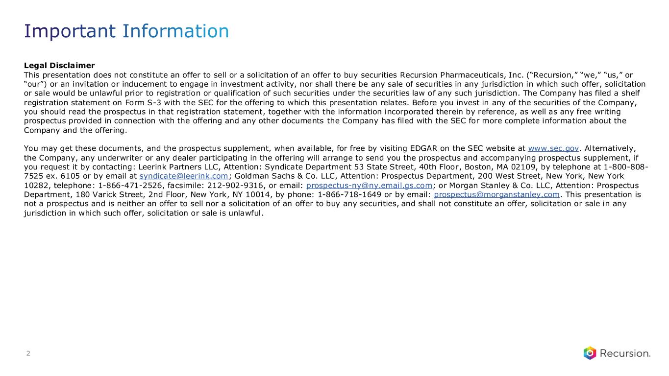
Legal Disclaimer This presentation does not constitute an offer to sell or a solicitation of an offer to buy securities Recursion Pharmaceuticals, Inc. (“Recursion,” “we,” “us,” or “our”) or an invitation or inducement to engage in investment activity, nor shall there be any sale of securities in any jurisdiction in which such offer, solicitation or sale would be unlawful prior to registration or qualification of such securities under the securities law of any such jurisdiction. The Company has filed a shelf registration statement on Form S-3 with the SEC for the offering to which this presentation relates. Before you invest in any of the securities of the Company, you should read the prospectus in that registration statement, together with the information incorporated therein by reference, as well as any free writing prospectus provided in connection with the offering and any other documents the Company has filed with the SEC for more complete information about the Company and the offering. You may get these documents, and the prospectus supplement, when available, for free by visiting EDGAR on the SEC website at www.sec.gov. Alternatively, the Company, any underwriter or any dealer participating in the offering will arrange to send you the prospectus and accompanying prospectus supplement, if you request it by contacting: Leerink Partners LLC, Attention: Syndicate Department 53 State Street, 40th Floor, Boston, MA 02109, by telephone at 1-800-808- 7525 ex. 6105 or by email at syndicate@leerink.com; Goldman Sachs & Co. LLC, Attention: Prospectus Department, 200 West Street, New York, New York 10282, telephone: 1-866-471-2526, facsimile: 212-902-9316, or email: prospectus-ny@ny.email.gs.com; or Morgan Stanley & Co. LLC, Attention: Prospectus Department, 180 Varick Street, 2nd Floor, New York, NY 10014, by phone: 1-866-718-1649 or by email: prospectus@morganstanley.com. This presentation is not a prospectus and is neither an offer to sell nor a solicitation of an offer to buy any securities, and shall not constitute an offer, solicitation or sale in any jurisdiction in which such offer, solicitation or sale is unlawful. Important Information 2

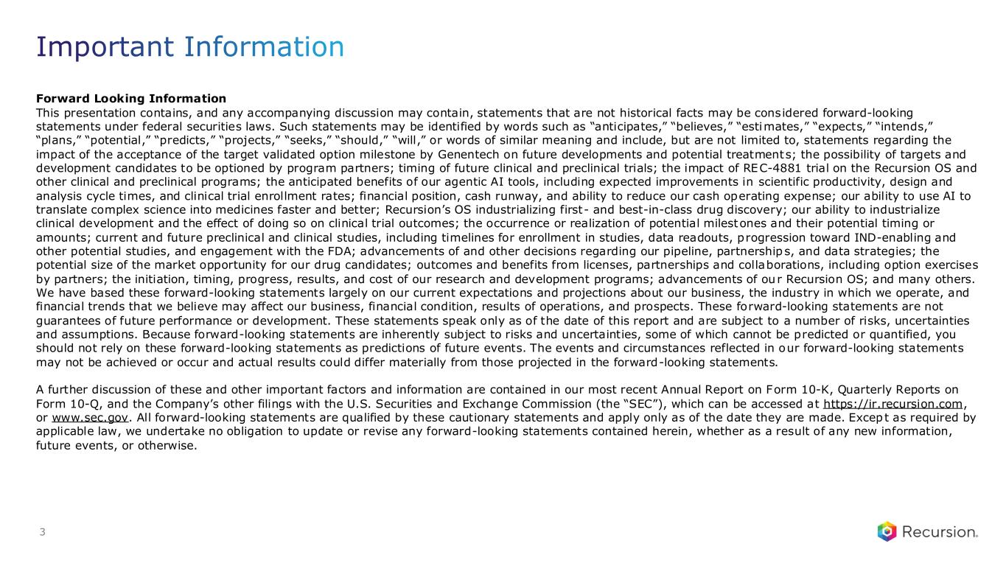
Forward Looking Information This presentation contains, and any accompanying discussion may contain, statements that are not historical facts may be considered forward-looking statements under federal securities laws. Such statements may be identified by words such as “anticipates,” “believes,” “estimates,” “expects,” “intends,” “plans,” “potential,” “predicts,” “projects,” “seeks,” “should,” “will,” or words of similar meaning and include, but are not limited to, statements regarding the impact of the acceptance of the target validated option milestone by Genentech on future developments and potential treatments; the possibility of targets and development candidates to be optioned by program partners; timing of future clinical and preclinical trials; the impact of REC-4881 trial on the Recursion OS and other clinical and preclinical programs; the anticipated benefits of our agentic AI tools, including expected improvements in scientific productivity, design and analysis cycle times, and clinical trial enrollment rates; financial position, cash runway, and ability to reduce our cash operating expense; our ability to use AI to translate complex science into medicines faster and better; Recursion’s OS industrializing first- and best-in-class drug discovery; our ability to industrialize clinical development and the effect of doing so on clinical trial outcomes; the occurrence or realization of potential milestones and their potential timing or amounts; current and future preclinical and clinical studies, including timelines for enrollment in studies, data readouts, progression toward IND-enabling and other potential studies, and engagement with the FDA; advancements of and other decisions regarding our pipeline, partnerships, and data strategies; the potential size of the market opportunity for our drug candidates; outcomes and benefits from licenses, partnerships and collaborations, including option exercises by partners; the initiation, timing, progress, results, and cost of our research and development programs; advancements of our Recursion OS; and many others. We have based these forward-looking statements largely on our current expectations and projections about our business, the industry in which we operate, and financial trends that we believe may affect our business, financial condition, results of operations, and prospects. These forward-looking statements are not guarantees of future performance or development. These statements speak only as of the date of this report and are subject to a number of risks, uncertainties and assumptions. Because forward-looking statements are inherently subject to risks and uncertainties, some of which cannot be predicted or quantified, you should not rely on these forward-looking statements as predictions of future events. The events and circumstances reflected in our forward-looking statements may not be achieved or occur and actual results could differ materially from those projected in the forward-looking statements. A further discussion of these and other important factors and information are contained in our most recent Annual Report on Form 10-K, Quarterly Reports on Form 10-Q, and the Company’s other filings with the U.S. Securities and Exchange Commission (the “SEC”), which can be accessed at https://ir.recursion.com, or www.sec.gov. All forward-looking statements are qualified by these cautionary statements and apply only as of the date they are made. Except as required by applicable law, we undertake no obligation to update or revise any forward-looking statements contained herein, whether as a result of any new information, future events, or otherwise. Important Information 3

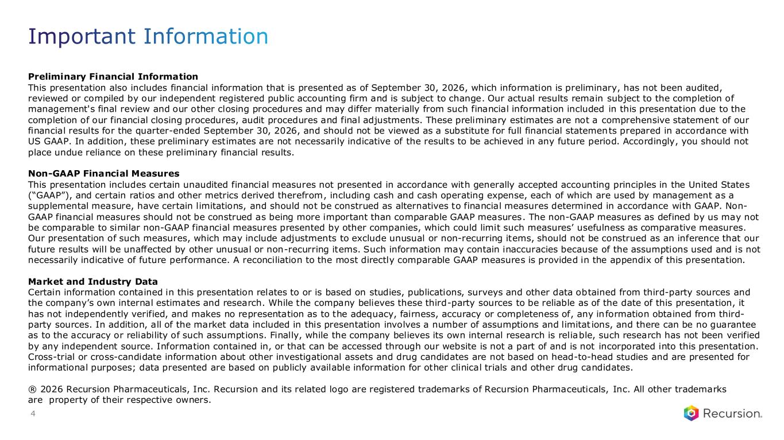
Preliminary Financial Information This presentation also includes financial information that is presented as of September 30, 2026, which information is preliminary, has not been audited, reviewed or compiled by our independent registered public accounting firm and is subject to change. Our actual results remain subject to the completion of management's final review and our other closing procedures and may differ materially from such financial information included in this presentation due to the completion of our financial closing procedures, audit procedures and final adjustments. These preliminary estimates are not a comprehensive statement of our financial results for the quarter-ended September 30, 2026, and should not be viewed as a substitute for full financial statements prepared in accordance with US GAAP. In addition, these preliminary estimates are not necessarily indicative of the results to be achieved in any future period. Accordingly, you should not place undue reliance on these preliminary financial results. Non-GAAP Financial Measures This presentation includes certain unaudited financial measures not presented in accordance with generally accepted accounting principles in the United States (“GAAP”), and certain ratios and other metrics derived therefrom, including cash and cash operating expense, each of which are used by management as a supplemental measure, have certain limitations, and should not be construed as alternatives to financial measures determined in accordance with GAAP. Non- GAAP financial measures should not be construed as being more important than comparable GAAP measures. The non-GAAP measures as defined by us may not be comparable to similar non-GAAP financial measures presented by other companies, which could limit such measures’ usefulness as comparative measures. Our presentation of such measures, which may include adjustments to exclude unusual or non-recurring items, should not be construed as an inference that our future results will be unaffected by other unusual or non-recurring items. Such information may contain inaccuracies because of the assumptions used and is not necessarily indicative of future performance. A reconciliation to the most directly comparable GAAP measures is provided in the appendix of this presentation. Market and Industry Data Certain information contained in this presentation relates to or is based on studies, publications, surveys and other data obtained from third-party sources and the company’s own internal estimates and research. While the company believes these third-party sources to be reliable as of the date of this presentation, it has not independently verified, and makes no representation as to the adequacy, fairness, accuracy or completeness of, any information obtained from third- party sources. In addition, all of the market data included in this presentation involves a number of assumptions and limitat ions, and there can be no guarantee as to the accuracy or reliability of such assumptions. Finally, while the company believes its own internal research is reliable, such research has not been verified by any independent source. Information contained in, or that can be accessed through our website is not a part of and is not incorporated into this presentation. Cross-trial or cross-candidate information about other investigational assets and drug candidates are not based on head-to-head studies and are presented for informational purposes; data presented are based on publicly available information for other clinical trials and other drug candidates. ® 2026 Recursion Pharmaceuticals, Inc. Recursion and its related logo are registered trademarks of Recursion Pharmaceuticals, Inc. All other trademarks are property of their respective owners. Important Information 4

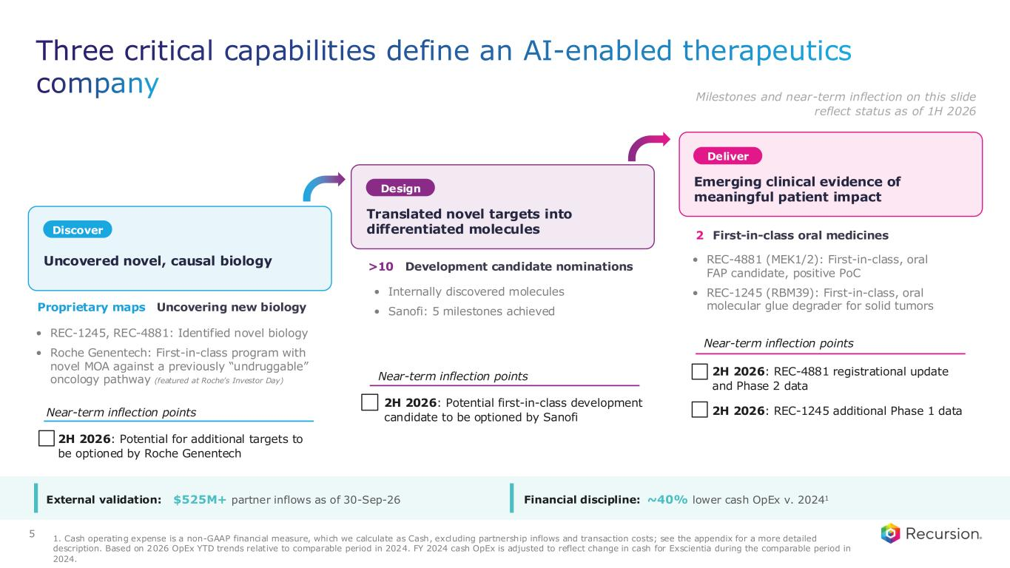
Three critical capabilities define an AI-enabled therapeutics company Proprietary maps Uncovering new biology • REC-1245, REC-4881: Identified novel biology • Roche Genentech: First-in-class program with novel MOA against a previously “undruggable” oncology pathway (featured at Roche’s Investor Day) >10 Development candidate nominations • Internally discovered molecules • Sanofi: 5 milestones achieved 2 First-in-class oral medicines • REC-4881 (MEK1/2): First-in-class, oral FAP candidate, positive PoC • REC-1245 (RBM39): First-in-class, oral molecular glue degrader for solid tumors 1. Cash operating expense is a non-GAAP financial measure, which we calculate as Cash, excluding partnership inflows and transaction costs; see the appendix for a more detailed description. Based on 2026 OpEx YTD trends relative to comparable period in 2024. FY 2024 cash OpEx is adjusted to reflect change in cash for Exscientia during the comparable period in 2024. • 2H 2026: Potential for additional targets to be optioned by Roche Genentech • 2H 2026: Potential first-in-class development candidate to be optioned by Sanofi • 2H 2026: REC-4881 registrational update and Phase 2 data • 2H 2026: REC-1245 additional Phase 1 dataNear-term inflection points Near-term inflection points Near-term inflection points Uncovered novel, causal biology Discover Design Deliver Translated novel targets into differentiated molecules Emerging clinical evidence of meaningful patient impact 5 External validation: $525M+ partner inflows as of 30-Sep-26 Financial discipline: ~40% lower cash OpEx v. 20241 Milestones and near-term inflection on this slide reflect status as of 1H 2026

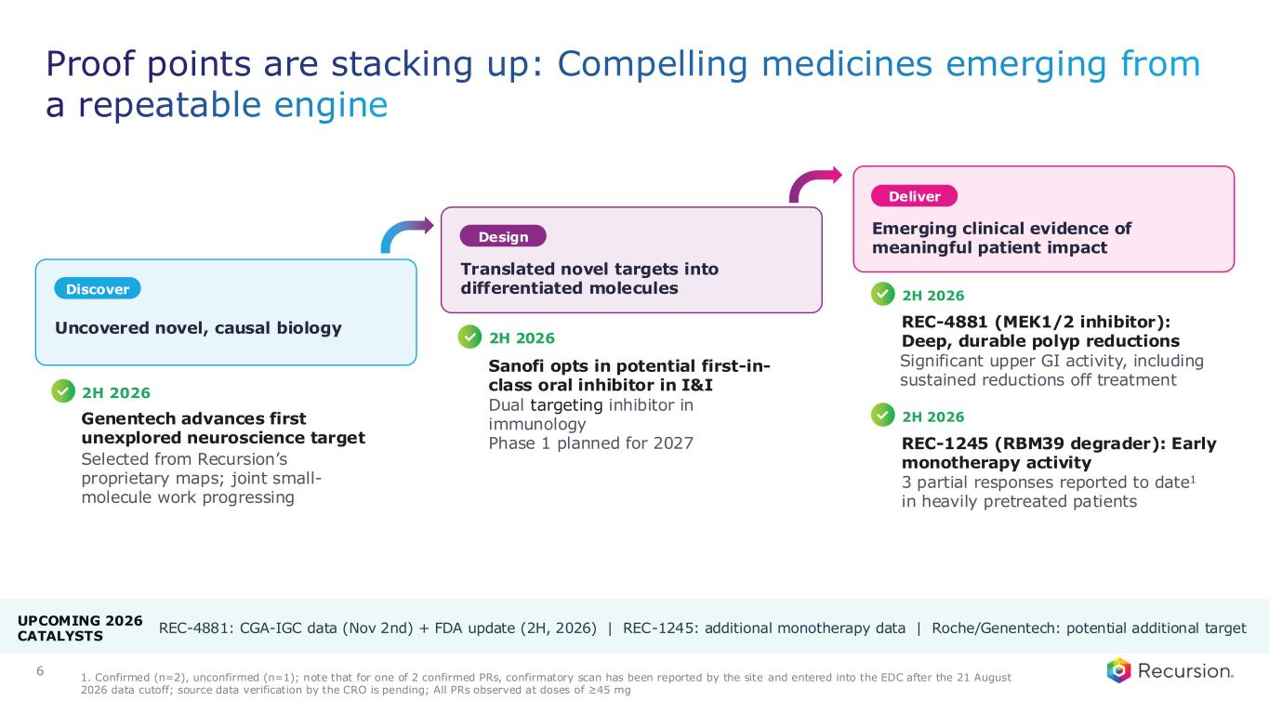
Proof points are stacking up: Compelling medicines emerging from a repeatable engine Uncovered novel, causal biology Discover Design Deliver Translated novel targets into differentiated molecules Emerging clinical evidence of meaningful patient impact 6 Selected from Recursion’s proprietary maps; joint small- molecule work progressing Dual targeting inhibitor in immunology Phase 1 planned for 2027 2H 2026 Genentech advances first unexplored neuroscience target 2H 2026 Sanofi opts in potential first-in- class oral inhibitor in I&I REC-4881 (MEK1/2 inhibitor): Deep, durable polyp reductions 2H 2026 REC-1245 (RBM39 degrader): Early monotherapy activity 3 partial responses reported to date1 in heavily pretreated patients Significant upper GI activity, including sustained reductions off treatment 2H 2026 1. Confirmed (n=2), unconfirmed (n=1); note that for one of 2 confirmed PRs, confirmatory scan has been reported by the site and entered into the EDC after the 21 August 2026 data cutoff; source data verification by the CRO is pending; All PRs observed at doses of ≥45 mg UPCOMING 2026 CATALYSTS REC-4881: CGA-IGC data (Nov 2nd) + FDA update (2H, 2026) | REC-1245: additional monotherapy data | Roche/Genentech: potential additional target

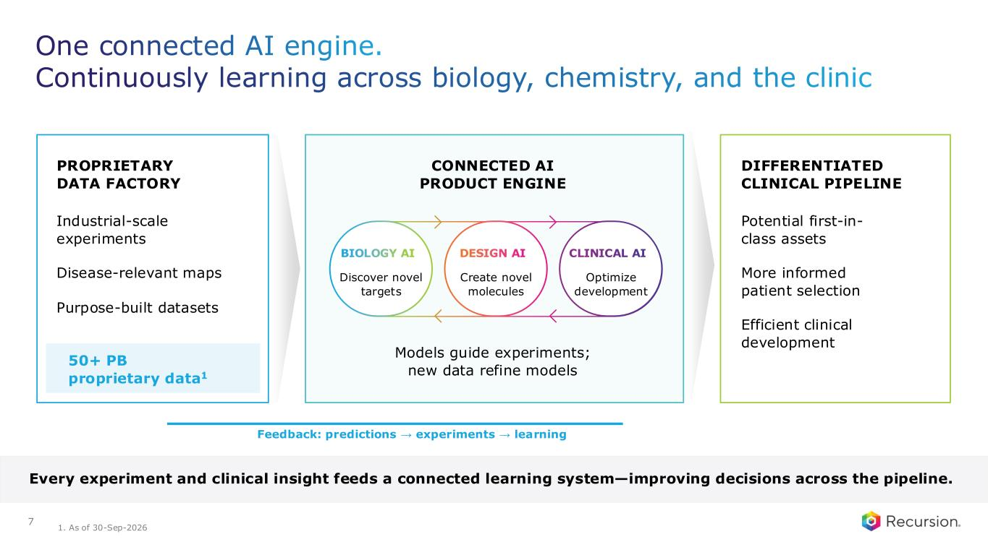
One connected AI engine. Continuously learning across biology, chemistry, and the clinic 7 PROPRIETARY DATA FACTORY Industrial-scale experiments Disease-relevant maps Purpose-built datasets 50+ PB proprietary data1 CONNECTED AI PRODUCT ENGINE Models guide experiments; new data refine models DIFFERENTIATED CLINICAL PIPELINE Potential first-in- class assets More informed patient selection Efficient clinical development Feedback: predictions → experiments → learning Every experiment and clinical insight feeds a connected learning system—improving decisions across the pipeline. BIOLOGY AI Discover novel targets DESIGN AI Create novel molecules CLINICAL AI Optimize development 1. As of 30-Sep-2026

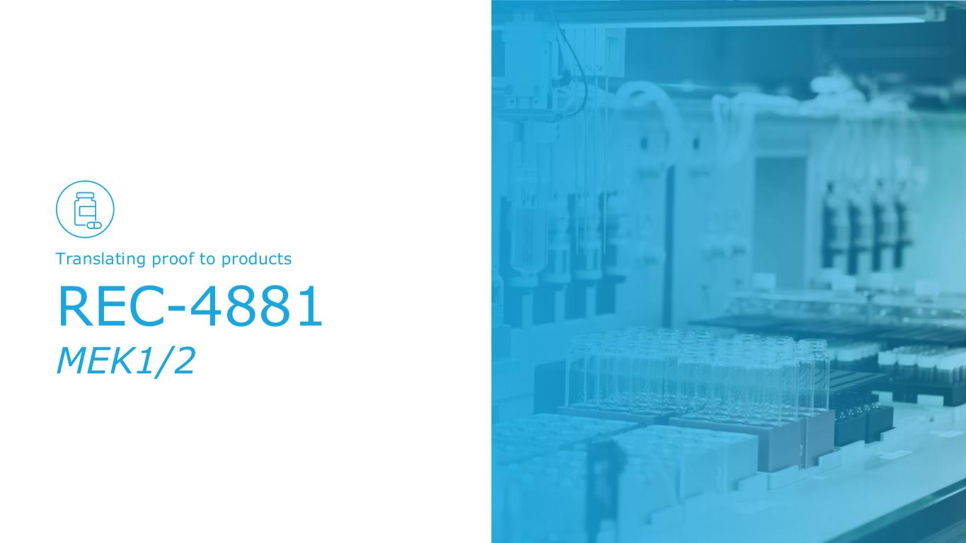
REC-4881 MEK1/2 Translating proof to products

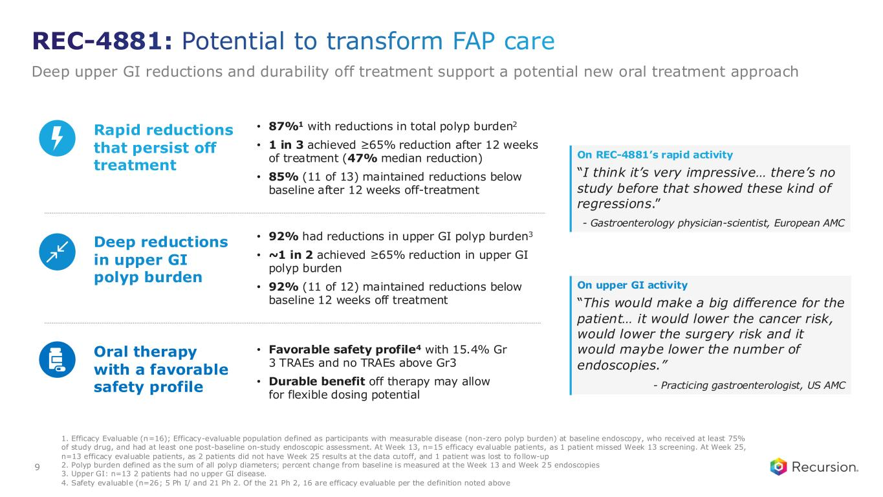
REC-4881: Potential to transform FAP care Deep upper GI reductions and durability off treatment support a potential new oral treatment approach 9 • Favorable safety profile4 with 15.4% Gr 3 TRAEs and no TRAEs above Gr3 • Durable benefit off therapy may allow for flexible dosing potential Oral therapy with a favorable safety profile • 87%1 with reductions in total polyp burden2 • 1 in 3 achieved ≥65% reduction after 12 weeks of treatment (47% median reduction) • 85% (11 of 13) maintained reductions below baseline after 12 weeks off-treatment Rapid reductions that persist off treatment On REC-4881’s rapid activity “I think it’s very impressive… there’s no study before that showed these kind of regressions.” - Gastroenterology physician-scientist, European AMC • 92% had reductions in upper GI polyp burden3 • ~1 in 2 achieved ≥65% reduction in upper GI polyp burden • 92% (11 of 12) maintained reductions below baseline 12 weeks off treatment Deep reductions in upper GI polyp burden On upper GI activity “This would make a big difference for the patient… it would lower the cancer risk, would lower the surgery risk and it would maybe lower the number of endoscopies.” - Practicing gastroenterologist, US AMC 1. Efficacy Evaluable (n=16); Efficacy-evaluable population defined as participants with measurable disease (non-zero polyp burden) at baseline endoscopy, who received at least 75% of study drug, and had at least one post-baseline on-study endoscopic assessment. At Week 13, n=15 efficacy evaluable patients, as 1 patient missed Week 13 screening. At Week 25, n=13 efficacy evaluable patients, as 2 patients did not have Week 25 results at the data cutoff, and 1 patient was lost to fo llow-up 2. Polyp burden defined as the sum of all polyp diameters; percent change from baseline is measured at the Week 13 and Week 25 endoscopies 3. Upper GI: n=13 2 patients had no upper GI disease. 4. Safety evaluable (n=26; 5 Ph I/ and 21 Ph 2. Of the 21 Ph 2, 16 are efficacy evaluable per the definition noted above

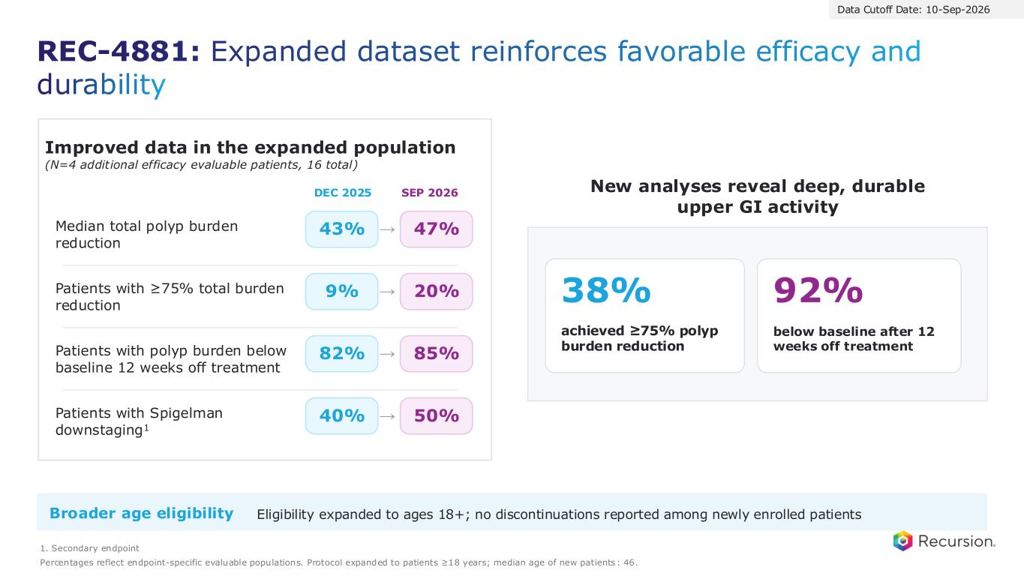
Improved data in the expanded population (N=4 additional efficacy evaluable patients, 16 total) DEC 2025 SEP 2026 Median total polyp burden reduction 43% → 47% Patients with ≥75% total burden reduction 9% → 20% Patients with Spigelman downstaging1 40% → 50% Patients with polyp burden below baseline 12 weeks off treatment 82% → 85% 38% achieved ≥75% polyp burden reduction 92% below baseline after 12 weeks off treatment Broader age eligibility Eligibility expanded to ages 18+; no discontinuations reported among newly enrolled patients 1. Secondary endpoint Percentages reflect endpoint-specific evaluable populations. Protocol expanded to patients ≥18 years; median age of new patients : 46. REC-4881: Expanded dataset reinforces favorable efficacy and durability New analyses reveal deep, durable upper GI activity Data Cutoff Date: 10-Sep-2026

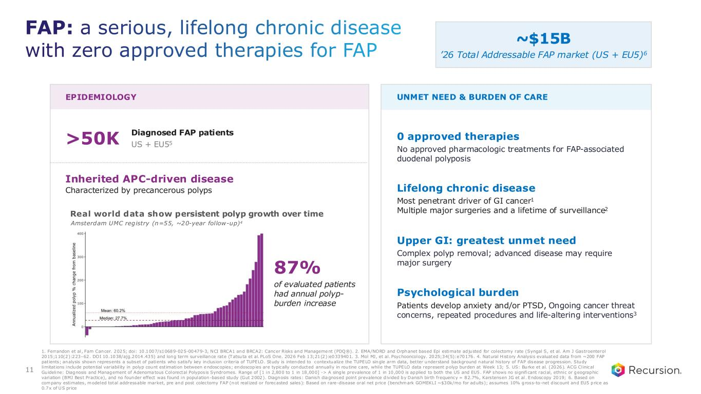
EPIDEMIOLOGY UNMET NEED & BURDEN OF CARE >50K Diagnosed FAP patients US + EU55 Inherited APC-driven disease Characterized by precancerous polyps Real world data show persistent polyp growth over time 0 approved therapies No approved pharmacologic treatments for FAP-associated duodenal polyposis Lifelong chronic disease Most penetrant driver of GI cancer1 Multiple major surgeries and a lifetime of surveillance2 Upper GI: greatest unmet need Complex polyp removal; advanced disease may require major surgery Psychological burden Patients develop anxiety and/or PTSD, Ongoing cancer threat concerns, repeated procedures and life-altering interventions3 Amsterdam UMC registry (n=55, ~20-year follow-up)4 87% of evaluated patients had annual polyp- burden increase 1. Ferrandon et al, Fam Cancer. 2025; doi: 10.1007/s10689-025-00479-3, NCI BRCA1 and BRCA2: Cancer Risks and Management (PDQ®). 2. EMA/NORD and Orphanet based Epi estimate adjusted for colectomy rate (Syngal S, et al. Am J Gastroenterol 2015;110(2):223–62. DOI 10.1038/ajg.2014.435) and long term surveillance rate (Tatsuta et al. PLoS One. 2026 Feb 13;21(2):e0339401. 3. Mol MJ, et al. Psychooncology. 2025;34(5):e70176. 4. Natural History Analysis evaluated data from ~200 FAP patients; analysis shown represents a subset of patients who satisfy key inclusion criteria of TUPELO. Study is intended to contextualize the TUPELO single arm data, better understand background natural history of FAP disease progression. Study limitations include potential variabil ity in polyp count estimation between endoscopies; endoscopies are typically conducted annually in routine care, while the TUPELO data represent polyp burden at Week 13; 5. US: Burke et al. (2026). ACG Clinical Guideline: Diagnosis and Management of Adenomatous Colorectal Polyposis Syndromes. Range of [1 in 2,800 to 1 in 18,000] -> A sing le prevalence of 1 in 10,000 is applied to both the US and EU5. FAP shows no significant racial, ethnic or geographic variation (BMJ Best Practice), and no founder effect was found in population-based study (Gut 2002). Diagnosis rates: Danish diagnosed point prevalence d ivided by Danish birth frequency = 82.7%, Karstensen JG et al. Endoscopy 2019; 6. Based on company estimates, modeled total addressable market, pre and post colectomy FAP (not realized or forecasted sales): Based on rare-disease oral net price (benchmark GOMEKLI ~$30k/mo for adults); assumes 10% gross-to-net d iscount and EU5 price as 0.7x of US price ~$15B ’26 Total Addressable FAP market (US + EU5)6 FAP: a serious, lifelong chronic disease with zero approved therapies for FAP 11

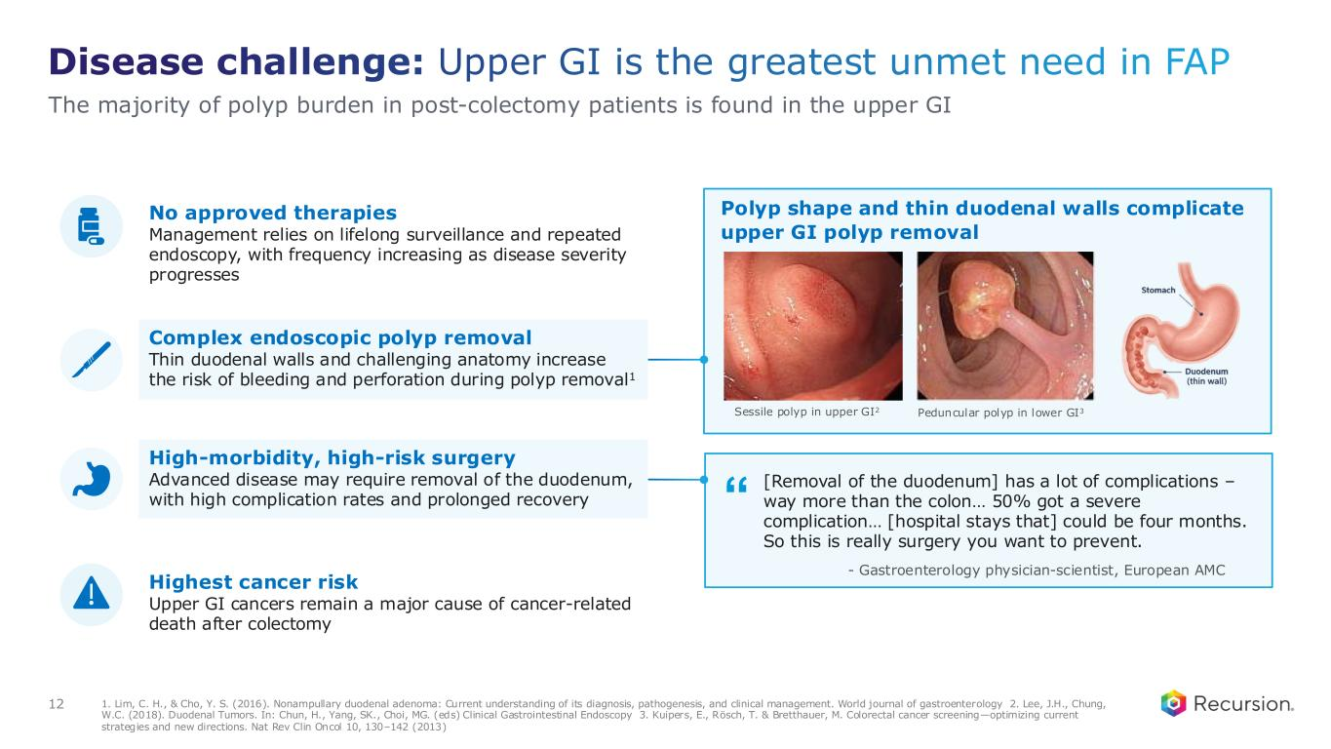
“ Disease challenge: Upper GI is the greatest unmet need in FAP 1. Lim, C. H., & Cho, Y. S. (2016). Nonampullary duodenal adenoma: Current understanding of its diagnosis, pathogenesis, and clinical management. World journal of gastroenterology 2. Lee, J.H., Chung, W.C. (2018). Duodenal Tumors. In: Chun, H., Yang, SK., Choi, MG. (eds) Clinical Gastrointestinal Endoscopy 3. Kuipers, E., Rösch, T. & Bretthauer, M. Colorectal cancer screening—optimizing current strategies and new directions. Nat Rev Clin Oncol 10, 130–142 (2013) No approved therapies Management relies on lifelong surveillance and repeated endoscopy, with frequency increasing as disease severity progresses Complex endoscopic polyp removal Thin duodenal walls and challenging anatomy increase the risk of bleeding and perforation during polyp removal1 High-morbidity, high-risk surgery Advanced disease may require removal of the duodenum, with high complication rates and prolonged recovery Highest cancer risk Upper GI cancers remain a major cause of cancer-related death after colectomy Polyp shape and thin duodenal walls complicate upper GI polyp removal Sessile polyp in upper GI2 Peduncular polyp in lower GI3 [Removal of the duodenum] has a lot of complications – way more than the colon… 50% got a severe complication… [hospital stays that] could be four months. So this is really surgery you want to prevent. - Gastroenterology physician-scientist, European AMC The majority of polyp burden in post-colectomy patients is found in the upper GI 12

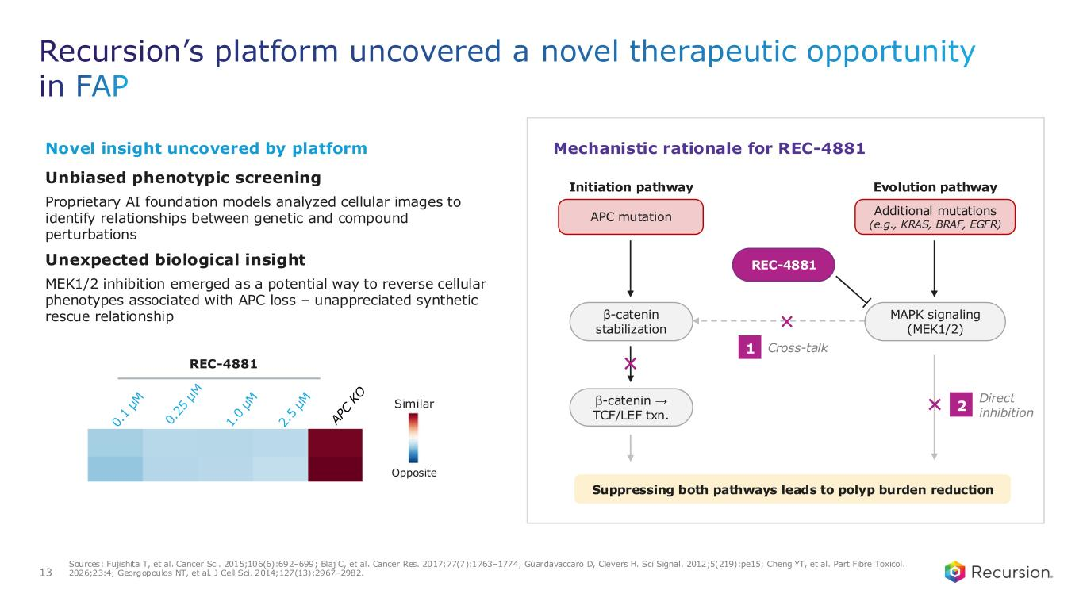
Recursion’s platform uncovered a novel therapeutic opportunity in FAP 13 Sources: Fujishita T, et al. Cancer Sci. 2015;106(6):692–699; Blaj C, et al. Cancer Res. 2017;77(7):1763–1774; Guardavaccaro D, Clevers H. Sci Signal. 2012;5(219):pe15; Cheng YT, et al. Part Fibre Toxicol. 2026;23:4; Georgopoulos NT, et al. J Cell Sci. 2014;127(13):2967–2982. REC-4881 Similar Opposite Unbiased phenotypic screening Proprietary AI foundation models analyzed cellular images to identify relationships between genetic and compound perturbations Novel insight uncovered by platform Suppressing both pathways leads to polyp burden reduction Initiation pathway APC mutation β-catenin stabilization β-catenin → TCF/LEF txn. Evolution pathway Additional mutations (e.g., KRAS, BRAF, EGFR) MAPK signaling (MEK1/2) REC-4881 Cross-talk1 Direct inhibition 2 Mechanistic rationale for REC-4881 Unexpected biological insight MEK1/2 inhibition emerged as a potential way to reverse cellular phenotypes associated with APC loss – unappreciated synthetic rescue relationship

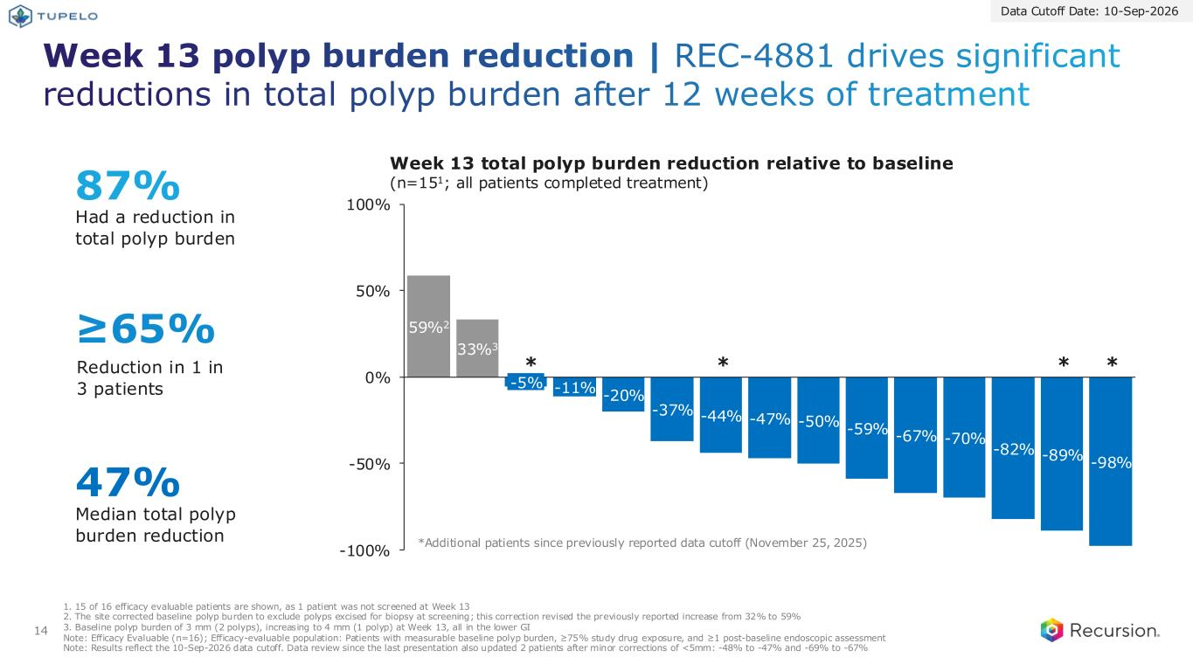
Week 13 polyp burden reduction | REC-4881 drives significant reductions in total polyp burden after 12 weeks of treatment 14 -11% -20% -37% -44% -47% -50% -59% -67% -70% -82% -89% -98% -100% -50% 0% 50% 100% -5% 59%2 33%3 Data Cutoff Date: 10-Sep-2026 87% Had a reduction in total polyp burden ≥65% Reduction in 1 in 3 patients 47% Median total polyp burden reduction Week 13 total polyp burden reduction relative to baseline (n=151; all patients completed treatment) 1. 15 of 16 efficacy evaluable patients are shown, as 1 patient was not screened at Week 13 2. The site corrected baseline polyp burden to exclude polyps excised for biopsy at screening; this correction revised the previously reported increase from 32% to 59% 3. Baseline polyp burden of 3 mm (2 polyps), increasing to 4 mm (1 polyp) at Week 13, all in the lower GI Note: Efficacy Evaluable (n=16); Efficacy-evaluable population: Patients with measurable baseline polyp burden, ≥75% study drug exposure, and ≥1 post-baseline endoscopic assessment Note: Results reflect the 10-Sep-2026 data cutoff. Data review since the last presentation also updated 2 patients after minor corrections of <5mm: -48% to -47% and -69% to -67% *** * *Additional patients since previously reported data cutoff (November 25, 2025)

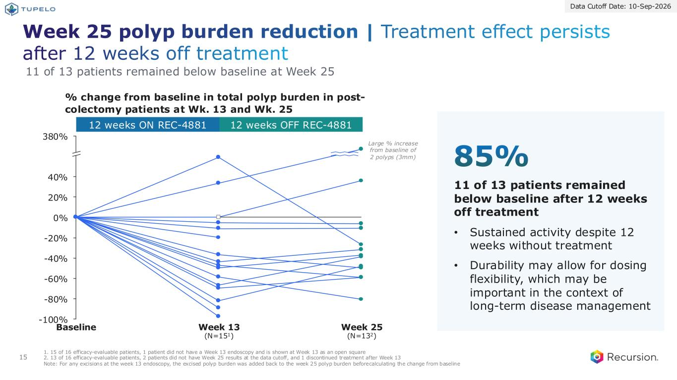
Week 25 polyp burden reduction | Treatment effect persists after 12 weeks off treatment 15 12 weeks ON REC-4881 12 weeks OFF REC-4881 % change from baseline in total polyp burden in post- colectomy patients at Wk. 13 and Wk. 25 1. 15 of 16 efficacy-evaluable patients, 1 patient did not have a Week 13 endoscopy and is shown at Week 13 as an open square 2. 13 of 16 efficacy-evaluable patients, 2 patients did not have Week 25 results at the data cutoff, and 1 discontinued treatment after Week 13 Note: For any excisions at the week 13 endoscopy, the excised polyp burden was added back to the week 25 polyp burden before calculating the change from baseline -100% -80% -60% -40% -20% 0% 20% 40% 380% Baseline Week 13 (N=151) Week 25 (N=132) 11 of 13 patients remained below baseline at Week 25 Large % increase from baseline of 2 polyps (3mm) 11 of 13 patients remained below baseline after 12 weeks off treatment • Sustained activity despite 12 weeks without treatment • Durability may allow for dosing flexibility, which may be important in the context of long-term disease management 85% Data Cutoff Date: 10-Sep-2026

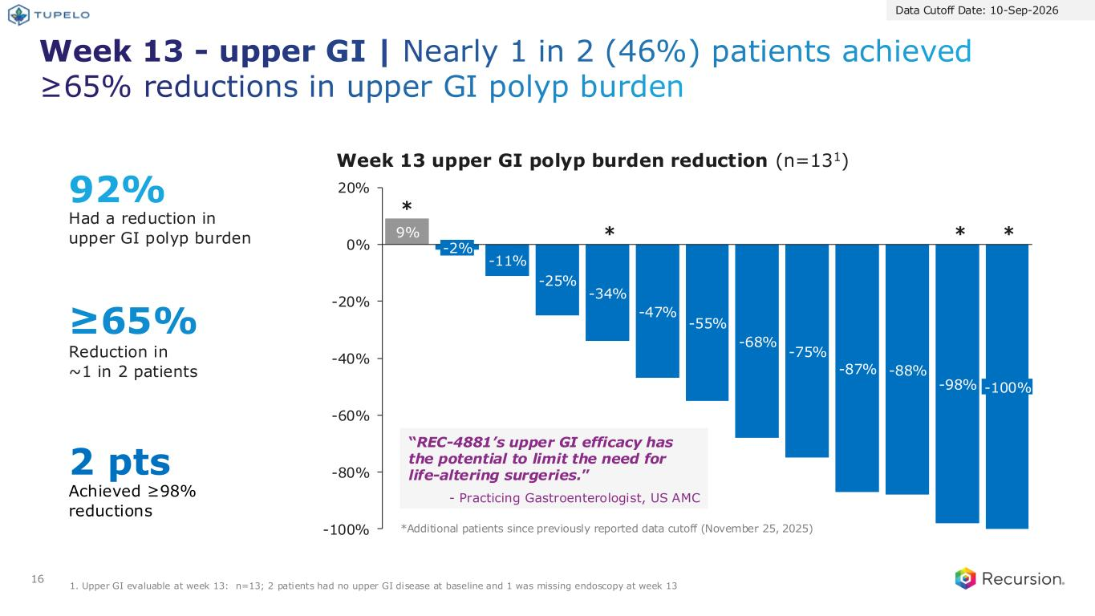
Week 13 - upper GI | Nearly 1 in 2 (46%) patients achieved ≥65% reductions in upper GI polyp burden 16 9% -11% -25% -34% -47% -55% -68% -75% -87% -88% -98% -100% -80% -60% -40% -20% 0% 20% -2% -100% Data Cutoff Date: 10-Sep-2026 Week 13 upper GI polyp burden reduction (n=131) “REC-4881’s upper GI efficacy has the potential to limit the need for life-altering surgeries.” - Practicing Gastroenterologist, US AMC *** * 92% Had a reduction in upper GI polyp burden ≥65% Reduction in ~1 in 2 patients 2 pts Achieved ≥98% reductions 1. Upper GI evaluable at week 13: n=13; 2 patients had no upper GI disease at baseline and 1 was missing endoscopy at week 13 *Additional patients since previously reported data cutoff (November 25, 2025)

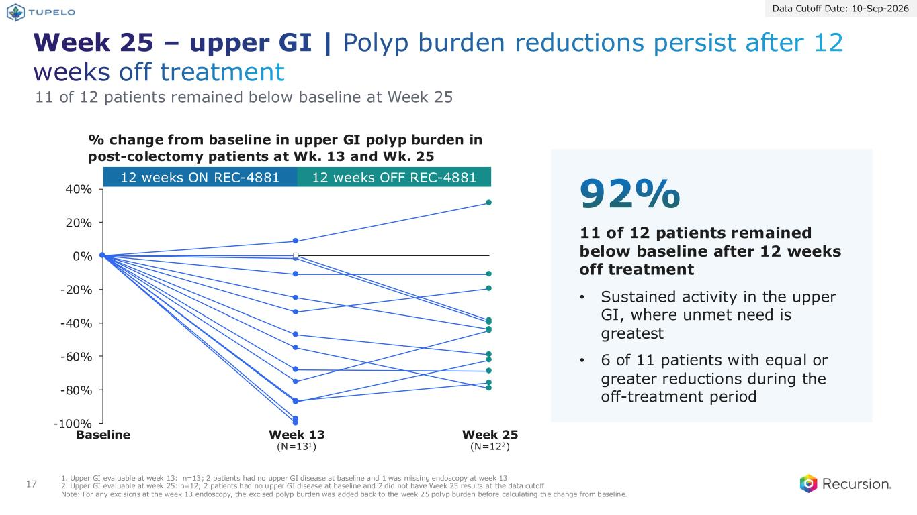
17 Week 25 – upper GI | Polyp burden reductions persist after 12 weeks off treatment -100% -80% -60% -40% -20% 0% 20% 40% Baseline Week 13 (N=131) Week 25 (N=122) 11 of 12 patients remained below baseline at Week 25 11 of 12 patients remained below baseline after 12 weeks off treatment • Sustained activity in the upper GI, where unmet need is greatest • 6 of 11 patients with equal or greater reductions during the off-treatment period 92% 12 weeks ON REC-4881 12 weeks OFF REC-4881 % change from baseline in upper GI polyp burden in post-colectomy patients at Wk. 13 and Wk. 25 1. Upper GI evaluable at week 13: n=13; 2 patients had no upper GI disease at baseline and 1 was missing endoscopy at week 13 2. Upper GI evaluable at week 25: n=12; 2 patients had no upper GI disease at baseline and 2 did not have Week 25 results at the data cutoff Note: For any excisions at the week 13 endoscopy, the excised polyp burden was added back to the week 25 polyp burden before calculating the change from baseline. Data Cutoff Date: 10-Sep-2026

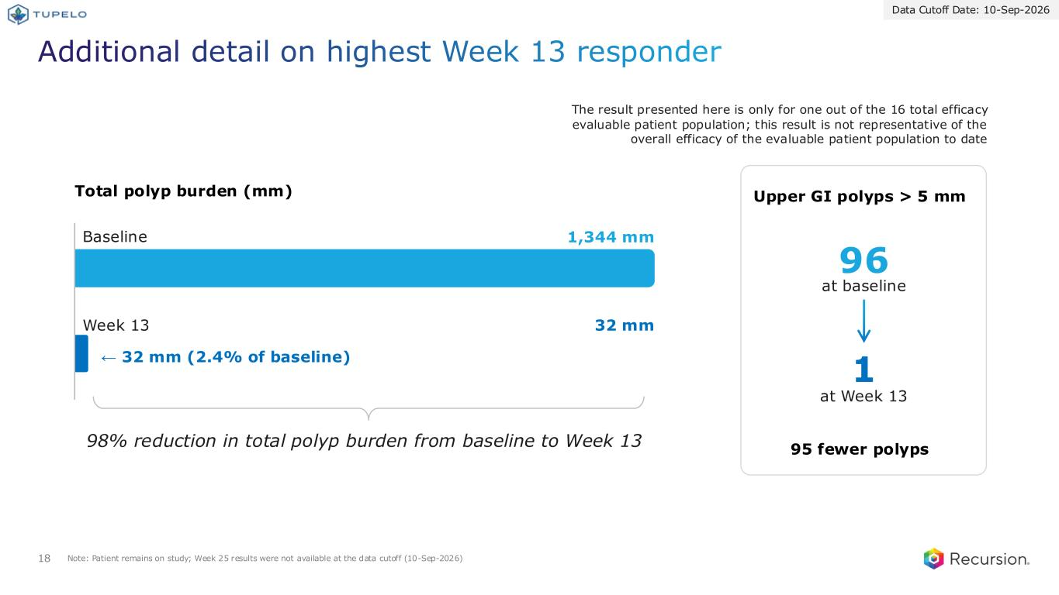
Total polyp burden (mm) 18 Additional detail on highest Week 13 responder 1,344 mm 32 mm ← 32 mm (2.4% of baseline) Baseline Week 13 96 1 at baseline at Week 13 Upper GI polyps > 5 mm 95 fewer polyps Note: Patient remains on study; Week 25 results were not available at the data cutoff (10-Sep-2026) Data Cutoff Date: 10-Sep-2026 The result presented here is only for one out of the 16 total efficacy evaluable patient population; this result is not representative of the overall efficacy of the evaluable patient population to date 98% reduction in total polyp burden from baseline to Week 13

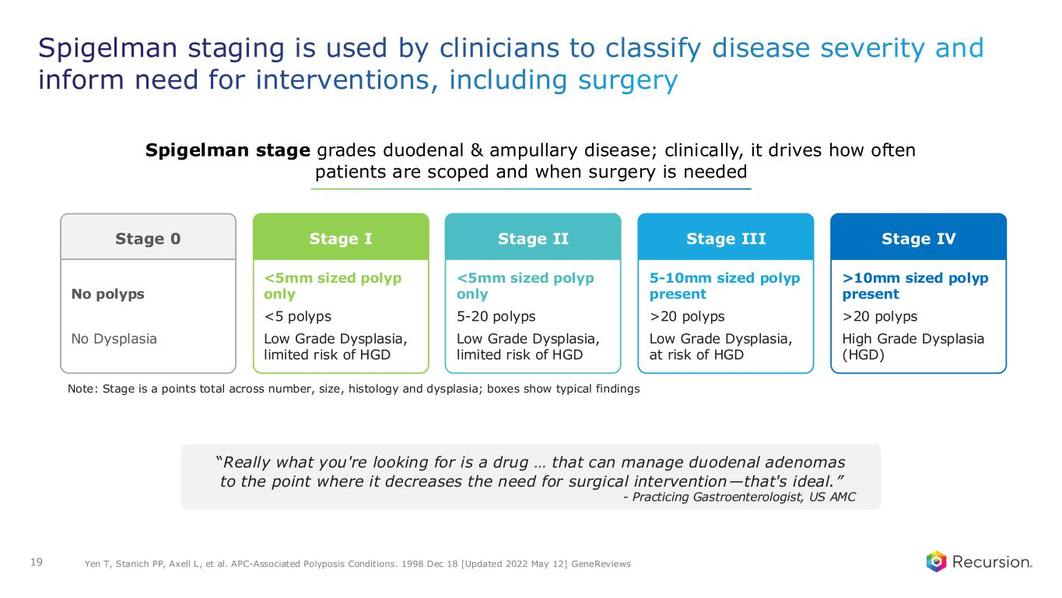
Spigelman staging is used by clinicians to classify disease severity and inform need for interventions, including surgery 19 “Really what you're looking for is a drug … that can manage duodenal adenomas to the point where it decreases the need for surgical intervention—that's ideal.” - Practicing Gastroenterologist, US AMC Spigelman stage grades duodenal & ampullary disease; clinically, it drives how often patients are scoped and when surgery is needed >10mm sized polyp present >20 polyps High Grade Dysplasia (HGD) Stage IV 5-10mm sized polyp present >20 polyps Low Grade Dysplasia, at risk of HGD Stage III <5mm sized polyp only 5-20 polyps Low Grade Dysplasia, limited risk of HGD Stage II <5mm sized polyp only <5 polyps Low Grade Dysplasia, limited risk of HGD Stage I Yen T, Stanich PP, Axell L, et al. APC-Associated Polyposis Conditions. 1998 Dec 18 [Updated 2022 May 12] GeneReviews No polyps No Dysplasia Stage 0 Note: Stage is a points total across number, size, histology and dysplasia; boxes show typical findings

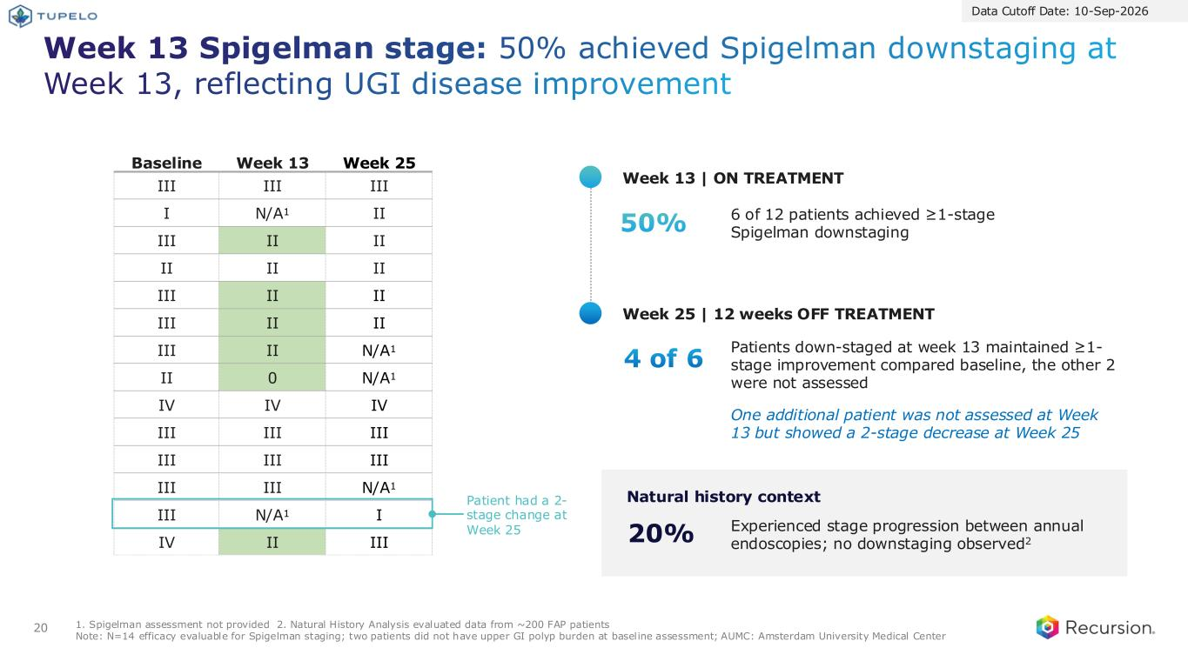
Week 13 Spigelman stage: 50% achieved Spigelman downstaging at Week 13, reflecting UGI disease improvement 20 1. Spigelman assessment not provided 2. Natural History Analysis evaluated data from ~200 FAP patients Note: N=14 efficacy evaluable for Spigelman staging; two patients did not have upper GI polyp burden at baseline assessment; AUMC: Amsterdam University Medical Center Data Cutoff Date: 10-Sep-2026 50% 4 of 6 Baseline Week 13 Week 25 III III III I N/A1 II III II II II II II III II II III II II III II N/A1 II 0 N/A1 IV IV IV III III III III III III III III N/A1 III N/A1 I IV II III 6 of 12 patients achieved ≥1-stage Spigelman downstaging Patients down-staged at week 13 maintained ≥1- stage improvement compared baseline, the other 2 were not assessed One additional patient was not assessed at Week 13 but showed a 2-stage decrease at Week 25 20% Experienced stage progression between annual endoscopies; no downstaging observed2 Patient had a 2- stage change at Week 25 Week 13 | ON TREATMENT Week 25 | 12 weeks OFF TREATMENT Natural history context

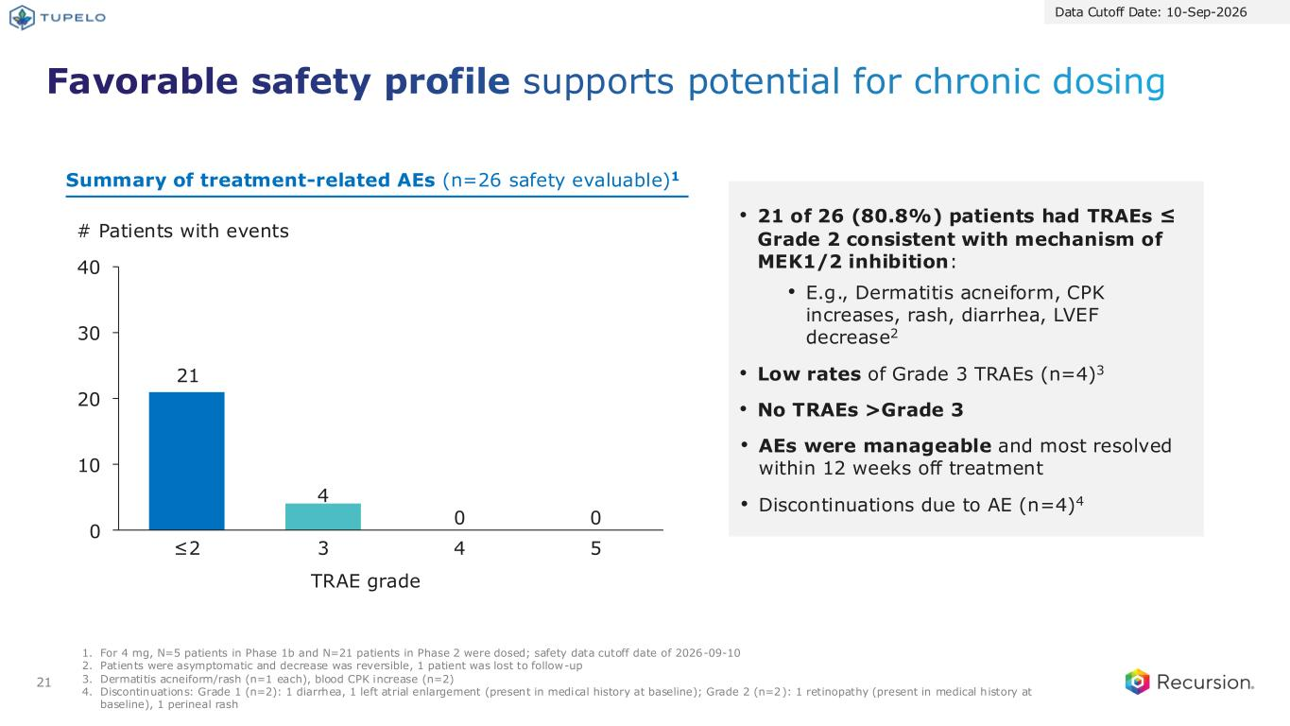
Favorable safety profile supports potential for chronic dosing 21 1. For 4 mg, N=5 patients in Phase 1b and N=21 patients in Phase 2 were dosed; safety data cutoff date of 2026-09-10 2. Patients were asymptomatic and decrease was reversible, 1 patient was lost to follow-up 3. Dermatitis acneiform/rash (n=1 each), blood CPK increase (n=2) 4. Discontinuations: Grade 1 (n=2): 1 diarrhea, 1 left atrial enlargement (present in medical history at baseline); Grade 2 (n=2): 1 retinopathy (present in medical history at baseline), 1 perineal rash • 21 of 26 (80.8%) patients had TRAEs ≤ Grade 2 consistent with mechanism of MEK1/2 inhibition: • E.g., Dermatitis acneiform, CPK increases, rash, diarrhea, LVEF decrease2 • Low rates of Grade 3 TRAEs (n=4)3 • No TRAEs >Grade 3 • AEs were manageable and most resolved within 12 weeks off treatment • Discontinuations due to AE (n=4)4 # Patients with events ≤2 3 4 5 0 0 TRAE grade Summary of treatment-related AEs (n=26 safety evaluable)1 21 4 0 10 20 30 40 Data Cutoff Date: 10-Sep-2026

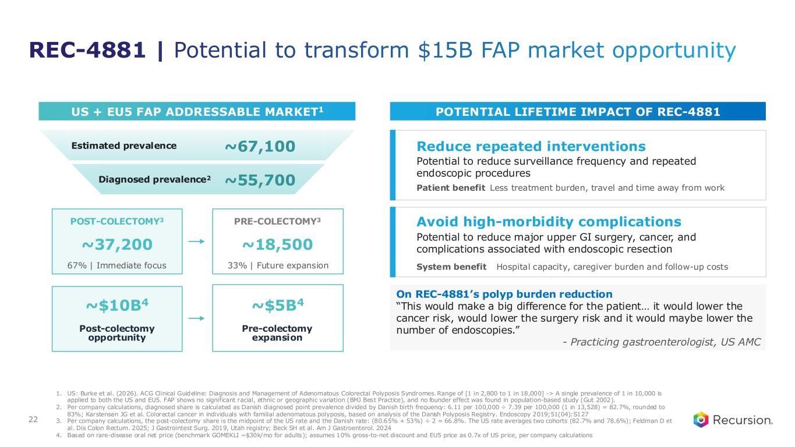
US + EU5 FAP ADDRESSABLE MARKET1 POTENTIAL LIFETIME IMPACT OF REC-4881 Reduce repeated interventions Potential to reduce surveillance frequency and repeated endoscopic procedures Patient benefit Less treatment burden, travel and time away from work Avoid high-morbidity complications Potential to reduce major upper GI surgery, cancer, and complications associated with endoscopic resection System benefit Hospital capacity, caregiver burden and follow-up costs 1. US: Burke et al. (2026). ACG Clinical Guideline: Diagnosis and Management of Adenomatous Colorectal Polyposis Syndromes.Range of [1 in 2,800 to 1 in 18,000] -> A single prevalence of 1 in 10,000 is applied to both the US and EU5. FAP shows no significant racial, ethnic or geographic variation (BMJ Best Practice), and no founder effect was found in population-based study (Gut 2002). 2. Per company calculations, diagnosed share is calculated as Danish diagnosed point prevalence divided by Danish birth frequency: 6.11 per 100,000 ÷ 7.39 per 100,000 (1 in 13,528) = 82.7%, rounded to 83%; Karstensen JG et al. Colorectal cancer in individuals with familial adenomatous polyposis, based on analysis of the Danish Polyposis Registry. Endoscopy 2019;51(04):S127 3. Per company calculations, the post-colectomy share is the midpoint of the US rate and the Danish rate: (80.65% + 53%) ÷ 2 = 66.8%. The US rate averages two cohorts (82.7% and 78.6%); Feldman D et al. Dis Colon Rectum. 2025; J Gastrointest Surg. 2019, Utah registry; Beck SH et al. Am J Gastroenterol. 2024 4. Based on rare-disease oral net price (benchmark GOMEKLI ~$30k/mo for adults); assumes 10% gross-to-net discount and EU5 price as 0.7x of US price, per company calculations Estimated prevalence ~67,100 Diagnosed prevalence2 ~55,700 POST-COLECTOMY3 ~37,200 67% | Immediate focus PRE-COLECTOMY3 ~18,500 33% | Future expansion ~$10B4 Post-colectomy opportunity ~$5B4 Pre-colectomy expansion On REC-4881’s polyp burden reduction “This would make a big difference for the patient… it would lower the cancer risk, would lower the surgery risk and it would maybe lower the number of endoscopies.” - Practicing gastroenterologist, US AMC REC-4881 | Potential to transform $15B FAP market opportunity 22

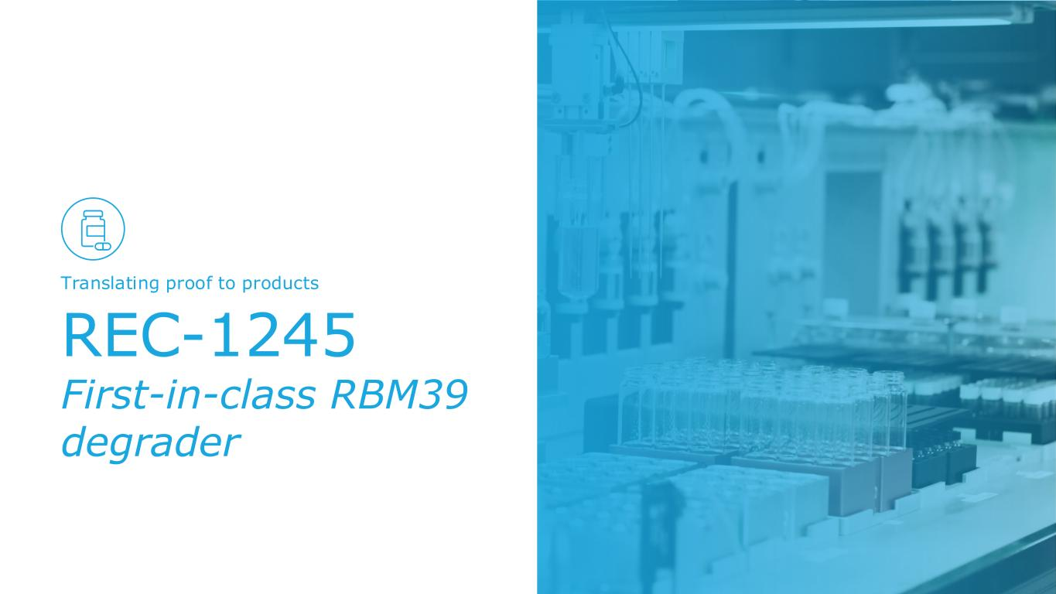
REC-1245 First-in-class RBM39 degrader Translating proof to products

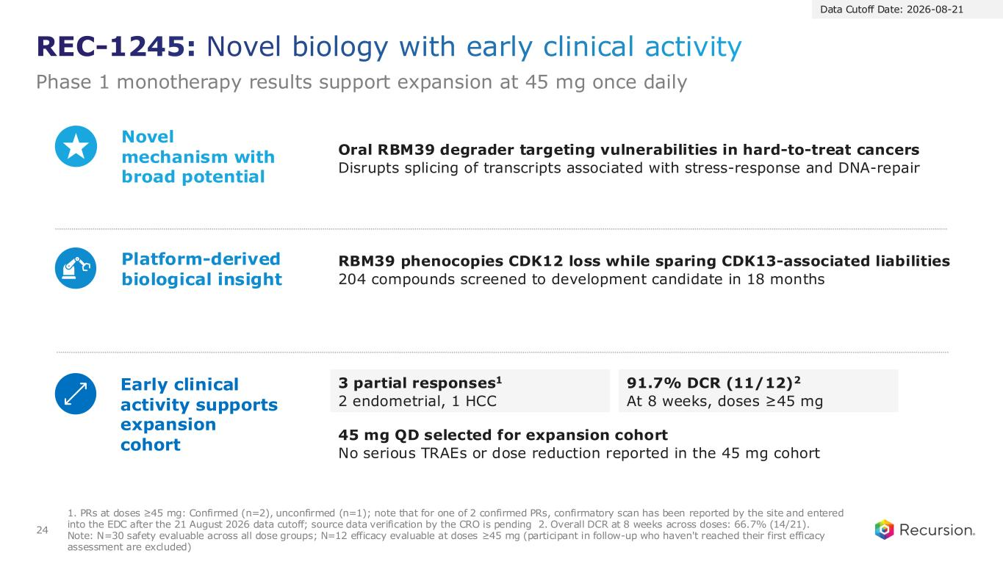
REC-1245: Novel biology with early clinical activity Phase 1 monotherapy results support expansion at 45 mg once daily 24 Oral RBM39 degrader targeting vulnerabilities in hard-to-treat cancers Disrupts splicing of transcripts associated with stress-response and DNA-repair 3 partial responses1 2 endometrial, 1 HCC Novel mechanism with broad potential Platform-derived biological insight Early clinical activity supports expansion cohort 1. PRs at doses ≥45 mg: Confirmed (n=2), unconfirmed (n=1); note that for one of 2 confirmed PRs, confirmatory scan has been reported by the site and entered into the EDC after the 21 August 2026 data cutoff; source data verification by the CRO is pending 2. Overall DCR at 8 weeks across doses: 66.7% (14/21). Note: N=30 safety evaluable across all dose groups; N=12 efficacy evaluable at doses ≥45 mg (participant in follow-up who haven't reached their first efficacy assessment are excluded) 91.7% DCR (11/12)2 At 8 weeks, doses ≥45 mg 45 mg QD selected for expansion cohort No serious TRAEs or dose reduction reported in the 45 mg cohort Data Cutoff Date: 2026-08-21 RBM39 phenocopies CDK12 loss while sparing CDK13-associated liabilities 204 compounds screened to development candidate in 18 months

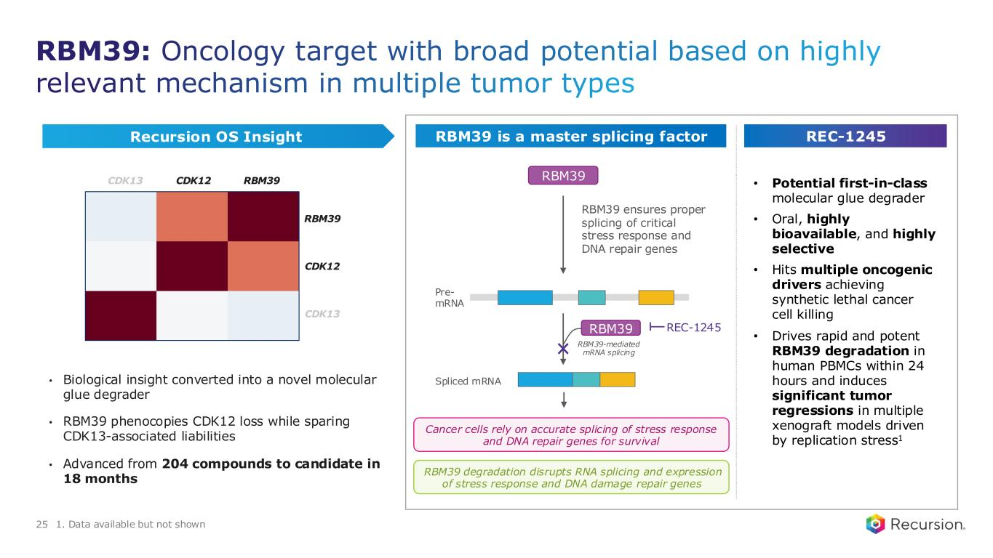
• Potential first-in-class molecular glue degrader • Oral, highly bioavailable, and highly selective • Hits multiple oncogenic drivers achieving synthetic lethal cancer cell killing • Drives rapid and potent RBM39 degradation in human PBMCs within 24 hours and induces significant tumor regressions in multiple xenograft models driven by replication stress1 RBM39 Pre- mRNA RBM39-mediated mRNA splicing Spliced mRNA Cancer cells rely on accurate splicing of stress response and DNA repair genes for survival RBM39 ensures proper splicing of critical stress response and DNA repair genes RBM39 RBM39: Oncology target with broad potential based on highly relevant mechanism in multiple tumor types • Biological insight converted into a novel molecular glue degrader • RBM39 phenocopies CDK12 loss while sparing CDK13-associated liabilities • Advanced from 204 compounds to candidate in 18 months 25 Recursion OS Insight RBM39 is a master splicing factor REC-1245 RBM39 degradation disrupts RNA splicing and expression of stress response and DNA damage repair genes 1. Data available but not shown CDK12 RBM39CDK13 RBM39 CDK12 CDK13 REC-1245

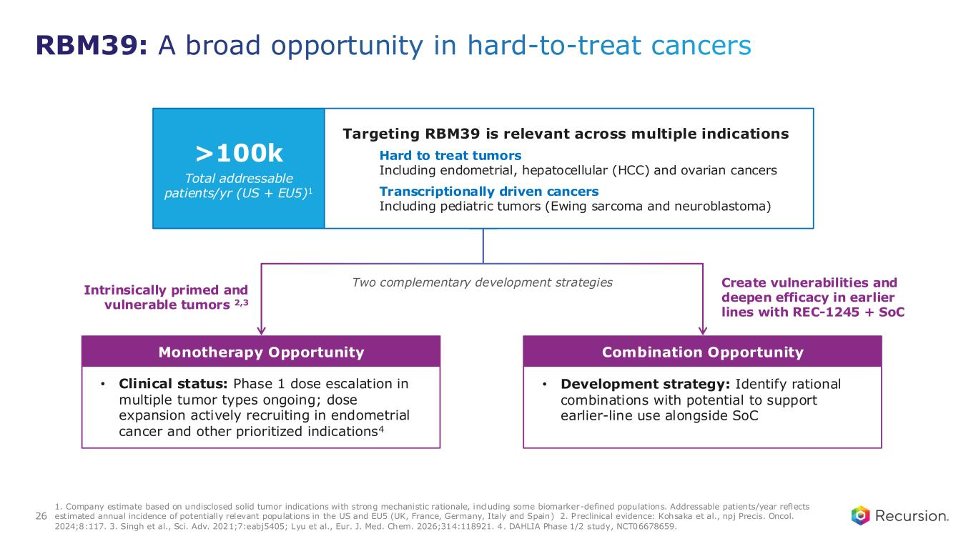
Monotherapy Opportunity Combination Opportunity RBM39: A broad opportunity in hard-to-treat cancers Targeting RBM39 is relevant across multiple indications Hard to treat tumors Including endometrial, hepatocellular (HCC) and ovarian cancers Transcriptionally driven cancers Including pediatric tumors (Ewing sarcoma and neuroblastoma) >100k Total addressable patients/yr (US + EU5)1 Two complementary development strategies Intrinsically primed and vulnerable tumors 2,3 Create vulnerabilities and deepen efficacy in earlier lines with REC-1245 + SoC • Clinical status: Phase 1 dose escalation in multiple tumor types ongoing; dose expansion actively recruiting in endometrial cancer and other prioritized indications4 • Development strategy: Identify rational combinations with potential to support earlier-line use alongside SoC 1. Company estimate based on undisclosed solid tumor indications with strong mechanistic rationale, including some biomarker-defined populations. Addressable patients/year reflects estimated annual incidence of potentially relevant populations in the US and EU5 (UK, France, Germany, Italy and Spain) 2. Preclinical evidence: Kohsaka et al., npj Precis. Oncol. 2024;8:117. 3. Singh et al., Sci. Adv. 2021;7:eabj5405; Lyu et al., Eur. J. Med. Chem. 2026;314:118921. 4. DAHLIA Phase 1/2 study, NCT06678659. 26

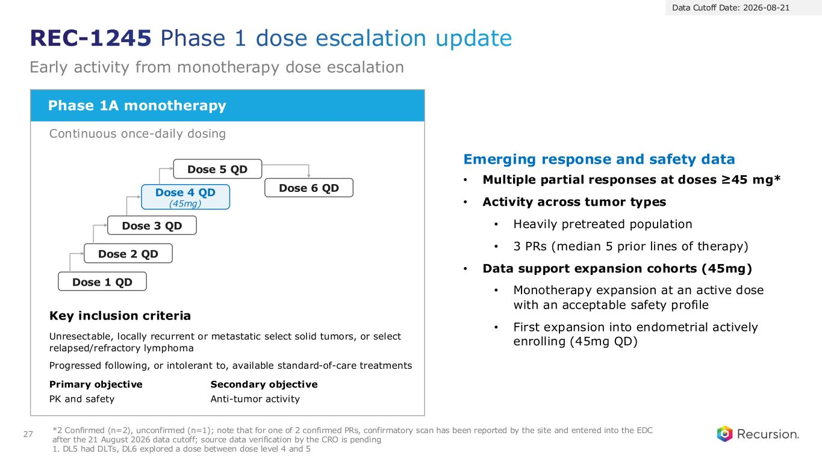
Phase 1A monotherapy Continuous once-daily dosing Key inclusion criteria Unresectable, locally recurrent or metastatic select solid tumors, or select relapsed/refractory lymphoma Progressed following, or intolerant to, available standard-of-care treatments Primary objective PK and safety Secondary objective Anti-tumor activity *2 Confirmed (n=2), unconfirmed (n=1); note that for one of 2 confirmed PRs, confirmatory scan has been reported by the site and entered into the EDC after the 21 August 2026 data cutoff; source data verification by the CRO is pending 1. DL5 had DLTs, DL6 explored a dose between dose level 4 and 5 Data Cutoff Date: 2026-08-21 REC-1245 Phase 1 dose escalation update Early activity from monotherapy dose escalation 27 Emerging response and safety data • Multiple partial responses at doses ≥45 mg* • Activity across tumor types • Heavily pretreated population • 3 PRs (median 5 prior lines of therapy) • Data support expansion cohorts (45mg) • Monotherapy expansion at an active dose with an acceptable safety profile • First expansion into endometrial actively enrolling (45mg QD) Dose 1 QD Dose 2 QD Dose 3 QD Dose 4 QD (45mg) Dose 6 QD Dose 5 QD

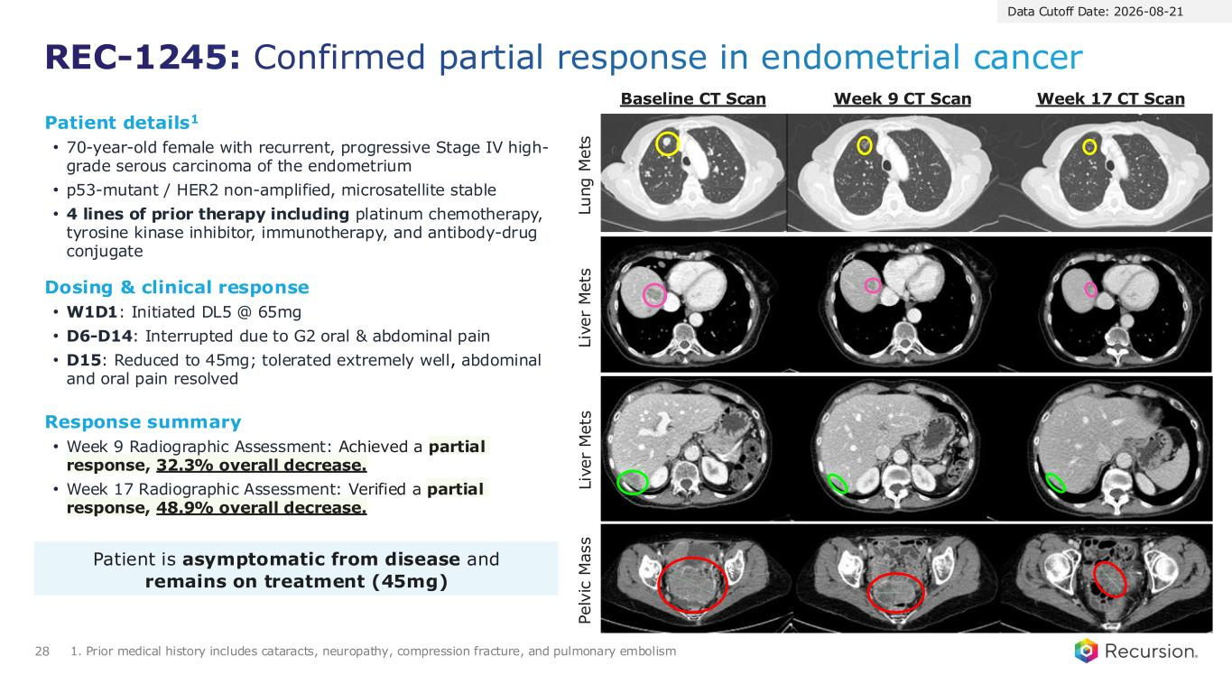
REC-1245: Confirmed partial response in endometrial cancer 28 1. Prior medical history includes cataracts, neuropathy, compression fracture, and pulmonary embolism Response summary • Week 9 Radiographic Assessment: Achieved a partial response, 32.3% overall decrease. • Week 17 Radiographic Assessment: Verified a partial response, 48.9% overall decrease. Patient details1 • 70-year-old female with recurrent, progressive Stage IV high- grade serous carcinoma of the endometrium • p53-mutant / HER2 non-amplified, microsatellite stable • 4 lines of prior therapy including platinum chemotherapy, tyrosine kinase inhibitor, immunotherapy, and antibody-drug conjugate Dosing & clinical response • W1D1: Initiated DL5 @ 65mg • D6-D14: Interrupted due to G2 oral & abdominal pain • D15: Reduced to 45mg; tolerated extremely well, abdominal and oral pain resolved Patient is asymptomatic from disease and remains on treatment (45mg) L iv e r M e ts P e lv ic M a s s L u n g M e ts L iv e r M e ts Baseline CT Scan Week 9 CT Scan Week 17 CT Scan Data Cutoff Date: 2026-08-21

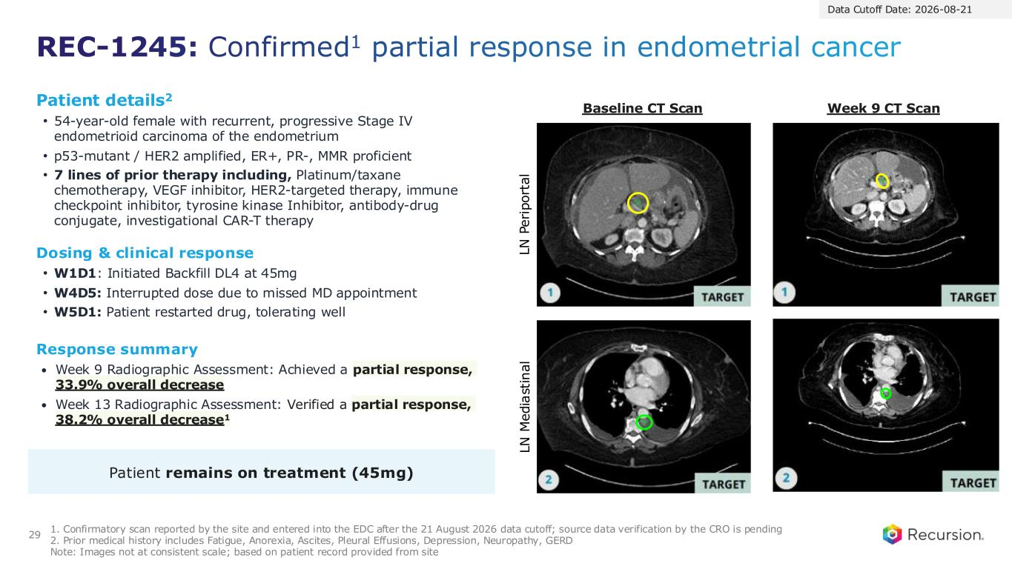
REC-1245: Confirmed1 partial response in endometrial cancer 29 1. Confirmatory scan reported by the site and entered into the EDC after the 21 August 2026 data cutoff; source data verification by the CRO is pending 2. Prior medical history includes Fatigue, Anorexia, Ascites, Pleural Effusions, Depression, Neuropathy, GERD Note: Images not at consistent scale; based on patient record provided from site Response summary • Week 9 Radiographic Assessment: Achieved a partial response, 33.9% overall decrease • Week 13 Radiographic Assessment: Verified a partial response, 38.2% overall decrease1 Patient details2 • 54-year-old female with recurrent, progressive Stage IV endometrioid carcinoma of the endometrium • p53-mutant / HER2 amplified, ER+, PR-, MMR proficient • 7 lines of prior therapy including, Platinum/taxane chemotherapy, VEGF inhibitor, HER2-targeted therapy, immune checkpoint inhibitor, tyrosine kinase Inhibitor, antibody-drug conjugate, investigational CAR-T therapy Dosing & clinical response • W1D1: Initiated Backfill DL4 at 45mg • W4D5: Interrupted dose due to missed MD appointment • W5D1: Patient restarted drug, tolerating well Patient remains on treatment (45mg) L N P e ri p o rt a l L N M e d ia st in a l Baseline CT Scan Week 9 CT Scan Data Cutoff Date: 2026-08-21

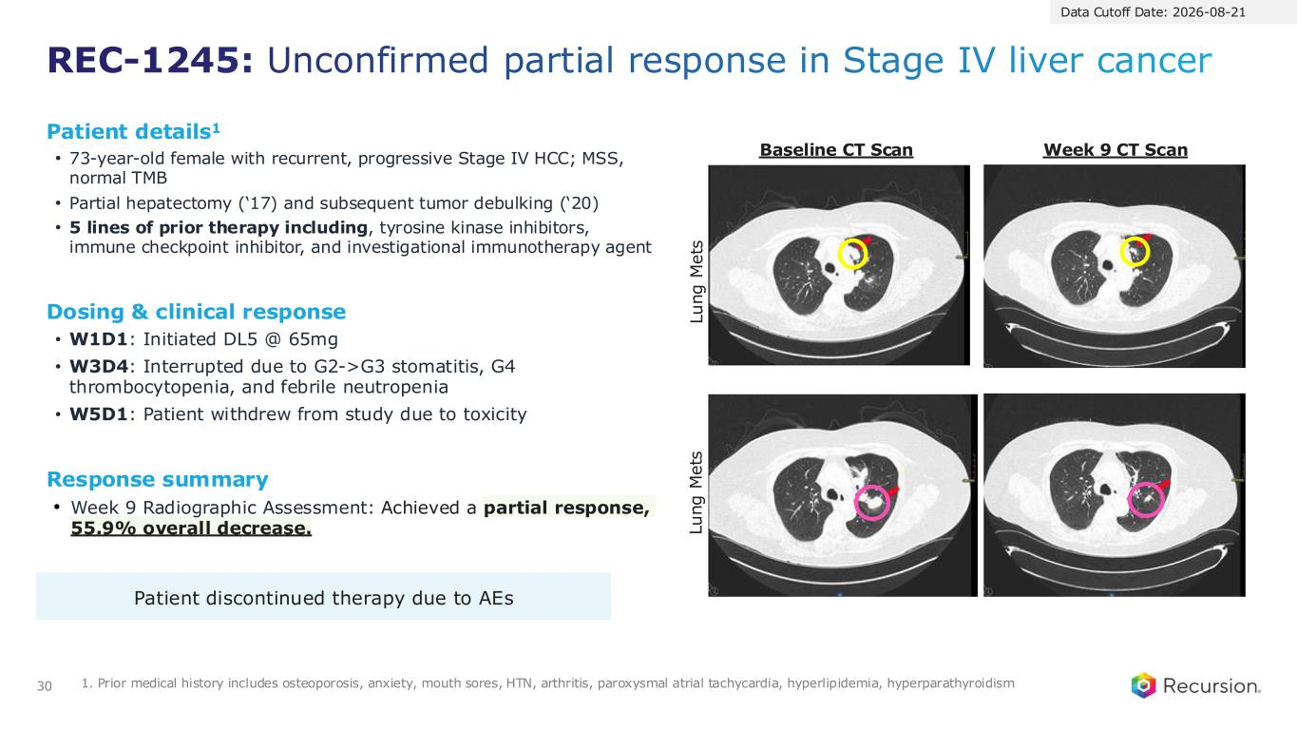
REC-1245: Unconfirmed partial response in Stage IV liver cancer 30 1. Prior medical history includes osteoporosis, anxiety, mouth sores, HTN, arthritis, paroxysmal atrial tachycardia, hyperlipidemia, hyperparathyroidism Response summary • Week 9 Radiographic Assessment: Achieved a partial response, 55.9% overall decrease. Patient details1 • 73-year-old female with recurrent, progressive Stage IV HCC; MSS, normal TMB • Partial hepatectomy (‘17) and subsequent tumor debulking (‘20) • 5 lines of prior therapy including, tyrosine kinase inhibitors, immune checkpoint inhibitor, and investigational immunotherapy agent Dosing & clinical response • W1D1: Initiated DL5 @ 65mg • W3D4: Interrupted due to G2->G3 stomatitis, G4 thrombocytopenia, and febrile neutropenia • W5D1: Patient withdrew from study due to toxicity Patient discontinued therapy due to AEs Baseline CT Scan L u n g M e ts L u n g M e ts Week 9 CT Scan Data Cutoff Date: 2026-08-21

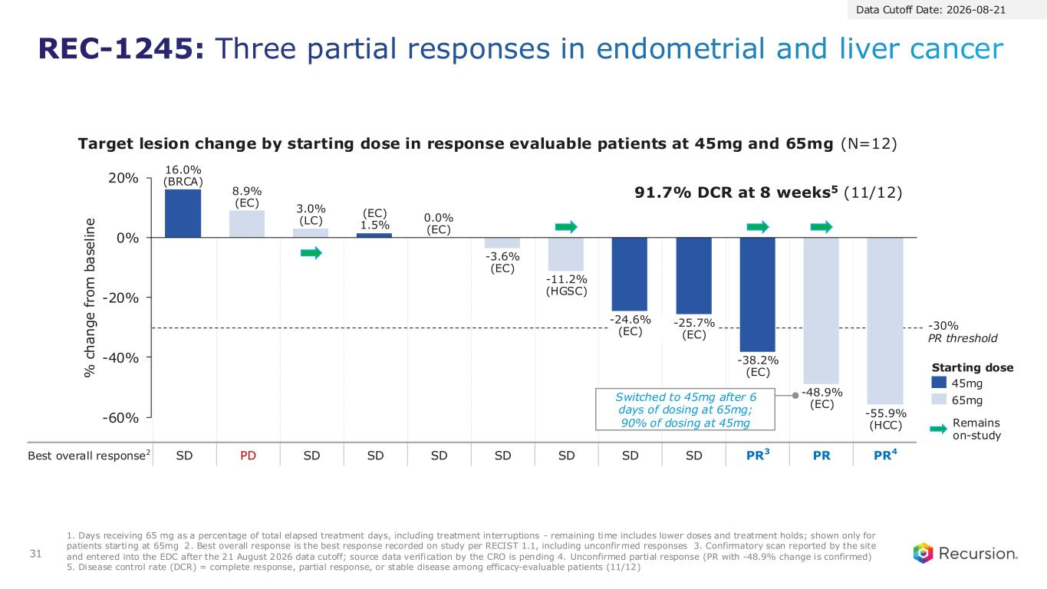
Best overall response2 SD PD SD SD SD SD SD SD SD PR3 PR PR4 REC-1245: Three partial responses in endometrial and liver cancer 31 -60% -40% -20% 0% 20% 16.0% (BRCA) 8.9% (EC) 3.0% (LC) (EC) 1.5% 0.0% (EC) -3.6% (EC) -11.2% (HGSC) -24.6% (EC) -25.7% (EC) -38.2% (EC) -48.9% (EC) -55.9% (HCC) 45mg 65mg Data Cutoff Date: 2026-08-21 % c h a n g e f ro m b a se li n e Remains on-study Target lesion change by starting dose in response evaluable patients at 45mg and 65mg (N=12) -30% PR threshold 1. Days receiving 65 mg as a percentage of total elapsed treatment days, including treatment interruptions - remaining time includes lower doses and treatment holds; shown only for patients starting at 65mg 2. Best overall response is the best response recorded on study per RECIST 1.1, including unconfirmed responses 3. Confirmatory scan reported by the site and entered into the EDC after the 21 August 2026 data cutoff; source data verification by the CRO is pending 4. Unconfirmed partial response (PR with -48.9% change is confirmed) 5. Disease control rate (DCR) = complete response, partial response, or stable disease among efficacy-evaluable patients (11/12) 91.7% DCR at 8 weeks5 (11/12) Switched to 45mg after 6 days of dosing at 65mg; 90% of dosing at 45mg Starting dose

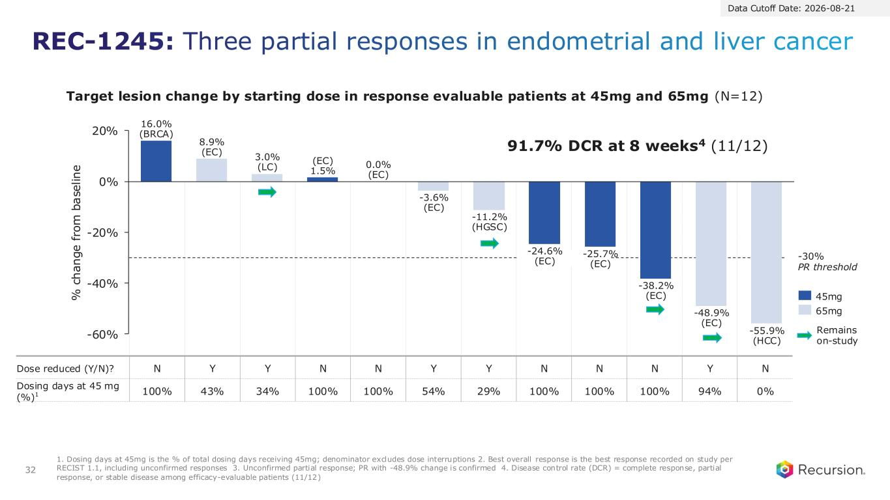
Dose reduced (Y/N)? N Y Y N N Y Y N N N Y N Dosing days at 45 mg (%)1 100% 43% 34% 100% 100% 54% 29% 100% 100% 100% 94% 0% REC-1245: Three partial responses in endometrial and liver cancer 32 -60% -40% -20% 0% 20% 16.0% (BRCA) 8.9% (EC) 3.0% (LC) (EC) 1.5% 0.0% (EC) -3.6% (EC) -11.2% (HGSC) -24.6% (EC) -25.7% (EC) -38.2% (EC) -48.9% (EC) -55.9% (HCC) 45mg 65mg Data Cutoff Date: 2026-08-21 % c h a n g e f ro m b a se li n e Remains on-study -30% PR threshold 1. Dosing days at 45mg is the % of total dosing days receiving 45mg; denominator excludes dose interruptions 2. Best overall response is the best response recorded on study per RECIST 1.1, including unconfirmed responses 3. Unconfirmed partial response; PR with -48.9% change is confirmed 4. Disease control rate (DCR) = complete response, partial response, or stable disease among efficacy-evaluable patients (11/12) 91.7% DCR at 8 weeks4 (11/12) Target lesion change by starting dose in response evaluable patients at 45mg and 65mg (N=12)

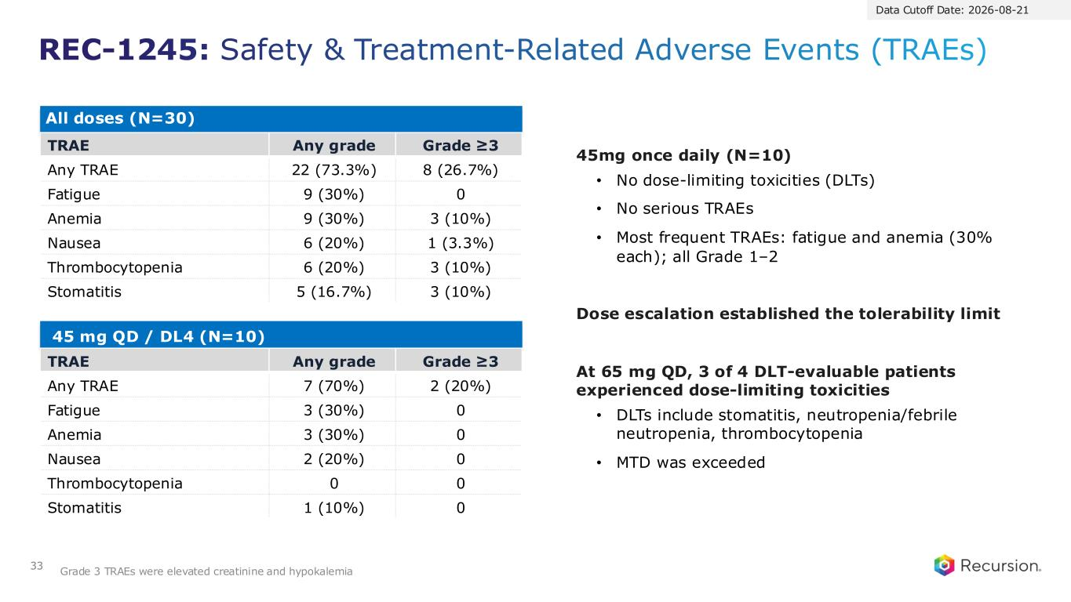
All doses (N=30) TRAE Any grade Grade ≥3 Any TRAE 22 (73.3%) 8 (26.7%) Fatigue 9 (30%) 0 Anemia 9 (30%) 3 (10%) Nausea 6 (20%) 1 (3.3%) Thrombocytopenia 6 (20%) 3 (10%) Stomatitis 5 (16.7%) 3 (10%) 45 mg QD / DL4 (N=10) TRAE Any grade Grade ≥3 Any TRAE 7 (70%) 2 (20%) Fatigue 3 (30%) 0 Anemia 3 (30%) 0 Nausea 2 (20%) 0 Thrombocytopenia 0 0 Stomatitis 1 (10%) 0 Data Cutoff Date: 2026-08-21 REC-1245: Safety & Treatment-Related Adverse Events (TRAEs) 33 Grade 3 TRAEs were elevated creatinine and hypokalemia 45mg once daily (N=10) • No dose-limiting toxicities (DLTs) • No serious TRAEs • Most frequent TRAEs: fatigue and anemia (30% each); all Grade 1–2 Dose escalation established the tolerability limit At 65 mg QD, 3 of 4 DLT-evaluable patients experienced dose-limiting toxicities • DLTs include stomatitis, neutropenia/febrile neutropenia, thrombocytopenia • MTD was exceeded

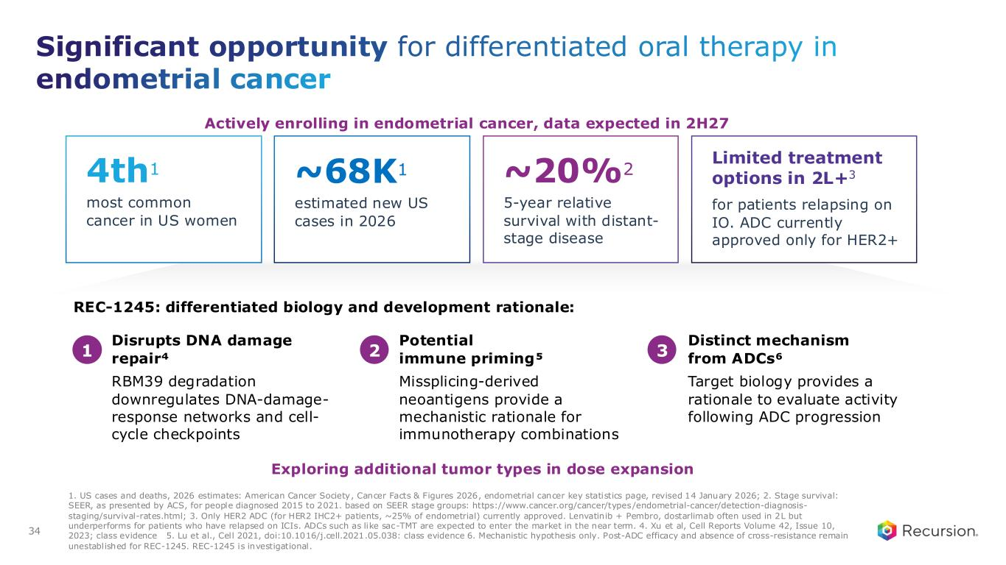
most common cancer in US women REC-1245: differentiated biology and development rationale: Disrupts DNA damage repair⁴ Potential immune priming⁵ Distinct mechanism from ADCs⁶ RBM39 degradation downregulates DNA-damage- response networks and cell- cycle checkpoints Missplicing-derived neoantigens provide a mechanistic rationale for immunotherapy combinations Target biology provides a rationale to evaluate activity following ADC progression 1. US cases and deaths, 2026 estimates: American Cancer Society, Cancer Facts & Figures 2026, endometrial cancer key statistics page, revised 14 January 2026; 2. Stage survival: SEER, as presented by ACS, for people diagnosed 2015 to 2021. based on SEER stage groups: https://www.cancer.org/cancer/types/endometrial-cancer/detection-diagnosis- staging/survival-rates.html; 3. Only HER2 ADC (for HER2 IHC2+ patients, ~25% of endometrial) currently approved. Lenvatinib + Pembro, dostarlimab often used in 2L but underperforms for patients who have relapsed on ICIs. ADCs such as like sac-TMT are expected to enter the market in the near term. 4. Xu et al, Cell Reports Volume 42, Issue 10, 2023; class evidence 5. Lu et al., Cell 2021, doi:10.1016/j.cell.2021.05.038: class evidence 6. Mechanistic hypothesis only. Post-ADC efficacy and absence of cross-resistance remain unestablished for REC-1245. REC-1245 is investigational. Significant opportunity for differentiated oral therapy in endometrial cancer 34 4th1 estimated new US cases in 2026 ~68K1 5-year relative survival with distant- stage disease ~20%2 for patients relapsing on IO. ADC currently approved only for HER2+ Limited treatment options in 2L+3 1 2 3 Actively enrolling in endometrial cancer, data expected in 2H27 Exploring additional tumor types in dose expansion


Partnerships Novel targets and programs Translating proof to products

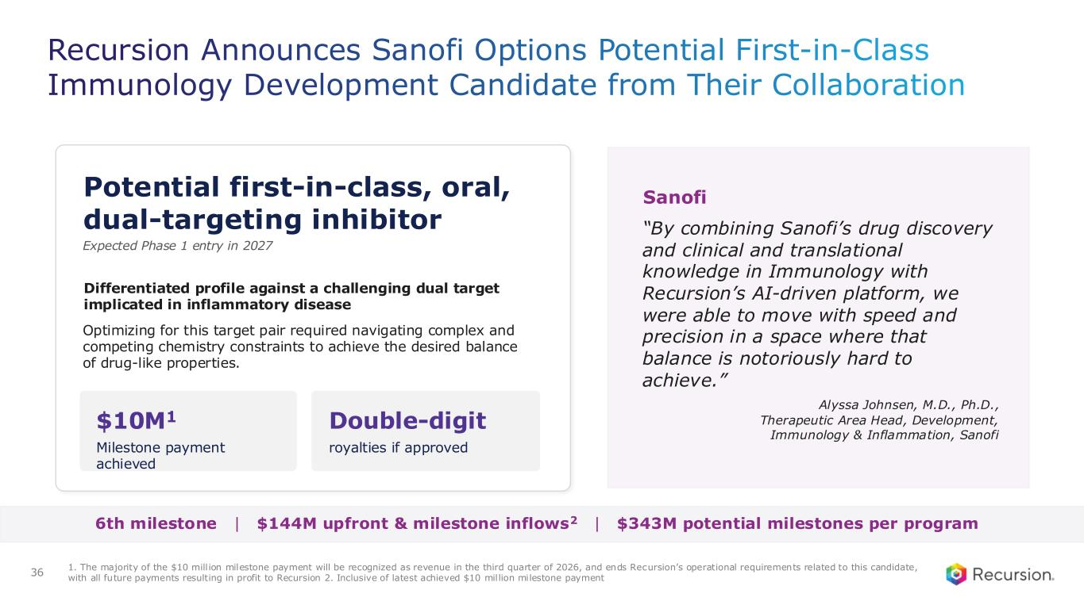
Recursion Announces Sanofi Options Potential First-in-Class Immunology Development Candidate from Their Collaboration 1. The majority of the $10 million milestone payment will be recognized as revenue in the third quarter of 2026, and ends Recursion’s operational requirements related to this candidate, with all future payments resulting in profit to Recursion 2. Inclusive of latest achieved $10 million milestone payment Potential first-in-class, oral, dual-targeting inhibitor $10M1 Milestone payment achieved Double-digit royalties if approved 36 Sanofi “By combining Sanofi’s drug discovery and clinical and translational knowledge in Immunology with Recursion’s AI-driven platform, we were able to move with speed and precision in a space where that balance is notoriously hard to achieve.” Alyssa Johnsen, M.D., Ph.D., Therapeutic Area Head, Development, Immunology & Inflammation, Sanofi 6th milestone | $144M upfront & milestone inflows2 | $343M potential milestones per program Expected Phase 1 entry in 2027 Differentiated profile against a challenging dual target implicated in inflammatory disease Optimizing for this target pair required navigating complex and competing chemistry constraints to achieve the desired balance of drug-like properties.

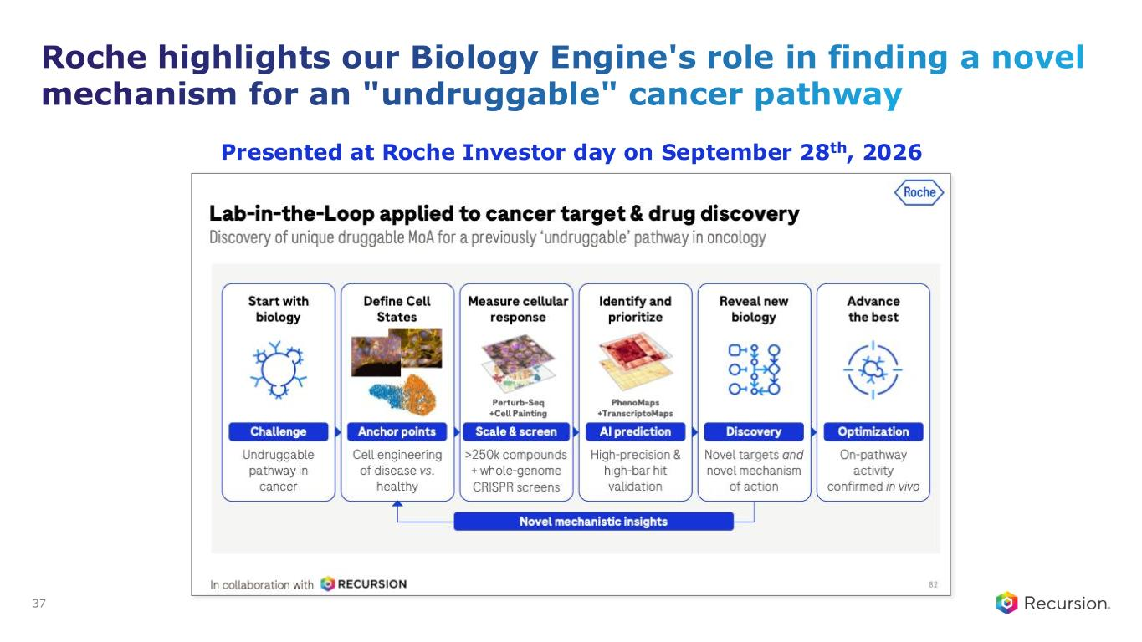
Roche highlights our Biology Engine's role in finding a novel mechanism for an "undruggable" cancer pathway Presented at Roche Investor day on September 28th, 2026 37

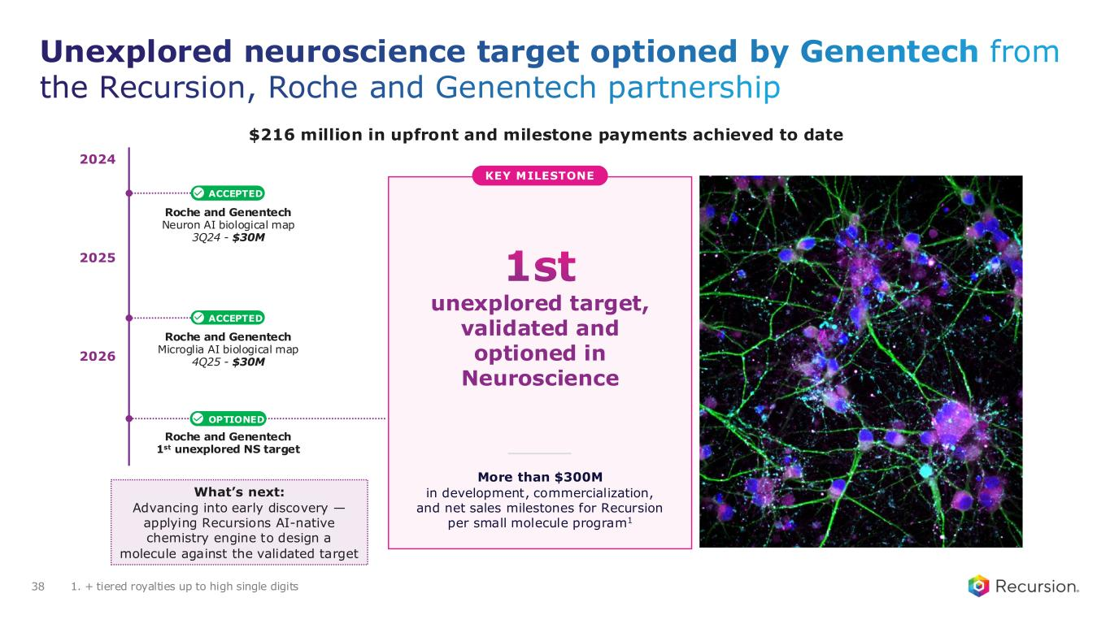
Unexplored neuroscience target optioned by Genentech from the Recursion, Roche and Genentech partnership 38 Roche and Genentech Neuron AI biological map 3Q24 - $30M Roche and Genentech Microglia AI biological map 4Q25 - $30M ACCEPTED ACCEPTED More than $300M in development, commercialization, and net sales milestones for Recursion per small molecule program1 OPTIONED 2026 2025 2024 Roche and Genentech 1st unexplored NS target What’s next: Advancing into early discovery — applying Recursions AI-native chemistry engine to design a molecule against the validated target 1st unexplored target, validated and optioned in Neuroscience KEY MILESTONE 1. + tiered royalties up to high single digits $216 million in upfront and milestone payments achieved to date

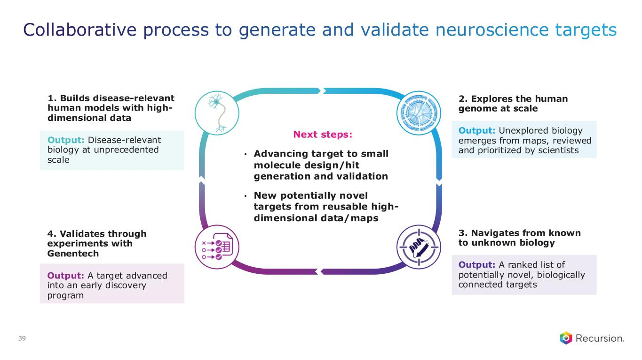
Collaborative process to generate and validate neuroscience targets 39 1. Builds disease-relevant human models with high- dimensional data Output: Disease-relevant biology at unprecedented scale 4. Validates through experiments with Genentech Output: A target advanced into an early discovery program 2. Explores the human genome at scale Output: Unexplored biology emerges from maps, reviewed and prioritized by scientists 3. Navigates from known to unknown biology Output: A ranked list of potentially novel, biologically connected targets Next steps: • Advancing target to small molecule design/hit generation and validation • New potentially novel targets from reusable high- dimensional data/maps

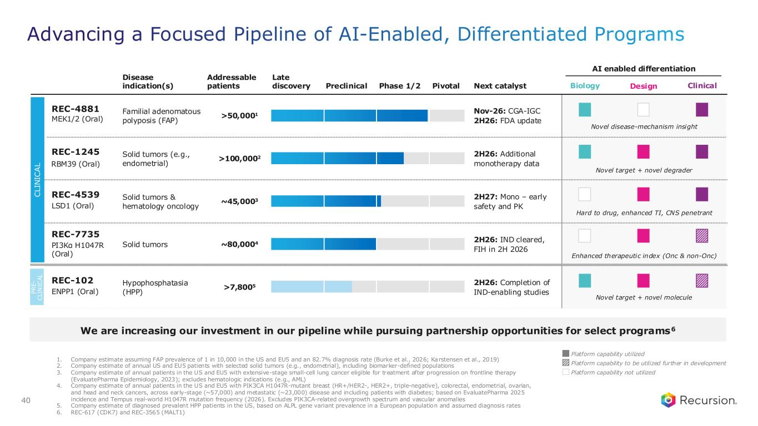
Advancing a Focused Pipeline of AI-Enabled, Differentiated Programs 40 Platform capability utilized Platform capability not utilized Platform capability to be utilized further in development Disease indication(s) Addressable patients Next catalyst AI enabled differentiation Late discovery Preclinical Phase 1/2 Pivotal Familial adenomatous polyposis (FAP) >50,0001 Nov-26: CGA-IGC 2H26: FDA update Solid tumors (e.g., endometrial) >100,0002 2H26: Additional monotherapy data Solid tumors & hematology oncology ~45,0003 2H27: Mono – early safety and PK Solid tumors ~80,0004 2H26: IND cleared, FIH in 2H 2026 Hypophosphatasia (HPP) >7,8005 2H26: Completion of IND-enabling studies C L IN IC A L P R E - C L IN IC A L Design Clinical REC-4881 MEK1/2 (Oral) REC-1245 RBM39 (Oral) REC-4539 LSD1 (Oral) REC-7735 PI3Kα H1047R (Oral) REC-102 ENPP1 (Oral) Biology Novel disease-mechanism insight Novel target + novel degrader Hard to drug, enhanced TI, CNS penetrant Enhanced therapeutic index (Onc & non-Onc) Novel target + novel molecule We are increasing our investment in our pipeline while pursuing partnership opportunities for select programs6 1. Company estimate assuming FAP prevalence of 1 in 10,000 in the US and EU5 and an 82.7% diagnosis rate (Burke et al., 2026; Karstensen et al., 2019) 2. Company estimate of annual US and EU5 patients with selected solid tumors (e.g., endometrial), including biomarker-defined populations 3. Company estimate of annual patients in the US and EU5 with extensive-stage small-cell lung cancer eligible for treatment after progression on frontline therapy (EvaluatePharma Epidemiology, 2023); excludes hematologic indications (e.g., AML) 4. Company estimate of annual patients in the US and EU5 with PIK3CA H1047R-mutant breast (HR+/HER2-, HER2+, triple-negative), colorectal, endometrial, ovarian, and head and neck cancers, across early-stage (~57,000) and metastatic (~23,000) disease and including patients with diabetes; based on EvaluatePharma 2025 incidence and Tempus real-world H1047R mutation frequency (2026). Excludes PIK3CA-related overgrowth spectrum and vascular anomalies 5. Company estimate of diagnosed prevalent HPP patients in the US, based on ALPL gene variant prevalence in a European population and assumed diagnosis rates 6. REC-617 (CDK7) and REC-3565 (MALT1)

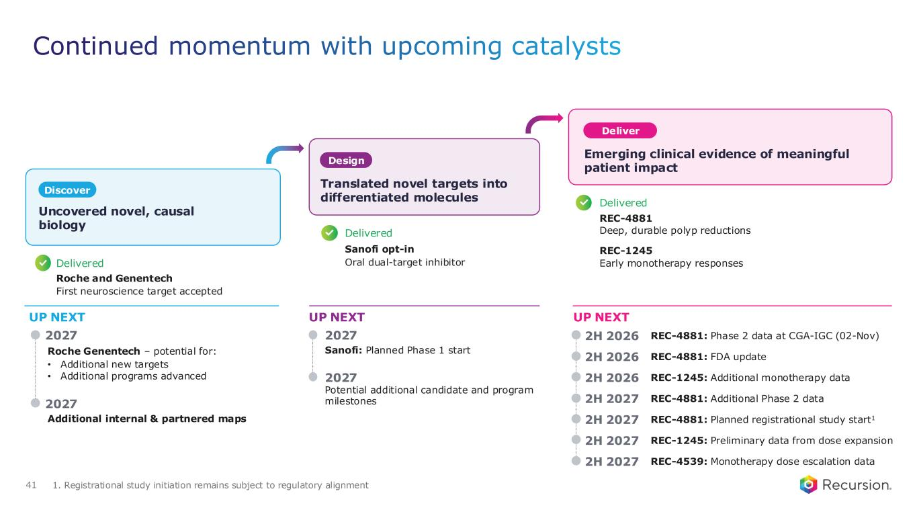
Sanofi: Planned Phase 1 start Continued momentum with upcoming catalysts 1. Registrational study initiation remains subject to regulatory alignment UP NEXT UP NEXT UP NEXT 2027 2027 2027 Potential additional candidate and program milestones 2H 2026 REC-4881: FDA update 2H 2027 REC-4881: Additional Phase 2 data 2H 2027 REC-4881: Planned registrational study start1 2H 2027 REC-1245: Preliminary data from dose expansion 2H 2027 REC-4539: Monotherapy dose escalation data Delivered Roche and Genentech First neuroscience target accepted Delivered Sanofi opt-in Oral dual-target inhibitor Delivered REC-4881 Deep, durable polyp reductions REC-1245 Early monotherapy responses Uncovered novel, causal biology Discover Design Translated novel targets into differentiated molecules Deliver Emerging clinical evidence of meaningful patient impact Roche Genentech – potential for: • Additional new targets • Additional programs advanced Additional internal & partnered maps 2027 2H 2026 REC-1245: Additional monotherapy data 2H 2026 REC-4881: Phase 2 data at CGA-IGC (02-Nov) 41

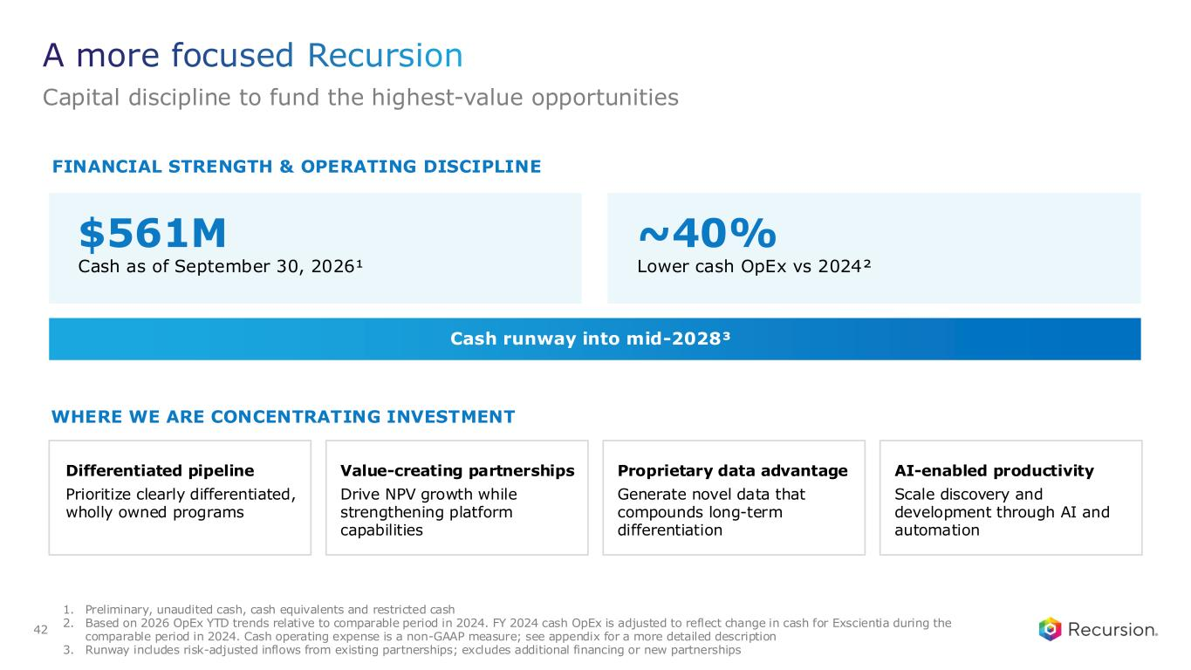
FINANCIAL STRENGTH & OPERATING DISCIPLINE $561M Cash as of September 30, 2026¹ ~40% Lower cash OpEx vs 2024² Cash runway into mid-2028³ WHERE WE ARE CONCENTRATING INVESTMENT Differentiated pipeline Prioritize clearly differentiated, wholly owned programs Value-creating partnerships Drive NPV growth while strengthening platform capabilities Proprietary data advantage Generate novel data that compounds long-term differentiation AI-enabled productivity Scale discovery and development through AI and automation A more focused Recursion Capital discipline to fund the highest-value opportunities 42 1. Preliminary, unaudited cash, cash equivalents and restricted cash 2. Based on 2026 OpEx YTD trends relative to comparable period in 2024. FY 2024 cash OpEx is adjusted to reflect change in cash for Exscientia during the comparable period in 2024. Cash operating expense is a non-GAAP measure; see appendix for a more detailed description 3. Runway includes risk-adjusted inflows from existing partnerships; excludes additional financing or new partnerships



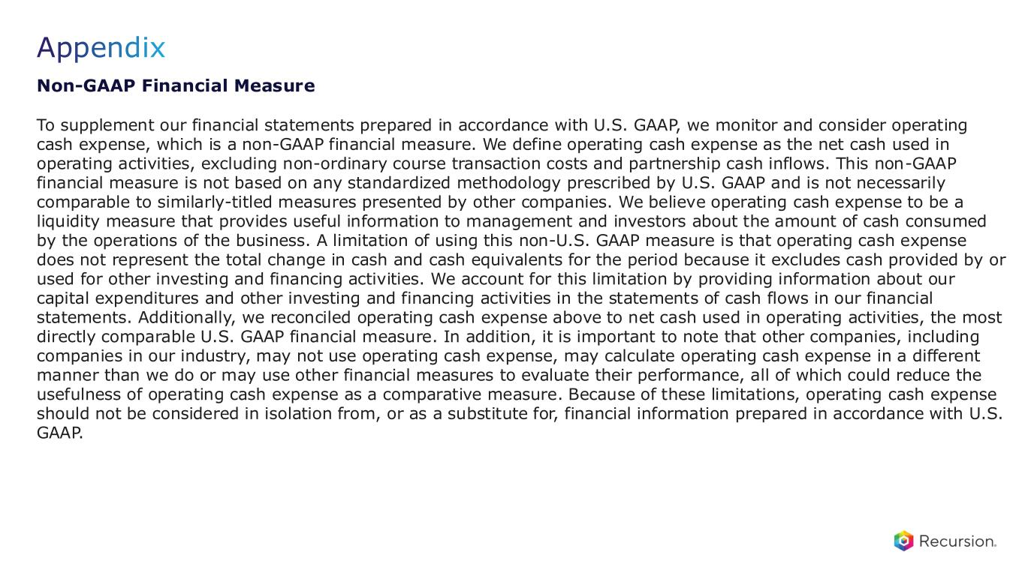
Appendix Non-GAAP Financial Measure To supplement our financial statements prepared in accordance with U.S. GAAP, we monitor and consider operating cash expense, which is a non-GAAP financial measure. We define operating cash expense as the net cash used in operating activities, excluding non-ordinary course transaction costs and partnership cash inflows. This non-GAAP financial measure is not based on any standardized methodology prescribed by U.S. GAAP and is not necessarily comparable to similarly-titled measures presented by other companies. We believe operating cash expense to be a liquidity measure that provides useful information to management and investors about the amount of cash consumed by the operations of the business. A limitation of using this non-U.S. GAAP measure is that operating cash expense does not represent the total change in cash and cash equivalents for the period because it excludes cash provided by or used for other investing and financing activities. We account for this limitation by providing information about our capital expenditures and other investing and financing activities in the statements of cash flows in our financial statements. Additionally, we reconciled operating cash expense above to net cash used in operating activities, the most directly comparable U.S. GAAP financial measure. In addition, it is important to note that other companies, including companies in our industry, may not use operating cash expense, may calculate operating cash expense in a different manner than we do or may use other financial measures to evaluate their performance, all of which could reduce the usefulness of operating cash expense as a comparative measure. Because of these limitations, operating cash expense should not be considered in isolation from, or as a substitute for, financial information prepared in accordance with U.S. GAAP.

Exhibit 99.4
Recursion Announces Pricing of $200 Million Underwritten Offering of Class A Common Stock

Recursion Pharmaceuticals, Inc. (“Recursion”) (NASDAQ: RXRX), a leading clinical-stage company pioneering AI-enabled drug discovery and development decoding biology to radically improve lives, today announced the pricing of an underwritten offering of 61,540,000 shares of its Class A common stock at a price of $3.25 per share. All of the shares are to be sold by Recursion. Before deducting the underwriting discounts and commissions and estimated offering expenses, Recursion expects to receive total gross proceeds of approximately $200 million. The offering is expected to close on or about October 16, 2026, subject to satisfaction of customary closing conditions.

Leerink Partners, Goldman Sachs & Co. LLC, Morgan Stanley & Co. LLC and Evercore Group L.L.C. are acting as joint bookrunning managers for the offering. Needham & Company, LLC is acting as lead manager for the offering.

The financing included participation from leading healthcare and institutional investors, including Janus Henderson Investors, Invus, Longaeva Partners, ARK Invest, Driehaus Capital Management and other prominent healthcare specialists and mutual funds.

The shares are being offered by Recursion pursuant to a registration statement on Form S-3, which became automatically effective upon filing with the U.S. Securities and Exchange Commission (“SEC”) on February 12, 2025. The offering is being made solely by means of a written prospectus and a prospectus supplement that form a part of the registration statement. The preliminary prospectus supplement and accompanying prospectus relating to the offering was filed on October 15, 2026. A final prospectus supplement and accompanying prospectus relating to the offering will also be filed with the SEC. These documents can be accessed for free through the SEC’s website at www.sec.gov. Alternatively, a copy of the final prospectus supplement and accompanying prospectus relating to this offering may be obtained, when available, by contacting: Leerink Partners LLC, Attention: Syndicate Department, 53 State Street, 40th Floor, Boston, MA 02109, by telephone at (800) 808-7525 ext. 6105 or by email at syndicate@leerink.com; Goldman Sachs & Co. LLC, Attention: Prospectus Department, 200 West Street, New York, NY 10282, by telephone at (866) 471-2526 or by email at prospectus-ny@ny.email.gs.com; Morgan Stanley & Co. LLC, Attention: Prospectus Department, 180 Varick Street, 2nd Floor, New York, NY 10014, by telephone at (866) 718-1649 or by email at prospectus@morganstanley.com; or Evercore Group L.L.C., Attention: Equity Capital Markets, 55 East 52nd Street, 35th Floor, New York, NY 10055, by telephone at (888) 474-0200 or by email at ecm.prospectus@evercore.com.

This press release does not constitute an offer to sell or a solicitation of an offer to buy, nor will there be any sale of these securities in any state or other jurisdiction in which such offer, solicitation, or sale would be unlawful before registration or qualification under the securities laws of that state or jurisdiction.

About Recursion

Recursion (NASDAQ: RXRX) is a leading clinical-stage company pioneering AI-enabled drug discovery and development decoding biology to radically improve lives. Recursion is advancing a portfolio of differentiated investigational medicines across its wholly owned and partnered pipeline in oncology, rare disease, neuroscience, immunology, and other therapeutic areas with significant unmet need. Enabling its mission is the Recursion OS, an AI-native, end-to-end drug discovery and development platform integrating biology, chemistry, and clinical development into a unified intelligence system. Powered by proprietary multimodal data, purpose-built AI models, and bilingual teams fluent in both science and AI, the Recursion OS is designed to translate complex science into medicines that matter — faster, better, and at scale — for patients who are waiting.

Recursion's platform infrastructure is anchored in Salt Lake City, Utah and Milton Park, Oxfordshire, where its automated biology and chemistry laboratories generate proprietary data at industrial scale. Recursion also maintains offices in New York, Montréal, and London, three global hubs for talent and leadership at the intersection of AI and scientific innovation.

Forward-Looking Statements

This press release contains information that includes or is based upon “forward-looking statements” within the meaning of the Private Securities Litigation Reform Act of 1995, including, without limitation, statements regarding

the expected completion and timing of closing of the offering, the anticipated total gross proceeds from the offering and all other statements that are not statements of historical facts. Forward-looking statements may or may not include identifying words such as “intend,” “plan,” “will,” “expect,” “anticipate,” “believe,” “potential,” “continue,” and similar terms. These statements are subject to known and unknown risks and uncertainties that could cause actual results to differ materially from those expressed or implied in such statements, including but not limited to: prevailing market conditions; the satisfaction of customary closing conditions; general economic, industry or political conditions; challenges inherent in pharmaceutical research and development, including the timing and results of preclinical and clinical programs, where the risk of failure is high and failure can occur at any stage prior to or after regulatory approval due to lack of sufficient efficacy, safety considerations, or other factors; the fact that interim and preliminary clinical data, including data from a small number of patients in a single-arm study, may not be predictive of final results; our ability to leverage and enhance our drug discovery platform; the performance and limitations of our artificial intelligence and machine learning models and the data on which they are trained; our reliance on third parties, including collaborators, contract research organizations, and manufacturers; our ability to initiate clinical trials and enroll patients on expected timelines; the outcome of our discussions with the FDA, which may result in changes to the design or timing of, or delays in, our planned registrational trial of REC-4881; competition from other therapies and platforms; our ability to obtain financing for development activities and other corporate purposes; the satisfaction of customary closing conditions for the offering; the possibility that our preliminary estimate of cash, cash equivalents and restricted cash may change upon completion of our quarter-end financial close procedures; the success of our collaboration activities and our collaborators' discretion over option exercises, program advancement, and funding; our ability to obtain regulatory approval of, and ultimately commercialize, drug candidates; our ability to obtain, maintain, and enforce intellectual property protections; cyberattacks or other disruptions to our technology systems; our ability to attract, motivate, and retain key employees and manage our growth; inflation and other macroeconomic issues; and other risks and uncertainties such as those described under the heading "Risk Factors" in our filings with the U.S. Securities and Exchange Commission, including our Annual Report on Form 10-K and our subsequent Quarterly Reports on Form 10-Q. All forward-looking statements speak only as of the date of this document and are based on management's current estimates, projections, and assumptions, and Recursion undertakes no obligation to correct or update any such statements, whether as a result of new information, future developments, or otherwise, except to the extent required by applicable law.

Investor Contact:
investor@recursion.com
Media Contact:
media@recursion.com

